

**UNIVERSITY OF GREENWICH**

COMP1682 **–** Final Year Project

Proposal

Develop an e-commerce system for selling leather shoes

|  |  |
| --- | --- |
| Student | **Do Huu Duy** |
| ID number | **001353267** |
| Supervisor | **Nguyen Thai Nghe** |
| Student submission date | **November 4th, 2023** |

**Project Proposal**

COMP1682 – Final Year Projects Proposal

Do Huu Duy – 001353267

Supervisor: Nguyen Thai Nghe

Due date: November 4th, 2023

**Project Name:** Develop an e-commerce system for selling leather shoes

**Program Title:** BSc Hons Computing

**Abstract:** E-commerce system shoe selling website is a convenient and safe shopping solution for customers. Customers can easily find footwear products that suit their needs. The website also offers many payment methods and delivery services, making shopping easy and convenient for customers.

Table of Contents

1. Introduction 1

1.1. Overview 1

1.2. Aim 1

1.3. Objective 1

1.3.1. Analysis of the basic features of the website 1

1.3.2. Design 3

1.3.3. Implement 3

1.3.4. Testing 3

1.3.5. Evaluation 3

1.4. Approach 3

1.4.1. The tools, software, and technologies to develop the website 3

1.4.2. Methodology 4

2. Literature Review 5

3. Product Research 5

3.1. Review 5

3.2. Compare 5

4. Legal, Social, Ethical, and Professional issues 6

5. Planning 7

6. References 8

Table of Figures

Figure 1. Waterfall structure of project 4

Figure 2. Gantt Char 7

Table of Tables

Table 1. Product Research 5

# 1. Introduction

# 1.1. Overview

Nowadays, fashion is developing strongly, with people who like shopping and choosing a nice and suitable outfit for them. From that, the fashion industry developed and became famous in a lot of countries. Many companies and businesses are established and sell products related to fashion such as shoes and clothes. However, besides opening the store to sell fashion goods. They often use online marketing to advertise their goods, approach customers, and advance their business ability. According to (Paizal & Yunanto, 2019), an excellent potential for business promotion is web marketing. Because everyone is becoming more digital and there are more and more people using the internet every day, many business owners nowadays want to advertise their products online. One of the popular methods to introduce goods and reach customers is E-commerce.

When using E-commerce, we can easily introduce products and reach many customers. Due to this, more and more e-commerce websites are being built and developed to support selling and buying goods. According to (Sulova & Snezhana, 2019), e-commerce is increasingly the preferred method of conducting business today. It refers to the procedures of purchasing and selling goods and services online and via the use of contemporary communication tools. E-commerce brings numerous successes in the sales of items through websites and the profits from this type of trading are increasing gradually all over the world.

Until now, shoes have been a good choice for everyone in each outfit. Besides, helps coordinate outfits to look nice and fashionable. It also helps us protect and cherish our feet. So, many people choose the type of products for business and there are many shoe stores sprung up to sell these products.

I have a brother, who sold the type of western shoes such as Loafer, Derby, Chelsea Boot, Zip Boot, and Harness Boot. He has a store to sell and advertise through Facebook social media. However, selling and reaching the customers still causes lots of difficulty. Recognize this, along with the benefits that E-commerce carries out. I decided to develop an E-commerce website to support him in selling products and reaching customers easily. Besides, with the website, everyone can easily view and buy the items online on some internet device instead of going to the store. This helps customers easily approach and choose the products to purchase. This will save time, be more convenient, and easy to shop.

This report is separated into 6 parts. Part 1 is an introduction; I will talk about the project that I will develop. Part 2, I will talk about the literature review. Part 3, I will show about the product research. Part 4, I will talk about the Legal, Social, Ethical, and Professional issues of E-commerce websites. Part 5, I will show the development plan of this project. The last one is part 6, I will show the references that I use to support me in developing projects and write report.

# 1.2. Aim

Developing an E-commerce system that is used for selling leather shoes.

# 1.3. Objective

To achieve the aim that is mentioned above I have some of the following objectives to perform.

## 1.3.1. Analysis of the basic features of the website

I will perform an analysis of the basic features of the website for each role such as features of guest, customer, and admin roles. The strong role of the website is Admin.

* **Functional requirements:**
  + Guest (who haven’t had an account)
    - View product
    - View information of the website
    - Searching for product
    - Register
    - Chat with the website
  + Customer (who has an account already)
    - Perform all functions that guests can perform
    - Login
    - Logout
    - Management of the cart (Adding, Updating, and Deleting)
    - Order
    - Cancel order
    - Management of their profile (Updating information and changing password)
    - Reset password when they forget their password
    - View order history
    - Chat with the website
  + Manager
    - Login
    - Logout
    - Management of the products
* Adding the products
* Updating the products
* Setting the product’s status
  + - Management of the accounts (View all accounts)
    - Management of the categories (View all categories)
    - Confirm the customer's orders
    - Create an account for the manager and customer
  + Admin
    - Login
    - Logout
    - Statistical revenue in a month
    - Statistical the best sale product in a month
    - Management of the products (Adding, Updating, and Deleting)
    - Management of the categories (Adding, Updating, and Deleting)
    - Management of the suppliers (Adding, Updating, and Deleting)
    - Management of the accounts (View all accounts)
* **Non-functional requirements:**
  + - Operational: The system should be able to work on any Web browser
    - Security: The functions must be allocated to each appropriate role
    - Performance: The interaction between the user and the system should not exceed 3 seconds and the system supports concurrent users

## 1.3.2. Design

After analyzing the basic features of a website. I will proceed to design the diagrams and prototypes support to develop the project.

* **Create the Use Case Diagram:** In my project, I have four roles of end-user; that is guest, customer, manager, and administrator so I need to create the use case to help me in the development processing.
* **Create the Entity Relationship Diagram (ERD):** After creating the use case diagram, the next diagram that I need to have been ERD. I need to design the ERD diagram to support when I create database to save the data of the website such as user’s information, product’s information.
* **Create the Wire Frame:** To perform a website, I also must have a wire frame of the website to based on it to design and develop the front-end of the website. So, I will create a wire frame diagram to help me do this.

To create those above diagrams, I will use the Draw.io tool to do them. I chose Draw.io tool to help me create the diagram because I feel it is easy to use and free.

## 1.3.3. Implement

After designing the diagrams support to develop the website. I will proceed to implement the website.

* **Create Database:** In this project, to save the data of information about the user and product I have to create the database to support saving the data.
* **Create Front-end:** I will design and develop the front-end of the website to support the user experience and interaction.
* **Create Back-end:** After designing and developing the front-end of the website, I will continue to develop the back-end of the website to perform the features of the website.

## 1.3.4. Testing

After building and developing the website completely. I will proceed to test the website to detect the errors that the website has and fix them.

* **Test function of the website:** I will test each function of the website to check whether the function that I developed performs well or not and detect issues that the website has to solve them.
* **Test the database:** Check database operation to detect the problem related to them.

## 1.3.5. Evaluation

The last objective, I will evaluate the website that I developed about the cons and pros and give the solutions improve to the website.

# 1.4. Approach

# 1.4.1. The tools, software, and technologies to develop the website

I will select tools to support me in website development processing and choose suitable programming languages to build and develop the website. To develop the website, I will choose and use some of the following tools and programming languages.

* **Tools**
* Visual Studio Code (using for front-end)
* Visual Studio (using for back-end)
* Draw.io
* **Programming language**
* C# (ASP.Net)
* **Framework**
* ASP.NET CORE (back-end)
* Angular (front-end)
* **Hardware**
* Lap Top core i7
* Ram: 8GB
* Operating System: Windows 10 – 11

# 1.4.2. Methodology

According to (Bahattab & Alshamrani, 2015), there is a lot of Software Development Life cycle (SDLC) models such as Scrum, Agile, and so on. However, one of the oldest and the most well-known SDLC models is the Waterfall model. This model is easy to use and used in projects a lot. This Waterfall model is suitable for the project with the small and medium size. The special features of this model are it performs step by step, and the phase of the model is performed sequentially in order from top to bottom. For example, it goes through the phases of requirements analysis, implementation, design, coding, testing, and maintenance. Besides, the waterfall model helps us to ensure the design mistakes before the product is developed.

In this project, I will choose the Waterfall model to use. The benefits and the features that the model brings fit with my project. Firstly, my project is small and does not take a lot of budget to perform. Secondly, the requirements of the project are well-defined, and I just need to base them on the requirements that are collected and analyzed to implement. Thirdly, with the waterfall model my project will perform sequentially in order from top to bottom, this will help me easily to control my project. Those are the reasons that make me choose the Waterfall model to use. However, this model will make my project inflexible, but I feel that excluding this model, other models are not suitable for my project because some SDLC models such as Scrum and Agile models, are suitable for big projects and fitter the big businesses and organizations. But my project just be performed by only me. I will do full stack for this project, so I need a model that supports me to perform the project in a sequential way to control it easily. Due to this, I decided to choose the Waterfall model to use in my project. My project will be performed through the following steps shown in Figure 1. Waterfall structure of project

Figure . Waterfall structure of project

# 2. Literature Review

To perform this project, I need some of the documents that are related to my project, and I search to find them. I search for them in a book or journal.

According to (Yunanto & Paizal, 2019), Online retailers of footwear provide a wide range of shoes, including sandals, sneakers, and boots. Customers may view their shoes by going to the website of the shoe product provider. In an online company, vendors showcase their best-selling shoes on the main menu and upload a selection of different shoe kinds along with descriptions to entice customers to purchase shoes. Because the website can be accessed at any time via electronic devices like computers and cellphones, buyers may place orders whenever and wherever they want.

I found and reference two websites is Leather Mart and Barker to help me in developing my project:

* Leather Mart is an online leather shop marketplace location in Europe. The Leather Mart is a Europe fashion brand that are a Netherlands based and known for the leather products (leathermart, 2020)
* Barker shoes is a British footwear company founded in 1873. The Barker specializes in manufacturing high-end leather shoes for men (barkershoes, 2023)

My website is developed to support for buy and sell online shoes and with the above article and websites I found that help me understand about the online business and the websites supply for me the interface template for shoe selling website, based on the information that the article and the website supplied I can reference to develop my website.

# 3. Product Research

# 3.1. Review

Leather Mart: The website has a beautiful interface and is easy to use. The website supplies many different models of men's shoes, meeting the needs of many customers. The website has a flexible return policy. The website offers many different payment methods, meeting the needs of many customers.

Barker: The website has a beautiful and professional interface. The website supplies many different shoe models, meeting the needs of many customers. Fashionable design, trendy. The website supplies many different payment methods, meeting the needs of many customers. The website has a fast and reliable delivery service. The site is easy to use with clear products and an effective search function. Customers can easily find the product they need to buy and view detailed product information, including images, sizes, colors, and prices.

# 3.2. Compare

Table . Product Research

|  |  |  |  |
| --- | --- | --- | --- |
|  | **DH Shoe Shop** | **Leather Mart [1]** | **Barker [2]** |
| **Design** | Well-designed, easy to use and friendly to user, color and layout is easy to view and read | Well-designed, easy to use and friendly to user | Clean and modern design, easy to navigate |
| **Function** | Website ensure fully featured for user and easy to navigate. Allow the user to add the product to their cart directly | The website has fully featured for user and easy to navigate but in the search of product of the website, the user takes some time to search because the website does not return the result search right now | The website has fully featured for the user and easy to navigate. However, the website does not support for the user add the product to their cart directly, that click to view the product's detail then to add the product to cart |
| **Compatible** | Compatible with many devices and browsers | Compatible with many devices and browsers | Compatible with many devices and browsers |
| **Security** | high | high | high |
| **Payment** | The website supplies many payment options, meeting the needs of many customers | The website supplies many payment options, meeting the needs of many customers | The website supplies many payment options, meeting the needs of many customers |
| **Add to Cart** | Allows adding products to cart when logged in succeed | Allows adding products to cart without logging in | Allows adding products to cart without logging in |
| 1. <https://leathermart.eu/product-category/shoes/mens-shoes/>  2. <https://row.barkershoes.com/search?type=product&q=brogues/> | | | |

# 4. Legal, Social, Ethical, and Professional issues

When building and developing an E-commerce website beyond the basic features and the design pattern that the website includes, we need to pay attention to the legal, social, ethical, and professional. These are four of the important things that an E-commerce website must be aware of.

The legal of the website, we ensure the information about the website that we develop for. For example, the product or goods that the website sells for, whether it is legal or not. Besides, we need to care about the features that the website brings for any users, whether they are fair, lawful, and suitable or not. What is the data that users can use to register to the website, and which is the data that allows the users access? In my view, this is the first issue of the website that I care for and with my website, I apply this criterion well. My website sells lawful goods this as shoes and the website assigns authority to each role. This ensures the users will do anything in different roles that they have (Michael Geist, 2002)

Regarding the social issue, according to (Huang, et al., 2012), the major focus of social applications is mobile commerce, Facebook commerce, and other pertinent applications that give clients the chance to engage with the company's services. Evidence from relevant studies indicates that a key feature of social media applications in e-business is to build a new communication channel, where customers have bidirectional interaction with the business and share the style and anything they want to the goods that the business provides. This helps the business understand the trends of the user today to provide the items suitable for the user. Besides, this helps the business catch the characteristics of users to help them build and develop a website more suitable for users to bring the experience well. From this, the social issue becomes important to the E-commerce website. My website is user-oriented. The website is developed to support users in their shopping. Due to this, my website has to be designed and developed fit to the user with the interface and features to carry out a good experience. For instance, the user can know and use the website easily.

"Behaving ethically is often practical because most of the time we are honest, we keep our promises, we do not steal, and we do our jobs. Therefore, behaving ethically, in the personal or professional sphere, is usually not a burden. In The business context, doing well ethically corresponds closely with good business in the sense that ethically developed products are more likely to please consumers" (Shivani & Grewal, 2012). The views of H. Grewal and Shivani bring me an understanding of the ethics in business and more specifically the business using E-commerce. As mentioned in the social issue, my website is user-oriented, beyond bringing good experiences and convenience in shopping. I also care about ethics in business, my website sells shoes, and I must ensure the items that I provide for the user must be quality, and products must be the same as the images described on the website. Moreover, the payment and transaction must be clear and ensure the safety of the user's information. Besides, I also must support the user about the return services when the goods get defective or wrong size. This helps me create a reputation for users with good service. In my view, these are the aspects of the ethics that a business using an E-commerce website should ensure.

To an E-commerce website become professional. I need to warrant that all of the features are operated well, and the website must be friendly to the user. My website must cover the criteria and aspects to support users and bring good experiences. Besides, the website must avoid the Dark Patterns model.

# 5. Planning

To manage the project performing process, I use the Gantt chart to set the plan to set time and tasks for the project.

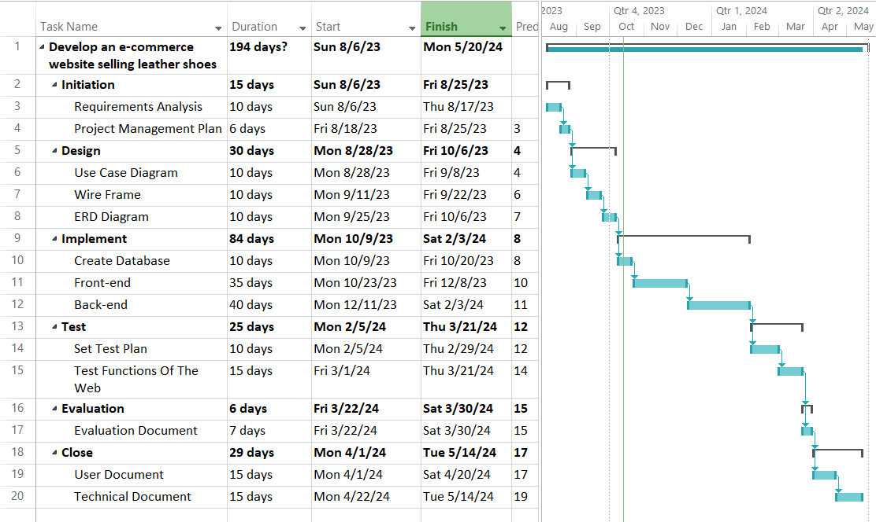

Figure . Gantt Char

# 6. References

Bahattab, A. & Alshamrani, 2015. A Comparison Between Three SDLC Models Waterfall Model, Spiral Model, and Incremental/Iterative Model. *IJCSI International Journal of Computer Science Issues,* 12(1).

barkershoes, 2023. *row.barkershoes.com.* [Online]   
Available at: https://row.barkershoes.com/pages/mens-shoes

Huang, Z., Yoon, S. Y. & Benyoucef, M., 2012. Adding Social Features to E-commerce. *2012 Proceedings of the Conference on Information Systems Applied Research New Orleans Louisiana, USA.*

Janarthanam, S., 2017. *Hands-On Chatbots and Conversational UI Development.* First ed. 35 Livery Street Birmingham B3 2PB, UK: Packt.

leathermart, 2020. *leathermart.eu.* [Online]   
Available at: https://leathermart.eu/product-category/shoes/mens-shoes/

Mayo, J., 2018. *Programming the Microsoft Bot Framework.* United States of America: Pearson Education.

Michael Geist, 2002. *Selected Legal Issues of E-Commerce.* s.l.:Springer Netherlands.

Paizal & Yunanto, R. A., 2019. E-Commerce in Online Business. 662(3).

Price, M. J., 2021. *C# 10 and .NET 6 - Modern Cross-Platform Development:.* Sixth ed. 35 Livery Street Birmingham B3 2PB, UK : Packt.

Shivani & Grewal, H., 2012. A Study of Ethical and Social Issues in E-Commerce. *International Journal of Advanced Research in Computer Science and Software Engineering,* 2(7).

Sulova & Snezhana, 2019. A System for E-Commerce Website Evaluation. 6.

Tamir Dresher, A. Z. S. F., 2018. *Hands-On Full-Stack Web Development with ASP.NET Core.* First ed. 35 Livery Street Birmingham B3 2PB, UK: Packt.

Yunanto, R. & Paizal, G. A., 2019. E-Commerce in Online Business. 662(3).