Cookie Tracer+
Install & User Guide — v19.1.16

1. How to Install
Cookie Tracer+ is a Chrome extension. You install it by loading the unzipped folder directly into Chrome.
1. Download the cookie-tracer-plus ZIP file and unzip it to a folder on your computer. Remember where you saved it.
2. Open Chrome and type chrome://extensions in the address bar. Press Enter.
1

Or click the icon in the top Chrome tool bar. (see screen shot below)
2
Then click manage extensions in the dropdown.
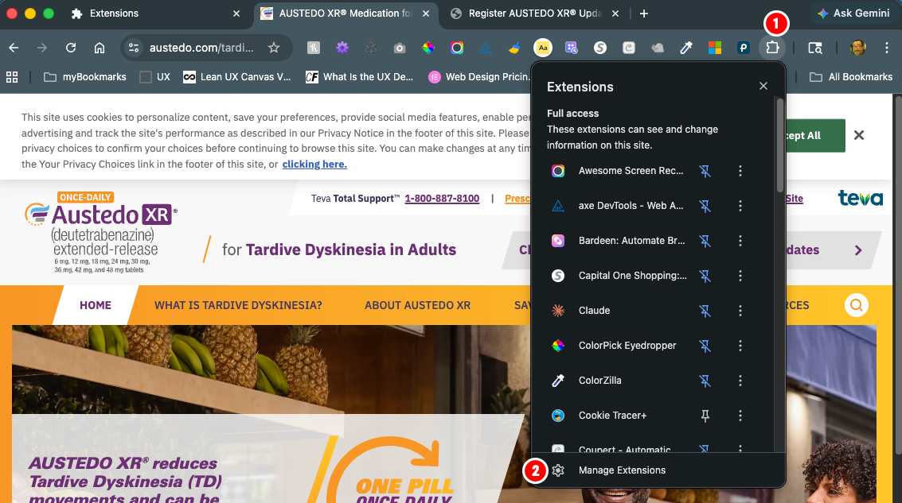
3. Turn on Developer mode using the toggle in the top right corner.
4. Click the Load unpacked button that appears in the top left.
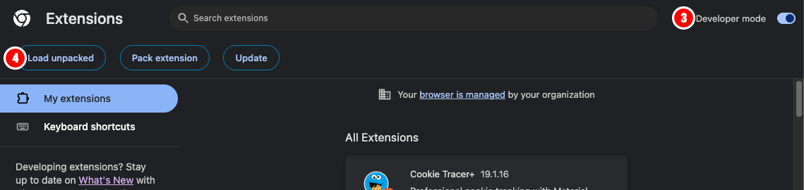
5. Select the unzipped cookie-tracer-plus folder. Click "Select Folder."

After loading, you should see Cookie Tracer+ in your extensions list:
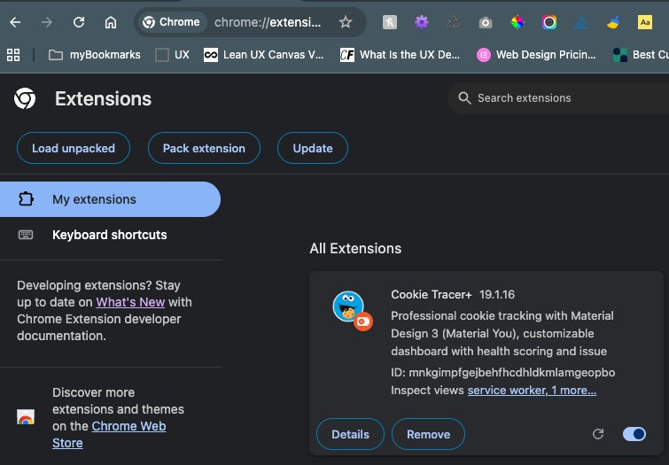
Tip: After installing, pin Cookie Tracer+ to your Chrome toolbar by clicking the puzzle piece icon (Extensions) in the top right of Chrome, then clicking the pin icon next to Cookie Tracer+.

2. The Toolbar
The toolbar at the top of the extension gives you quick access to all controls.
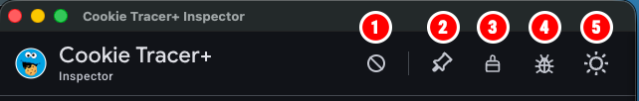
1. Banner Blocker — Hides cookie consent banners on the tracked site. Only works when a tab is pinned.
2. Pin Tab — Selects which tab to track. Click once to pin, click again to unpin.
3. Clear & Reload — Clears cache and cookies for the tracked site, then reloads the page.
4. Diagnostics — Opens a panel that checks if everything is working. Use this if something seems wrong.
5. Light/Dark — Switches between light and dark mode.

3. Pinning a Tab
Before Cookie Tracer+ can do anything, you need to tell it which tab to watch.
1. Open AustedoXR.com or the UAT staging site in a Chrome tab.
2. Click the Pin icon in the Cookie Tracer+ toolbar.
3. The extension will start tracking cookies and page changes on that tab.
Tip: Cookie Tracer+ is built for AustedoXR.com and the UAT staging environment. Journey cookies and condition detection only work on these sites.

4. Journey Cookies
Journey cookies control which visitor experience the site shows you. Cookie Tracer+ lets you switch between journeys instantly without filling out forms or clearing your browser.
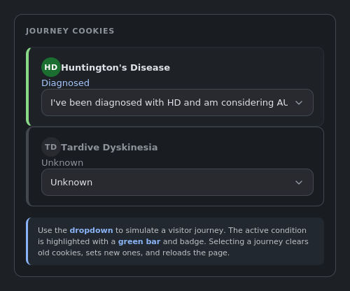
Each condition (HD and TD) has its own block showing the current cookie value and a dropdown to change it.

Available Journeys
Unknown — No journey set (default)
Undiagnosed — "I haven't been diagnosed"
Diagnosed — "I've been diagnosed and am considering AUSTEDO XR"
Treating — "I'm taking AUSTEDO XR"
Partner — "I'm a care partner to a loved one"
When you select a journey from the dropdown, Cookie Tracer+ clears the old cookies, sets new ones, and reloads the page.
Condition Switch Warning: If you navigate from an HD page to a TD page (or vice versa), an amber banner appears to let you know the condition has changed. This is expected.

5. Running Diagnostics
If something isn't working, the built-in diagnostics tool can tell you exactly what's wrong.
1. Click the bug icon (4) in the toolbar.
2. The diagnostics panel opens and automatically runs all checks.
3. Each check shows a green checkmark (pass), amber warning, or red X (fail).
4. Click Copy Report to copy the results to your clipboard.
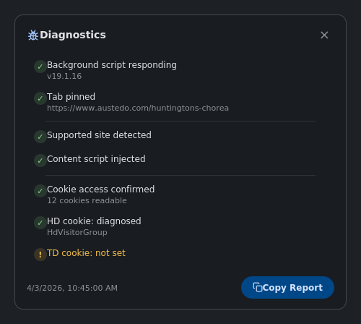

What Gets Checked
Background script — Is the extension engine running?
Pinned tab — Is a tab pinned and still open?
Supported site — Is the pinned tab on AustedoXR.com or UAT?
Content script — Is the tracker injected into the page?
Cookie access — Can the extension read cookies?
Journey cookies — Current HD and TD cookie values

6. Troubleshooting & Support
If Cookie Tracer+ isn't behaving as expected, follow these steps:
1. Click the bug icon in the toolbar to run diagnostics.
2. Click Copy Report at the bottom of the diagnostics panel.
3. Open Microsoft Teams and paste the report into a message to Carl Edholm.
4. Include a brief description of what you were doing when the issue happened.
Need Help?
Run diagnostics, copy the report, and send it to:
Carl Edholm
via Microsoft Teams

Common Fixes
Page not tracking? Make sure a tab is pinned. Click the pin icon.
Cookies not showing? Click the broom icon to clear cache and reload.
Extension not responding? Go to chrome://extensions, find Cookie Tracer+, and click the refresh icon to reload it.

