Game Design Document

*Name of the game*

# Overview

## Project Scope

Single player procedurally generated game that mixes casino and roguelike mechanics and features simple click/tap controls.

## Elevator Pitch

Play as a **merchant** deep in **debt**. Pay your debt installments by **trading** with the different cities in the **procedurally generated map**. In this world you can only **get goods by gambling**, hit the slot machine in a city to try and get some goods to **sell to other cities** before the time to pay is up. Every time you pay an installment to your creditor you **get an item** that will help you in your journey. **If you can’t pay the game is over.** Your objective is to last for the longest time possible.

## Target Platforms

The game suits **mobile platforms** since it doesn’t require complex 3D graphics and the controls can be implemented with only tap/click.

Releasing on **desktop** (PC) is also viable because the game has enough complexity on its mechanics to make it interesting for experienced pc gamers.

The game shouldn’t target a console release since point and click controls don’t mix very well with controllers, and this genre of game isn’t very popular on consoles.

## Monetization

The ideal monetization model would be an **upfront payment**. PC gamers are used to paying for games but for mobile users it could be a hard sell since most games on mobile are free to play, for this reason releasing a free to play limited version and a priced full version should be considered.

# Gameplay

## Game Mechanics

### Game Mechanic 1: Map and movement

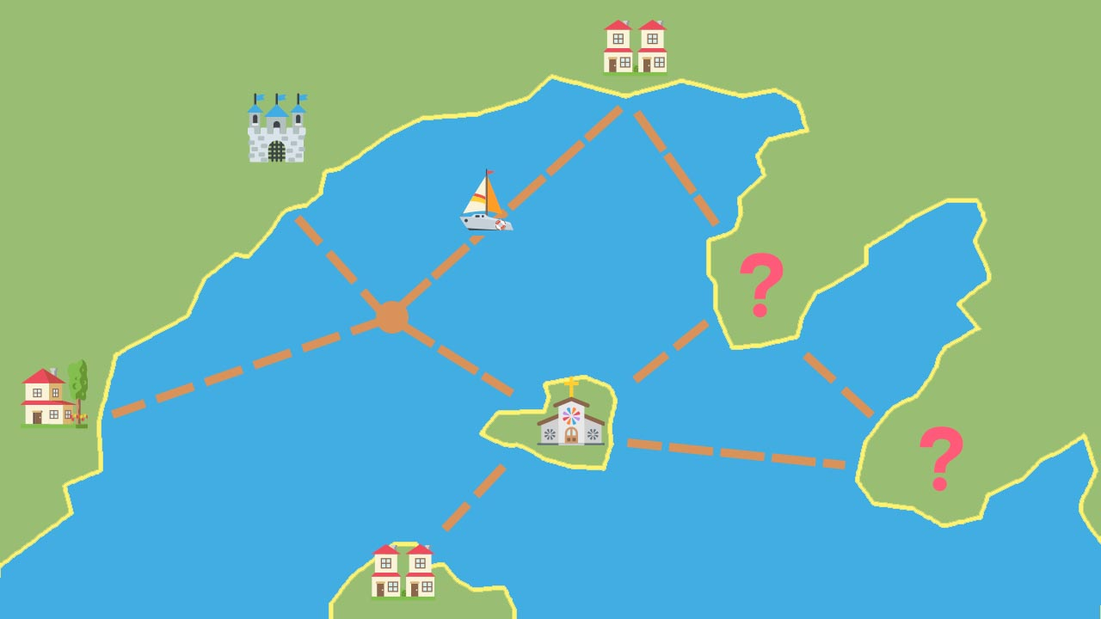

* In each game the map will be procedurally generated.
* The map will contain cities and paths connecting these cities through the sea.
* Each city can be of a certain type and that will influence what goods are available in their market. Some city types could be castle, village, monastery, city…
* Travelling to each city will cost at least 1 turn ⌚ and taking some paths will cost more.

### Game Mechanic 2: Obtaining goods

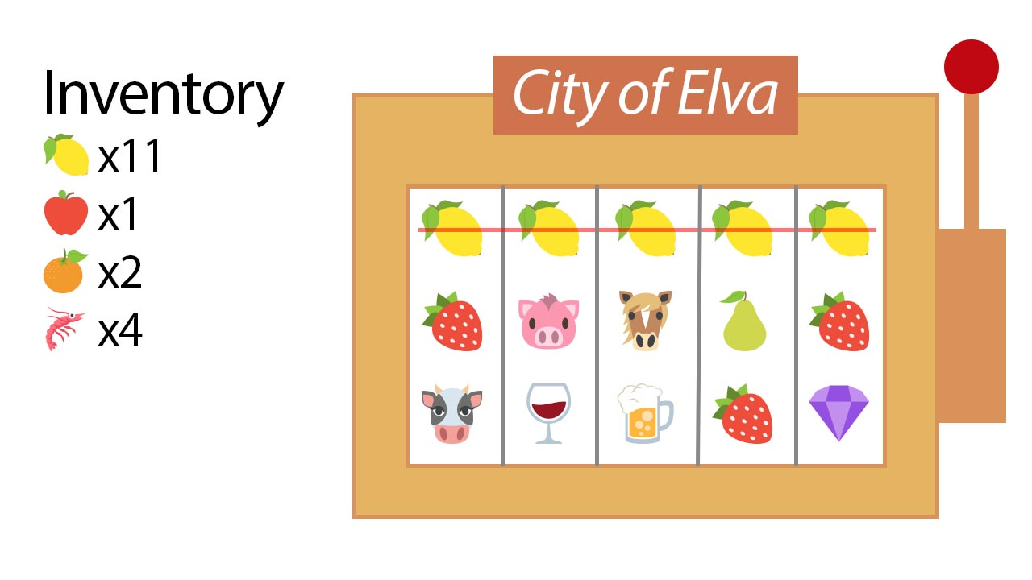

* To stock your boat with goods you will have to play the slot machine on a city.
* The slot machine will be filled with the goods that the city offers.
* Spinning the slot machine costs 1 turn ⌚.
* If after spinning the machine you get at least 3 of the same good adjacent to each other, you will add one of that good to your inventory.
* Goods of the same type that were adjacent in the previous spin will be removed from the machine.

### Game Mechanic 3: Selling goods

* To earn some gold, you will have to sell the goods that you won playing the slot machines.
* You can sell goods when you arrive to any city.
* The type of city will influence what goods you can sell and their price.
* The prices for a given good will be especially low if the city has had stock of that object during the day.

### Game Mechanic 4: Day progression

* Each day will last for a certain number of turns ⌚.
* Once all turns have passed, the day is over, and you will be asked to pay your debt installment 💰.
* The quantity to pay each day will increase.
* If you can’t afford to pay, the game ends.
* If you are able to pay, you can choose one of N items that will give you a bonus passive effect for the rest of the game.
* At the start of each day the cities will restock their machines with additional goods.
* The goal of the game is to last for the maximum amount of days possible.

### Game Mechanic 5: Items

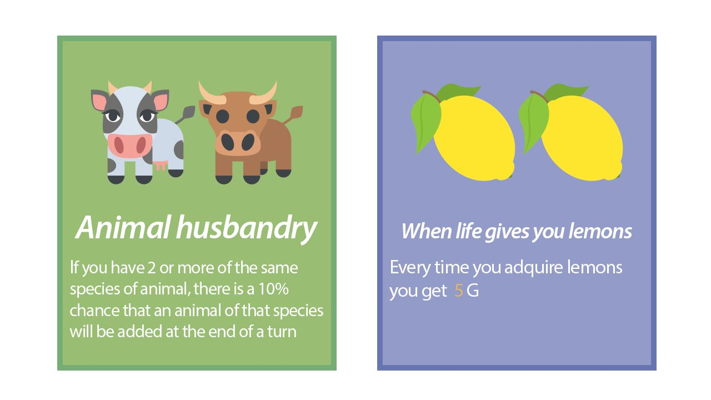

* You will be able to add an item to your collection when a new day begins.
* The items will influence different aspects of the game such as:
  + Value or quantity of goods.
  + Length of day.
  + Special interactions when specific goods are adjacent to each other on the slot machine.
  + Special effects when specific goods are in your inventory.
  + Bonuses when spinning the slot machine in certain types of cities.
  + Resistance to negative events that might occur during the game.
  + Bonuses when selling or acquiring certain goods.
* Items’ effects can synergize and stack with each other.

## Gameplay Loop

