**PstS: COG0226**

**PstC: COG0573(permease)**

**PstA: COG0581 (permease)**

**PstA: COG4985 (auxiliary component)**

**PstB: COG1117 (ATPase)**

**PhnC: COG3638**

**PhnD: COG3221**

**PhnE: COG3639**

**PhnG: COG3624**

**PhnH: COG3625**

**PhnI: COG3626**

**PhnJ: COG3627**

**PhnK: COG4107**

**PhnL: COG4778**

**PhnM: COG3454**

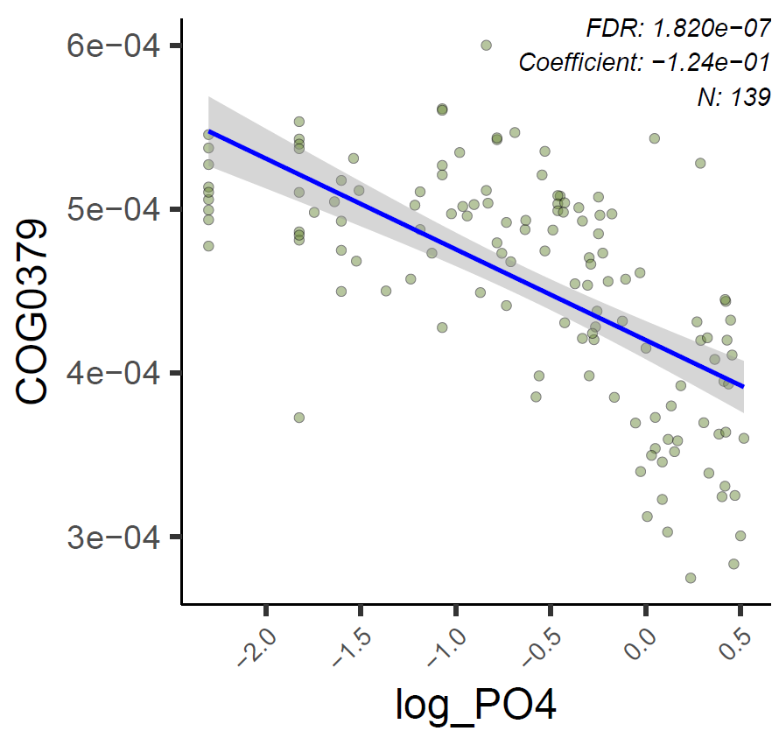

PhnN: COG3709

No significant correlation detected -> PhnB: COG2764

No sig -> UgpE: COG0395 (ABC-type glycerol-3-phosphate transport permease)

No sig -> UgpB: COG1653 (periplasmic component)

No sig -> TagH: COG1134 (ABC-type polysaccharide/polyol phosphate transport system, ATPase)

YkaA: COG1392 (phosphate transport regulator, distantly related to PhoU)

No sig -> AfuA: COG1840 (ABC transporter for hexose phosphate, periplasmic)

PhoU: COG0704

For the non-significant COGs:

COG | Raw p-value | adjusted p using BH correction

COG0395: 0.376903849 0.583880379

COG1653: 0.219382186 0.415927296

COG1134: 0.084092009 0.220140889

COG1840: 0.174798061 0.359015272