Notes:
1. [LOW PRIORITY] For the output dashboard view, all boxes should be of matching height; please always format boxes to match tallest height
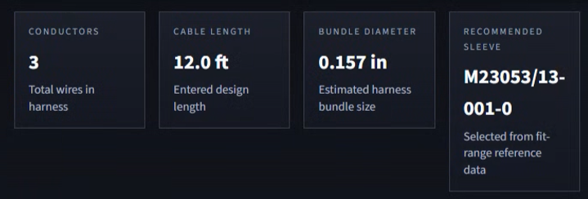
2. [CRITICAL PRIORITY] In wiring diagram (harness routing view), AWG must be shown
3. [HIGH PRIORITY] In wiring diagram (harness routing view), length dimension indicator should span full harness depiction width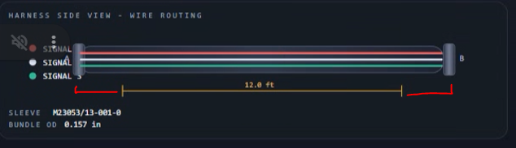
4. [CRITICAL PRIORITY] In BOM, QTY for wiring should reflect length*(QTY indicated); the BOM should tell procurement how many feet of wire to buy total, and the unit will be a single foot
5. [CRITICAL PRIORITY] In BOM, same QTY for shrink sleeve; QTY should be a function of length, where unit is 1 foot (i.e., a 12 ft cable should reflect QTY 12 in this field)
6. [LOW PRIORITY] We lowkey hate the packaging notes, connection summary, and connection diagram; we would like to hide those for now, but if they serve some functionality, we can keep the code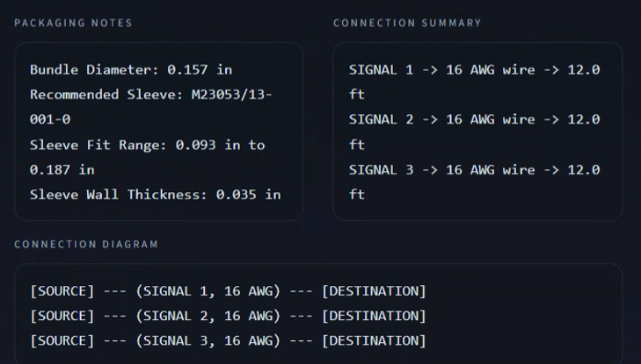
7. [CRITICAL PRIORITY] The wiring diagram (harness side view) is not formatted correctly: the signal names overlap the contact designators. These shall not overlap and must be legible. We are also unclear on why pin B is alone by itself on the right side. Takeaway, please correct this formatting.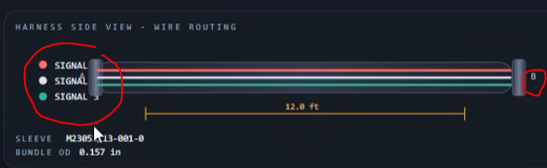

Notes:
- [CRITICAL PRIORITY] Add black as a color option in input section
- [CRITICAL PRIORITY] AWG needs to be visible for all conductors. For simplicity, remove A/B designators; only signal names should be shown on the harness left, and corresponding AWG values shown on the right. 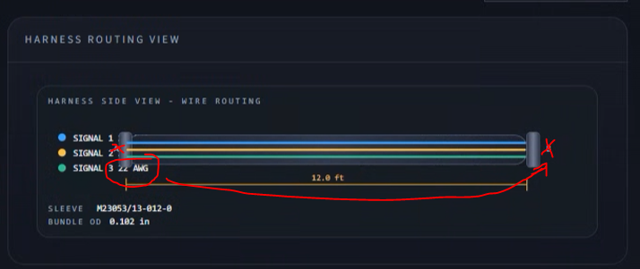
- [CRITICAL UPDATE] As conductor count grows, the harness routing view table also needs to expand, and it needs to format correctly. 