Notes:
- [CRITICAL PRIORITY] Add black as a color option in input section
- [CRITICAL PRIORITY] AWG needs to be visible for all conductors. For simplicity, remove A/B designators; only signal names should be shown on the harness left, and corresponding AWG values shown on the right. 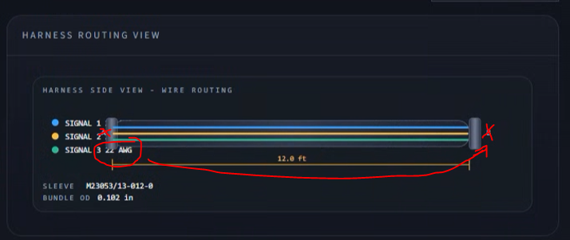
- [CRITICAL UPDATE] As conductor count grows, the harness routing view table also needs to expand, and it needs to format correctly. 