- [CRITICAL UPDATE] Remove color badges from harness view, as they are causing a formatting conflict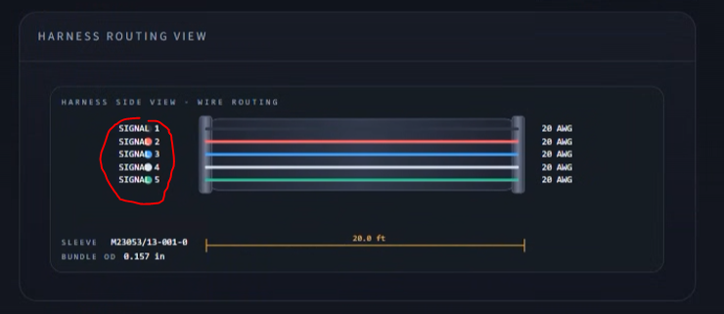
- [LOW PRIORITY] Create additional headroom for deploy bar when using terminal; this helps us visually verify user-friendliness of tool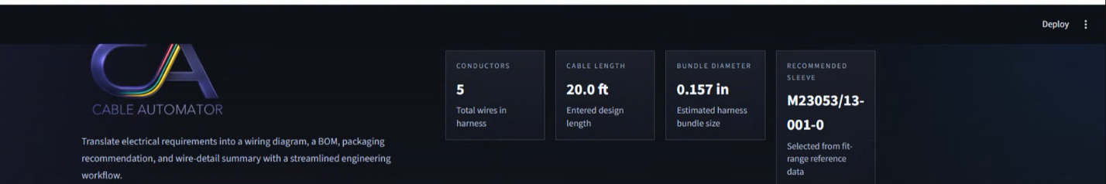
- [CRITICAL PRIORITY] Check current/AWG lookup function; we are skeptical that 14 AWG is correct for 41A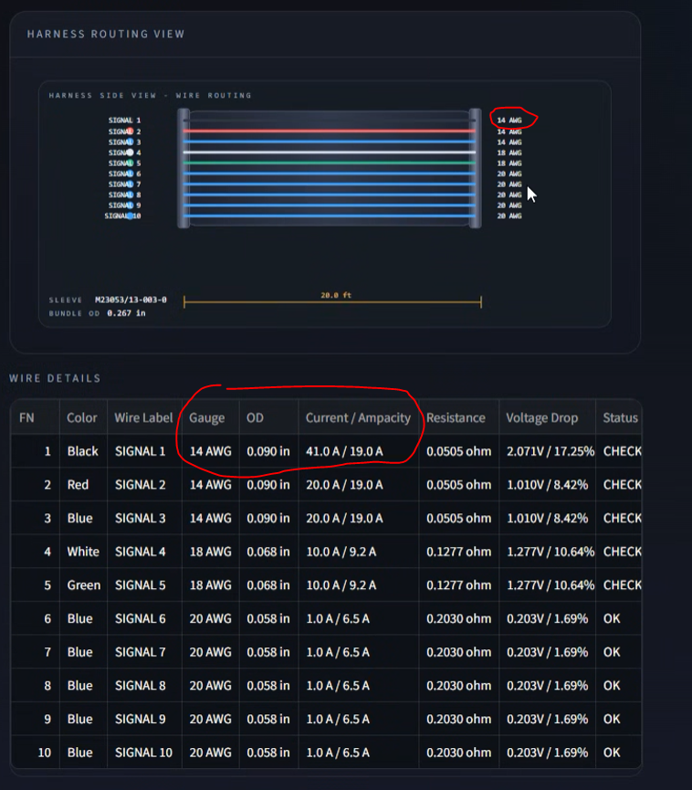
- [CRITICAL UPDATE] please fix the top to where there is even more headroom for the deploy bar. The text is cut off. And can you make each box the same dimension? Some are longer than others and it looks weird.