Earthquake location and magnitude is determined via triangulation, or back projection. If seismic waves travel at a particular velocity, then we can estimate the time, t(i), it takes the wave to arrive at the i^{th} seismometer (t(i)_{est} = x(i)/v) based on the known distance, x(i), for a given earthquake location. So, we test a bunch of hypothetical earthquake locations and determine at what location the relative arrivals at each station match up best with the observed data. The goal is to minimize the error in relative times, or σ:
,
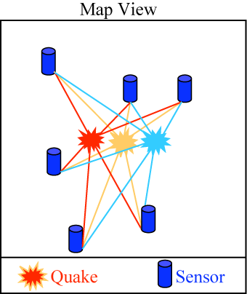
where N is the total number of recorded trigger times, dt(i)_{obs} is the observed relative travel time , and dt(i)_{est} is the estimated relative travel time, or . Note that and .
We will weight the data according to the significance of the trigger. This is done by:
,
where w(i) is the significance level for the i^{th} sensor. Lets say that we have 2000 triggers and we want to test 1,000,000+ possible locations (1X1 km grid of California), it could take a while (5-10 minutes) on a single CPU, but wouldn’t take long on 100s or 1000s.
Because the amplitude of a recorded wave depends on the magnitude of the earthquake and the distance from the earthquake to the sensor, magnitude estimation also depends upon distance. The easiest way to think about this is geometric spreading like a light bulb; the farther you are from the bulb, the dimmer it seems because the energy is spread over a greater volume/surface are. So we need to locate the earthquake first, and then determine the magnitude.
At first, we wont be able to estimate magnitude from the measured amplitudes because we don’t know exactly how our sensors compare to regular sensors (especially because they could be sitting on couches, at the top of a skyscrapers, or resting on wobbly tables). With so many sensors (typical networks use 10s to 100s) the errors may just average out, and we may not have to worry about site conditions. Richter magnitude (not the most useful) is usually measured as
,
where Δx is the distance from the earthquake to sensor in kilometers, and A is amplitude as measured on a Wood-Anderson seismometer.
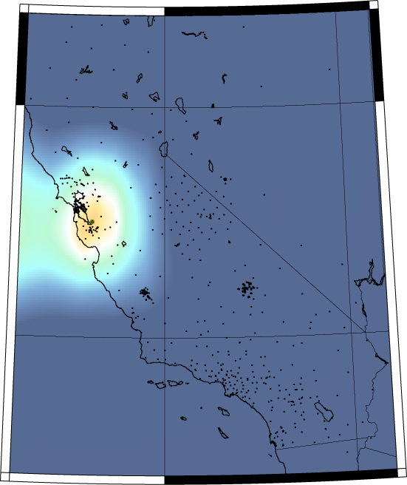
The following figure is from the simulation codes I wrote (qcn_server_verify, qcn_server_loc & qcn_client_loc) to mimic the detection & locating of an earthquake given a fictitious set of triggers from a 959 sensor locations. I added noise to the data to mimic problems we’ll have with real data (timing, location, spurious results). The tiny dots are the hypothetical sensor locations I used (959 broadband sensors from 2000-2005 – not real time). We would probably expect a different distribution with sensors in more populous places. Orange & green are the lowest misfit between epicenter location & the hypothetical data. There are a green dot & red triangle at the center (hard to see) that are the input & output hypocenter. They are less than 0.5 km different given data 1 second after rupture.

