Benchmarking Computational Peritoneal dialysis Models: a comparative study

S Swapnasrita1, JC de Vries2,CM Öberg3 , KGF Gerritsen2, AMF Carlier1

1 MERLN Institute for Regenerative Medicine, Maastricht University, Universiteitssingel 40, 6229 ER Maastricht, The Netherlands

2 Department of Nephrology and Hypertension, University Medical Center Utrecht, Heidelberglaan 100, 3584 CX Utrecht, The Netherlands

3 Department of Clinical Sciences Lund, Division of Nephrology, Skåne University Hospital, Lund University, Lund, Sweden

# Abstract

Peritoneal dialysis (PD) is a gentle form of dialysis, which uses a hypertonic glucose-based solution to remove toxic solutes from the blood via the abdominal lining of patients with low residual kidney function. *Mathematical modeling is useful to study and improve peritoneal dialysis because it can help clinicians and researchers better understand the underlying physiological processes involved in this type of renal replacement therapy.* Several mathematical models have been developed in the past decades but what is lacking is a benchmarking of the models to compare their accuracy with respect to predicting experimental data*. This paper compares four mathematical models of peritoneal dialysis (three two-compartmental models and the three pore model) to predict the dialysate concentrations of six solutes throughout a PD session, measured in a pig model. The models are compared using the root mean square error and parameters are fitted using the SLSQP minimisation technique from the Python Scipy package.* We also obtained, for the first time, pig specific mass transfer area coefficients which would be helpful in cross-species validation. In summary, the benchmarking test establishes the three pore model as the best tool to predict small solute concentration and as such opens up avenues to use the three pore model to simulate future improvements in PD.

Keywords: peritoneal dialysis, three pore model, sodium transport, mathematical modeling

# Introduction

*Peritoneal dialysis involves the use of the peritoneum, a membrane lining the abdominal cavity, as a natural filter to remove solute and excess fluid from the body.* Over the >60 years progress in PD device development, the corresponding mathematical models have also grown in complexity and understanding of the PD process. Mathematical modeling is a good way of combining general knowledge with clinical knowledge and providing quantification of solute and fluid transport necessary for optimizing any PD process. *It can also help to quantify relationships between the structure and physiological state of peritoneal tissue and its transport characteristics.* For example, the model of Kallen1, Miller2 and Henderson3 considers the peritoneal membrane, i.e., the abdominal lining to be homogeneously porous and that the solute transfer across the membrane occurs purely due to diffusion. However, as our understanding of the peritoneal membrane has increased, we now know there to be aquaporin channels that are instrumental in water transfer4. We also know that the membrane does not transfer all kinds of solutes similarly; instead, solutes are transferred depending on size, thus indicating a heteroporous network. The lymphatic delivery system is also important in the removal of isosmotic fluid and macromolecules5-9. So models like Öberg10, Gotch11 and Flessner12 have increased the captured complexity where they underscore the importance of diffusion, convection and lymphatics in their models (fig. 1).

*There are several well-known mathematical models of peritoneal dialysis that have been developed over the years. Some of the most commonly used models include:*

1. *The three-pore model: This is one of the earliest and most widely used models of peritoneal transport. It describes the movement of solutes and water across three different types of pores in the peritoneal membrane: small, medium, and large. The three-pore model is still used today as a basis for many more complex models of peritoneal dialysis10, 13.*
2. *The two-compartment model: This model divides the peritoneal cavity into two compartments, representing the intracellular and extracellular fluid spaces. It is used to predict the rate of solute removal during peritoneal dialysis and to optimize dialysis prescriptions14, 15.*
3. *The distributed model: This is a more recent model that takes into account the heterogeneity of the peritoneal membrane, incorporating differences in pore size and transport properties across different regions of the membrane16, 17.*

However, what we lack is a rigorous comparison of the accuracy of various models in predicting different features of a PD process. In this paper, we focus on the ability of 4 models (3 two-compartmental models and the three pore model) to predict the dialysate concentrations of 6 solutes throughout a PD session, measured in a pig model. We show that some models are only accurate for specific solutes while other models are more generalizable and are able to correctly predict multiple solute concentrations. We also benchmark the computational efficiency of the models. These results contribute to an improved validation of all PD models, particularly for description of small solute transport.

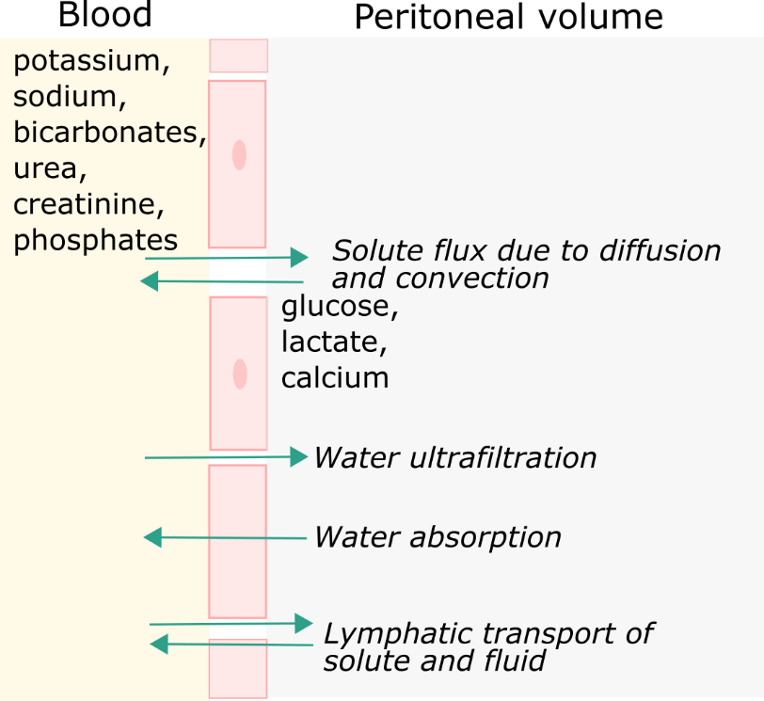

**Figure** 1: Schematic summary of the transport processes occurring between the tissue surrounding the peritoneal cavity and the peritoneal cavity.

# Methods

In order to determine which computational model predicts the clinical data with the least error, we compare 9 existing models. The transport of solute is determined by its size and charge, thus most models are built solute specific. But, we were also interested in a generalised model, a model that can be at once applied to multiple solutes and provide accurate determination of peritoneal mass transfer. Therefore, we compare seven models (4 linear and 3 non-linear) with two empirical models. These specific models were chosen because of their widespread use in specifically PD modeling or in clinical practice to determine mass transfer coefficients, PS. The four models are:

1. Graff and Fugleberg model18-23: This is the least used model but we chose it because of their individual solute approach to modeling PD. They proposed a series of models comprised of one specific or a combination of diffusion, convection and lymphatic transport to describe the solute flux of six solutes. Each solute concentration of their patient dataset is predicted best by one unique combination of the three processes (section 9.1). Here, we investigated the model accuracy when the same model is applied to all solutes. We investigated all six combinations resulting in 6 models.
2. Three pore model10: This is a non-linear model based on the three pore model (TPM) proposed by Rippe24. The TPM assumes the transport of solutes and water through three different sized pores, one for large molecules such as albumin and proteins, one for middle molecules such as urea and creatinine, and one for water transport (mimicking the aquaporins). Öberg adapted the TPM to solute transport in a continuous flow PD device. Their model captures the total osmotic pressure difference due to the concentration difference of solutes and this total osmotic pressure then drives the diffusion and convection processes (section 9.2). Here we apply, for the first time, the TPM to pigs.
3. Garred model15: They proposed a simplified (empirical) solution for predicting the MTAC of only small solutes (i.e. urea and creatinine) of a patient undergoing static dwell. They assumed that the sieving coefficient is always equal to 1, thereby ignoring the possibility of diffusion of a solute hindering the convection or vice versa. (a parameter defined by $f$ which is set to 0) (section 9.3).
4. Waniewski model14: The only differing assumption between the Garred model and this model is that they do not restrict $f$ to 0. However, they found that a value of 0.5 worked well with most solutes except sodium (which no value of $f$ seem to predict well) (section 9.4).

All model definitions can be found in the Appendix. We ignored the distributed model on account of its complexity. In particular, the distributed model is of importance when the peritoneal membrane transport itself needs to be investigated otherwise the TPM is the limit of the distributed model. We assume that vasodilation of the peritoneal membrane in response to the dialysis fluid does not occur and a stable mass transfer coefficient is maintained throughout the dwell session.

**Table** 1: All models chosen for comparison (properties fitted, *n* = total number of fitted parameters, values of fixed parameters). MTAC = mass transfer area coefficient of the solutes. $fct/f$ = interdependence of diffusion and convection for a solute. L = lymphatic absorption rate. SiCo = sieving coefficient of the solute.

|  |  |  |  |
| --- | --- | --- | --- |
| Model | Parameter fitted | *n* | Fixed |
| 1 | $MTAC, fct$ | 12 | $SiCo$ = 0, $L$ = 0.00065 L/min |
| 2 | $MTAC, fct, L$ | 13 | $SiCo$ = 1 |
| 3 | $MTAC, fct, SiCo$ | 18 | $L$ = 0.00065 L/min |
| 4 | $MTAC, fct, L$ | 13 | $SiCo$ = 0 |
| 5 | $MTAC, fct$ | 12 | $SiCo$ = 1, $L$ = 0.00065 L/min |
| 6 | $MTAC, fct, SiCo, L$ | 19 | - |
| 7 | $MTAC$ | 6 | $L=0.3, SiCo$ from literature |
| 8 | $MTAC$ | 6 | $f=0, SiCo=1$ |
| 9 | $MTAC$ | 6 | $f=0.5, SiCo=1$ |

## Clinical data

Detailed methods are described elsewhere25, 26. In short, standard peritoneal permeability analysis (SPA) was performed in four uremic female Yorkshire pigs (Sus scrofa domesticus), weighing 45-130 kg. Uremia was established by subtotal renal artery embolization and Gentamicin was administered prior to the testing of the SAPD system resulting in plasma concentrations of uremic toxins in the range of those observed in dialysis patients. Static dwell was performed for 4 hours in all pigs. Venous blood samples were drawn at 0, 2, and 4 hours post start of dialysis for measurement of urea, creatinine, phosphate, potassium, sodium and glucose. Peritoneal effluent was collected before start and at 10, 20, and 30 minutes followed by samples at 1, 2, 3 and 4 hours for measurement of dialysate solute concentration. The dialysis bag was weighed before and after instillment to calculate fill volume and residual volume was calculated based on albumin concentrations.

Our aim is to see which model could predict the dialysate concentration best for future sessions provided that we trained the models on some previous PD static dwell sessions. In order to compare the predictions for the same six solutes (urea, creatinine, sodium, potassium, phosphates and glucose) across the 9 models, we use the fitted MTAC in each case to compare the root mean square error between the predicated and measured dialysate concentrations. Using the SLSQP minimisation technique from the Python Scipy package27, parameters are fitted (table 1, “parameter fitted”). Notably, with such high number of fitted parameters for the models (at least 6 MTACs), the fitting results may depend on the starting points 28. Thus, to avoid local minima and find global minima, we repeated each simulation for 10 different initial values of the parameters. The boundary value for each parameter (MTAC, fct , SiCo, L, table 1) is set between 0 and 200 for two reasons 1) to avoid negative values and 2) to fit with the experimentally and theoretically reported parameter values. Note that, 200 is beyond the reported values for all fitting parameters, the idea being that any values fitted for sieving coefficients and fct outside 0 and 1 can be automatically rejected due to physical implausibility. The root mean square error is given by,

|  |  |
| --- | --- |
| $$RMSE = \frac{{\left(\sum_{all solutes}{\sum_{t=0}^{t=end}{{{(c}_{d, predicted}-c_{d,measured})}^{2}}}\right)}^{0.5}}{n}$$ | 2.1 |

where $c_{d, predicted}$ and $c_{d,measured}$ are the predicted and measured dialysate concentrations respectively and $n$ is the number of time points. In this work, the end time is 240 minutes. The model with the lowest RMSE for all three outputs (figure 2) and fitted MTAC within physiological boundaries is chosen as the best performing model for this dataset.

All calculations are performed on a remote HPZ820 Workstation with 2x Intel Xeon E5 2.80 GHz CPU (20 physical, 40 logical cores), 128 GB RAM, NVIDIA Quadro K2000 2GB.

## Training and test data set

In order to train the nine models (see Table 1), the data is split into training and test data. The training sets help to estimate the parameters (here: MTAC, fct, L and SiCo) and then the testing set is used to check the accuracy of the model predictions.

From our pig data, we have isolated 16 sessions of one pig. The pig underwent sessions of 4 hours each. In five cases, the pig underwent two sessions one after the other. For each session, residual volume, initial and drain volume is noted. The dialysate solute concentrations (urea, creatinine, sodium, phosphate, glucose and potassium) are measured at eight time points (0, 10, 20, 30, 60, 120, 180, 240 min) by sampling an as small as possible volume (ranging between 3-6 mL per sample). To avoid overfitting of the models, we split the 11 first sessions into test (*yellow*, fig. 2) and training data sets (*orange,* fig. 2). We randomly chose $x$ training data sets and the other data sets were automatically the test data sets for that iteration. The training:test split is 6:5 and 7:4 (to avoid overfitting when the training set is too big or underfitting when the training set is too small). For all the training data sets, we fitted the parameter values by minimizing the difference between the predicted and measured dialysate concentrations for all solutes (table 1). We repeated this for 10 iterations with different starting points for the fitted parameters per training dataset and selected the parameter set with the lowest RMSE as the fitted set for that training dataset. We repeat this process for all datasets in the training set. After all the training sets have their best fits for the parameters, We took a mean of the parameters as the base for our training data set (output 1) ignoring those sets for which the RMSE is greater than 1e6. We used the same mean to also check for the average RMSE for our test set (output 1). We used the 5 second sessions as the second test set and calculated the corresponding RMSE (output 3, *blue*, fig. 2). We repeat this 3 times per model with a different training set to avoid any bias for any dataset.

To calculate the solute specific RMSE, each model is run again with the average fitted parameter values to calculate the error per solute. We repeat the process for all the three iterations (different training set each time) to get mean and standard deviation of the error per solute.

## Fitting hydraulic conductivity for the three pore model in pigs

Previously, the TPM was fitted to human data. Here, we aim to determine the parameter values for pig data, which has not been done before and is relevant for cross-species comparison and data extrapolation. In the above detailed procedure, only the dialysate solute concentrations are fitted to determine the optimal values of MTAC, L, fct and SiCo (see Table 1). Here, in order to get species-specific values, we also fitted the total hydraulic conductivity (via thethe intraperitoneal volume profile(equation **9.2**)) and the fractional pore fraction for transcellular pores using equation **9.7**, via the sodium concentration profiles.

All models and fitting routines have been written in Python 3.10 and are available on Github.

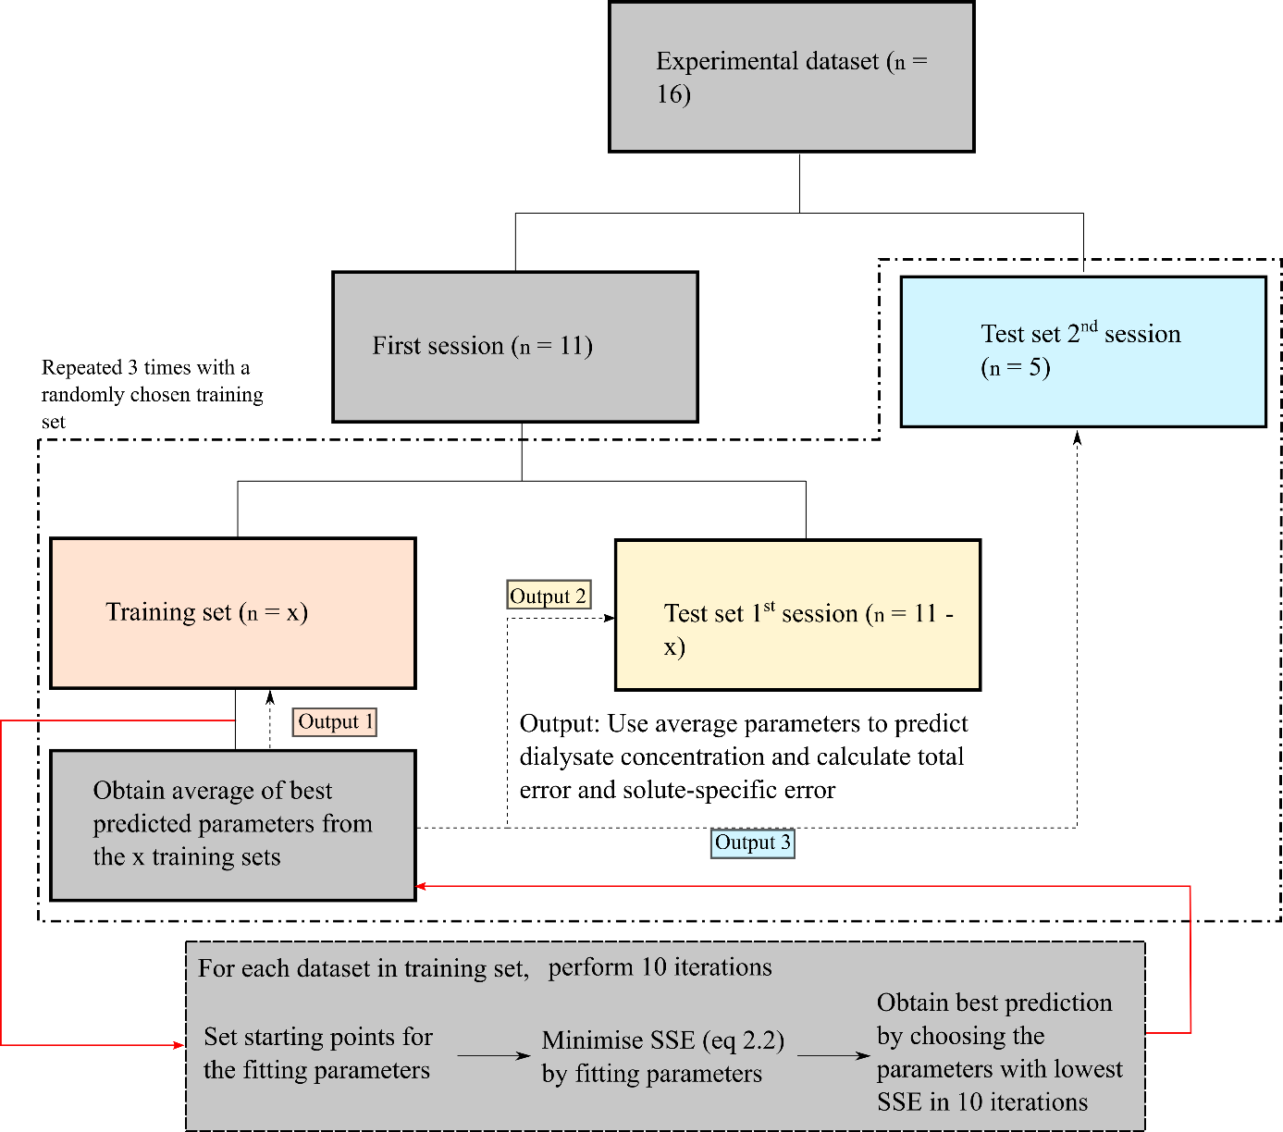

Figure 2: Flowchart explaining the benchmarking process used in this paper. After obtaining the mean of the fitted parameters from the 10 iterations, the best fit is used to calculate the average RMSE in the training set (output 1), test set-first session (output 2) and test set-second session (output 3).

# Results and discussion

We performed all training with two train:test data splits. All the results discussed below are for a training set and test set ratio of 7:4 only (unless mentioned explicitly).

## *Model 7, 8 and 9 predict all solute concentrations with least error*

First, we trained each of the 9 models and test their predictions on two different data sets as shown in figure 2 (yellow and blue, Figure 2). The total RMSE is calculated as per equation 2.15 and is shown in figure 3. Each model predicts similar total RMSE in each set despite the train:test split ratio.

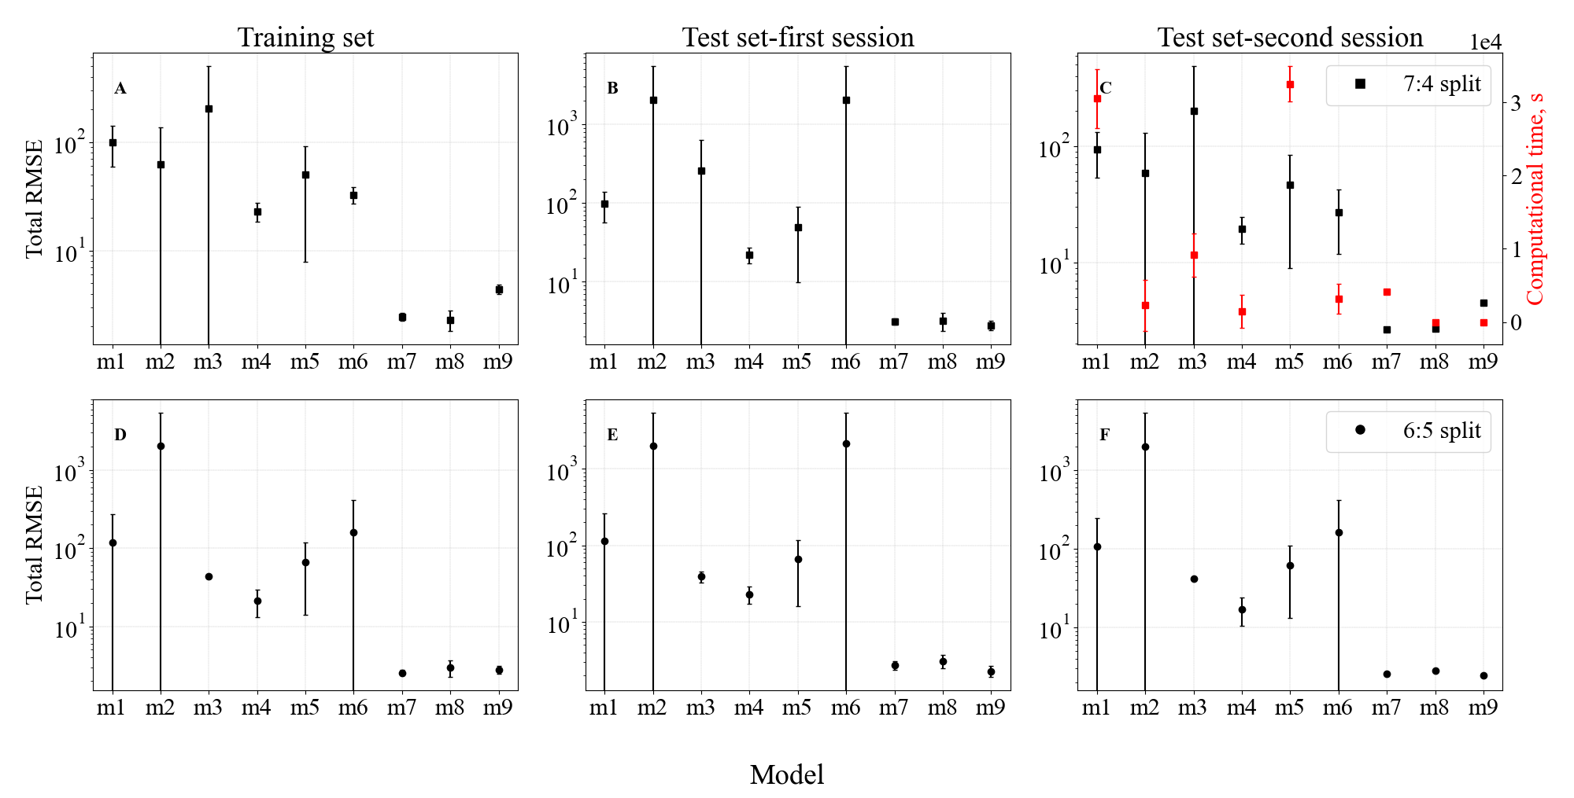

Figure 3: Total RMSE calculated for all solutes for all nine models. Since there are three iterations per model, here we have shown mean and standard deviation of the error. A, B and C are for a 7:4 split of training to test data and D, E and F are for 6:4. C (right y-axis) also shows the computational time required to run the fitting for a chosen dataset. See figure 2 for a schematic representation of the fitting procedure.

The computational time taken to execute one full fitting process independent of the number of fitted parameters is shown in Figure 3C (right y-axis). The SLSQP program used to minimise the objective function (section *training and test data*) has a time complexity of O(*n*^3) where *n* is the number of fitted parameters29. Model 3 and 6 have 18 and 19 fitted parameters (table 1, MTAC, fct and SiCo for all 6 solutes), and due to the largeness of the matrix decomposition employed by SLSQP27, these often resulted in premature termination of simulations. Model 2 and 4 with sieving coefficient fixed to 0 and 1 for all solutes, gave unrealistic results (Table S1) and can also be ignored. Model 7 required the most computational time compared to model 8 and 9 due to the non-linear nature of the model. Model 7, 8 and 9 all result in a low total RMSE.

## *Model prediction accuracy is solute dependent*

Understanding that all solutes have a different transport mechanisms which are a combination of diffusion, non-lymphatic and lymphatic convection, it is also necessary to see how well the 9 models fit each individual solute concentration. As expected, urea and creatinine, being small solutes, are predicted well (RMSE < 10) by 8 models with the exception of model 6 (figure 4). However, sodium is often hindered from diffusion into the peritoneal membrane due to its association with negatively charged ions. As the water rushes into the peritoneal cavity at the start of the treatment (high osmotic gradient from glucose), there is a dilution of the sodium concentration, which explains the dip usually seen in sodium dialysate concentration, a phenomenon otherwise known as ‘sodium sieving’. This could not be captured well by models 1-6. Glucose, the osmotic agent, is highly diffusible. While this behavior is captured well by low sieving models (i.e. models 1, 3, 4 and 5), models which incorporate high rates of sieving and lymphatics (such as models 2 and 6) resulted in poor fits.

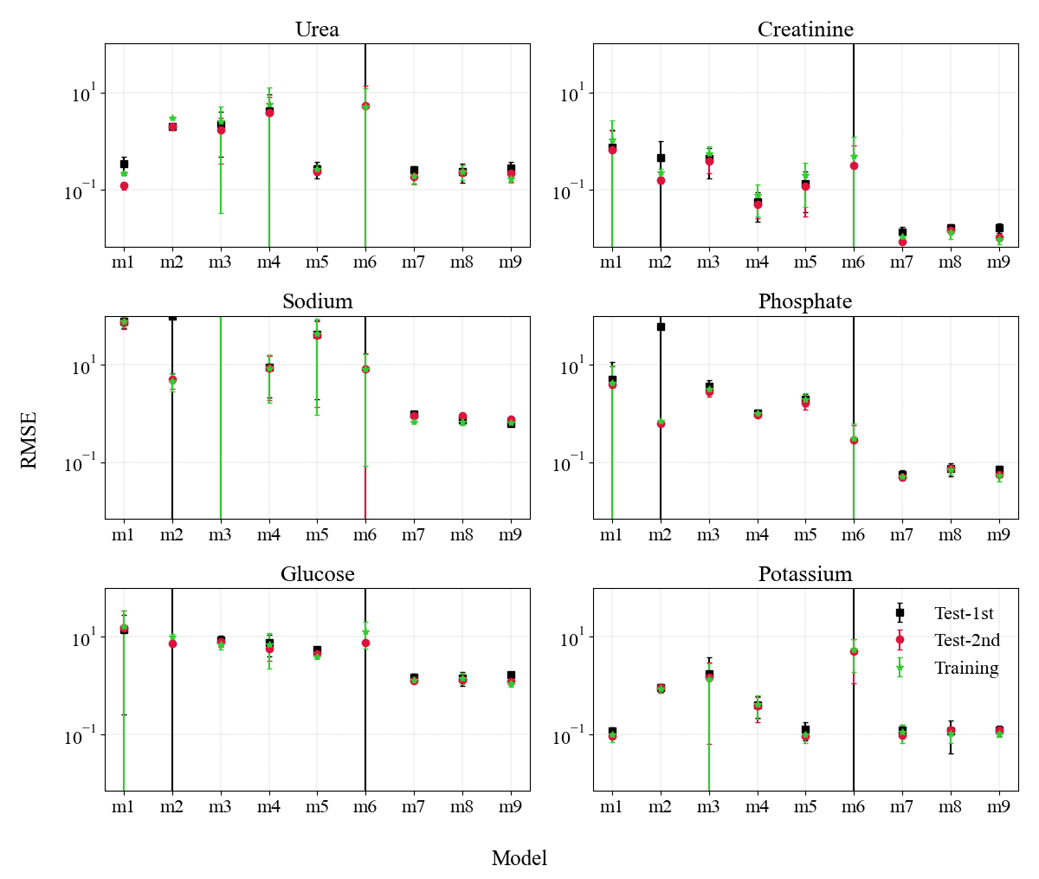

**Figure** 4: RMSE per solute for all datasets for a split of 7:4 (training, test set 1st session and test set 2nd session). The different testsessions shown here are explained in Figure 2. Each model was run for 3 different iteration to get a mean and standard deviation.

## *Overall model validation*

In the previous sections we investigated specific measures to quantify the model validity, i.e. how well the model predicts the individual solute concentrations (goodness of fit), how well the model is able to predict all solute concentrations (generalisability) and how well the fitted parameters match with literature/experimentally determined values (parameter plausibility). See Table 1 for a tabular view of the fitted parameters (MTAC, fct, SiCo, L).

Here we combine these measures to analyze overall model validity (see table 2). We found model 7 or the three-pore model to be the best model to interpret dialysate solute concentration in static dwell PD for the benchmark pig dataset.

**Table** 2: Overall model validation to explore the goodness of fit for each solute, generalisability and parameter plausibility of the models tested.

|  |  |  |  |  |  |  |  |  |  |
| --- | --- | --- | --- | --- | --- | --- | --- | --- | --- |
| Model |  | Urea | Creatinine | Sodium | Phosphate | Glucose | Potassium | Generalised | Physiological |
| 1 | Graff | ✓ | ✓ |  | ✓ | ✓ | ✓ | ✓ |  |
| 2 | ✓ | ✓ |  |  |  | ✓ |  |  |
| 3 | ✓ | ✓ |  | ✓ | ✓ | ✓ |  |  |
| 4 | ✓ | ✓ | ✓ | ✓ | ✓ | ✓ | ✓ |  |
| 5 | ✓ | ✓ |  | ✓ | ✓ | ✓ | ✓ |  |
| 6 | very high RMSE values | | | | | | |  |
| 7 | TPM | ✓ | ✓ | ✓ | ✓ | ✓ | ✓ | ✓ | ✓ |
| 8 | Garred | ✓ | ✓ | ✓ | ✓ | ✓ | ✓ | ✓ |  |
| 9 | Waniewski | ✓ | ✓ | ✓ | ✓ | ✓ | ✓ | ✓ |  |

## *Three pore model for pigs*

The three pore model has been applied previously to human9, 24, 30-32, rat33-35 and mouse36. This is the first time the TPM has been applied to clinical data from pigs. Since there are many versions of the TPM10, 13, 24, 37-39, which includes varying definitions of hydraulic conductivity, lymphatic flow rate and MTAC, we decided to determine these parameters specifically for pigs to enable cross-species comparison. The lymphatic flow rate in pigs is adapted from literature at 0.7 mL/min40 compared to the usual 0.3 mL/min in human41. We fitted the time course of the intraperitoneal volume measurement to find the hydraulic conductivity. As mentioned before, sodium concentration dilutes in the first hour of the dwell as a result of fluid flowing into the peritoneal cavity due to the high glucose osmotic gradient (which explains the dip in sodium concentration). The amount of fluid incoming to the peritoneal cavity will depend on the amount of transcellular pores (exclusive water pathways). We fitted the parameter pertaining to the ratio of transcellular pores in the three pore membrane and found that the ultrasmall pores for the pig dataset is higher (= 0.052) than the generally accepted value of 0.02. Note that, this parameter is often fitted in personalised simulations to accommodate sodium sieving. After adjusting lymphatic flow rate, hydraulic conductivity and ultrasmall pore amount, we fitted finally for sodium MTAC (figure 5, red solid line, “TPM-N”). All parameters that are changed are noted in table 2.

Furthermore, we know that the osmotic gradient disperses faster in the first 60 minutes of the dwell42, 43. So, we also modelled a time dependent diffusive mass transfer coefficient by multiplying the MTAC with a function similar to Waniewski *et al*.39,

|  |  |
| --- | --- |
|  | 3.1 |

where $x_{1}$ and $x_{2}$ are two further constants fitted, starting from the MTAC predicted from “TPM- N”. This fitted curve is shown as “TPM-MTAC” in Figure 5. We can observe that the time dependent MTAC is able to predict the sharp dissipation of the glucose gradient at the beginning but it overestimates the solute transfer for other solutes. For the particular session tabulated in table 3, $x_{1}$ is fitted at 10.0084 and $x_{2}$ at 1.7744. The predicted MTAC also compare well with the literature (see supplementary).

In figure 5, we show the best fit predicted dialysate concentration at different time points for all solutes. Here we have chosen one particular session as a representative example.

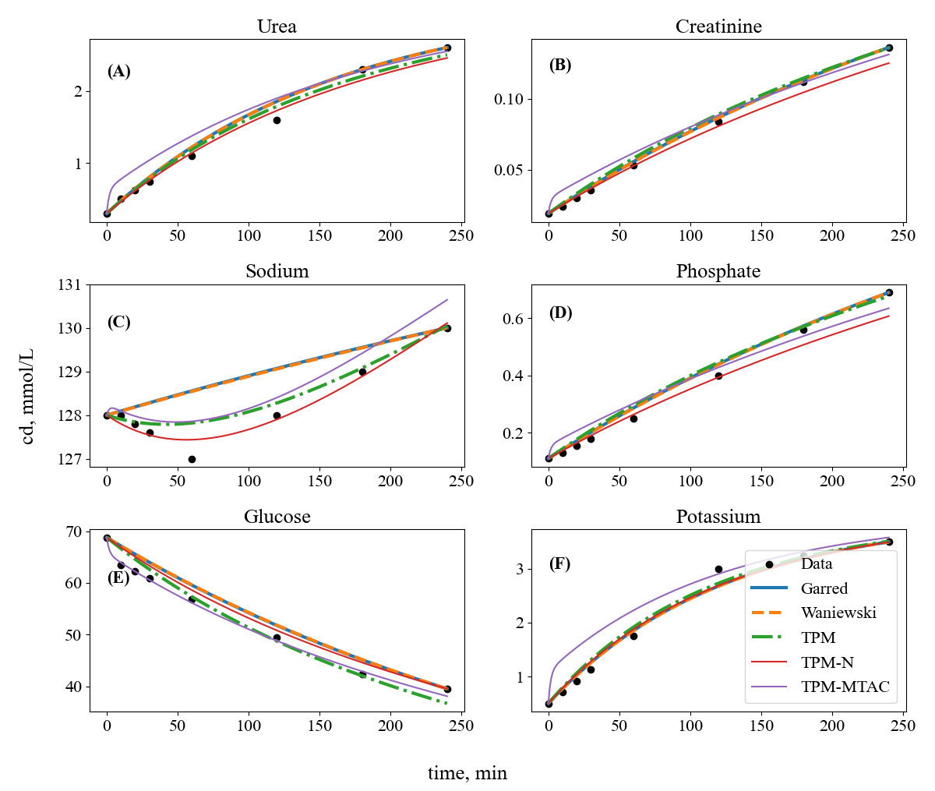

**Figure** 5: Predicted dialysate concentration by each model after going through 10 iterations to find the best fit for a selected session of PD in pig. There are three different implementations of TPM. TPM is the original model proposed10, TPM-N is the model with parameters fitted specifically for pigs and TPM-MTAC is TPM-N with a time dependent MTAC addition.

**Table** 3: TPM parameters fitted specifically for one pig and one dialysis session (same as in figure 5).

|  |  |  |
| --- | --- | --- |
| Parameter | TPM (human) | TPM-N (pig) |
| Lymphatic flow rate, L [mL/min] | 0.3 | 0.7 40 |
| Hydraulic conductivity, LpS [ml/min/mmHg] | 0.074 | 0.045 |
| Ultrasmall pore fraction, $α_{C}$ | 0.02 | 0.052 |
| MTAC sodium [mL/min] | 1.936 | 2.747 |
| Small pore fraction, $α_{S}$ | 0.9 | 0.9 |
| Small pore radius, $r_{s}$ [Å] | 43 | 43 |
| Large pore radius, $r_{L}$ [Å] | 250 | 250 |

# Discussion

*Benchmarking is necessary in mathematical modeling to assess the accuracy and reliability of the model and to identify areas where the model may need improvement.* With the number of PD models available, it is necessary to benchmark the models for proper quantification of solute concentration profiles. This would aid in choosing which model to be extended for investigating and simulating improvements in PD systems, such as bio-compatible dialysis fluids or different PD treatments (automated PD, continuous flow PD, tidal PD). In this paper, we benchmark 9 different models to predict 6 solute dialysate concentrations at 8 different time points for static dwell PD.

The models were trained on the training datasets to find the best fitting mass transfer area coefficients ($MTAC$), $fct$, sieving coefficients $\left(SiCo\right)$ and lymphatic flow rate $\left(L\right)$. The fitted parameters were then used to predict the dialysate concentrations for the test datasets. We had two different test datasets to see whether there is a difference between two different session types of static dwell. We used RMSE given by equation 2.1 as the objective function to find the best fit and also as the method of comparison for the models. There is no significant difference in both test:training splits, thus we continued with a 7:4 data split.

Our 9 models included 2 lumped models (model 8 and 9) and 7 models with more defined kinetics (Table 1). Figure 3 shows that out of the 7 models, model 1-6 were predicting dialysate concentration with at least one order of magnitude higher error than the rest. Figure 3 also shows that the lumped models (model 8 and 9) and model 7 provided the best generalised model fit. Figure 4 shows the solute specific RMSE. It confirms that model 7, 8 and 9 are good at predicting all solutes while some other models (model 1 for urea and potassium, all models for creatinine) could also be considered if those particular solutes are of more interest. After comparing the fitted parameters, we were able to reject most models completely based on unphysiological values, i.e. negative values for the $MTAC$ for sodium (table 3). We can also visualise this in figure 5, where model 8 and 9 are not able to capture the sodium sieving in the first hour which could lead to different ultrafiltration profiles. Additionally, the TPM was modified to represent the vasodilation in the peritoneum as a result of glucose shock44, 45. In figure 5, a time dependent MTAC is able to represent the quick dissipation of the glucose gradient in the first 60 minutes of the dwell.

In summary, we found model 7 (TPM model) to be the best overall model for our benchmarking scenario. The model includes diffusion, lymphatic and non-lymphatic convection. The TPM is able to capture the size based sieving of solutes into the peritoneal cavity. The model itself can also be modified for other modes of PD such as continuous flow PD10, APD46. The sodium concentration cannot be accurately predicted as its sieving coefficient is around 0.6 and convective transport is more important than diffusive transport 14. However, since this model indirectly includes convection, there is no need for a simplified assumption for the sieving coefficient of sodium as in case of the other 8 models. However, because of the continuous, non-linear equations, the TPM can take a long time to fit compared to the analytical models of Garred and Waniewski. The TPM, even though more advanced than some of the models we have tested, still lumps the surrounding of the peritoneal tissue as one volume compartment. As such, the TPM lacks the ability to inform about the penetration of certain drugs given during procedures such as chemotherapy, which are often introduced by PD. Others have also shown that the TPM is unable to capture macromolecules transport with the same accuracy as that of the small solutes used in this paper47.

In this work, TPM was modified to fit the dialysis session specifically in pigs. The lymphatic absorption rate was fixed to a higher value in pigs than in human according to literature 40. Note that this lymphatic rate is taken from the thoracic duct rather than the peritoneum due to lack of specific data. We saw significant sodium sieving in most of the sessions, which indicates that the initial transcellular flow is high in the first few minutes (also observed in human). This also explains the high transcellular pore amounts in the heteroporous network of TPM, compared to human (0.052 vs 0.02). Notably, this parameter can be fitted per patient to make the TPM more personalised.

The study focuses purely on RMSE to rank the different models in predicting dialysate concentration. There are other quality predictors such as Akaike Information Criterion which penalises the models for having more parameters. We have captured some variability with 4 pigs and a total of 29 sessions, but we acknowledge that future work should focus on training the models with 10 times the degrees of freedom of the model48 as input data.

# Conclusions

The three-pore model is a good descriptor of fluid and solute kinetics in static dwell in pigs although it requires extra assessment of few parameters based on individual datasets. It also requires more computational time than the popularly used Garred and Waniewski method of determining solute transport although it is more accurate in representing particularly water and sodium transport. The extra assessment of parameters could also turn out to be an asset in favour of the TPM as treatment can be personalised to each individual. Additionally, the TPM can also be coupled with the distributed model to determine the solute penetration into the surrounding tissue to further study peritoneal membrane characteristics of patients.

# Funding

This work is supported by the partners of Regenerative Medicine Crossing Borders (RegMed XB), a public-private partnership that uses regenerative medicine strategies to cure common chronic diseases, by the Dutch Kidney Foundation and Dutch Ministry of Economic Affairs by means of the PPP Allowance made available by the Top Sector Life Sciences & Health to stimulate public-private partnerships (DKF project code PPS08), by a grant from the Dutch Kidney Foundation ( 22OK1018) and by the European Union (CORDIAL, Horizon 2020 research and innovation program, grant agreement no. 945207).

# Declaration of conflict

*None*

# Author contribution

Writing – Original Draft Preparation, S.S.; Writing – Review & Editing, J.V., K.G., A.C., C.O. ; Funding Acquisition, K.G., A.C, S.S.

# Appendix- Model definitions

## Graff model (model 1-6)

Graff and Fugleberg *et al*., in a series of articles compared 6 models of transport for the peritoneal solute transport of urea, creatinine, glucose, sodium, potassium and phosphate18-23. The solute flux is given by a combination of three main processes: diffusion, convection from blood to dialysate and lymphatic absorption from the dialysate. It is assumed that there is no solute generation in the peritoneal tissue or the peritoneal cavity (the time frame is too small) and the interactions between the solutes are negligible.

|  |  |
| --- | --- |
| $$\frac{dc_{D}}{dt}=\frac{1}{\underset{ml}{\underbrace{V}}}*\left(\underset{diffusive}{\underbrace{\overset{ml/min}{\overbrace{MTAC}}*\left(\overset{-}{\overbrace{fct}}*\overset{mol/ml}{\overbrace{c_{p}}}-c_{D}\right)}}+\underset{Non-lymphatic}{\underbrace{\overset{-}{\overbrace{SiCo}}*\overset{ml/min}{\overbrace{UF}}*\overset{mol/ml}{\overbrace{c_{I}}}}}-\underset{lymphatic}{\underbrace{\overset{ml/min}{\overbrace{L}}*\overset{mol/ml}{\overbrace{c^{*}}}}}\right)$$ | 9.1 |

where,

$c_{D}$ is the dialysate concentration at time $t,$

$V$ is the peritoneal volume at time t,

$MTAC$ is the mass transfer area coefficient of the particular solute (fitted),

$fct$ is the equilibrium ratio for solute concentration in dialysate and plasma concentration $\left(\frac{C_{D}}{C_{p}}\right)$ (fitted),

$c_{p}$ is the plasma concentration at time $t,$

$SiCo$ is the solute specific sieving coefficient to account for the fraction of molecules dragged along during the water transport (fitted),

$UF$ is the ultrafiltration rate given by $\frac{dV}{dt}$,

$c_{I}$ is the intramembrane solute concentration to account for the non-lymphatic convective transfer across the peritoneal membrane given by $c_{p}-f(c_{p}-c_{d})$,

$f$ is the interdependence between diffusion and convection,

$L$ is the lymphatic flow rate. The lymphatic flow is modelled as a sum total of different water transport mechanisms such as the dialysate sampling, lymphatic entry and blood entry and

$c^{*}$ is to account for the direction of the lymphatic flow ($c^{*}=c_{p}$ if flow is from plasma to peritoneal cavity or else $c^{*}=c_{D}$).

Different combinations of the constants $MTAC, fct, SiCo$ and $L$ (in bold in eq 2.1) were fitted to the experimental data according to the model (table 1, 1-6).

Input: The initial and final intraperitoneal volume, $V[0]$ and $V[t]$ are taken from experimental data. For other time steps, $V$ is linearly interpolated from the initial and final value. The plasma solute concentrations, $c_{p}$ values are also taken from patient data and interpolated. The dialysate solute concentrations, $c_{d}$ at different time steps (t = 0, 10, 20, 30, 60, 120, 180, 240) are also taken from patient data.

## Three pore model (model 7)

Öberg and Martuseviciene developed an ODE based 3 pore model of continuous flow peritoneal dialysis (CFPD)10. They extended the regular 3 pore model by including the physical changes attributed to the fill ($J_{fill}$) and drain $(J_{drain})$ flow rate in addition to the transport processes occurring over the peritoneal membrane.

|  |  |
| --- | --- |
| $$\frac{dV}{dt}=\underset{pore contribution}{\underbrace{J_{vC}+J_{vS}+J_{vL}}}+\underset{device}{\underbrace{J_{fill}-J_{drain}}}-\underset{lymphatic}{\underbrace{L}}$$ | 9.2 |

|  |  |
| --- | --- |
|  | 9.3 |

The volume flux (first part of equation 2.3) is given by the Starling equation 49 and the solute flux (first part of equation 2.4) by the Patlak equation 50.

There is no solute flow through the ultrasmall pores (water-exclusive pores).

|  |  |
| --- | --- |
| $$J_{sC}=0.$$ | 9.4 |

For static dwell, the device flow rates can be set to zero.

|  |  |
| --- | --- |
| $$J_{fill}=J_{drain}=0$$ | 9.5 |

Thus, equation 2.3 and 2.4 become,

|  |  |
| --- | --- |
| $$\frac{dV_{D}}{dt}=J_{vC}+J_{vS}+J_{vL}-L$$ $$\frac{dC_{D}}{dt}= \frac{J_{sS}+J_{sL}}{V}-C_{D}\frac{J_{vC}+J_{vS}+J_{vL}}{V}$$ | 9.6 |

where

|  |  |
| --- | --- |
| $$J_{vC}=L_{p}S*\left[∆P- σ∆π\right]*af*α_{C}$$ | 9.7 |
| $$J_{vS}=L_{p}S*\left[∆P- σ∆π\right]*af*α_{S}$$ |  |
| $$J_{vL}=L_{p}S*\left[∆P- σ∆π\right]*af*α_{L}$$ |  |

and

|  |  |
| --- | --- |
| $$∆P= ∆P_{0}-\frac{V\left[t\right]-(V_{fill}+V_{res})}{490}$$ | 9.8 |

Where $J_{vC}, J_{vS} and J_{vL}$ are the volume flux through ultrasmall, small and large pores, $af$ is the fraction of peritoneum in contact with the dialysis fluid and $α_{C}, α_{S}$ and $α_{L}$ are the ultrasmall, small and large pore fraction. The fill volume and residual volume are represented by $V_{fill}$ and $V_{res}$. The solute flux through the small and large pores is given by,

|  |  |
| --- | --- |
| $$J_{sS}=J_{vS}(1-σ)\frac{c_{p}-c_{D}e^{-Pe,S}}{1-e^{-Pe,S }}$$ | 9.9 |
| $$J_{sL}=J_{vL}(1-σ)\frac{c_{p}-c_{D}e^{-Pe, L}}{1-e^{-Pe, L }}$$ |  |

where

|  |  |
| --- | --- |
| $$Pe,S=\frac{J_{vS}\left(1-σ\right)}{MTAC}$$ | 9.10 |
| $$Pe,L=\frac{J_{vL}\left(1-σ\right)}{MTAC}$$ |  |

The reflection coefficients for solutes are given by σ51.

Input: In addition to the input in the previous models, the initial fill volume $V_{fill}$ and the residual volume $V_{res}$ (calculated from total protein) are also taken from patient data. The reflection coefficient $σ$ are calculated from solute radius51, which are in turn taken from literature.

## Garred model (model 8)

The simplified model proposed by Garred *et al*.15 is given by,

|  |  |
| --- | --- |
| $$\ln\left\{V\left(\overline{c_{p}}-c_{D}\right)\right\}=\ln\left\{V\left[0\right]\left(\overline{c_{p}}-c_{D}\left[0\right]\right)\right\}-\frac{MTAC}{\overline{V}}×t$$ | 9.11 |

where $V$ is the dialysate volume, $\overline{c_{p}}$ is the mean plasma concentration during the session, $c_{D}$ is the dialysate concentration at time $t$, $\overline{V}$ is the mean dialysate volume during the session, $V\left[0\right]$ and $c_{D}\left[0\right]$ are the dialysate volume and dialysate concentration at time $0$. They assume that there is no interdependence of the two transport processes- diffusion and convection, which is fixed to zero $(f=0)$. Further they also assumed that for small solutes, the sieving coefficient or $SiCo$ can be set to $1$. Plotting a straight line through $\ln\left\{V\left(\overline{c_{p}}-c_{D}\right)\right\}$ for two different time points can then give us the slope $\frac{MTAC}{\overline{V}}$ from which $MTAC$ can then be derived. Using this predicted $MTAC$, we can calculate $c_{D}$ as,

|  |  |
| --- | --- |
| $$c_{D}=\overline{c_{p}}-\frac{V\left[0\right]}{V}\left(\overline{c_{p}}-c_{D}\left[0\right]\right)exp\left(-\frac{MTAC}{\overline{V}}×t\right)$$ | 9.12 |

Input: The intraperitoneal volume and plasma and dialysate solute concentration at $t$ = 0 and $t$ = 240 min are collected from experimental data.

## Waniewski model (model 9)

They modified the simplistic model of Garred by making one major change, i.e., instead of assuming $f=0$ for all solutes, they assumed $f$ is a constant14. Thus in their generalised model, equation 2.12 can be modified as

|  |  |
| --- | --- |
| $$\ln\left\{V^{1-f}\left(\overline{c_{p}}-c_{D}\right)\right\}=\ln\left\{{\left(V\left[0\right]\right)}^{1-f}\left(\overline{c_{p}}-c_{D}\left[0\right]\right)\right\}-\frac{MTAC}{\overline{V}}×t$$ | 9.13 |

and this gives us the dialysate concentration as,

|  |  |
| --- | --- |
| $$c_{D}=\overline{c_{p}}-{\left(\frac{V\left[0\right]}{V}\right)}^{1-f}\left(\overline{c_{p}}-c_{D}\left[0\right]\right)exp\left(-\frac{MTAC}{\overline{V}}×t\right)$$ | 9.14 |

Input: In addition to the input for Garred, $f$ value is fixed at 0.5 as per the observation in their paper14. We have also fitted $f$ to see if it would improve the fit, but that does not seem to be the case.

# References

1. R.J. Kallen, *A Method for Approximating the Efficacy of Peritoneal Dialysis for Uremia.* American Journal of Diseases of Children, 1966. **111**(2): p. 156-160.

2. J.H. Miller, R. Gipstein, R. Margules, M. Schwartz and M.E. Rubini, *AUTOMATED PERITONEAL DIALYSIS: ANALYSIS OF SEVERAL METHODS OF PERITONEAL DIALYSIS.* ASAIO Journal, 1966. **12**(1).

3. L.W. Henderson and K.D. Nolph, *Altered permeability of the peritoneal membrane after using hypertonic peritoneal dialysis fluid.* Journal of Clinical Investigation, 1969. **48**(6): p. 992-1001.

4. O. Devuyst and A.J. Yool, *Aquaporin-1: New Developments and Perspectives for Peritoneal Dialysis.* Peritoneal Dialysis International, 2010. **30**(2): p. 135-141.

5. R. Khanna and R. Mactier, *Role of Lymphatics in Peritoneal Dialysis.* Blood Purification, 1992. **10**(3-4): p. 163-172.

6. H. Florey, *Reactions of, and absorption by, lymphatics, with special reference to those of the diaphragm.* British journal of experimental pathology, 1927. **8**(6): p. 479.

7. L. Allen and E. Vogt, *A mechanism of lymphatic absorption from serous cavities.* American Journal of Physiology-Legacy Content, 1937. **119**(4): p. 776-782.

8. B. Rippe, B.-I. Rosengren and D. Venturoli, *The Peritoneal Microcirculation in Peritoneal Dialysis.* Microcirculation, 2001. **8**(5): p. 303-320.

9. E.F. Vonesh and B. Rippe, *Net Fluid Absorption under Membrane Transport Models of Peritoneal Dialysis.* Blood Purification, 1992. **10**(3-4): p. 209-226.

10. C.M. Öberg and G. Martuseviciene, *Computer Simulations of Continuous Flow Peritoneal Dialysis Using the 3-Pore Model—A First Experience.* Peritoneal Dialysis International, 2019. **39**(3): p. 236-242.

11. F.A. Gotch, *Kinetic Modeling of Continuous Flow Peritoneal Dialysis.* Seminars in Dialysis, 2001. **14**(5): p. 378-383.

12. M.F. Flessner, R.L. Dedrick and J.S. Schultz, *A distributed model of peritoneal-plasma transport: theoretical considerations.* American Journal of Physiology-Regulatory, Integrative and Comparative Physiology, 1984. **246**(4): p. R597-R607.

13. C.M. Öberg and B. Rippe, *Optimizing Automated Peritoneal Dialysis Using an Extended 3-Pore Model.* Kidney International Reports, 2017. **2**(5): p. 943-951.

14. J. Waniewski, A. Werynski, O. Heimbürger and B. Lindholm, *Simple Models for Description of Small-Solute Transport in Peritoneal Dialysis.* Blood Purification, 1991. **9**(3): p. 129-141.

15. L.J. Garred, B. Canaud and P.C. Farrell, *A simple kinetic model for assessing peritoneal mass transfer in chronic ambulatory peritoneal dialysis.* asaio J, 1983. **6**(3): p. 131-7.

16. R.L. Dedrick and M.F. Flessner, *Pharmacokinetic Problems in Peritoneal Drug Administration: Tissue Penetration and Surface Exposure.* JNCI: Journal of the National Cancer Institute, 1997. **89**(7): p. 480-487.

17. J. Stachowska-Pietka, J. Waniewski, M.F. Flessner and B. Lindholm, *Distributed model of peritoneal fluid absorption.* American Journal of Physiology-Heart and Circulatory Physiology, 2006. **291**(4): p. H1862-H1874.

18. J. Graff, S. Fugleberg, J. Brahm and N. Fogh‐Andersen, *The transport of phosphate between the plasma and dialysate compartments in peritoneal dialysis is influenced by an electric potential difference.* Clinical Physiology, 1996. **16**(3): p. 291-300.

19. J. Graff, S. Fugleberg, J. Brahm and N. Fogh‐Andersen, *Transperitoneal transport of sodium during hypertonic peritoneal dialysis.* Clinical Physiology, 1996. **16**(1): p. 31-39.

20. S. Fugleberg, J. Graff, P. Joffe, H. Løkkegaard, B. Feldt‐Rasmussen, N. Fogh‐Andersen and S.L. Nielsen, *Transperitoneal transport of creatinine. A comparison of kinetic models.* Clinical Physiology, 1994. **14**(4): p. 443-457.

21. J. Graff, S. Fugleberg, P. Joffe, J. Brahm and N. Fogh‐Andersen, *Parameter estimation in six numerical models of transperitoneal transport of potassium in patients undergoing peritoneal dialysis.* Clinical Physiology, 1995. **15**(3): p. 185-197.

22. J. Graff, S. Fugleberg, P. Joffe and N. Fogh-Andersen, *Parameter estimation in six numeric models of transperitoneal transport of glucose.* ASAIO Journal (American Society for Artificial Internal Organs: 1992), 1994. **40**(4): p. 1005-1011.

23. J. Graff, S. Fugleberg, P. Joffe, J. Brahm and N. Fogh-Andersen, *An evaluation of twelve nested models of transperitoneal transport of urea: the one-compartment assumption is valid.* Scandinavian Journal of Clinical and Laboratory Investigation, 1995. **55**(4): p. 331-339.

24. B. Rippe, *A Three-Pore Model of Peritoneal Transport.* Peritoneal Dialysis International, 1993. **13**(2_suppl): p. 35-38.

25. M.M. Pannekeet, A.L.T. Imholz, D.G. Struijk, G.C.M. Koomen, M.J. Langedijk, N. Schouten, R. de Waart, J. Hiralall and R.T. Krediet, *The standard peritoneal permeability analysis: A tool for the assessment of peritoneal permeability characteristics in CAPD patients.* Kidney International, 1995. **48**(3): p. 866-875.

26. J.C. De Vries, M.K. Van Gelder, A.S. Monninkhof, S. Ahmed, D.H.M. Hazenbrink, T.Q. Nguyen, G.A.P. De Kort, E.-J.P.A. Vonken, K.R.D. Vaessen, J.A. Joles, M.C. Verhaar, and K.G.F. Gerritsen, *A Uremic Pig Model for Peritoneal Dialysis.* Toxins, 2022. **14**(9): p. 635.

27. P. Virtanen, et al., *SciPy 1.0: fundamental algorithms for scientific computing in Python.* Nature Methods, 2020. **17**(3): p. 261-272.

28. B. Juillet, C. Bos, C. Gaudichon, D. Tomé and H. Fouillet, *Parameter Estimation for Linear Compartmental Models—A Sensitivity Analysis Approach.* Annals of Biomedical Engineering, 2009. **37**(5): p. 1028-1042.

29. D. Kraft, *A software package for sequential quadratic programming.* Forschungsbericht- Deutsche Forschungs- und Versuchsanstalt fur Luft- und Raumfahrt, 1988.

30. D. Venturoli and B. Rippe, *Transport asymmetry in peritoneal dialysis: application of a serial heteroporous peritoneal membrane model.* American Journal of Physiology-Renal Physiology, 2001. **280**(4): p. F599-F606.

31. B. Rippe, D. Venturoli, O. Simonsen and J. De Arteaga, *Fluid and electrolyte transport across the peritoneal membrane during CAPD according to the three-pore model.* Peritoneal Dialysis International, 2004. **24**(1): p. 10-27.

32. B. Rippe, G. Stelin and B. Haraldsson, *Computer simulations of peritoneal fluid transport in CAPD.* Kidney International, 1991. **40**(2): p. 315-325.

33. A. Akonur, C.J. Holmes and J.K. Leypoldt, *Predicting the peritoneal absorption of icodextrin in rats and humans including the effect of α–amylase activity in dialysate.* Peritoneal Dialysis International, 2015. **35**(3): p. 288-296.

34. O. Carlsson, S. Nielsen, e.-R. Zakaria and B. Rippe, *In vivo inhibition of transcellular water channels (aquaporin-1) during acute peritoneal dialysis in rats.* American Journal of Physiology-Heart and Circulatory Physiology, 1996. **271**(6): p. H2254-H2262.

35. B. Rippe and O. Carlsson, *Role Oftranscellularwater Channels in Peritoneal Dialysis.* Peritoneal dialysis international, 1999. **19**(2_suppl): p. 95-101.

36. A. Rippe, C. Rippe, K. Swärd and B. Rippe, *Disproportionally low clearance of macromolecules from the plasma to the peritoneal cavity in a mouse model of peritoneal dialysis.* Nephrology Dialysis Transplantation, 2007. **22**(1): p. 88-95.

37. C.M. Öberg and B. Rippe, *A distributed two-pore model: theoretical implications and practical application to the glomerular sieving of Ficoll.* American Journal of Physiology-Renal Physiology, 2014. **306**(8): p. F844-F854.

38. B. Rippe and G. Stelin, *Simulations of peritoneal solute transport during CAPD. Application of two-pore formalism.* Kidney International, 1989. **35**(5): p. 1234-1244.

39. J. Waniewski, M. Debowska and B. Lindholm, *How accurate is the description of transport kinetics in peritoneal dialysis according to different versions of the three-pore model?* Peritoneal dialysis international, 2008. **28**(1): p. 53-60.

40. X. Lu, M. Wang, L. Han, J. Krieger, J. Noblet, S. Chambers, M. Itkin and G.S. Kassab, *Morphometry and Lymph Dynamics of Swine Thoracic Duct.* Lymphatic Research and Biology, 2020. **18**(5): p. 406-415.

41. B. Rippe and C.M. Öberg, *Albumin Turnover in Peritoneal and Hemodialysis.* Seminars in Dialysis, 2016. **29**(6): p. 458-462.

42. M. Fischbach, A. Zaloszyc, B. Schaefer and C.P. Schmitt, *Optimizing peritoneal dialysis prescription for volume control: the importance of varying dwell time and dwell volume.* Pediatric Nephrology, 2014. **29**(8): p. 1321-1327.

43. R.T. Krediet, E.W. Boeschoten, F.M.J. Zuyderhoudt, J. Strackee and L. Arisz, *Simple Assessment of the Efficacy of Peritoneal Transport in Continuous Ambulatory Peritoneal Dialysis Patients.* Blood Purification, 1986. **4**(4): p. 194-203.

44. S. Mortier, A.S. De Vriese, J. Van de Voorde, T.P. Schaub, J. Passlick-Deetjen and N.H. Lameire, *Hemodynamic effects of peritoneal dialysis solutions on the rat peritoneal membrane: role of acidity, buffer choice, glucose concentration, and glucose degradation products.* Journal of the American Society of Nephrology, 2002. **13**(2): p. 480-489.

45. J.A. Diaz-Buxo, *Evolution of Continuous Flow Peritoneal Dialysis and the Current State of the Art.* Seminars in Dialysis, 2001. **14**(5): p. 373-377.

46. C.M. Öberg and B. Rippe, *Is Adapted APD Theoretically More Efficient than Conventional APD?* Peritoneal Dialysis International, 2017. **37**(2): p. 212-217.

47. J. Waniewski, J. Poleszczuk, S. Antosiewicz, D. Baczynnski, M. Galach, M. Pietribiasi and Z. Wannkowicz, *Can the Three Pore Model Correctly Describe Peritoneal Transport of Protein?* ASAIO Journal, 2014. **60**(5).

48. D. Chicco, *Ten quick tips for machine learning in computational biology.* BioData Mining, 2017. **10**(1): p. 35.

49. E.H. Starling, *On the Absorption of Fluids from the Connective Tissue Spaces.* J Physiol, 1896. **19**(4): p. 312-326.

50. C.S. Patlak, D.A. Goldstein and J.F. Hoffman, *The flow of solute and solvent across a two-membrane system.* Journal of Theoretical Biology, 1963. **5**(3): p. 426-442.

51. R. Drake and E. Davis, *A corrected equation for the calculation of reflection coefficients.* Microvascular Research, 1978. **15**(2): p. 259.

52. M.K. van Gelder, G. Ligabue, S. Giovanella, E. Bianchini, F. Simonis, D.H.M. Hazenbrink, J.A. Joles, M.A. Bajo Rubio, R. Selgas, G. Cappelli, and K.G.F. Gerritsen, *In vitro efficacy and safety of a system for sorbent-assisted peritoneal dialysis.* American Journal of Physiology-Renal Physiology, 2020. **319**(2): p. F162-F170.

Supplementary

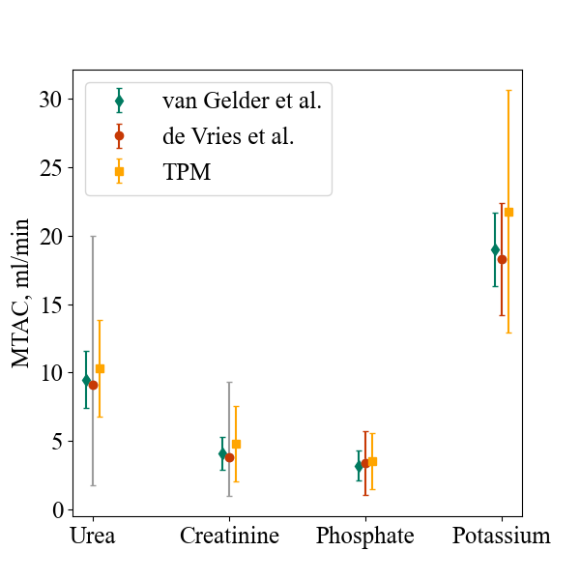

Figure S1: The comparison of literature values26, 52 found for MTAC of some solutes and the ones predicted with the three pore model.

|  |  |  |  |  |  |  |  |  |  |  |  |  |  |  |  |  |  |  |  |
| --- | --- | --- | --- | --- | --- | --- | --- | --- | --- | --- | --- | --- | --- | --- | --- | --- | --- | --- | --- |
| model | MTAC_urea | MTAC_crea | MTAC_sodium | MTAC_phosphate | MTAC_glu | MTAC_potassium | fct_urea | fct_crea | fct_sodium | fct_phosphate | fct_glu | fct_potassium | sico_urea | sico_crea | sico_sodium | sico_phosphate | sico_glu | sico_potassium | L |
| Units | ml/min | ml/min | ml/min | ml/min | ml/min | ml/min | ­ | ­ | ­ | ­ | ­ | ­ | ­ | ­ | ­ | ­ | ­ | ­ | ml/min |
| 1 |  |  |  |  |  |  |  |  |  |  |  |  | 0 | 0 | 0 | 0 | 0 | 0 | 0.65 |
| 2 |  |  |  |  |  |  |  |  |  |  |  |  | 1 | 1 | 1 | 1 | 1 | 1 |  |
| 3 |  |  |  |  |  |  |  |  |  |  |  |  |  |  |  |  |  |  | 0.65 |
| 4 |  |  |  |  |  |  |  |  |  |  |  |  | 0 | 0 | 0 | 0 | 0 | 0 |  |
| 5 |  |  |  |  |  |  |  |  |  |  |  |  | 1 | 1 | 1 | 1 | 1 | 1 | 0.65 |
| 6 |  |  |  |  |  |  |  |  |  |  |  |  |  |  |  |  |  |  |  |
| 7 | 9.84±3.63 | 4.22±2.91 | 0.51±1.37 | 2.89±2.25 | 15.49±30.16 | 21.60±9.24 | ­ | ­ | ­ | ­ | ­ | ­ | 0.036 | 0.041 | 0.032 | 0.038 | 0.052 | 0.038 | 0.3 |
| 7a |  |  |  |  |  |  | ­ | ­ | ­ | ­ | ­ | ­ | 0.068* | 0.073* | 0.064* | 0.07* | 0.083* | 0.07* | 0.7 |
| 8 | 10.63±3.56 | 5.22±3.40 | -0.98±3.54 | 3.98±2.77 | 5.69±4.90 | 16.71±3.27 | ­ | ­ | ­ | ­ | ­ | ­ | 0 | 0 | 0 | 0 | 0 | 0 | ­ |
| 9 | 10.71±3.10 | 5.30±2.86 | -0.90±3.03 | 4.06±2.16 | 5.96±4.52 | 16.72±3.02 | ­ | ­ | ­ | ­ | ­ | ­ | 0.5 | 0.5 | 0.5 | 0.5 | 0.5 | 0.5 | ­ |
| 9* | 8.23±13.86 | 5.40±6.31 | 4.85±13.81 | 5.55±11.37 | 2.81±15.66 | 16.49±10.53 | ­ | ­ | ­ | ­ | ­ | ­ | -2.80±6.32 | -0.85±3.05 | 3.53±7.37 | -2.18±6.91 | -5.11±6.42 | -0.30±6.62 | ­ |
| van Gelder | 9.5±2.1 | 4.1±1.2 |  | 3.2±1.1 |  | 19±2.7 |  |  |  |  |  |  |  |  |  |  |  |  |  |
| de Vries | 9.1 (7.3-10.9) | 3.8(2.8-5.5) |  | 3.4±2.3 |  | 18.3±4.1 |  |  |  |  |  |  |  |  |  |  |  |  |  |

Table S1: Fitted parameters for all models. 7a represents TPM-N with pig-specific parameters. 9* represents the modified model 9 with fitted $f$ instead of fixing $f$ at 0.5.