9/16/2019

Jack O’Kane || Conor McGrory || Sean Carlin

**COMPANY NAME HERE**

Business Application Development

***Project Report***

**Contents**

Section 1 – Introduction 2

Background to the Project 2

Fact-Finding 2

Methodologies 2

Section 2 - Documentation of existing system 3

Background to the current system 3

Organisation and staffing structure of the development area being considered 3

Inputs / Outputs / Processes / Files 3

Inputs 3

Outputs 3

Processes 3

Files 3

Data Flow Diagrams 3

Context Diagram 3

Level 1 Diagram 3

Associated Level 2 Diagram 3

Section 3 – System Requirements 4

Functional Requirements 4

Non-Functional Requirements 4

Section 4 – Proposed System Specification 5

Data Flow Diagram Design 5

Interface/ Form Design 5

Functionality Design 5

Report Generation 5

Appendix 1 6

Appendix 2 6

Appendix 3 6

# **Section 1 – Introduction**

## **Background to the Project**

Our task as a team involves browsing local businesses and deciding which organisation, we are going to investigate in order to develop a real business-like system that could be used in the real industry. The criteria used by our team to determine which businesses to look at are as follows:

The scope of the business – It’s important that we chose a business that is not too large and established to where it would be difficult to make substantial improvements or have too many processes for our team numbers to handle. However, there must be enough content for us to work with as a team and individually.

Accessibility – We should have a clear line of contact with the business so that they can be contacted regularly for any information we need. For example, if one of the team members know someone/ has connections to the organisation it would be a great help in getting more qualitative/quantitative information.

As a team we brainstormed a variety of different local businesses that we would consider. Such as Tesco, Dispo, myDentist, StoreFront and Lloyds Pharmacy.

When looking at investigating Tesco the team concluded that an organisation that size would be too much to handle for our team size, it would require us to only look at a certain department or a selection of departments within such a large organisation. It didn’t suit any of the team therefore we didn’t select Tesco for our investigation.

Dispo was another option, a janitorial cleaning/ power washing Supplier Company that Sean had good connections with the owner. At first this seemed like the go-to option as it was very accessible and from first glance it seemed like the business was big enough. However, with further investigation with the support of our Lecturer we concluded that Dispo was in fact too small for a team of 3 to investigate and that we’d be limiting ourselves in what we could design in the future. Therefore, we didn’t select Dispo.

Another idea was to investigate StoreFront, a brand-new clothing store just recently established locally in Derry. Jack has good connections with the owner meaning it would not be difficult to gather information about the business. However, like Dispo, upon further investigation it was concluded that StoreFront was also too limited in what we as a team of 3 could design for the business.

myDentist was another potential organisation, it certainly had enough content for us to work with as a team of 3 in terms of tables and services they provide. However, the issue with this organisation was not the scope of the project but the accessibility. It was difficult to get in contact with the business and the organisation didn’t seem like they wanted to work with us. So, we didn’t continue to investigate their business.

Lloyd’s Pharmacy was the organisation we selected, Sean lives close to the local store In Eglinton and knows the staff, so accessibility won’t be an issue. When looking into the services a chemist provides at a first glance there is a lot of work for a team of 3 to do in terms of tables and design, we felt that it is much better to have more to work with that we could potentially cut out areas of the business if necessary than having too little to work with.. We as a team feel is the best choice of business to use for the project, as well as being accepted by our lecturer’s feedback to our proposal.

## **Fact-Finding**

## Interviews

Interviews are a good way to get tons of information about Lloyds Pharmacy is to arrange an interview with one of their employees and ask them questions about the system. Sean went to speak directly to the manager since a member of his family works there and they would only allow one person to come in for the interview due to busy scheduling. He asked the manager a list of open-ended questions that the whole team came up with that were related to various parts of the business, including their current system, stock, courses and suppliers, he then transcribed the manager’s answers by typing them up in his PC. We knew the manager wouldn’t be able to answer all our questions in one meeting, so Sean agreed to meet with them again until he got answers for all the questions that the manager was willing to answer, except for a few that he could not answer due to business reasons. The interviews were structured, since Sean had set of questions ready to be asked. Once Sean was finished with the interviews, we looked over his transcriptions and used them to begin designing our data flow diagrams.

We decided having an interview with the manager is beneficial since they would know all about how the business is run, so we can ask them all sorts of questions which they will more than likely know the answer to. We can also ask the manager for clarification on any answers that we may not understand. Most websites say that Interviews are a good way to get qualitative information about a business, person, etc. However, interviews can take a while to arrange with the business and depending on the amount of questions can take a while to finish. The manager may feel intimidated by us if we come on to strongly or the questions are overly complex. The manager may also refuse to give out information that isn’t confidential and may just give information that is not needed for the system. ***Interviews can be defined as a qualitative research technique which involves “conducting intensive individual interviews with a small number of respondents to explore their perspectives on a particular idea, program or situation.”***(Available at https://research-methodology.net/research-methods/qualitative-research/interviews/ *(Accessed:10/10/2019)*).

## Analysing Documents

During a business visit, Sean asked the manager if they would let him look over any of their company documents, since we knew that analysing a company’s documentation is a good way to help us learn what types of data is used in their current system. The manager explained to Sean what documents he could and could not look over because of privacy and confidentiality, after which they allowed him to look over their prescription records which included prescription types as well as receipts that are kept on their computer system. He also analysed both their physical and digital stock invoices and looked through their stock warehouse to see what kinds of products they keep stored. With the documents that he was provided, Sean gained a better idea of what kind of information and data the business keeps and wrote down what he learned, he then handed his findings to the rest of the team during one of our weekly meetings and we used this information to help with our data flow diagram designs.

We chose to analyse documents as they give an insight into the business’ various items including stock, suppliers and customers and depending on the number of documents. It can be less time-consuming than other fact-finding techniques since it revolves around selecting data rather than collecting data. Business documents will cover a long span of time and provide a complete overview of the business by showing exact names, dates and references which makes it easier when researching. By analysing them, we can identify the types of documentation that they use to run their business and can also help us see which existing documents are relevant. Some drawbacks to this method however are that the business has the right to refuse to let us look through most of, if not all their documents, which limits our research greatly. Some of their documents can contain information that can either be out of date, have irrelevant information, or contain financial and confidential information, which is something we don’t need for our system.

## Observation

During the second visit, the manager allowed Sean to observe some areas of the business to see how they operate daily. They first let him take a glimpse at their current system on a computer, which allowed Sean to see how the system is designed and run, as well as see some of the inputs, outputs and processes that the business has. They also let him look in their dispensary where all their stock is kept, this showed him how the business keeps their stock. He was even allowed to observe some employees doing work and he asked the employees some questions to gain even more information about how various factors are handled within the business. As Sean observed the business, he took down notes of what he saw so he could take his findings back to the team and we could all analyse his notes together during our meetings and we could start designing our data flow diagrams.

We chose observation as we could learn a lot about the business by observing them rather than just asking them questions, by actually seeing how the business is managed in person, we will have a better understanding about what happens within their headquarters, how their employees work in different sectors, as well as see how their current computer system is operated. Observing a business has its drawbacks, as the employees can act differently when they know they are being observed, they may feel taken aback or agitated with someone looking over them and taking notes. It can also take up a lot of time if the business is large and can waste some time if we are not gathering relevant information. The staff in charge may also refuse to let us observe certain sections of the building due to business ethics, therefore limiting our collection of information. **“The observation method involves human or mechanical observation of what people actually do or what events take place during a buying or consumption situation.”** (Available at https://www.managementstudyguide.com/observation_method.htm *(Accessed:11/10/2019)*).

# **Methodologies**

## Waterfall Method - Overview

The waterfall method is still used today, quite commonly in fact, due to its efficiency and success rates within major projects. This methodology is deemed most appropriate in most cases as the requirements are well established early-on as the project goal is easily defined (the client knows exactly what they want and how it will be achieved), I.e. the scope of the project is stable and unlikely to result in scope creep. It’s a linear process that clientele that are unfamiliar with system’s development lifecycles would still be able to understand. As the system works in stages that do not progress until one stage is complete it reinforces that stages are carefully and thoroughly developed that with qualitative information gathered from the analysis stage can result in a higher quality product.

### Waterfall Method – History

It is a traditional methodology that has existed for a long time (regarded as one of the earliest lifecycle processes. It has consistently performed to a high standard, particularly when the technology and requirements are understood. “The waterfall Process was an early SE attempt to get organised”, (Available at *https://www.sciencedirect.com/topics/computer-science/waterfall-process (Accessed:10/10/2019)*).

Most systems today use waterfall not necessarily because it is the best, but it is the most familiar especially to companies that have been around for a long time. Business owners unfamiliar with ICT can easily follow the illustration of the model as well. It is primarily driven by the analyst resulting in either high quality or poor products depending on how well the analysis stage is carried out. It is well known for its high level of stability and control for management as it involves plenty of planning and simplified trackable strategies.

### Waterfall Model - Stages

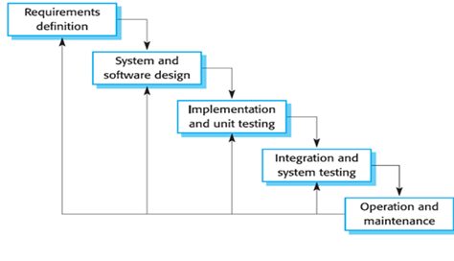

In the requirements definition (Analysis) stage, it’s important to be thorough and precise as this stage will impact how the rest of the system is developed. In development, all information collected during fact-finding and communication with the client will be used to clearly define requirements for a system for the client.

The design stage follows once the analysis stage has been signed off and documents / sketches will be produced for the client, where they can come up with any additional ideas and needs of the application. These changes cannot involve changing critical requirements otherwise the analysis stage will have to be scrapped and repeated.

Implementation follows where software development takes place involving coding/installation and unit testing. (Testing using small parts of the system to identify bugs and functionality errors).

Integration takes all the individual sections of code and puts them together to become a fully-fledged system. System testing takes place to ensure the elements of the system work cohesively with one another.

Operation and Maintenance is the last steps in the system’s development lifecycle, it involves putting the product into operation (installation) and staff are trained on how to handle the system. Maintenance takes place for a long time after the product is complete in ways such as hardware, software, correct and adaptive maintenance.

### Advantages

The waterfall methodology brings many advantages such as allowing for more controlled scheduling with deadlines being set for each of the development stages as the product builds increasingly each stage. If the client has questions such as how the project scheduled/which process is coming next it is much easier to explain with the waterfall model as it outlines the steps in a very simple format.

In terms of project management, the waterfall model allows for a much more focused/detailed approach as each stage has a cut-off point (the goal of the section must be completed before the next stage can continue), therefore project managers can keep the project going in the right direction easier. As the requirements are clearly understood it is much easier to develop elements of the system as stages do not overlap with one-another.

### Disadvantages

There are limitations with the waterfall model, such as time management. It is difficult to estimate how long each stage may last, for example the implementation and unit testing stage may take significantly longer than expected, this will affect how the project had been scheduled from the beginning and therefore result in more time needing to be allocated to the project which increases development costs. This methodology does not bode well with rapid changes that are very common in the industry, changes such as time and budget allocation can very easily change that can critically impact the quality of the system in development.

### Justification for choosing Waterfall

**Find key quotes / references for waterfall model**

Chose two more

Explain why you wanted this one etc

## Agile Method

### History

When a business wants to plan a major project on a given time limit, they use the Agile Method. This management process is good for extreme programming projects. With this method comes a high disciplinary project management approach most specifically with the time limits for the project. As soon as the project reaches its time limit, that’s it finished, even if the group workers aren’t finished. Also known as a sprint.

### Stages

Advantages *(Source -* [*http://ilearn.nwrc.ac.uk/course/view.php?id=674*](http://ilearn.nwrc.ac.uk/course/view.php?id=674) *PowerPoint Software Methodologies Overview)*

Using Agile methodologies comes with many benefits. It’s much more simplistic in concept and can start right away without extreme amounts of planning especially as smaller teams are usually used for this methodology. Different phases of the life cycle can be completed at any time/at any speed. Some phases such as testing may be completed faster than others using a sprint. It’s very useful for projects that need to be completed sooner rather than later. For a methodology it is quite adaptable meaning dependant on the organisation and product the methodology can vary slightly to suit the clients' needs.

Disadvantages *(Source -* [*http://ilearn.nwrc.ac.uk/course/view.php?id=674*](http://ilearn.nwrc.ac.uk/course/view.php?id=674) *PowerPoint Software Methodologies Overview)*

Agile also has its own issues that need to be considered when being used such as the following: It’s important for the client and developer to be in close contact throughout the entire development lifecycle in order to ensure the team is developing at the correct pace as not to lead to an everlasting project (scope creep) as well as any changes from major to minor to be delivered directly to the client etc.

<https://en.wikipedia.org/wiki/Agile_software_development#The_Manifesto_for_Agile_Software_Development>

<https://www.knowledgehut.com/blog/agile/difference-agile-scrum>

## The Prototyping Model Overview

The prototyping model is commonly used in all engineering related industries (including software) as businesses like to develop a model before mass production of a product. Clientele (especially those unfamiliar with ICT) prefer to visually see the product as how it would be used in the industry so they can further understand what it is they asked for and is easier to determine if their requirements are met. There are two main types of prototyping – Exploratory/Evolutionary & Throwaway.

The exploratory/evolutionary method involves producing a very generic model that is demonstrated to the client for feedback, refinement of the product takes place until it ‘evolves’ into an agreeable product. It’s more commonly used than its counterpart (throwaway), as many companies may not wish to ‘waste’ resources such as costs and time by continuously restarting their project.

The throwaway method takes the initial build, it is tested to determine if the developers of the project should begin to be built further upon. If not, the build is scrapped and started again hence the name ‘throwaway’. The focus in this method is the functional requirements.

### Stages - Evolutionary

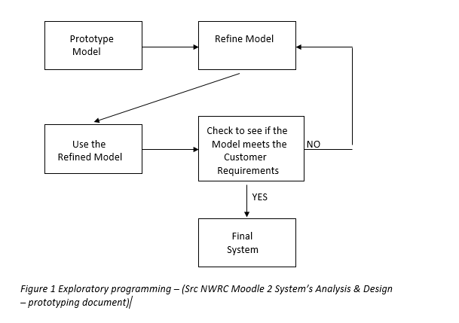

### Stages - Throwaway

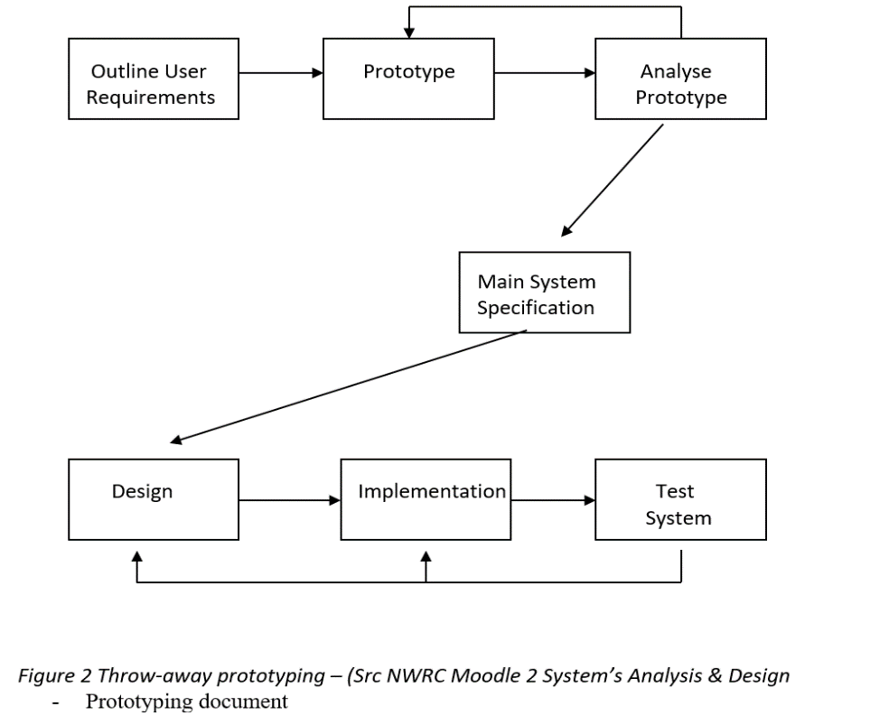

### History

Software prototyping derives from the original industry development process of prototyping – which involves developing a rough/incomplete version of the product to present real-life proposals of the design for the product that the user can usually interact with the product and offer more in-depth criticism of the product. It’s a different take on development than building the entire program first and potentially wasting software costs and time.

(Resources used[*https://www.ukessays.com/essays/information-technology/the-history-of-the-software-prototyping-information-technology-essay.php*](https://www.ukessays.com/essays/information-technology/the-history-of-the-software-prototyping-information-technology-essay.php) *)*

### Advantages

Uncertainties in a software development team and the client(s) can be identified easier as the focus of prototyping is showcasing the functional requirements of the system. As there is a functional product to be used, missing links can be identified easier. Optimization on the main functions of the system that aren’t complete can be easily modified. Systems are readily available for demonstrative purposes to determine whether the prototype should be continued or discarded depending on which prototyping method is being used.

### Disadvantages

As prototyping usually takes place under rapid software development, management problems potentially come up such as project planning, it is difficult for project managers to determine the scope of the project in terms of cost and time with prototyping for example, it may be unknown how many models of the system will be built and how many resources may be ‘wasted’.

As there are two very different types of prototyping, each come with their own disadvantages that come as follows:

Evolutionary/Exploratory prototyping involves a large amount of changes continuously taking place which can create an unknown amount of problems for the system in areas such as potential bugs, extended deadlines & budget allocation. These are dangerous to businesses who need to be certain of how much they want to spend and how long it will take. Large scale systems would be most affected by this. It is difficult to maintain this type of system with version control as it is an evolving system and comparing previous versions of the software may be entirely different to the current version of end up creating a whole new range of bugs that require more time and cost to fix.

Throw-away prototyping comes with its own problems, one of the key issues being that the main/core system functions are developed which means other necessary functions end up not being included. Requirements (functional) are usually agreed at the beginning of a project, with throw-away prototyping requirements may not be able to be met therefore there is a sense of uncertainty between developer(s) and client(s). Non-functional requirements are not even considered in this development process.

* Detail of methodologies considered by the group to be used in the project (SELECT AND JUSTIFY EACH POTENTIAL CHOICE)
* Include all supporting documents of section 1 in Appendices.

# **Section 2 - Documentation of existing system**

## Background to the current system

Dial up computer, two separate computers then one master computer. See questions, sean will actually do this don’t worry xx

## Organisation and staffing structure of the development area being considered

Basically hierarchy of all staff members by job roles. Eg home office, and this one too x

## Inputs / Outputs / Processes / Files

### Inputs

* **Customer Enquiry –** A Customer can make an enquiry to the business for information on various things like courses and prescriptions.
* **Customer Payment –** Customers will pay the business for the item which they bought that may include medicine.
* **Completed Course Form –** The customer will return the course form to the business with their details all filled out.
* **Minor Ailment Request –** The customer makes a request to the business for service on any minor ailments.
* **Customer Prescription –** A prescription for the customer that authorises them to be issued with a medicine or treatment.
* **Address Confirmation –** Address will be confirmed when the customer replies to the business’ request for their address.
* **Prescription Reorder Request –** Customers can ask the business to reorder their prescriptions.
* **Prescription Delivery Request –** Deliveries for prescriptions can be made by customers if they want it delivered to their address.
* **Stock Enquiry Response –** The warehouse will respond to a stock enquiry by showing if they have the stock that was asked for.
* **Stock Invoice –** The warehouse can send invoices to the business.
* **Order Delivery Note –** A note that is sent to the business containing information about the delivery of an order.
* **Stock Receipt –** A receipt for the stock that was ordered by the business which confirms that they have received it.
* **Holiday Leave Acceptance –** A response from the home office on whether the staff can get off for holiday leave.
* **Promotional Material –** Promotional material to help promote the business and the products they sell.
* **Staff Contracts –** Contracts for employees to sign so they can agree to the terms provided to them by the business.
* **Supplier Receipt –** A receipt which the supplier sends to the business after they have paid for their ordered stock.
* **Supplier Invoice –** An invoice that the business receives about the stock they receive from the supplier.
* **Supplier Delivery Note –** A delivery note that lists the items and quantity of items that the business receives from the supplier.
* **Supplier Enquiry –** An Enquiry from a supplier that asks the business for information relating to their stock.
* **Reorder Prescription –** A prescription that was reordered by the business and sent from the Medica Practice.
* **Medication Enquiry Response –** The Medical Practice's response to an enquiry from the business about medication.
* **Alternate Medication Confirmation –** A confirmation from the Medical Practice for the alternate medication that the business requested.

### Outputs

* **Customer Enquiry Response –** The business responds to a customer’s enquiry and gives them information.
* **Customer Receipt –** A receipts that is sent to the customer for the items which they bought from the business
* **Blank Course Form –** A course form that is sent to the customer for them to fill out in order to join a course.
* **Course Details –** Details for a course chosen by the customer and are sent from the business.
* **Minor Ailment Advice –** Advice relating to minor ailments that is sent to the customer to gain a better understanding.
* **Address Request –** A request from the business that asks a customer for their address details.
* **Prescription Delivery Confirmation –** The business will let the customer know that the delivery for their prescription has been confirmed.
* **Stock Enquiry –** The business will make an enquiry to the warehouse for stock in case they are running short on certain items.
* **Stock Order –** The business will order any stock that they need from the warehouse in case they have run out of certain items.
* **Stock Payment –** After receiving the stock, the business will then pay the warehouse for the ordered stock.
* **Stock Discrepancies –** Inconsistent Information between different types of stock that’s given to the warehouse for inspection.
* **Staff Rota –** A complete roster of all the employees working in the business and information about them including working hours.
* **Holiday Leave Request –** Employees from the business can make a request to the home office if they can be allowed off for holiday leave.
* **Completed Staff Contracts –** The staff contracts that have been sent out to the employees will come back fully completed.
* **Supplier Payment –** The business issues a payment to the Supplier for all the items that they ordered from them.
* **Supplier Discrepancies –** Information about the suppliers that is invalid and not the same between each other that is sent from the business.
* **Supplier Enquiry Response –** The business will respond to an enquiry from the supplier by providing them information.
* **Supplier Order –** The business will make an order from the supplier for various items that they may need.
* **Sickness Report –** A report that is given to the home office about employees in the business that have been off sick.
* **Weekly Report –** A summary of all work that was done during the week and is sent to the Home Office to look over.
* **Prescription Reorder Request –** The business requests that the Medical Practice reorder prescriptions that the business can provide for their customers.
* **Medication Enquiry –** The business makes an enquiry to the Medical Practice for information about medication.
* **Alternate Medication Request –** A request from the business that asks the Home Office for alternate medication.

### Processes

* **Manage Customers –** Information relating to customers is handled with this process and uses files such as ‘Customers’, ‘Minor Ailments’ and ‘Customer Payments’.
* **Manage Suppliers –** This process manages supplier information and uses files like ‘Supplier’, ‘Supplier Invoice’ and ‘Supplier Payment’.
* **Manage Enquiries –** A process that handles all enquiries for customers, suppliers, medication and stock going in and out of the business.
* **Manage Stock –** This process handles all things related to stock, these include invoices, receipts, payments, discrepancies as well as order delivery notes.
* **Manage Prescriptions –** The business’ details related to prescriptions like deliveries, alternate medication, addresses and re-order details are handled with this process.
* **Manage Staff –** All staff details are managed with this process which include the staff rota, promotional material, staff contracts, reports and holiday leave details.

### Files

* **Enquiries –** This file will contain a variety of different types of enquiries from the customer and the business itself such as enquiries about courses and prescriptions. This file also contains stock enquiries from the business to the warehouse about stock as well as supplier enquiries about the suppliers' stock.
* **Customers –** This file will contain all relevant information about the customer, generic information such as their name/address/medical history etc.
* **Customer Payments –** This file will contain all payment details relating to the customer, name/address/payment information.
* **Receipts –** This file will store all the different kinds of receipts handled in the business. (Customer receipt, supplier receipt).
* **Courses –** This file will store all course information (course forms/completed course forms) and customer’s details that are on the course(s).
* **Minor Ailments –** This file will contain a variety of minor ailments the business can treat, as well as how many customers are treated for these minor ailments.
* **Discrepancies –** This file will contain a record of all the supplier discrepancies, it will flow back and forth between the business itself and the supplier.
* **Orders –** This file will store all relevant order information the business makes to the supplier (stock orders, supplier orders).
* **Stock –** This file will hold record of all stock available/unavailable in the local store itself (not prescriptions) but items in the shop itself that anyone can come in and buy.
* **Stock Payments –** This file will contain a record of all stock payments carried out from the business to the warehouse.
* **Suppliers –** This file will hold record of all the different suppliers and relevant information about them.
* **Supplier Invoices –** This file will contain information on all invoices and payment details for every supplier.
* **Supplier Payments –** This file will contain a record of all the different payments that are made to the business(s) suppliers.
* **Supplier Receipts –** This file will contain all the supplier receipts; it will flow back and forth between the business and the supplier.
* **Deliveries –** This file will contain stored details on all deliveries carried out from the business, containing files such as delivery receipts, order delivery notes etc.
* **Prescriptions –** This file will contain details on prescriptions, what the prescription is and who it is for & for how long.
* **Alternate Prescriptions –** This file will contain alternative-prescription details, these will flow back and forth between the business and the medical practice.
* **Reorder Prescriptions –** This file will contain the re-order details for prescriptions.
* **Staff –** This file will contain all staff details such as name/address/job role etc.
* **Reports –** This file will contain all the produced reports from the business, such as staff and enquiry reports.
* **Rota –** This file will contain all the rota details about the staff. It contains details such as their days/hours to work for that week.
* **Sickness –** This file will contain all the sickness report details which are taken and sent to the home office.
* **Holidays –** This file will store all the holiday related details such as holiday leave requests and confirmation forms.
* **Promotions –** This file will store all the promotional material to be used in the business as directed by the home office.
* **Staff Contracts –** This file will contain a copy of all the staff contracts that are sent out by the home office and completed by the staff. A copy is taken as the completed staff contracts are returned to the home office.
* **Medical Practice Details –** This file will contain all details regarding medical practices, it will receive these details from the Medical Practice external entity.

## Data Flow Diagrams

### Context Diagram

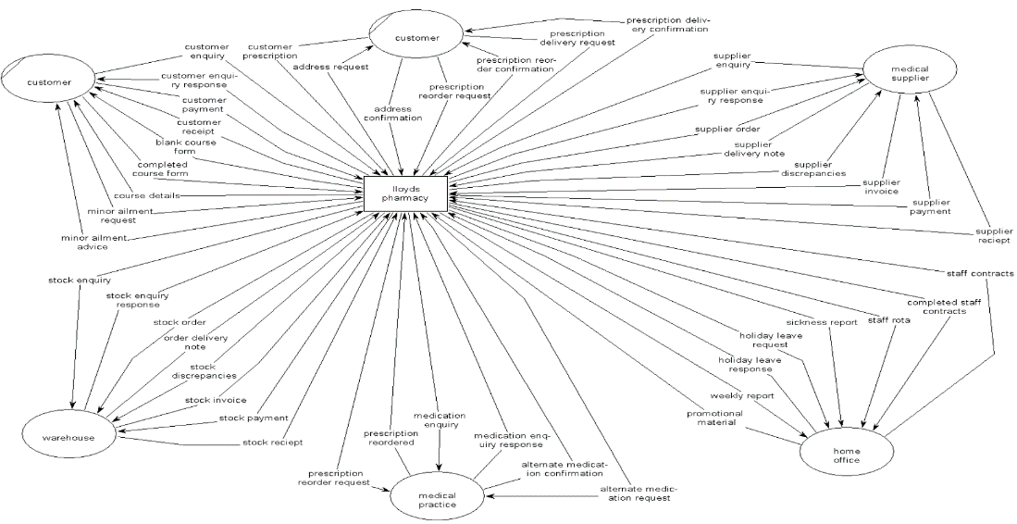

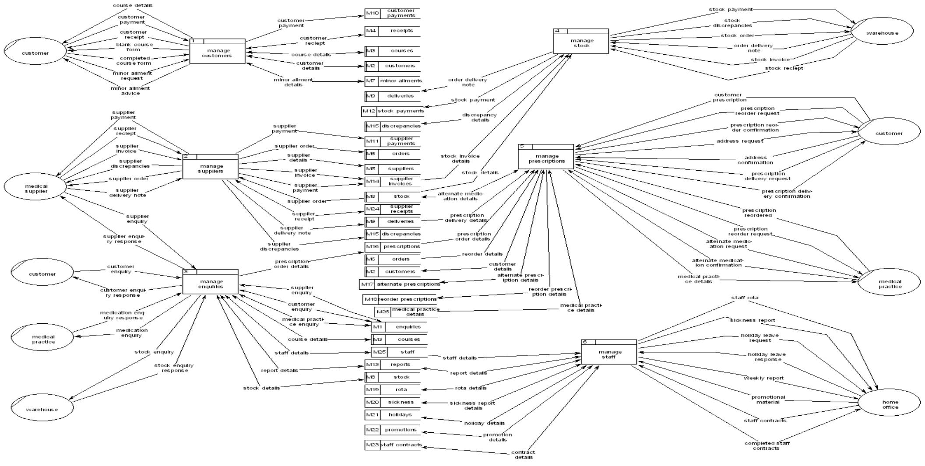Level 1 Diagram

### Associated Level 2 Diagrams

#### Manage Customers

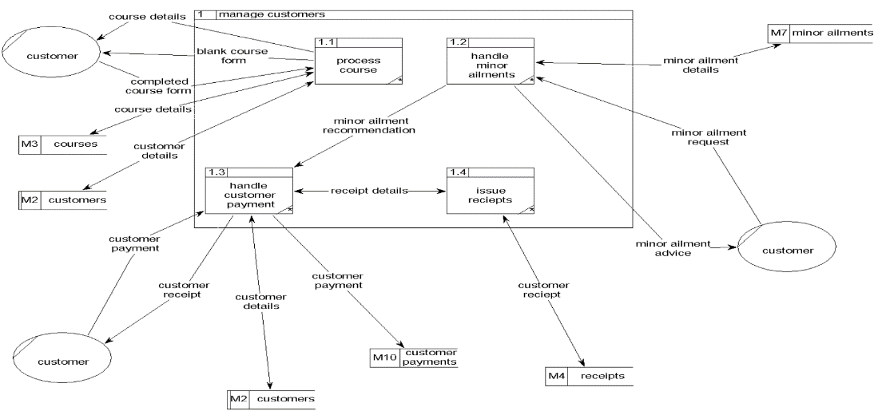

#### Manage Suppliers

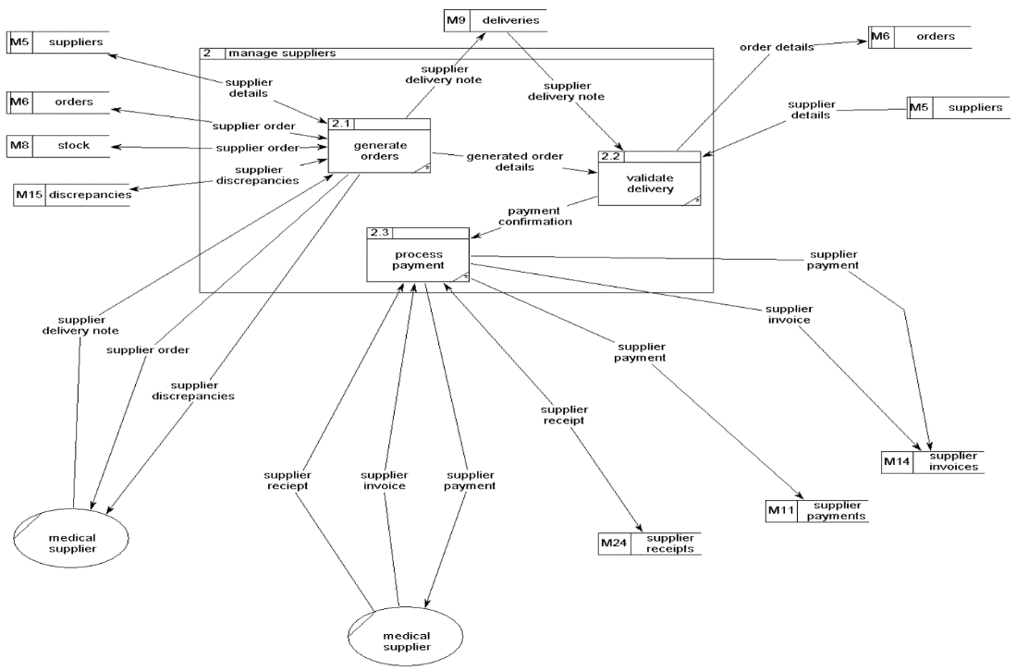

#### Manage Enquiries

#### Manage Stock

#### Manage Prescriptions

#### Manage Staff

# **Section 3 – System Requirements**

Document system requirements – the team should be able to identify what requirements are needed based on the problems with the current system

|  |  |  |
| --- | --- | --- |
| 1 | Customers | |
| # | Requirement ID | Requirement Description |
|  | Add Customer | The system must be able to add Customer details to a database using Customer IDs to identify each unique customer. |
|  | Edit Customer | The system must be able to edit Customer details from the database and their details should be updated in real time. |
|  | Delete Customer | The system must be able to delete Customers |
|  | Search Customer | System must allow staff members to search for specific customers |
|  | Generate Customer Report | System must allow staff to generate customer reports |
|  | Display Customers | System will allow staff to display all customers |

|  |  |  |
| --- | --- | --- |
| 2 | Course | |
| # | Requirement ID | Requirement Description |
|  | Add Course | System has to allow the user to add more courses |
|  | Edit Course | System has to allow the user to edit existing course information |
|  | Delete Course | System has to allow the user to delete existing courses |
|  | Search Courses |  |
|  | Generate Course Report |  |
|  | Display Courses |  |

|  |  |  |
| --- | --- | --- |
| 3 | Minor Ailments | |
| # | Requirement ID | Requirement Description |
|  | Add Minor Ailments |  |
|  | Edit Minor Ailments |  |
|  | Delete Minor Ailments |  |
|  | Search Minor Ailments |  |
|  | Generate Minor Ailment Report |  |
|  | Display Minor Ailments |  |

|  |  |  |
| --- | --- | --- |
| 4 | Orders | |
| # | Requirement ID | Requirement Description |
|  | Add Orders |  |
|  | Edit Orders |  |
|  | Delete Orders |  |
|  | Search Orders |  |
|  | Generate Orders Report |  |
|  | Display Orders |  |
|  | Print Receipt |  |

|  |  |  |
| --- | --- | --- |
| 5 | Stock | |
| # | Requirement ID | Requirement Description |
|  | Add Stock |  |
|  | Edit Stock |  |
|  | Delete Stock |  |
|  | Search Stock |  |
|  | Generate Stock Report |  |
|  | Display Stock |  |

|  |  |  |
| --- | --- | --- |
| 6 | Stock Payments | |
| # | Requirement ID | Requirement Description |
|  | Add Stock Payments |  |
|  | Edit Stock Payments |  |
|  | Delete Stock Payments |  |
|  | Search Stock Payments |  |
|  | Generate Stock Payments Report |  |
|  | Display Stock Payments |  |
|  | Authorize User Access | The system must identify that its either the Head Office or Branch manager accessing these files |

|  |  |  |
| --- | --- | --- |
| 7 | Suppliers | |
| # | Requirement ID | Requirement Description |
|  | Add Suppliers |  |
|  | Edit Suppliers |  |
|  | Delete Suppliers |  |
|  | Search Suppliers |  |
|  | Generate Suppliers Report |  |
|  | Display Suppliers |  |

|  |  |  |
| --- | --- | --- |
| 8 | Supplier Invoices | |
| # | Requirement ID | Requirement Description |
|  | Add Supplier Invoices |  |
|  | Edit Supplier Invoices |  |
|  | Delete Supplier Invoices |  |
|  | Search Supplier Invoices |  |
|  | Generate Supplier Invoices Report |  |
|  | Display Supplier Invoices |  |

|  |  |  |
| --- | --- | --- |
| 9 | Supplier Payments | |
| # | Requirement ID | Requirement Description |
|  | Add Supplier Payments |  |
|  | Edit Supplier Payments |  |
|  | Delete Supplier Payments |  |
|  | Search Supplier Payments |  |
|  | Generate Supplier Payments Report |  |
|  | Display Supplier Payments |  |
|  | Authorize User Access | The system must identify that its either the Head Office or Branch manager accessing these files |

|  |  |  |
| --- | --- | --- |
| 10 | Deliveries | |
| # | Requirement ID | Requirement Description |
|  | Add Deliveries |  |
|  | Edit Deliveries |  |
|  | Delete Deliveries |  |
|  | Search Deliveries |  |
|  | Generate Deliveries Report |  |
|  | Display Deliveries |  |

|  |  |  |
| --- | --- | --- |
| 11 | Prescription | |
| # | Requirement ID | Requirement Description |
|  | Add Prescription |  |
|  | Edit Prescription |  |
|  | Delete Prescription |  |
|  | Search Prescription |  |
|  | Generate Prescription Report |  |
|  | Display Prescriptions |  |

|  |  |  |
| --- | --- | --- |
| 12 | Staff | |
| # | Requirement ID | Requirement Description |
|  | Add Staff Member |  |
|  | Edit Staff Member |  |
|  | Delete Staff Member |  |
|  | Add Staff Rota |  |
|  | Edit Staff Rota |  |
|  | Delete Staff Rota |  |
|  | Search Staff Member |  |
|  | Generate Staff Report |  |
|  | Display Staff Members |  |
|  | Search Staff Rota |  |
|  | Display Staff Rota |  |
|  | Authorize User Access | The system must identify that its either the Head Office or Branch Manager accessing these files |

## Functional Requirements DRAFT

The business should be able to generate and store weekly reports from all aspects of the business in a database.

Reports should include non-generic details for example quantity of how many of that item was sold in order to make business decisions.

Access to reports should be restricted only to authorised members of the organisation.

When the customer places an order online, their details should be stored in a database.

When the customer places an order via telephone, their details should be entered into a database.

## Non-Functional Requirements DRAFT

# **Section 4 – Proposed System Specification**

* Document the system design, use a range of methods to represent the new system.

## Data Flow Diagram Design

## Interface/ Form Design

## Functionality Design

## Report Generation

**Appendix 1**

## Questions

### Stock Related – Within the Shop, Not prescription stock.

1. **What kind of products do you sell?**

Medicines, cosmetics, hair products, hygienic products, dental care, baby food, foot care, vitamins, perfumes, aftershaves etc, easy living products. (Accessibility chairs)

1. **Do you keep your stock in a warehouse?**

When we receive stock, it is put into our storeroom, overstock. The rest is put on the shelves straight away.

1. **How do you re-order stock?**

We order stock through our computer system, which is an internal system to our stock warehouse.

1. **How do you keep track of stock records?**

We get invoices in for every order, we also have a digital copy of it on our computer system, and we only order what we need to keep overstock levels at a minimum.

1. **Is there a limit to the stock you can order?**

No, but obviously we don’t over-order stock that will not sell and eventually go out of date.

1. **How is your stock organized?**

Drug wise, our stock is kept in the dispensary and all stored generically (by drug, not brand name). Over the counter (OTC) medicine is kept in glass cabinets behind the tills, this saves customer consumption abuse, as it is protocol to ask the customer why they need this medicine for their personal use. (What are your symptoms etc). We must follow standard operating procedures (SOP).

1. **Where do you keep stock records? Digitally or physical copy?**

Both, the physical copies are kept in box files and kept for a minimum 3 years – law states 3 years.

1. **What does the process involve when wanting to add a new item to the store to sell?**

We do not have choices, we must go by our head offices marketing team, this is only for the shop floor, and this doesn’t involve any medicines. Their statistics is what they use to see what sells best.

### Prescription Related

1. **What types of prescriptions does your pharmacy dispense?**

We dispense private prescriptions, dentist prescriptions, nurses’ prescriptions and then your GP prescriptions. We also provide a service where we write our own prescriptions that cover a wide range of ailments, signed by the pharmacist. (Minor ailments). We also provide prescriptions for our stop smoking service which covers nicotine patches and products.

1. **How do you process prescriptions? Scripts = prescriptions**

Most GP script pads have a bar code on them, which holds all the patients details and the product the doctor has prescribed for that prescription, but it can hold up to four items per prescription. Handwritten prescriptions that have a bar code cannot be scanned because they were handwritten, same goes for private scripts and dentist scripts.

1. **Do all prescriptions need to be signed by the doctor/clinic?**

Yes, it is a legal requirement, if they are not signed, they cannot be dispensed. They will have to go back to the doctor to get it signed before receiving their prescription.

1. **Do all customers need a prescription docket?**

Yes, they are needed for drugs etc, not for over the counter medicine.

1. **What happens once the customer hands you a prescription docket?**

We check with the customer that their name and address is correct to ensure it is right for that person, and that the doctor has signed it and that the prescription is in date.

1. **Is there a hold limit for customers to collect their prescription?**

Yes, if they are sitting there over two weeks, we must phone the customer to tell them it is awaiting collection, we do this twice, after the second time it is pulled off the shelf. We have a colour system, when we get a prescription for say today, we file it in alphabetical order, we number where we put the customers actual bag of medicine, on the shelf and determine how long it has been sitting there by the colour. The colours change every week, we have a chart showing what week was which colour. This represents the weeks it has been laying on the shelf awaiting collection.

1. **What happens if you run out of the specified drug/medicine needed for a prescription?**

First, we must check if is short supplied with our suppliers, we also check around the rest of our pharmacies locally to see if they have any in stock, if we can’t acquire it from any of our branches/suppliers, we ask the doctor if we can do an alternative for our customer. If the doctor refuses to sign for the alternative then we recommend the customer to try an independent pharmacy, in case they may have stock.

1. **Do you keep receipts for prescriptions? (Physical or Digitally)**

There is a record on our computer system, once the barcode is scanned on most scripts, the computer stores all information about it, e.g. the date and time it was scanned and processed.

1. **What do you do if a customer were to return unused medicine?**

If somebody were to return unused medicine, we have a special tray that we aren’t allowed to touch with naked hands in case there are any needles, sharp objects or even cytotoxic drugs. We then take it to our disposing buckets, which when are filled, are sealed and then the drugs are taken to be incinerated.

1. **How do you store your medicine/drugs? (describe the types)**

We store our drugs in pharma drawers and on shelves. Controlled drugs are stored in a time delayed safe in an undisclosed location.

1. **Do most prescriptions come with a use by date?**

All prescriptions have a use by date. But, when the customer gets their script signed by the doctor, they must take it to the pharmacy within 6 months to get it processed.

1. **~~How do you dispose of prescriptions?~~ – see question 9**

### Enquiries/Customer Related

1. **How would a customer make an enquiry? Email, in store?**

The customers would come in store to make an enquiry or even call our phone.

1. **How would you handle customer enquiries?**

Depending on what the enquiry is, if they're looking a specific product or medication, we would ask them for more details regarding the enquiry then get in contact with our suppliers if it’s a rare product.

1. **How would you handle a complaint?**

A complaint is addresses straight to the store manager, depending on the complaint it could take up to three working days, however we try to deal with the complaint straight away.

1. **Do you handle/deal with enquiries over the phone?**

Yes, every day. – See question 2

1. **Do you take note of these enquiries? (electronically or handwritten)**

Yes, they are handwritten.

1. **Where do these enquiries go? (File / database)**

After they are dealt with and sorted out the physical copies are shredded and put into confidential waste.

### Course Related

1. **Does your business offer any ~~courses~~ Services?**

Yes, we offer a stop smoking course as well as a blood pressure check and diabetes check. We also offer a free house bound and elderly deliveries. We even collect prescriptions from every surgery in the town.

1. **How can customers apply for Services?**

Within Store.

1. **How do you process course applications? (If Any)**

We only record patient information for the stop smoking course, we only record what they’re given each week dependant on their progress on the course.

1. **Do you keep records of all customers who have applied for courses? (Physical or Digitally)**

Yes, both, all in a confidential file on the computer and physically.

1. **~~Does the customer get a confirmation letter, for the course?~~**

### Supplier Related

1. **How are supplier payments made? (Done locally or through head office?)**

Head office deals with everything regarding payments.

1. **How many suppliers do you have?**

We have three main suppliers, AH, Sangers, Alliance.

1. **How do you get in contact with your suppliers?**

By telephone, email and through the computer.

1. **~~How do you request an order?~~**
2. **Do you store supplier information?**

We have all their details, contact numbers and addresses etc.

1. **~~Are supplier orders recorded and stored? If so, is it physical/digital copies or both?~~**

### Delivery Related

1. **Do you deliver prescriptions locally?**

Yes, only to the house bound and elderly, as well as the care and nursing homes daily.

1. **Is there an extra fee for deliveries?**

No.

1. **Is the delivery driver employed or from a separate courier?**

They are employed within our branch, by the pharmacy company.

1. **Do you issue delivery receipts?**

We keep a copy of their name and address, on a delivery sheet. They must sign this upon delivery to confirm they have received that order.

1. **Do you keep records of all deliveries made? (Physical or Digitally)**

Yes, only physically.

1. **~~Where do you receive deliveries from suppliers?~~**
2. **How do delivery drivers receive their delivery docket?**

We print them out within the pharmacy and give them to the driver.

1. **Do clients receive a delivery receipt?**

No, they sign for it so that’s all that is needed.

### Online Related

1. **Can Customers order prescriptions online?**

Yes, but not through us, it must be through a doctor.

1. **~~How do you handle online prescription orders, are they handled the same way as if a customer wants a delivery?~~ – see question 1**
2. **Can you make enquiries online, to your branch?**

Not to our branch, but in general online yes.

1. **~~Where are online orders/enquiries stored?~~**

## Management/Business Related

1. **~~What kind of services does your business provide?~~**
2. **How do you think your current system could perform better?**

Our overall system has been updated recently therefore we have no need for it to be improved any better.

1. **What kind of accessibility does your business offer?**

We have automatic doors and are wheelchair friendly.

1. **Does your business offer a Christmas club?**

No

1. **Are you dependant on a ‘head office’?**

Yes, our head office is needed for guidance.

1. **What is your target audience?**

Everybody, of all ages that require anything needed, nobody is excluded

1. **If you carry out cost reports, are they done weekly/monthly etc.**

We have regular external auditors hired by head office that come in and check our stock for pricing values etc.

1. **Do you keep records and details of all your employees? (Physical or Digitally)**

Yes, all on a computer system and not accessible to anyone but management.

1. **~~Could you allow me to look over your documentation to analyse for our system?~~**
2. **~~Could you allow me to observe your system and see how your business is run?~~**

## Business Limitations?

1. **Is there anything that would cause errors within the workplace?**

Lack of concentration, which could happen to anyone or any place. Other than that, none that we can see, in confidence.

1. **~~Are there any day-to-day tasks you think take too long / wish they could be improved?~~**
2. **Are there any areas in the workplace that you think can be more efficient?**

Time given to prepare prescriptions.

1. **If your computer system were to fail, can the business still operate without it?**

Yes, we would write the prescription labels manually with all directions from the doctors.

1. **Do you ever find that important handwritten notes can take up too much space / become disorganised / are easy to lose track of?**

Of course, handwritten notes can be dismissed very easily and lost. So, we feel that putting a note on the patient’s record (digitally) helps to keep track.

1. **Would you say the computer systems you have in place communicate well with each other / work well together?**

We have a master computer, and two slaves. The master computer sends all the orders straight to the warehouse and suppliers. The two slaves do the rest of the work, handling patient records, price listing, they can ONLY put items on to the order, which is on the master computer, but the slave computers can not send the final order that is on the master.

1. **Has there ever been any significant delays/holdups? If so, is it due to problems with the computer system you’re using?**

We can have holdups, as everyone in the pharmacy MUST have their orders sent/ordered before 12.30pm (lunchtime) or else it won’t be until 5.30 – 6pm as we receive two orders daily from one of the suppliers.

# **Appendix 2**

* Develop Test Plans for testing proposed system against the teams created user requirements.

# **Appendix 3**

* Details on how the team plans to test the functional aspects of the project.