Campus Marketplace App
Project Planning Group A
INFO 2413 System Development Project S10
Instructor: Nukhet Tuncbilek

Team Members:
Carline Gu - 100475907
Mary Klassen - 100432441
Navneet Grewal - 100448246
Natash Rana - 100438422
Joseph Yang – 100459636
Varleen Jaswal - 100465304
Date: 5/15/2026

Table of Contents
1. Project Initiation 4
2. Relationship with the Customer 4
3. Project Management Environment 5
4. Project Charter 5
4.1 Project Title 5
4.2 Authorization Date 5
4.3 Project Manager / Contact Information 5
4.4 Customer Information 6
4.5 Project Start and End Dates 6
4.6 Project Objectives and Description 6
4.7 Key Assumptions 7
4.8 Signature Section 7
5. Baseline Project Plan 7
5.1 Introduction 7
5.2 System Description 8
5.2.1 Overview 8
5.2.2 User Roles 8
5.2.3 Main Functions 8
5.2.4 High-Level System Workflow 9
5.3 Feasibility Assessment 10
5.3.1 Technical Feasibility 10
5.3.2 Operational Feasibility 10
5.3.3 Schedule Feasibility 10
5.3.4 Economic Feasibility 10
5.4 Management Issues 11
5.4.1 Team Communication 11
5.4.2 Version Control 11
5.4.3 Potential Management Challenges 11
5.4.4 Solutions 11
5.5 Task Responsibility Matrix 12
5.6 The Project Communication Matrix 13
6. Project Scope Statement 13
6.1 General Project Information 14
6.2 Problem/Opportunity Statement 14
6.3 Project Objectives 14
6.4 Project Description 15
6.5 Business Benefits 15
6.6 Project Deliverables 16
6.7 Estimated Project Duration 16
7. Preliminary Schedule / Gantt Chart 17
8. References 17

1. Project Initiation
Table 1: Project Team Roles and Responsibilities
Team Member | Role | Responsibilities
Carline Gu | UI/UX Designer | Designs interface and user experience
Mary Klassen | System Analyst | Collects requirements and analyzes system needs
Navneet Grewal | Project Presenter | Presents the project
Natash Rana | UI/UX Designer | Designs interface and user experience
Joseph Yang | Developer | Developing database and application features
Varleen Jaswal | Project Manager | Coordinates meetings

As shown in Table 1, each team member has a clearly defined role and set of responsibilities within our project.

2. Relationship with the Customer
The primary stakeholders of the Campus Marketplace App include KPU students and faculty members who will use the system to buy and sell used items within the campus community. This project team will communicate with stakeholders through online meetings to ensure requirements are clearly understood and met.

Table 2: Stakeholder Communication Methods
Communication Method | Purpose
Weekly Meetings | Discuss project progress, updates, and feedback
Shared Documents | Review system requirements and change

As outlined in Table 2, the project team will use multiple communication methods to ensure effective communication and engagement with the stakeholders throughout the project.

3. Project Management Environment
Our team will utilize collaborative tools to support the development of this project, documentation, and meeting schedule. These tools are to be used to ensure project management is organized throughout the development lifecycle.

Table 3: Project Management Tools and Their Purpose
Tool | Purpose
WhatsApp | Team Communication
Zoom | Weekly Meetings
OneDrive | Shared Documentation
GitHub | Shared Source Code

As presented in Table 3, the team will use multiple collaboration tools to ensure effective communication, coordination, and collaboration throughout the system development process.

4. Project Charter

4.1 Project Title
Campus Marketplace Application

4.2 Authorization Date
May 15, 2026

4.3 Project Manager / Contact Information
Table 4.3: Project Manager and Team Contact Information
Role | Name | Email
Project Manager | Varleen Jaswal | varleen.jaswal@student.kpu.ca
Team Member | Carline Gu | carline.gu@student.kpu.ca
Team Member | Mary Klassen | mary.klassen@student.kpu.ca
Team Member | Navneet Grewal | navneet.grewal7@student.kpu.ca
Team Member | Natash Rana | natash.rana@student.kpu.ca
Team Member | Joseph Yang | chushuo.yang@student.kpu.ca

As listed in Table 4.3, the project team contact information includes all team member names and email addresses.

4.4 Customer Information
Table 4.4: Project Customer Information
Customer | Description
Students | Primary users
Faculty Members | Primary users
Instructor | Project evaluator and advisor

As shown in Table 4.4, the primary customers of the system include KPU students, and KPU faculty members, while the instructor acts as the project evaluator and advisor.

4.5 Project Start and End Dates
Project Start Date: May 15, 2026
Project End Date: August 10, 2026

4.6 Project Objectives and Description
- Develop a secure marketplace platform for the KPU community.
- Allow students and faculty members to sell and buy used items.
- Provide a communication platform between buyers and sellers.
- Provide account verification using school accounts.

4.7 Key Assumptions
- All team members will contribute equally throughout the whole project
- Stakeholders provide feedback when required to support project development
- The project will be completed before the deadline

4.8 Signature Section
Table 4.8: Project Signature Section
Name | Role | Signature | Date
Nukhet Tuncbilek | Instructor
Varleen Jaswal | Project Manager
KPU Community | Customer

As presented in Table 4.8, the project manager, advisor and KPU Community Representative provide approval for the completion and authorization of the project.

5. Baseline Project Plan

5.1 Introduction
The Campus Marketplace App is a web-based application designed for students to buy and sell used items within the KPU community. The system aims to provide a platform where students and faculty members can easily create listings, browse available products, and comment on posts. The purpose of this project is to support students and faculty members in trading personal belongings. This project provides convenience, accessibility, and a trusted and reliable communication system for users.

5.2 System Description

5.2.1 Overview
Users will be able to create their own accounts using their official KPU email addresses. The system will allow users to search for product names, tags, categories, etc. Users will also be able to comment on listings once logged in.

5.2.2 User Roles
Buyers
- Search for products
- View listings
- Comment on listings
- Save favorite items
- Communicate with sellers regarding listings
Sellers
- Create product listings
- Upload product images
- Edit or remove listings created by themselves
- Comment on listings
Administrators
- Remove listings
- Manage user accounts
- Monitor system activity

Main Functions
- User Registration and Login
- Users will be able to create accounts using their school email addresses and securely log into the system. The system will also include a ‘Forgot My Password’ feature.
- Product Search
- Users can search for products using keywords, categories, tags, or product names. This makes it easy to find relevant listings in the marketplace.
- Product Listing
- Sellers can create listings by posting items with details/descriptions, price, images, categories, and tags.
- Listing Management
- Sellers can edit or remove their postings, while administrators can remove postings if inappropriate.
- Messaging System
- Buyers can initiate communication with sellers to discuss listing, but not the other way around. Additionally, all users can comment on product listings.

5.2.4 High-Level System Workflow
Figure 5.2.4: Workflow Diagram
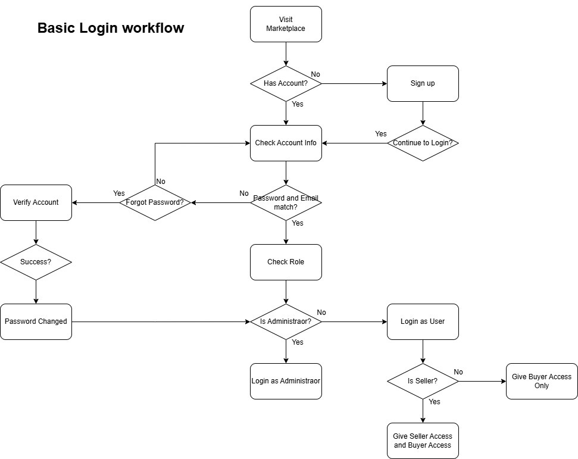
As seen in Figure 5.2.4, this workflow diagram illustrates the basic login workflow of the platform. This outlines the sequence of options presented to a user when accessing the platform. The process begins for the user when they open the marketplace platform and will determine whether they have an existing account or need to create one; new users are directed to the registration process, while existing users proceed to log in by providing their credentials. Depending on the user’s role in the system, different privileges will be given.

5.3 Feasibility Assessment

5.3.1 Technical Feasibility
The team has prior experience in database management systems (DBMS), website development, and a few programming languages. In addition, online resources, tutorials, and learning materials are available to help develop a better understanding and support to complete the project.

5.3.2 Operational Feasibility
Students and faculty members frequently buy and sell used items both online and offline. This project is operationally feasible because it provides a centralized online platform that provides accessibility, organization, and convenience.

5.3.3 Schedule Feasibility
After conducting the initial assessment, the team believes that the system can be completed within the semester timeline. The project tasks will be divided into phases and between the team, allowing enough time for planning, design, implementation, and testing.

5.3.4 Economic Feasibility
This project does not require significant amounts of financial investment because we will be implementing the project in a virtual environment and utilizing free resources for students. As a result, the system is economically feasible for implementation.

5.4 Management Issues

5.4.1 Team Communication
The team will use WhatsApp for group communication and coordination. In addition, regular meetings will be held to discuss project progress, tasks, and deadlines.

5.4.2 Version Control
A GitHub repository will be used to manage and store the project’s source code. This allows all the team members to collaborate efficiently and effectively.

5.4.3 Potential Management Challenges
This project may encounter several challenges during development. A possible challenge is scheduling conflicts, as team members will have different availability. This will affect meeting consistency and progress. As many team members are full-time students and have jobs, it may be difficult to find a meeting time that works for all of us.

Another challenge is the integration of different components. Since six team members will be working on separate parts of the application, finding harmony and smooth integration will be challenging. Additionally, unequal workloads may occur if tasks are not distributed evenly or if certain tasks require more effort than others.

5.4.4 Solutions
To address scheduling conflicts, the team will use flexible meeting times and plan meetings in advance to accommodate all team members' availability. In addition, the scheduled class time (Monday 4:00 pm – 6:50 pm) will be used for meetings, brainstorming, and collaborating sessions. Regular communication through WhatsApp will also ensure that progress continues even if some members cannot attend meetings.

To reduce integration issues, we will follow a structured development pan where each component is clearly defined and understood by all team members. The use of GitHub repository and an online shared word document will help ensure the team is working in harmony and integration is smooth of all system components.

To prevent unequal workload distribution, tasks will be clearly assigned at the beginning of the project. Furthermore, having a team leader will help monitor project progress and ensure workload is evenly distributed across team members. In addition, maintaining good teamwork, open communication, and a safe environment to collaborate will significantly support the project.

5.5 Task Responsibility Matrix
Table 5.5: Task Responsibility Matrix
Task | Carline | Mary | Navneet | Natash | Joseph | Varleen
UI Design
Backend Dev
Database Dev
Testing
Documentation
Presenting

As listed in Table 5.5, each team member has been assigned specific tasks to ensure balanced workload and effective project execution.

5.6 The Project Communication Matrix
Table 5.6: Project Communication Matrix
Communication Type | Participants | Method | Frequency | Purpose
Team Meetings | All Members | Online & In-person | Flexible | Discuss Project progress and updates
File Sharing | All Members | GitHub & WhatsApp | When needed | Share files
Task Updates | Team Leader | WhatsApp | When needed | Improve coordination, efficiency and task tracking
Testing Discussion | All Members | WhatsApp | At least twice a week | Improve the system quality
Instructor Consultation | All Members & Instructor | Online & In-person | Twice a semester | Getting Feedback
Baseline Project Plan Review | All Members | Online & In-person | At the end of each major phase | Review project progress, collect feedback and ensure the project plan remains accurate and complete

As shown in Table 5.6, the team will use various communication methods to support effective collaboration and communication. In addition, regular reviews of the baseline project plan will be held with all the team members at the end of each major phase to ensure the project remains organized and aligned with project objectives throughout the semester.

6. Project Scope Statement

6.1 General Project Information
Project Title: Campus Marketplace Application
Date: 5/15/2026
Course Name: INFO 2413: System Development Project (S10)
Instructor: Nukhet Tuncbilek
Team Leader: Varleen Jaswal
Team Members: Carline Gu, Mary Klassen, Navneet Grewal, Natash Rana, Joseph Yang
Customer: Kwantlen Polytechnic University (KPU) community

6.2 Problem/Opportunity Statement
Currently, KPU students do not have a centralized platform that is dedicated to buying and selling used personal items within the campus community. As a result, students often rely on external platforms such as Facebook Marketplace and community postings to contact potential sellers.
These methods can lead to several challenges including poor communication, lack of organization and safety, and trust concerns. In addition, using external platforms may expose students to risks such as fraud, theft, and burglary.
This project presents an opportunity to develop a secure, centralized, and user-friendly web-based marketplace that allows the KPU community to safely buy and sell items within a trusted community environment.

6.3 Project Objectives
- Develop a secure and centralized marketplace platform for the KPU community.
- Enable students and faculty members to buy and sell new or used personal items with the platform.
- Provide a communication system that allows buyers and sellers to interact
- Provide user account verification using official KPU email address to ensure a trusted environment.
- Improve safety and trust in transactions

6.4 Project Description
The system will include the following core functionalities:
- User Registration and Login
- Users will be able to create accounts and log in using their official KPU email addresses. The system will include basic authentication features to ensure secure access.
- User Profile Management
- Users will be able to view and update their profile information, including name, contact details, and profile settings.
- Product Search
- Users will be able to search for items using keywords and categories. This allows users to quickly find relevant listings on the platform.
- Product Listing
- Sellers will be able to create listings by adding item details such as title, description, price, category, and images.
- Favorites and Saved Listings
- Users will be able to choose their favorite listings and save them for easy access for the future.
- Listing Management
- Sellers will be able to edit or delete their own listings.
- Messaging system
- The platform will allow communication between buyers and sellers to discuss listed items and coordinate meetings and transactions.
- Reporting Functions
- Users will be able to report suspicious listings and suspicious activity to help maintain a safe and trusted environment.

6.5 Business Benefits
- Students will save money by purchasing affordable used textbooks and personal items from other members of the KPU community
- The platform will reduce waste by encouraging the reuse of resources and promoting sustainability.
- The system will improve safety by providing a trusted environment for transactions.
- The platform will increase convenience by allowing users to search, browse, and communicate easily with an all-in-one platform.

6.6 Project Deliverables
- Project Planning Document
- Project Planning PowerPoint
- Project Design Document
- Project Design PowerPoint
- Web Prototype
- Database Design
- Functional Application
- Final Presentation
- Testing Documentation

6.7 Estimated Project Duration
Table 6.7: Estimated Project Duration
Phase | Duration
Project Initiation & Planning | 2 Weeks
Project Analysis | 2 Weeks
Project Design | 4 Weeks
Project Implementation & Testing | 5 Weeks
Project Presentation | 1 Week

As outlined in Table 6.7, the project is planned to be completed over a 14-week period, with each phase allocated a specific duration to support structured development and completion on time.

7. Preliminary Schedule / Gantt Chart
Figure 7: Preliminary Gantt Chart for the Campus Marketplace App
Phase | W1 | W2 | W3 | W4 | W5 | W6 | W7 | W8 | W9 | W10 | W11 | W12 | W13 | W14
Project Initiation & Planning
Project Analysis
Project Design
Project Implementation & Testing
Project Presentation

As shown in Figure 7, the project schedule is divided into planning, analysis, design, implementation, testing, and presentation phases to ensure the project is completed within the semester timeline.

8. References
- Canva. (2026). Presentation slides created using Canva. Retrieved from https://www.canva.com
- diagrams.net. (2026). Diagram created using diagrams.net. Retrieved from https://app.diagrams.net/
- Microsoft. (2026). Microsoft Word. Retrieved from https://www.microsoft.com/microsoft-365/word

