Describing beach-cast kelp as a function of wave parameters in Muizenberg

Carlin Landsberg

19 November 2018

# Introduction

Kelp beds dominate a significant amount of the world’s rocky shore ecosystems (Steneck et al. 2002). In South Africa, kelp beds occur extensively along the Western Cape, from De Hoop to Port Nolloth (Bolton et al. 2012, Field et al. 1977, Velimirov et al. 1977). These kelp beds play a large role in the functioning of their immediate ecosystems and the ecosystems adjacent to them. It is well known that kelp beds play a role in trophic structuring of habitats as they are a source of energy to the aforementioned systems (Field et al. 1977, Koop et al. 1982, Koop and Griffiths 1982, Robertson and Hanson 1982).

Waterflow is an important factor influencing the growth of kelp as it may indirectly affect factors such as light levels, photosynthesis, and nutrient delivery and uptake (Wheeler 1988), as well as affecting the settlement and recruitment of gametes and spores (Vadas et al. 1990). Kelp mortality is brought about by grazing, excessive epiphytism, old age, commercial harvesting, and by breakage and dislodgement due to wave and swell activity and strong water flow (Bekkby et al. 2014, de Bettignies et al. 2015, Denny et al. 1997). Here we use the term ‘breakage’ to refer to the breaking of the stipe at any point above the holdfast, with the holdfast remaining attached *in situ*, while ‘dislodgement’ implies the loss of an entire kelp when the whole plant is ‘uprooted’ with the holdfast still connected to the stipe. Because wave-driven mortality occurs as a result of hydrodynamic forces acting upon the kelp thallus, it can be inferred that various wave parameters, possibly in concert, would result in either of the two wave-driven modes of mortality. Furthermore, it can also be suggested that presence of aggregates aid in preventing this mortality as the holdfast supporting multiple individuals are generally large in size and are thus not easily stirred by wave action (Wernberg 2005).

Due to their extensive occurrence around the coast, kelp populations are also exposed to varying hydrodynamic environments and it has been well documented that kelp adapt morphologically in response to the specific wave climate they are exposed to (Fowler-Walker et al. 2006, Krumhansl and Scheibling 2011, Wernberg and Thomsen 2005, Wernberg and Vanderklift 2010). Waterflow is known to be a determinant of kelp growth as kelp may display length-related adaptations to wave exposure or strength-related adaptations at increased waterflows to prevent breakage or dislodgement (Bekkby et al. 2014). Length-related adaptations lends to fexibility and extensibility of kelp allowing them to ‘go with the flow’ and hereby reducing hydrodynamic forces acting on the kelp (Denny et al. 1998, Friedland and Denny 1995, Koehl 1999). Strength-related adaptations such as stipe thickness and holdfast size compromises lengthwise growth of kelp (Bekby et al. 2014) and it can thus be argued that a trade-off exists between trying to attain maximum light exposure for photosynthesis (Koehl and Alberte 1988, Stewart and Carpenter 2003, Haring and Carpenter 2007) while attempting to minimise biomass loss due to breakage and dislodgemnet (Blanchette et al. 2002, Buck and Buchholz 2005, Kawamata 2001).

Additionally, a number of studies have looked at blade morphology where blades or fronds have shown speciifc adaptations in response to the specific wave exposure they are found in (*i.e* wave-exposed or wave-sheltered) (Cheshire and Hallam 1988, Jackelman and Bolton 1990, Koehl et al. 2008, Koehl and Alberte 1988, Roberson and Coyer 2004). Further studies have found that holdfasts also tend to adapt according to degree of exposure, with wave-exposed kelp possessing larger holdfasts with stronger attachment abilities (Bekkby et al. 2014, Fowler-Walker et al. 2006, Koehl et al. 2008, Wernberg and Vanderklift 2010). The aforementioned studies suggest wave exposure is a signifcant factor in the observed variation of kelp morphology. Wave climate metrics reach a peak during storm events, with these events typically ocurring in winter (Lemm et al. 1999). Consequently, kelp cannot withstand this and are broken or dislodged leading to portions of these kelp being deposited onto adjacent shores (Colombini and Chelazzi 2003, Filbee-Dexter and Scheibling 2012, Graham et al. 1997, Jones et al. 2004, Seymour et al. 1989).

The end result of the aforementioned mortality events is the transport of the broken and dislodged plants to adjacent ecosystems (on-shore and off-shore). Some of the material is broken up and decomposed to particulate organic matter and is available as a food or energy source to intertidal organisms and zooplankton (Bustamante and Branch 1996, Dyer 2018, Soares et al. 1997). Another fraction of the detrital kelp is transported to the deep sea as masses known as kelp rafts (Smith 2002), and the balance washes up on sandy and rocky intertidal shores. The kelp that washes up onto sandy shores, usually permanently deposited by tidal action, is known commonly as beach-cast kelp or kelp wracks (Dugan et al. 2011, Jones et al. 2004, Orr et al. 2005). It is this beach cast kelp that is the subject of this paper.

Wrack dynamics are highly variable and distribution is generally stochastic in nature (Barreiro et al. 2011, Dugan et al. 2003, Orr et al. 2005). The amount of kelp washing up over time also tends to fluctuate and previous studies have reported contrasting results on seasons with the highest number of kelp (Koop and Field 1980, Kotwicki et al. 2005, Mateo 2010, Ochieng and Erftemeijer 1999, Piriz et al. 2003, Stenton-Dozey and Griffiths 1983) . Thus, this variability in wrack input on sandy beaches may be as a result of interactions between factors such as life cycle of kelp, buoyancy properties of kelp, wave exposure, and spatial and temporal (seasonality) variations in wave climate (Barreiro et al. 2011).

Beach-cast kelp is of high importance in sandy beach ecosystems where they provide a source of nutrients and refuge for organisms living in these ecosystems (Dugan et al. 2011, Bustamante et al. 1995, Jones et al. 2004). Some of this material is also collected in for use in a number of economic-driven endeavours, such as in the production of alginate, or as feeds/fertilisers in the agricultural and aquacultural sectors. Therefore, beach-cast kelp have socioeconomic importance (Kirkman and Kendrick 1997) and as a result, monitoring of ecosystems that receive input of kelp wrack is important.

The amount of wrack washing up on beaches depends on how productive areas adjacent or close to these beaches are. It can thus be assumed that beaches near areas with high production of macroalgae, such as kelps forests, will receive large amounts of wrack inputs (Barreiro et al. 2011). In this project, we propose that the amounts of kelp washing up on the shores also highlight the intensity and characteristics of the hydrodynamic forces that are responsible for causing the breakage and dislodgement of kelp from the habitats where they are produced. Since wrack input on beaches is a result of interactions among physical factors (of the hydrodynamic regime) and the morphometric properties of kelp (*e.g.* stipe and frond length, stipe thickness, size of the holdfast), measuring the morphometic properties of beach-cast kelp and interpreting these data within a framework of knowledge of the wave environment derived from climatologies and time series of hindcast modelled wave parameters, will provide us with an insight into how the nearshore hydrodynamics shape kelp population dynamics. This information will contribute towards quantify the variability in the deposition of wrack on beaches, which is generally still unknown (Klosinski 2015).

The intention of this study is to quantify the deposition of kelp on beaches over a seasonal scale spanning from Austral late summer until the onset of spring. Over this period, the changing nature of the wave climate as it progresses to higher levels of wave and swell energy in winter will be recorded. These data will then be related to weekly measurments of beach cast kelp, together with the kelps’ morphometric properties. From these observations we will infer how morphometric properties of the kelps such as size (length), holdfast size, and presence of aggregates sharing a holdfast may play a role in overcoming stressors in their environment such as wave-driven breakage and dislodgement.

We hypothesize that, over the sampling period, *i)* a higher number of kelp will be washing up on the beach, possibly due to stronger wave action in winter months dislodging more individuals, *ii)* larger kelp washing up on the beach due to strong waves dislodging even larger individuals, and *iii)* an increased number of holdfasts washing up inferring that individuals are completely dislodged (*i.e.* “uprooted”) due to stronger wave action in winter months instead of breaking off above the holdfast as a result of weaker wave action during summer.

# Method and materials

## Study site

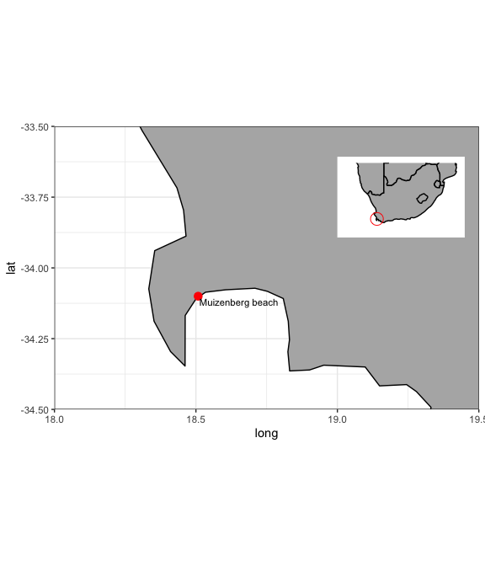

Site map showing the location of the study site, Muizenberg beach. ***find high res map***

The study was conducted at Muizenberg Beach (34.0899°S, 18. 4959°E) in an area where kelp wrack is not cleared by the City of Cape Town (CoCT) beach cleaning teams (Figure 2). This site has no adjacent kelps beds to the beach but the area has been known to experience large amounts of beach-cast kelp on a regular basis.

A 10 m wide section along the beach was measured using a 10 m long rope held perpendicular to the edge of the low tide line. Two people, each holding one end of the rope, then proceeded to walk along the strip for a distance of 250 m along the beach parallel to the low tide line (Figure 3).



Set-up of area sampled at Muizenberg Beach.

## Beach-cast recordings

Every kelp that was found within this 250 m long x 10 m wide strip was counted and various morphological charateristics were measured and recorded. These morphological characteristics included holdfast presence or absence, diameter of holdfast, stipe length, and longest frond length. Additionally, each kelp was numbered and if more than one individual was present on the same holdfast (*i.e.* aggregates) and recorded with an associated number. For example, if three individuals share a holdfast, it was recorded as 1.1, 1.2, and 1.3. Stipe and frond length were measured and recorded for each kelp individual in the aggregate, provided the stipe length was at least 10cm long.

Since wave climate may have varied seasonally, this method was repeated weekly over the period from 2018-03-24 to 2018-09-30. We separated seasons as summer (December-February), autumn (March-May), winter (June-August), and spring (September-November). Thus, our study period took place from autumn until the begining of spring. Consequently, no samples were collected in summer months. This study period extending across several seasons allowed for temporal comparison of morphological characteristics amongst beach-cast kelp over a varying wave climate.

## Wave climate

Wave data at a latitude 34.50000°S and a longitude of 18.50000°E were obtained from Dr. Christo Rautenbach of the South African Weather Service (SAWS). These ocean wave hindcasts were derived from the National Centers for Environmental Prediction (NCEP) wind/wave data (Kalnay et al. 1996) feeding into the WaveWatch III wave model (Tolman 1991). We obtained data from 2012-01-01 to 2018-08-01. Over this time, data were present daily at a three-hourly resolution. Specific wave parameters were measured, namely, primary wave mean period (s), significant height of combined wind, waves, and swell (m), primary wave direction (TNorth) and accompanying wind components, namely, wave direction () and wind speed (). Subsequent analyses were performed on the aforementioned parameters.

## Statistical analysis

### *Time series*

All exploratory and statistical analyses were performed in R 3.5.1 (R Core Team 2018). The data and comprehensive script used for setting up the data correctly, data analyses, and production of figures are to be found at <https://github.com/carlinlandsberg/honours>.

Due to the nature of the resolution of the wave data, the data had to be converted to circular data in order to have one data reading per day instead of in three hour intervals. We plotted wave period, significant wave height, wave direction, wind direction, and wind speed for each day across the time series of our study period of 2018-03-24 to 2018-09-30, including a week prior to the beginning of this period. Following this, we overlayed the beach-cast data that were collected, namely, the total number of casts, mean holdfast diameter, and mean stipe and frond length were plotted on days of data collection (*i.e.* weekly) over the total time series.

### *Yearly seasonal comparison*

In addition to the time series, we explored the previous two years, namely, 2016 and 2017 in an attempt to determine if any significant seasonal changes in wave climate exists in 2018 in comparison to 2016 and 2017. Over these three years, dates corresponding with that of the study period in 2018 were separated into their respective seasons as previously discussed. A two-way ANOVA was then performed to statistically determine if significant differences exist among seasons each year. Hereafter, a TukeyHSD *post-hoc* test was performed to determine where these significant differences exist.

# Results

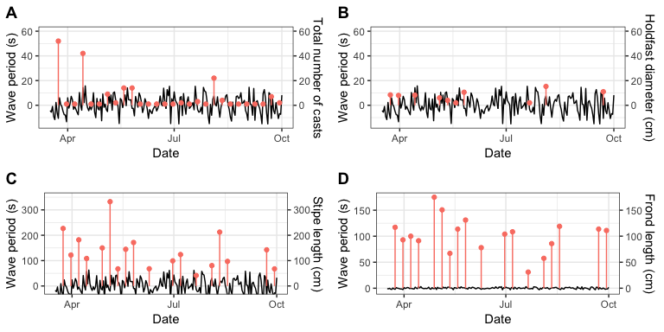

Time series of primary wave mean period (s) over the study period with corresponding weekly beach-cast recordings. **A** shows the total number of casts, **B** is the mean holdfast diameter, **C** is mean stipe length, and **D** is mean frond length. ***fix y axis scale***

No clear pattern exists between peaks and dips in peak wave period (Figure 3). Beach-cast observations and the accompanying morphometric measurments appear to fluctuate in random fashion over the study period.

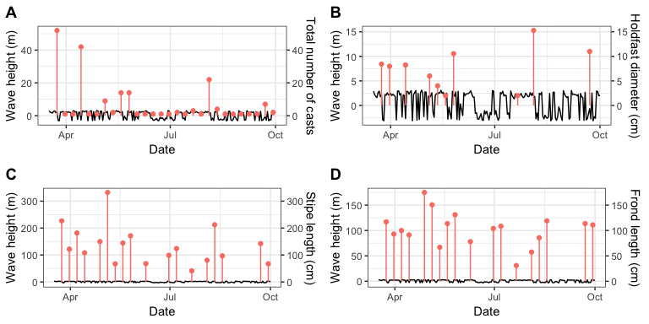

Time series of significant height of combined wind, waves, and swell (m) over the study period with corresponding weekly beach-cast recordings. **A** shows the total number of casts, **B** is the mean holdfast diameter, **C** is mean stipe length, and **D** is mean frond length. ***fix y axis scale***

A similar seemingly random pattern is observed in Figure 4 when looking at period 2 over the study period.

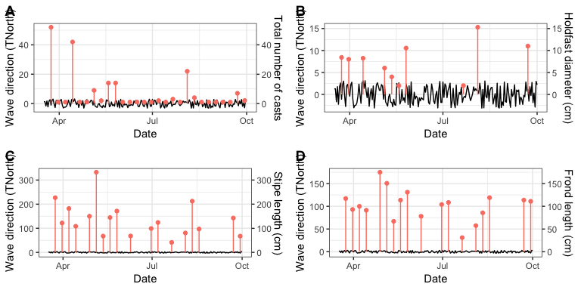

Time series of primary wave direction () over the study period with corresponding weekly beach-cast recordings. **A** shows the total number of casts, **B** is the mean holdfast diameter, **C** is mean stipe length, and **D** is mean frond length. ***fix y axis scale***

Lastly, in Figure 5, no clear pattern is observed as also suggested in Figure 3 and Figure 4.

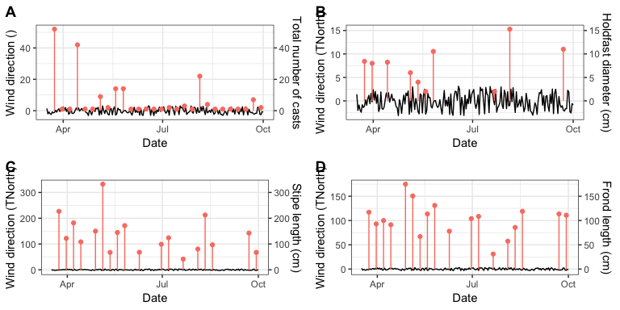

Time series of wind direction () over the study period with corresponding weekly beach-cast recordings. **A** shows the total number of casts, **B** is the mean holdfast diameter, **C** is mean stipe length, and **D** is mean frond length. ***fix y axis scale***

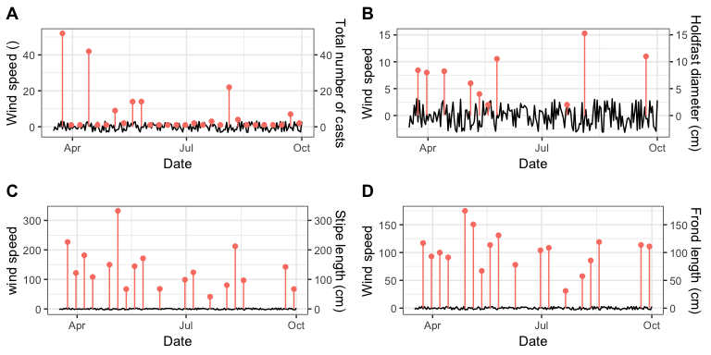

Time series of wind speed () over the study period with corresponding weekly beach-cast recordings. **A** shows the total number of casts, **B** is the mean holdfast diameter, **C** is mean stipe length, and **D** is mean frond length. ***fix y axis scale***

For the wind components, direction (Figure 6) and speed (Figure 7), seemingly similar patterns are suggested as observed in the wave parameters.

Our hypotheses suggest that, simply put, where peaks in wave parameters occur we would expect a surplus of casts and larger morphological properties. However, figures 3, 4, 5, 6, and 7 do not supoort this notion and therefore, it can be suggested that overall, the number of casts and morphological properties of casts seem as if they are not dictated by the various wave parameters included in this analysis.

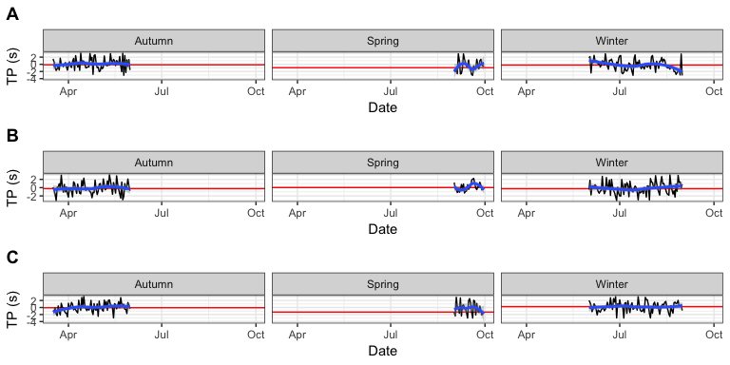

Comparison of peak period (s) across seasons in 2016 (**A**) and 2017 (**B**) corresponding to 2018 sampling period (**C**). The red line indicates the mean peak period per season.

A two-way ANOVA and TukeyHSD *post-hoc* test indicates no significant difference in primary wave mean period between seasons and between years (*P* = 0.310 and 0.795, respectively.). These statistical tests support what is observed on Figure 8 as the red mean line does not differ much per season and per year.

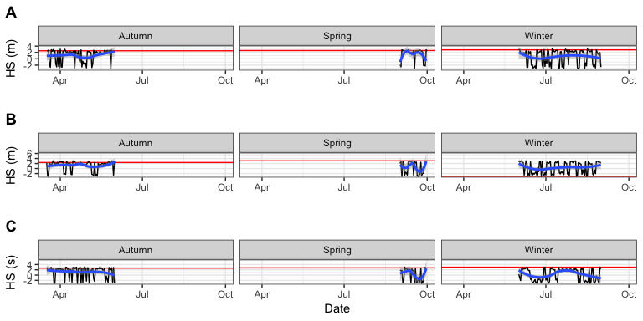

Comparison of significant wave height (m) across seasons in 2016 (**A**) and 2017 (**B**) corresponding to 2018 sampling period (**C**). The red line indicates the mean significant wave height per season.

A similar observation is made in Figure 9 where the two-way ANOVA and TukeyHSD *post-hoc* test indicates no significant difference in significant height of combined wind, waves, and swell between seasons and between years (*P* = 0.527 and 0.480, respectively.). In the winter panel in **B**, the mean red line is a lot lower than autumn and spring in 2017 and lower than winter 2016 and winter 2018. However, the aforementioned statistical tests confirm that this observed difference is negligible.

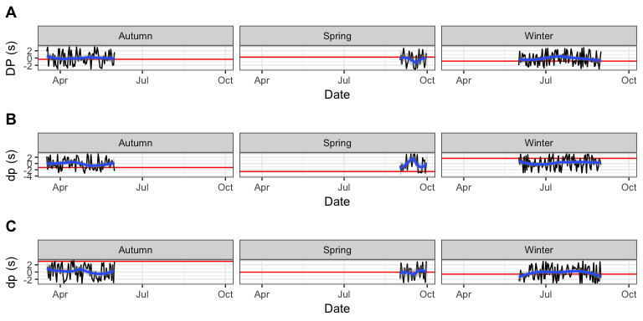

Comparison of primary wave direction () across seasons in 2016 (**A**) and 2017 (**B**) corresponding to 2018 sampling period (**C**). The red line indicates the mean primary wave direction per season.

In Figure 10, primary wave direction shows variability in means across seasons and years. The two-way ANOVA and TukeyHSD *post-hoc* test, however, indicated no significant differences between seasons and between years (*P* = 0.747 and 0.643, respectively). Therefore, observed variability can be ignored.

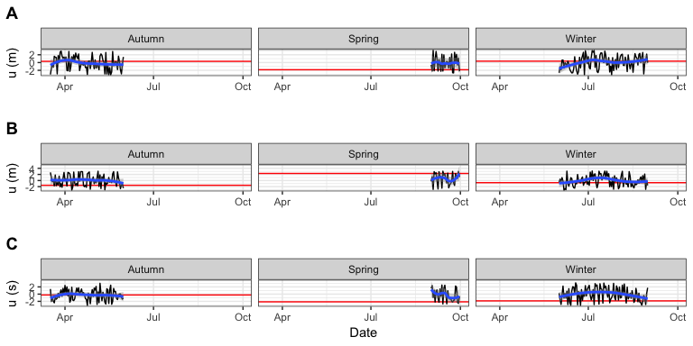

Comparison of wind direction () across seasons in 2016 (**A**) and 2017 (**B**) corresponding to 2018 sampling period (**C**). The red line indicates the mean wind direction per season.

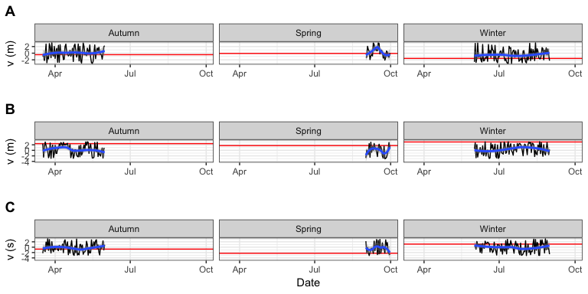

Comparison of wind speed () across seasons in 2016 (**A**) and 2017 (**B**) corresponding to 2018 sampling period (**C**). The red line indicates the mean wind speed per season.

Similarily for wind components, variability is observed at mean wind direction (Figure 11) and mean wind speed (Figure 12), but the ANOVA and TukeyHSD *post-hoc* test have shown that all differences observed between seasons (*P* = 0.985 (wave direction) and 0.6022 (wave speed)) and between years (*P* = 0.648 (wave direction) and 0.0632 (wave speed)) are not significant and, therefore, negligible.

# Discussion

The aim of this study was to determine if, when, and how beach-cast kelp differs in composition over months spanning across seasons. Our results, however, do not concur with our expected outcomes and thus our hypotheses can be rejected. Our results showed that weekly kelp depositions varied and this is because initailly, a large number of kelp was deposited onto he beach and hereafter, much fewer kelp were observed on the beach. This result was not only insignifcant but was the opposite of our expected outcome as very few and in several cases, no kelp was observed even in the peak of winter (typically August).

## Number of beach-cast kelp

de Bettignies et al. (2015) has mapped out several theories explaining scenarios of kelp dislodgement and deposition with our results displaying elements from each of these theories. The first of which is referred to as “first-flush” scenario. This theory states that throughout autumn, kelp forests are under stress by the forces brought about waves acting on them. After being exposed to these forces for an extended period of time, the weakly attached kelp eventually break off or dislodge at an event when wave action may be more pronounced (*i.e.* the first major storm following mild summer conditions). As a result, a large number of kelp are then transported from their source population and are deposited onto beaches or drift into the deep ocean leaving strongly attached individuals *in situ* which are able to withstand subsequent storm events. Another theory described in this study is that of constant flushing where kelp deposits onto beaches tend to be low in number and constant temporally. This would be as a result of kelps holdfast-substrate attachment being strong enough to withstand harsh storm wave climates. This theory is supported by figures 4A, 5A, and 6A showing a constant low number of kelp throughout the study period with exception of a few points where pulses of kelp were deposited which, in turn, is in accordance with the final theory that kelp deposits occur in pulses following storm events. The first (first-flush) and final (pulsed) scenarios have been hypothesised to occur in winter when storms are more frequent and often severe – which is what our initial hypothesis was built on. Our results displaying elements from each theory speaks to the complex varaiablity of wrack dynamics and it can be suggested that a number of additional factors may also add to this variability (Barreiro et al. 2011, Dugan et al. 2003, Orr et al. 2005).

For example, adding to the first flush and pulsed scenarios, it has also been observed that abrasions and grazing on kelp result in weakening of the individual, which makes them more susceptible to breakage and dislodgement during storm events (de Bettignies et al. 2012, Koehl and Wainwright 1977). Additionally, kelp that are older may have the ability to resist wave action in summer but at a storm event, are too weak or deteriorated to remain attached to their substrate (Mach et al. 2007, 2011). Studies on kelp such as *Ecklonia radiata* have shown that they may undergo seasonal changes whereby their biomass is decreased by low growth and erosion (de Bettignies et al. *2013*) as a means to reduce hydrodynamic drag and hence, making them less susceptible to dislodgement during storm events (de Bettignies et al. 2012, 2015).

Following breakage or dislodgement, the kelp either drift offshore or are deposited onto beaches (Barreiro et al. 2011, Kirkman and Kendrick 1997). Therefore, kelp with buoyancy properties such as prevalent pneumatocysts are assisted in drifting, often across a large area from their *in situ* population to their final deposition point (Barreiro et al. 2011, Orr et al. 2005). Additionally, wave exposure also plays a role in beach cast kelp variability. Previous studies have shown that kelp wrack quantities are higher at wave-sheltered sites in comparison to wave-exposed sites (Barreiro et al. 2011, Orr et al. 2005). Muizenberg beach is a sheltered beach and is known to receive a lot of kelp deposits. This phenomenon may be as a result of a reduction in the flow of water at bays or beaches (Barreiro et al. 2011, Witman et al. 2004). This low wave energy experienced at the beach front casues this reduction in waterflow which creates conditions which are more conducive to deposition of kelp (Whitman et al. 2004). Therefore, all aforementioned factors and their interactions may add to the complex variability in wrack quantities and should be taken into account in further studies and monitoring of beach casts.

## Morphometric properties

The morphometric properties observed in this study do not support our hypotheses. There was no clear pattern of larger kelp being deposited in winter. Mean stipe sizes were generally quite similar in length with only three observed points being over 200cm, one of which was over 300cm. A similar observation was made with mean frond length with points being generally variable but not drastically fluctuating throughout the study period, with only two points reaching over 150cm. *Ecklonia maxima* stipes can typically grow to 15 meters in length (Stegenga et al. 1997), and studies have shown that kelp length tends to increase with increased wave exposure (Molloy and Bolton 1996, Wernberg and Thomsen 2005, Wernberg and Vanderklift 2010). The kelp we have observed had stipes that did not exceed a maximum length of 630cm may infer that the kelp that has been deposited at the study site may come from a source population that is more wave-sheltered. However, this cannot be stated with certainty as longer kelps may still be *in situ* where their increased length may aid in them being able to withstand wave stressors. This increased length and flexibility, an adaptation to wave exposure, allows the kelp to ‘go with the flow’ by reducing hydrodynamic forces (Denny et al. 1998, Friedland and Denny 1995, Koehl 1999). It can thus be argued that the large kelp we expected to see washing up in winter may have been well enough adapted to their environment so as to not be dislodged except in extreme events such as during storms.

A large proportion of the observed beach cast kelp had no holdfasts attatched and thus were broken anywhere along the stipe or at the stipe-holdfast junction. a smaller proportion of the total observed kelp were dislodged completely with their holdfasts in tact, indicating stronger wave action leading to their dislodgement. ***fix holdfast figure and data*** Holdfast lengths increased as number of aggregates increased as to support multiple individuals sharing a single holdfast. These aggregations with their subsequent large holdfasts have been shown to withstand harsh wave conditions (Koehl et al. 2008, Wernberg and Vanderklift 2010), therefore, when we observed these aggregates being deposited onto the beach, we could infer that very harsh wave conditions may have dislodged them.

Holdfasts play a major role in kelp mechanics as this is the only point where the kelp is attached to a substratum and therefore they are adapted in response to the degree of wave exposure (Bekkby et al. 2014). Kelp growing in wave-exposed areas tend to have larger holdfasts and are, hence, stronger and more likely to withstand harsh wave climates. However, over time, holdfasts do tend to weaken with age or may be grazed upon (de Bettignies et al. 2012, 2015) and may, in accordance to the ‘first flush’ theory be dislodged at the first severe storm of the season (de Bettignies et al 2014). Consequently, the impact of grazers and age on deterioration of attachment strength as well as how the reef substartum becomes brittle over time should also be taken into account. Therefore, size of wrack holdfasts is not the only indicator of wave-driven dislodgement and *in situ* properties of kelp also has to be investigated.

Over the smapling period, we came across a number of aggregations, all varying in the number of stipes emerging from one holdfast. These aggregations and close proximities are known to be beneficial as it protects kelp from grazing (Velimirov and Griffiths 1979), and harsh hyrdodynamic environments which could cause mortality by dislodgement (Johnson 2001). Due to the closeness of thalli in aggregates, this morphology may reduce hydrodynamic drag and in turn, allow kelp to withstand strong wave activity and prevent breakage or dislodgment (Wernberg 2005). It has been found that as wave exposure increases, frequency of aggregates increase. This could be due to either higher recruitment and formation rates or decreased mortality. Although it wa snot looked at in this study, Wernberg (2005) has found that individuals in aggregations are more slender than solitary individuals and this morphological property is associated with reduced drag and hence, lower chance of wave-driven morpholgy. Furthermore, attachment force was found to be higher in aggregates than in solitary individuals. Therefore, we suggest that we did not come across very many aggregates deposited on the beach due to their resilience against harsh wave activity and at points where we observed a larger number of aggregates, it may have followed a period of peak wave activity such as a storm event.

## Yearly seasonal variation

Our results have shown no statistically significant differences in wind or wave parameters between seasons or between the years 2016-2018. We can thus infer that no drastic changes in wave and wind factors have ocurred over the past three years which in turn should suggest to us that the composition of beach cast kelp quantified this year should not be very different to the previous years observed. Additionally, no significance in wind and wave parameters between seasons was established and our hypotheses may therefore be discounted. This is because no differences in wave or wind parameters were observed between seasons, hence factors driving kelp dislodgement and transport were not more pronounced in winter months in comparion to others. Therefore, our constant low, and somewhat stochastic, observations of kelp deposition is supported by this result.

## Implications and suggestions for further research

Beach-cast kelp has been known to be of high importance to sandy beach ecosystems which relies on allochthonus subsidies of matter to sustain organisms living in this otherwise harsh environment (Barreriro et al. 2011). Additionally, beach casts are also harvested and used as a primary products and therefore have socioeconomic importance (Kirkman and Kendrick 1997). Therefore, monitoring of these beach casts should be of value as any changes in the wrack deposition could have a range of knock-on effects. Additionally, the environmental factors that play a role in dislodgement and transport of kelp should also be monitored especially in the wake of global climate change (*e.g* sea-level rise, increased storms) to determine how this will affect ecosystems that are reliant on wrack subsidies. We suggest that yearly seasonal comparisons be carried out over a large number of years to ensure statistical strength and to take into account changes in these abiotic factors that may have occurred over long periods of time.

In conclusion, this study has provided a glimpse into what can be expected from kelp wracks regarding seasonality. However, as mentioned previously, a myriad of factors and their interactions should be considered when observing patterns of dislodgement and deposition of kelp. Therefore, it is suggested that a similar study should be carried out at a spatiotemporal scale. This should be done at a number of sites of varying wave exposures and over a longer period of time, possibly over several years, to compare seasonal data. A number of additional morphometrics should be looked at such as biomass, blade type, and presence of wounds.

# References

1. Barreiro F, G??mez M, Lastra M, L??pez J, De la Huz R. 2011. Annual cycle of wrack supply to sandy beaches: effect of the physical environment. *Marine Ecology Progress Series* 433: 65–74.
2. Bekkby T, Rinde E, Gundersen H, Norderhaug K, Gitmark J, Christie H. 2014. Length, strength and water flow: relative importance of wave and current exposure on morphology in kelp *Laminaria hyperborea*. *Marine Ecology Progress Series* 506: 61–70.
3. Blanchette CA, Miner BG, Gaines SD. 2002. Geographic variability in form, size and survival of *Egregia menziesii* around Point Conception, California. *Marine Ecology Progress Series*, 239: 69–82.
4. Bolton JJ, Anderson RJ, Smit AJ, Rothman MD. 2012. South African kelp moving eastwards: the discovery of *Ecklonia maxima* (Osbeck) Papenfuss at De Hoop Nature Reserve on the south coast of South Africa. *African Journal of Marine Science* 34: 147–151.
5. Buck BH, Buchholz CM. 2005. Response of offshore cultivated *Laminaria saccharina* to hydrodynamic forcing in the North Sea. *Aquaculture* 250: 674–691.
6. Bustamante RH, Branch GM, Eekhout S. 1995. Maintenance of an exceptional intertidal grazer biomass in South Africa: subsidy by subtidal kelps. *Ecology* 76: 2314–2329.
7. Bustamante RH, Branch GM. 1996. The dependence of intertidal consumers on kelp-derived organic matter on the west coast of South Africa. *Journal of Experimental Marine Biology and Ecology* 196: 1–28.
8. Cheshire AC, Hallam ND. 1988. Biomass and density of native stands of *Durvillaea potatorum* (southern bull-kelp) in south eastern Australia. *Marine Ecology Progress Series. Oldendorf* 48: 277–283.
9. Colombini I, Chelazzi L. 2003. Influence of marine allochthonous input on sandy beach communities. *Oceanography and Marine Biology*, an Annual Review 41: 115–159.
10. de Bettignies T, Thomsen MS, Wernberg T. 2012. Wounded kelps: patterns and susceptibility to breakage. *Aquatic Biology* 17: 223–233.
11. de Bettignies T, Wernberg T, Lavery P, Vanderklift M, Gunson J, Symonds G, Collier N. 2015. Phenological decoupling of mortality from wave forcing in kelp beds. *Ecology* 96: 850–861.
12. de Bettignies T, Wernberg T, Lavery PS, Vanderklift MA, Mohring M. 2013. Contrasting mechanisms of dislodgement and erosion contribute to production of kelp detritus. *Limnology and Oceanography* 58: 1680–1688.
13. Denny MW, Gylord BP, Cowen EA. 1997. Flow and flexibility. II. The roles of size and shape in determining wave forces on the bull kelp *Nereocystis luetkeana*. *Journal of Experimental Biology* 200: 3165–3183.
14. Denny MW, Gaylord BP, Helmuth B, Daniel T. 1998. The menace of momentum: dynamic forces on flexible organisms. *Limnology and Oceanography* 43: 955–968
15. Dugan JE, Hubbard DM, McCrary MD, Pierson MO. 2003. The response of macrofauna communities and shorebirds to macrophyte wrack subsidies on exposed sandy beaches of southern California. *Estuarine, Coastal and Shelf Science* 58: 25–40.
16. Dugan JE, Hubbard DM, Page HM, Schimel JP. 2011. Marine macrophyte wrack inputs and dissolved nutrients in beach sands. *Estuaries and Coasts* 34: 839–850.
17. Field J, Griffiths C, Linley E, Carter R, Zoutendyk P. 1977. Upwelling in a nearshore marine ecosystem and its biological implications. *Estuarine and Coastal Marine Science* 11: 133–150.
18. Filbee-Dexter K, Scheibling RE. 2014. Sea urchin barrens as alternative stable states of collapsed kelp ecosystems. *Marine Ecology Progress Series* 495: 1–25.
19. Fowler-Walker MJ, Wernberg T, Connell SD. 2006. Differences in kelp morphology between wave sheltered and exposed localities: morphologically plastic or fixed traits?. *Marine Biology* 148: 755–767.
20. Friedland MT, Denny MW. 1995. Surviving hydrodynamic forces in a wave-swept environment: consequences of morphology in the feather boa kelp, *Egregia menziesii* (Turner). *Journal of Experimental Marine Biology and Ecology* 190: 109–133.
21. Graham MH, Harrold C, Lisin S, Light K, Watanabe JM, Foster MS. 1997. Population dynamics of giant kelp *Macrocystis pyrifera* along a wave exposure gradient. *Marine Ecology Progress Series* 148: 269–279.
22. Haring R, Carpenter R. 2007. Habitat-induced morphological variation influences photosynthesis and drag on the marine macroalga *Pachydictyon coriaceum*. *Marine Biology* 151: 243–255.
23. Jackelman JJ, Bolton JJ. 1990. Form variation and productivity of an intertidal foliose Gigartina species (Rhodophyta) in relation to wave exposure. *Hydrobiologia* 204: 57–64.
24. Johnson AS. 2001. Drag, drafting, and mechanical interactions in canopies of the red alga *Chondrus crispus*. *The Biological Bulletin* 201: 126–135.
25. Jones A, Gladstone W, Hacking N. 2004. Sandy-beach ecosystems and climate change: potential ecological consequences and management implications. In Coast to Coast Conference, Hobart, Tasmania, CRC.
26. Kalnay E, Kanamitsu M, Kistler R, Collins W, Deaven D, Gandin L, Iredell M, Saha S, White G, Woollen J, Zhu Y. 1996. The NCEP/NCAR 40-year reanalysis project. *Bulletin of the American Meteorological Society* 77: 437–472.
27. Kawamata S. 2001. Adaptive mechanical tolerance and dislodgement velocity of the kelp *Laminaria japonica* in wave-induced water motion. *Marine Ecology Progress Series* 211: 89–104.
28. Kirkman H, Kendrick G. 1997. Ecological significance and commercial harvesting of drifting and beach-cast macro-algae and seagrasses in Australia: a review. *Journal of Applied Phycology* 9: 311–326.
29. Klosinski J. 2015. Deposition, persistence, and utilization of kelp wrack along the central California coast. Masters. California State University, Monterey Bay.
30. Koehl MAR. 1999. Ecological biomechanics of benthic organisms: life history, mechanical design and temporal patterns of mechanical stress. *Journal of Experimental Biology* 202: 3469–3476.
31. Koehl MAR, Alberte RS. 1988. Flow, flapping, and photosynthesis of *Nereocystis leutkeana*: a functional comparison of undulate and flat blade morphologies. *Marine Biology* 99: 435–444.
32. Koehl MAR, Silk WK, Liang H, Mahadevan L. 2008. How kelp produce blade shapes suited to different flow regimes: a new wrinkle. *Integrative and Comparative Biology* 48: 834–851.
33. Koehl MAR, Wainwright SA. 1977. Mechanical adaptations of a giant kelp. *Limnology and Oceanography* 22: 1067–1071.
34. Koop K, Field JG. 1980. The influence of food availability on population dynamics of a supralittoral isopod, *Ligia dilatata* Brandt. *Journal of Experimental Marine Biology and Ecology* 48: 61–72.
35. Koop K, Griffiths CL. 1982 The relative significance of bacteria, meio- and macrofauna on an exposed sandy beach. *Marine Biology* 66: 295–300.
36. Koop K, Newell RC, Lucas MI. 1982. Biodegradation and carbon flow based on kelp (*Ecklonia maxima*) debris in a sandy beach microcosm. *Marine Ecology Progress Series* 7: 315–326.
37. Kotwicki L, Weslawski JM, Raczynska A, Kupiec A. 2005. Deposition of large organic particles (macrodetritus) in a sandy beach system (Puck Bay, Baltic Sea). *Oceanologia* 47: 181–199.
38. Krumhansl KA, Scheibling RE. 2012. Production and fate of kelp detritus. *Marine Ecology Progress Series* 467: 281–302.
39. Lemm AJ, Hegge BJ, Masselink G. 1999. Offshore wave climate, Perth (Western Australia), 1994–1996. *Marine and Freshwater Research* 50: 95–102.
40. Mach KJ, Hale BB, Denny MW, Nelson DV. 2007. Death by small forces: a fracture and fatigue analysis of wave-swept macroalgae. *Journal of Experimental Biology* 210: 2231–2243.
41. Mach KJ, Tepler SK, Staaf AV, Bohnhoff JC, Denny MW. 2011. Failure by fatigue in the field: a model of fatigue breakage for the macroalga Mazzaella, with validation. *Journal of Experimental Biology* 214: 1571–1585.
42. Mateo MA. 2010 Beach-cast *Cymodocea nodosa* along the shore of a semienclosed bay: sampling and elements to assess its ecological implications. *Journal of Coastal Research* 26: 283–291.
43. Molloy FJ, Bolton JJ. 1996. The effects of wave exposure and depth on the morphology of inshore populations of the Namibian kelp, *Laminaria schinzii* Foslie. *Botanica Marina* 39: 525–532.
44. Ochieng CA, Erftemeijer PL. 1999. Accumulation of seagrass beach cast along the Kenyan coast: a quantitative assessment. *Aquatic Botany* 65: 221–238.
45. Orr M, Zimmer M, Jelinski DE, Mews M. 2005. Wrack deposition on different beach types: spatial and temporal variation in the pattern of subsidy. *Ecology* 86: 1496–1507.
46. Piriz ML, Eyras MC, Rostagno CM. 2003. Changes in biomass and botanical composition of beach-cast seaweeds in a disturbed coastal area from Argentine Patagonia. *Journal of Applied Phycology* 15: 67–74.
47. R Core Team (2018). R: A language and environment for statistical computing. R Foundation for Statistical Computing, Vienna, Austria. URL <https://www.R-project.org/>.
48. Roberson LM, Coyer JA. 2004. Variation in blade morphology of the kelp *Eisenia arborea*: incipient speciation due to local water motion? *Marine Ecology Progress Series* 282: 115–128.
49. Robertson AI, Hansen JA. 1982. Decomposing Seaweeds: A nuisance or a vital link in coastal food chains? CSIRO Marine Laboratories Research Report 75–83.
50. Seymour RJ, Tegner MJ, Dayton PK, Parnell PE. 1989. Storm wave induced mortality of giant kelp, *Macrocystis pyrifera*, in southern California. *Estuarine, Coastal and Shelf Science* 28: 277–292.
51. Smith SD. 2002. Kelp rafts in the Southern Ocean. *Global Ecology and Biogeography* 11: 67–69.
52. Soares AG, Schlacher TA, McLachlan A. 1997. Carbon and nitrogen exchange between sandy beach clams (*Donax serra*) and kelp beds in the Benguela coastal upwelling region. *Marine Biology* 127: 657–664.
53. Stegenga H, Bolton JJ, Anderson RJ. 1997. Seaweeds of the South African west coast. *Contrib. Bolus Herb* 18: 3–637.
54. Steneck R, Graham M, Bourque B, Corbett D, Erlandson J, Estes J, Tegner M. 2002. Kelp forest ecosystems: biodiversity, stability, resilience and future. *Environmental Conservation* 29: 436–459.
55. Stenton-Dozey JME, Griffiths CL. 1983. The fauna associated with kelp stranded on a sandy beach. In *Sandy beaches as ecosystems* (557–568). Springer, Dordrecht.
56. Stewart HL, Carpenter RC. 2003. The effects of morphology and water flow on photosynthesis of marine macroalgae. *Ecology* 84: 2999–3012.
57. Thomsen M, Wernberg T, Kendrick G. 2004. The effect of thallus size, life stage, aggregation, wave exposure and substratum conditions on the forces required to break or dislodge the small kelp *Ecklonia radiata*. *Botanica Marina* 47: 454–460.
58. Tolman HL. 1991. A third-generation model for wind waves on slowly varying, unsteady, and inhomogeneous depths and currents. *Journal of Physical Oceanography* 21: 782–797.
59. Vadas RL, Wright WA, Miller SL. 1990. Recruitment of *Ascophyllum nodosum*: wave action as a source of mortality. *Marine Ecology Progress Series* 61: 263-???272
60. Velimirov B, Field J, Griffiths C, Zoutendyk P. 1977. The ecology of kelp bed communities in the Benguela upwelling system. *Helgol??nder Wissenschaftliche Meeresuntersuchungen* 30: 495–518.
61. Velimirov B, Griffiths CL. 1979. Wave-induced kelp movement and its importance for community structure. *Botanica Marina* 22: 169–172.
62. Wernberg T. 2005. Holdfast aggregation in relation to morphology, age, attachment and drag for the kelp *Ecklonia radiata*. *Aquatic Botany* 82: 168–180.
63. Wernberg T, Thomsen MS. 2005. The effect of wave exposure on the morphology of *Ecklonia radiata*. *Aquatic Botany* 83: 61–70.
64. Wernberg T, Vanderklift MA. 2010. Contribution of temporal and spatial components to morphological variation in the kelp Ecklonia (Laminariales) 1. *Journal of Phycology* 46: 153–161.
65. Wheeler WN. 1988. Algal productivity and hydrodynamics – a synthesis. *Progress in Phycological Research* 6: 23–58.
66. Witman JD, Ellis JC, Anderson WB. 2004. The influence of physical processes, organisms, and permeability on cross-ecosystems fluxes. In: Polis GA, Power ME, Huxel GR (eds) *Food webs at the landscape level*. University of Chicago Press, Chicago, IL, 335–358