**DSA LAB**

**Name : Khalid Abbas**

**Reg # 2312236**

**Submitted to : Ma’am Maria Bibi**

**Section : 3D**

Source Code :

#include <iostream>

using namespace std;

struct Node {

int data;

Node* left;

Node* right;

Node(int value) {

data = value;

left = right = NULL;

}

};

Node* insert(Node* root, int value) {

if (root == NULL)

return new Node(value);

if (value < root->data)

root->left = insert(root->left, value);

else

root->right = insert(root->right, value);

return root;

}

void levelOrderTraversal(Node* root) {

if (root == NULL) return;

Node* queue[100];

int front = 0, rear = 0;

queue[rear++] = root;

while (front < rear) {

Node* current = queue[front++];

cout << current->data << " ";

if (current->left != NULL)

queue[rear++] = current->left;

if (current->right != NULL)

queue[rear++] = current->right;

}

}

int main() {

Node* root = NULL;

int values[] = {10, 8, 2, 3, 12, 13, 16};

int n = sizeof(values) / sizeof(values[0]);

for (int i = 0; i < n; i++) {

root = insert(root, values[i]);

}

cout << "Level-order traversal of the BST: ";

levelOrderTraversal(root);

return 0;

}

**Output :**

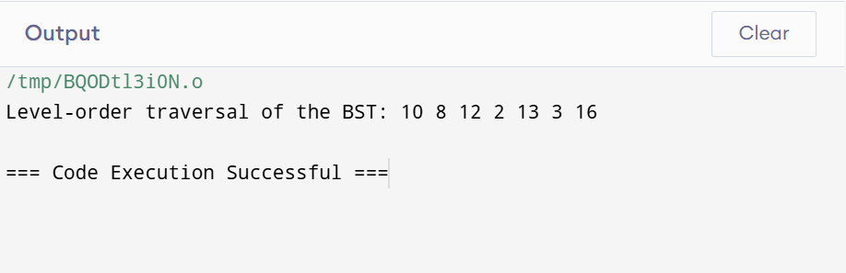

//CodeWithCarlito

//TheEnd