How to stream a pattern image with VD55G0
- Disable 2 lps DUSTER CONTROL REGISTER
DUSTER_CTRL ADDRESS: 0x0316
DUSTER_CTRL VALUE: 0x00
- Disable DARKCAL CONTROL REGISTER (Bypass Darkcal average)
DARKCAL_CTRL ADDRESS: 0x032C
DARKCAL_CTRL VALUE: 0x02
- Enable pattern PATTERN GENERATION REGISTER and select pattern type
PATGEN_CTRL ADDRESS: 0x0400
PATGEN_CTRL VALUE: 0x01 enable pat + pattern type
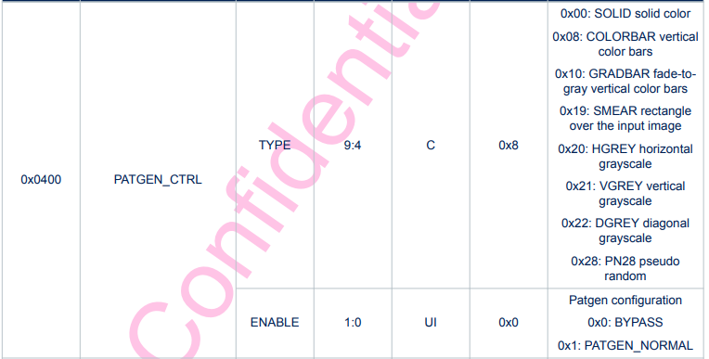
- Once the image has been transmitted, restore the default values in the registers to allow image acquisitions.
PATGEN_CTRL DEFAULT VALUE: 0x00
DUSTER_CTRL DEFAULT VALUE: 0x13
DARKCAL_CTRL DEFAULT VALUE: 0x01

