HackerEarth Practice
Problem statements and code screenshots, written in C
This document records three HackerEarth practice problems using the supplied screenshots. Problem details are transcribed only where visible; cropped or obscured portions are identified rather than reconstructed.

Contents
# | Problem | Platform | Difficulty | Submission / visible status
1 | A. Digit Sum | HackerEarth | Easy | Not shown
2 | Read from STDIN, Write to STDOUT | HackerEarth | Very Easy | Not shown
3 | Roy and Profile Picture | HackerEarth | Easy | Accepted shown

Source note: All three screenshots show the C language selected. No submission dates or problem IDs are visible in the supplied images.

1. A. Digit Sum
HackerEarth | Easy | Language: C (gcc 10.3)

Problem
Danial likes to separate out the digits of a number and play with them. This time he wants you to help him with a problem. Given an integer N, he would like you to find the sum of the first and last digits of N.
INPUT: The first line of the input contains a single integer T, denoting the number of test cases. Each of the next T lines contains a single integer N.
OUTPUT: Each line of the output contains a single integer S denoting the sum of the first and last digits of N.

Constraints
- 0 < N <= 10⁶
- 0 < T <= 100

Sample Input / Output
The sample table is cut off in the supplied screenshot. The visible portion begins with T = 3 and N = 1234; the visible output begins with 5 and 5. Remaining sample lines are not visible.

Code screenshot
The screenshot shows the C editor and part of the implementation. A path-like overlay obscures part of the for-loop line, and the lower portion of the code is outside the captured area.
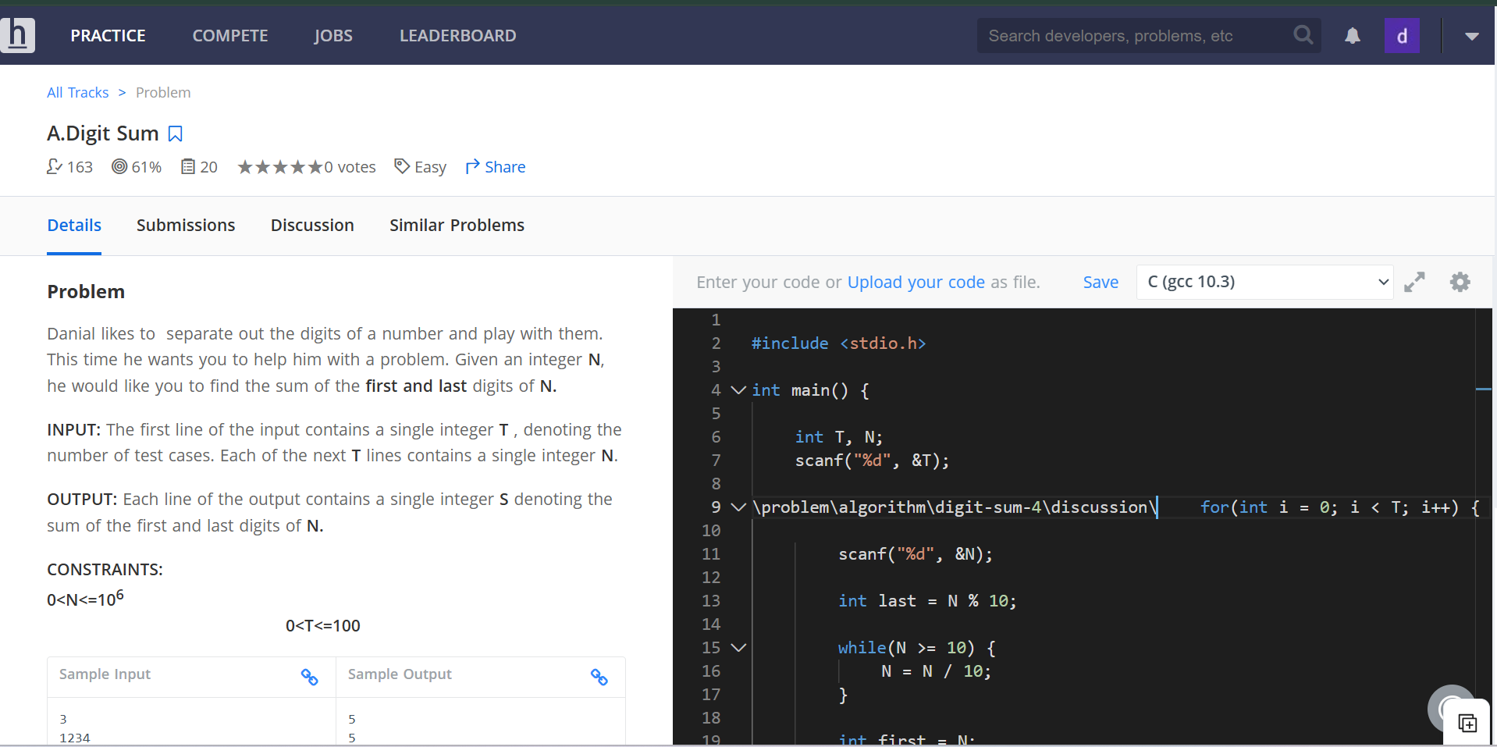
HackerEarth problem statement and C editor screenshot

2. Read from STDIN, Write to STDOUT
HackerEarth | Very Easy | Language: C

Problem
Read different types of data from standard input, process them as shown in output format and print the answer to standard output.

Input Format
- First line contains integer N.
- Second line contains string S.

Output Format
- First line should contain N x 2.
- Second line should contain the same string S.

Constraints
The constraints section is visible as a heading, but its values are below the captured area and cannot be read from the screenshot.

Code screenshot
The screenshot shows the complete visible C program: it reads an integer and a string, prints the integer multiplied by two, and then prints the same string.
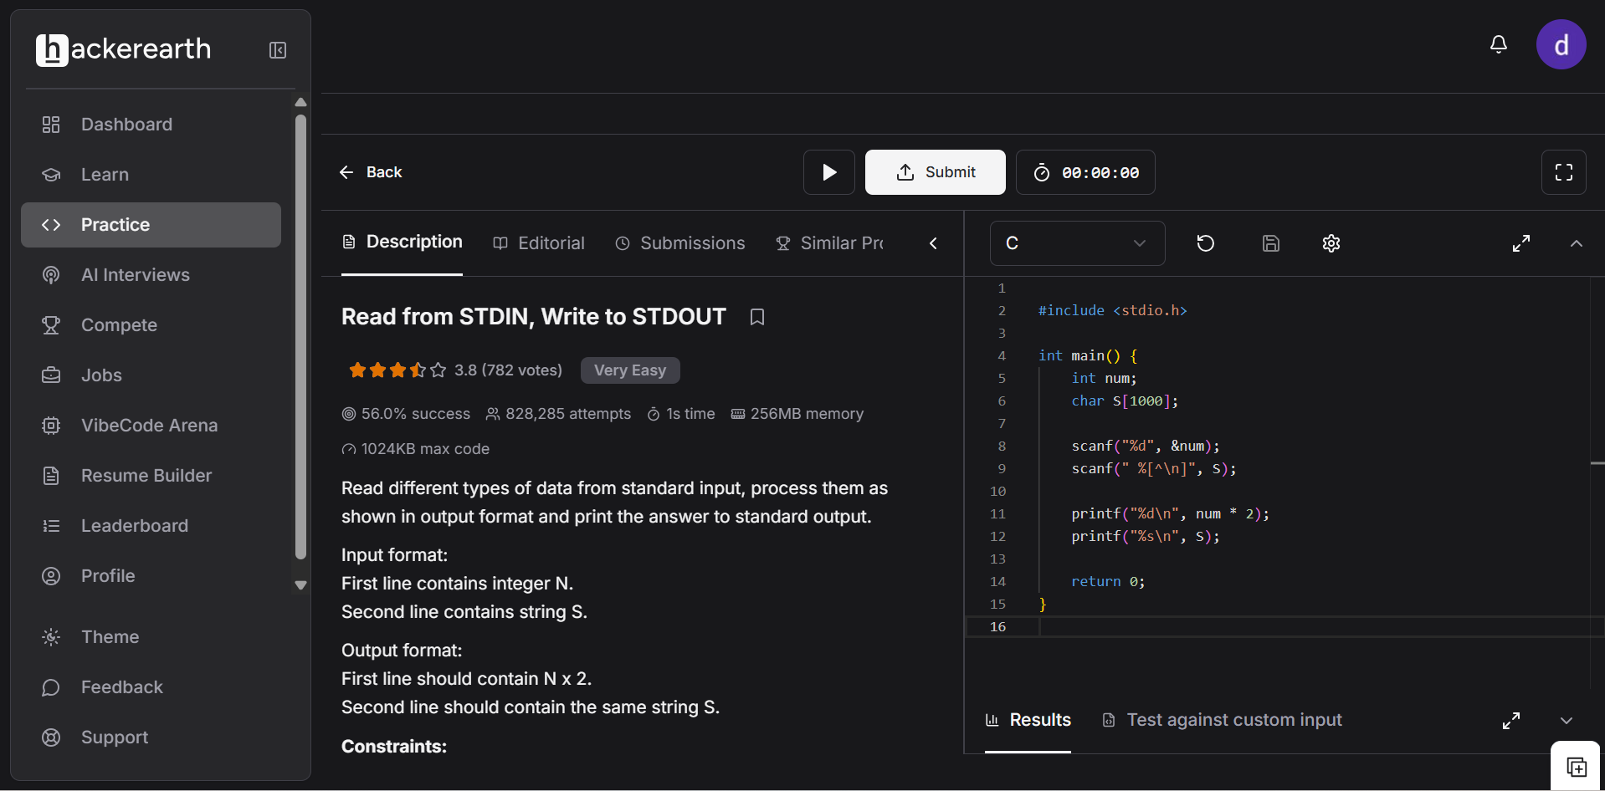
HackerEarth problem statement and C solution screenshot

3. Roy and Profile Picture
HackerEarth | Easy | Language: C | Result panel: Accepted

Problem
Roy wants to change his profile picture on Facebook. Now Facebook has some restriction over the dimension of picture that we can upload. Minimum dimension of the picture can be L x L, where L is the length of the side of square.
Now Roy has N photos of various dimensions. Dimension of a photo is denoted as W x H, where W - width of the photo and H - Height of the photo.
The screenshot is cut off after this definition, so the remaining problem statement, input/output format, examples and constraints are not visible in the supplied material.

Visible problem metadata
- Rating: 4.0 (1,867 votes)
- Success rate: 82.0%
- Attempts: 315,009
- Time limit: 1 second | Memory: 256 MB | Maximum code: 1024 KB
- Tags shown: Ad Hoc, Approved, Basic programming, Easy, Implementation, Open

Code and result screenshot
The screenshot shows the beginning of the C implementation and an Accepted result in the Results panel. The lower portion of the code is not visible.
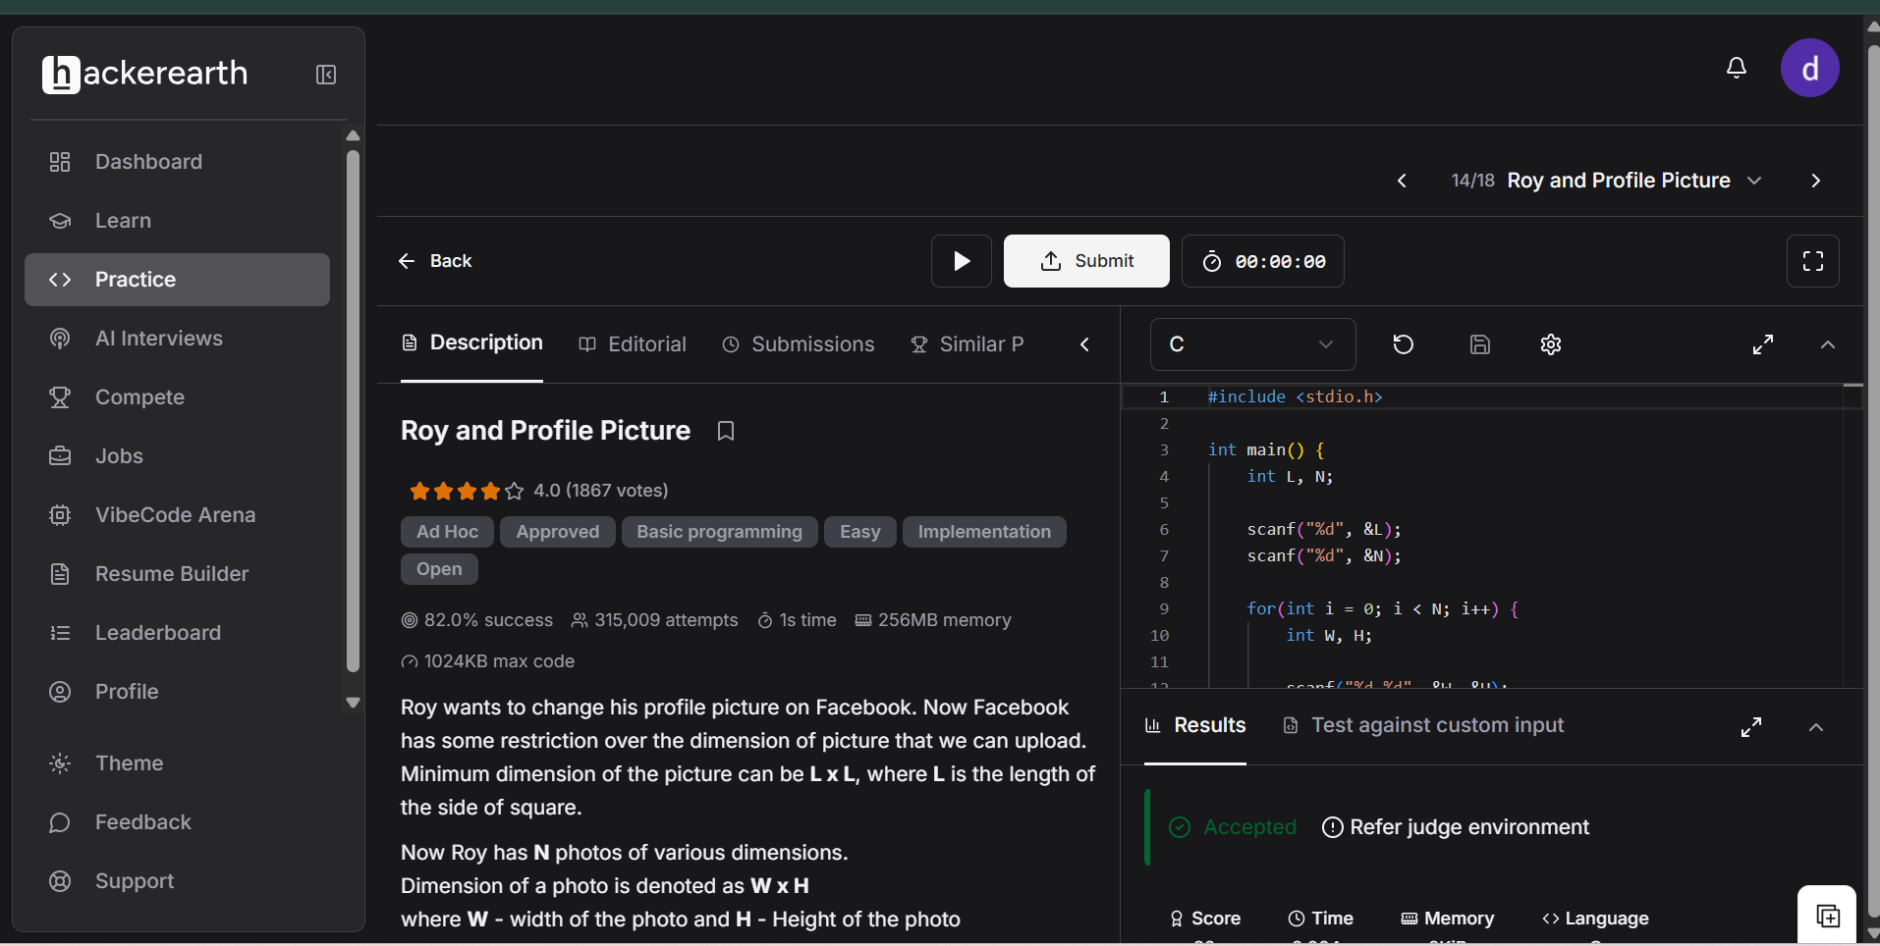
HackerEarth problem statement, code editor and Accepted result

