LeetCode Practice
Questions and accepted solutions, written in C
Each problem below has the question written out as text, followed by the screenshot of the solution. Where a question screenshot was uploaded, it sits next to the text. Problems are in the order they were solved (Nov 8 – Nov 11, 2026).

# | Problem | LeetCode | Difficulty | Submitted
1 | Add Two Integers | #2235 | Easy | Nov 8, 2026, 12:13
2 | Calculate Delayed Arrival Time | #2651 | Easy | Nov 8, 2026, 12:27
3 | Smallest Even Multiple | #2413 | Easy | Nov 8, 2026, 16:21
4 | Number of Steps to Reduce a Number to Zero | #1342 | Easy | Nov 10, 2026, 18:40
5 | Sum Multiples | #2652 | Easy | Nov 10, 2026, 22:24
6 | Subtract the Product and Sum of Digits of an Integer | #1281 | Easy | Nov 11, 2026, 14:01
7 | Count the Digits That Divide a Number | #2520 | Easy | Nov 11, 2026, 16:17
8 | Palindrome Number | #9 | Easy | Nov 11, 2026, 16:22
9 | Reverse Integer | #7 | Medium | Nov 11, 2026, 16:39
10 | Power of Two | #231 | Easy | Nov 11, 2026, 17:21
11 | Power of Three | #326 | Easy | Run on sample cases (no submission shown)
Note: statements marked “added from original problem” were not visible in the uploaded screenshots.

1. Add Two Integers
LeetCode #2235 | Easy | Language: C | Nov 8, 2026 · 12:13
Accepted · 262/262 test cases · 0 ms (beats 100.00%) · 8.42 MB (beats 74.38%)

Question
Transcribed from your question screenshot.
Given two integers num1 and num2, return the sum of the two integers.  Example 1:  Input: num1 = 12, num2 = 5  Output: 17  Explanation: num1 is 12, num2 is 5, and their sum is 12 + 5 = 17, so 17 is returned.  Example 2:  Input: num1 = -10, num2 = 4  Output: -6  Explanation: num1 + num2 = -6, so -6 is returned.  Constraints:  - -100 <= num1, num2 <= 100 | 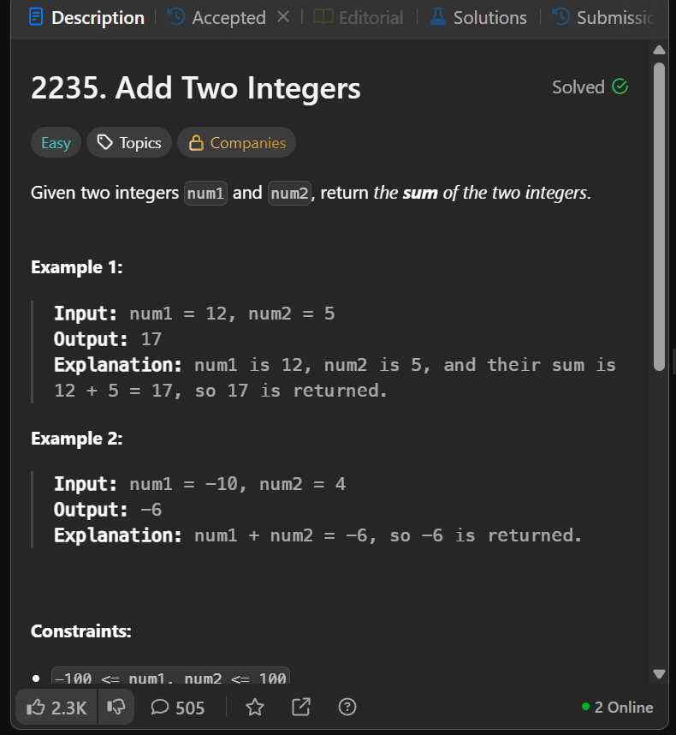  Question screenshot

Solution
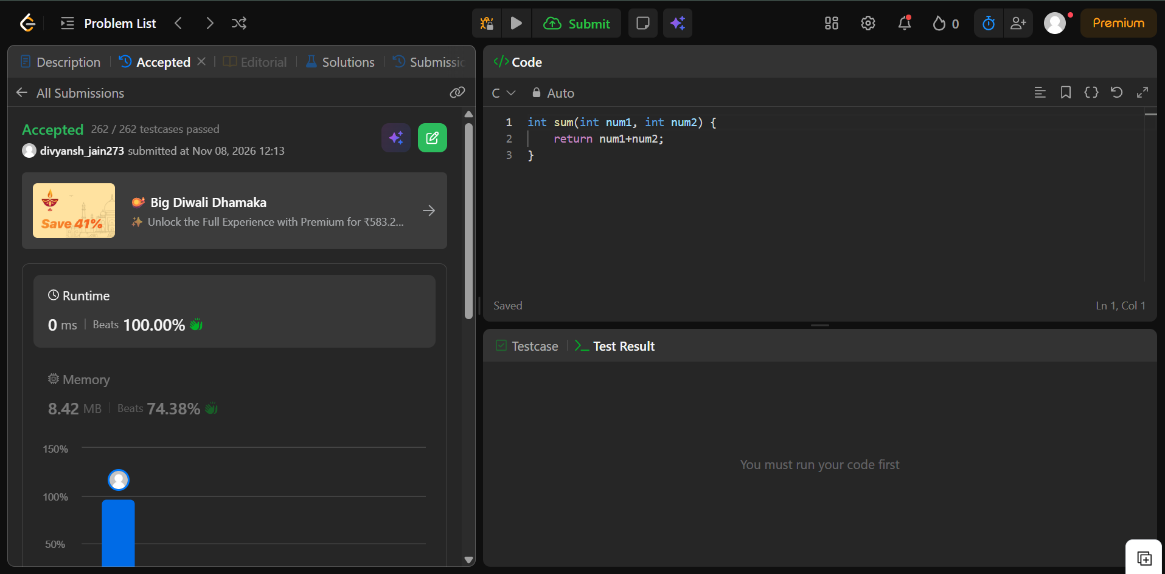

2. Calculate Delayed Arrival Time
LeetCode #2651 | Easy | Language: C | Nov 8, 2026 · 12:27
Accepted · 556/556 test cases · 0 ms (beats 100.00%) · 8.60 MB (beats 84.02%)

Question
Transcribed from your question screenshot. Example 2 and the constraints were cut off in the screenshot, so they are added from the original problem.
You are given a positive integer arrivalTime denoting the arrival time of a train in hours, and another positive integer delayedTime denoting the amount of delay in hours.  Return the time when the train will arrive at the station.  Note that the time in this problem is in 24-hours format.  Example 1:  Input: arrivalTime = 15, delayedTime = 5  Output: 20  Explanation: Arrival time of the train was 15:00 hours. It is delayed by 5 hours. Now it will reach at 15+5 = 20 (20:00 hours).  Example 2: (added from original problem)  Input: arrivalTime = 13, delayedTime = 11  Output: 0  Explanation: Arrival time of the train was 13:00 hours. It is delayed by 11 hours. Now it will reach at 13+11 = 24, which is denoted by 00:00 in 24-hours format, so 0 is returned.  Constraints: (added from original problem)  - 1 <= arrivalTime < 24  - 1 <= delayedTime <= 24 | 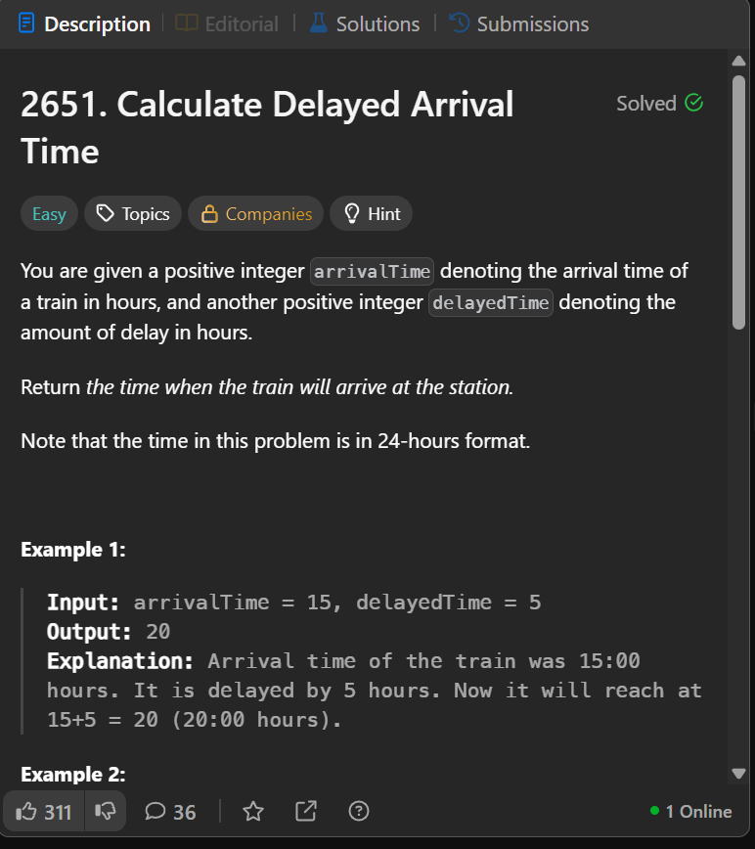  Question screenshot

Solution
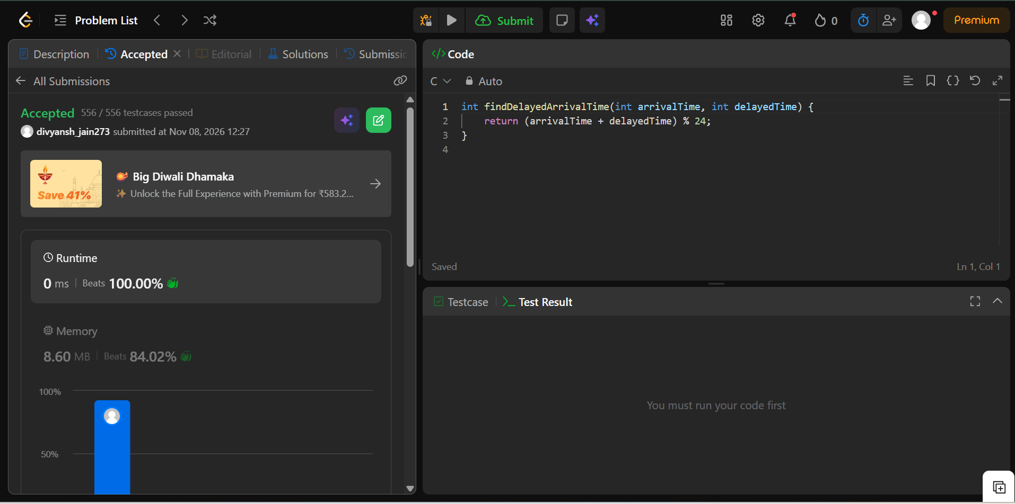

3. Smallest Even Multiple
LeetCode #2413 | Easy | Language: C | Nov 8, 2026 · 16:21
Accepted · 150/150 test cases · 0 ms (beats 100.00%) · 8.47 MB (beats 57.62%)

Question
Transcribed from your question screenshot. The constraints were cut off in the screenshot, so they are added from the original problem.
Given a positive integer n, return the smallest positive integer that is a multiple of both 2 and n.  Example 1:  Input: n = 5  Output: 10  Explanation: The smallest multiple of both 5 and 2 is 10.  Example 2:  Input: n = 6  Output: 6  Explanation: The smallest multiple of both 6 and 2 is 6. Note that a number is a multiple of itself.  Constraints: (added from original problem)  - 1 <= n <= 150 | 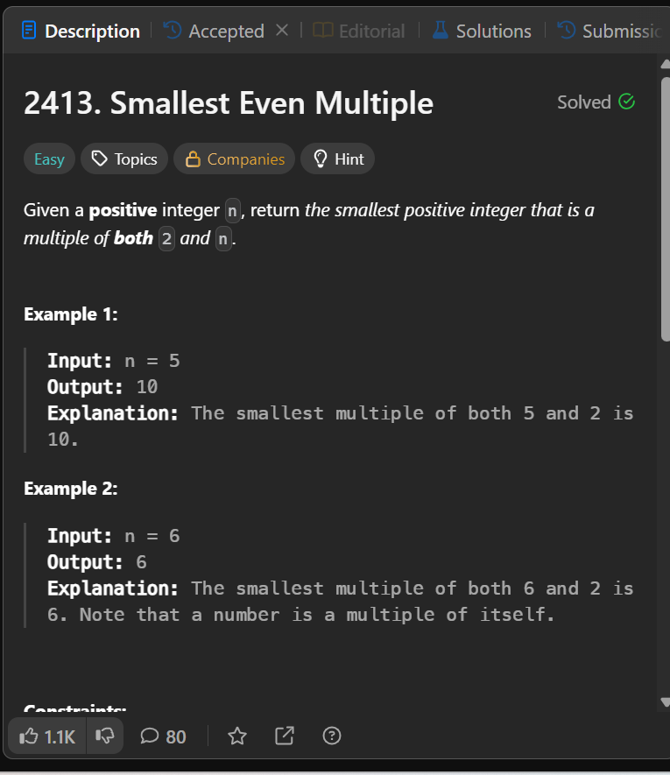  Question screenshot

Solution
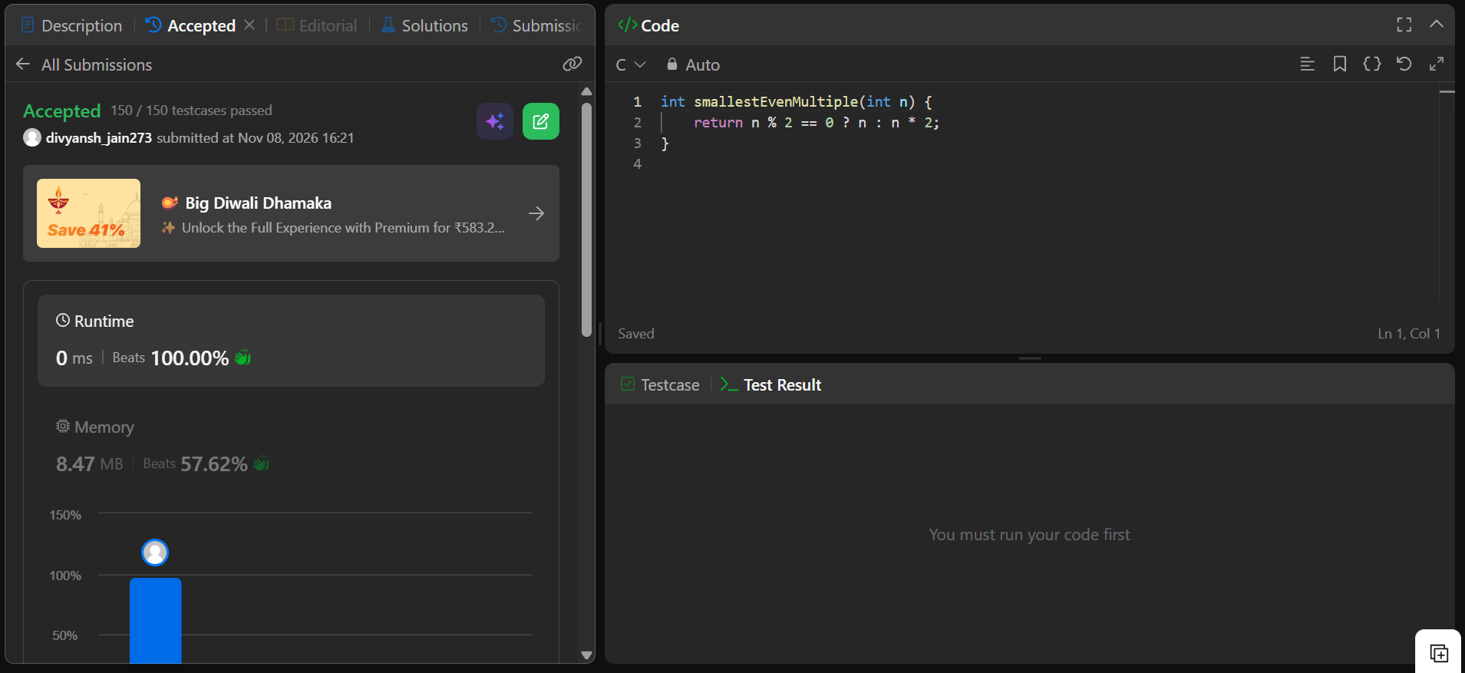

4. Number of Steps to Reduce a Number to Zero
LeetCode #1342 | Easy | Language: C | Nov 10, 2026 · 18:40
Accepted · 204/204 test cases · 0 ms (beats 100.00%) · 8.40 MB (beats 85.19%)

Question
Your screenshot shows only the solution, so the problem statement below is written out from the original LeetCode problem.
Given an integer num, return the number of steps to reduce it to zero.
In one step, if the current number is even, you have to divide it by 2, otherwise, you have to subtract 1 from it.
Example 1:
Input: num = 14
Output: 6
Explanation: 14 → 7 → 6 → 3 → 2 → 1 → 0. That is 6 steps (divide, subtract, divide, subtract, divide, subtract).
Example 2:
Input: num = 8
Output: 4
Explanation: 8 → 4 → 2 → 1 → 0.
Constraints:
- 0 <= num <= 10⁶

Solution (screenshot)
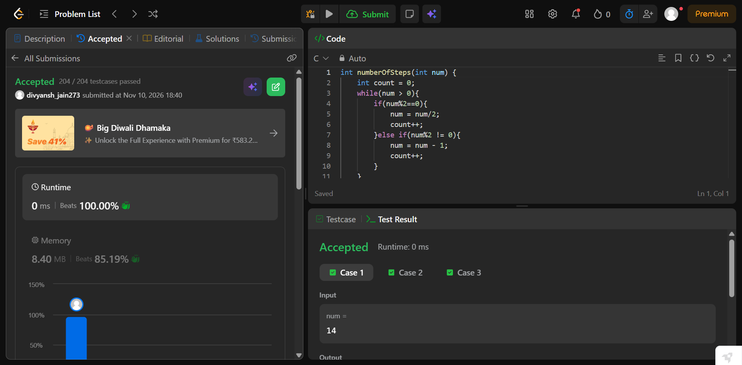

5. Sum Multiples
LeetCode #2652 | Easy | Language: C | Nov 10, 2026 · 22:24
Accepted · 1000/1000 test cases · 0 ms (beats 100.00%) · 9.14 MB (beats 53.45%)

Question
Your screenshot shows only the solution, so the problem statement below is written out from the original LeetCode problem.
Given a positive integer n, find the sum of all integers in the range [1, n] inclusive that are divisible by 3, 5, or 7.
Return an integer denoting the sum of all numbers in the given range satisfying the constraint.
Example 1:
Input: n = 7
Output: 21
Explanation: Numbers in the range [1, 7] that are divisible by 3, 5, or 7 are 3, 5, 6, 7. The sum of these numbers is 21.
Example 2:
Input: n = 10
Output: 40
Explanation: The numbers 3, 5, 6, 7, 9, 10 are divisible by 3, 5, or 7. Their sum is 40.
Constraints:
- 1 <= n <= 1000

Solution (screenshot)
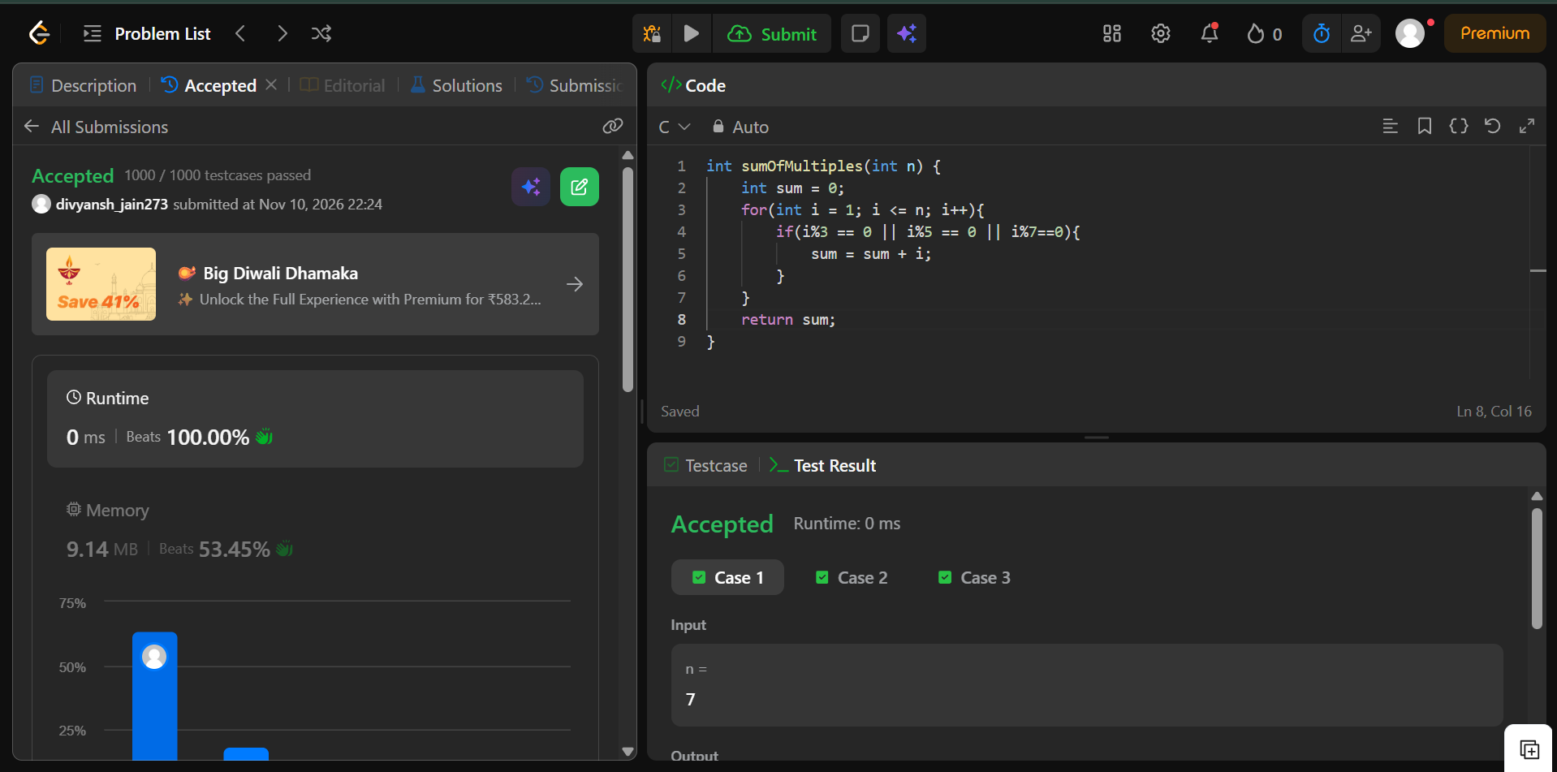

6. Subtract the Product and Sum of Digits of an Integer
LeetCode #1281 | Easy | Language: C | Nov 11, 2026 · 14:01
Accepted · 123/123 test cases · 0 ms (beats 100.00%) · 8.22 MB (beats 82.62%)

Question
Your screenshot shows only the solution, so the problem statement below is written out from the original LeetCode problem. (The Test Result panel in the screenshot is from an earlier run; the submission itself on the left is Accepted.)
Given an integer number n, return the difference between the product of its digits and the sum of its digits.
Example 1:
Input: n = 234
Output: 15
Explanation: Product of digits = 2 * 3 * 4 = 24. Sum of digits = 2 + 3 + 4 = 9. Result = 24 - 9 = 15.
Example 2:
Input: n = 4421
Output: 21
Explanation: Product of digits = 4 * 4 * 2 * 1 = 32. Sum of digits = 4 + 4 + 2 + 1 = 11. Result = 32 - 11 = 21.
Constraints:
- 1 <= n <= 10⁵

Solution (screenshot)
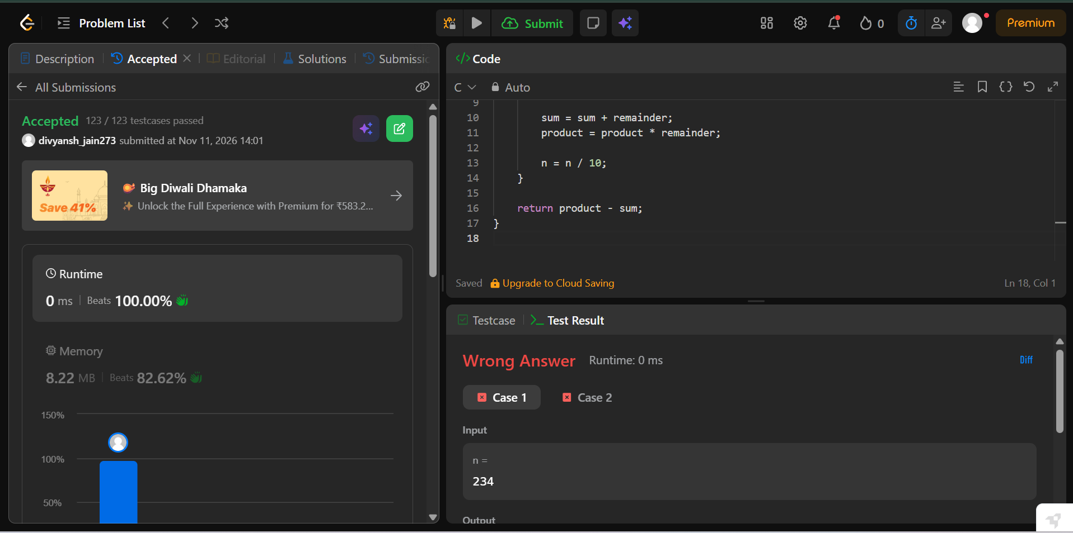

7. Count the Digits That Divide a Number
LeetCode #2520 | Easy | Language: C | Nov 11, 2026 · 16:17
Accepted · 56/56 test cases · 0 ms (beats 100.00%) · 8.49 MB (beats 36.41%)

Question
Your screenshot shows only the solution (the file name says “question”, but it is the accepted submission), so the problem statement below is written out from the original LeetCode problem.
Given an integer num, return the number of digits in num that divide num.
An integer val divides nums if nums % val == 0.
Example 1:
Input: num = 7
Output: 1
Explanation: 7 divides itself, hence the answer is 1.
Example 2:
Input: num = 121
Output: 2
Explanation: 121 is divisible by 1, but not by 2. Since 1 occurs twice as a digit, the answer is 2.
Example 3:
Input: num = 1248
Output: 4
Explanation: 1248 is divisible by all of its digits, hence the answer is 4.
Constraints:
- 1 <= num <= 10⁹
- num does not contain 0 as one of its digits.

Solution (screenshot)
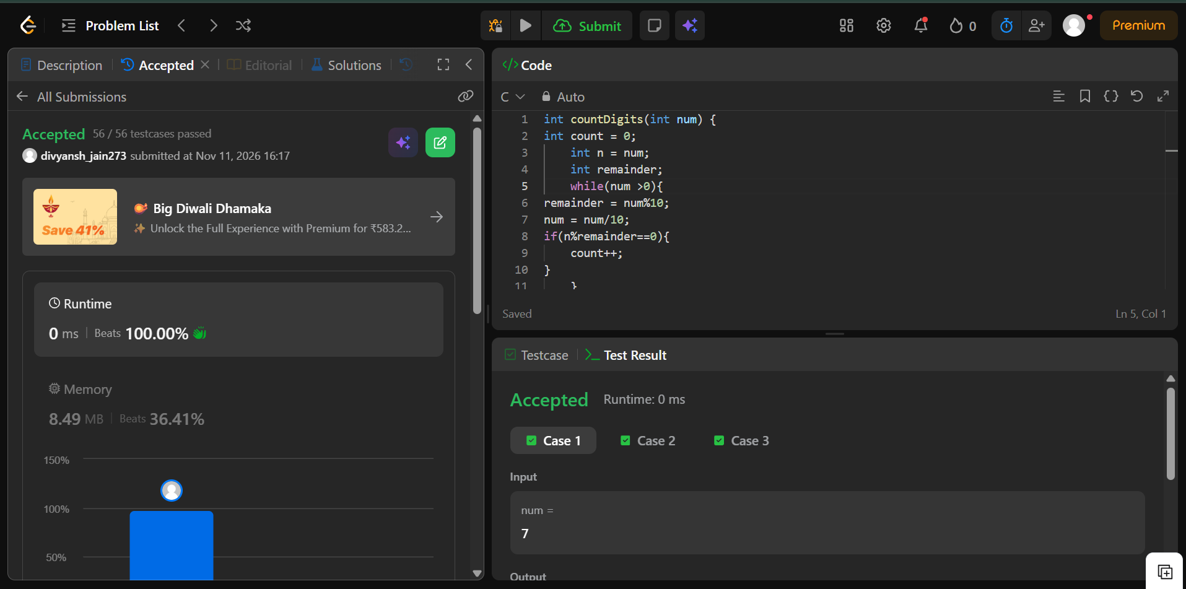

8. Palindrome Number
LeetCode #9 | Easy | Language: C | Nov 11, 2026 · 16:22
Accepted · 11515/11515 test cases · 3 ms (beats 63.58%) · 8.78 MB (beats 61.94%)

Question
Your screenshot shows only the solution, so the problem statement below is written out from the original LeetCode problem.
Given an integer x, return true if x is a palindrome, and false otherwise.
Example 1:
Input: x = 121
Output: true
Explanation: 121 reads as 121 from left to right and from right to left.
Example 2:
Input: x = -121
Output: false
Explanation: From left to right, it reads -121. From right to left, it becomes 121-. Therefore it is not a palindrome.
Example 3:
Input: x = 10
Output: false
Explanation: Reads 01 from right to left. Therefore it is not a palindrome.
Constraints:
- -2³¹ <= x <= 2³¹ - 1
Follow-up: Could you solve it without converting the integer to a string?

Solution (screenshot)
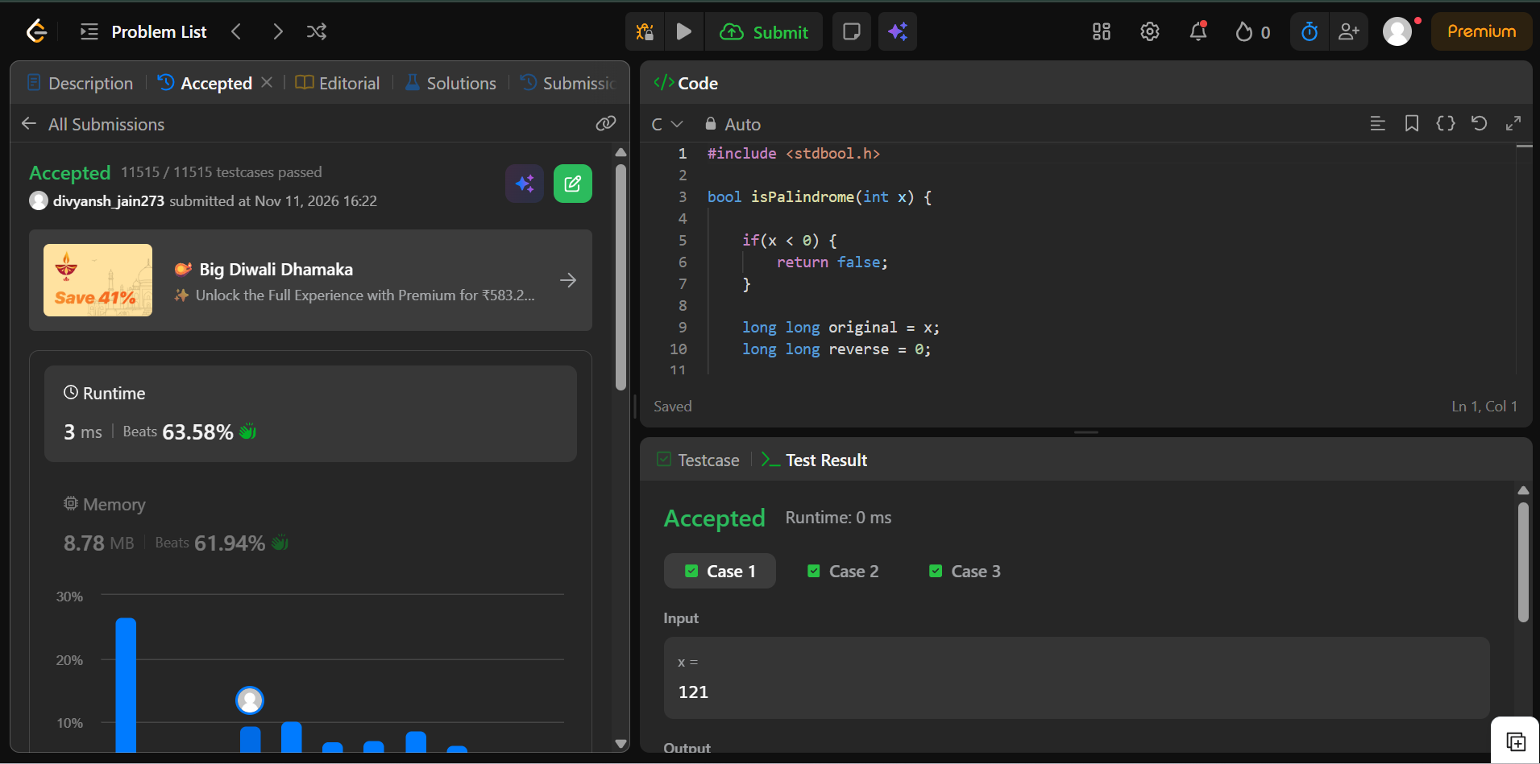

9. Reverse Integer
LeetCode #7 | Medium | Language: C | Nov 11, 2026 · 16:39
Accepted · 1046/1046 test cases · 4 ms (beats 28.56%) · 9.20 MB (beats 61.21%)

Question
Your screenshot shows only the solution, so the problem statement below is written out from the original LeetCode problem.
Given a signed 32-bit integer x, return x with its digits reversed. If reversing x causes the value to go outside the signed 32-bit integer range [-2³¹, 2³¹ - 1], then return 0.
Assume the environment does not allow you to store 64-bit integers (signed or unsigned).
Example 1:
Input: x = 123
Output: 321
Example 2:
Input: x = -123
Output: -321
Example 3:
Input: x = 120
Output: 21
Constraints:
- -2³¹ <= x <= 2³¹ - 1

Solution (screenshot)
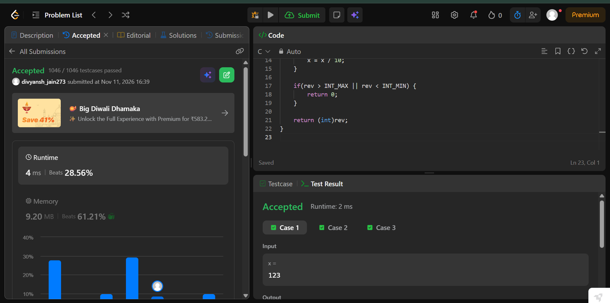

10. Power of Two
LeetCode #231 | Easy | Language: C | Nov 11, 2026 · 17:21
Accepted · 1110/1110 test cases · 0 ms (beats 100.00%) · 8.26 MB (beats 84.09%)

Question
Your screenshot shows only the solution (the top of the code is scrolled out of view), so the problem statement below is written out from the original LeetCode problem.
Given an integer n, return true if it is a power of two. Otherwise, return false.
An integer n is a power of two, if there exists an integer x such that n == 2^{x}.
Example 1:
Input: n = 1
Output: true
Explanation: 2⁰ = 1
Example 2:
Input: n = 16
Output: true
Explanation: 2⁴ = 16
Example 3:
Input: n = 3
Output: false
Constraints:
- -2³¹ <= n <= 2³¹ - 1
Follow-up: Could you solve it without loops/recursion?

Solution (screenshot)
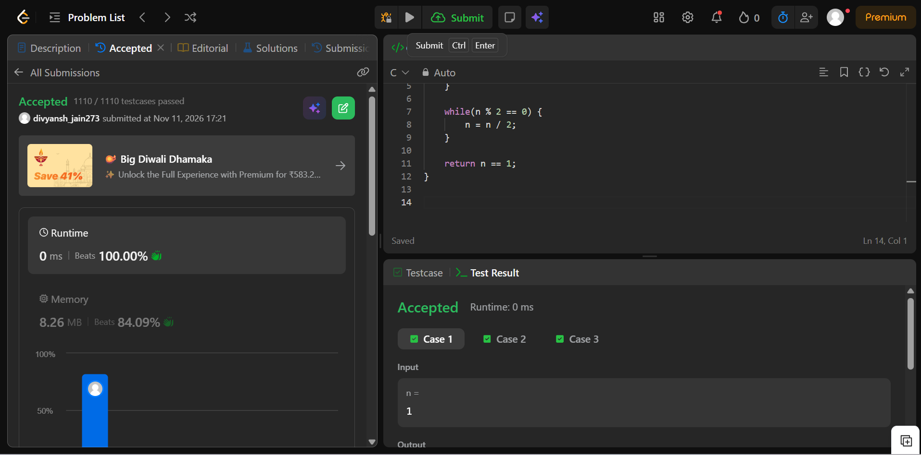

11. Power of Three
LeetCode #326 | Easy | Language: C | Run on sample cases (no submission shown)
Test Result: Accepted · sample cases 1–3 passed · 0 ms

Question
Transcribed from your screenshot, which shows the question and your code together. Example 3 was cut off, so it is added from the original problem.
Given an integer n, return true if it is a power of three. Otherwise, return false.
An integer n is a power of three, if there exists an integer x such that n == 3^{x}.
Example 1:
Input: n = 27
Output: true
Explanation: 27 = 3³
Example 2:
Input: n = 0
Output: false
Explanation: There is no x where 3^{x} = 0.
Example 3: (added from original problem)
Input: n = -1
Output: false
Explanation: There is no x where 3^{x} = (-1).
Constraints: (added from original problem)
- -2³¹ <= n <= 2³¹ - 1
Follow-up: Could you solve it without loops/recursion?

Solution (screenshot)


