Programming Practice
HackerEarth and HackerRank questions, code screenshots and visible results
This document compiles the problems shown in the supplied screenshots. Statements and metadata are transcribed from the visible portions of those screenshots. Where a screenshot is cropped or a code/result image was not supplied, that limitation is stated instead of filling in missing information.

Contents
# | Problem | Platform | Difficulty | Visible material
1 | A. Digit Sum | HackerEarth | Easy | Problem + editor screenshot
2 | Find Digits | HackerRank | Easy | Statement + function screenshot
3 | FizzBuzz | HackerRank | Advanced | Statement screenshot
4 | For Loop | HackerRank | Easy | Statement + code screenshot
5 | Grading Students | HackerRank | Easy | Statement + code + test result
6 | Kangaroo | HackerRank | Easy | Statement + function screenshot
7 | Printing Pattern Using Loops | HackerRank | Medium | Statement screenshot
8 | Solve Me First | HackerRank | Easy | Statement + code + accepted result
9 | Staircase | HackerRank | Easy | Statement screenshot
Documentation note: Only Solve Me First has a clear overall “Congratulations / solved” result screen in this batch. Grading Students shows successful test cases. Other screenshots do not establish final acceptance.

1. A. Digit Sum
HackerEarth | Easy | Language: C | Submission status not shown

Problem
Danial likes to separate out the digits of a number and play with them. This time he wants you to help him with a problem. Given an integer N, he would like you to find the sum of the first and last digits of N.
INPUT: The first line contains a single integer T, denoting the number of test cases. Each of the next T lines contains a single integer N.
OUTPUT: Each line contains a single integer S denoting the sum of the first and last digits of N.

Constraints
- 0 < N <= 10⁶
- 0 < T <= 100
The sample table is partly cut off. The visible portion shows T = 3, the first input N = 1234, and visible output values beginning with 5 and 5.

Screenshot
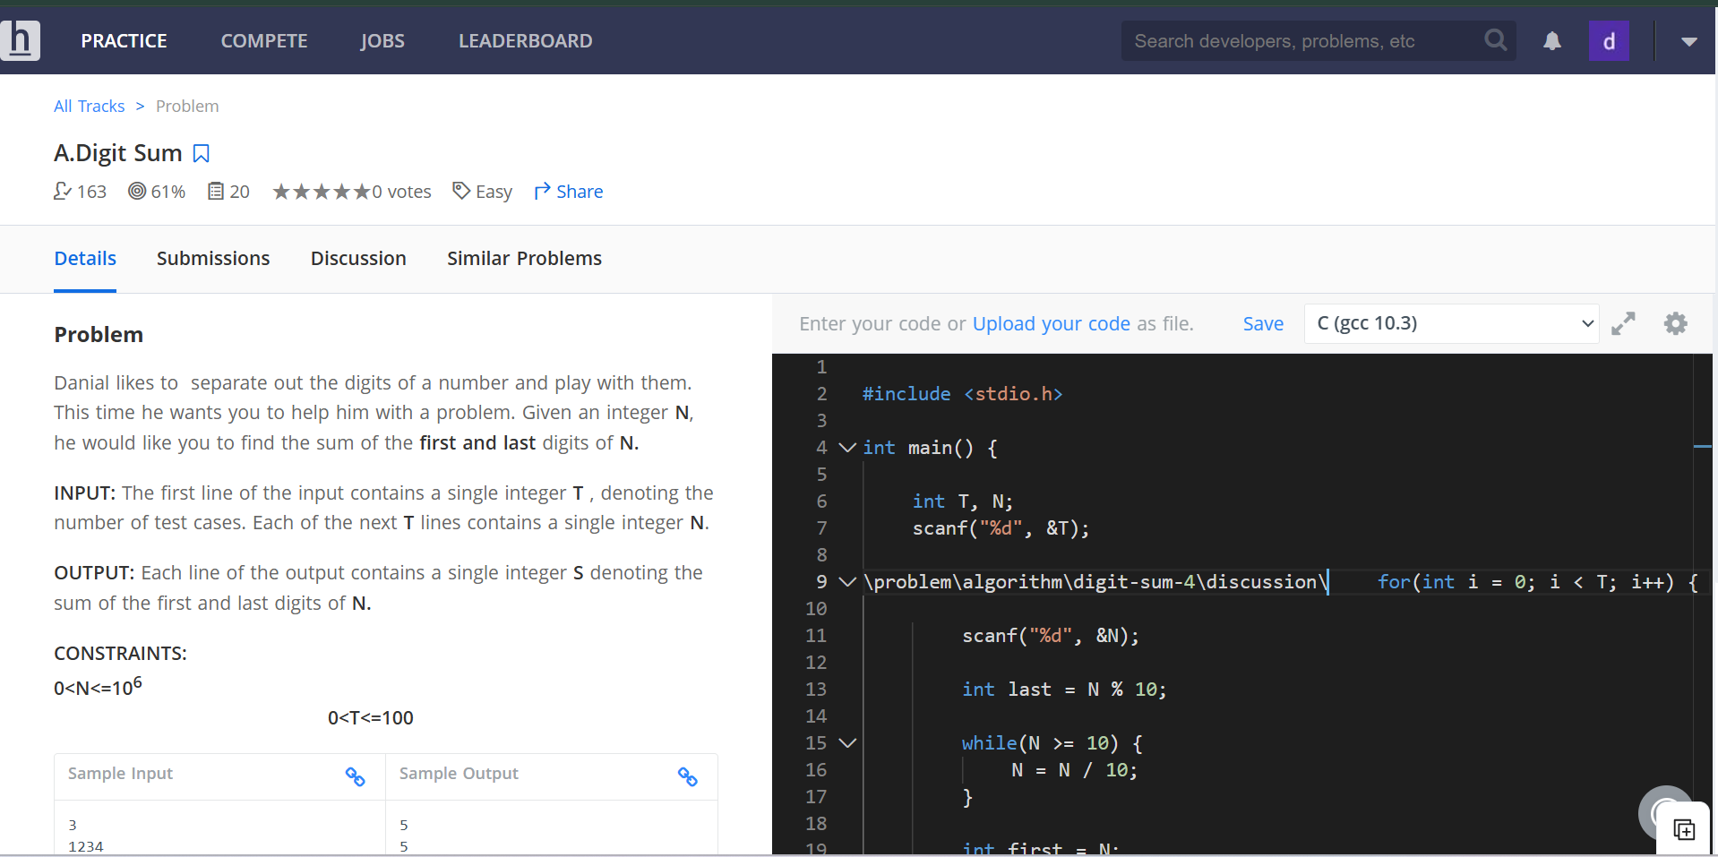
HackerEarth problem statement and C editor screenshot

2. Find Digits
HackerRank | Easy | Language: C | Code screenshot supplied; overall submission result not shown

Problem
An integer d is a divisor of an integer n if the remainder of n ÷ d = 0. Given an integer, for each digit that makes up the integer determine whether it is a divisor. Count the number of divisors occurring within the integer.

Examples
- n = 124: digits 1, 2 and 4 all divide 124 evenly. Return 3.
- n = 111: each of the three digits 1 divides 111. Return 3.
- n = 10: 1 divides 10, but 0 is not a divisor. Return 1.

Function Description
Complete the findDigits function. Parameter: int n, the value to analyze. Returns an integer: the number of digits in n that are divisors of n.

Visible code
The supplied function stores the original number, extracts digits using n % 10, skips zero digits, checks original % digit == 0, increments a counter, and returns the count.
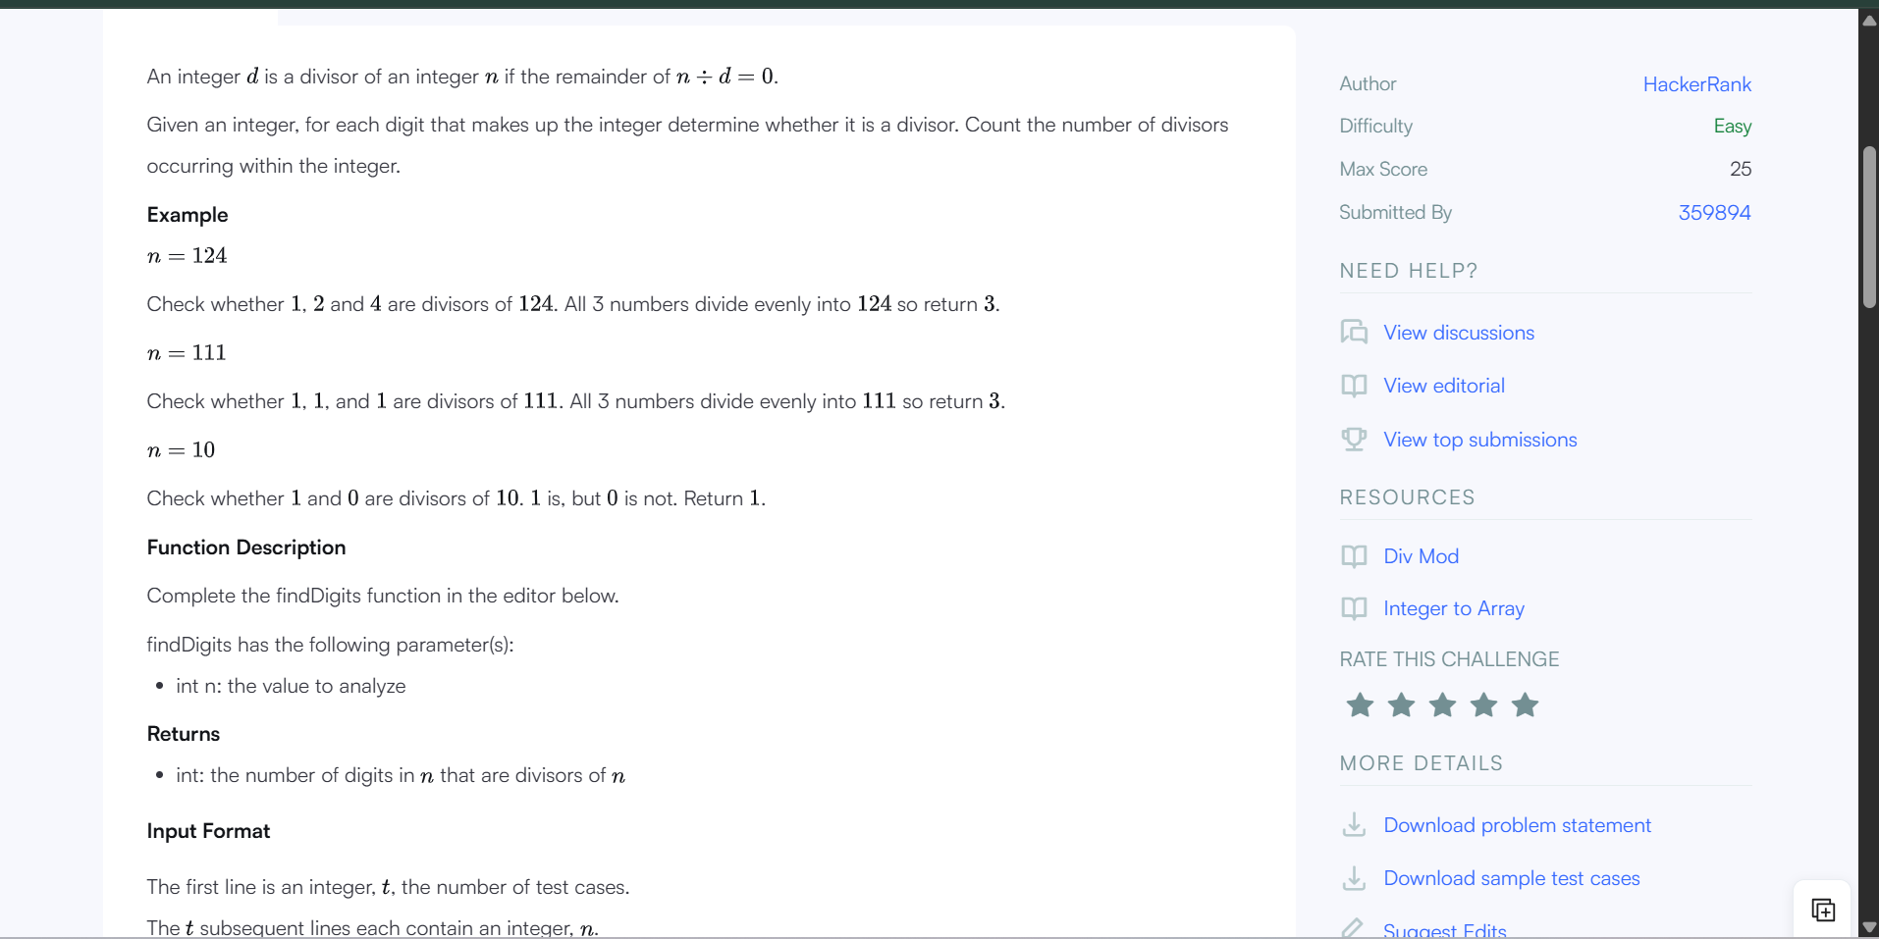
HackerRank Find Digits statement screenshot
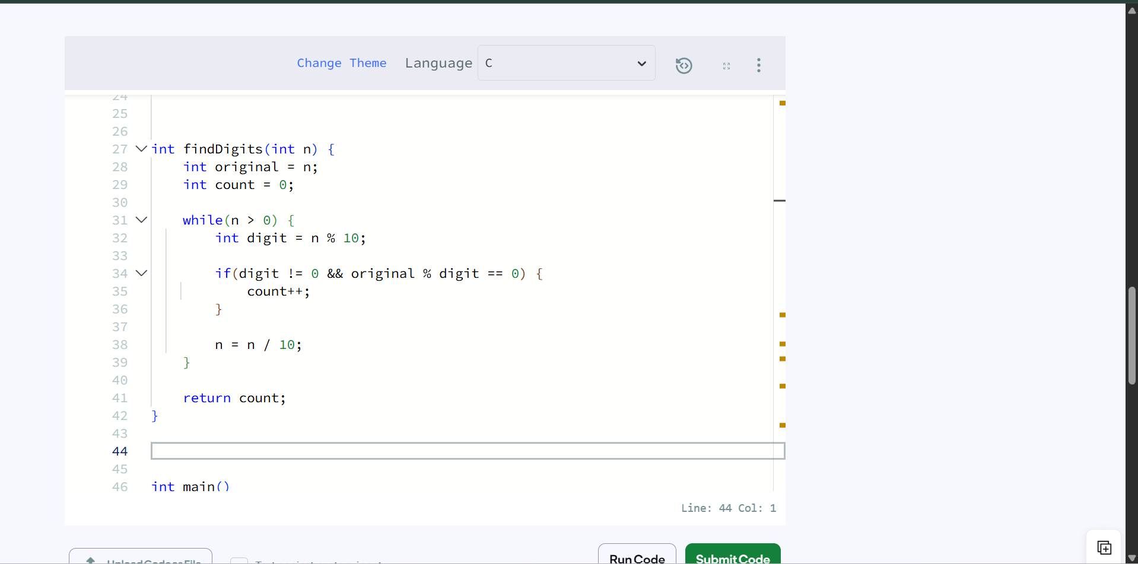
Find Digits C function screenshot

3. FizzBuzz
HackerRank | Advanced | Language: C | Problem statement screenshot only

Problem
Write a short program that prints each number from 1 to 100 on a new line.
- For each multiple of 3, print "Fizz" instead of the number.
- For each multiple of 5, print "Buzz" instead of the number.
- For numbers that are multiples of both 3 and 5, print "FizzBuzz" instead of the number.
Write a solution (or reduce an existing one) so it has as few characters as possible.

Scoring
Your score is: (200 − number of characters in your source code) / 100.
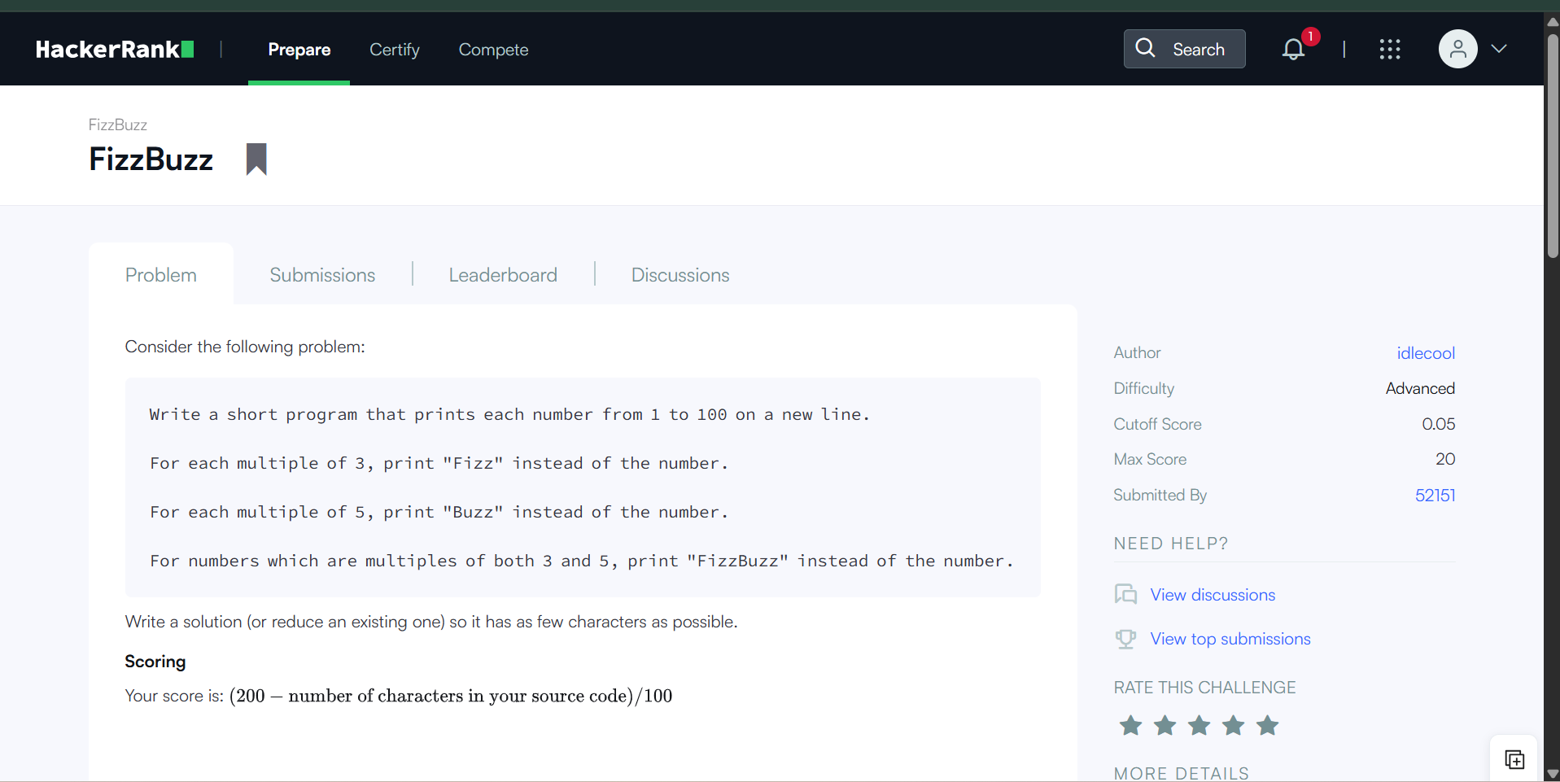
HackerRank FizzBuzz problem screenshot
No solution-code or result screenshot was included for this problem.

4. For Loop
HackerRank | Easy | Language: C | Problem and code screenshots supplied

Task
For each integer n in the interval [a, b] (given as input):
- If 1 <= n <= 9, print the English representation of it in lowercase ("one" for 1, "two" for 2, and so on).
- Else if n > 9 and it is an even number, print "even".
- Else if n > 9 and it is an odd number, print "odd".

Input Format
- The first line contains an integer a.
- The second line contains an integer b.

Constraints
1 <= a <= b <= 10⁶

Output Format
Print the appropriate English representation, even, or odd, based on the conditions described in the task.

Sample Input
8
11
The sample output area is cut off in the supplied screenshot.

Code screenshot
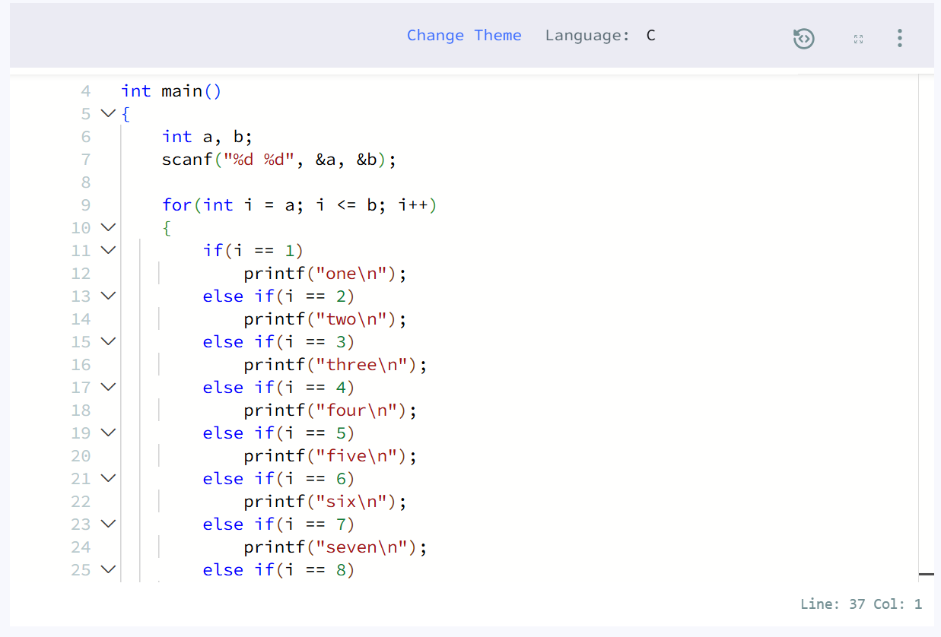
For Loop C implementation screenshot
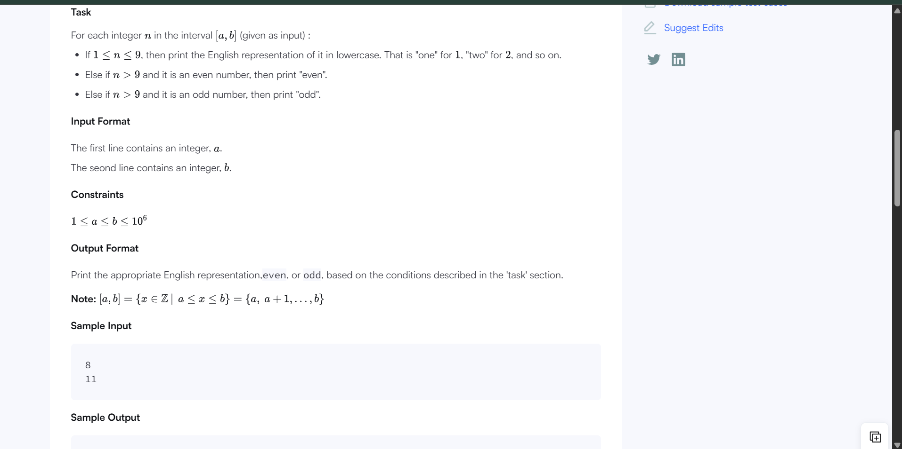
For Loop statement screenshot

5. Grading Students
HackerRank | Easy | Language: C | Successful test cases shown; no overall submission banner

Problem
HackerLand University has the following grading policy:
- Every student receives a grade in the inclusive range from 0 to 100.
- Any grade less than 40 is a failing grade.
Sam is a professor at the university and likes to round each student's grade according to these rules:
- If the difference between the grade and the next multiple of 5 is less than 3, round the grade up to the next multiple of 5.
- If the value of grade is less than 38, no rounding occurs as the result will still be a failing grade.

Examples
- 84 rounds to 85 (85 − 84 is less than 3).
- 29 does not round (result is less than 38).
- 57 does not round (60 − 57 is 3 or higher).
Given the initial value of grade for each of Sam's n students, write code to automate the rounding process.

Visible implementation logic
The supplied gradingStudents function loops through the grades. Grades below 38 are left unchanged. For other grades it calculates grades[i] % 5 and rounds up when 5 − remainder < 3.

Screenshots
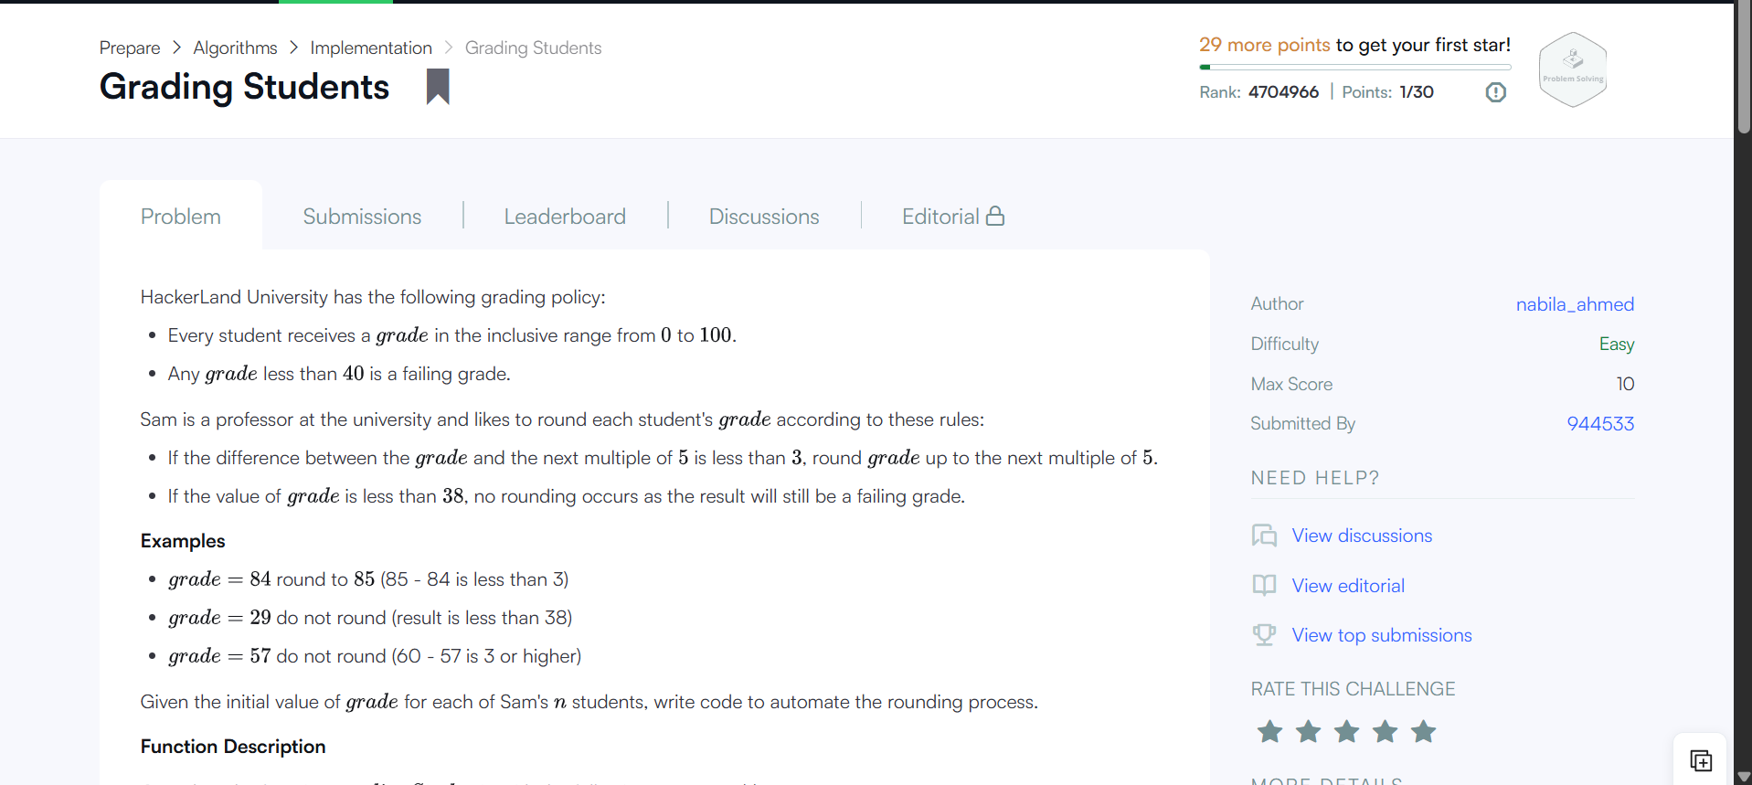
Grading Students problem statement screenshot
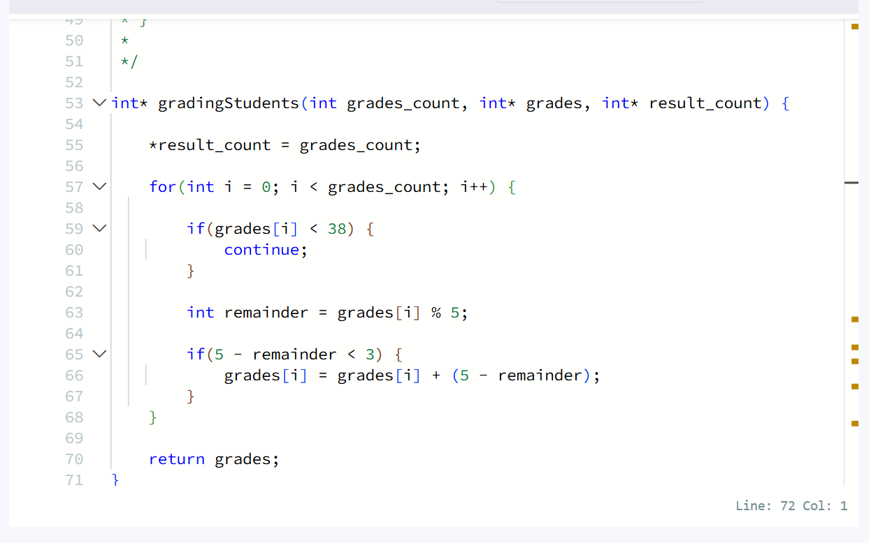
C implementation screenshot
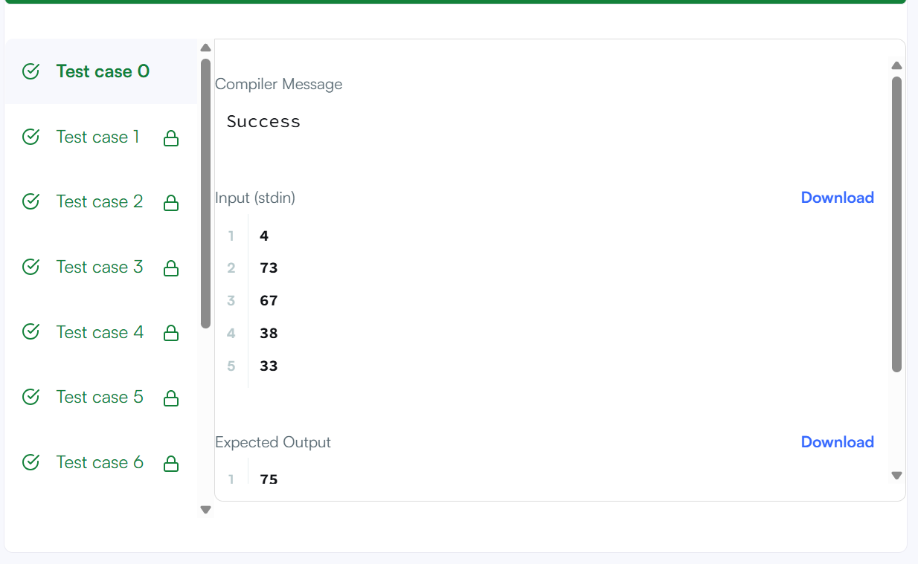
Test results screenshot: visible test cases show successful checks

6. Kangaroo
HackerRank | Easy | Language: C | Function screenshot supplied; overall result not shown

Problem
You are choreographing a circus show with various animals. For one act, you are given two kangaroos on a number line, both ready to jump in the positive direction (toward positive infinity).
- The first kangaroo starts at location x1 and moves at a rate of v1 meters per jump.
- The second kangaroo starts at location x2 and moves at a rate of v2 meters per jump.
Determine whether both kangaroos can be at the same location at the same time. If possible, return YES; otherwise, return NO.

Visible example
- x1 = 2, v1 = 1, x2 = 1, v2 = 2.

Visible code logic
The function calculates the initial distance (x2 − x1) and speed difference (v1 − v2). It handles equal speeds separately, then checks whether the distance is divisible by the speed difference and whether the quotient is non-negative.
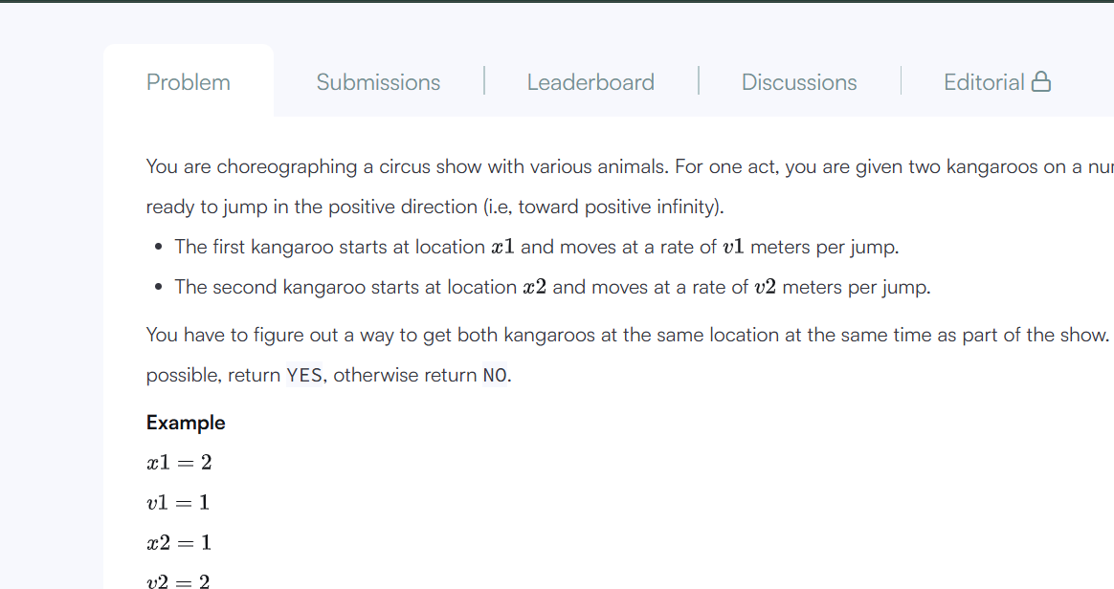
Kangaroo problem statement screenshot
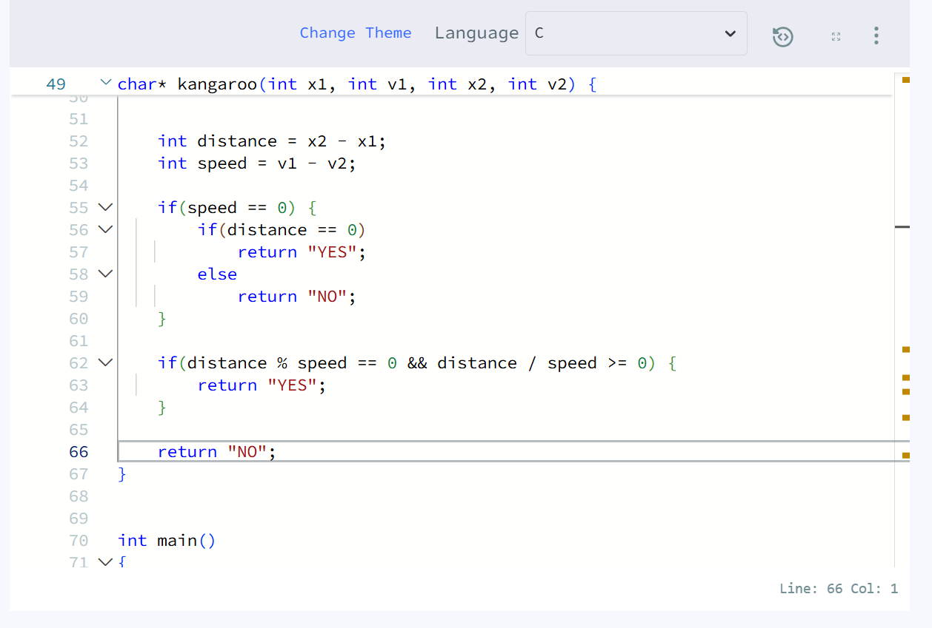
Kangaroo C function screenshot

7. Printing Pattern Using Loops
HackerRank | Medium | Language: C | Problem statement screenshot only

Problem
Print a pattern of numbers from 1 to n as shown. Each of the numbers is separated by a single space.

Visible pattern example
The screenshot shows a symmetric square pattern for n = 4, with 4s around the outside, decreasing toward 1 at the centre:
4 4 4 4 4 4 4
4 3 3 3 3 3 4
4 3 2 2 2 3 4
4 3 2 1 2 3 4
4 3 2 2 2 3 4
4 3 3 3 3 3 4
4 4 4 4 4 4 4

Input Format
The input contains a single integer n.

Constraints
1 <= n <= 1000
The sample input/output section is below the captured area. No solution-code screenshot was supplied.
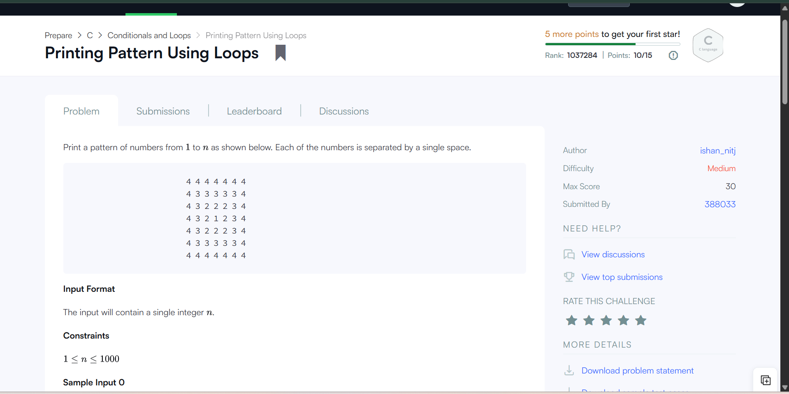
Printing Pattern Using Loops problem screenshot

8. Solve Me First
HackerRank | Easy | Language: C | Accepted result screenshot supplied

Problem
Complete the function solveMeFirst to compute the sum of two integers.

Example
- a = 7
- b = 3
Return 10.

Function Description
Complete solveMeFirst with the following parameters: int a (the first value) and int b (the second value). Returns an int: the sum of a and b.

Constraints
1 <= a, b <= 1000

Sample Input
2
3

Sample Output
5

Screenshots
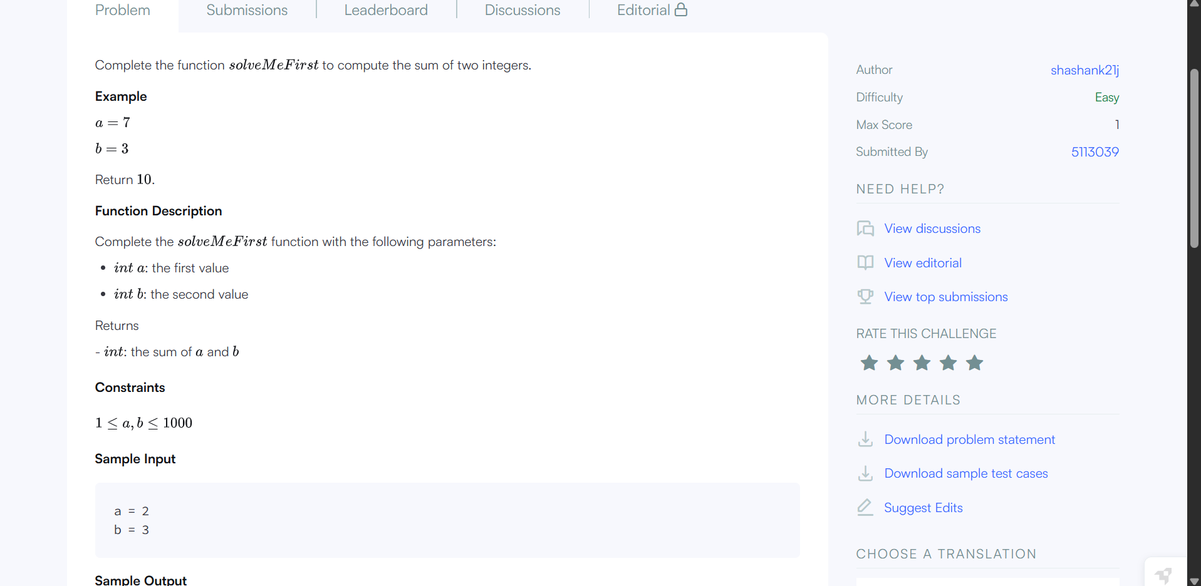
Solve Me First problem statement screenshot
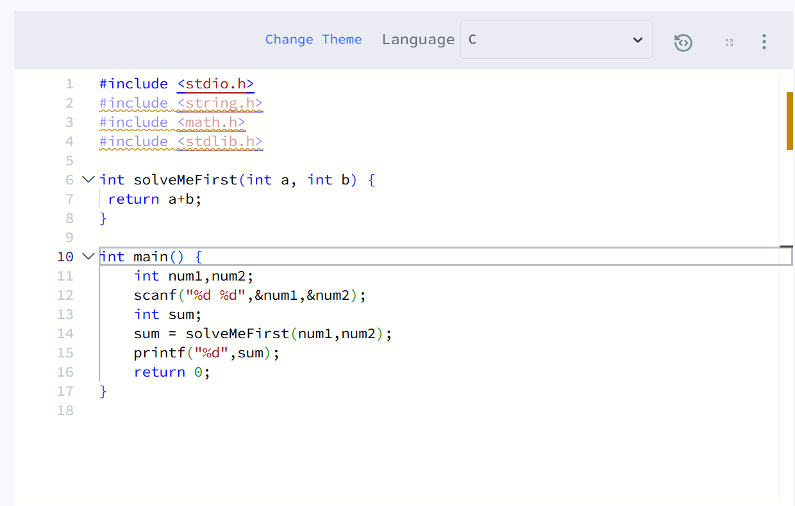
Solve Me First C implementation screenshot
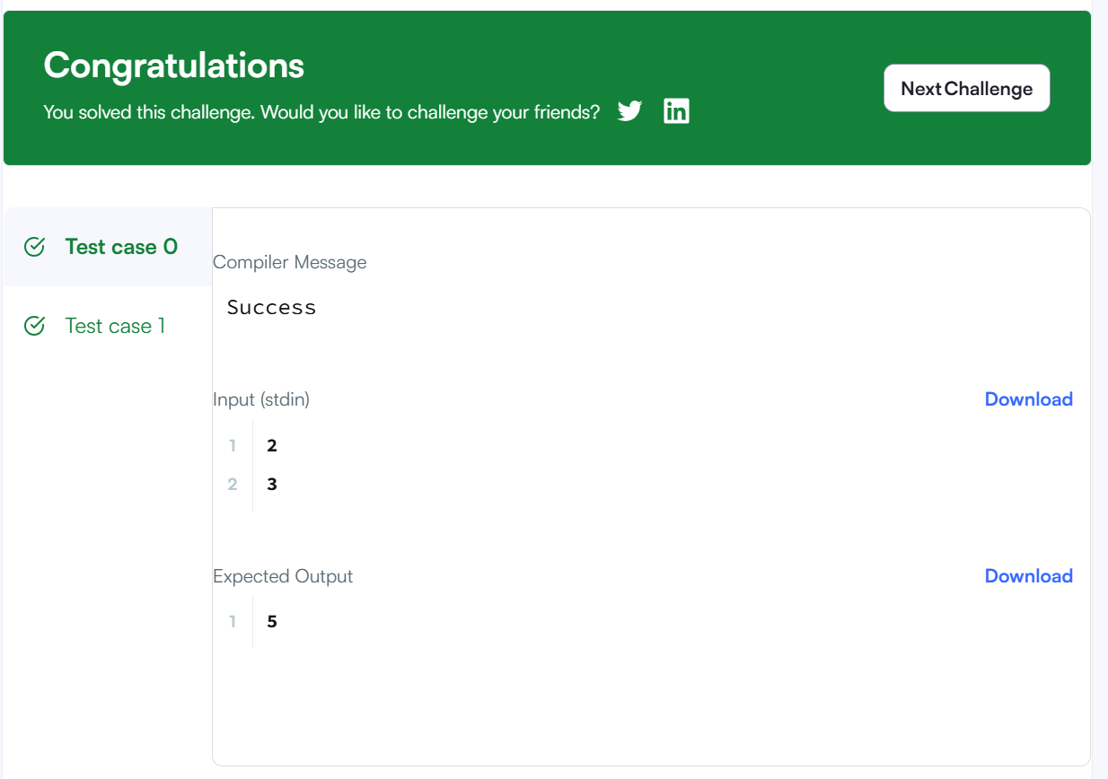
Accepted result screenshot: congratulations banner and expected output 5

9. Staircase
HackerRank | Easy | Language: C | Problem statement screenshot only

Problem
This is a staircase of size n = 4:
#
##
###
####
Its base and height are both equal to n. It is drawn using # symbols and spaces. The last line is not preceded by any spaces.
Write a program that prints a staircase of size n.

Function Description
Complete the staircase function with the parameter int n, an integer.

Print
Print a staircase as described above. No value should be returned. The last line is not preceded by spaces; all lines are right-aligned.

Input Format
A single integer n, denoting the size of the staircase. The remainder of the statement is below the captured area.
No solution-code or result screenshot was supplied.
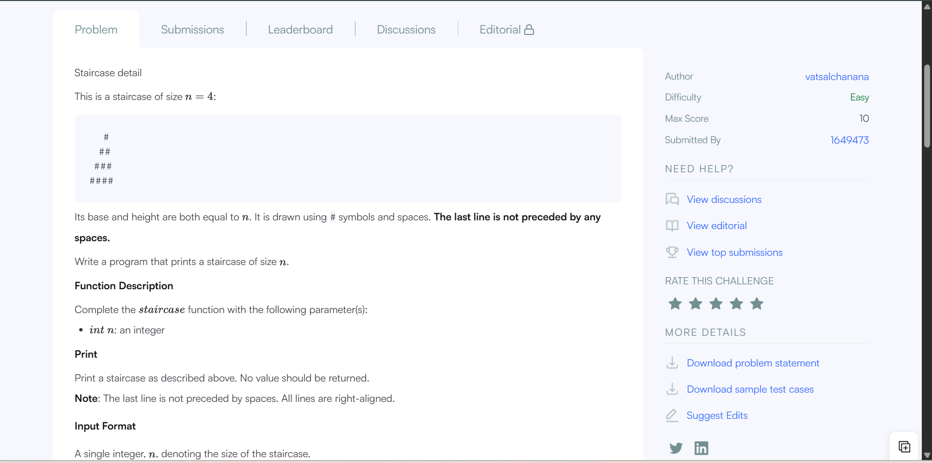
Staircase problem statement screenshot

