Key Design Elements

This document outlines the key design and structural elements of the Carob Cottage website.

# Pages

The site will contain the following pages:

* Home page (landing)
* Amenities
* The area
* About
* Photos
* Reservations
* Rates
* Contact
* Terms and Conditions

# Page Layouts

## Generic Layout

The following format will be used for all pages.

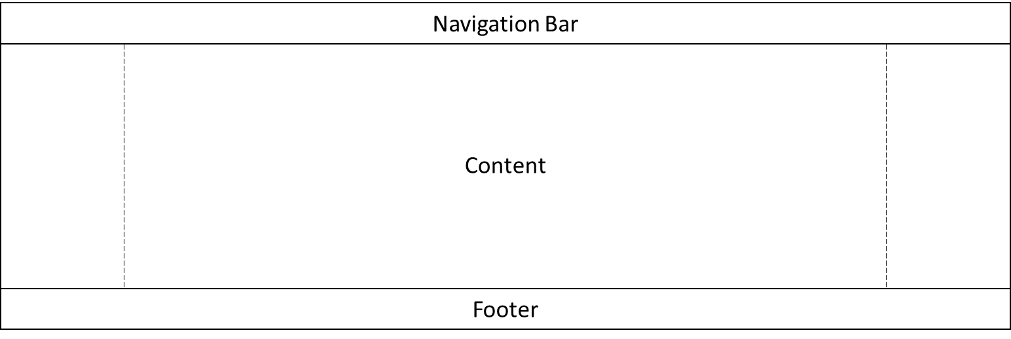

## Home

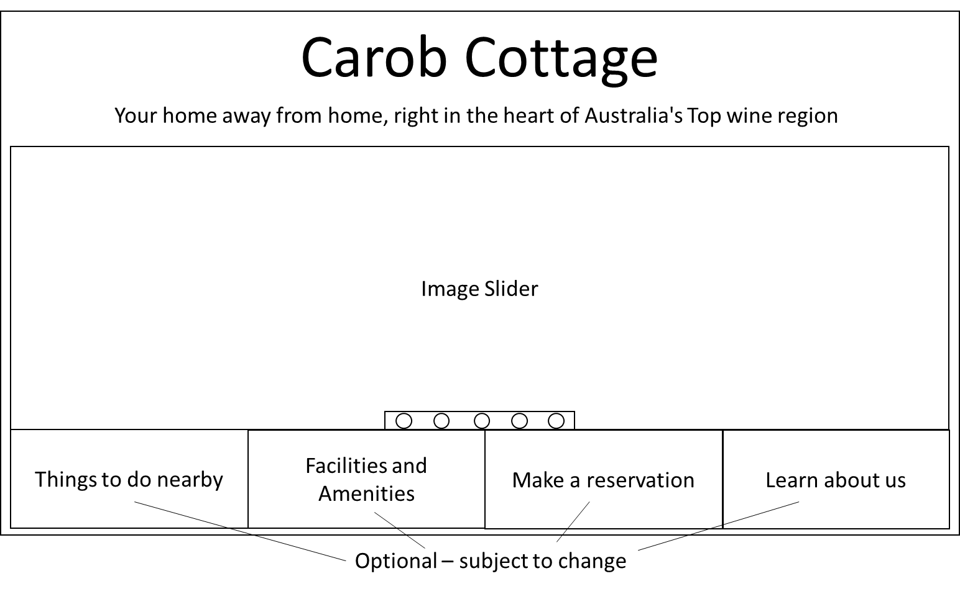

# Amenities

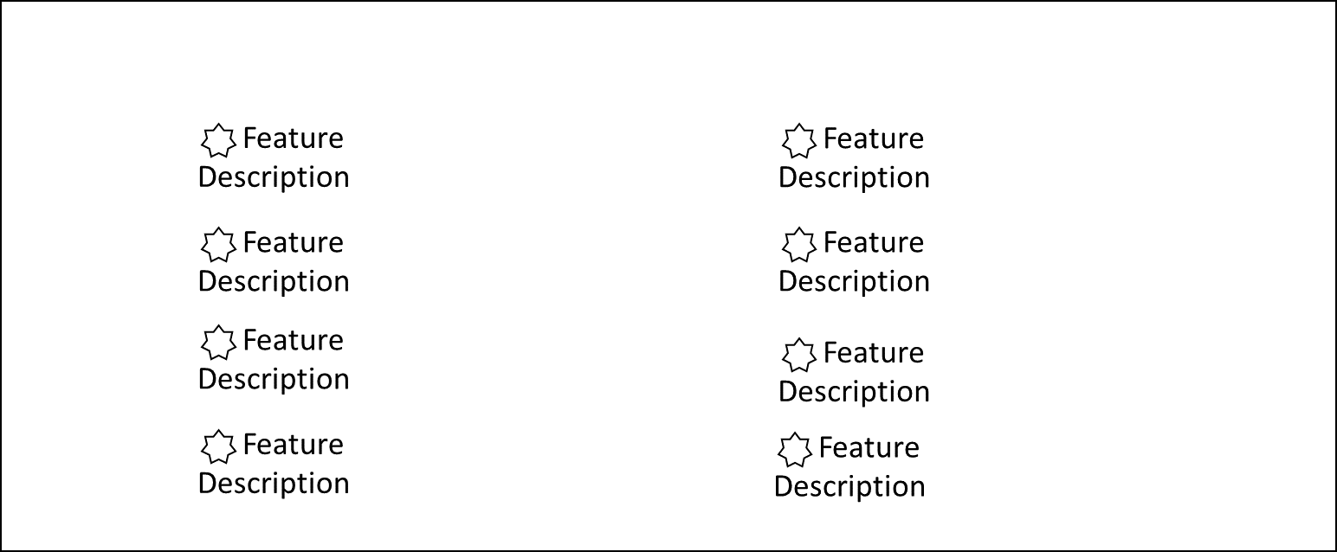

- Logo

# About

# Navigation Bar

This is a rough outline of the navigation bar:



# Footer

