Project Final
Carl Kawodza
2023-12-04
library(socviz)
library(tidyverse)
## ── Attaching core tidyverse packages ──────────────────────── tidyverse 2.0.0 ──
## ✔ dplyr 1.1.4 ✔ readr 2.1.4
## ✔ forcats 1.0.0 ✔ stringr 1.5.0
## ✔ ggplot2 3.4.4 ✔ tibble 3.2.1
## ✔ lubridate 1.9.3 ✔ tidyr 1.3.0
## ✔ purrr 1.0.2
## ── Conflicts ────────────────────────────────────────── tidyverse_conflicts() ──
## ✖ dplyr::filter() masks stats::filter()
## ✖ dplyr::lag() masks stats::lag()
## ℹ Use the conflicted package (<http://conflicted.r-lib.org/>) to force all conflicts to become errors
data(boomer)
str(boomer)
## tibble [1,644 × 6] (S3: tbl_df/tbl/data.frame)
## $ date : Date[1:1644], format: "1938-01-01" "1938-02-01" ...
## $ month : int [1:1644] 1 2 3 4 5 6 7 8 9 10 ...
## $ n_days : int [1:1644] 31 28 31 30 31 30 31 31 30 31 ...
## $ births : int [1:1644] 51820 47421 54887 54623 56853 53145 53214 50444 50545 50079 ...
## $ total_pop: int [1:1644] 41215000 41215000 41215000 41215000 41215000 41215000 41215000 41215000 41215000 41215000 ...
## $ country : chr [1:1644] "England and Wales" "England and Wales" "England and Wales" "England and Wales" ...
## - attr(*, "spec")=
## .. cols(
## .. year = col_integer(),
## .. month = col_integer(),
## .. n_days = col_integer(),
## .. births = col_integer(),
## .. total_pop = col_integer(),
## .. births_pct = col_double(),
## .. births_pct_day = col_double(),
## .. date = col_date(format = ""),
## .. seasonal = col_double(),
## .. trend = col_double(),
## .. remainder = col_double(),
## .. country = col_character()
## .. )
missing_values <- colSums(is.na(boomer))
print(missing_values)
## date month n_days births total_pop country
## 0 0 0 0 0 0
duplicates <- sum(duplicated(boomer))
print(paste("Number of duplicates:", duplicates))
## [1] "Number of duplicates: 0"
#Handling missing values by imputation
boomer_imputed <- boomer%>%
mutate_all(~ifelse(is.na(.), mean(., na.rm = TRUE), .))
#Removing duplicates
boomer_no_duplicates <- distinct(boomer)
#How does the total population vary over time? Are there specific periods of notable population growth or decline?
boomer$date <- as.Date(boomer$date)
# Plotting the total population over time
ggplot(boomer, aes(x = date, y = total_pop)) +
geom_line() +
labs(title = "Total Population Over Time",
x = "Date",
y = "Total Population") +
theme_minimal()
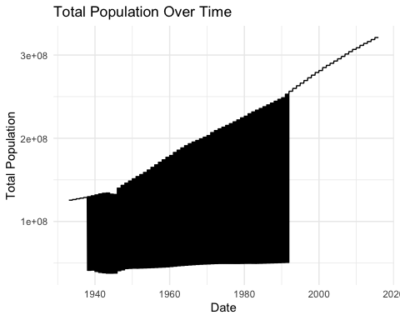
#summary statistics
summary(boomer[c('total_pop', 'births')])
## total_pop births
## Min. : 37785000 Min. : 41560
## 1st Qu.: 49327100 1st Qu.: 60578
## Median :143446000 Median :254876
## Mean :148257771 Mean :205888
## 3rd Qu.:229465714 3rd Qu.:324270
## Max. :321039839 Max. :392230
ggplot(boomer, aes(x = country, y = births / total_pop * 1000, fill = country)) +
geom_bar(stat = "identity") +
labs(title = "Birth Rate Across Countries",
x = "Country",
y = "Birth Rate (per 1000 people)",
fill = "Country") +
theme_minimal() +
theme(axis.text.x = element_text(angle = 45, hjust = 1))
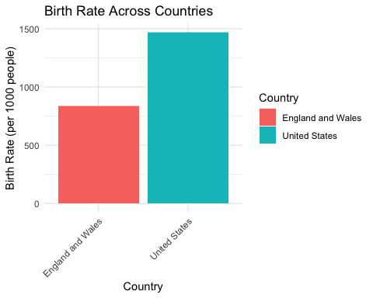
#Are there any seasonal variations in birth rates throughout the year?
library(ggplot2)
#Plotting the birth rates across different months
ggplot(boomer, aes(x = factor(births), fill = factor(births))) +
geom_bar() +
labs(title = "Seasonal Variations in Birth Rates",
x = "Month",
y = "Number of Births") +
scale_x_discrete(labels = month.name) +
theme_minimal()
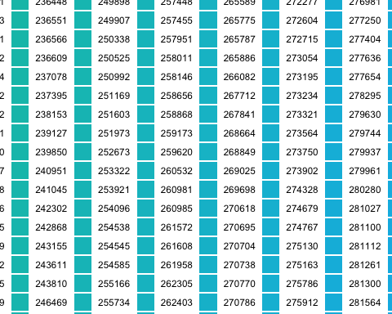
#For a specific country, what is the distribution of births across different months?
library(ggplot2)
#Plotting the distribution of births across different countries
ggplot(boomer, aes(x = factor(country), fill = factor(country))) +
geom_bar() +
labs(title = "Distribution of Births Across Different Countries",
x = "Country",
y = "Number of Births") +
theme_minimal() +
theme(axis.text.x = element_text(angle = 45, hjust = 1))
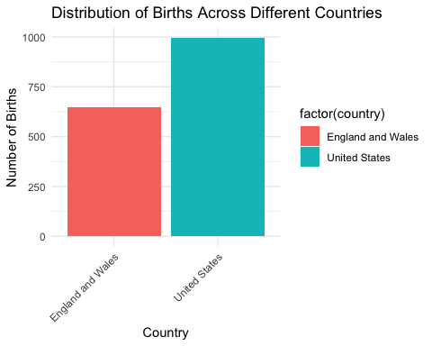
#What is the overall trend in population growth or decline over the years?
library(ggplot2)
boomer$date <- as.Date(boomer$date)
# Extract the year from the date
boomer$year <- lubridate::year(boomer$date)
# Plotting a boxplot to show the overall trend in population growth or decline over the years
ggplot(boomer, aes(x = factor(year), y = total_pop)) +
geom_boxplot() +
labs(title = "Population Growth Over the Years",
x = "Year",
y = "Total Population") +
theme_minimal() +
theme(axis.text.x = element_text(angle = 45, hjust = 1))
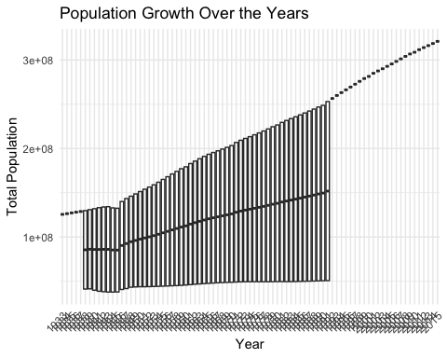
#Is there any correlation between the total population and the number of births within a given time frame?
library(ggplot2)
boomer$date <- as.Date(boomer$date)
#Scatter plot to visualize the relationship
ggplot(boomer, aes(x = births, y = total_pop)) +
geom_point() +
labs(title = "Correlation Between Total Population and Births",
x = "Number of Births",
y = "Total Population") +
theme_minimal()
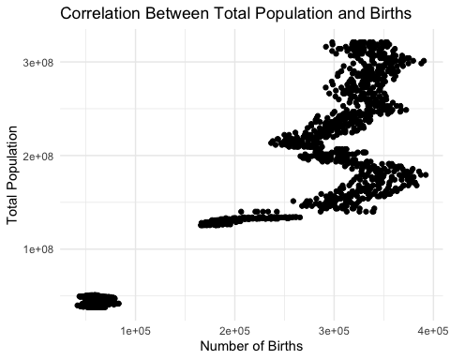
#Calculating correlation coefficient
correlation_coefficient <- cor(boomer$total_pop, boomer$births)
print(paste("Correlation Coefficient: ", round(correlation_coefficient, 2)))
## [1] "Correlation Coefficient: 0.92"

