Read me before installing or uninstalling the Publication Writing Aid add-on for MS Word

1. Install add-on

Please follow the next steps to install the Writing aid add-on:

1) Double click install.dotm

2) Enable Macros (see fig.1)

3) Click the check mark in the top menu bar (see fig.1)

4) Close MS Word completely (close all open MS Word documents)

5) Start MS Word or open a MS Word document

6) An extra menu tab is added: “Publication Writing Aid” (see fig.1)

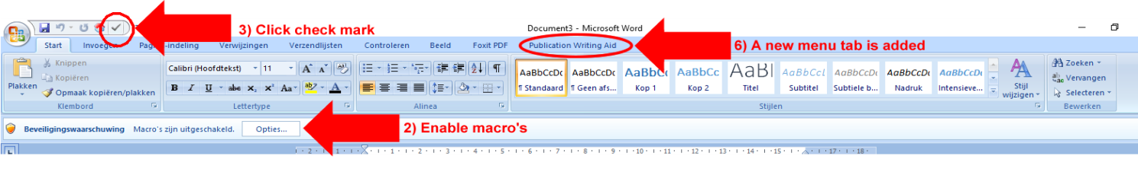

Fig. 1: MS Word menu for installer

1. Uninstall add-on

**Note: to upgrade to a newer version of the Writing Publication Aid add-on, it is NOT needed to uninstall the older version first. The newer version will install itself over the older version.**

To uninstall the add-on completely and to delete the files created during the installation of the add-on follow the following steps:

* Close all MS word documents,
* go to the Install directory and double-click on the Uninstall.dotm file in the unzipped directory,

**Note: if the install directory is not present anymore on your pc, please download the install.zip again, unpack all the files in the zipped directory again.**

* click on the white cross symbol in the top menu op the MS Word document the opened (see fig.2) ,
* choose if you want to delete all checklists files (checklists and help files) in the WritePublicationAid directory or not (see fig.3),
* a popup will show when the uninstall is done,
* close the popup and the word document.

The Write Publication Aid add-on in completely uninstalled.

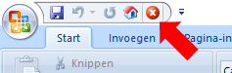

Fig. 2: White cross symbol

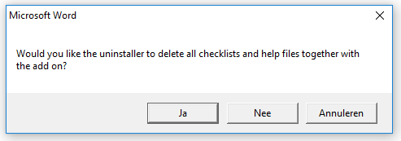

Fig. 3: Uninstaller popup

.

|  |  |  |  |  |  |
| --- | --- | --- | --- | --- | --- |
| **Section/topic** | **Item no** | **Checklist item** | **Extension** | **Tagged section** | **Page no** |
| **Title and abstract** |  |  |  |  |  |
| Randomised trial | 1a | Identification as a randomised trial in the title |  |  |  |
| Structured summary | 1b | Structured summary of trial design, methods, results, and conclusions (for specific guidance see CONSORT for abstracts) |  |  |  |
| **Introduction** |  |  |  |  |  |
| Background /rationale | 2a | Scientific background and explanation of rationale |  |  |  |
| Objectives/hypotheses | 2b | Specific objectives or hypotheses |  |  |  |
| **Methods** |  |  |  |  |  |
| Descrition trial design | 3a | Description of trial design (such as parallel, factorial) including allocation ratio |  |  |  |
| Changes to methods | 3b | Important changes to methods after trial commencement (such as eligibility criteria), with reasons |  |  |  |
| Participants | 4a | Eligibility criteria for participants |  |  |  |
| Settings/locations data | 4b | Settings and locations where the data were collected |  |  |  |
| Interventions | 5 | The interventions for each group with sufficient details to allow replication, including how and when they were actually administered |  |  |  |
| Outcomes | 6a | Completely defined pre-specified primary and secondary outcome measures, including how and when they were assessed |  |  |  |
| Changes to outcomes | 6b | Any changes to trial outcomes after the trial commenced, with reasons |  |  |  |
| Sample size | 7a | How sample size was determined |  |  |  |
| Interim analyses | 7b | When applicable, explanation of any interim analyses and stopping guidelines |  |  |  |
| Randomisation:Sequence generation | 8a | Method used to generate the random allocation sequence |  |  |  |
| Type of randomisation | 8b | Type of randomisation; details of any restriction (such as blocking and block size) |  |  |  |
| Randomisation:Allocation concealment mechanism | 9 | Mechanism used to implement the random allocation sequence (such as sequentially numbered containers), describing any steps taken to conceal the sequence until interventions were assigned |  |  |  |
| Randomisation: Implementation | 10 | Who generated the random allocation sequence, who enrolled participants, and who assigned participants to interventions |  |  |  |
| Blinding | 11a | If done, who was blinded after assignment to interventions (for example, participants, care providers, those assessing outcomes) and how |  |  |  |
| Similarity of interventions | 11b | If relevant, description of the similarity of interventions |  |  |  |
| Statistical methods | 12a | Statistical methods used to compare groups for primary and secondary outcomes |  |  |  |
| Methods for additional analyses | 12b | Methods for additional analyses, such as subgroup analyses and adjusted analyses |  |  |  |
| **Results** |  |  |  |  |  |
| Participant flow (a diagram is strongly recommended) | 13a | For each group, the numbers of participants who were randomly assigned, received intended treatment, and were analysed for the primary outcome |  |  |  |
| Losses and exclusions | 13b | For each group, losses and exclusions after randomisation, together with reasons |  |  |  |
| Recruitment | 14a | Dates defining the periods of recruitment and follow-up |  |  |  |
| Reason end/stop | 14b | Why the trial ended or was stopped |  |  |  |
| Baseline data | 15 | A table showing baseline demographic and clinical characteristics for each group |  |  |  |
| Numbers analysed | 16 | For each group, number of participants (denominator) included in each analysis and whether the analysis was by original assigned groups |  |  |  |
| Outcomes and estimation | 17a | For each primary and secondary outcome, results for each group, and the estimated effect size and its precision (such as 95% confidence interval) |  |  |  |
| Absolute/relative effect sizes | 17b | For binary outcomes, presentation of both absolute and relative effect sizes is recommended |  |  |  |
| Ancillary analyses | 18 | Results of any other analyses performed, including subgroup analyses and adjusted analyses, distinguishing pre-specified from exploratory |  |  |  |
| Harms | 19 | All important harms or unintended effects in each group (for specific guidance see CONSORT for harms) |  |  |  |
| **Discussion** |  |  |  |  |  |
| Limitations | 20 | Trial limitations, addressing sources of potential bias, imprecision, and, if relevant, multiplicity of analyses |  |  |  |
| Generalisability | 21 | Generalisability (external validity, applicability) of the trial findings |  |  |  |
| Interpretation | 22 | Interpretation consistent with results, balancing benefits and harms, and considering other relevant evidence |  |  |  |
| **Other information** |  |  |  |  |  |
| Registration | 23 | Registration number and name of trial registry |  |  |  |
| Protocol | 24 | Where the full trial protocol can be accessed, if available |  |  |  |
| Funding | 25 | Sources of funding and other support (such as supply of drugs), role of funders |  |  |  |