Quarterly Complaints Reporting Macro Documentation

Date: 2023-11-16

Table of Contents

How to get the macro 3

Steps: 3

Using the macro 4

TAB: Record of complaint 4

TAB: Run 5

# How to get the macro

The macro can be found at this GitHub repository <https://github.com/carlmacro/QUARTERLY-COMPLAINTS-REPORTING>.

I can't email the macro because your AV software will remove any macros from workbooks which are emailed from external email addresses.

## Steps:

1. Navigate to <https://github.com/carlmacro/QUARTERLY-COMPLAINTS-REPORTING/blob/main/Quarterly-Complaints-Reporting_Macro_005.xlsm>
2. Click the download icon (top right)
3. 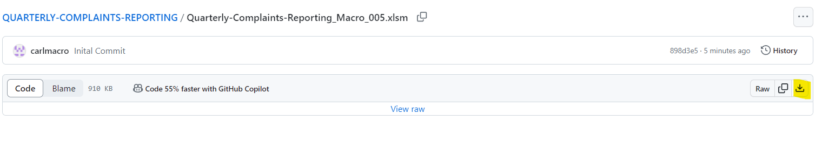
4. After downloading, move the file to a desired location
5. Right click on the file select "Properties", from there unblock the file by clicking the checkbox (Microsoft by default blocks any macro from unknown publishers)  
   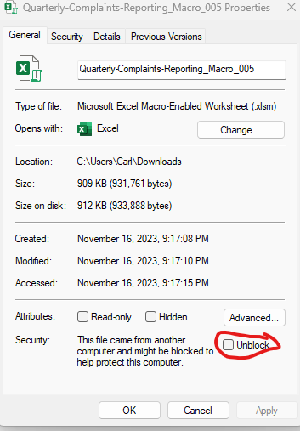
6. After downloading, enabled editing
7. 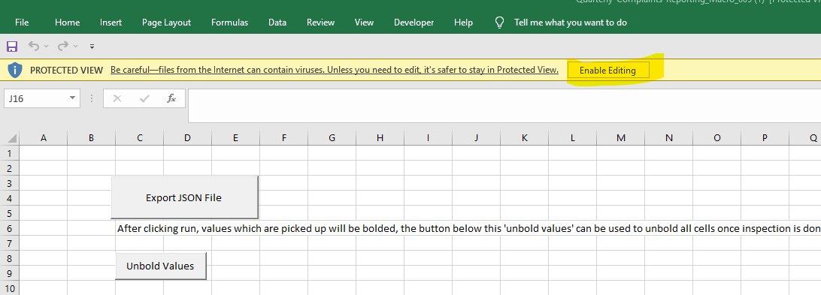

## Using the macro

There are two tabs in the document, “Record of complaint”, and “Run”

### TAB: Record of complaint

This is where the complaint data needs to go, many of the fields have field validation enabled to help with your data quality (One example: Anonymous must be either True of False)  
  
The first line is populated strictly as an example, this line should be **overwritten** when the macro is actually run.



Field: (primary-product-service, secondary-product-service)  
(primary-product-service, secondary-product-service) is a little bit different than other fields, it needs to be in a particular format, because the field can have 1 or more pairings as per the schema.

For 1 pairing use format:

(primary-product-service, secondary-product-service)

**Example: (Account, Estate)**

For 2 pairings use format

(primary-product-service, secondary-product-service) (primary-product-service2, secondary-product-service2)

**Example: (Account, Estate) (Other, Other)**

For “n” pairings, repeat the same format

(primary-product-service, secondary-product-service) (primary-product-service2, secondary-product-service2) …. (primary-product-serviceN, secondary-product-serviceN)

**Example: (Account, Estate) (Other, Other) (Mortgage, Agreement)**

#### General notes to allow the macro to work

* Don’t insert extra columns
* Don’t change header titles
* Ensure that all rows inserted are complete rows

### TAB: Run

The "Run" tab contains two buttons: "Export JSON File" and "Unbold Values". The "Record of Complaint" tab is where the user interacts with the data. Upon pressing the "Export JSON File" button, a JSON file is generated. This file will be located in the same directory where the script was executed and will follow the naming convention "QUARTERLY-COMPLAINTS-REPORTING_yyy-mm-dd_hh-MM-ss.json". The user can view this file by right-clicking and opening it in Notepad.

After the "**Export JSON File**" button is clicked, any **values** selected from the "Record of Complaint" tab will be bolded for the user's convenience. To unbold these values, the user should click the "Unbold Values" button.