**EXPERIMENT 8: PANDAS**

**PROBLEM 1**

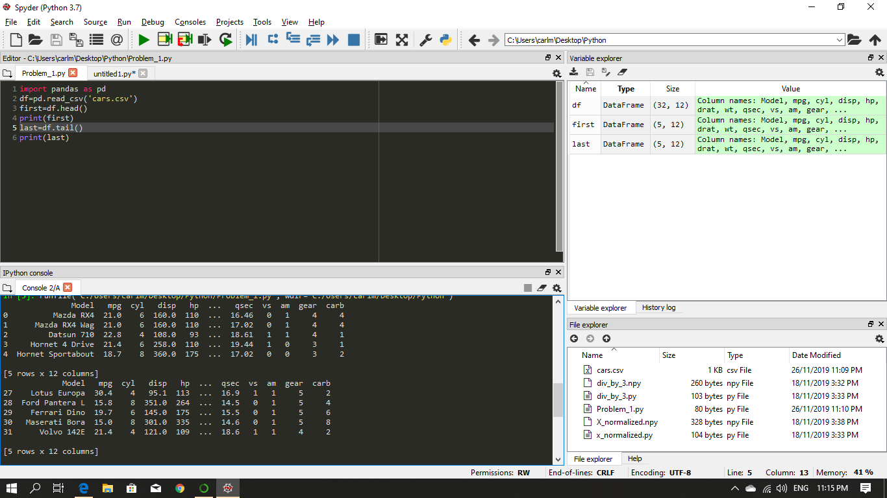

**PROBLEM 2.A**

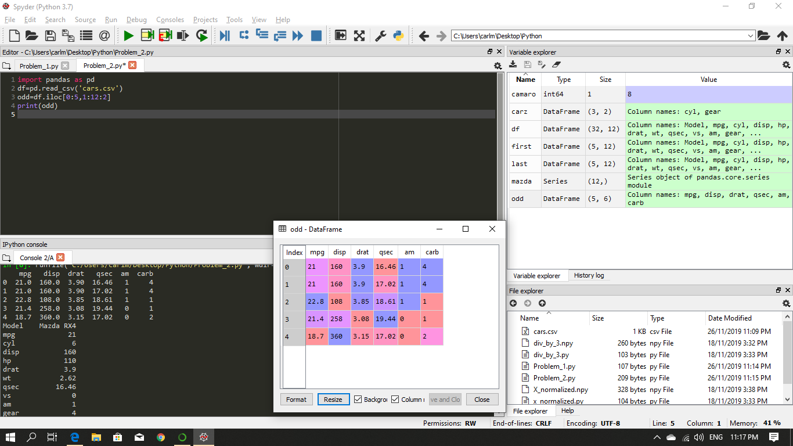

**PROBLEM 2.B**

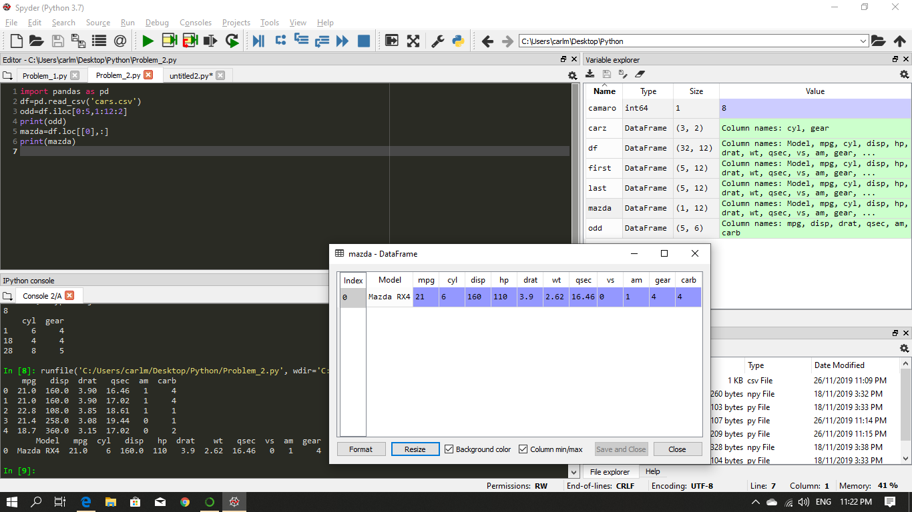

**PROBLEM 2.C**

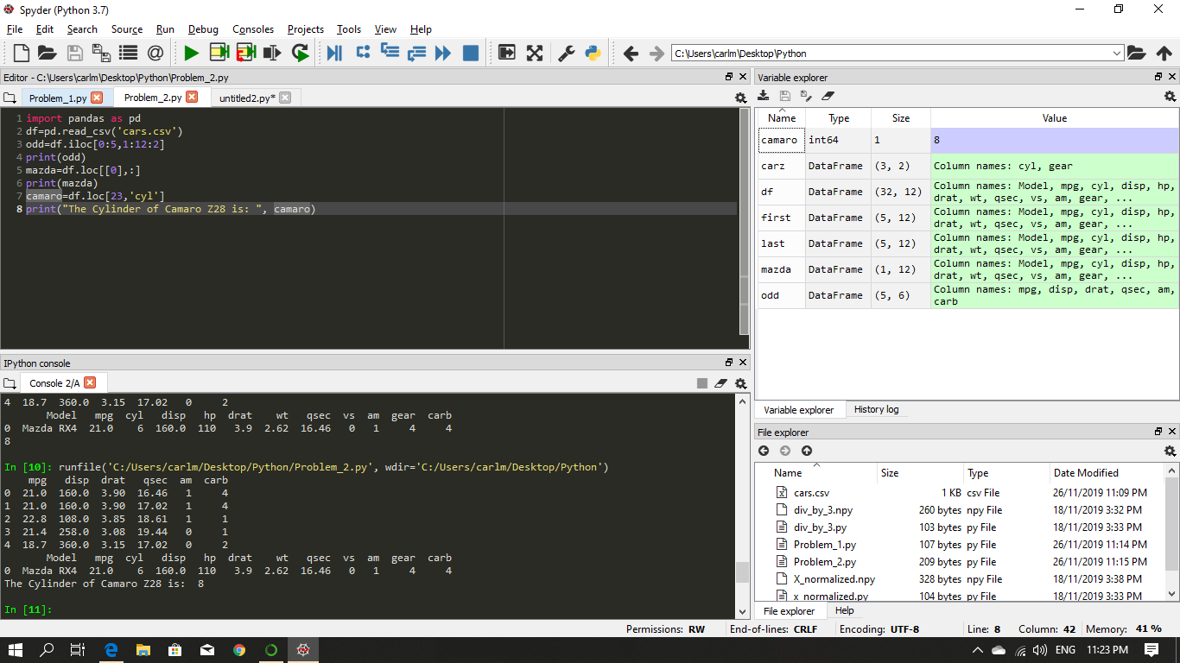

**PROBLEM 2.D**

