UNGOS, Carl Marco E.

2-ECE-B

Experiment 8 Pandas

Problem 1

A)

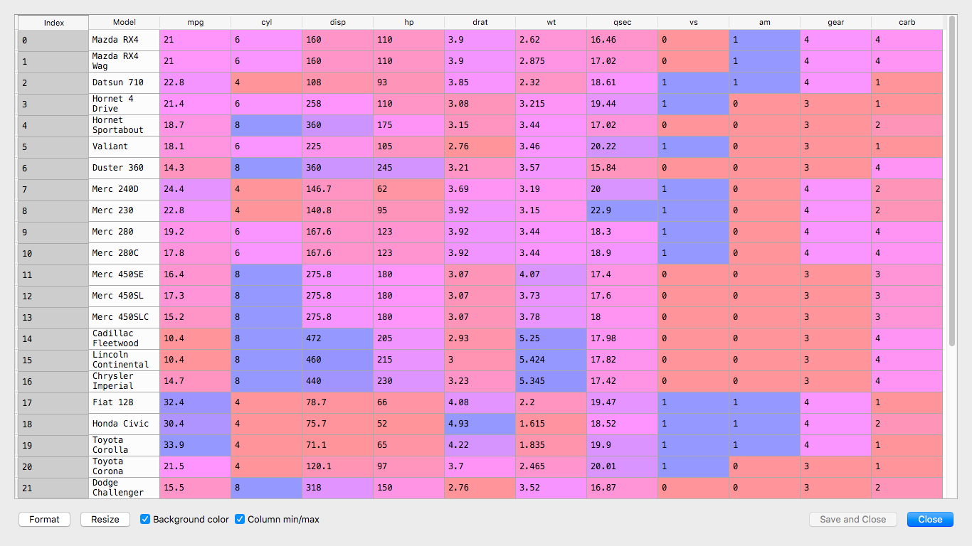

B)

Problem 2

A)

C)

D)

