Ungos, Carl Marco E.

2-ECE-B

**Experiment 9: Data Wrangling**

**Problem 1.a**

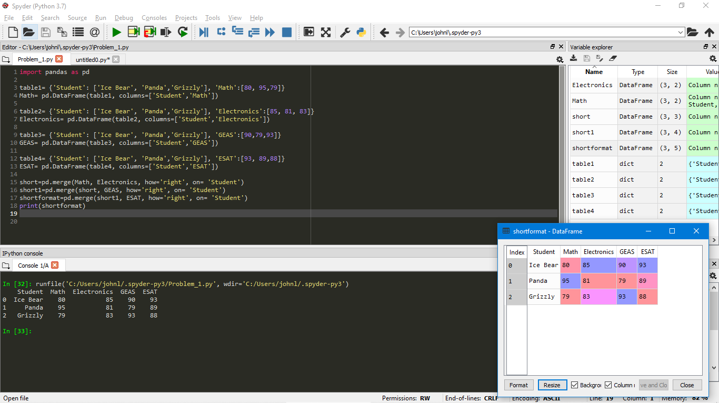

**Problem 1.B**

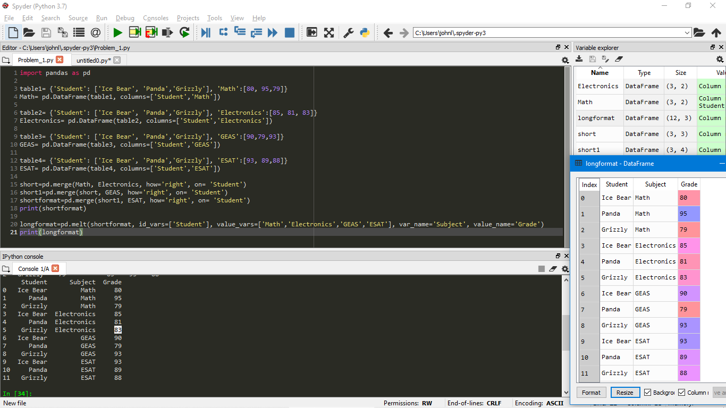

**Problem 2.A**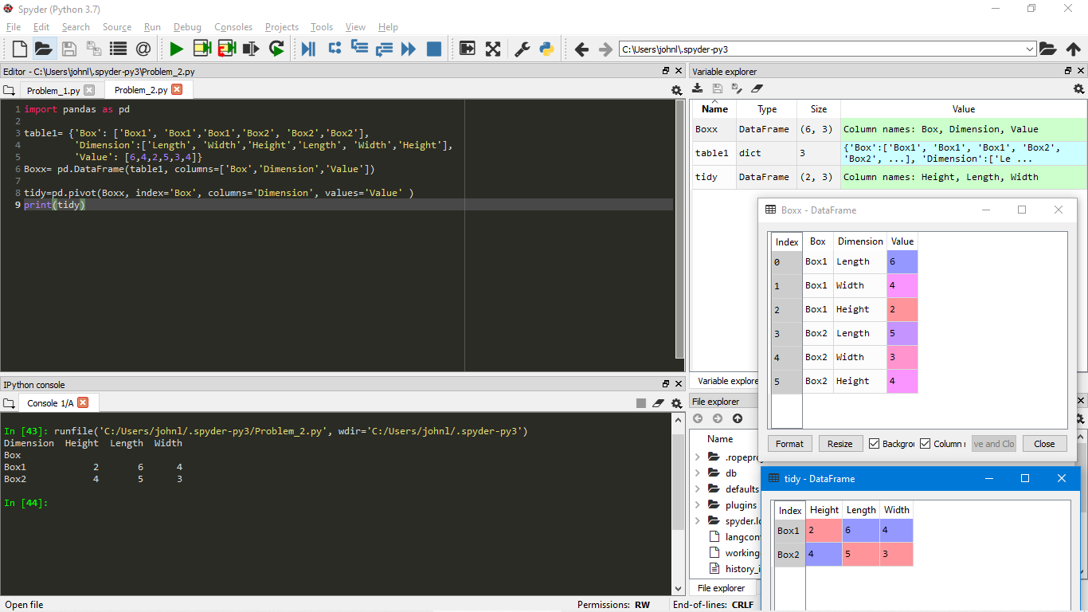

**Problem 2.B**

