Statistics and dIagnostic Graphs for HTS (SIGHTS) software
SIGHTS is a suite of normalization methods, statistical tests, and diagnostic graphical tools for high throughput screening (HTS) assays. SIGHTS software is implemented in the R statistical language and is accessed through Excel using the RExcel add-in package created by statconn (http://rcom.univie.ac.at/). RExcel only works on Microsoft Windows (XP, Vista, or 7) with Excel 2003, 2007, and 2010. SIGHTS has been tested on Windows XP and Vista for Excel 2003 and 2007 versions.

There are two files in the SIGHTS software suite.

- SIGHTS_Workbook_ver1.40.xls
This is the RExcel interface that contains the RExcel functionality.
- SIGHTS.r
This is the R code that is executed in the RExcel file. The user will typically not directly access the code in this file.

The workflow of a SIGHTS session is to open the RExcel workbook, load the data into an R object, and then apply the R commands which are written within Excel cells. The instructions below refer to the SIGHTS workbook with pre-set values. It’s a good idea to make a copy of the workbook to work on and to retain the original file for future reference.
There are certain limitations to making R code available in this way. Running the software can be a little clumsy but we hope that it will nonetheless prove useful for those who are not proficient in R. Experienced R users may prefer to use the SIGHTS.r file directly.
The citation for the software is:

Murie, C., Barette, C., Lafanechere, L., & Nadon, R. (2011). Improving detection of rare biological events in high-throughput screens, Journal, Vol., pages.

Installing RExcel

RExcel can be installed in one of two ways:
- RAndFriends
A windows executable available in the download section at http://rcom.univie.ac.at/. This will install all the necessary components, including R, to run RExcel. This is the recommended way to install RExcel if you do not already have R installed.
- RExcelInstaller
An R package called RExcelInstaller is available in the CRAN package repository (http://cran.r-project.org/). This is useful if you already have R installed.

After the installation process, a RExcel menu will appear on top.

Starting an RExcel session

  - Open “SIGHTS_Workbook_2007ver1.40.xlsx” in Excel.
Start the RExcel add-in by choosing the RExcel->Start R menu command (Note that it is necessary to close any existing R processes before starting RExcel as they may interfere with connecting to the R server).
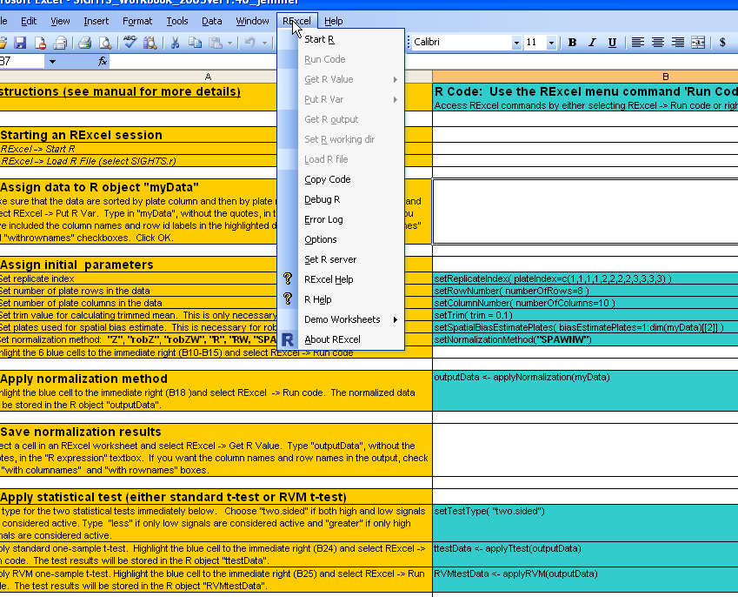
The R startup will take a few moments to complete. Once the startup has been completed, the topmost menu command will read “Disconnect R” and the R Console tab will appear in the Windows taskbar. To exit gracefully from a SIGHTS session, use this “Disconnect R” command before exiting Excel.
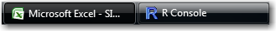
  - Load SIGHTS.r code file.
Select RExcel -> Load R file. This will open a pop-up box in which you can browse to the location of SIGHTSver1.40.r. Select the SIGHTSver1.40.r file and click “Open”.
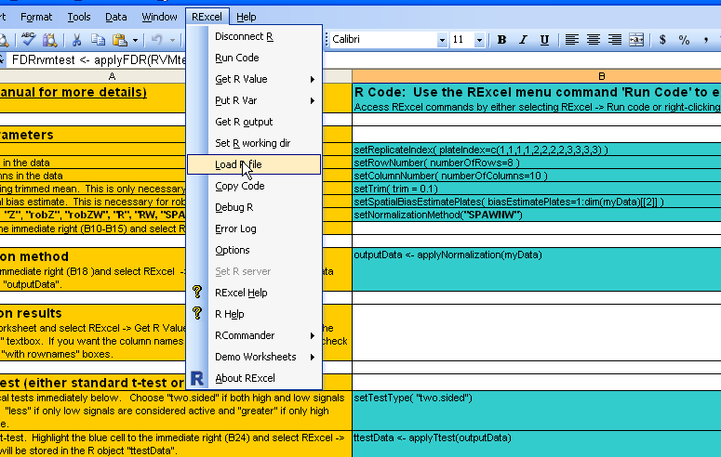
If this is the first time that you have used SIGHTS, a pop-up will appear asking you to choose a CRAN mirror site. Select a site near you and click OK. This will download and install the qvalue package for calculating the positive false discovery rate . You will need an internet connection to do this.
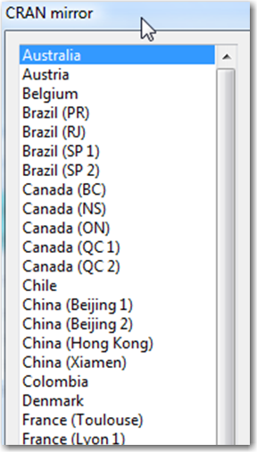
If the installation has been successful, the message “package 'qvalue' successfully unpacked and MD5 sums checked” will appear in the R Console Window.

Assign data to R object "myData"
This step loads the data set into R. The SIGHTS workbook contains a sample data set in the first worksheet, rawData, which will be used to illustrate the software. (To use your own data, paste the data into a new worksheet within the SIGHTS workbook). The sample data are derived from twelve 96-well HTS plates with the first and last columns containing positive and negative controls. The controls are not used in the SIGHTS methods and have been removed from the data, leaving 80 data points for each plate (8 rows and 10 columns).

The arrangement of the data

The data are arranged such that each Excel column contains data for one individual plate. The first two columns in the rawData worksheet show the plate row and column indices. The third column contains the compound IDs for the example data. The plate data must always be ordered first by column and then by row. In general, plates can be of any size but must be ordered in this way for the software to work correctly. Also, the data must form a complete matrix. If, for example, you had controls in the first two columns and in rows A and B of the 3rd column, you would need to include all of the rows in Column 3 and replace the two control values by blanks (i.e., empty cells).
Selecting the data to be analyzed

It is important to select the data as a single block. Do not select one column or row and then another – doing so will generate only partial data. Also do not select the data by selecting entire columns or rows since this will select all of the cells in the columns or rows, including the empty ones.

An easy way to select the data is to click the top left Excel cell of the data that you want to select and press “Ctrl-Shift-right arrow” on the keyboard followed by “Ctrl-Shift-down arrow”. Alternatively, you can left-click on the top left Excel cell and drag to the bottom right Excel cell of the data.
It is usually a good idea to include plate and feature ID labels (in blue font in the screenshot below), although it is not required. Note that only one row and one column with labelling information may be selected.

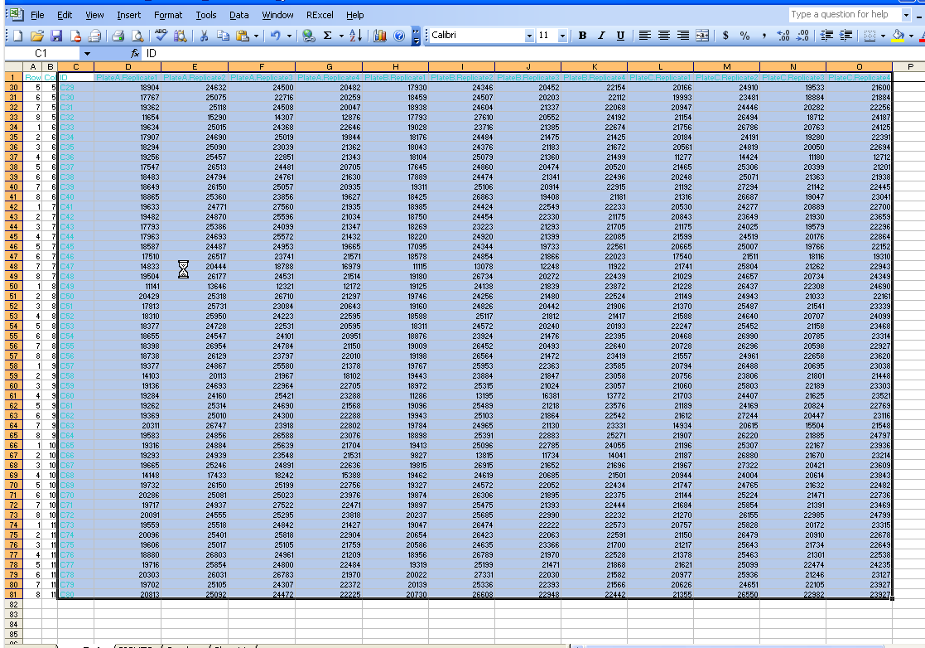
N.B. It is important to follow the instructions above when selecting the data. Select the data as shown in the screenshot. An easy way to do this is to click the top left Excel cell of the data that you want to select and press “Ctrl-Shift-right arrow” on the keyboard followed by “Ctrl-Shift-down arrow”. Do not select the data by selecting entire columns (this will select all of the rows in the file, including the blank ones).
Creating an R data array

Right-click on the selected data and choose the “Put R Var” menu command. Another way to do this is to use the RExcel menu, select "Put R Var", and then select “Array”.

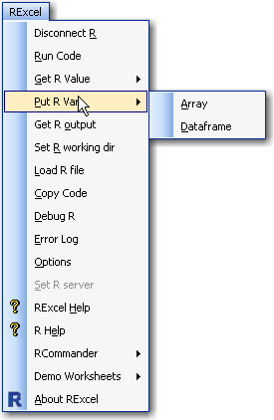
Type “myData” (without the quotes) in the “Array name in R” textbox. Be sure to check "with rownames" and "with columnames" because both plate labels and ID labels were selected in the previous step. Click OK. In R terminology, this step assigns the selected data to the R array object “myData”.

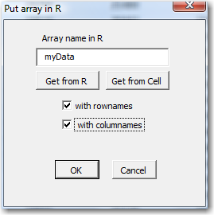

It is a good idea to verify that the data were assigned correctly. One way to do this is to verify the dimensions of the newly created “myData” array. In the present example, the dimensions should be 80 (rows) by 12 (columns). Typing the R command “dim(myData)” without the quotes in the R Console Window will output the dimension of the array “myData”. You can also view the first row of “myData” with the R command “myData[1,]” or the first column with “myData[,1]” to check if “myData” matches the selected RExcel data.

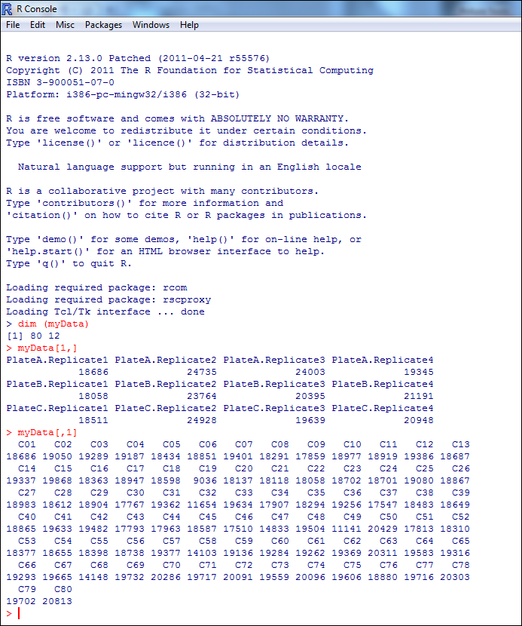

Assign initial parameters
The cells of the first column (orange fill) of the SIGHTS worksheet contain descriptions of the procedures and the second column (blue fill) contains, when appropriate, the R code to be executed. In the following vignette, R code will be run for one cell at a time. Once you have learned how to use the software, however, you may find it more convenient to select multiple cells and run them all with one command.
  - Set Replicate Index
The first parameter to be set is the plate label vector indicating the replicates, if any, of each plate. This parameter is called the replicateIndex and is located in cell B10 of the "SIGHTS" worksheet. There are three different compound plates (A, B, and C) with four replicates each (1 to 4) in the sample data. This can be seen in the column names in the first row. The replicateIndex is a vector of the same length as the number of plates selected when defining “myData” (i.e., the number of Excel columns, excluding the ID row identification column). For the sample data, the plates are ordered such that the 4 replicates for the first plate are in columns 1 through 4 of the data matrix, the 4 replicates of the second plate are in columns 5 through 8, and the 4 replicates of the third plate are in columns 9 through 12. The R vector defined in cell B10 describing this plate organization is as follows:

c(1,1,1,1,2,2,2,2,3,3,3,3)
This vector is correct for the sample data set but must be set individually for each particular data set. For example, if the plates had been ordered such that the first of the replicate runs for all three plates were in columns 1 to 3, the second replicate runs in columns 4 to 6, and so on, the replicate labels would have looked like this:
c(1,2,3,1,2,3,1,2,3,1,2,3)
The replicateIndex can be changed by double-clicking on the “setReplicateIndex” cell and manually changing the values.
The values in replicateIndex can be assigned in R by right-clicking on the cell containing the “setReplicateIndex” function (B10) and choosing the “Run code” menu option.

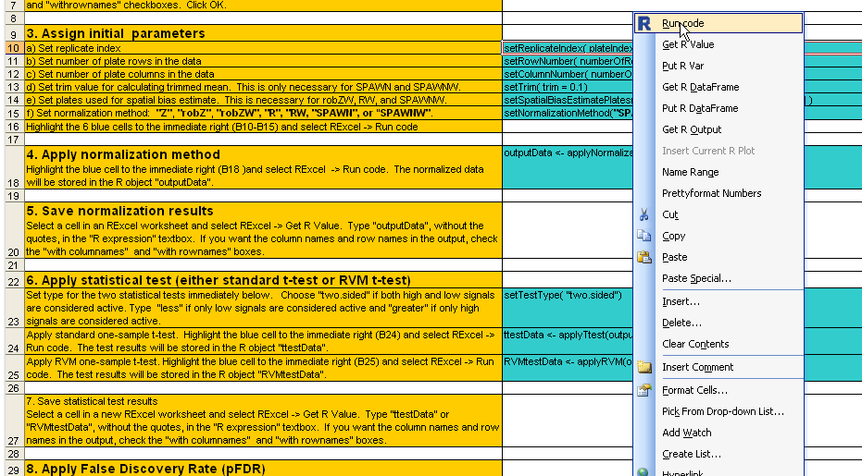
A message will be outputted in the R console, showing the values of the replicateIndex.

  - Set number of plate rows in the data
The B11 cell code assigns the number of rows of the plate using the setRowNumber function. In the present example, the correct number of rows (8) is already indicated (If you need to change the row number for other data, double-click on the cell and change the number to the desired value). Right-click on the cell and select “Run code”. A message will be outputted in the R console indicating the assigned number of rows.
  - Set number of plate columns in the data
The B12 cell code assigns the number of columns using the setColumnNumber function. In the present example, the correct number of columns (10) is already indicated (To change the column number for other data, double-click on the cell and change the number to the desired value). Right-click on the cell and select “Run code”. A message will be outputted in the R console indicating the assigned number of columns.

  - Set trim factor (for SPAWN only, with or without well correction)

SPAWN’s trim value is the proportion of high and low values to be excluded from rows and columns when calculating their trimmed means during the polish procedure. This is done with the “setTrim” function found in cell B13. A trim of 0 will result in no trimming (i.e., a mean will be calculated for each of the rows and columns); this is not recommended because the means will be unduly influenced by outliers. A trim of 0.5 will result in the median being used for trimming; this provides robust estimates of row and column effects but can introduce distortions to the data . Values between 0 and 0.5 generate trimmed means. The trimmed mean approach has been shown to have good robustness and reduces the number of false positives generated by the B-score . A good robustness/efficiency trade-off is often achieved with a trim of 0.1 for 96-well plates and 0.2 for 384 and 1536 well-plates, although higher trim values should be considered if a larger proportion of true hits is expected within some columns or rows.

The default trim value is set to 0.1. Double-click on the B13 cell if you wish to change it. Right-click on the cell and choose “Run Code” to assign the defined trim value. A message showing the trim value will be outputted in the R console.

  - Set spatial bias estimate plates

Optionally, well correction can be applied as an additional normalization to three normalization methods within SIGHTS (Robust Z, R, and SPAWN). For a discussion of the normalization procedures, see Murie, C., Barette, C., Lafanechere, L., & Nadon, R. (2011). Improving detection of rare biological events in high-throughput screens, Journal, Vol., pages. Well correction requires that the additional spatialBiasEstimatePlates parameter, contained in cell B14, be set. This is a vector that indicates which plates in “myData” are to be used for estimating the well biases.

The default is to use all of the plates, in which case this setting does not need to be changed. If you wish to use a subset of the plates, however, double-click on the B14 cell and modify the vector accordingly. If you want to include the first plate (Excel column) defined in “myData” you would include the number 1 in the vector. Similarly if you want to include the second plate you would include the number 2, and so on.

For example if you only wanted to use the first three and the last three plates of the sample data (i.e., the first and last three columns in the myData matrix), you would change the text in cell B14 from (altered text in blue)

setSpatialBiasEstimatePlates( biasEstimatePlates=1:dim(myData)[[2]] )

to

setSpatialBiasEstimatePlates( biasEstimatePlates= c(1,2,3,10,11,12))

Once you’re done, right-click on the cell and choose “Run code”. A message showing the value of spatialBiasEstimatePlates will be outputted to the R console.

  - Set normalization method

There are four normalization methods offered in SIGHTS:

- Z score
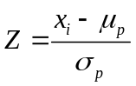
where x_{i} is the signal intensity of the i^{th} compound and μ_{p} and σ_{p} are the mean and standard deviation of the raw well intensities of a given plate, respectively. The mean and standard deviation are calculated excluding controls.
In the B15 cell, replace “SPAWN” by “Z”. Right-click on the cell and select “Run code”. A message will be outputted in the R console:

The following three methods provide an additional well normalization step which, depending on the study design, may be desirable. Individual well normalization is accomplished by shifting the score for each well location by the spatial bias template estimate, which is the median of the scores at the i^{th} row and j^{th} column of plates in the screen (The default setting of all plates can be modified to use a subset only). The resulting scores are then rescaled again by dividing by the MAD of each plate.
- Robust Z
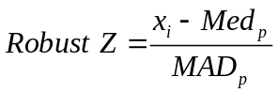
where x_{i} is the signal intensity of the i^{th} compound and Med_{p} and MAD_{p} are the median and median absolute deviation of the raw well intensities for a given plate, respectively (excluding controls).
In the B15 cell, replace “SPAWN” by “robZ” or, if you wish to use the well normalization option, by “robZW”. For this latter option, the robust Z is first calculated for all plates. The median value for each well across plates defined in cell B14 by the bias template (explained in section “3e - Set spatial bias estimate plates” above) is then subtracted from the corresponding well for each of the plates. Plate values are rescaled anew by dividing by the MAD of each plate. Once you have made your choice, right-click on the B15 cell and select “Run code”. A message will be outputted in the R console.
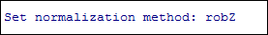
or
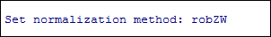

- R score
Wu et al. used a robust regression procedure to fit the following linear model:
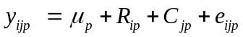

where y_{ijp} is the well value for the i^{th} row and j^{th} column of the p^{th} plate, μ _{p} is the grand mean of the p^{th} plate, R_{ip} is the i^{th} row effect, C_{jp} is the j^{th} column effect, and e_{ijp} is the residual for the i^{th} row, j^{th} column of the p^{th} plate. Parameters are estimated by the R statistical language’s rlm function from the MASS package . In the SIGHTS version of the method, robust Z values are calculated for each plate prior to applying the regression algorithm. R scores are the e_{ijp} residuals produced by the model rescaled by dividing by the standard deviation estimate from the regression function.
In the B15 cell, replace “SPAWN” by “R or, if you wish to use the well normalization option, by “RW”. Right-click on the cell and select “Run code”. A message will be outputted in the R console.
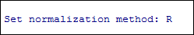
or
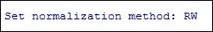

- SPAWN
The Spatial Polish And Well Normalization (SPAWN) method uses a trimmed mean polish on individual plates to remove row and column effects. Data from each well location on each plate are initially fitted to the same model as the R score. Model parameters are estimated with an iterative polish technique as with the B-score but with a trimmed mean, rather than a median, as a measure of central tendency for the row and column effects. The e_{ijp} residuals are rescaled by dividing by the median average deviation (MAD) of their respective plates.
In the B15 cell, keep “SPAWN” as is or, if you wish to use the well normalization option, replace “SPAWN” by “SPAWNW”. For this latter option, the SPAWN is first calculated for all plates. The median value for each well across plates defined in cell B14 by the bias template (explained in section "3e - Set spatial bias estimate plates" above) is then subtracted from the corresponding well for each of the plates. Plate values are rescaled anew by dividing by the MAD of each plate.
Once you have made your choice, right-click on the B15 cell and select “Run code”. A message will be outputted in the R console.
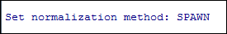
or
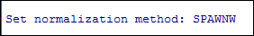

Apply normalization method

Right-clicking on cell B18 and choosing “Run code” runs the normalization method selected in cell B15 on the “myData” data set defined in section 2 - Assign data to R object "myData".

Save normalization results

To save the normalization results, open a new worksheet in the SIGHTS workbook and right-click in the top upper left hand cell (Cell A1). Choose the “Get R Value” menu option. Type "outputData" in the R expression textbox. If you want the row and column labels be sure to check "with rownames" and "with columnames" boxes, and then click OK. It is a good idea to rename this new worksheet to keep track of the normalization method used (i.e., ZData, RobZData, RobZWData, RData, RWData, SPAWNData, or SPAWNRWData)

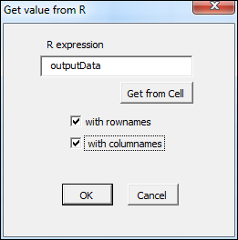

Apply statistical test (either standard t-test or RVM t-test)

First set the direction of the statistical test in cell B23. Choose "two.sided" if both high and low signals are considered active. Type "less" if only low signals are considered active and "greater" if only high signals are considered active. The default is to apply a two-sided test. Select RExcel -> Run code to select the type of one sample test.

Select to apply either a standard one-sample t-test (“applyTtest”) or the RVM one-sample t-test (“applyRVM”) to the normalized data (“outputData” defined in cell B18). To run a one-sample t-test, right-click on cell B24 and select RExcel -> Run code. To run a one-sample RVM t-test, right-click on cell B25 and select RExcel -> Run code.

After the statistical test is complete, a message will be outputted to the R console.

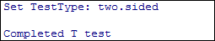
or

N.B. If you use the RVM one-sample t-test, it is recommended that you check that the across-replicate variances are distributed according to an inverse gamma distribution (a key assumption of the model). Cell A18 of the Graphs worksheet shows how to do this. See also Malo et al. and Wright and Simon . The screenshot below shows that the assumption is met for the SPAWN normalized data (because the theoretical and empirical cumulative distribution curves overlap) but not for the raw data.

SPAWN | Raw Data
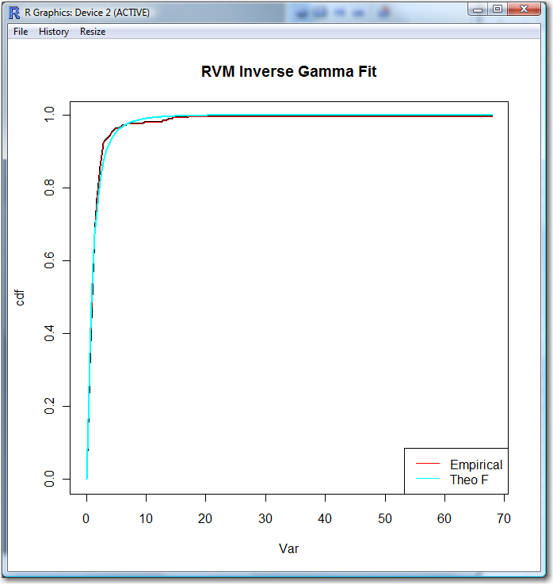 | 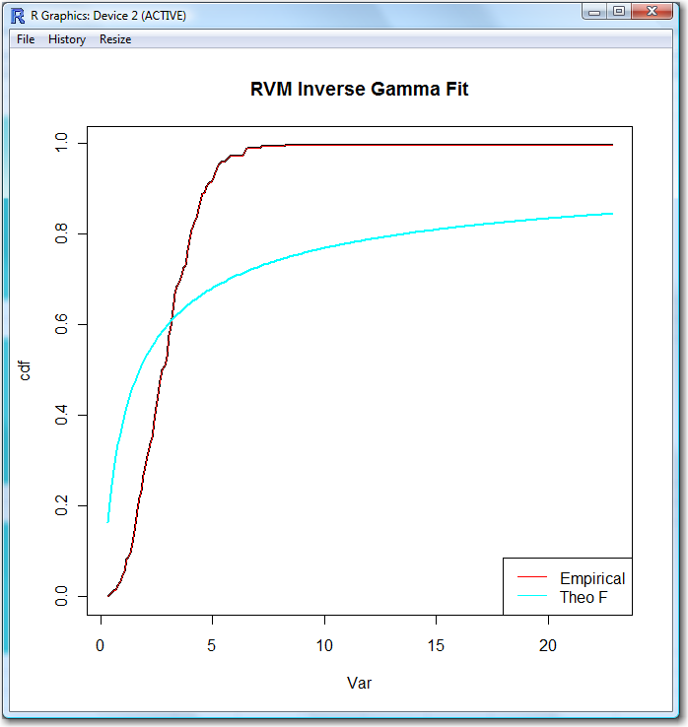

Save statistical test results

To save the statistical test results, select the top left cell (A1) in a new RExcel worksheet and select RExcel -> Get R Value. Type "ttestData" or "RVMtestData", without the quotes, in the "R expression" textbox. If you want the column names and row names in the output, check the "with columnames" and "with rownames" boxes. Make sure to rename the worksheet to include the test used (i.e., ttest, RVMtest).

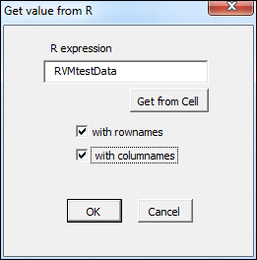

Apply False Discovery Rate (FDR)

False Discovery Rate (FDR) procedures can be used to control the proportion of false positives in your results. The FDR method implemented in SIGHTS is the positive false discovery (pFDR) procedure of Storey . It is necessary to set the method used in Storey's pFDR estimation before applying the pFDR procedure. Type either "smoother", the default, or "bootstrap" inside cell B31. Select RExcel -> Run code. See http://genomics.princeton.edu/storeylab/qvalue/ for details.

Right-clicking on cell B31 and choosing “Run code” runs the pFDR procedure on the standard t-test results ; right-clicking on cell B32 runs the pFDR procedure on the RVM t-test results. The results will be stored in the R object “FDRttest” for the standard t-test and in “FDRrvmtest” for the RVM t-test. A message will be outputted to the R console.
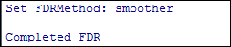

Save pFDR results

To save the pFDR results, open a new worksheet in the workbook and right-click in the upper left hand cell. Choose the “Get R Value” menu option. Type either “FDRttest” for the standard t-test or “FDRrvmtest” for the RVM t-test, without the quotes. If you want the column names and row names in the output, check the "with columnames" and "with rownames" boxes. Make sure to rename the worksheet to include which pFDR procedure was used (i.e., FDRttest or FDRrvmtest).

Graphics

When selecting data to graph, copy and paste the columns and rows needed in the graph to a new worksheet, then select the data as described in section 2. As mentioned above, it is important to select the data as a single block. Do not select one column or row and then another – doing so will generate only partial data. Also do not select the data by selecting entire columns or rows since this will select all of the columns or rows in the file, including the blank ones.

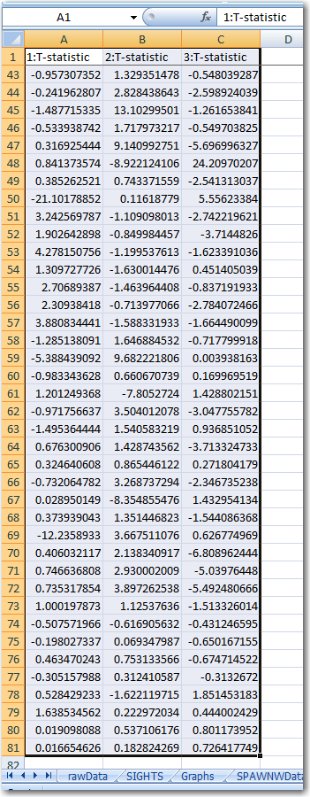

Various graphs are available. Detailed instructions can be found in the worksheet labelled "Graphs".
N.B. If you experience difficulty generating one of the graphs, try closing the R Graphics window if it is open and retry generating the desired graph.

Acknowledgements

We thank Richard Simon and George Wright for permission to incorporate some of their original RVM code into the SIGHTS software. We also thank Jennifer Button and Haig Djambazian for testing the software and for providing useful suggestions.

References

Brideau, C., Gunter, B., Pikounis, B., & Liaw, A. (2003). Improved statistical methods for hit selection in high-throughput screening. Journal of Biomolecular Screening, 8(6), 634-647.
Makarenkov, V., Zentilli, P., Kevorkov, D., Gagarin, A., Malo, N., & Nadon, R. (2007). An efficient method for the detection and elimination of systematic error in high-throughput screening. Bioinformatics, 23, 1648-1657.
Malo, N., Hanley, J. A., Carlile, G., Liu, J., Pelletier, J., Thomas, D., & Nadon, R. (2010). Experimental design and statistical methods for improved hit detection in high-throughput screening. Journal of Biomolecular Screening, 15(8), 990-1000.
Malo, N., Hanley, J. A., Cerquozzi, S., Pelletier, J., & Nadon, R. (2006). Statistical practice in high-throughput screening data analysis. Nature Biotechnology, 24(2), 167-175.
Storey, J. D. (2002). A direct approach to false discovery rates. Journal of the Royal Statistical Society: Series B (Statistical Methodology), 64(3), 479-498.
Venables, W. N., & Ripley, B. D. (2002). Modern applied statistics with S (4th ed.). New York: Springer.
Wright, G. W., & Simon, R. M. (2003). A random variance model for detection of differential gene expression in small microarray experiments. Bioinformatics, 19(18), 2448-2455.
Wu, Z. J., Liu, D. M., & Sui, Y. X. (2008). Quantitative assessment of hit detection and confirmation in single and duplicate high-throughput screenings. Journal of Biomolecular Screening, 13(2), 159-167.

