Yellow Taxi vs. Uber/Lyft in New York City 2025
A Big Data Analysis following CRISP-DM
Group Project, Big Data
Master in Analytics, Universidad de La Sabana
Lecturer: Rodolfo Meza
Benedikt Urth
Carlo Twyrdy
Yorlieth González
October 2026
Repository: github.com/carlo120702/nyc-taxi-vs-uber-lyft

Contents

Abstract
Yellow taxis served 15.3 % of the 287.1 million passenger trips in New York City in 2025, against 61.3 % for Uber and 23.4 % for Lyft. This project analyses all Yellow Taxi and High Volume For-Hire Vehicle (HVFHV) trip records of 2025 published by the NYC Taxi & Limousine Commission (TLC), 24 Parquet files with 6.8 GB and 292.3 million raw rows, following the CRISP-DM methodology.
A recurring ETL flow orchestrated with Prefect cleans and harmonises both sources in parallel with Dask, applies eight data quality rules per file and loads only aggregated KPI tables into a PostgreSQL database on AWS RDS. A Grafana dashboard presents the results to management.
Three findings stand out. First, the taxi has become a niche product of Manhattan and the airports, with about 30 % of pickups in Manhattan and below 8 % in every other borough. Second, it remains price-competitive on trips under five miles and earns tips of 22 % on card payments, against 4 to 5 % for the apps. Third, a baseline model using only place and time reaches a ROC-AUC of 0.867 in predicting whether a trip is a taxi trip, while rainy weather does not shift the market split.
Keywords: big data, CRISP-DM, Dask, Prefect, AWS RDS, Grafana, NYC taxi, ride-hailing.

1. Introduction and Business Understanding
Since app-based ride-hailing entered New York City, the yellow taxi has lost most of its trips. A mobility operator, a fleet owner or the regulator itself needs to know where, when and at what price the taxi still competes. This project answers that question with the complete trip records of 2025 and follows the six phases of CRISP-DM [1]: business understanding, data understanding, data preparation, modelling, evaluation and deployment.
TABLE I
PROJECT DEFINITION
Element | Definition in this project
Business question | Where, when and at what price can Yellow Taxi still compete with Uber and Lyft?
Analysis objective | Compare the three services on demand, price, trip characteristics and tipping by zone, hour, weekday and month, and prepare a model that predicts whether a trip is served by a yellow taxi
Unit of analysis | One completed passenger trip (one row = one trip)
Target variable | is_taxi = 1 if the trip was a Yellow Taxi trip, 0 if Uber or Lyft
Period | 1 January to 31 December 2025

The competition between taxi and app services was chosen as our own angle because the TLC data is widely used for generic analyses of fares and tips. Comparing two sources with different schemas also makes the data preparation and the Big Data tooling more demanding.

2. Data Understanding
The dataset is the TLC Trip Record Data [2], published as one Parquet file per month and service. Together the two sources used here hold 6.79 GB and 292.3 million rows, more than four times the 1.5 GB required by the assignment.
TABLE II
DATA SOURCES AND VOLUME
Source | Content | Files | Size (GB) | Raw rows | Columns
fhvhv_tripdata_2025-MM | High Volume For-Hire Vehicles: Uber (HV0003) and Lyft (HV0005) | 12 | 5.96 | 243,589,684 | 25
yellow_tripdata_2025-MM | Yellow Taxi trips recorded by the taximeter | 12 | 0.83 | 48,722,602 | 20
Total |  | 24 | 6.79 | 292,312,286

The two sources describe the same event, a paid trip, with different schemas. Table III shows how their key columns were mapped to one harmonised schema in src/pipeline.py.
TABLE III
MAPPING OF BOTH SOURCES TO THE HARMONISED SCHEMA
Harmonised column | Yellow Taxi column | Uber/Lyft column
service | constant "Yellow Taxi" | hvfhs_license_num mapped to Uber or Lyft
pickup_datetime | tpep_pickup_datetime | pickup_datetime
trip_miles | trip_distance | trip_miles
fare (base fare) | fare_amount | base_passenger_fare
tip | tip_amount | tips
total_paid | total_amount | sum of fare, tolls, fees, taxes and tips
cbd_fee | cbd_congestion_fee | cbd_congestion_fee
driver_pay | not recorded | driver_pay
wait_min | not recorded | pickup_datetime minus request_datetime
card_payment | payment_type = 1 | always 1 (in-app payment)

Both sources reference pickup and drop-off locations by a numeric LocationID (1 to 265). Without the TLC zone lookup these IDs cannot be interpreted, which is why it was added as context data (Section 6).

3. Data Preparation and Data Quality
Cleaning removed 9.7 % of the Yellow Taxi rows but only 0.2 % of the Uber/Lyft rows, leaving 287,129,085 trips for the analysis. Each raw month is read in batches of one million rows, mapped to the harmonised schema and filtered by six rules applied in a fixed order; every removed row is counted for the first rule it violates.
TABLE IV
CLEANING RULES AND SHARE OF REMOVED ROWS
Cleaning rule | Threshold (config.py) | Yellow Taxi removed | Uber/Lyft removed
Missing pickup time or zone | any null | 0.00 % | 0.00 %
Pickup outside the file's month | year/month differ | 0.00 % | 0.00 %
Invalid duration | under 1 min or over 180 min | 2.28 % | 0.02 %
Invalid distance | 0 or over 100 miles | 2.10 % | 0.02 %
Invalid fare | 0 or negative, or over 500 USD | 5.29 % | 0.16 %
Implausible speed | over 80 mph | 0.01 % | 0.00 %
Total removed |  | 9.67 % | 0.19 %

Negative fares are refunds and voided transactions that the taximeter stores as separate rows; they make up 5.8 % of all raw Yellow Taxi rows. Trips with unknown zones (264, 265) were kept, because the trip itself is valid, and appear as zone "Unknown" in the zone analysis.
Besides cleaning, the Prefect flow evaluates eight quality rules per source and month (row count, expected columns, shares of missing keys, out-of-period rows, negative fares, zero distances, unknown zones and total removed rows). Of the 192 checks, 16 failed, all for Yellow Taxi: the share of negative fares exceeded 5 % in nine months and the total removed share exceeded 10 % in seven months, peaking at 13.2 % in November. The results are stored in the table quality_check in AWS and shown in the dashboard.
Some gaps are structural rather than errors and were therefore documented, not imputed. Taxi cash tips are not recorded by the meter, and the meter records neither the request time nor the driver's pay, so waiting time and driver share exist only for Uber and Lyft.

4. Exploratory Data Analysis
The EDA in notebooks/01_eda.ipynb was computed with Dask over all 287.1 million clean trips. Its central result: the taxi holds a stable 14 to 16 % of trips every month, concentrated in Manhattan and at the airports, with shorter and cheaper trips and much higher tips than the apps.

4.1 Central Tendency and Dispersion
TABLE V
MEAN AND MEDIAN BY SERVICE
Variable | Statistic | Yellow Taxi | Uber | Lyft
Base fare (USD) | mean / median | 19.96 / 19.10 | 27.62 / 22.80 | 25.19 / 21.43
Distance (miles) | mean / median | 3.50 / 2.24 | 5.09 / 3.27 | 4.83 / 3.27
Duration (min) | mean / median | 17.3 / 15.6 | 19.9 / 17.6 | 19.7 / 17.4
Tip (USD) | mean / median | 3.04 / 3.00 | 1.17 / 0.00 | 1.26 / 0.00
Total paid (USD) | mean / median | 28.79 / 25.94 | 34.63 / 27.45 | 31.91 / 26.62
Trips | count | 44,009,192 | 175,898,263 | 67,221,630

All money and distance variables are right-skewed: the mean lies above the median because a small number of long airport trips pulls it up (Fig. 1). For management reporting the median, or ratios computed from totals, are therefore more robust than single averages. The median Uber or Lyft passenger tips nothing, while the median taxi passenger tips 3 USD.
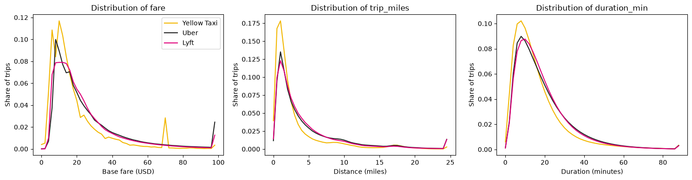
Fig. 1. Distributions of base fare, distance and duration by service (share of each service's trips).

4.2 Market Share over Time, Zone and Hour
Over 2025, Uber served 61.3 % of trips, Lyft 23.4 % and Yellow Taxi 15.3 %. The taxi share stays between 13.7 % and 16.4 % in every month (Fig. 2). By weekday it varies only between 14.6 % (Friday to Sunday) and 16.3 % (Tuesday), so taxis are slightly stronger on working days.
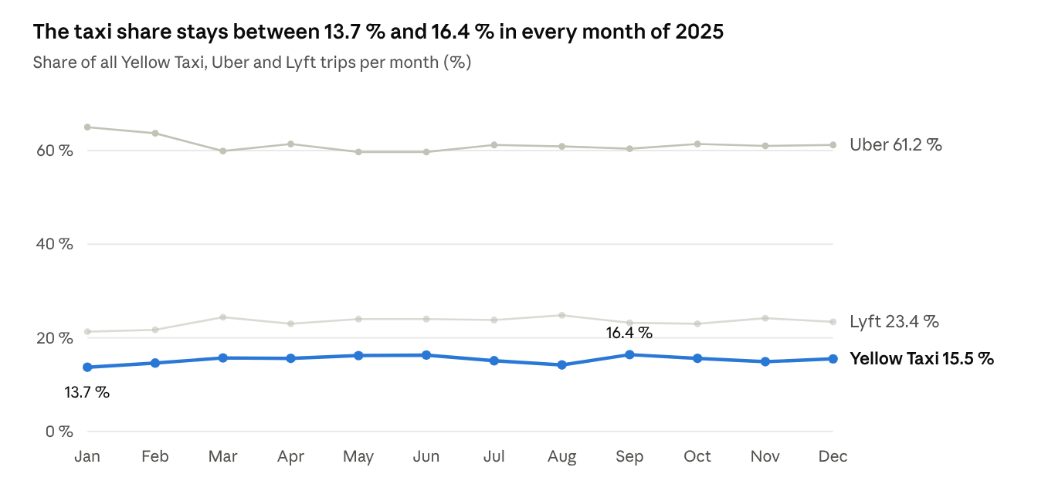
Fig. 2. Market share per month, January to December 2025.
The time of day matters more than the weekday. The taxi share falls to about 7 % at 5 a.m. and rises to about 18 % between noon and 3 p.m. (Fig. 3). All three services peak in the evening around 6 p.m.
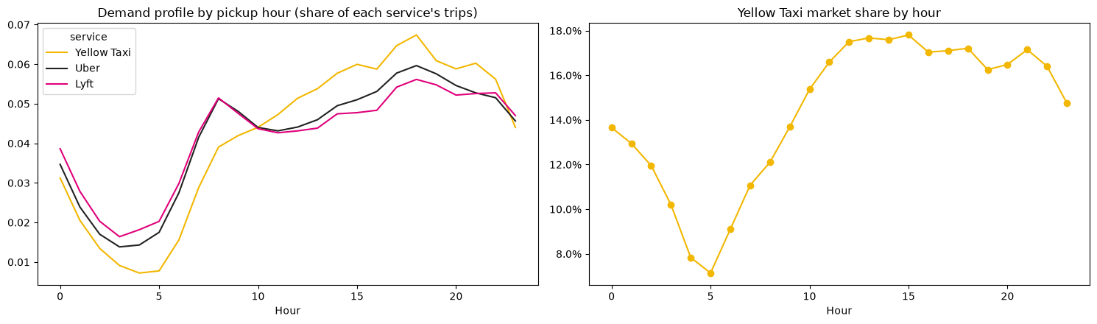
Fig. 3. Demand profile by pickup hour (left) and Yellow Taxi market share by hour (right).
The city-wide share hides strong regional differences (Fig. 4). Taxis may pick up street hails, which are frequent only in Manhattan and at the airports. In Manhattan they serve about 30 % of pickups, in Queens about 7 %, in Brooklyn, the Bronx and Staten Island almost none. In single zones the taxi still leads: 62 % of pickups at Central Park and about 50 % on the Upper East Side. The busiest taxi pickup zones are Upper East Side South (2.0 M trips), Midtown Center (1.9 M) and JFK Airport (1.9 M).
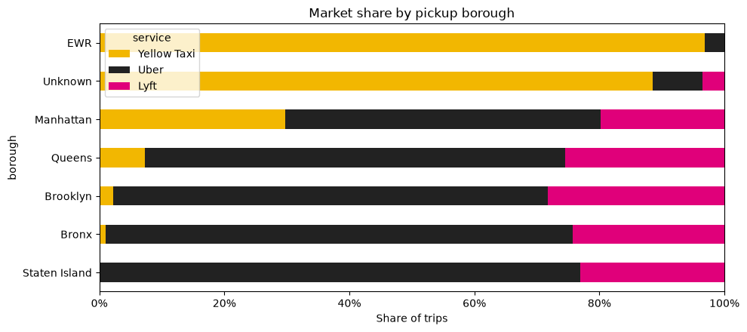
Fig. 4. Market share by pickup borough.

4.3 Price
The comparison uses the base fare before tips, taxes and surcharges, because surcharges differ by law between taxis and app services. Up to five miles the taxi is cheaper than Uber in every distance band; Lyft prices are close to the taxi.
TABLE VI
AVERAGE BASE FARE BY DISTANCE BAND (USD)
Distance band | Yellow Taxi | Uber | Lyft
up to 1 mile | 8.44 | 10.63 | 8.61
1 to 2 miles | 12.40 | 14.19 | 12.88
2 to 3 miles | 17.31 | 19.24 | 17.52
3 to 5 miles | 22.93 | 24.42 | 23.22
5 to 10 miles | 33.81 | 34.57 | 33.72
10 to 20 miles | 59.41 | 58.54 | 57.43
over 20 miles | 92.79 | 114.85 | 100.31

Per mile over all trips the taxi appears more expensive (5.71 USD against 5.42 for Uber and 5.21 for Lyft), but only because taxi trips are shorter on average and short trips always cost more per mile. The distance bands remove this composition effect. Fig. 5 shows how the price per mile of the apps varies with the time of day.
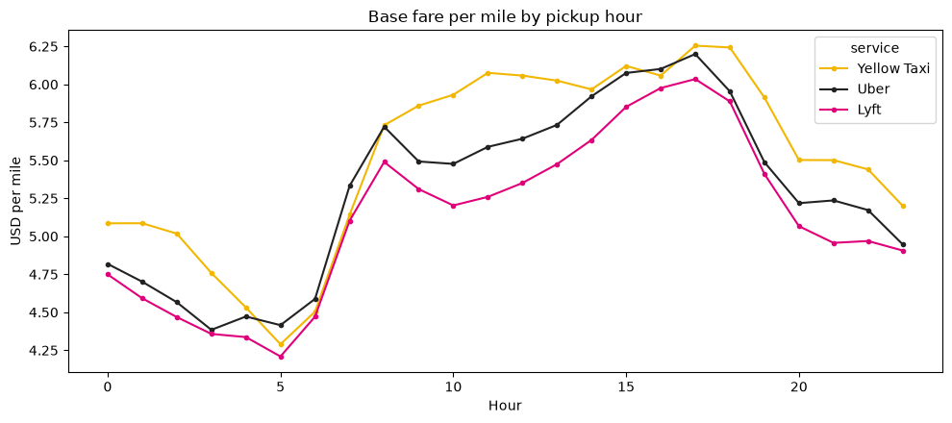
Fig. 5. Base fare per mile by pickup hour.

4.4 Tips
TABLE VII
TIPPING BY SERVICE
Service | Trips with a tip | Tip as share of fare, card payments
Yellow Taxi | 65.5 % | 22.0 %
Lyft | 20.3 % | 5.0 %
Uber | 18.5 % | 4.2 %

In the taxi data only card tips are recorded: card payments carry 130.3 M USD of tips on 593.0 M USD of fares, cash payments only 3.5 M USD on 285.6 M USD. Tip analysis is therefore restricted to card payments. A plausible cause of the gap is the taxi payment screen, which suggests tips of 20 to 30 %.

5. Target Variable, Features and Baseline Model
Place and time alone predict well whether a trip is a taxi trip: a baseline model reaches a ROC-AUC of 0.867. The target is_taxi is imbalanced, with 44.0 M positive trips (15.3 %) against 243.1 M negative ones (84.7 %). Models must therefore be evaluated with ROC-AUC, PR-AUC, precision and recall rather than accuracy, and trained with class weights or resampling.
Only features known at the moment a trip starts were used. Fare, tip, total paid and duration were excluded on purpose, because they are a consequence of the service chosen and would leak the target.
TABLE VIII
CANDIDATE FEATURES
Feature | Source | Rationale
hour, day_of_week, month | pickup time | taxi share depends on the time of day
pu_borough, do_borough, pu_service_zone | TLC zone lookup | street hails are allowed only in the Yellow Zone and at airports
trip_miles | trip record | taxi trips are shorter
is_airport | zone ID (JFK, LGA, EWR) | dedicated taxi ranks at the airports
precip_mm, temp_mean_c | Open-Meteo weather | tests whether bad weather shifts demand

As a feasibility check for the modelling phase, a HistGradientBoostingClassifier from scikit-learn [8] with balanced class weights was trained on a random sample of 499,995 trips (70 % training, 30 % test, stratified).
TABLE IX
BASELINE MODEL RESULTS
Metric | Model | Random baseline
ROC-AUC | 0.867 | 0.500
PR-AUC | 0.513 | 0.153

The permutation importance (Fig. 6) shows that the pickup service zone dominates, followed by trip distance and the drop-off borough. Time variables add little, and the weather variables add nothing. The variable is therefore suitable for a full modelling phase with zone-level features.
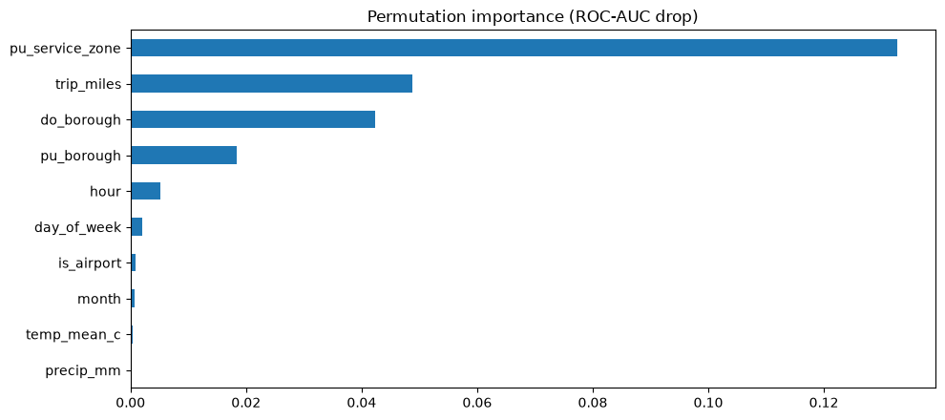
Fig. 6. Permutation importance of the baseline model (drop in ROC-AUC).

6. Additional Context Information
Two external sources were required and integrated; further context would be needed to explain some findings. The trip records reference zones only by number, and they contain no information on weather.
TABLE X
CONTEXT DATA
Context data | Source | Use in the project | Status
Taxi zone lookup (265 zones) | TLC [2] | LocationID to borough, zone name and service zone | integrated
Daily weather, Central Park | Open-Meteo [7] | temperature, precipitation, snowfall per day, joined to daily_kpi | integrated
Reasons for refunds and voids | TLC (not public) | explain the rising share of negative fares | missing
Surge multipliers, active vehicles | Uber, Lyft (not public) | explain price differences by hour | missing
Requests not served | all services (not public) | measure unmet demand | missing

The weather data led to a clear negative result. On days with at least 5 mm of rain the taxi share was 15.4 %, on dry days 15.3 %. Rain raises demand slightly for all three services (taxi trips per day from 119,700 to 124,600), but it does not shift passengers from apps to taxis. Temperature correlates negatively with daily Uber trips (r = -0.29) and positively with the taxi share (r = 0.26).

7. Recurring ETL with Prefect
The Prefect [3] flow nyc-taxi-vs-uber-lyft-etl (flows/etl_flow.py) processes only source-months that are not yet in the database, so a new monthly TLC file is cleaned, checked, analysed and loaded by simply running the flow again. All transformation logic lives in src/pipeline.py, which the flow, the Dask benchmark and the EDA notebook share, so every step uses the same rules (Fig. 7).
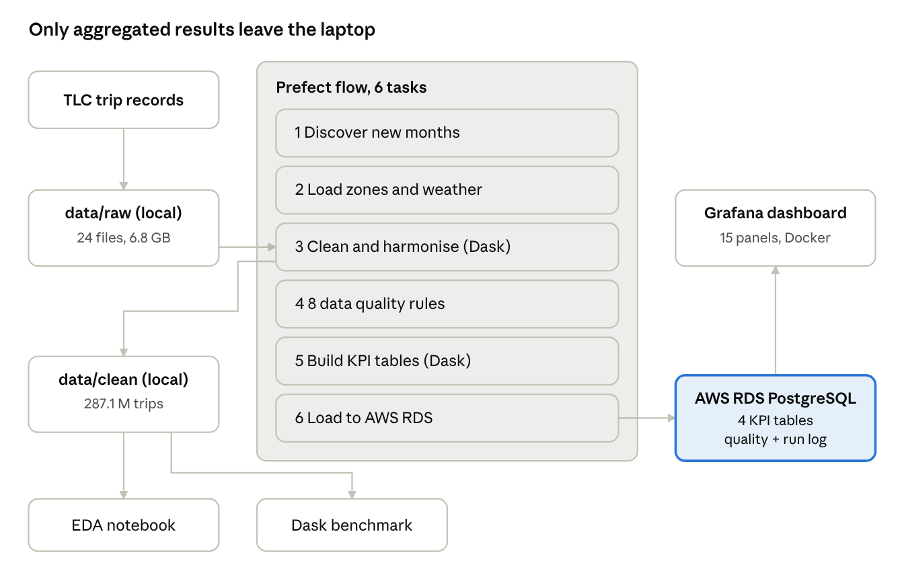
Fig. 7. Project architecture: only aggregated results leave the laptop.
TABLE XI
TASKS OF THE PREFECT FLOW
Task | What it does | Tool
discover-new-files | compares the raw files in data/raw with the (source, year, month) keys already in AWS | SQLAlchemy
load-context-data | loads the zone lookup and daily weather | pandas
clean-and-harmonise-dask | maps both schemas to one, applies the cleaning rules, writes data/clean | Dask, PyArrow
data-quality-checks | 8 rules per source and month, results to quality_check | Python
build-aggregates-dask | computes the four KPI tables in one Dask pass | Dask
load-to-aws-rds | deletes and re-inserts the affected months (idempotent) | SQLAlchemy ORM

Every run that processes data is logged in the table etl_run_log with start, end, status, Dask configuration and number of trips.
TABLE XII
EXECUTION HISTORY (PREFECT FLOW RUNS)
Run | Status | Duration | Cause and result
vehement-trout (8 Oct, 17:37) | failed | 6 s | no .env file yet, so the flow tried a local database instead of AWS RDS; fixed by creating .env with the RDS endpoint
unique-partridge (8 Oct, 17:43) | failed | 4 min 56 s | two Uber/Lyft files (April, August) were truncated during download; the download script now verifies each file and downloads incomplete ones again
neat-jackrabbit (8 Oct, 18:05) | failed | 6 min 58 s | Dask workers ran out of memory because a whole Uber/Lyft month was read as one partition; fixed by one partition per Parquet row group
quaint-oryx (8 Oct, 18:17) | success | 6 min 5 s | 287,129,085 trips in 24 source-months; 192 checks, 16 warnings; 4 tables loaded
cinnamon-dodo (9 Oct, 08:54) | success | 4 s | "24 source-months available, 0 to process": no new files

The run "cinnamon-dodo" writes nothing to AWS, because a run without new files has nothing to load. It demonstrates the recurring behaviour: without new data nothing is reprocessed. A new month (for example python src/download_tlc.py --year 2026 --month 1) would be the only file processed in the next run. The flow can be scheduled monthly with a Prefect deployment. Fig. 8 shows the run history, Fig. 9 the task graph of the full run "quaint-oryx", where the analysis task with about five minutes dominates the run time.
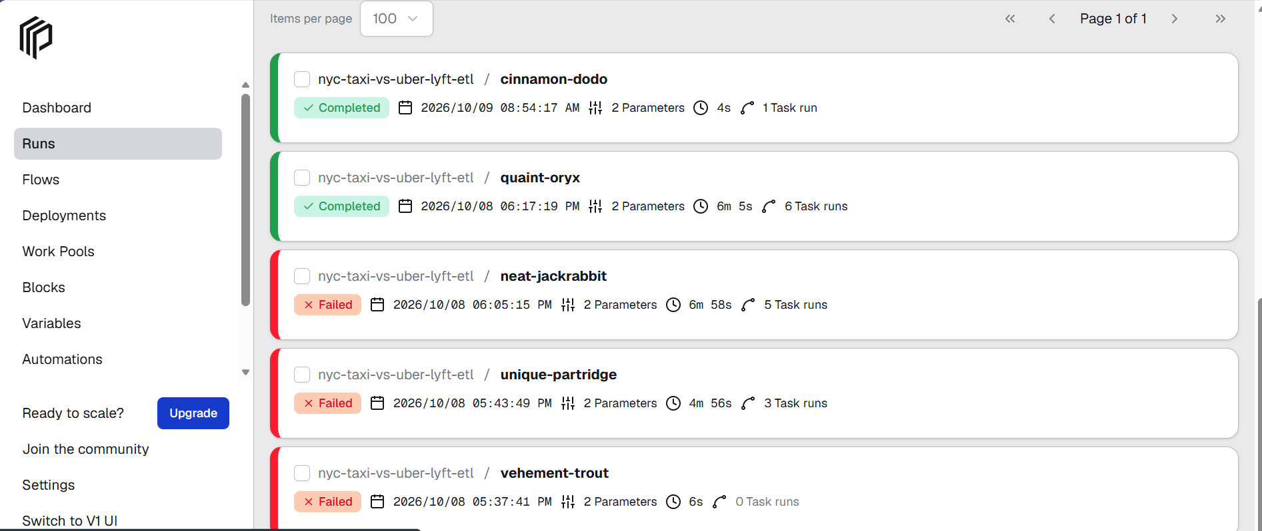
Fig. 8. Prefect UI: run history of the flow, three failed runs during development, the full run and the recurring run without new files.
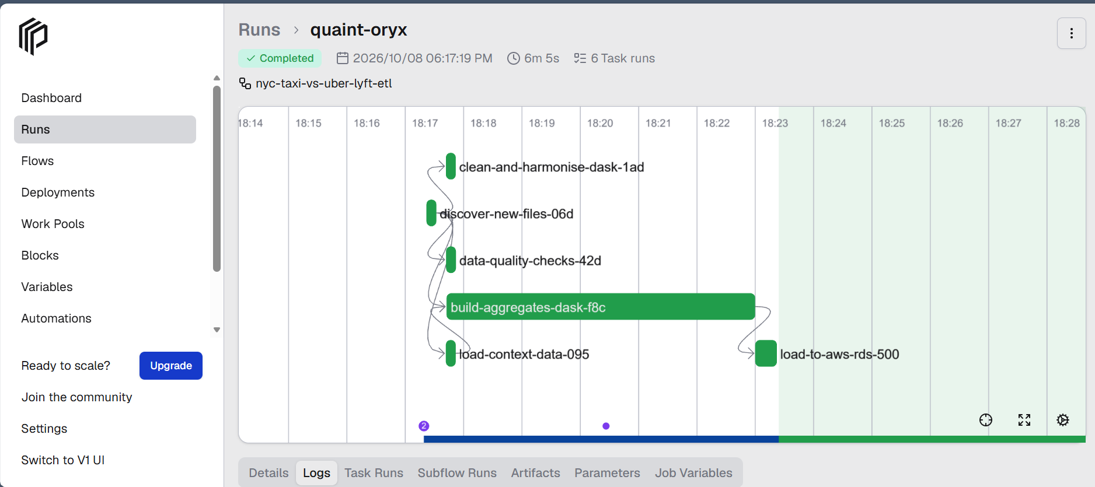
Fig. 9. Prefect UI: task graph of the successful full run "quaint-oryx", 6 tasks, 6 min 5 s.
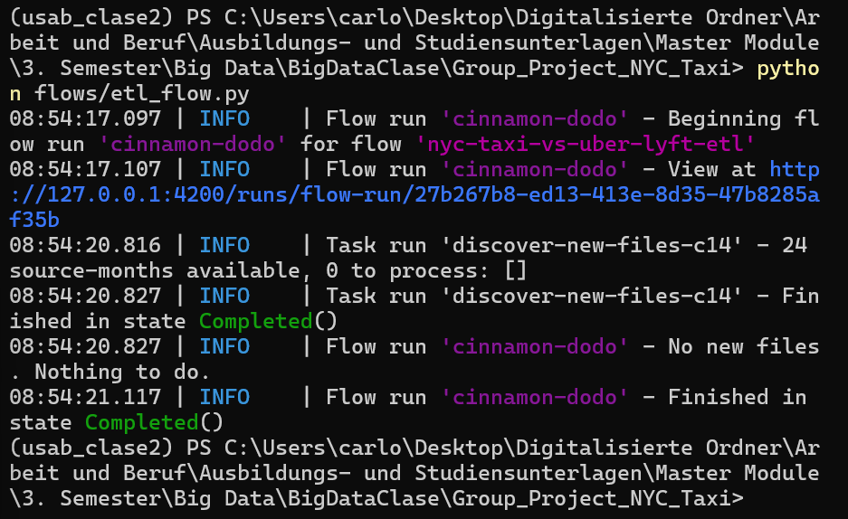
Fig. 10. Terminal output of the run "cinnamon-dodo" (9 October 2026): the flow finds 24 source-months, 0 to process, and ends with "No new files. Nothing to do."

8. Distributed Processing with Dask
With the same total resources, two large workers processed the full year 35 % faster than four small ones (286 s against 441 s). Dask [4] is used in two places: the cleaning step runs one task per source-month in parallel, and the analysis reads the 287.1 M clean trips as one lazy DataFrame of 305 partitions and computes all KPI tables in a single pass.
The benchmark src/dask_benchmark.py ran the descriptive statistics and the KPI aggregation twice per configuration on a laptop with an Intel i7-1185G7 (4 cores, 8 threads) and 32 GB RAM. Both configurations use 8 threads and 12 GB in total, so only the split into workers differs. Values are medians of two runs.
TABLE XIII
DASK BENCHMARK (MEDIAN RUNTIME IN SECONDS)
Configuration | Workers x threads | Memory per worker | Descriptive statistics | KPI aggregation | Total
A_2workers_6GB | 2 x 4 | 6 GB | 59 | 227 | 286
B_4workers_3GB | 4 x 2 | 3 GB | 106 | 335 | 441

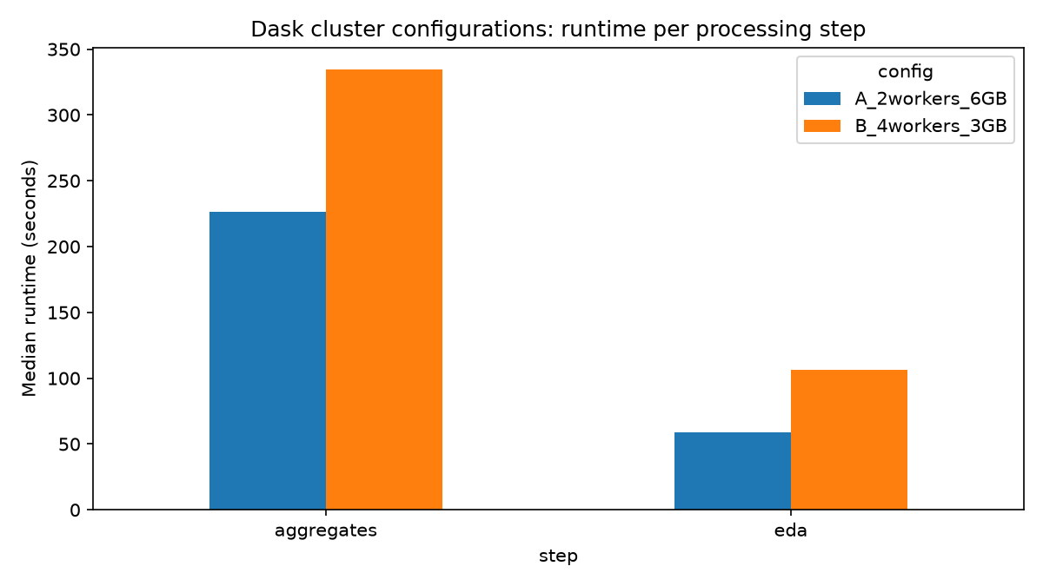
Fig. 11. Runtime per processing step for both Dask configurations.
A plausible explanation is the data exchange between worker processes: group-by results and shuffles must travel between processes, and with two processes there is less to exchange than with four. Configuration A was therefore made the default for the flow and the notebook.
The second lesson concerns partition size. In the first full run each Uber/Lyft month (about 20 million trips, several GB in memory) became a single partition, which exceeded the 3 GB limit of a worker, and Dask terminated the workers (KilledWorker). Reading one partition per Parquet row group (at most one million trips, about 150 MB) solved the problem. Partition size and memory per worker must be planned together.

9. Results Database in AWS RDS
Only 16,541 rows of results reach AWS, not the 6.8 GB of raw data, as the assignment requires. The database is a PostgreSQL instance on Amazon RDS [5] (db.t3.micro, AWS Academy Learner Lab, instance groupproject-taxi, database nyctaxi), accessed through SQLAlchemy ORM models defined in src/db.py. The credentials are read from a local .env file that is excluded from GitHub.
TABLE XIV
RESULT TABLES IN AWS RDS
Table | Grain | Rows | Main content
service_month_kpi | month x service | 36 | trips, spending, fares, distance, duration, tips, card tips, congestion toll, airport trips, waiting time, driver pay
zone_month_kpi | month x pickup zone x service | 9,362 | trips, spending, fares, with borough, zone and service zone
hour_weekday_kpi | month x weekday x hour x service | 6,048 | demand, fare per mile, speed, waiting time
daily_kpi | day x service | 1,095 | trips and spending joined with temperature and precipitation
quality_check | run x source x month x rule | 192 per run | value, threshold and pass/fail of each quality rule
etl_run_log | run | 1 per run | start, end, status, Dask configuration, trips processed

The KPI tables store sums (for example fare_sum, miles_sum, card_tip_sum) next to the averages. A dashboard can then re-aggregate any time range correctly, for instance fare per mile as the sum of fares divided by the sum of miles, instead of averaging averages. The load is idempotent: the rows of the affected (year, month, source) are deleted before they are inserted again, so a repeated run never creates duplicates.

Fig. 12. Grafana data source test against the AWS RDS instance: "Database Connection OK".
[Insert screenshot: RDS instance groupproject-taxi in the AWS console]

10. Management Dashboard in Grafana
A Grafana [6] dashboard with 15 panels gives management the main findings at a glance and can be filtered by service and time range. Grafana 11.2 runs in Docker; the PostgreSQL data source on AWS RDS and the dashboard are provisioned from files in the folder grafana/, so the setup is reproducible with one command.
TABLE XV
STRUCTURE OF THE DASHBOARD
Row | Panels | Question answered
Headline | trips, taxi market share, passenger spending, taxi share of spending | How big is the market and what share does the taxi hold?
Development | trips per month by service, market share per month | Is the taxi losing ground during the year?
Where and when | market share by borough, trips by pickup hour | Where and when does the taxi compete?
Price and service | fare per mile, tip rate on card payments, average trip | How do price and trip profile differ?
Zones and apps | zones where the taxi is strongest, waiting time and driver share of Uber/Lyft | Which zones should a taxi operator focus on?
Operations | ETL runs and data quality, daily trips against precipitation | Is the data current and reliable?

The headline row shows 287.1 M trips, a taxi market share of 15.3 %, passenger spending of 9.5 billion USD and a taxi share of spending of 13.3 % (Fig. 13). The taxi's share of spending is below its share of trips because taxi trips are shorter.
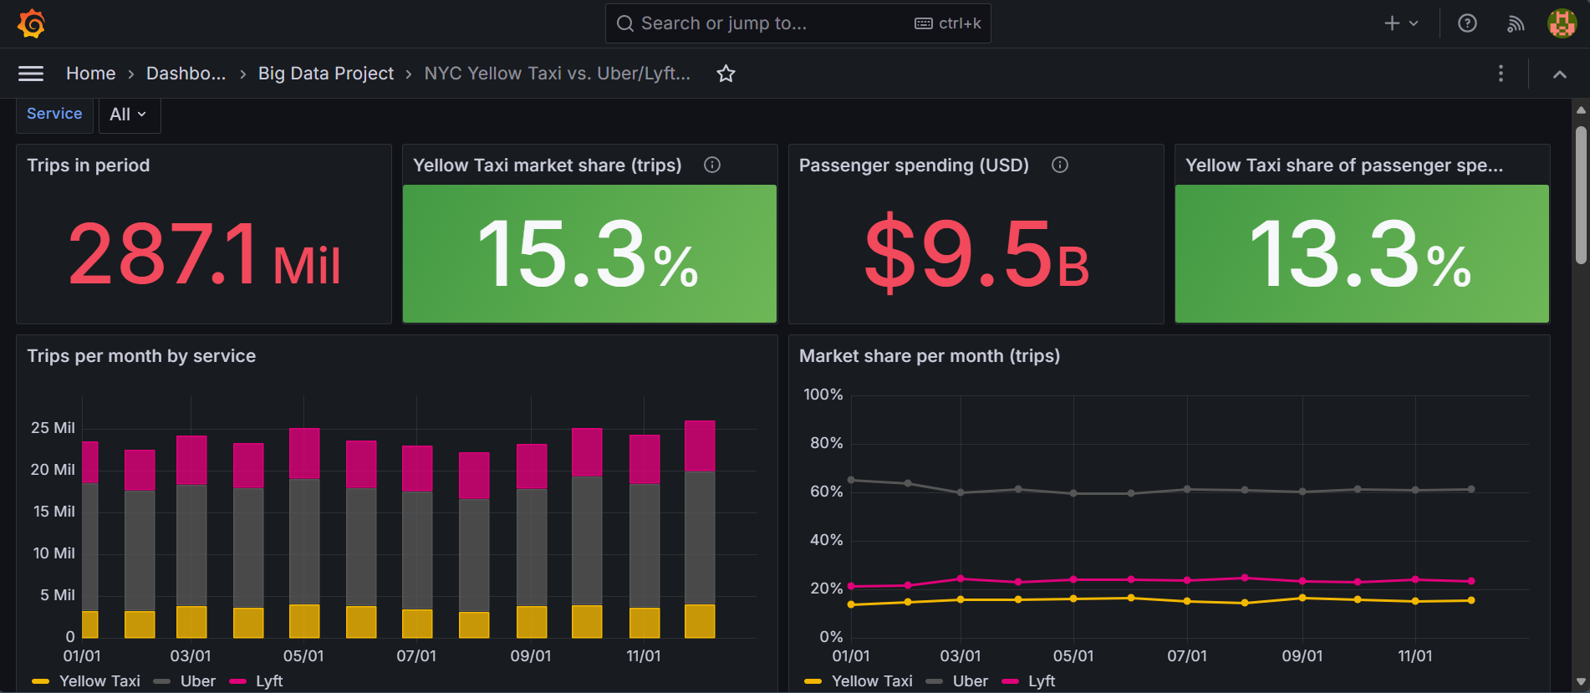
Fig. 13. Grafana headline row and monthly development.
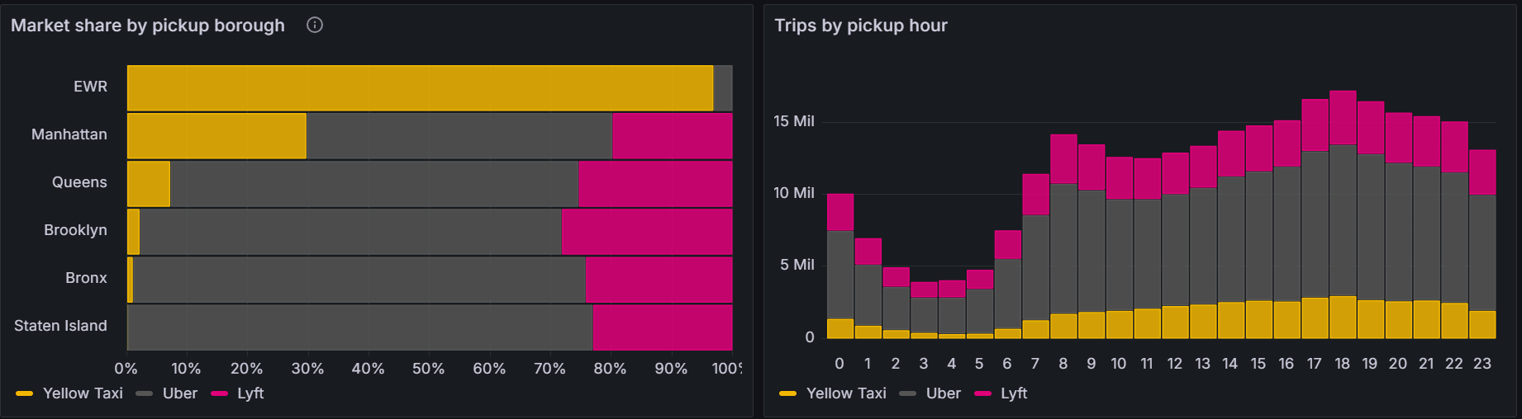
Fig. 14. Grafana: market share by pickup borough and trips by pickup hour.
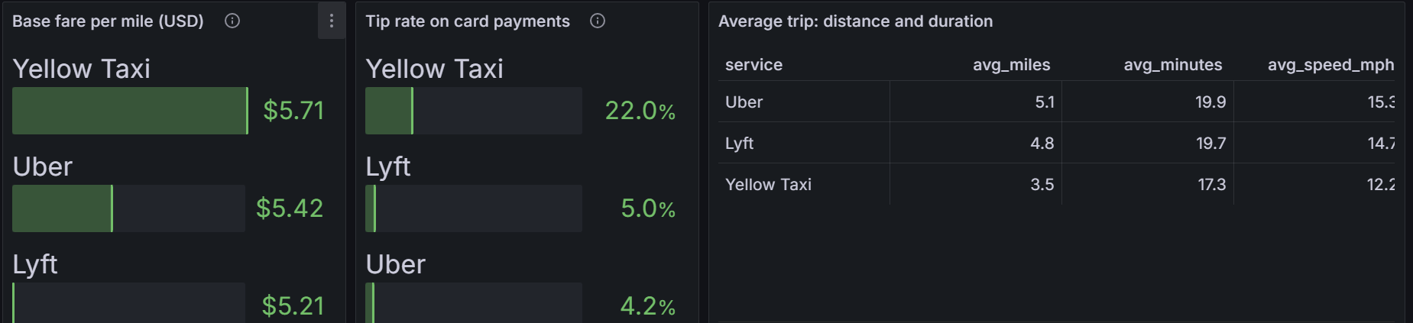
Fig. 15. Grafana: base fare per mile, tip rate on card payments and average trip by service.
During testing all panels first showed no data. The Grafana macro $__timeFilter() splits its argument at commas, so make_date(year, month, 1) was broken apart; replacing the macro by an explicit BETWEEN $__timeFrom() AND $__timeTo() fixed it.

11. Conclusions
The yellow taxi has not disappeared, but it has become a niche product of Manhattan and the airports. The analysis of 287.1 million trips leads to five conclusions.
- Market position. The taxi serves 15.3 % of trips and receives 13.3 % of passenger spending. Its share is stable over 2025 (13.7 % to 16.4 % per month), so the decline has levelled off.
- Geography and time decide. In Manhattan the taxi serves about 30 % of pickups and leads in single zones such as Central Park (62 %); outside Manhattan it plays almost no role. Its share is highest at midday (about 18 %) and lowest at night. A taxi operator should concentrate fleet and dispatch on Manhattan and the airports during the day.
- Price and tips. On trips up to five miles the taxi base fare is below Uber's in every distance band, by about 20 % under one mile. Card-paying taxi passengers tip 22 %, app users 4 to 5 %, which makes taxi driving attractive in short-trip markets.
- Predictability. Place and time alone predict a taxi trip with a ROC-AUC of 0.867, driven mainly by the pickup service zone, while rainy weather does not change the market split. The target variable is_taxi is suitable for a full modelling phase.
- Data quality. The taximeter data needed far more cleaning (9.7 % removed) than the app data (0.2 %). The rising share of refunds in the taxi data during 2025 is a finding in itself and requires context from the TLC.
On the technical side, the project shows that a laptop with Prefect and Dask can process close to 300 million records in a recurring and incremental way, provided that partition size and worker memory are planned together, and that only a few thousand rows of results need to reach the cloud for management reporting.

12. Limitations and Future Work
Limitations.
- Taxi cash tips are not recorded, so tip comparisons cover card payments only.
- The comparison uses base fares; surcharges, tolls and the congestion toll differ by law between services and are only included in total spending.
- Only 2025 was analysed, so long-term trends cannot be shown.
- The baseline model was trained on a 0.17 % sample and was not tuned or cross-validated.
- Borough shares quoted from the dashboard were read from a chart and are approximate.
Future work.
- Full modelling phase with zone-level features and cross-validation.
- Add 2023 and 2024 to analyse the trend of the taxi share.
- Schedule the Prefect flow monthly as a deployment, since TLC publishes one new file per month.
- Clarify the cause of the rising refund share with the TLC.
[Feedback from the presentation on 10 October to be added here]

References
[1] R. Wirth and J. Hipp, "CRISP-DM: Towards a standard process model for data mining," in Proc. 4th Int. Conf. Practical Applications of Knowledge Discovery and Data Mining, Manchester, U.K., 2000, pp. 29-39.
[2] NYC Taxi & Limousine Commission, "TLC Trip Record Data." [Online]. Available: https://www.nyc.gov/site/tlc/about/tlc-trip-record-data.page
[3] Prefect Technologies, "Prefect documentation." [Online]. Available: https://docs.prefect.io
[4] M. Rocklin, "Dask: Parallel computation with blocked algorithms and task scheduling," in Proc. 14th Python in Science Conf. (SciPy), Austin, TX, USA, 2015, pp. 126-132.
[5] Amazon Web Services, "Amazon RDS for PostgreSQL." [Online]. Available: https://aws.amazon.com/rds/postgresql/
[6] Grafana Labs, "Grafana documentation: PostgreSQL data source." [Online]. Available: https://grafana.com/docs/grafana/latest/datasources/postgres/
[7] Open-Meteo, "Historical Weather API." [Online]. Available: https://open-meteo.com/en/docs/historical-weather-api
[8] F. Pedregosa et al., "Scikit-learn: Machine learning in Python," J. Mach. Learn. Res., vol. 12, pp. 2825-2830, 2011.

Appendix: Repository and Evidence
TABLE XVI
FILES IN THE REPOSITORY
Item | Location
Code, notebook, dashboard definition | github.com/carlo120702/nyc-taxi-vs-uber-lyft
EDA with all outputs | notebooks/01_eda.ipynb
Prefect flow | flows/etl_flow.py
Cleaning, quality rules, aggregation | src/pipeline.py
Dask benchmark results | outputs/dask_benchmark_summary.csv, outputs/dask_benchmark.png
Prefect log of the full run | outputs/prefect_log_full_run.csv
Grafana dashboard | grafana/dashboards/nyc_taxi_vs_apps_management.json

