Goethe University Frankfurt am Main
Faculty of Economics and Business (Department 02)
Professorship of Monetary Economics
Prof. Dr. Wieland

Bachelor Thesis

Inflation Expectations and Monetary Policy Credibility after 2020

A Coibion-Gorodnichenko Test of the ECB Survey of Professional Forecasters before and after 2020

Submitted by: Carlo Rappenecker
E-mail: carlo-rappenecker@t-online.de
Matriculation number: 8445645
Semester of study: 5
Submission date: 23.09.2026

Table of Contents
Abstract III
List of Abbreviations IV
List of Figures and Tables V
1 Introduction 1
2 Theoretical Framework 4
2.1 Time Inconsistency and Credibility 5
2.2 Rational Expectations and Full-Information Rational Expectations 8
2.3 Information Rigidities 10
3 State of Research and Hypotheses 12
3.1 Empirical State of Research 13
3.2 Research Gap and Hypotheses 15
4 Methodology 16
4.1 The Coibion-Gorodnichenko Test 16
4.2 Identification Strategy in the Pre-Post-2020 Comparison 17
4.3 Statistical Power of the Break Test 17
4.4 Inference and Robustness Tests 18
5 Data 19
5.1 The ECB Survey of Professional Forecasters 19
5.2 Construction of Forecast Errors and Revisions 19
6 Empirical Results 22
6.1 Results for the Full Sample 22
6.2 Results in the Pre-Post-2020 Comparison 24
6.3 Robustness Analyses 26
6.4 Anchoring of Long-Term Inflation Expectations 26
6.5 Time Variation in the Predictability Coefficient 28
6.6 Forecaster Disagreement 30
6.7 Individual-Level Evidence 31
6.8 Influence of the Post-2020 Observations 32
7 Discussion 35
8 Conclusion 39
References 41
Appendix A: Software and Reproducibility 44
Appendix B: Overview of AI-Based Tools 45
Statement of Academic Integrity 46

Abstract
This thesis applies the Coibion-Gorodnichenko predictability test to the European Central Bank’s Survey of Professional Forecasters in order to ask two questions about euro-area inflation expectations after 2020: whether the consensus forecast displays information rigidity, and whether the degree of that rigidity changed with the inflation surge of 2021 to 2023. Using 111 quarterly survey rounds from 1999Q1 to 2026Q3 and realised HICP inflation from Eurostat, the consensus forecast error is regressed on the consensus forecast revision across the current-year, one-year-ahead and two-year-ahead fixed-event horizons. The pooled slope is positive and significant (β = 0.81, Newey-West t = 2.36), so Full-Information Rational Expectations is rejected, although the statistical precision of this result rests disproportionately on the current-year horizon; the estimate implies a sticky-information share of about 0.45, and remains in a range of roughly 0.6 to 0.9 under robust estimators that down-weight high-leverage observations. The second question cannot be settled for the slope itself: an explicit power analysis shows that the twenty post-2020 one-year-ahead observations could identify only implausibly large changes in the coefficient, and the interaction estimate is insignificant and sign-unstable across candidate break dates. The consensus error does, however, show a significant level shift after 2020 of one to two percentage points, independently of the revision, so the data cannot identify a change in the speed with which forecasters updated, but do identify a change in the accuracy of the level they updated to. Long-term five-year-ahead expectations, by contrast, remained within a narrow band around two percent throughout the surge. The episode is therefore better characterised as a failure of short-run information processing than as a demonstrable loss of ECB credibility.

List of Abbreviations
CG | Coibion-Gorodnichenko
ECB | European Central Bank
FIRE | Full-Information Rational Expectations
HICP | Harmonised Index of Consumer Prices
HAC | Heteroskedasticity and Autocorrelation Consistent
OLS | Ordinary Least Squares
SPF | Survey of Professional Forecasters

List of Figures and Tables
Figure 1 Euro-area inflation: realised vs. one-year-ahead SPF expectations
Figure 2 Consensus forecast error vs. forecast revision
Figure 3 SPF consensus forecast for the 2021 target vs. realised inflation
Figure 4 Realised inflation versus the long-term SPF consensus
Figure 5 Rolling estimate of the CG coefficient β
Figure 6 Forecaster disagreement about one-year-ahead inflation
Table 1 Descriptive statistics
Table 2 Baseline Coibion-Gorodnichenko estimates
Table 3 Pre/post-2020 comparison
Table 4 Robustness checks
Table 5 Individual-level Coibion-Gorodnichenko estimates
Table 6 Influence checks on the pooled baseline slope

1 Introduction
The return of high inflation between 2021 and 2023 marked a significant structural change in the macroeconomic landscape of the euro area, ending two decades of low and stable inflation. Headline inflation soared above the ECB’s two percent inflation objective and proved far more persistent than expected, first due to the impacts of the pandemic on supply chains and a change in demand, and then further heightened by the energy price shock that followed the Russian invasion of Ukraine. This severe macroeconomic shock was not just a shock to price levels. It constituted a fundamental stress test for the institutional credibility of the European Central Bank (ECB). In modern monetary economics, a central bank’s credibility is reflected in its ability to keep the inflation expectations of the public and of professional forecasters firmly anchored to its target, even in the presence of severe disturbances. When a central bank is highly credible, expectations remain stable and prevent temporary price shocks from becoming entrenched in wage- and price-setting behaviour. Observing how professional forecasters reacted to the unprecedented price dynamics of the early 2020s therefore provides a valuable empirical window into the resilience of the ECB’s monetary framework.
Despite the magnitude of the unfolding shock, the forecasting instruments on which policy relies failed to anticipate it. Professional forecasters substantially under-predicted the scale and persistence of the price increases. As Tatar and Wieland (2025) demonstrate, the mean forecasts of the ECB Survey of Professional Forecasters (SPF) did not capture the inflation surge, and because these forecasts were highly inaccurate, monetary policy rules that relied on SPF projections failed to respond adequately to the shifting macroeconomic environment and provided no early warning to policymakers at a critical juncture. In this episode, a considerable gap opened between the process generating macroeconomic data and the process by which economic agents formed their expectations.
To investigate the mechanics of this forecasting failure systematically, this thesis applies the predictability test developed by Coibion and Gorodnichenko (2015) to the euro-area SPF. The approach rests on the concept of information rigidities, which holds that forecasters update their expectations slowly and imperfectly rather than instantaneously, in contrast to the strict assumptions of Full-Information Rational Expectations. In practical terms, information rigidities imply that forecasters incorporate incoming news only gradually, so that their past forecast revisions still carry information about their future errors. Building on this idea, the thesis pursues a two-stage research question. First, does the euro-area SPF display a systematic under-reaction to new information, indicated by a positive predictability coefficient (β > 0)? Second, can a structural change in this coefficient after 2020 be identified in the available data, which would signal a shift in the expectations-formation process during the surge?
Both the findings and the limits of the design are stated at the outset. The primary empirical finding is a statistically significant confirmation of consensus under-reaction: the SPF consensus failed to foresee the inflation of 2021 and 2022 because forecasters were systematically slow to update their information sets, which produced continuous and predictable under-predictions of realised inflation. However, current data limitations preclude a definitive empirical assessment of the second research question. Because the observational window after the first quarter of 2020 is very short, the statistical power to find a change in the expectations-formation process is severely limited. As is formally quantified in Section 4.3, the post-2020 sample is too small to identify an economically plausible change in β, so the data remain silent on whether the speed of updating shifted during the crisis. They are not silent on its accuracy: the consensus error displays a significant level shift of one to two percentage points after 2020, independently of the revision.
By making these boundaries explicit, the thesis sets clear priorities and offers a targeted contribution to the empirical literature. It links the descriptive failure of the SPF during the recent inflation surge directly to a formal, testable measure of information rigidity. While the presence of information rigidities in professional forecasts is well documented, the explicit application of the Coibion-Gorodnichenko test to the pre- and post-2020 period in the ECB SPF data, together with the connection to monetary policy credibility, has so far received comparatively little systematic attention. The priority of the analysis is therefore to establish sluggish updating, that is, under-reaction, as the statistical footprint of the recent forecasting failure, while defining precisely the limits of what standard inference can reveal about post-2020 structural change.
The remainder of the thesis is structured as follows. Chapter 2 develops the theoretical framework, covering time inconsistency, monetary policy credibility, and the transition from Full-Information Rational Expectations to models of information rigidity. Chapter 3 reviews the empirical state of research and derives the hypotheses. Chapter 4 sets out the methodology, formalising the Coibion-Gorodnichenko predictability regression, the identification strategy for the pre/post-2020 comparison, and a transparent assessment of the statistical power of the break test. Chapter 5 describes the dataset constructed from the ECB Survey of Professional Forecasters and the realised inflation series. Chapter 6 presents the empirical results, including the full-sample estimates, the structural-break analysis, and a range of robustness checks. Chapter 7 discusses the findings and connects the statistical evidence of forecaster under-reaction to the broader question of the ECB’s credibility. Chapter 8 concludes and offers an outlook for future research once longer post-crisis samples become available.

2 Theoretical Framework
This chapter establishes the theoretical foundation for the empirical analysis performed in this thesis. It first explores the concepts of time inconsistency and monetary policy credibility to explain why central banks must keep inflation expectations firmly anchored. Subsequently, it contrasts the idealised benchmark of Full-Information Rational Expectations (FIRE) with models of information rigidity, providing the theoretical mechanism for how agents actually form and update their expectations in response to macroeconomic shocks.

2.1 Time Inconsistency and Credibility
The analysis of macroeconomic policy changed fundamentally once economists recognised that monetary policy does not operate in isolation. Its effects depend on the interaction between policymakers and the expectations of the financial and economic actors who anticipate their decisions. In this context, the credibility of a central bank is more than a desirable institutional characteristic; it is a key precondition for keeping inflation expectations stable and close to their socially desirable level.
An important starting point for understanding this issue is the concept of time inconsistency, introduced by Kydland and Prescott (1977). They argued that economic policy cannot simply be treated as a standard optimisation problem. A policy that is optimal when it is announced may no longer be optimal for the policymaker at a later point in time. This creates a time-inconsistency problem (Kydland & Prescott, 1977, p. 474). Once people have made decisions based on the announced policy, such as negotiating wages or setting prices, the central bank may have an incentive to change its policy afterwards (Kydland & Prescott, 1977, p. 475).
However, rational economic agents understand this incentive and therefore do not simply trust the central bank’s initial announcement. If the central bank makes decisions on a period-by-period basis without being committed to a specific rule, people anticipate its behaviour. As a result, the economy can end up in an equilibrium that is worse than the outcome under a credible and binding policy rule (Kydland & Prescott, 1977, p. 481). Barro and Gordon (1983a) applied this idea to monetary policy, showing why central banks may have an incentive to create unexpected inflation in order to achieve short-term economic benefits. For example, higher-than-expected inflation can temporarily reduce unemployment or lower the real value of debt. They describe this problem using a social loss function z, which includes both the cost of inflation π, the inflation rate, and the difference between actual and expected inflation πᵉ (Barro & Gordon, 1983a, p. 593):
z = (a/2) π² − b(π − πᵉ)
a > 0 represents the cost of inflation, while b > 0 represents the short-term benefit of creating unexpected inflation; this is a simplified representation of the Barro-Gordon loss function. Under discretionary monetary policy, the central bank takes inflation expectations πᵉ as given, and minimising the loss function yields:
π̂ = b / a > 0
However, people understand this incentive and therefore anticipate that the central bank will choose a positive inflation rate. They adjust their expectations accordingly:
πᵉ = π̂ = b / a
As a result, actual inflation equals expected inflation, so that there is no surprise inflation. The central bank gains no real economic benefit from its attempt to create unexpected inflation. Nevertheless, inflation remains permanently above zero, which creates an unnecessary social cost. This is known as the inflation bias (Barro & Gordon, 1983a, p. 594).
A credible commitment to zero inflation (π* = 0) could avoid this inflation bias. However, such a policy is difficult to maintain without some form of commitment mechanism. If people actually expected zero inflation, the central bank would have a strong incentive to create unexpected inflation for a short-term economic benefit (Barro & Gordon, 1983a, p. 594). Without a legally binding rule, credibility can instead be supported through reputation. Barro and Gordon (1983b, pp. 106–107) show how this can work in a repeated game: if the central bank breaks its promise, the public can respond by expecting higher inflation in the future. The central bank therefore has to weigh the short-term benefit of breaking its commitment against the long-term cost of losing credibility.
The best outcome under such a system usually lies somewhere between the ideal of zero inflation and the inflation rate that results from pure discretion. How effective this reputation mechanism is depends, among other things, on how much the central bank values future outcomes. If the central bank places too much weight on short-term benefits and too little on future costs, it becomes more difficult to maintain low and stable inflation (Barro & Gordon, 1983b, p. 108).
This framework is particularly useful when looking at periods of economic crisis. The size of the inflation bias depends partly on the parameter b, which represents the central bank’s incentive to stimulate the economy, and during major economic shocks this incentive may become stronger. Examples include pandemic-related supply chain disruptions, energy crises, or situations in which large fiscal expansions create pressure for monetary policy to support government spending. From this perspective, the high inflation observed in 2021 and 2022 can be seen not only as the result of supply-side shocks but also as a major test of central bank credibility (Reis, 2022). The credibility of a central bank can be undermined if some households and firms start to doubt its willingness to withstand short-term pressures on the economy in order to meet its inflation target, thereby reducing the effectiveness of the reputation mechanism and raising the risk of a de-anchoring of inflation expectations.
Overall, the theory of time inconsistency explains why central bank credibility is so important for macroeconomic stability. However, to test this idea empirically, it is necessary to understand more precisely how economic agents actually form and update their expectations. The key question is therefore not only whether central bank credibility matters, but also how people form their expectations about future inflation and how these expectations change when new information becomes available.

2.2 Rational Expectations and Full-Information Rational Expectations
Testing the empirical implications of central bank credibility for macroeconomic outcomes requires a theoretical benchmark of how economic agents form expectations in a perfectly functioning environment. The theory of rational expectations establishes this foundational baseline by positing that economic agents make optimal use of all available information when forecasting the future. Under this standard, any resulting forecast errors are purely random and cannot be predicted from the information that was available at the time the forecast was made.
The Full-Information Rational Expectations (FIRE) benchmark takes this concept to its theoretical limit by combining rational expectations with a very strong supplementary assumption: all relevant macroeconomic information is available to every agent immediately and completely. Under FIRE there are no frictions, costs, or delays in the acquisition or cognitive processing of data. Every forecaster observes the true state of the economy in real time and updates their predictions instantaneously.
Mathematically, the FIRE benchmark implies that a forecast error must be orthogonal to the information set available at time t. In practical forecasting terms, this means that a professional forecaster’s current error cannot be systematically predicted from their most recent forecast revision. A forecast revision is part of the forecaster’s information set at the time the new prediction is made. Any correlation between the revision and the subsequent error therefore violates this orthogonality condition. This thesis applies the Coibion-Gorodnichenko predictability test, which examines whether forecast errors can be predicted from past revisions and thereby tests the strict FIRE null of a predictability coefficient β equal to zero.
Although FIRE serves as an elegant and tractable baseline, it is frequently and consistently rejected in empirical macroeconomics. The literature, notably Coibion, Gorodnichenko and Kamdar (2018), has shown that forecasters do not, in reality, possess perfect information. The assumption of frictionless, instantaneous updating contradicts the observable realities of data publication lags, cognitive constraints, and attention limits.
Within the euro area, this deviation from FIRE is well documented and adds important nuance to the concept of expectation anchoring. As shown in the previous section, a fully credible central bank keeps expectations well anchored to its target. Empirical evidence from Łyziak and Paloviita (2017) and Corsello et al. (2021) indicates that while euro-area inflation expectations tend to remain successfully anchored over the longer term, they adjust only imperfectly and sluggishly in the short run. Importantly, anchoring concerns the level at which long-run expectations settle, whereas the Coibion-Gorodnichenko test concerns the speed and efficiency of short-run updating, and the two can diverge. As discussed in the next section, both the assumption of long-run credibility and the idealised FIRE benchmark leave this short-run dimension largely unaccounted for, creating a gap between the theoretical treatment of forecasts and the way they are actually formed.

2.3 Information Rigidities
Because the strict assumptions of FIRE fail to describe actual forecasting behaviour, macroeconomics has increasingly turned to models of information rigidity. These models provide the theoretical foundation for the alternative hypothesis tested in this thesis, proposing that forecasters systematically under-react to new information, which generates a positive predictability slope (β > 0). Two primary micro-foundational models are commonly used to explain this systematic under-reaction.
The first model is the sticky-information model developed by Mankiw and Reis (2002). This framework assumes that agents face inherent costs when obtaining and processing information, leading them to update their information sets only periodically. With a fixed probability (1 − λ) of updating in any given period, the aggregate consensus forecast evolves as a geometric average of past rational forecasts. This structural friction naturally produces a slow, delayed response to economic shocks and predictable forecast errors.
The second approach is the noisy-information and rational-inattention model introduced by Sims (2003) and Woodford (2003). In this model, agents receive information continuously, but those signals are obscured by noise. Because attention acts as a limited cognitive resource, agents must process these noisy signals through a Kalman filter, resulting in only a partial reaction to incoming macroeconomic news.
Despite capturing distinct cognitive frictions, Coibion and Gorodnichenko (2015) established a unifying result: both sticky and noisy information models imply the same testable empirical prediction, namely a positive predictability coefficient (β > 0). Furthermore, the estimated β maps directly into the structural parameters of either underlying theory. Under sticky information, the share of agents not updating, λ, equals β / (1 + β), while under noisy information, the implied Kalman gain G equals 1 / (1 + β). A notable analytical strength of this test is its ability to identify and quantify information rigidity without needing to isolate the specific underlying mechanism.
As emphasised by Bordalo et al. (2020), this predictability depends heavily on aggregation. While salient news can occasionally lead individual forecasters to over-react, the averaging of forecasts at the consensus level consistently yields an aggregate under-reaction. The intuition is that forecasters update at different times and on the basis of different information, so the consensus follows incoming news only partially even when individuals do not. This aggregation property is precisely why the present analysis is conducted on the consensus forecast. The approach follows Andrade and Le Bihan (2013), who apply the same logic to the ECB Survey of Professional Forecasters and use the consensus as a measure of inattention in the euro area. Its methodological appeal is that it translates the question of how fully agents process incoming information into a single coefficient that can be estimated and tested. The remainder of the thesis builds upon this framework by reviewing the existing empirical literature that estimates the coefficient identified in the models and therefore defines the exact gap that the thesis attempts to fill.

3 State of Research and Hypotheses
The theoretical models of information rigidity presented in the prior chapter serve as a conceptual basis for explaining how economic actors interpret macroeconomic news. This chapter reviews the existing literature that has measured these rigidities and subsequently derives the specific hypotheses to be tested, to contextualise the empirical investigation of this thesis.

3.1 Empirical State of Research
The empirical literature on inflation expectations, information rigidities and monetary policy credibility has developed along three distinct but related lines of inquiry.
The first strand is primarily methodological and concerns the development of the predictability test itself. Coibion and Gorodnichenko (2012, 2015) were the first to document the phenomenon of general under-reaction among US professional forecasters, showing that recent forecast revisions predict systematic errors in the consensus forecast. Coibion et al. (2018) extended the evidence across a broader range of macroeconomic variables, reinforcing the view that information rigidities are a general feature of the expectations-formation process. Bordalo et al. (2020) added an important distinction between the individual and consensus levels, showing that individual forecasters may over-react to salient news while the consensus average nonetheless displays sluggish under-reaction.
The second strand focuses on the euro area and on the dataset used in this thesis, the ECB Survey of Professional Forecasters (SPF). Andrade and Le Bihan (2013) were among the first to document rational inattention systematically in the euro-area SPF, showing that European forecasters exhibit updating frictions similar to those of their US counterparts. A parallel literature has examined the broader question of expectation anchoring in Europe. The studies of Łyziak and Paloviita (2017) and Corsello et al. (2021) indicate that euro-area inflation expectations have remained comparatively well anchored in the long run, despite considerable volatility in short-term forecasts.
The third strand concerns the link between expectation formation, the conduct of monetary policy and institutional credibility during recent macroeconomic shocks. Tatar and Wieland (2025) identified a key policy shortcoming during the recent inflation surge. Policy rules derived from SPF forecasts issued no early warning, because those forecasts were highly inaccurate and failed to anticipate the incoming inflation. Nautz (2026) studied the credibility of the ECB’s inflation target and examined the interplay between that credibility and a prolonged period in which the target was missed. Reis (2022) characterised the macroeconomic environment itself, arguing that the exceptional inflation of 2021 and 2022 was a stress test that made it difficult to distinguish an ordinary supply shock from a more fundamental challenge to central bank credibility.
Taken together, the three strands point to a clear narrative: an adequate methodological toolkit exists to identify information rigidity, there is historical evidence of forecaster inattention in the euro area, and the 2021 to 2022 surge represented a genuine test of both policy rules and the credibility of policymakers. What remains open, however, is the connection between these themes. The explicit application of the Coibion-Gorodnichenko test across the post-2020 inflation surge, and the subsequent link to credibility, has received comparatively little systematic attention and it is this connection that the present thesis seeks to make.

3.2 Research Gap and Hypotheses
The empirical analysis is guided by two hypotheses. The first concerns the extent of information rigidity: under Full-Information Rational Expectations, the consensus forecast error should be unpredictable from the revision. Accordingly, H1 states that the slope is positive, β > 0, as predicted by models of information rigidity. The second concerns the stability of this relationship across the 2020 break: H2 asks whether the degree of under-reaction changed following the inflation surge, that is, whether β differs between the pre- and post-2020 periods. Given the short post-2020 window, H2 is formulated as an open, two-sided question rather than as a directional prediction; as Section 4.3 shows, the relevant issue is whether a change of plausible magnitude can be identified at all. Establishing under-reaction (H1) and honestly delimiting what the data can reveal about its stability (H2) are therefore treated as equally informative outcomes. Given the limited power of a single break dummy, the stability of β is examined not only at fixed break dates but also through a rolling-window estimate (Section 6.5) that does not impose a predetermined break.

4 Methodology
This chapter translates the two hypotheses into an estimable procedure. Section 4.1 introduces the Coibion-Gorodnichenko predictability test and the mapping from its slope coefficient to the degree of information rigidity. Section 4.2 sets out the identification strategy for the pre/post-2020 comparison, Section 4.3 assesses the statistical power of that comparison, and Section 4.4 describes the inference approach and the battery of robustness checks.

4.1 The Coibion-Gorodnichenko Test
The empirical work rests on the predictability regression proposed by Coibion and Gorodnichenko (2015). For a given calendar-year target Y and survey round t, let the consensus forecast Fₜ(Y) be the cross-forecaster mean of the individual point forecasts, and let π(Y) denote realised inflation in the target year. The test regresses the consensus forecast error on the consensus forecast revision:
eₜ = α + β · rₜ + uₜ
where the forecast error is eₜ = π(Y) − Fₜ(Y) and the forecast revision is rₜ = Fₜ(Y) − Fₜ₋₁(Y). Given Full-Information Rational Expectations (FIRE) the forecast error will be orthogonal to all the information that is available at the time the forecast is generated. FIRE suggests β = 0 since the revision is part of that information set. A positive coefficient, β > 0, indicates under-reaction. Having revised upward, forecasters still tend to under-predict, so the error remains positively predictable from the revision.
Both leading models of information rigidity, sticky information (Mankiw & Reis, 2002) and noisy information (Sims, 2003; Woodford, 2003), imply the same testable relationship. The slope, however, maps one-to-one into the structural degree of rigidity. Under sticky information the implied share of forecasters not updating their information each quarter is λ = β / (1 + β); under noisy information the implied Kalman gain is G = 1 / (1 + β).
The test is run on the consensus (mean) forecast rather than on individual responses, which matters for the interpretation of β. Coibion and Gorodnichenko (2015) show that the predictability of errors from revisions is an emergent property of aggregation: it holds for the average forecast even though it need not hold at the individual level, where it may even reverse in the case of over-reaction (Bordalo et al., 2020). The consensus specification therefore isolates the information-rigidity channel of interest. The regression is estimated by ordinary least squares.

4.2 Identification Strategy in the Pre-Post-2020 Comparison
To test whether the expectations-formation process changed with the post-2020 inflation surge (H2), the sample is split at the first quarter of 2020 and the two regimes are compared within a single pooled regression that interacts the revision with a post-break indicator:
eₜ = α + β · rₜ + γ · Dₜ + δ · (Dₜ · rₜ) + uₜ
where Dₜ = 1 for survey rounds from 2020Q1 onward and zero otherwise. Here β is the slope before the break, β + δ the slope after it, and the single coefficient δ measures the change in the degree of under-reaction. H2 is tested directly by the significance of δ. A pooled interaction is preferred to two separate regressions because it yields an explicit, testable estimate of the difference and pools the residual variance efficiently. The break is defined on the survey-round date rather than the target year, because β describes the updating behaviour of forecasters at the moment a forecast is formed. The design applies directly the state-dependence documented by Coibion and Gorodnichenko (2015), namely that the degree of information rigidity varies over time and with the volatility of the environment. One qualification applies to this choice of date. The ECB concluded its strategy review in July 2021, which provides an institutionally motivated alternative break point; the sensitivity of the estimate to the break date is examined in Section 6.3 and its implications are discussed in Section 6.4. Because the post-2020 window is short, the power of this test is limited a priori; this limitation is quantified in Section 4.3 and discussed in Chapter 7.

4.3 Statistical Power of the Break Test
Before turning to the data it is important to establish what the pre/post-2020 comparison can and cannot reveal, because the post-break window is short. Two considerations bound its informativeness. First, the slope itself is estimated with considerable sampling uncertainty at the sample sizes available here: in a Monte Carlo experiment calibrated to a sticky-information data-generating process, the estimated slope is dispersed across repeated samples with a 90% range of approximately [−0.05, 1.52] at the one-year-ahead sample size (about 100 observations) and [0.23, 1.33] in the pooled sample (about 255 observations). Even the level of β is therefore pinned down only loosely.
Second, the ability to detect a change in β is governed by the standard error of the interaction term δ. With that standard error at about 1.1 for the one-year-ahead specification and 0.5 for the pooled one, a change would have to exceed roughly 3.1 and 1.5 respectively to be detected with conventional (80%) power at the 5% level. Because the full-sample slope is itself only about 0.8, only an implausibly large change, a coefficient that more than doubles or reverses sign, could be identified on the available post-2020 window. The break test is thus underpowered against economically plausible changes by construction. This is a feature of the short sample rather than a shortcoming of the estimator, and the interaction estimates in Section 6.2 must be read in this light.

4.4 Inference and Robustness Tests
Inference. Consecutive fixed-event forecasts of the same target overlap in the future information they must predict, which induces serial correlation in the error term and biases ordinary least squares standard errors. All specifications therefore report Newey-West (HAC) standard errors (Newey & West, 1987), with the lag length set to the horizon overlap, and results are shown to be stable across lag choices from one to eight quarters. Because up to three target years are observed at each survey date, standard errors are additionally computed clustering two-way on the survey round and on the target year, following Cameron, Gelbach and Miller (2011).
Decomposition. As a further check on the FIRE null, the revision is decomposed into its two components, eₜ = α + β₁ · Fₜ + β₂ · Fₜ₋₁ + uₜ; the revision specification implies β₁ > 0, β₂ < 0 and β₁ + β₂ = 0.
Horizons and further checks. The test is run separately for the current-year (h = 0), one-year-ahead (h = 1) and two-year-ahead (h = 2) fixed-event forecasts, as well as pooled. In addition, the consensus is recomputed as the cross-forecaster median, the COVID-affected rounds of 2020 are excluded, and the break date is moved from 2020Q1 to 2021Q1.

5 Data
This chapter describes the data underlying the empirical analysis. Section 5.1 introduces the ECB Survey of Professional Forecasters and the realised inflation series used to compute forecast errors, and Section 5.2 sets out how errors and revisions are constructed from the raw survey rounds, together with the sample restrictions this imposes.

5.1 The ECB Survey of Professional Forecasters
The primary data source is the European Central Bank’s Survey of Professional Forecasters (SPF), which is a quarterly survey conducted since the first quarter of 1999 that collects expectations for euro-area HICP inflation, real GDP growth and unemployment at several horizons from a panel of professional forecasters affiliated with financial and non-financial institutions (European Central Bank, 2026). The dataset used here comprises all 111 survey rounds from 1999Q1 to 2026Q3. The number of forecasters reporting an inflation point forecast ranges from 47 to 72 per round, with a median of 57. Forecasters report both point forecasts and probability distributions. This thesis uses the point forecasts for HICP inflation.
The survey also includes fixed-event (calendar-year) forecasts for the current year, the next year and the year after, as well as a longer term (roughly five years ahead) forecast, and rolling one- and two-year-ahead forecasts. The calendar-year fixed events serve as the baseline, because they map directly onto the annual realised inflation series and because successive forecasts of a given target year provide the revisions the test requires. Following Coibion and Gorodnichenko (2015), the analysis is conducted on the consensus (cross-forecaster mean); the fully anonymised microdata are used to construct this consensus and, in a robustness check, its median. The same microdata are used again in Section 6.7, where the predictability regression is re-estimated on the full panel of individual responses. The microdata are publicly available from the ECB’s SPF webpage.

5.2 Construction of Forecast Errors and Revisions
For each survey round t and calendar-year target Y, the consensus forecast Fₜ(Y) is the mean of the available individual point forecasts. The forecast revision is the change in the consensus for the same target between consecutive rounds, rₜ = Fₜ(Y) − Fₜ₋₁(Y); non-consecutive observations are discarded so that every revision spans exactly one quarter. The forecast error is eₜ = π(Y) − Fₜ(Y), where π(Y) stands for the realised annual HICP inflation. Realised inflation comes from Eurostat’s harmonised index of consumer prices, annual average rate of change for the euro area with changing composition (Eurostat, 2026), an external source and therefore is not mechanically linked to any SPF-internal measurement. Ideally, the first-release (“real-time”) value would be used. However, because HICP annual averages are subject to only marginal revisions, the final vintage is used here; this choice is noted as a limitation in Chapter 7. Two features of the survey design bear on the interpretation of the revision variable. The panel is unbalanced, with forecasters entering and leaving between rounds, so a change in the cross-forecaster mean reflects both genuine revisions by continuing respondents and shifts in the composition of the panel. The revision is therefore measured with error, which attenuates the estimated slope towards zero and makes the baseline estimate a conservative lower bound on the degree of information rigidity; Andrade and Le Bihan (2013) discuss this issue for the same survey. The individual-level estimates in Section 6.7 are not affected by compositional change in the same way. The baseline retains the current-year, one-year-ahead and two-year-ahead horizons, yielding 255 usable observations (107, 102 and 46 at horizons of zero, one and two years respectively). The two-year-ahead horizon yields fewer observations than the other two because the corresponding calendar-year question is not asked in every round.
The shortfall traces to the survey design rather than to sample construction. The two-year-ahead calendar-year question was not part of every round. It is absent in all four rounds of 1999 and in the first- and second-quarter rounds from 2000 to 2012, and present in every round from 2012Q3 onward, so it is asked in 81 of the 111 rounds rather than all of them (European Central Bank, 2026). Because a revision requires two consecutive rounds to ask about the same target, these historical gaps also break the link to the preceding round for 27 of the 81 available observations, leaving 54 with a valid revision. Another factor contributing to the loss of observations is the change in the calendar year. During each fourth quarter, the survey asks about a specific target two years in the future, but the following first-quarter round drops this target as the "year after next" shifts forward. Consequently, no two consecutive survey rounds spanning a year boundary ever share an identical target year. In addition to this disconnect, eight target years had yet to occur at the time of writing, ultimately resulting in the 46 usable observations previously identified.
Table 1 reports descriptive statistics. The average forecast error is mildly positive (0.31 percentage points), indicating a slight tendency to under-predict over the full sample, and its dispersion is large (standard deviation 1.45, maximum 7.14), the latter driven by the 2021 to 2022 surprises. The raw correlation between error and revision is positive (0.19), a first indication of under-reaction. Figure 1 plots the one-year-ahead consensus against realised inflation and shows the phenomenon that motivates the thesis: forecasts tracked realised inflation reasonably well until 2020 but heavily under-predicted the 2021 to 2022 surge, missing the 2022 outturn by almost seven percentage points.
Table 1 Descriptive statistics of the pooled estimation sample (horizons 0, 1, 2).
Variable | Mean | Std. dev. | Min | Max
Forecast error eₜ (pp) | 0.31 | 1.45 | −2.26 | 7.14
Forecast revision rₜ (pp) | 0.04 | 0.34 | −1.28 | 2.95
Notes: N = 255 pooled observations. Correlation between error and revision = 0.19. pp = percentage points.
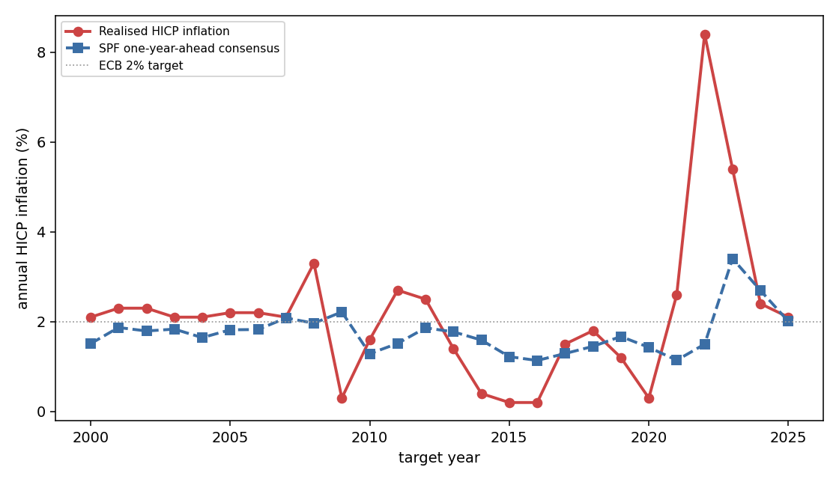
Figure 1 Euro-area inflation: realised (Eurostat) vs. one-year-ahead SPF consensus expectations, target years 2000 to 2025.
Source: own illustration based on ECB SPF and Eurostat data.

6 Empirical Results
This chapter provides a detailed account of the empirical results. The first part (Section 6.1) presents the baseline estimates of predictability for the full sample. The second part (Section 6.2) compares the pre- and post-2020 estimates to test Hypothesis Two. The remaining sections (6.3 through 6.8) examine the two key findings using various approaches. These include standard robustness checks, the characteristics of long-term expectations, the development of the coefficient over time, forecaster disagreement, individual-level evidence, and the effect of the post-2020 observations on the full-sample estimates.

6.1 Results for the Full Sample
Table 2 reports the baseline estimates. In the pooled specification the slope is positive and statistically significant, β = 0.81 (Newey-West t = 2.36, p = 0.02; two-way clustered t = 3.53, p < 0.01), so the FIRE null of β = 0 is rejected. The point estimate implies a sticky-information share of λ = β / (1 + β) ≈ 0.45, meaning the average forecaster behaves as if updating their information set roughly every other quarter. The magnitude lies somewhat below the value of about 1.2 that Coibion and Gorodnichenko (2015) report for US professional forecasters, indicating a comparable but slightly weaker degree of information rigidity in the euro-area SPF. Figure 2 visualises the relationship. The upward-sloping fit confirms that larger upward revisions are systematically followed by larger positive errors. The 95% confidence interval for the slope is [0.14, 1.49] under Newey-West standard errors and the tighter [0.36, 1.26] under two-way clustering. Zero lies well outside it in both cases. Expressed as an updating frequency, λ ≈ 0.45 implies that the average forecaster refreshes their information set about once every 1.8 quarters. The clustered interval is narrower than the Newey-West one, which is consistent with the small number of target-year clusters and possible negative intra-cluster correlation, so the wider Newey-West interval is treated as the more conservative benchmark.
Disaggregating by horizon shows that the precision of the pooled result comes mainly from the current-year forecasts (h = 0: β = 0.90, p < 0.01). At the one-year-ahead horizon the point estimate is virtually identical (β = 0.90) but imprecise on this sample (p = 0.22), and the two-year-ahead horizon is uninformative (β = −1.00 with a standard error of 3.97 on only 46 observations). The consistency of the point estimate for shorter horizons, as well as the significant pooled and decomposition findings, supports an interpretation of true under-reaction as opposed to a horizon-specific artefact. A caveat exists for the current year horizon, which accounts for much of the pooled precision. At h = 0 a portion of the target year’s data has been released prior to the time the forecast is produced. Therefore, revision and error have shared observation of monthly outcomes based upon how they are constructed and a positive slope at this horizon partially reflects the mechanical overlap in information rather than solely slow updating. The h = 1 point estimate, which is free of this overlap, is virtually identical at 0.90, which is reassuring, but it is not individually significant on this sample. The pooled result should therefore be read as evidence of under-reaction whose statistical precision rests disproportionately on the horizon most exposed to this objection.
Table 2 Baseline Coibion-Gorodnichenko estimates: consensus forecast error on consensus forecast revision.
Specification | β | Std. err. | t | p | λ | N
Pooled (h = 0,1,2), Newey-West | 0.812 | 0.344 | 2.36 | 0.018 | 0.45 | 255
Pooled, two-way cluster | 0.812 | 0.230 | 3.53 | <0.01 | 0.45 | 255
Current year (h = 0), NW | 0.895 | 0.201 | 4.46 | <0.01 | 0.47 | 107
One year ahead (h = 1), NW | 0.901 | 0.730 | 1.23 | 0.217 | 0.47 | 102
Two years ahead (h = 2), NW | −1.004 | 3.971 | −0.25 | 0.800 | n.a. | 46
Notes: OLS of error on revision. Standard errors are Newey-West (4 lags) unless stated; “cluster” = two-way clustered on survey round and target year. λ = β/(1+β).
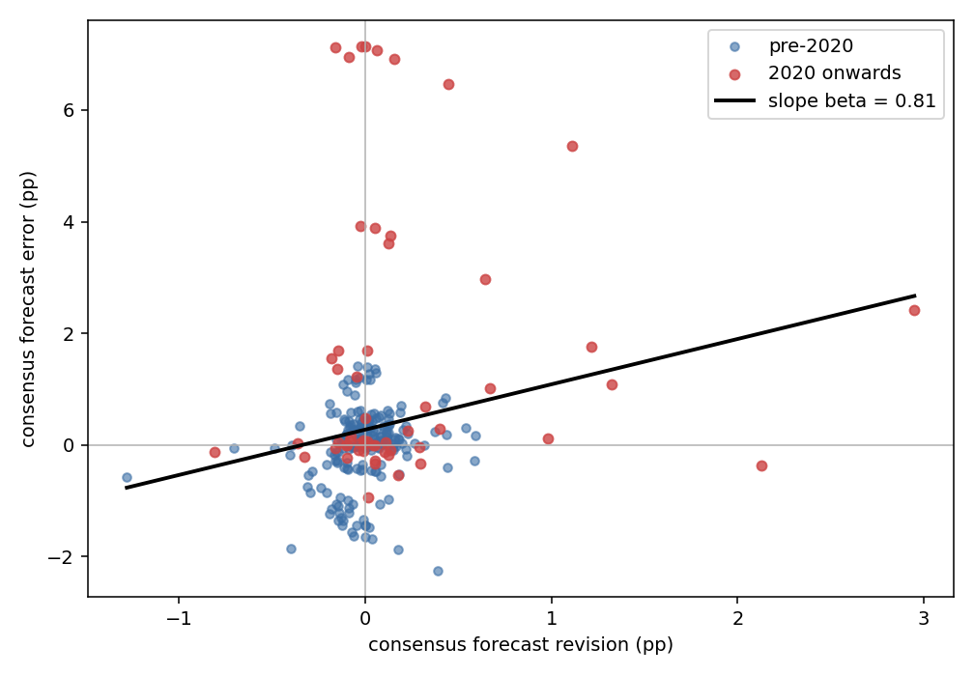
Figure 2 Consensus forecast error vs. consensus forecast revision, ECB SPF HICP, 1999 to 2025 (pooled horizons; red = 2020 onward).
Source: own illustration based on ECB SPF and Eurostat data.

6.2 Results in the Pre-Post-2020 Comparison
Table 3 reports the interaction model. In both the one-year-ahead and the pooled specifications the interaction coefficient δ is negative, which would point to a decline in under-reaction after 2020, but it is statistically insignificant (one-year-ahead: δ = −1.18, p = 0.29; pooled: δ = −0.37, p = 0.49). The hypothesis that the CG coefficient changed at 2020 (H2) therefore cannot be established from these data. The direction of the point estimates is economically intuitive. Forecasters appear to have adjusted their forecasts more quickly during the surge, which is consistent with attention rising in an environment of high volatility and large increases in inflation (Sims, 2003). The estimate is imprecise, however, and the reason is clear: the power analysis in Section 4.3 shows that the interaction is underpowered against plausible changes, and only 20 one-year-ahead observations fall in the post-2020 regime.
Figure 3 illustrates the dynamics of the 2021 target. The consensus was lowered to 0.9% during the pandemic, then rose steeply throughout 2021. It never reached the realised rate of 2.6%. Forecasters therefore revised their expectations upward while continuing to under-predict inflation. Reflecting this imprecision, the 95% confidence interval for the interaction coefficient is wide and contains zero in both specifications, from [−3.35, 0.99] at the one-year-ahead horizon to [−1.41, 0.68] in the pooled model; Section 6.5 revisits the question with a rolling estimate that does not impose a single break date.
Table 3 Pre/post-2020 comparison (pooled interaction model); δ tests H2.
Specification | β (pre) | Std. err. | δ | Std. err. | p(δ) | β (post) | γ | Std. err. | p(γ) | N
One year ahead (h = 1) | 0.892 | 0.908 | −1.181 | 1.109 | 0.287 | −0.288 | 2.089 | 1.162 | 0.072 | 102
Pooled (h = 0,1,2) | 0.611 | 0.242 | −0.366 | 0.533 | 0.492 | 0.245 | 1.485 | 0.533 | 0.005 | 255
Notes: D = 1 from 2020Q1 (survey-round date). γ is the coefficient on D alone (the level shift in the error at the break, holding the revision fixed); β(post) = β(pre) + δ. Newey-West (4 lags).
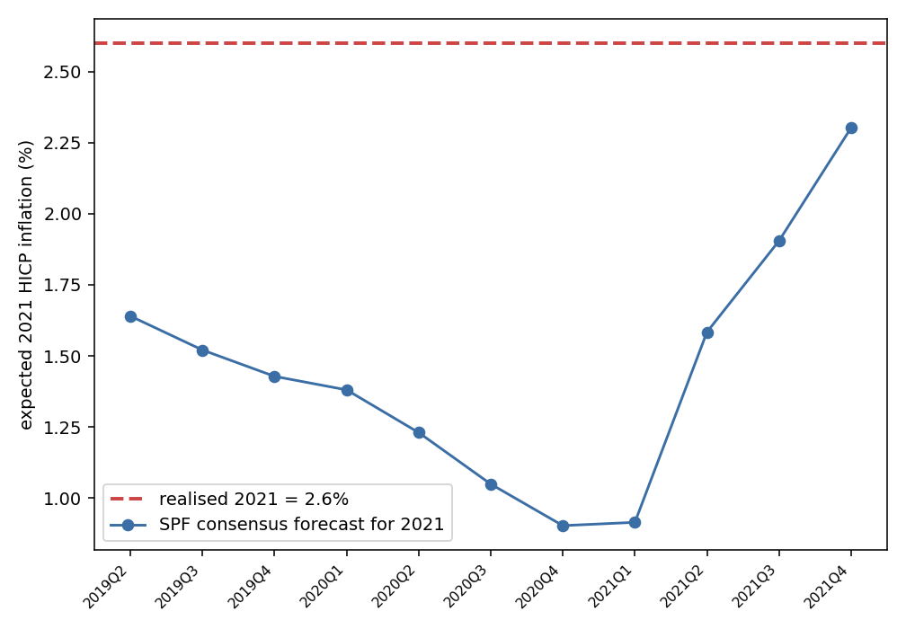
Figure 3 SPF consensus forecast for the 2021 target across survey rounds vs. realised 2021 inflation (2.6%).
Source: own illustration based on ECB SPF and Eurostat data.
Table 3 also reports the coefficient on the post-2020 dummy alone, γ, which captures a pure level shift in the error at the break, holding the revision fixed. This coefficient is economically large and statistically significant in the pooled specification (γ = 1.485, standard error 0.533, p = 0.005) and marginally so at the one-year-ahead horizon (γ = 2.089, standard error 1.162, p = 0.072): after 2020, the consensus was surprised by an additional 1 to 2 percentage points on average, independently of how much it had just revised. This level shift is a direct, estimated counterpart to the persistent bias discussed as one interpretation of the decomposition test in Chapter 7.

6.3 Robustness Analyses
The robustness checks are collected in Table 4. The baseline result is unchanged when the consensus is computed as the cross-forecaster median (β = 0.78, p = 0.02) and when the COVID-affected rounds of 2020 are excluded (one-year-ahead β = 1.00). So it is not an artefact of the aggregation choice or of the pandemic outliers. The decomposition test yields β₁ = 1.03 (p < 0.01) and β₂ = −1.32 (p < 0.01), the signs predicted by information-rigidity models. The restriction β₁ + β₂ = 0 is rejected, however (p = 0.01), indicating that forecast errors are related to the level of the lagged forecast in additional ways that are not consistent with pure revision. This leaves room for other sources of predictability besides rigidity. The Newey–West standard error of the one-year-ahead slope decreases monotonically as the lag length increases from one to eight quarters, but the estimated slope itself does not change. The result is also dependent on the choice of the break date. If the break is moved to 2021Q1, the interaction coefficient changes sign and becomes positive (δ = 0.16, p = 0.78). This implies that the structural-break estimate is sensitive to the exact choice of the break date. This again reinforces the conclusion of the previous section, Section 6.2, that a change in the slope cannot be reliably detected given the available sample period. Similarly, when the interaction is estimated for various candidate break dates spanning 2018 to 2022, the estimated values of δ range from −0.37 to +0.16, change sign across the different break dates, and fail to be statistically significant in every case.
Table 4 Robustness checks.
Check | Estimate | Std. err. | p | N
Median consensus (pooled β) | 0.783 | 0.324 | 0.016 | 255
Excl. 2020 COVID rounds (h = 1, β) | 1.002 | 0.766 | 0.191 | 98
Decomposition β₁ (Fₜ) | 1.032 | 0.338 | 0.002 | 255
Decomposition β₂ (Fₜ₋₁) | −1.315 | 0.410 | 0.001 | 255
Alternative break 2021Q1 (δ, pooled) | 0.161 | 0.581 | 0.782 | 255
Notes: Newey-West (4 lags). Decomposition tests eₜ = α + β₁ Fₜ + β₂ Fₜ₋₁ + uₜ; the restriction β₁ + β₂ = 0 is rejected (p = 0.01).

6.4 Anchoring of Long-Term Inflation Expectations
The Coibion-Gorodnichenko test examines the speed at which forecasters revise their short-horizon expectations, but it is silent on the level at which long-run expectations are anchored, which is the dimension most directly associated with central bank credibility. To examine this aspect in more detail, the SPF’s longer-term inflation expectations, referring to the roughly five-year-ahead forecast, are analysed separately. Figure 4 plots the long-term consensus against realised annual inflation over the full sample.
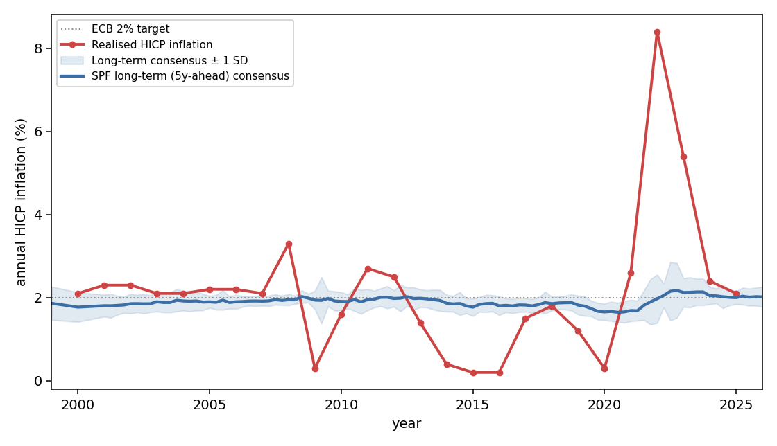
Figure 4 Realised euro-area inflation versus the long-term (five-year-ahead) SPF consensus, 1999 to 2025.
Source: own illustration based on ECB SPF and Eurostat data.
One qualification applies before the comparison is drawn. The ECB’s quantitative objective was not constant over the sample. Until the strategy review concluded in July 2021 the aim was an inflation rate below but close to two percent, and only from that point onward has the target been a symmetric two percent (European Central Bank, 2021). The two percent reference line in Figures 1 and 4 should therefore be read as the approximate objective throughout rather than as a formally unchanged target, and the modest upward drift of the long-term consensus from about 1.9 to about 2.0 percent is consistent with forecasters re-centring their expectations on the new symmetric formulation rather than with de-anchoring. The strategy review also provides an institutional break date that competes with the 2020Q1 split used in Section 6.2, which is a further reason for the sensitivity to the break date documented in Section 6.3. With that qualification, the contrast between the two horizons is pronounced. While realised inflation rose to 8.4% in 2022 and the short-horizon consensus failed to anticipate it, the long-term consensus remained within a narrow band around the ECB’s two percent target throughout the episode. It averaged 1.88% before 2021 and 2.00% over the period 2021 to 2023. In individual survey rounds it moved from about 1.67% at the end of 2019 to a peak of 2.18% in late 2022, before settling back to 2.02% by the end of 2025. Cross-forecaster disagreement about the long-term rate increased temporarily at the height of the surge, with the standard deviation rising from about 0.21 to 0.70 percentage points, but subsequently returned to its pre-crisis level.
This pattern qualifies the interpretation of the main results in an important way. The significant short-horizon under-reaction documented above coexisted with long-term expectations that remained well anchored. In the language of the theoretical framework, the 2021 to 2022 episode affected the speed of short-run updating far more than the level of long-run anchoring. This is consistent with the euro-area evidence of Łyziak and Paloviita (2017) and Corsello et al. (2021) and supports the reading that the surge represented an information-processing failure rather than a visible loss of the ECB’s credibility. Using a regime-switching model on the same long-term SPF series, Christoffel and Farkas (2025) reach a consistent conclusion, finding that the 2021 to 2023 surge is not identified as a de-anchoring episode because the increase in inflation was comparatively short-lived and met with a forceful policy response. Their reading is nonetheless a qualified one, and the qualification applies here as well: the same paper documents that the level of long-term SPF expectations is time-varying rather than constant, sitting below the ECB’s objective for much of the pre-2021 period and above it thereafter, so “anchored” should be understood as movement within a narrow band around the objective rather than as a fixed point on it. Because the long-term anchor held in that sense, the sluggish updating captured by β is better understood as a forecasting friction than as evidence that agents fundamentally doubted the central bank’s commitment to its target.

6.5 Time Variation in the Predictability Coefficient
A single break dummy imposes a discrete, one-time shift at a chosen date. As a complementary and more flexible check, the predictability coefficient is re-estimated on a rolling ten-year window that moves through the sample quarter by quarter. Figure 5 plots the resulting sequence of estimates together with a 90% confidence band.
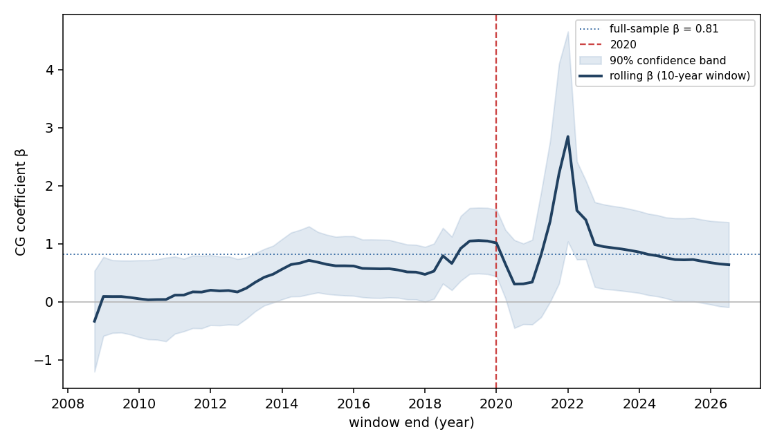
Figure 5 Rolling ten-year estimate of the Coibion-Gorodnichenko coefficient β, with a 90% confidence band.
Source: own illustration based on ECB SPF and Eurostat data.
The figure shows three features, the first of which qualifies the baseline result. The rolling coefficient is not stable across the sample: in the earliest windows, which end between 2009 and 2013 and therefore cover the low-inflation years up to and including the global financial crisis, the estimate lies close to zero, between about 0.0 and 0.2, with confidence bands that comfortably contain zero. It then drifts upward, reaching roughly 0.5 to 0.7 in the windows ending between 2014 and 2019, and only approaches the full-sample value of 0.81 towards the end of that decade. The full-sample estimate is thus not a constant that the data reproduce in every subperiod, but closer to an average of a rising profile. Second, in the windows dominated by the 2021 to 2022 surprises the estimate becomes both far larger and far more uncertain, peaking at about 2.85 before falling back towards 0.6 to 0.7, while the confidence band widens to include values above four. Third, immediately around the break date itself the estimate dips to roughly 0.3, so the movement across 2020 is non-monotonic rather than a single shift. The direction of this movement differs from the negative point estimate of the interaction term in Section 6.2. The two summaries are not directly comparable: each rolling window mixes post-2020 rounds with a decade of earlier observations, so the spike reflects the influence of the surge observations within an otherwise pre-crisis window, whereas the interaction dummy separates the two regimes and additionally absorbs the level shift between them through the intercept term. Read together, the two exercises support the same conclusion for H2, namely that the available data do not identify a stable, well-determined change in the degree of information rigidity after 2020. They also raise a question for H1 that the baseline specification leaves open, namely how much of the full-sample slope is contributed by the post-2020 observations; Section 6.8 addresses this directly.

6.6 Forecaster Disagreement
The consensus forecast used throughout collapses the cross-section of forecasters into a single number, yet the dispersion of the underlying individual forecasts is itself informative. Models of information rigidity predict that disagreement widens when the information environment changes rapidly (Mankiw, Reis & Wolfers, 2003). Figure 6 plots the cross-forecaster standard deviation of the one-year-ahead point forecasts over the full sample.
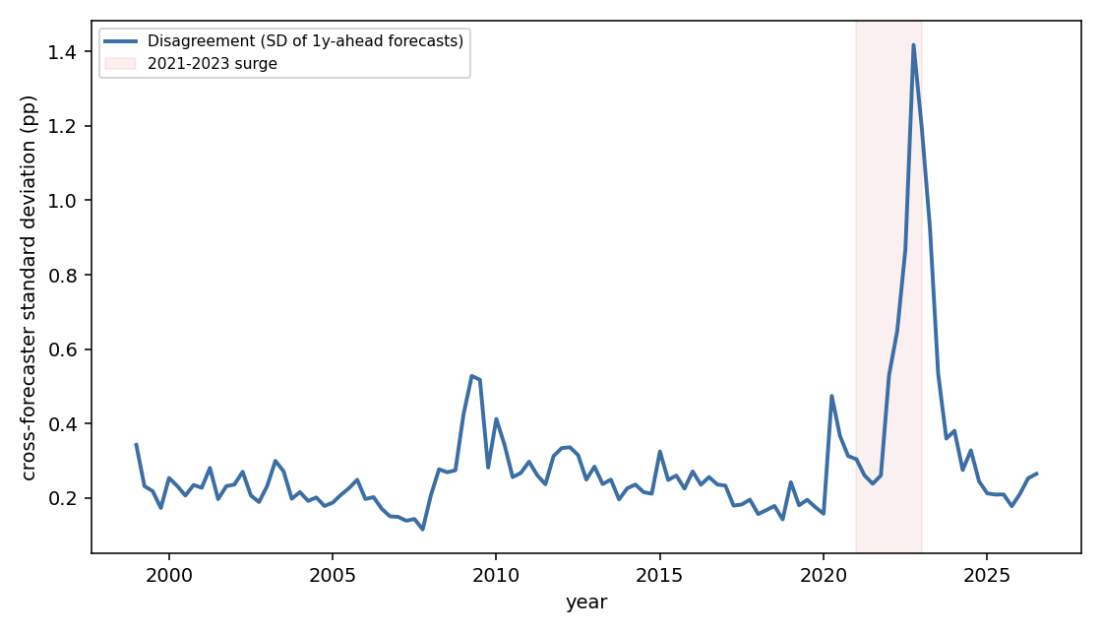
Figure 6 Cross-forecaster disagreement (standard deviation) about one-year-ahead inflation, 1999 to 2025.
Source: own illustration based on ECB SPF and Eurostat data.
Disagreement was low and stable for most of the sample, averaging about 0.24 percentage points before 2021, but it rose sharply during the surge to an average of 0.63 and a peak of 1.42 percentage points in the fourth quarter of 2022, before receding. Consistent with the mechanism of Mankiw, Reis and Wolfers (2003), disagreement is positively correlated with the absolute change in realised inflation across the sample, with a correlation of 0.72. This figure should be read with care: the series is flat for most of the sample and the correlation is carried largely by two episodes, the 2009 commodity-price reversal and the 2021 to 2022 surge, rather than by continuous co-movement. This is complementary evidence for the information-rigidity interpretation: when inflation moved abruptly, forecasters not only under-reacted on average but also diverged sharply in how they processed the incoming news, precisely the behaviour expected when agents update their information sets infrequently and at different times.

6.7 Individual-Level Evidence
The analysis so far has focused on the consensus forecast. Because the predictability of consensus errors is understood as an emergent property of aggregation, it is instructive to compare the consensus slope with the same regression estimated on the individual forecasts. The unit of observation here is a forecaster-round-horizon triple: for each respondent, each survey round and each of the three fixed-event horizons for which both a current and a lagged forecast of the same target year are available, one error and one revision are constructed exactly as in Section 5.2. Pooling across the three horizons and requiring consecutive responses from the same forecaster yields 11,603 usable observations. The Coibion-Gorodnichenko regression is re-estimated on this panel at the forecaster level, with standard errors clustered two-way by forecaster and by survey round.
Table 5 reports the individual-level estimates. The individual-level slope is markedly smaller than the consensus slope: 0.33 in the pooled specification and 0.29 once forecaster fixed effects are included, compared with 0.81 for the consensus, and it is not statistically significant. This gap is the pattern predicted by the aggregation mechanism and documented for other survey panels by Bordalo et al. (2020) and Angeletos et al. (2021): individual forecasters revise their expectations more fully than the consensus, so the pronounced sluggishness detected by the baseline test is a property of the average forecast rather than of the typical forecaster. The gap between the two slopes is formally tested rather than merely observed. Because the consensus observation for a given round and target is the cross-forecaster mean of the individual observations for that same cell, the two slopes are not independent, so a stacked regression with a consensus indicator C and an interaction term C times revision is estimated on the pooled consensus and individual rows, with standard errors clustered on survey round to accommodate this shared dependence. The interaction coefficient, delta = beta_consensus minus beta_individual, is 0.482 (cluster-robust standard error 0.145, t = 3.33, p = 0.001; two-way clustered on round and target year, standard error 0.099, p < 0.001). A cluster bootstrap that resamples survey rounds and rebuilds both samples from the resampled rounds (2,000 replications) gives a consistent picture: delta = 0.482, bootstrap standard error 0.196, 95% percentile interval [0.275, 1.039], p = 0.014. The wedge between consensus and individual under-reaction is therefore established, not merely a pattern in the point estimates, and it is consistent with the aggregation mechanism of Coibion and Gorodnichenko (2015) and Bordalo et al. (2020): the individual slope remains imprecisely estimated in level terms, but the difference from the consensus slope is not. The finding reinforces the interpretation of β as a measure of aggregate information rigidity and offers one of two complementary accounts of the excess predictability identified by the decomposition test, since a wedge between individual and consensus behaviour is one mechanism that generates predictability beyond simple under-reaction. The second account, a persistent level bias in the forecasts, is developed in Chapter 7; the two are not mutually exclusive, and the present data do not separate them. The individual-level point estimate nonetheless remains positive. The evidence therefore does not indicate individual over-reaction in the sense of Bordalo et al. (2020) and the formal test above confirms weaker information rigidity at the individual level than at the consensus level.
Table 5 Individual-level Coibion-Gorodnichenko estimates (pooled horizons 0, 1, 2).
Specification | β / δ | Std. err. | p | N
Pooled individual (two-way cluster) | 0.330 | 0.208 | 0.113 | 11,603
Individual, forecaster fixed effects | 0.286 | 0.201 | 0.155 | 11,603
Consensus minus individual, δ (cluster on round) | 0.482 | 0.145 | 0.001 | 11,858
Consensus minus individual, δ (two-way cluster) | 0.482 | 0.099 | <0.001 | 11,858
Notes: Standard errors for the individual-level rows are two-way clustered on forecaster and survey round. The final two rows report δ, the consensus-minus-individual slope difference from the stacked interaction regression of Section 6.7, with standard errors clustered on survey round and, in the fourth row, two-way clustered on survey round and target year; N there is the stacked sample (255 consensus plus 11,603 individual observations). For comparison, the consensus (baseline) pooled slope is β = 0.812 (Table 2).

6.8 Influence of the Post-2020 Observations
Sections 6.2 and 6.5 both leave one question about the baseline result unresolved. The pooled full-sample slope of 0.81 is larger than the pre-break slope of 0.61 and the post-break slope of 0.25 reported in Table 3, and the rolling estimate of Figure 5 lies close to zero in the earliest windows. Both patterns are consistent with a full-sample coefficient that is partly a between-regime phenomenon rather than a within-regime one: once a post-2020 intercept is allowed for, the slope estimated within each regime falls. Figure 2 also shows this: the observations lying furthest from the fitted line are concentrated in the rounds from 2020 onward. Three checks are used below to quantify how far the full-sample estimate depends on them.
First, the predictability regression is estimated on the pre-2020 sample alone, so that the pre-break slope can be assessed with its own standard error rather than read off an interaction model in which only the interaction term is tested. The slope is β = 0.611 (Newey-West standard error 0.242, t = 2.53, p = 0.012, N = 199) for the pooled specification; at the one-year-ahead horizon alone the pre-2020 slope is 0.892 but imprecise (standard error 0.908, p = 0.326, N = 82), consistent with the low power already documented for that horizon in Section 4.3. This point estimate and standard error are numerically identical to the coefficient on the revision term in the pooled interaction model of Table 3, a property of the fully interacted dummy specification rather than a separate calculation, and are reported here mainly so that the pre-break slope can be assessed on its own terms, with its own N and t-statistic, independently of the interaction term.
Second, standard influence diagnostics based on Cook’s distance (Cook, 1977) identify the individual survey rounds that drive the estimate. Eleven observations exceed the conventional threshold of 4/n, and ten of these eleven fall after 2020, led by the 2022Q4 round (target 2023, one-year-ahead, Cook’s distance 0.31) and the 2022Q1 round (target 2022, current-year, Cook’s distance 0.21); the eleventh, and the only one from before 2020, is the 2008Q3 round at the onset of the global financial crisis. This confirms that the post-2020 surprises, together with one earlier crisis episode, are the high-leverage points in the estimation sample.
Third, the regression is re-estimated with a robust estimator, Huber M-estimation (Huber, 1964) and median regression (Koenker & Bassett, 1978), which down-weight rather than exclude high-leverage observations. Because these estimators do not have an off-the-shelf HAC-consistent variance formula, their standard errors are obtained by a cluster bootstrap over survey rounds (2,000 replications). This respects the grouping of horizons within a round in the same way that two-way clustering does for the baseline OLS estimates. The naive, non-clustered standard errors that these estimators report by default would understate the uncertainty for the same reason that plain OLS standard errors are inappropriate in Section 4.4, and are not used here. On this basis, the Huber M-estimator gives a slope of 0.687 (bootstrap standard error 0.208, p = 0.001) and the median regression gives 0.581 (bootstrap standard error 0.214, p = 0.007), both markedly more conservative than the naive standard errors but still clearly significant. That these bootstrap standard errors are nonetheless smaller than the full-sample OLS Newey-West standard error (0.344) is expected rather than anomalous. Huber M-estimation and median regression down-weight the extreme post-2020 observations that inflate the OLS variance, so their sampling distributions are tighter precisely because they are less exposed to the high-leverage points documented above.
Table 6 Influence checks on the pooled baseline slope.
Specification | β | Std. err. | p | N
Full sample OLS (Newey-West), for reference | 0.812 | 0.344 | 0.018 | 255
Pre-2020 subsample, pooled (h=0,1,2) | 0.611 | 0.242 | 0.012 | 199
Pre-2020 subsample, one year ahead (h=1) | 0.892 | 0.908 | 0.326 | 82
Huber M-estimator (cluster bootstrap) | 0.687 | 0.208 | 0.001 | 255
Median regression (cluster bootstrap) | 0.581 | 0.214 | 0.007 | 255
Notes: pre-2020 estimates use Newey-West (4 lags); Huber and median regression standard errors are cluster-bootstrapped by survey round (2,000 replications).
The three checks demonstrate that the baseline slope is a general feature of the euro-area consensus rather than an artefact of the rounds since 2020. The point estimate falls somewhat once those rounds carry less weight, but the substantive result is unchanged. The pre-2020 subsample, the robust estimates and the full-sample OLS estimate of 0.812 each fall in the range of roughly 0.6 to 0.9. Each of these estimates is also statistically significant. Furthermore, the rolling estimates depicted in Figure 5 confirm the previous results. For each window ending between 2009 and 2013, the rolling coefficient is close to zero. The pre-2020 average of 0.611 represents both a time frame where rigidity levels were comparatively low (during and immediately after the Global Financial Crisis) and a time frame where rigidity levels were significantly higher (from around 2013 onwards). From 2013 onwards, the rolling coefficient has exceeded 0.5 and continued to rise until the end of the decade. As such, the evidence indicates that under-reaction is a structural characteristic of the euro-area consensus, rather than solely a function of the unexpected events of 2021 and 2022. The surprises of 2021 and 2022 raise the point estimate somewhat, but they are also the episode in which the magnitude of under-reaction can be observed most clearly. A slope concentrated in the post-2020 rounds would instead have indicated that the degree of under-reaction is purely state-dependent, rising only with the volatility of the inflation environment; the evidence here is more consistent with a persistent baseline degree of rigidity that the 2021 to 2022 surge made unusually easy to detect.

7 Discussion
This chapter interprets the empirical findings in light of the two research questions and the theoretical framework, rather than restating them. One hypothesis is confirmed, the other cannot be tested on the available sample: the euro-area consensus displays statistically significant under-reaction (H1), whereas the data cannot establish whether the degree of that under-reaction changed with the 2020 inflation surge (H2), even though they do show that the level of forecast errors shifted. Both outcomes are informative. The following discussion interprets these results step by step and explain how they connect to the credibility framework underlying this thesis.
The rejection of Full-Information Rational Expectations places the results within the information-rigidity paradigm and echoes earlier euro-area evidence of forecaster inattention (Andrade & Le Bihan, 2013). The test is not designed to discriminate between the two leading micro-foundations, sticky information (Mankiw & Reis, 2002) and noisy information (Sims, 2003). Both imply the same predictability at the consensus level (Coibion et al., 2018), which is the analytical convenience of the test and at the same time the limit of what it identifies. What the estimate does deliver is a magnitude, which is economically substantial without being extreme, sitting somewhat below the value Coibion and Gorodnichenko (2015) document for US professional forecasters. The consensus focus deserves emphasis. The under-reaction found here is a property of the average forecast rather than of the typical forecaster. Bordalo et al. (2020) show for other survey panels that individuals may even over-react while the consensus under-reacts; the individual-level estimates in Section 6.7 do not reproduce that over-reaction for the euro-area SPF, and the individual slope lies well below the consensus slope, a gap that Section 6.7 shows is statistically significant (delta = 0.482, p = 0.001) rather than merely suggestive. The results therefore speak to the aggregate expectations that matter for macroeconomic dynamics, without claiming that every forecaster updates sluggishly. The sharp rise in forecaster disagreement during the surge, documented in Section 6.6 and positively correlated with the size of the inflation change, albeit driven mainly by two episodes rather than continuous co-movement, provides further model-consistent evidence that information frictions rather than full information characterise the euro-area panel.
Translating β into a statement about credibility requires care, because the Coibion-Gorodnichenko coefficient measures the speed of information updating, not the level at which long-run expectations are anchored. In the Barro-Gordon (1983b) framework, credibility is what keeps private expectations tied to the central bank’s target. A loss of credibility would show up as expectations drifting away from target, not merely as sluggish short-run revisions. The under-reaction of forecasters to news about inflation between 2021 and 2022 therefore provides only limited evidence on whether they lost confidence in the ECB’s ability to meet its commitments: the data show how slowly forecasters responded to incoming information, not whether they came to doubt the target itself. In conjunction with additional research on anchoring, these findings indicate that the problem lies in the way forecasters process information rather than in a decline in the ECB’s credibility. Łyziak and Paloviita (2017) and Corsello et al. (2021) find that euro-area survey expectations remained comparatively anchored at longer horizons, and Nautz (2026) documents that, although consumers’ perceived credibility of the ECB’s target fell during the surge, and did so asymmetrically by declining when inflation was too high without a symmetric recovery, the long-run anchor was not lost. The short-run under-reaction found here is consistent with that picture: expectations were slow to move, but not unmoored. The long-term expectations analysed in Section 6.4 corroborate this reading directly. The five-year-ahead SPF consensus stayed within a narrow band around two percent throughout the surge, so the anchor itself held even as short-horizon forecasts under-reacted.
This interpretation connects directly to Tatar and Wieland (2025). They show that policy rules fed with SPF forecasts issued no early warning of the 2021 to 2022 surge, precisely because those forecasts failed to anticipate it. Figure 1 makes the same failure visible, and the test formalises the mechanism behind it: the systematic, predictable under-reaction quantified by β is the statistical footprint of the forecasting failure that left rule-based guidance behind the curve. The contribution of the present analysis is thus to move from the descriptive observation that the SPF was wrong to a formal characterisation of how it was wrong, namely through sluggish, one-directional updating.
The second research question, whether the degree of under-reaction changed after 2020, cannot be answered for the slope itself with the available data. The insignificant interaction coefficient, its reversal of sign when the break is moved to 2021, and the power calculation of Section 4.3 point in the same direction. All three are manifestations of the same underlying problem: with roughly twenty post-break observations, a genuine change in the slope cannot be separated from ordinary sampling variation. The correct reading is therefore not that the expectations-formation process remained unchanged, but that the available data cannot determine whether it did. The rolling estimate in Section 6.5 reinforces this from a different angle: the coefficient fluctuates within wide confidence bands that contain the full-sample value throughout, so no stable post-2020 shift in the slope can be pinned down. The data are not silent, however, on the level of the error: as Section 6.2 reports, the post-2020 dummy γ is significant and economically sizeable, so forecasters were surprised by an additional 1 to 2 percentage points after 2020 independently of their most recent revision. The more precise statement of the second finding is therefore that the break test identifies a significant change in the level of forecast errors after 2020, while it can neither establish nor rule out a change in the speed with which those errors are corrected.
One finding was not anticipated. The decomposition test confirmed the qualitative signature of information rigidity, a positive loading on the current forecast and a negative loading on the lagged one, but rejected the restriction that the two coefficients sum to zero. Forecast errors are thus predictable not only from the revision but also from the level of past forecasts, pointing to a component of predictability beyond pure under-reaction, such as a persistent bias or a more complex mixture of over- and under-reaction across horizons. This cautions against reading β as a complete description of euro-area expectations formation and identifies a natural direction for further work. It also aligns with the synthesis of Angeletos, Huo and Sastry (2021), who show that aggregate expectations tend to under-react on impact but overshoot later; a component of predictability beyond simple under-reaction is precisely what their evidence would lead one to expect. Two non-exclusive sources of this residual predictability can be considered. The first, developed in Section 6.7, is the wedge between individual and consensus updating, which generates predictability that the revision alone does not capture. The second is a persistent level bias in the forecasts, for instance an implicit expectation that inflation would revert quickly to the two percent target; such a bias generates error predictability from the level of past forecasts, over and above the sluggish updating captured by the revision, and would have been especially costly during 2021 and 2022. The level-shift coefficient γ estimated in Section 6.2 gives this suggestion an empirical counterpart: forecasters were, on average, surprised by a further 1 to 2 percentage points after 2020 independently of their most recent revision, consistent with a persistent bias of the kind that would generate exactly this excess predictability.
Several limitations qualify these conclusions. The first concerns the baseline result itself. As Section 6.8 sets out, most of the high-leverage observations of the pooled regression fall after 2020, and the slope estimated within each regime is smaller than the full-sample slope. The result nonetheless survives on the pre-2020 subsample alone and under two robust estimators, so it is best read as a general feature of the euro-area consensus rather than a property specific to the high-volatility rounds, albeit with a somewhat smaller point estimate once these rounds are down-weighted. Second, the post-2020 window comprises only about twenty one-year-ahead observations, which, as quantified in Section 4.3, deprives the break test of power; a longer sample will be needed before the stability of β can be assessed. The analysis uses the final vintage of realised inflation; although HICP annual-average revisions are small, a genuine real-time treatment would sharpen the picture. The use of an individual-level regression (Section 6.7) helps address many of the concerns raised in this thesis. However, it only addresses these concerns partially, as it still relies on the “final-vintage” aggregate output data and does not take into account the entry and exit of forecasters. The euro-area aggregate also does not allow for differences across countries in their responses to new information, while the link between informational rigidity and credibility remains a very indirect one. While these limitations may not change the overall conclusion that there is substantial under-reaction at the aggregate level, they should be taken into account when interpreting the results of this thesis.
Taken together, the evidence portrays the 2021 to 2022 episode in the euro area as one in which professional forecasters updated too slowly rather than one in which the ECB’s credibility visibly unravelled. That distinction is one the Coibion-Gorodnichenko test is well suited to draw at short horizons, even as the deeper credibility question remains, by its nature, only partially observable through this lens.

8 Conclusion
The return of high inflation between 2021 and 2023 raised a question that two decades of near-target inflation had left dormant, whether euro-area inflation expectations would remain well behaved, and what their behaviour would reveal about the credibility of the ECB. This thesis examined the degree to which the consensus in the ECB Survey of Professional Forecasters exhibits information rigidity using the Coibion-Gorodnichenko predictability test. It also examined whether the degree of information rigidity changed following the post-2020 increase in inflation.
The answer to the first question is clear: the consensus forecast error is significantly predictable from the forecast revision, with a slope of about 0.81, an implied sticky-information share of roughly 0.45, and a range of roughly 0.6 to 0.9 under robust estimators, so Full-Information Rational Expectations is rejected. The precision of the pooled estimate rests disproportionately on the current-year horizon, at which revision and error partly share already released monthly data, so the magnitude should be read with that qualification. The second question cannot be settled for the slope itself. The short post-2020 window is too small to identify a change of plausible magnitude in the speed of updating, as the power analysis makes explicit. The consensus error nonetheless shows a significant level shift after 2020, of one to two percentage points independently of the revision, so the more precise conclusion is that the data cannot establish whether forecasters updated at a different speed, but do show that they were systematically less accurate. At the same time, the long-term expectations examined in Section 6.4 remained firmly anchored near the two percent target throughout the surge. Taken together, the episode is therefore better described as a failure of forecasters to update their short-run expectations quickly enough than as a demonstrable loss of the ECB’s credibility, since the test speaks to the speed of information processing rather than to the anchoring of long-run expectations, which held.
Three extensions follow from these limitations. As the sample becomes longer, the stability of the coefficient can be reassessed with greater statistical power than is available in the current sample. A genuine real-time analysis, together with an individual-level approach that explicitly accounts for forecaster entry and exit rather than pooling the unbalanced panel, would provide a useful complement to the short-horizon consensus test used here. In addition, the predictability identified in the decomposition, beyond pure under-reaction, warrants further investigation into the biases that influence professional forecasts. The central message, however, remains clear: professional forecasters in the euro area were slow and systematically biased in incorporating the return of inflation into their expectations. This helps explain why forecast-based policy guidance responded too late to the changing economic environment, even though the long-term anchor of expectations remained intact.

References
Andrade, P., & Le Bihan, H. (2013). Inattentive professional forecasters. Journal of Monetary Economics, 60(8), 967–982.
Angeletos, G.-M., Huo, Z., & Sastry, K. A. (2021). Imperfect macroeconomic expectations: Evidence and theory. NBER Macroeconomics Annual, 35(1), 1–86.
Barro, R. J., & Gordon, D. B. (1983a). A positive theory of monetary policy in a natural rate model. Journal of Political Economy, 91(4), 589–610.
Barro, R. J., & Gordon, D. B. (1983b). Rules, discretion and reputation in a model of monetary policy. Journal of Monetary Economics, 12(1), 101–121.
Bordalo, P., Gennaioli, N., Ma, Y., & Shleifer, A. (2020). Overreaction in macroeconomic expectations. American Economic Review, 110(9), 2748–2782.
Cameron, A. C., Gelbach, J. B., & Miller, D. L. (2011). Robust inference with multiway clustering. Journal of Business & Economic Statistics, 29(2), 238–249.
Christoffel, K., & Farkas, M. (2025). Managing the risks of inflation expectation de-anchoring (ECB Working Paper No. 3082). European Central Bank.
Coibion, O., & Gorodnichenko, Y. (2012). What can survey forecasts tell us about information rigidities? Journal of Political Economy, 120(1), 116–159.
Coibion, O., & Gorodnichenko, Y. (2015). Information rigidity and the expectations formation process: A simple framework and new facts. American Economic Review, 105(8), 2644–2678.
Coibion, O., Gorodnichenko, Y., & Kamdar, R. (2018). The formation of expectations, inflation, and the Phillips curve. Journal of Economic Literature, 56(4), 1447–1491.
Cook, R. D. (1977). Detection of influential observations in linear regression. Technometrics, 19(1), 15–18.
Corsello, F., Neri, S., & Tagliabracci, A. (2021). Anchored or de-anchored? That is the question. European Journal of Political Economy, 69, 102031.
European Central Bank. (2021). The ECB’s monetary policy strategy statement. https://www.ecb.europa.eu/home/search/review/html/ecb.strategyreview_monpol_strategy_statement.en.html
European Central Bank. (2026). Survey of Professional Forecasters (SPF) [Data set]. https://www.ecb.europa.eu/stats/ecb_surveys/survey_of_professional_forecasters/html/index.en.html
Eurostat. (2026). HICP: annual data (average index and rate of change) [prc_hicp_aind] [Data set]. https://ec.europa.eu/eurostat/databrowser/view/prc_hicp_aind
Huber, P. J. (1964). Robust estimation of a location parameter. Annals of Mathematical Statistics, 35(1), 73–101.
Koenker, R., & Bassett, G. (1978). Regression quantiles. Econometrica, 46(1), 33–50.
Kydland, F. E., & Prescott, E. C. (1977). Rules rather than discretion: The inconsistency of optimal plans. Journal of Political Economy, 85(3), 473–491.
Łyziak, T., & Paloviita, M. (2017). Anchoring of inflation expectations in the euro area: Recent evidence based on survey data. European Journal of Political Economy, 46, 52–73.
Mankiw, N. G., & Reis, R. (2002). Sticky information versus sticky prices: A proposal to replace the New Keynesian Phillips curve. Quarterly Journal of Economics, 117(4), 1295–1328.
Mankiw, N. G., Reis, R., & Wolfers, J. (2003). Disagreement about inflation expectations. NBER Macroeconomics Annual, 18, 209–248.
Nautz, D. (2026). Inflation target credibility and the Taylor rule. Contemporary Economic Policy, 1–9.
Newey, W. K., & West, K. D. (1987). A simple, positive semi-definite, heteroskedasticity and autocorrelation consistent covariance matrix. Econometrica, 55(3), 703–708.
Reis, R. (2022). The burst of high inflation in 2021–22: How and why did we get here? BIS Working Paper No. 1060.
Sims, C. A. (2003). Implications of rational inattention. Journal of Monetary Economics, 50(3), 665–690.
Tatar, B., & Wieland, V. (2025). Policy rules and the inflation surge: The case of the ECB. Economics Letters, 252, 112338.
Woodford, M. (2003). Imperfect common knowledge and the effects of monetary policy. In P. Aghion, R. Frydman, J. Stiglitz & M. Woodford (Eds.), Knowledge, Information, and Expectations in Modern Macroeconomics: In Honor of Edmund S. Phelps (pp. 25-58). Princeton University Press.

APPENDIX

Appendix A: Software and Reproducibility
All results in this thesis are fully reproducible. The empirical analysis was implemented in Python 3.12 using pandas, NumPy, statsmodels and matplotlib. The raw inputs are the ECB Survey of Professional Forecasters microdata (individual HICP point forecasts, survey rounds 1999Q1 to 2026Q3) and the Eurostat realised HICP inflation series (annual average rate of change, euro area of changing composition, dataset prc_hicp_aind), both retrieved in August 2026 and cited in the References.
The complete replication package, comprising the data-construction pipeline, the estimation code, and a README documenting how each table and figure in Chapters 5 and 6 is produced, is available at:
https://github.com/carlorappenecker/bachelor-thesis-spf
The pipeline reads the two raw data files, builds the consensus forecasts, constructs the forecast errors and revisions exactly as described in Section 5.2, and reproduces Tables 1 to 6 and Figures 1 to 6 from a single entry point. The estimation is deterministic; none of the reported results depends on a random seed.

Appendix B: Overview of AI-Based Tools
Table B1 documents the generative AI systems used in the preparation of this thesis, the purpose for which each was used, and the parts of the work affected. All AI-assisted passages were checked by the author for factual accuracy and for consistency with the underlying sources and estimation results.
Table B1 Overview of AI-based tools used in this thesis.
AI-based tool | Form of use | Parts of the thesis affected | Remarks
Claude (Anthropic) | Language polishing: suggestions for wording and formal revision of the author’s own text | Text throughout | Used as an aid only; content, analysis and argumentation developed independently by the author
Gemini (Google) | Language polishing: suggestions for wording and formal revision of the author’s own text | Text throughout | Used as an aid only; content, analysis and argumentation developed independently by the author
ChatGPT (OpenAI) | Language polishing: suggestions for wording and formal revision of the author’s own text | Text throughout | Used as an aid only; content, analysis and argumentation developed independently by the author
Note. “Language polishing” refers to suggestions for wording, phrasing and formal revision applied to text drafted by the author. No research question, hypothesis, empirical specification, estimation result or interpretation was generated by an AI system.

Statement of Academic Integrity
I hereby declare that I have written the present work independently and without the use of any aids other than those indicated. All passages taken verbatim or in substance from published or unpublished sources are identified as such. This work has not been submitted in the same or a similar form to any other examination authority.
Declaration on the use of generative artificial intelligence. I further declare that Appendix B discloses every use of generative AI systems in the preparation of this work, including the systems used, the purposes for which they were used, and the parts of the work affected. All content generated with such assistance has been checked by me for factual accuracy and consistency with the underlying sources and results, and I take full responsibility for the entire text.

Place, Date

_______________________________
Carlo Rappenecker

