  CARLOS OLIVEIRA  Senior Test Automation Engineer  Test Automation • Quality Engineering  Lisbon, Portugal • Open for relocation  T.: +351 911 956 381  Email: carloseduardo1984@gmail.com  My Professional profiles:  https://linkedin.com/in/carlosoliveira1984  https://github.com/carloseduardo1984  https://github.com/carlos-eduardo-1984  CORE PROFILE  23 years in Quality Engineering  14+ years in IT software projects and SQA  7+ years in test automation, Test Planning, Strategies, Bug Tracking, and Test Management.  GUI • Integration • Performance • E2E • UAT  API • Kafka • Web & Mobile Testing  TECHNOLOGIES  Code Langages: ● Java ● Python ● JavaScript ● C# & C++ Automation Frameworks: ● Robot Fram. ● Selenium ● Playwright ● Cypress CI/CD & QA tools: ● Docker ● GitHub ● Jenkins ● GitLab  Tests manage. tools: ● Jira Xray ● Jira Zephyr QA Approaches: ● Agile Test ● Shift-Left ● QAOps AI-Tools ● GitH-Copilot ● MCP ● Functionalize ● Ollama  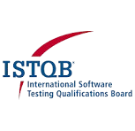  CERTIFICATIONS  - ISTQB Advanced Core – Test Manager | CTAL-TM  - ISTQB CTFL | Agile Tester | 2021  - ISTQB CTFL | 2021  - Atlassian University | Jira & Agile Mindset  - Atlassian University | Jira Admin  - ScrumAssembler | ISM - Scrum Master    CARLOS OLIVEIRA  Senior Test Automation Engineer  Test Automation • Quality Engineering  Lisbon, Portugal • Open for relocation  T.: +351 911 956 381  Email: carloseduardo1984@gmail.com  My Professional profiles:  https://linkedin.com/in/carlosoliveira1984  https://github.com/carloseduardo1984  https://github.com/carlos-eduardo-1984  CORE PROFILE  23 years in Quality Engineering  14+ years in IT software projects and SQA  7+ years in test automation, Test Planning, Strategies, Bug Tracking, and Test Management.  GUI • Integration • Performance • E2E • UAT  API • Kafka • Web & Mobile Testing  LANGUAGES  ● Portuguese — Native  ● English — C2 Advanced  ● Spanish — B1 Intermediate  ● German — A2 Basic Advanced  EDUCATION  ● MBA - Strategic Management & Innovation  ● Bachelor's Postgraduate - Electronic Systems & Automation Engineering  ● Bachelor's - Industrial Automation Analyst  ● Technician — IT Analyst  ● Technician — Automation Electronics ●Technician — Telecommunication | SENIOR QA ENGINEER – SENIOR TEST ENGINEER  SOFTWARE TEST AUTOMATION • SQA • CI/CD • WEB & MOBILE TESTING • SDTE  PROFESSIONAL SUMMARY  Senior Quality Assurance and Test Automation Engineer with extensive experience in software quality engineering, automation and quality leadership. Strong background in frontend (web and mobile), integration (REST API microservices and Kafka), performance tests, regression tests, and end-to-end testing, with hands-on experience in Frameworks: Robot, Selenium, Cypress, and Playwright with languages: JavaScript, Python, Java and CI/CD QA’s pipelines settings. Experienced in test strategy, planning, risk assessment, bug tracking, Agile Scrum, troubleshooting and mentoring QA engineers.  COMPANY PROFESSIONAL EXPERIENCE  SWISS POST – Spice-P. IT Lisbon Campus - Portugal Areas: Customs Clearance ERP, SAP, Microservices, Kafka, Transport Logistics systemas.  Senior Test Engineer | QA Manager Apr 2023 – Present ● Web Testing ● Mobile Testing ● Jira Xray ● Robot Framework ●RPA.Desktop, Browser & Requests libraries ● Jmeter Performance ● Selenium ● Playwright ● Appium ●Kakfa-perf ● CICD | Jenkins ● GitHub actions ● Python | JavaScript ● Confluence API - Management about QA strategies, PI Planning’s, Test Automation tools selections, QA mentoring, Risk-based strategies, Go-lives review assessments, and AI-tools assessments. - Design and maintain automated regressions (web & systems) and integration (API & Kafka) tests for international Customs Clearance and Transport/logistics systems. - Develop automation tests solutions with Python and JavaScript, Robot Framework, Playwright and Selenium to integrate quality checks into CI/CD pipelines/infrastructures: Jenkins and/or GitHub Actions. - Create test strategies, test plans, risk assessments and regression approaches for business-critical systems with AI-driven tools. - Bug tracking, management, and investigation of failures, supporting troubleshooting, root-cause analysis and continuous quality improvement. - Mentor QA engineers and collaborate with distributed Agile teams using Test Automation, Jira, Xray, Confluence, Git and Bitbucket.   AUBAY S.A. Consultancy EUROPE- Portugal  Client account: VW Group Areas: Vehicle e-commerce ERP, Microservices, and Logistics systems. Senior Test Engineer | QA Mentor Mar 2022 – Apr 2023 ● Web Testing ● API Testing ● Jira Zephyr ● Cypress Framework ● Allure Reports ● e2e, regression, UAT & Integration tests ● Postman ● JavaScript ● Python ● CICD | Jenkins ● GitHub actions ● AzureDevOps - Contributed to quality engineering for an e-commerce AI platform supporting Volkswagen Group brands. - Developed API and Web frontend automated functional tests using Cucumber (BDD), Cypress, JavaScript, Node.js and Mocha. - Supported test management, defect analysis and automation improvements in Scrum and Kanban environments. - Bug tracking with Bugzilla and root-cause analysis for continuous quality improvement.  COMPANY PROFESSIONAL EXPERIENCE  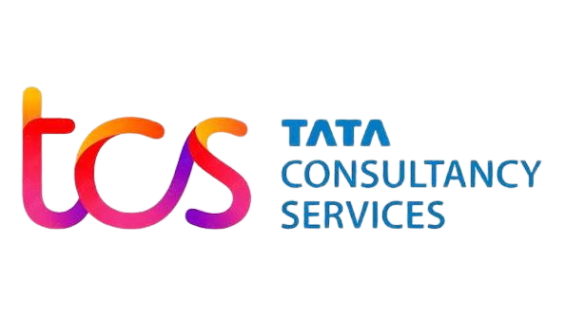 TCS Consultancy S.A. LATAM – Brazil 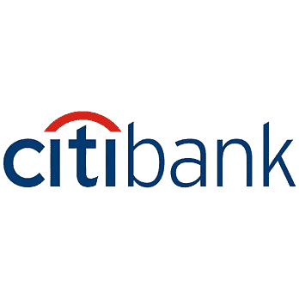 Client account: Citibank Areas: Finance ERP solutions, Bank, Microservices, and corporative payment platforms. Senior Test Engineer | Test Lead 2021 ● Web Testing ● Performance Testing ● Jira Zephyr ● Selenium Framework ● Allure Reports ● Jmeter ● Postman ● JavaScript ● Java ● CICD ● GitHub ● Jenkins - Acted as Test Lead for a Payment Platform, coordinating automation activities and quality governance. - Developed frontend and API automation frameworks using Selenium, Java, JavaScript, Node.js and Maven. - Managed test backlog, traceability, defect reviews and test management activities.  INFOSYS Consultancy S.A. Global – Brazil   Client account: J&J Global Areas: Medical, SAP, Salesforce, e-commerce, finance, automation, microservices, logistics. Software Quality Assurance Engineer | Agile Coach | SME 2019 – 2021 ● Web Testing ● Jira Zephyr & Xray and ● HP-ALM & SAP solution manager ● Selenium Java Framework ● GxP | Agile & Waterfall ● CSV and Validation reviewer ● Postman ● JavaScript ● SME & SQA ● SQA Mentor ● e2e testing ● GitHub actions ● Integration & SIT, and UAT ● RPA developer for SQA BI dashboard - Software Quality Assurance activities across 18 global go-lives in Healthcare, Medical, Consumer, ERP and Finance. - Created test plans and strategies and coached teams on SDLC QA GxP best practices and Agile ways of working. - Used Jira Xray, Zephyr, HP ALM and Power BI for test tracking, metrics and quality reporting.  EARLIER EXPERIENCE  SQA Test Engineer - CEO Mentoring & Personal Improvement Consultancy S.A. | 2012 – 2018  SQA, Test coach, and technology consulting across LATAM projects in Agile and traditional approach for any companies as freelancer (+200 software projects under my QA support – web and mobile).  QA Automation & Electronics Eng. Consultancy | MCM, Denso and Tamura projects | 2003 – 2012  Quality, automation and engineering consulting involving electronics product launches, project reviews and client engagements across LATAM (+ 2000 projects go-lives under my QA support).  TEACHING & MENTORING  Test Automation Mentor – Aubay & Swiss Post, Lisbon | Apr 2022 – Today  Test Automation Teacher – Rumos Academy, Lisbon | Jan 2023 – Jul 2024  Test Automation Course Instructor – Ultima School | Jan 2021 – Dec 2022  SQA & SME Mentor – J&J | Jan 2020 – Dec 2020

