Taller Scrum Codigo Webinar

presented by Eduardo Josue de Jesus Vela... on March 13, 2021

/srv/www/prod/ct/releases/2021-03-11-224507-4b367ebe8eea58632ed4f65167b8d66a0591a1ef/src/images/studentNotes/line.jpg

Slide 1 of 78

/srv/www/prod/ct/releases/2021-03-11-224507-4b367ebe8eea58632ed4f65167b8d66a0591a1ef/src/images/studentNotes/icon_signin.png Notes by Carlos Farfan



Slide 2 of 78

/srv/www/prod/ct/releases/2021-03-11-224507-4b367ebe8eea58632ed4f65167b8d66a0591a1ef/src/images/studentNotes/icon_image.png Slide

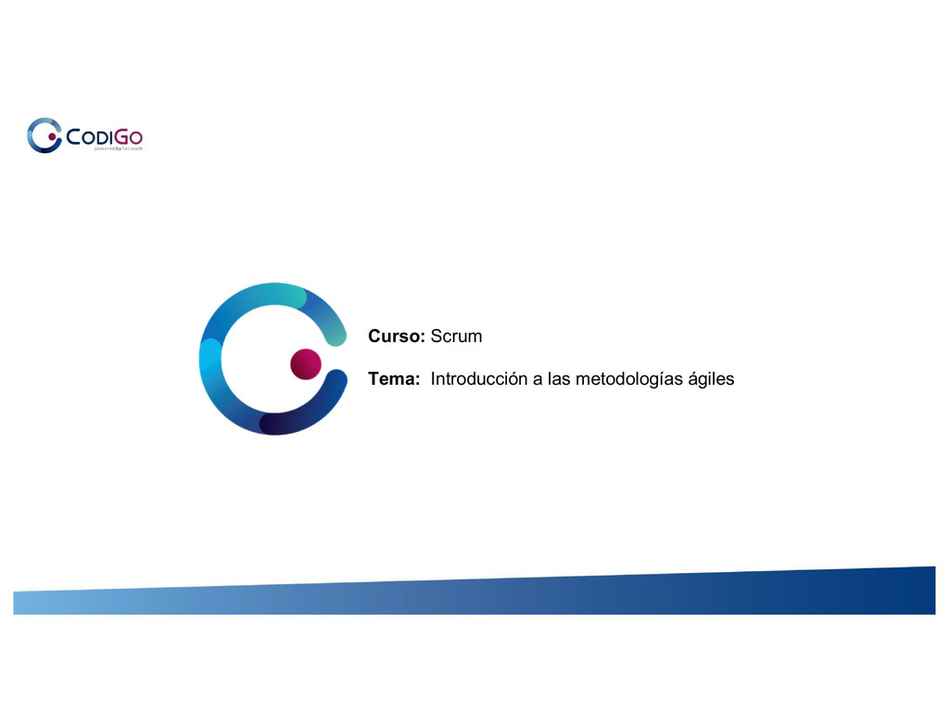

Slide 3 of 78

/srv/www/prod/ct/releases/2021-03-11-224507-4b367ebe8eea58632ed4f65167b8d66a0591a1ef/src/images/studentNotes/icon_image.png Slide



Slide 4 of 78

/srv/www/prod/ct/releases/2021-03-11-224507-4b367ebe8eea58632ed4f65167b8d66a0591a1ef/src/images/studentNotes/icon_image.png Slide

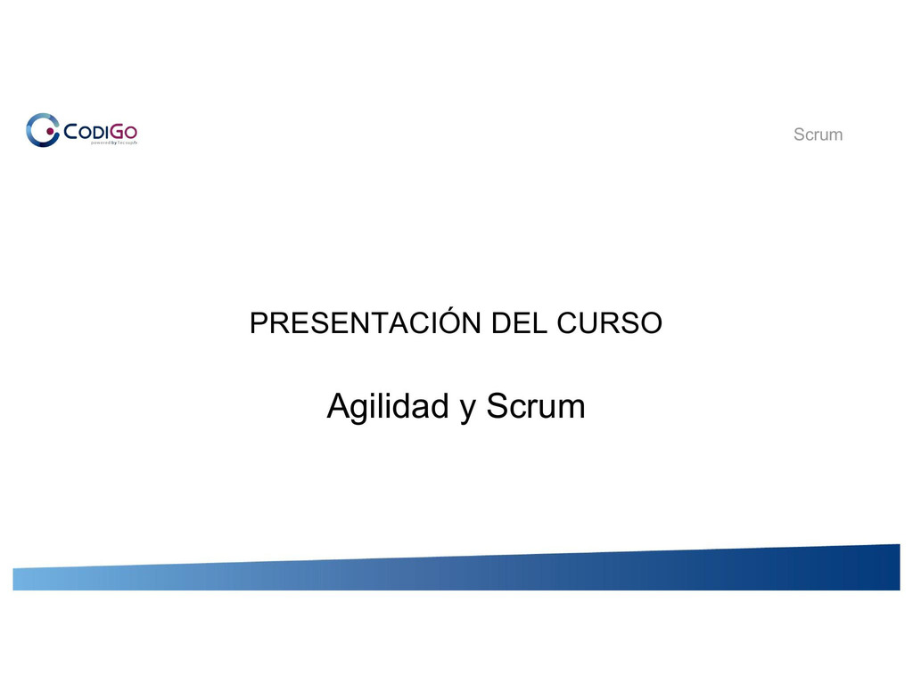

Slide 5 of 78

/srv/www/prod/ct/releases/2021-03-11-224507-4b367ebe8eea58632ed4f65167b8d66a0591a1ef/src/images/studentNotes/icon_image.png Slide

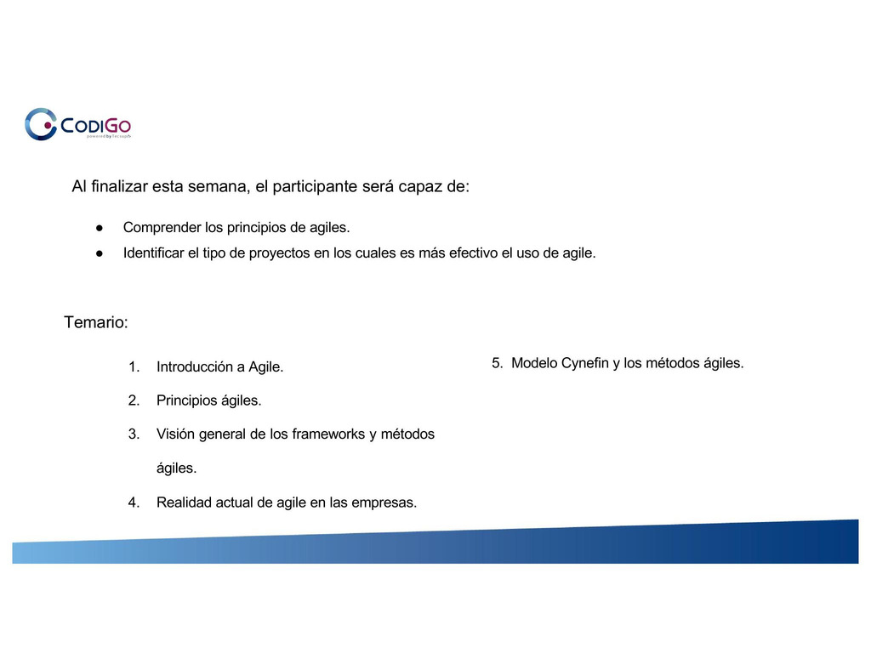

Slide 6 of 78

/srv/www/prod/ct/releases/2021-03-11-224507-4b367ebe8eea58632ed4f65167b8d66a0591a1ef/src/images/studentNotes/icon_image.png Slide

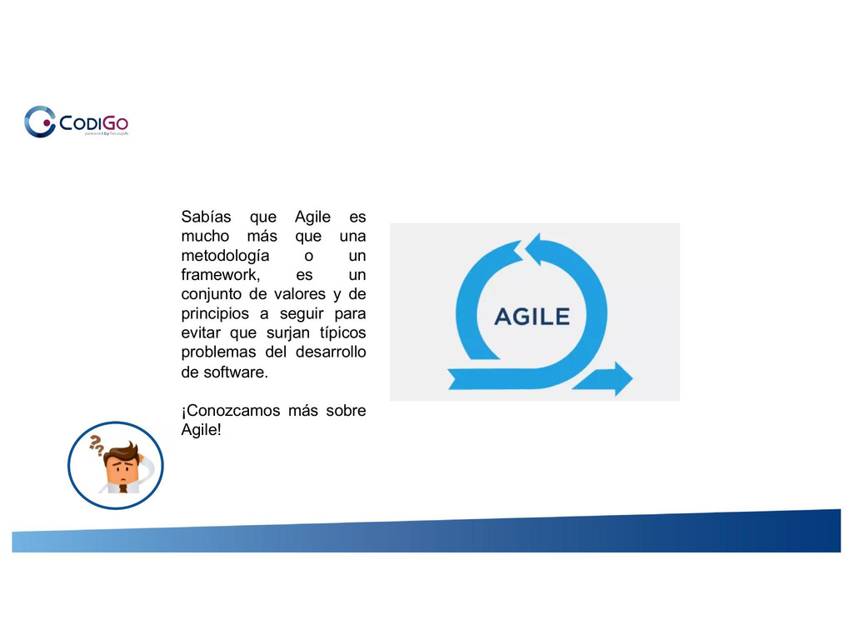

Slide 7 of 78

/srv/www/prod/ct/releases/2021-03-11-224507-4b367ebe8eea58632ed4f65167b8d66a0591a1ef/src/images/studentNotes/icon_image.png Slide

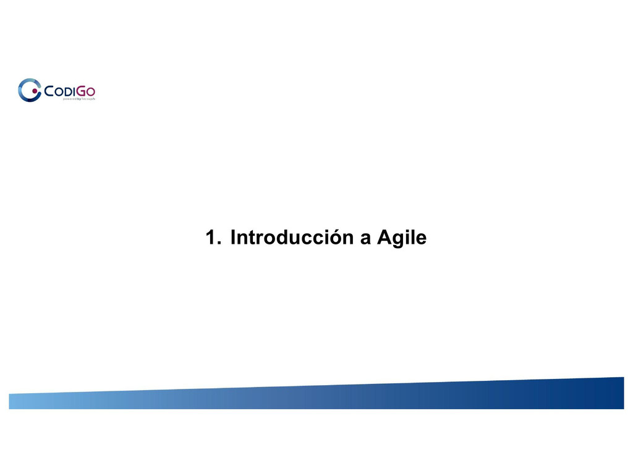

Slide 8 of 78

/srv/www/prod/ct/releases/2021-03-11-224507-4b367ebe8eea58632ed4f65167b8d66a0591a1ef/src/images/studentNotes/icon_image.png Slide

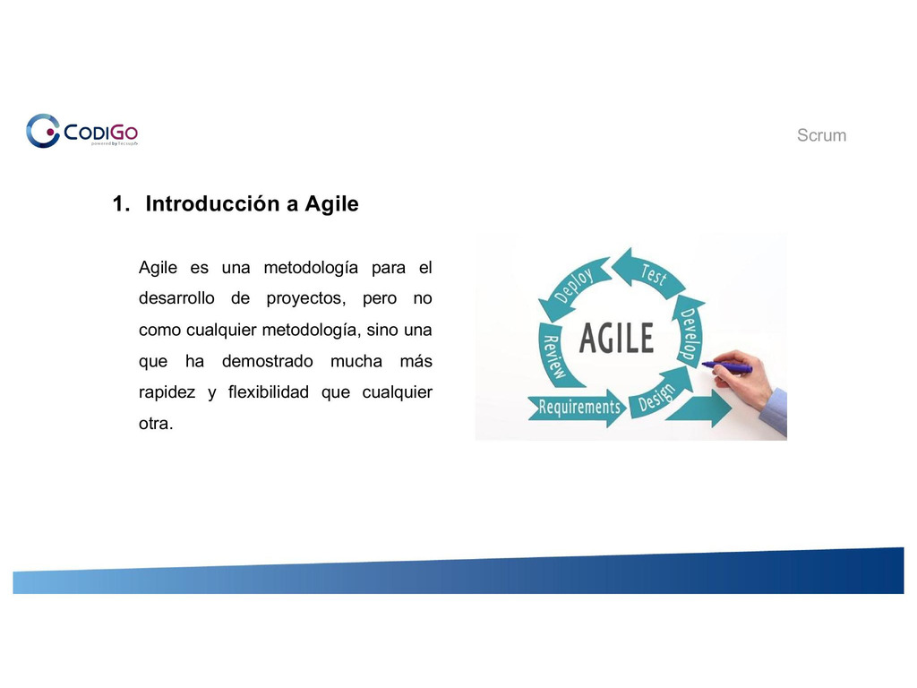

Slide 9 of 78

/srv/www/prod/ct/releases/2021-03-11-224507-4b367ebe8eea58632ed4f65167b8d66a0591a1ef/src/images/studentNotes/icon_image.png Slide

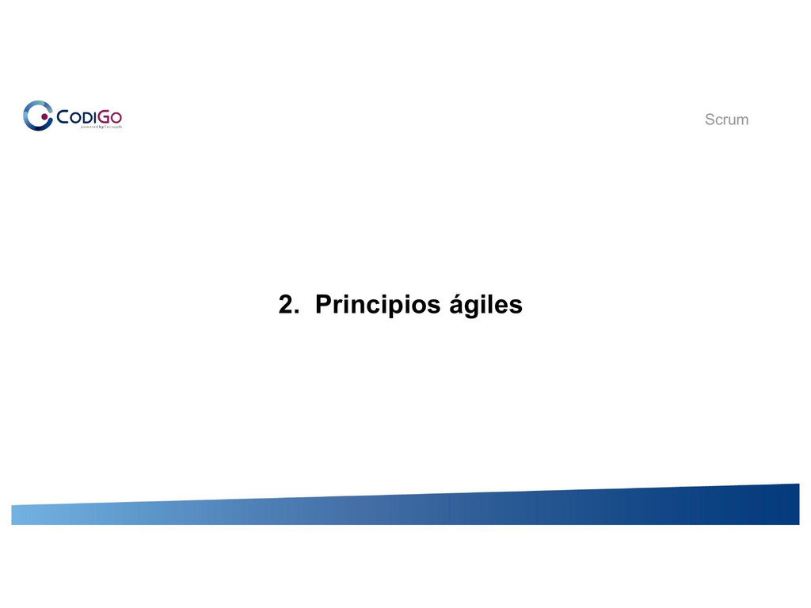

Slide 10 of 78

/srv/www/prod/ct/releases/2021-03-11-224507-4b367ebe8eea58632ed4f65167b8d66a0591a1ef/src/images/studentNotes/icon_image.png Slide

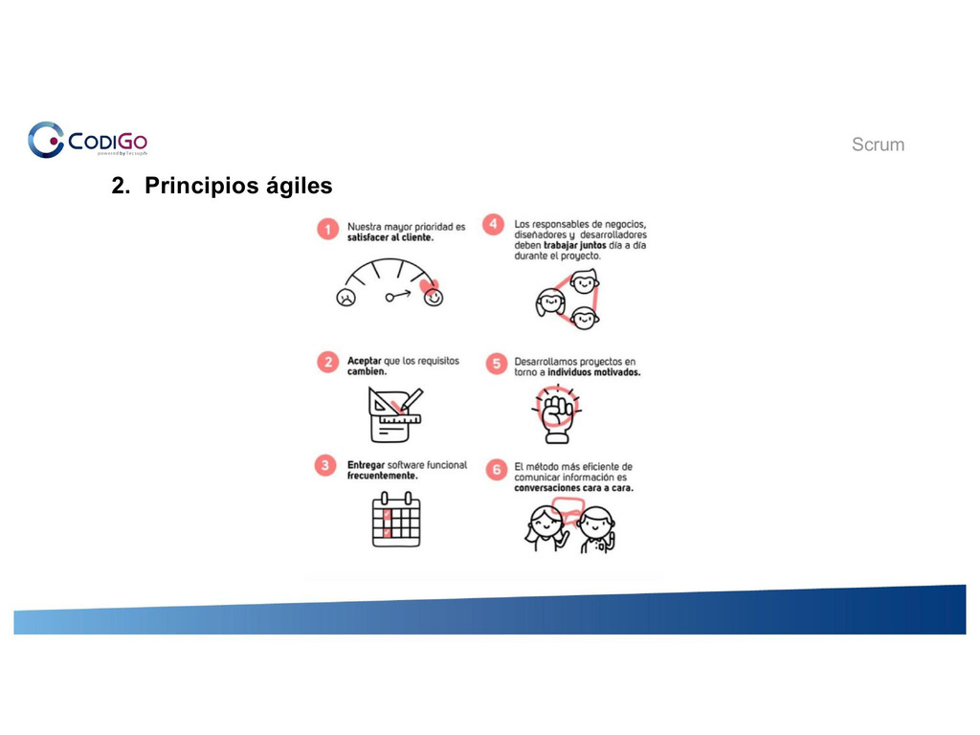

Slide 11 of 78

/srv/www/prod/ct/releases/2021-03-11-224507-4b367ebe8eea58632ed4f65167b8d66a0591a1ef/src/images/studentNotes/icon_image.png Slide

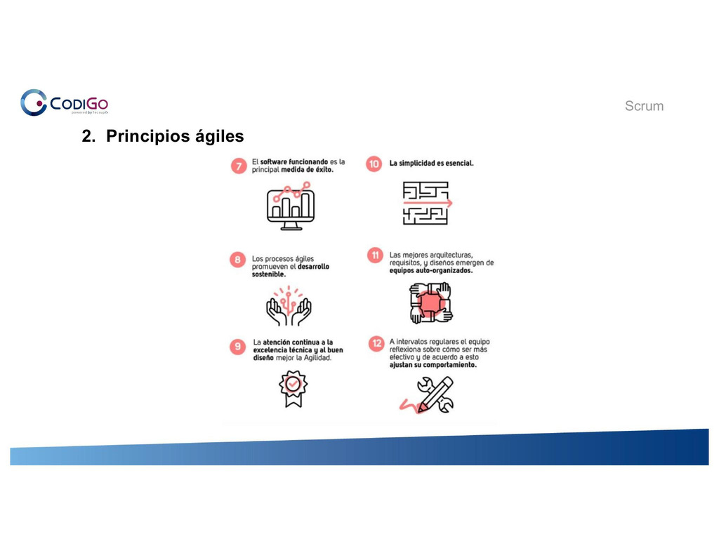

Slide 12 of 78

/srv/www/prod/ct/releases/2021-03-11-224507-4b367ebe8eea58632ed4f65167b8d66a0591a1ef/src/images/studentNotes/icon_collaborative.png Collaborate Board Principios Agiles

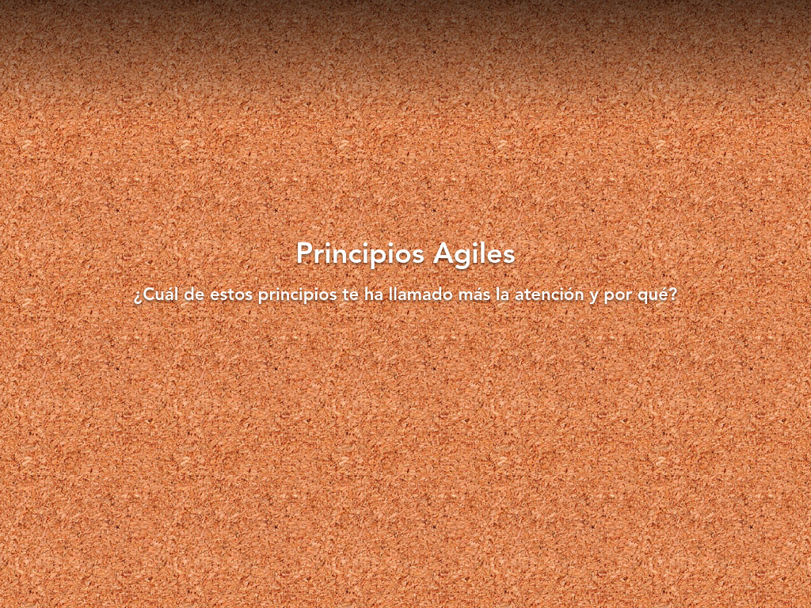

[Open the Original](https://collaborative.nearpod.com/reports/354060028/cb2c0ff4f46d93121ae5419fde7a65c0?&parent_id=0&hideStudentNames=1)

Slide 13 of 78

/srv/www/prod/ct/releases/2021-03-11-224507-4b367ebe8eea58632ed4f65167b8d66a0591a1ef/src/images/studentNotes/icon_image.png Slide

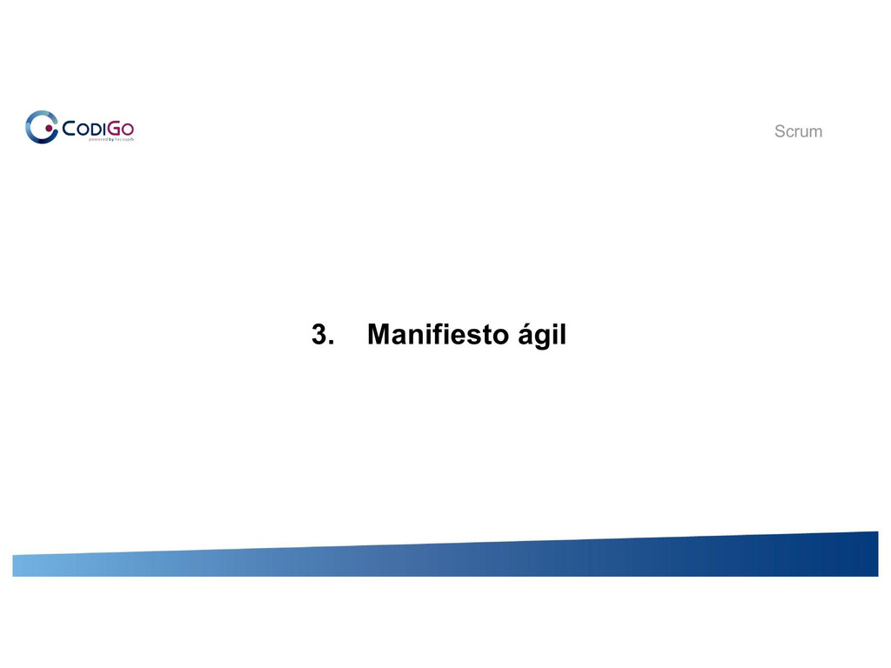

Slide 14 of 78

/srv/www/prod/ct/releases/2021-03-11-224507-4b367ebe8eea58632ed4f65167b8d66a0591a1ef/src/images/studentNotes/icon_image.png Slide

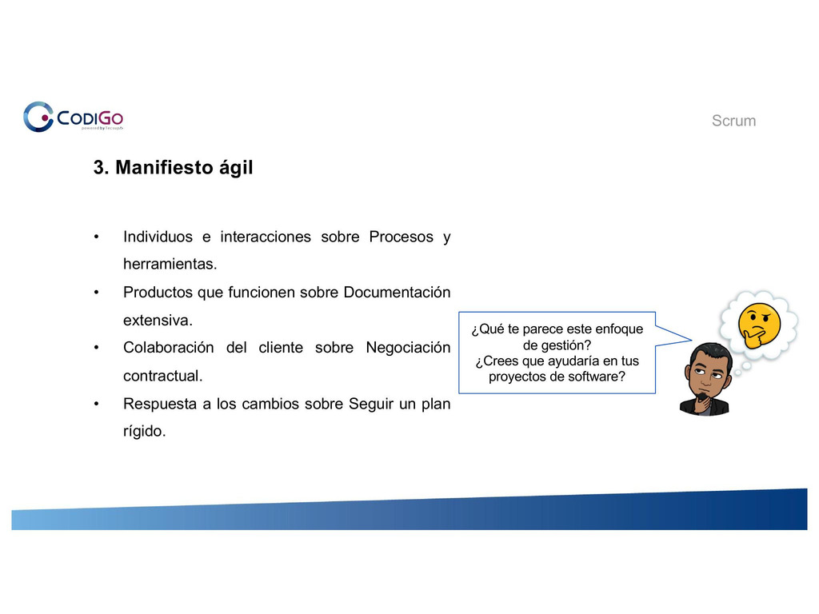

Slide 15 of 78

/srv/www/prod/ct/releases/2021-03-11-224507-4b367ebe8eea58632ed4f65167b8d66a0591a1ef/src/images/studentNotes/icon_collaborative.png Collaborate Board Valores Ágiles

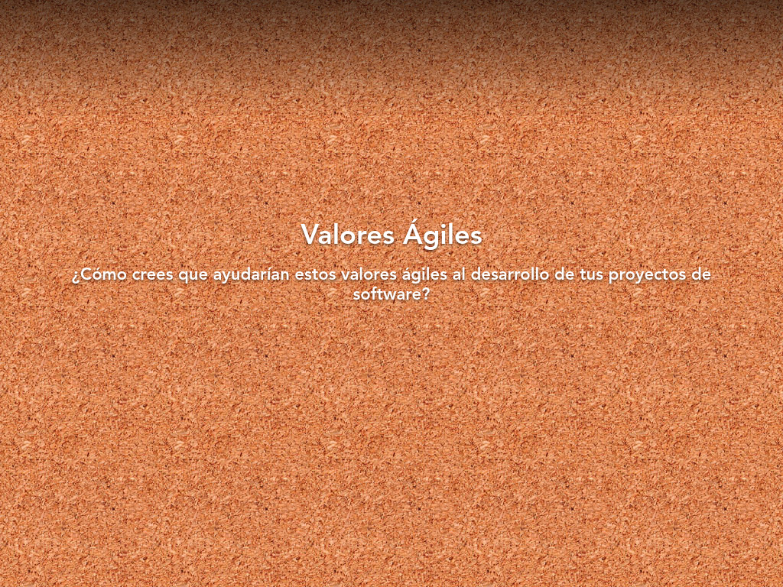

[Open the Original](https://collaborative.nearpod.com/reports/354060158/cb2c0ff4f46d93121ae5419fde7a65c0?&parent_id=0&hideStudentNames=1)

Slide 16 of 78

/srv/www/prod/ct/releases/2021-03-11-224507-4b367ebe8eea58632ed4f65167b8d66a0591a1ef/src/images/studentNotes/icon_image.png Slide

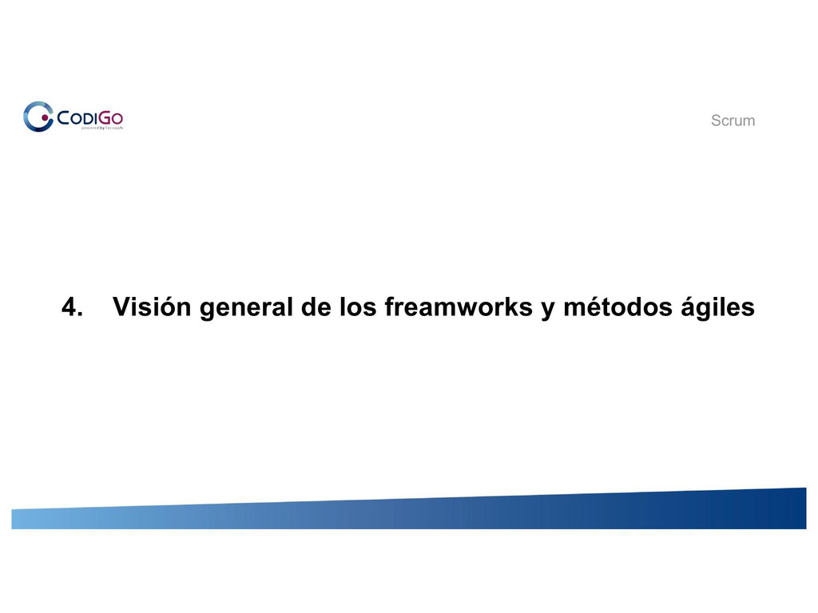

Slide 17 of 78

/srv/www/prod/ct/releases/2021-03-11-224507-4b367ebe8eea58632ed4f65167b8d66a0591a1ef/src/images/studentNotes/icon_image.png Slide

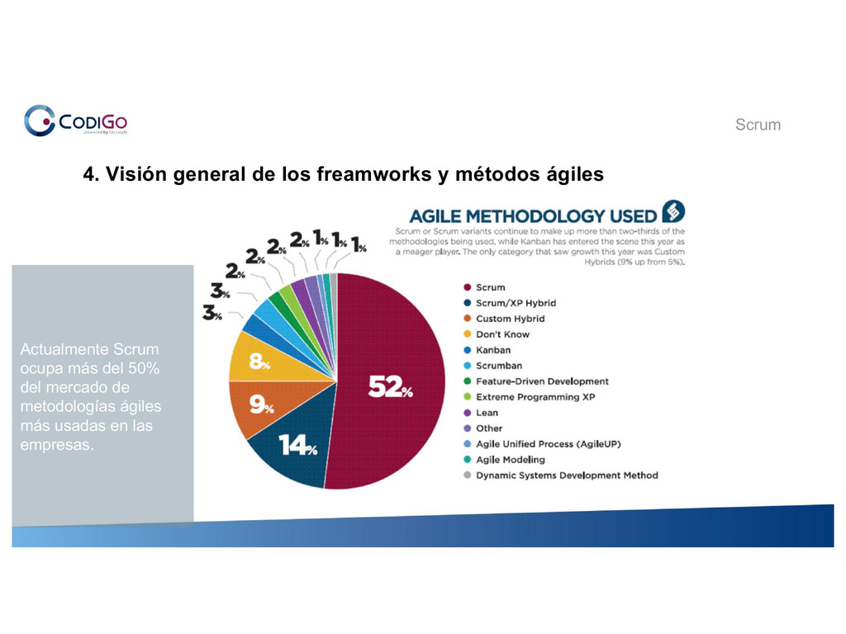

Slide 18 of 78

/srv/www/prod/ct/releases/2021-03-11-224507-4b367ebe8eea58632ed4f65167b8d66a0591a1ef/src/images/studentNotes/icon_image.png Slide

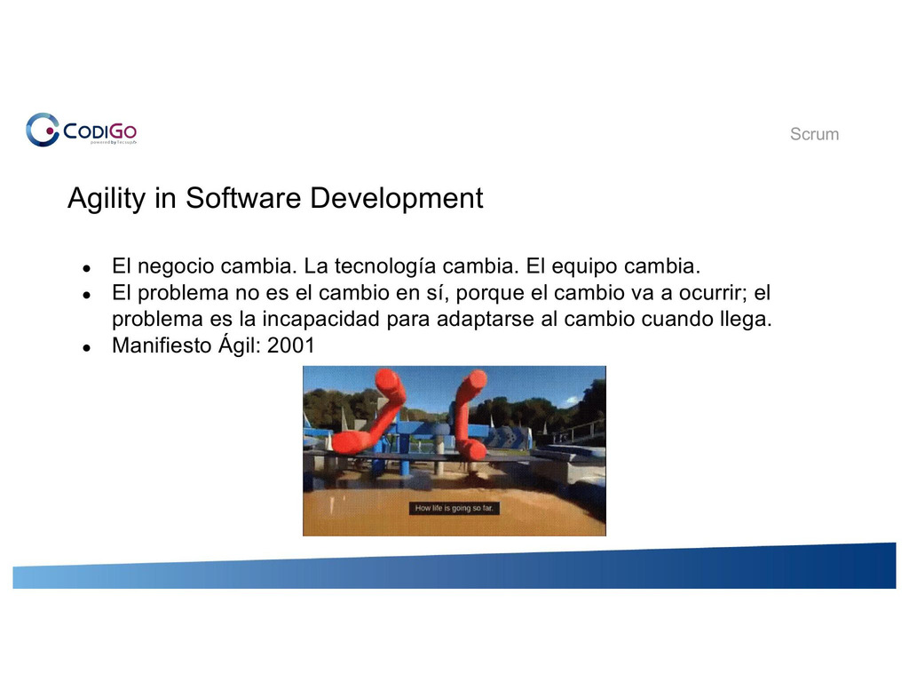

Slide 19 of 78

/srv/www/prod/ct/releases/2021-03-11-224507-4b367ebe8eea58632ed4f65167b8d66a0591a1ef/src/images/studentNotes/icon_image.png Slide

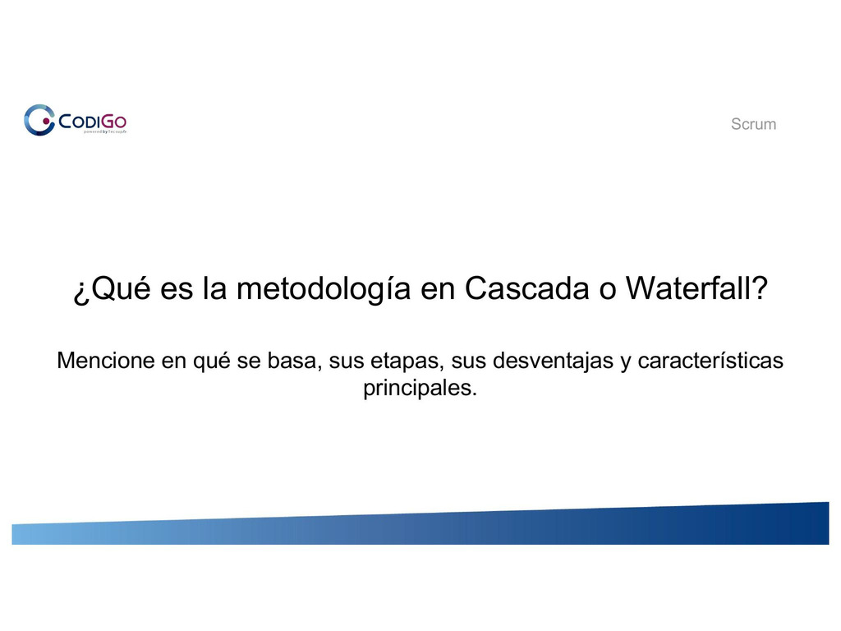

Slide 20 of 78

/srv/www/prod/ct/releases/2021-03-11-224507-4b367ebe8eea58632ed4f65167b8d66a0591a1ef/src/images/studentNotes/icon_image.png Slide

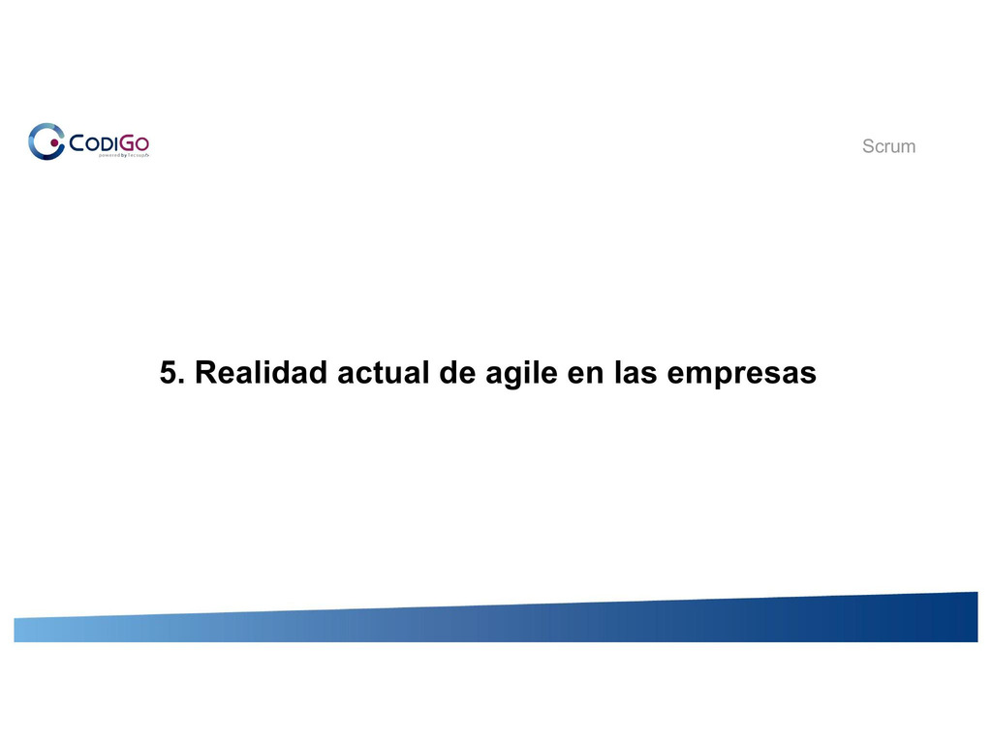

Slide 21 of 78

/srv/www/prod/ct/releases/2021-03-11-224507-4b367ebe8eea58632ed4f65167b8d66a0591a1ef/src/images/studentNotes/icon_image.png Slide

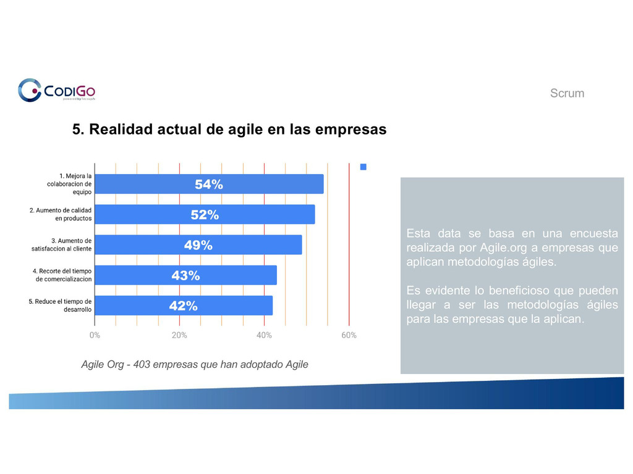

Slide 22 of 78

/srv/www/prod/ct/releases/2021-03-11-224507-4b367ebe8eea58632ed4f65167b8d66a0591a1ef/src/images/studentNotes/icon_image.png Slide

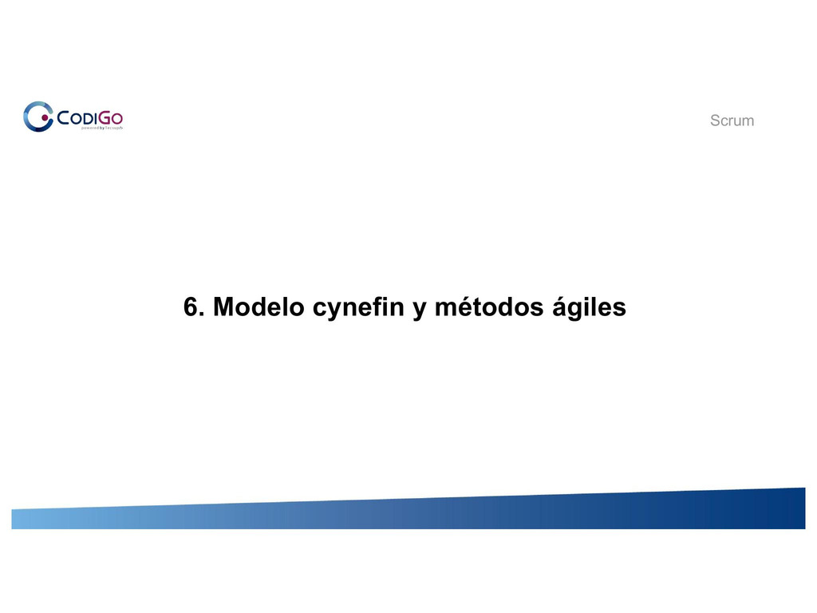

Slide 23 of 78

/srv/www/prod/ct/releases/2021-03-11-224507-4b367ebe8eea58632ed4f65167b8d66a0591a1ef/src/images/studentNotes/icon_image.png Slide

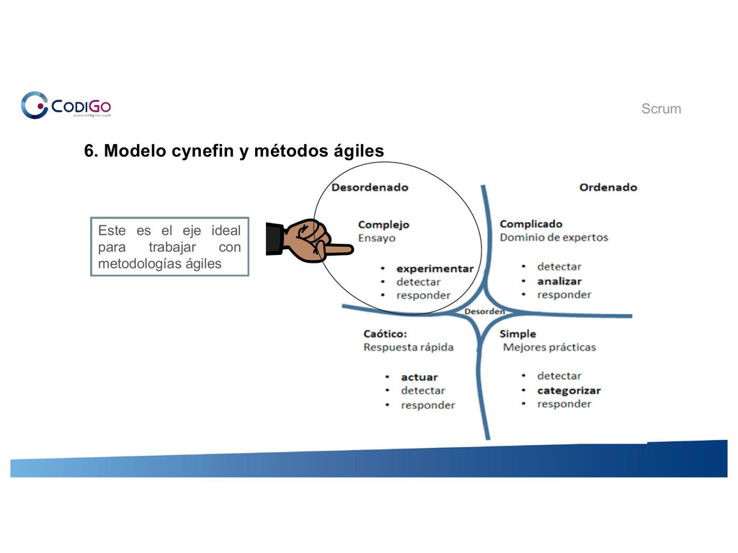

Slide 24 of 78

/srv/www/prod/ct/releases/2021-03-11-224507-4b367ebe8eea58632ed4f65167b8d66a0591a1ef/src/images/studentNotes/icon_image.png Slide

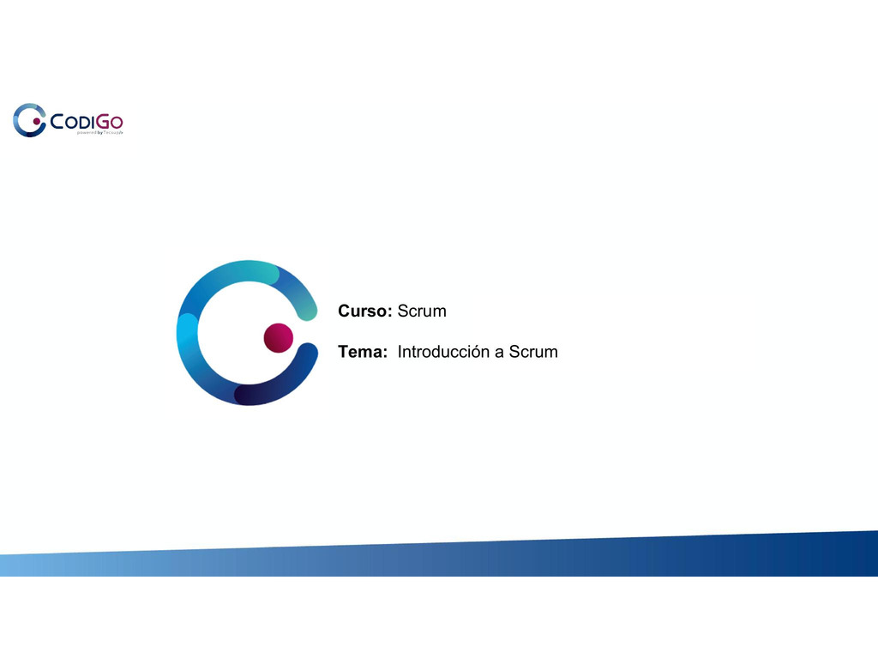

Slide 25 of 78

/srv/www/prod/ct/releases/2021-03-11-224507-4b367ebe8eea58632ed4f65167b8d66a0591a1ef/src/images/studentNotes/icon_image.png Slide

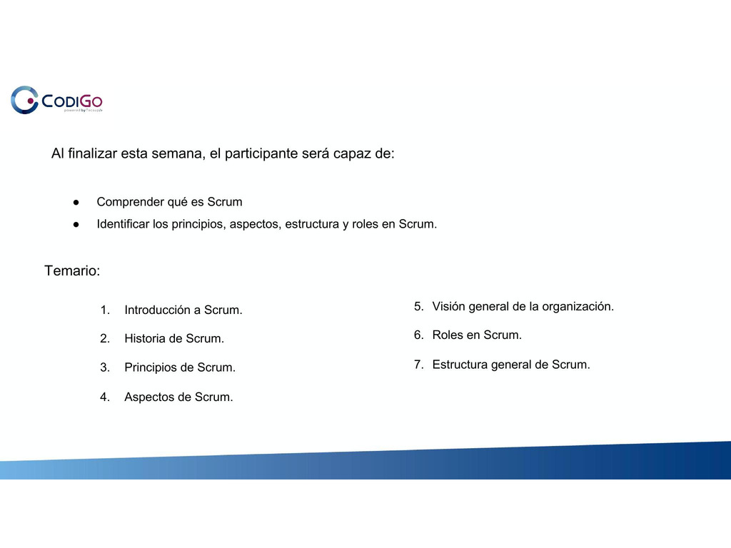

Slide 26 of 78

/srv/www/prod/ct/releases/2021-03-11-224507-4b367ebe8eea58632ed4f65167b8d66a0591a1ef/src/images/studentNotes/icon_image.png Slide

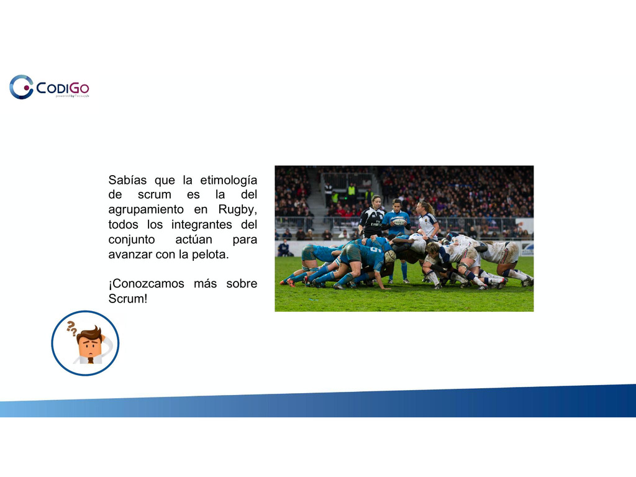

Slide 27 of 78

/srv/www/prod/ct/releases/2021-03-11-224507-4b367ebe8eea58632ed4f65167b8d66a0591a1ef/src/images/studentNotes/icon_image.png Slide

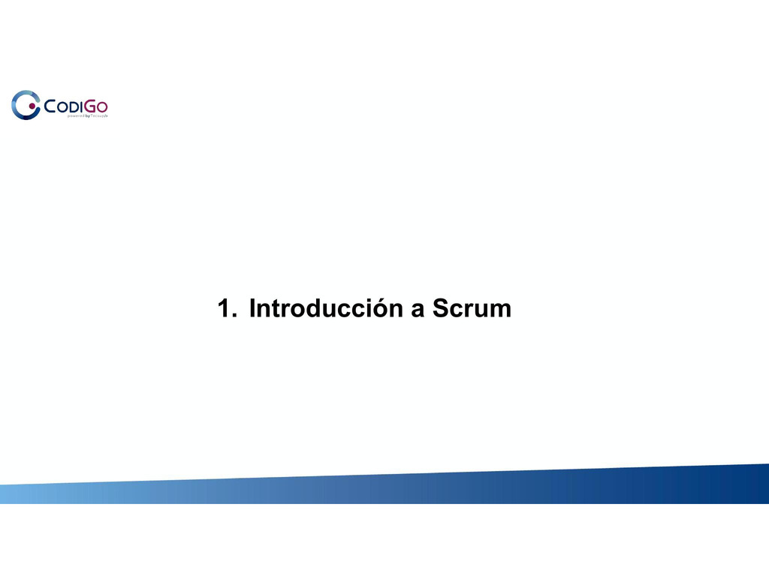

Slide 28 of 78

/srv/www/prod/ct/releases/2021-03-11-224507-4b367ebe8eea58632ed4f65167b8d66a0591a1ef/src/images/studentNotes/icon_image.png Slide

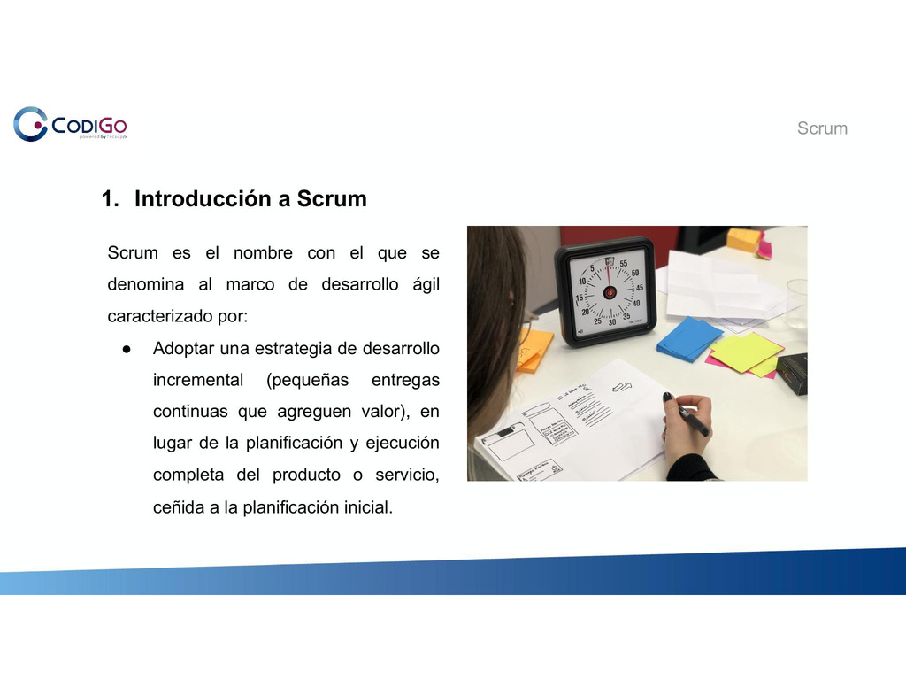

Slide 29 of 78

/srv/www/prod/ct/releases/2021-03-11-224507-4b367ebe8eea58632ed4f65167b8d66a0591a1ef/src/images/studentNotes/icon_image.png Slide

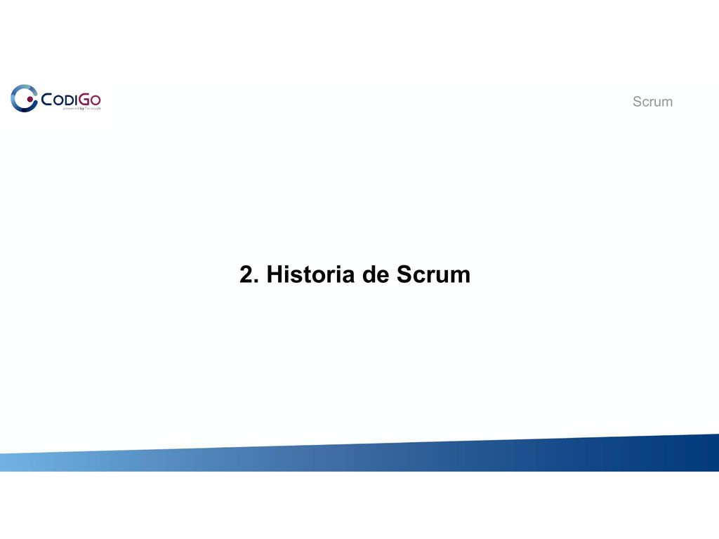

Slide 30 of 78

/srv/www/prod/ct/releases/2021-03-11-224507-4b367ebe8eea58632ed4f65167b8d66a0591a1ef/src/images/studentNotes/icon_image.png Slide

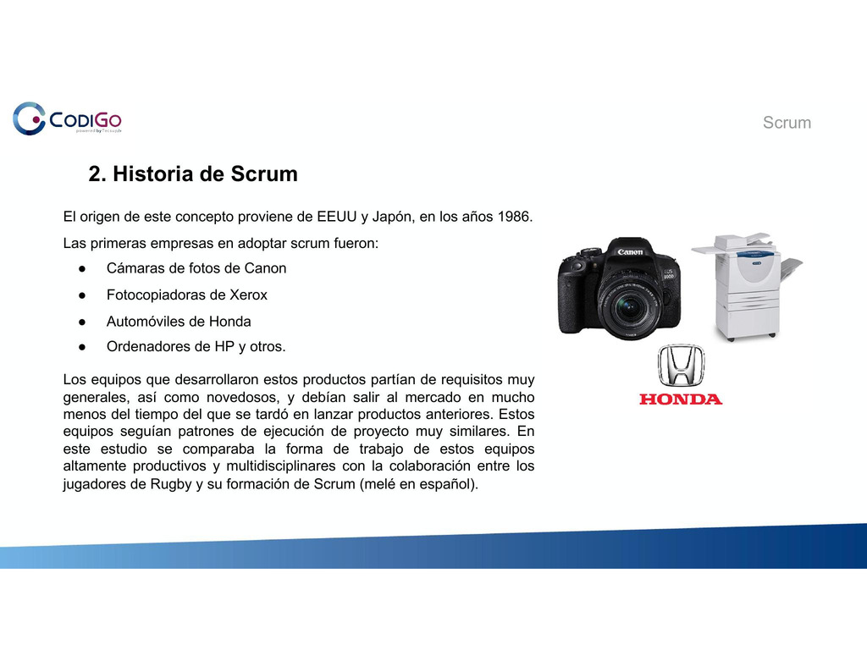

Slide 31 of 78

/srv/www/prod/ct/releases/2021-03-11-224507-4b367ebe8eea58632ed4f65167b8d66a0591a1ef/src/images/studentNotes/icon_image.png Slide

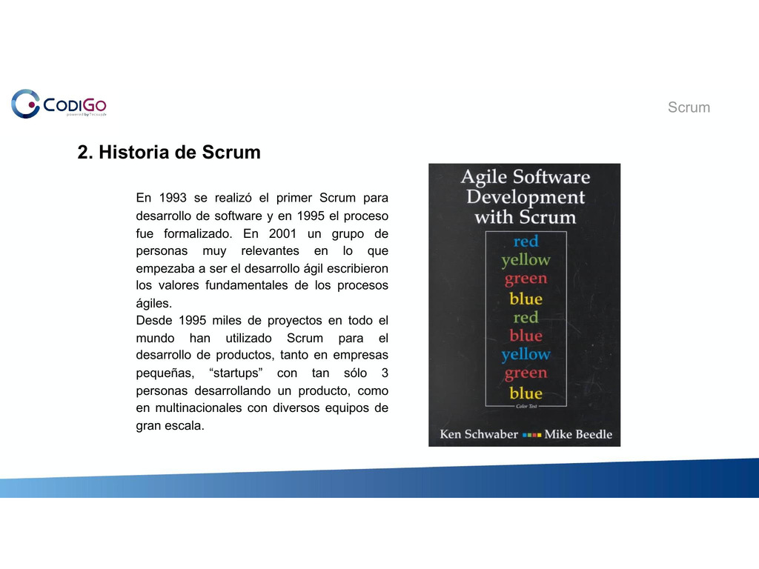

Slide 32 of 78

/srv/www/prod/ct/releases/2021-03-11-224507-4b367ebe8eea58632ed4f65167b8d66a0591a1ef/src/images/studentNotes/icon_image.png Slide

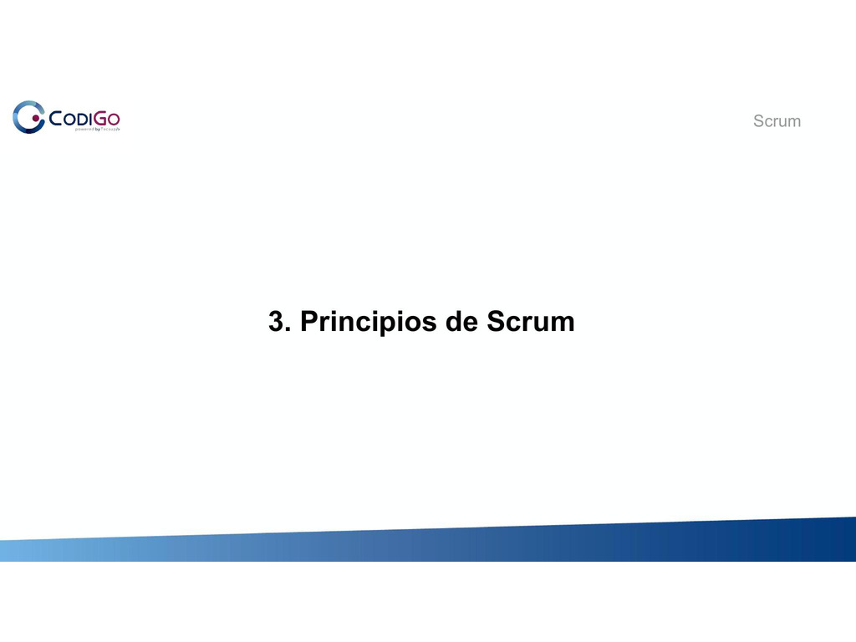

Slide 33 of 78

/srv/www/prod/ct/releases/2021-03-11-224507-4b367ebe8eea58632ed4f65167b8d66a0591a1ef/src/images/studentNotes/icon_image.png Slide

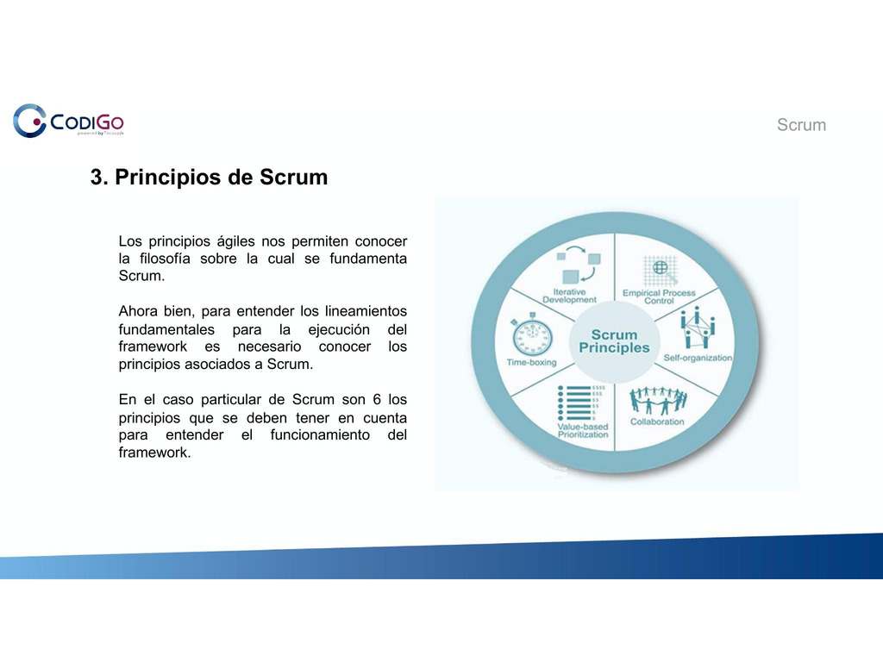

Slide 34 of 78

/srv/www/prod/ct/releases/2021-03-11-224507-4b367ebe8eea58632ed4f65167b8d66a0591a1ef/src/images/studentNotes/icon_image.png Slide

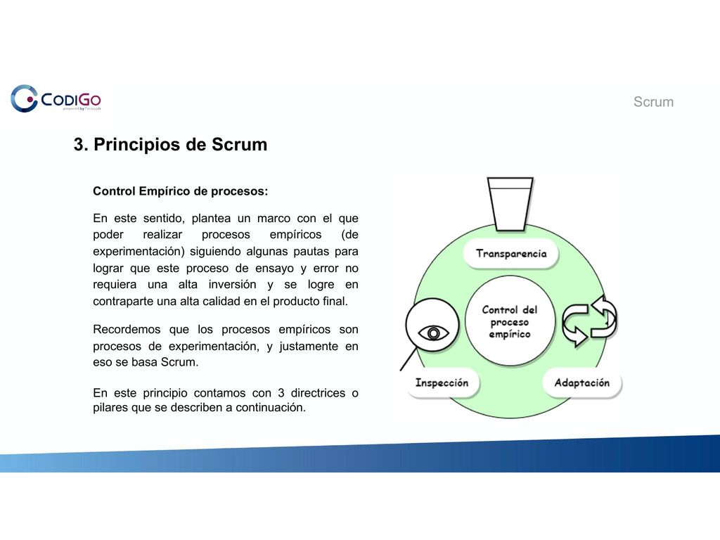

Slide 35 of 78

/srv/www/prod/ct/releases/2021-03-11-224507-4b367ebe8eea58632ed4f65167b8d66a0591a1ef/src/images/studentNotes/icon_image.png Slide

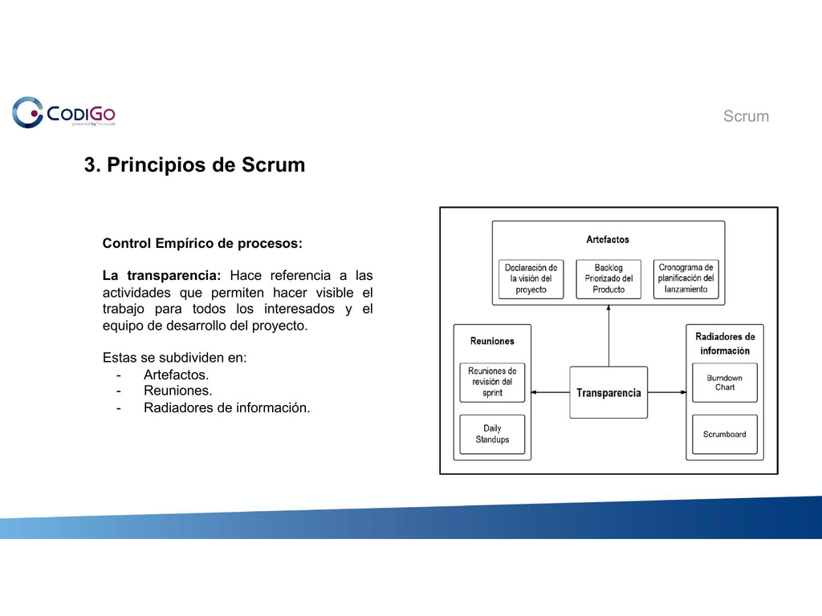

Slide 36 of 78

/srv/www/prod/ct/releases/2021-03-11-224507-4b367ebe8eea58632ed4f65167b8d66a0591a1ef/src/images/studentNotes/icon_image.png Slide

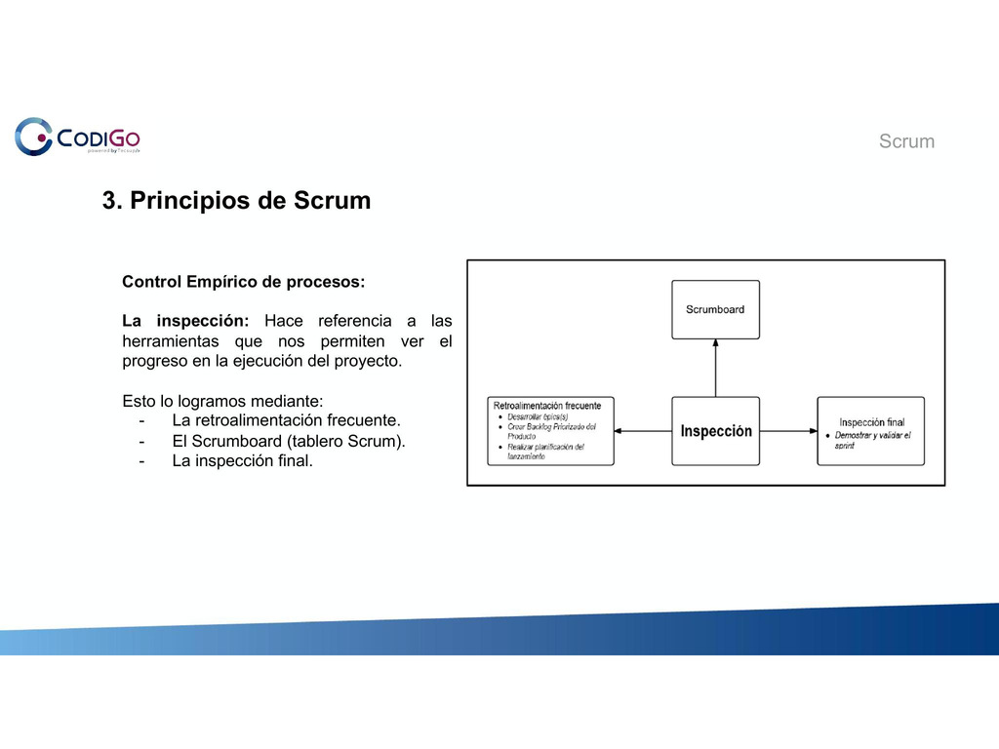

Slide 37 of 78

/srv/www/prod/ct/releases/2021-03-11-224507-4b367ebe8eea58632ed4f65167b8d66a0591a1ef/src/images/studentNotes/icon_image.png Slide

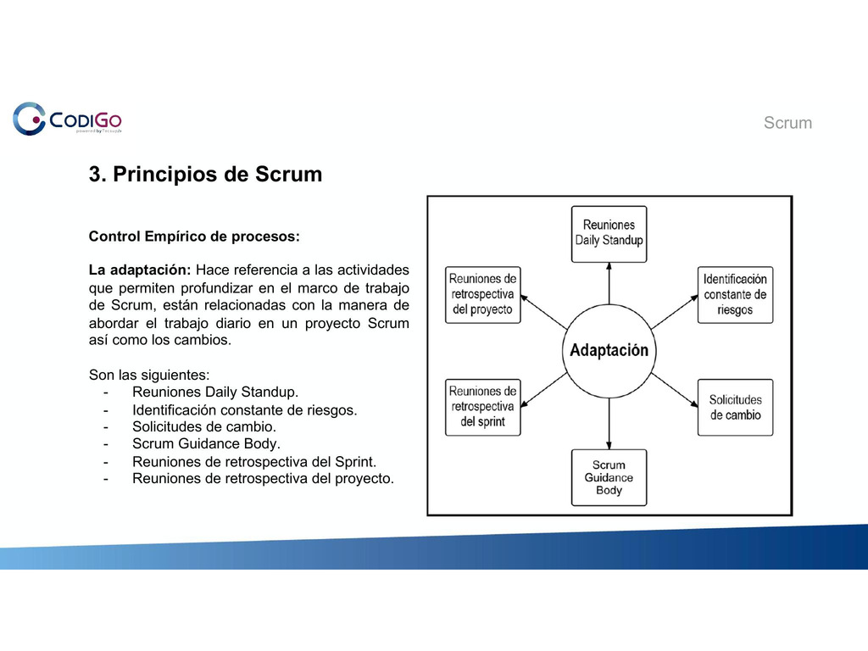

Slide 38 of 78

/srv/www/prod/ct/releases/2021-03-11-224507-4b367ebe8eea58632ed4f65167b8d66a0591a1ef/src/images/studentNotes/icon_image.png Slide

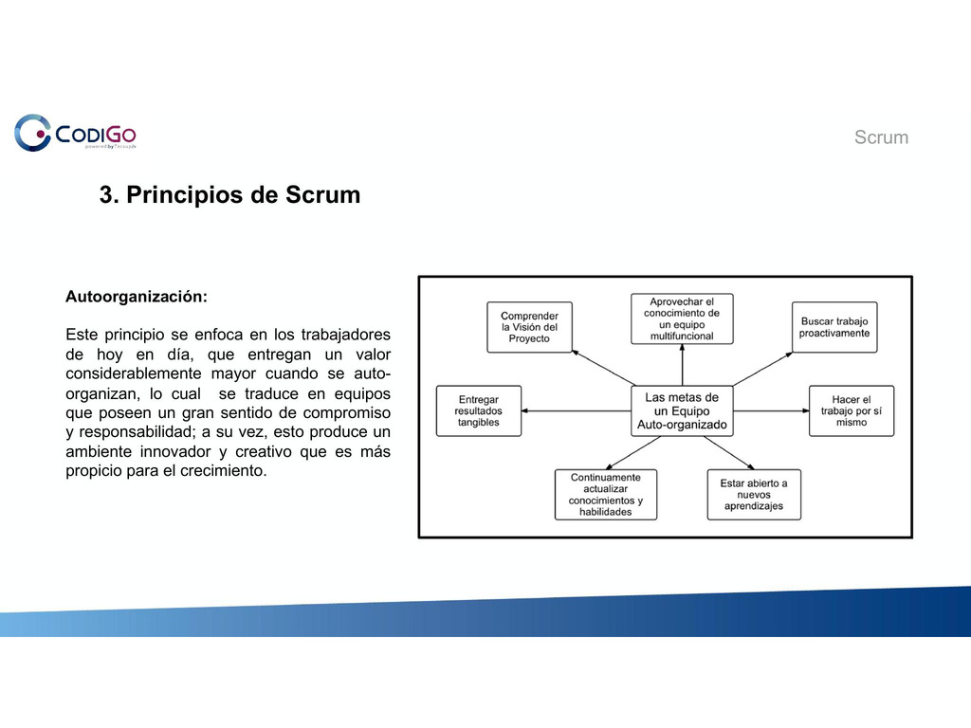

Slide 39 of 78

/srv/www/prod/ct/releases/2021-03-11-224507-4b367ebe8eea58632ed4f65167b8d66a0591a1ef/src/images/studentNotes/icon_image.png Slide

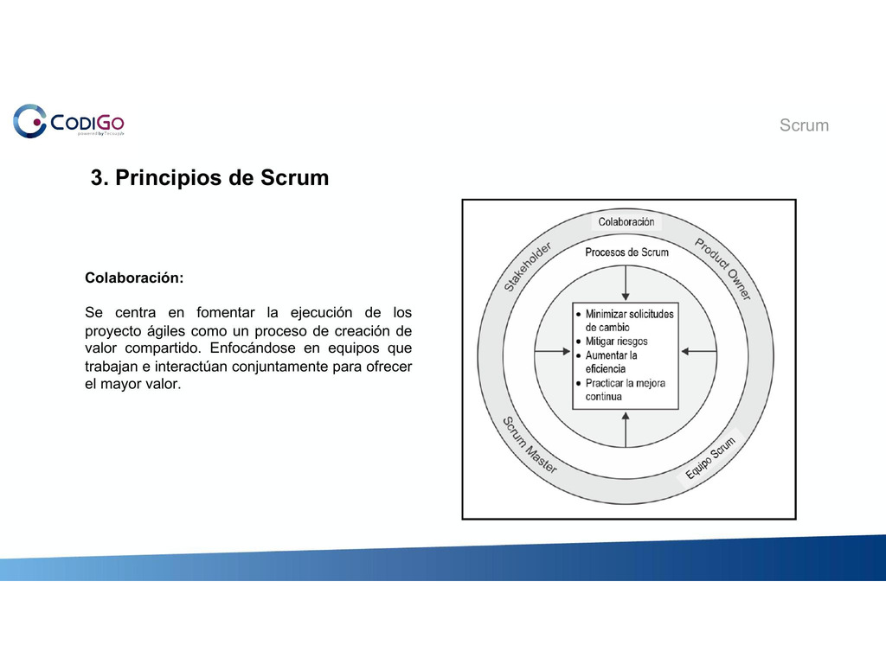

Slide 40 of 78

/srv/www/prod/ct/releases/2021-03-11-224507-4b367ebe8eea58632ed4f65167b8d66a0591a1ef/src/images/studentNotes/icon_image.png Slide

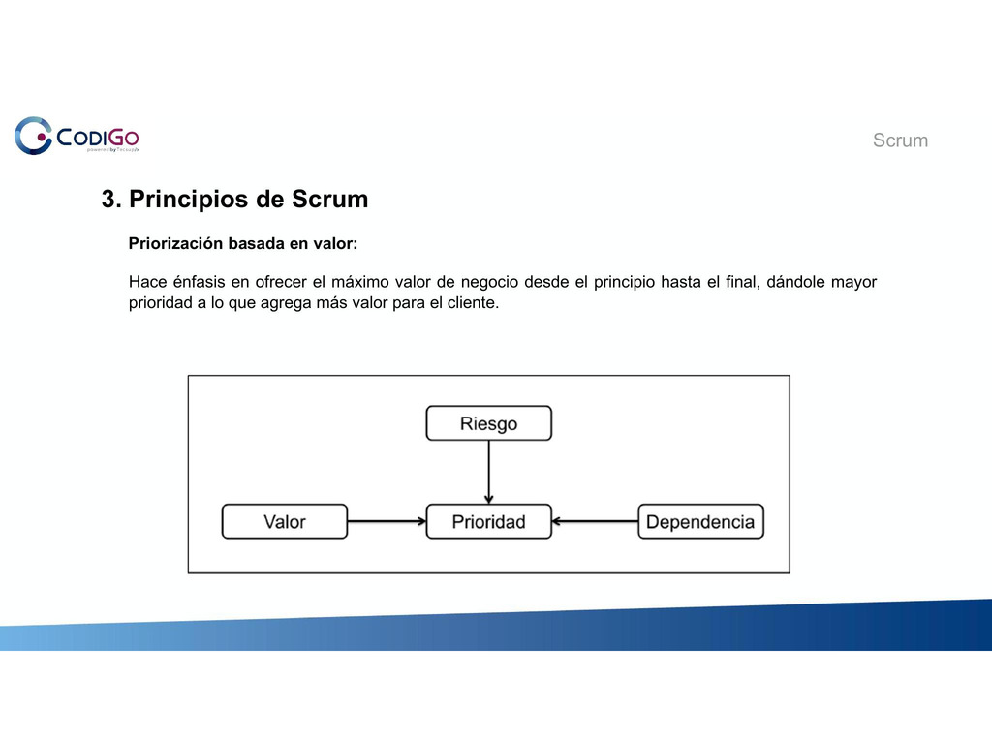

Slide 41 of 78

/srv/www/prod/ct/releases/2021-03-11-224507-4b367ebe8eea58632ed4f65167b8d66a0591a1ef/src/images/studentNotes/icon_image.png Slide

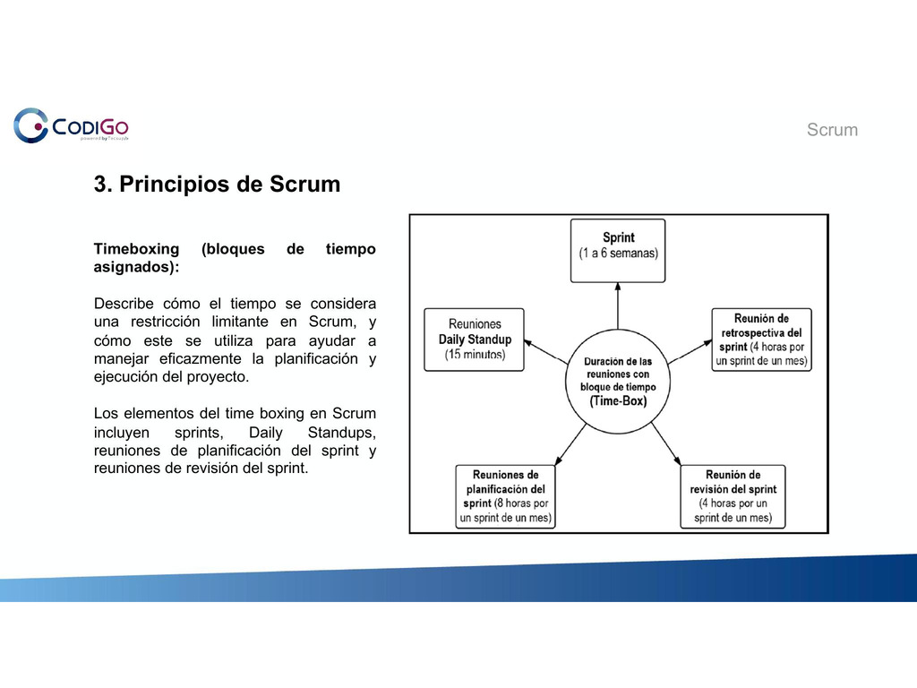

Slide 42 of 78

/srv/www/prod/ct/releases/2021-03-11-224507-4b367ebe8eea58632ed4f65167b8d66a0591a1ef/src/images/studentNotes/icon_image.png Slide

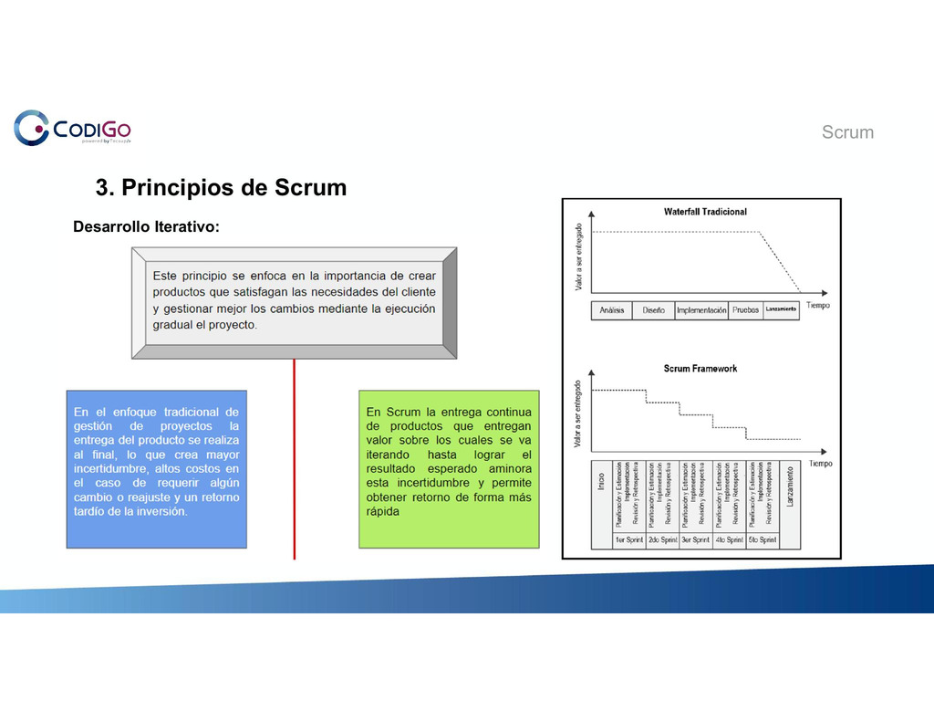

Slide 43 of 78

/srv/www/prod/ct/releases/2021-03-11-224507-4b367ebe8eea58632ed4f65167b8d66a0591a1ef/src/images/studentNotes/icon_collaborative.png Collaborate Board Dudas o comentarios sobre los principios...



[Open the Original](https://collaborative.nearpod.com/reports/354061659/cb2c0ff4f46d93121ae5419fde7a65c0?&parent_id=0&hideStudentNames=1)

Slide 44 of 78

/srv/www/prod/ct/releases/2021-03-11-224507-4b367ebe8eea58632ed4f65167b8d66a0591a1ef/src/images/studentNotes/icon_image.png Slide

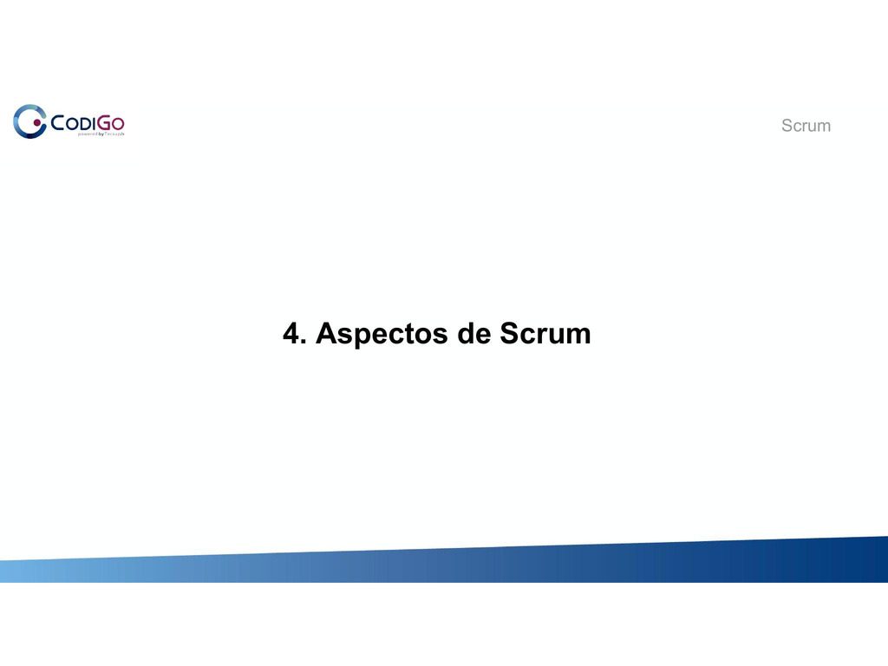

Slide 45 of 78

/srv/www/prod/ct/releases/2021-03-11-224507-4b367ebe8eea58632ed4f65167b8d66a0591a1ef/src/images/studentNotes/icon_image.png Slide

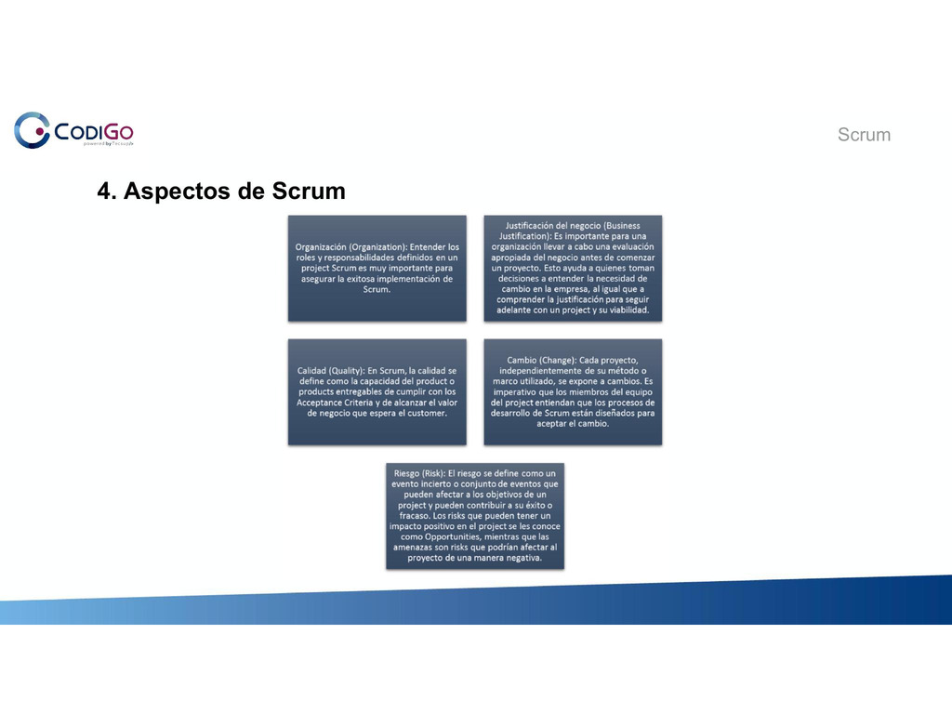

Slide 46 of 78

/srv/www/prod/ct/releases/2021-03-11-224507-4b367ebe8eea58632ed4f65167b8d66a0591a1ef/src/images/studentNotes/icon_image.png Slide

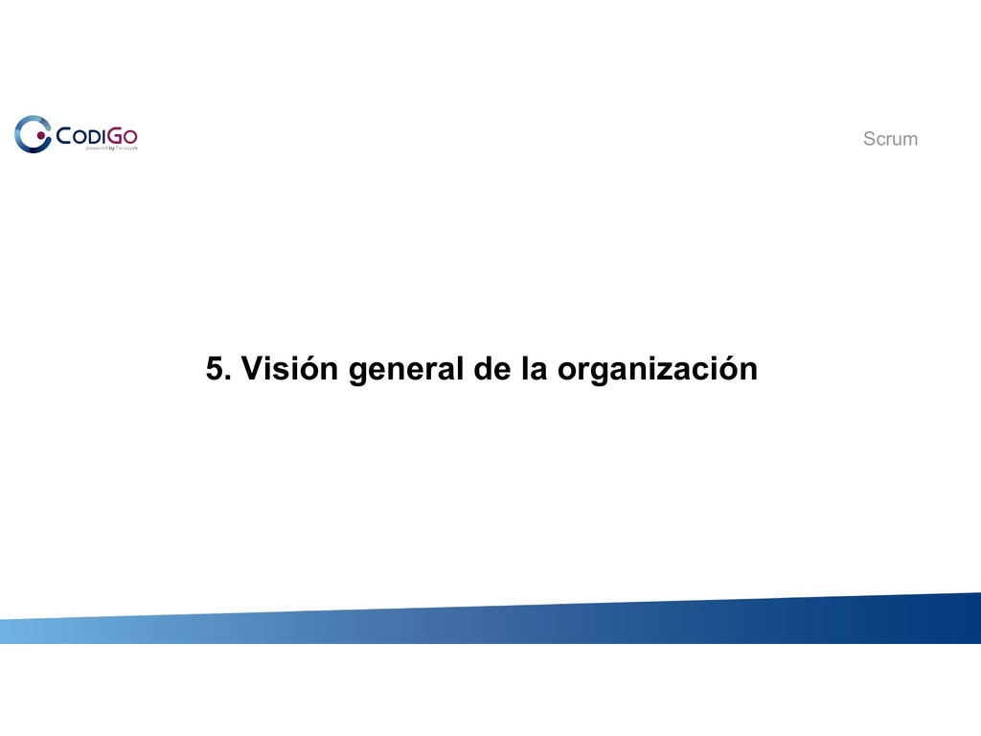

Slide 47 of 78

/srv/www/prod/ct/releases/2021-03-11-224507-4b367ebe8eea58632ed4f65167b8d66a0591a1ef/src/images/studentNotes/icon_image.png Slide

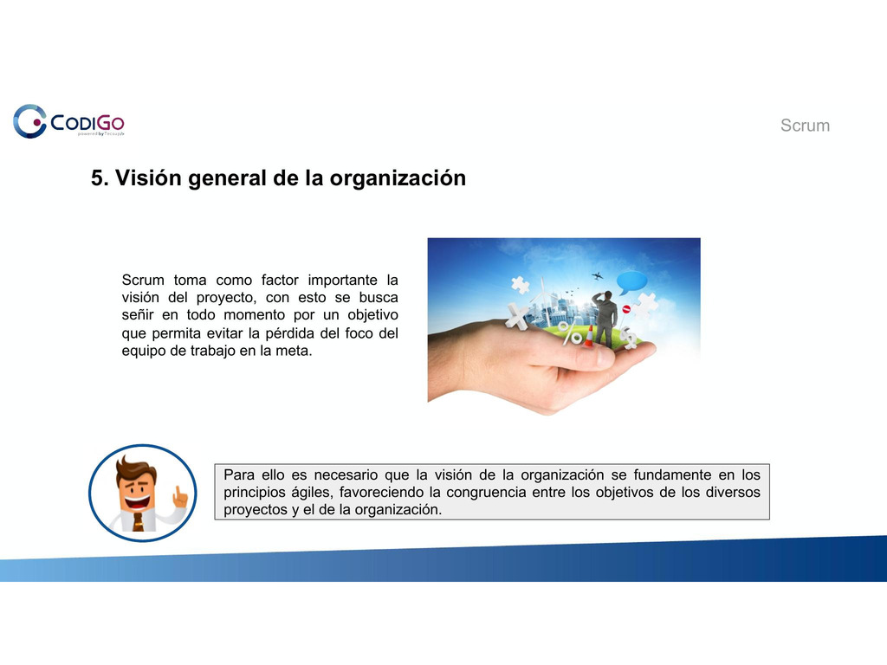

Slide 48 of 78

/srv/www/prod/ct/releases/2021-03-11-224507-4b367ebe8eea58632ed4f65167b8d66a0591a1ef/src/images/studentNotes/icon_image.png Slide



Slide 49 of 78

/srv/www/prod/ct/releases/2021-03-11-224507-4b367ebe8eea58632ed4f65167b8d66a0591a1ef/src/images/studentNotes/icon_image.png Slide

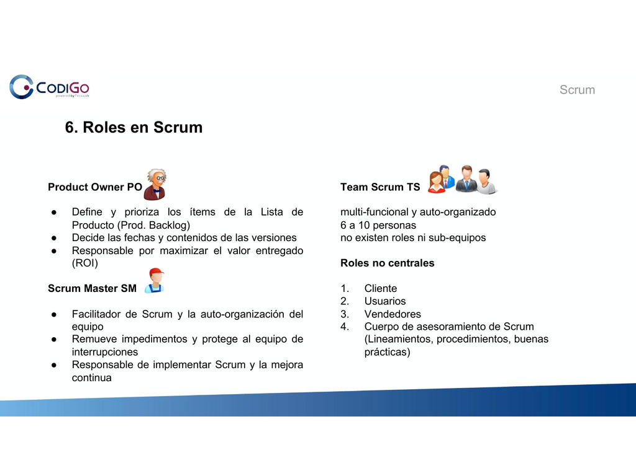

Slide 50 of 78

/srv/www/prod/ct/releases/2021-03-11-224507-4b367ebe8eea58632ed4f65167b8d66a0591a1ef/src/images/studentNotes/icon_image.png Slide



Slide 51 of 78

/srv/www/prod/ct/releases/2021-03-11-224507-4b367ebe8eea58632ed4f65167b8d66a0591a1ef/src/images/studentNotes/icon_image.png Slide

