CEBU INSTITUTE OF TECHNOLOGY UNIVERSITY

COLLEGE OF COMPUTER STUDIES

Software Requirements Specifications
for
CATalyst 2.0

Change History 3
Table of Contents 4
- Introduction 5
  - Purpose 5
  - Scope 5
  - Definitions, Acronyms and Abbreviations 5
  - References 5
- Overall Description 7
  - Product perspective 7
  - User characteristics 7
  - Constraints 7
  - Assumptions and dependencies 7
- Specific Requirements 9
  - External interface requirements 9
    - Hardware interfaces 9
    - Software interfaces 9
    - Communications interfaces 9
  - Functional requirements 9
Module 1 10
Module 2 14
  - Non-functional requirements 17
Performance 38
Security 38
Reliability 38

Introduction

  - Purpose
The purpose of this document is to provide a detailed description of CATalyst, an academic platform to guide students and researchers in looking for potential problem statements and topics in the early stages of research. This document serves as a reference for developer, project managers and stakeholders to ensure alignment with functional and non-functional requirements.
  - Scope
CATalyst is a web application that can assist researchers in the early stages of research in finding gaps or problem statements from existing literature by providing a platform for users to analyze said literature using Artificial Intelligence for a list of problem statements and suggesting topics from said problems.
The system ensures users to guide and reduce the amount of time spent reading through multiple research papers, searching for gaps to get a problem statement for their possible topic. The system consists of the following core functionalities:
- Authentication
- Workflows
- Document Extractor
- Summarizer
- Gap Extractor
- Topic Suggester
  - Definitions, Acronyms and Abbreviations
- AI (Artificial Intelligence) – the application of computer systems able to perform tasks or produce output normally requiring human intelligence, especially by applying machine learning techniques to large collections of data.
- LLM (Large Language Model) - a software tool capable of corpus-based linguistic analysis and prediction, particularly an artificial intelligence system that processes written instructions (prompts) and can generate natural language text.
- RRL (Review of Related Literature) - a comprehensive, critical summary and analysis of existing academic works, theories, and concepts relevant to a specific research topic
- n8n – a workflow automation platform that uniquely combines AI capabilities with business process automation, which gives the flexibility of code using the speed of no-code

  - References

- https://n8n.io/
- Identify each document by title, report number (if applicable), date, and publishing organization;

- Specify the sources from which the references can be obtained.

Overall Description

  - Product perspective
CATalyst is an AI-assisted support system designed for early-stage thesis and research development. It utilizes a client-server architecture wherein the backend processes research and orchestrates AI workflows to analyze literature, extract gaps, and potential research directions. CATalyst uses large language models to synthesize insights from multiple research papers. It is mainly designed as a web-based application for students and researchers to upload research papers and received structured outputs such as summaries, research gaps and suggested research topics.
  - User characteristics
  - Researchers: Main users of the system who upload or input research papers to be analyzed, generate summaries, identify research gaps, and receive suggested research topics. These users are expected to have basic familiarity with academic research and basic expertise with software systems
  - Faculty/ Academic Advisors: Users who review outputs such as research gaps and suggested topics to guide students in refining their research directions. These users are expected to have a strong domain knowledge in research but basic technical proficiency
  - System Administrator: Responsible for maintaining the system, managing user accounts, monitoring system performance, and ensuing the reliability of AI workflow processes. This user is expected to have advanced technical knowledge of system administration and backend services.

  - Constraints
- External AI Service Dependency: The system relies on external large language model services for natural language processing tasks such as summarization, research gap extraction, and topic suggestion. The availability and performance of these services may affect system response times.
- Internet Connectivity: Since CATalyst operates as a web-based system, users much have stable internet connection to upload research papers and retrieve analysis results.
- Security and Authentication: The system must enforce a secure user authentication to protect user data, including uploaded research papers and generated outputs.
- Document Processing Limitations: The system may impose restrictions on the size or format of research papers (e.g., PDF or word files) to ensure efficient processing and system performance.
- System Reliability Requirements: The system must maintain reliable processing of AI workflows and generated outputs are delivered without loss or corruption of user-submitted documents.

2.5. Assumptions and dependencies
  - Availability of AI Processing Services: The system assumes that external large language model services used for text analysis, summarization, and research gap identification will remain available and functional.

  - User-Provided Research Materials: The system assumes that users will provide relevant academic papers or research materials as input for analysis. The quality of generated insights depends on the quality and relevance of the provided documents.
  - Stable Internet Connectivity: The system assumes that users have reliable internet access to upload documents and retrieve AI-generated outputs from the server.
  - Availability of Web Browser Environment: The system assumes that users will access CATalyst through modern web browsers that support standard web technologies.
  - Availability of Backend Infrastructure: The system depends on cloud-based services and backend infrastructure to handle authentication, document processing, and AI workflow execution.

- Specific Requirements

  - External interface requirements

Hardware interfaces

The CATalyst system operates as a web-based application and does not directly interface with specialized hardware devices. The system is designed to run on standard computing platforms including desktop computers, laptops, tablets, and smartphones. User interaction with the system occurs through conventional input and output devices such as keyboards, mice, touchscreens, and display monitors using a web browser.

Software interfaces

      - Web Browser Interface – The system is accessed through modern web browsers that support standard web technologies such as HTML5, CSS, and JavaScript. The browser acts as the client interface through which users upload research documents and receive generated outputs. Built using React.js and Vite and deployed using Vercel.
      - Backend Application Server – The system uses a cloud-based database and authentication service responsible for storing user information, research inputs, and system outputs. Authentication services manage user login, session validation and access control. Built using Express.js and Supabase and deployed using Render.
      - AI Processing Services – The system interfaces an external AI service that provide natural language processing capabilities. These services are used to perform document summarization, research gap extraction, and topic suggestion based on the analysis of research papers. Built using n8n and deployed in a private server.

Communications interfaces

      - Client–Server Communication – The system uses HTTP and HTTPS protocols to facilitate communication -between the web client and the application server.
      - Data Transmission Format – Information exchanged between the client and server is transmitted using structured data formats suitable for web communication.
      - Internet Connectivity – The system requires an active internet connection to allow users to access the platform and retrieve generated research analysis results.
  - Functional requirements

Module 1: Authentication

Registration
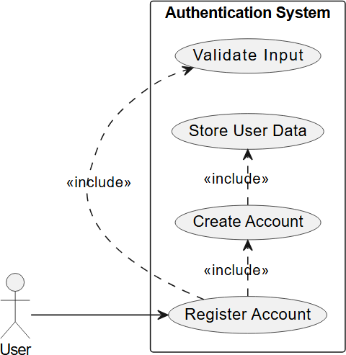

Use Case Description
Pre Conditions
      - User is not yet registered
      - System is available Main Flow
- New user initiates registration
- New user enters required information (email, password)
- System validates input
- System creates a new account
- System stores user data in database
- System confirms successful registration Alternate Flows:
  - Invalid Input: System shows validation errors
  - Duplicate Account: System notify user that an existing account exists Postconditions:
    - User Account is successfully created

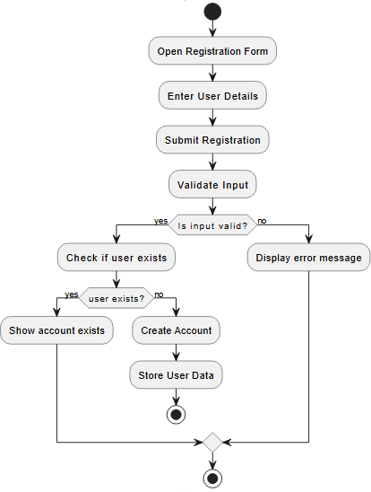
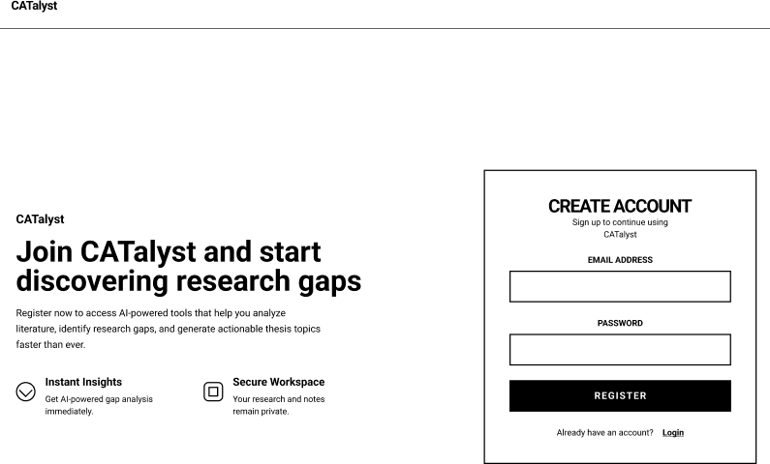

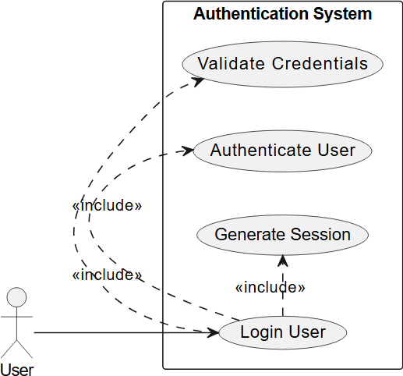
Login

Use Case Description
Pre Conditions:
      - User account exists
      - User account is not logged in Main Flow:
        - User initiates log in
        - User enters credentials
        - System validates credentials
        - System authenticates credentials
        - System generates session or token
        - User is granted access Alternate Flow:
          - Invalid Credentials: System denies access and shows error
          - Account not found: System prompts registration Post Conditions:
            - User is authenticated and logged into the system

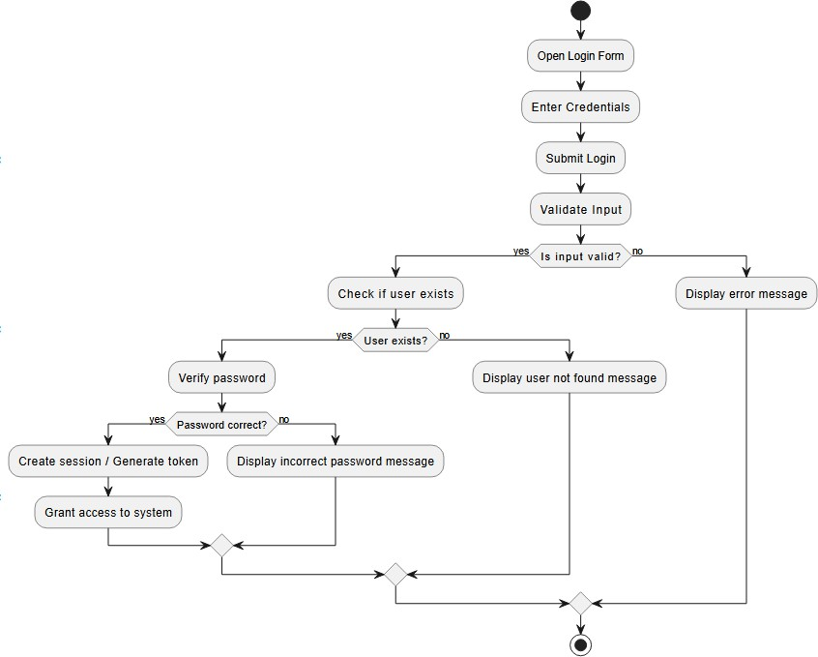

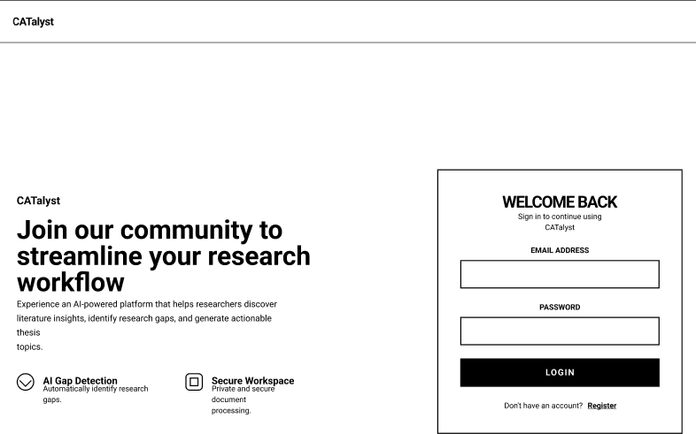

. . .

Module 2: Workspaces

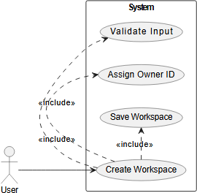
Create Workspace

Use Case Description
Pre Conditions:
      - User is logged in Main Flow:

- User selects Create Workspace
- User enters Group Details
- System validates user input
- System assigns Owner ID
- System saves the workspace to the database
- Workspace is now available for the user Alternate Flow:
  - Missing required fields: System warns user for missing fields Post Conditions:
    - New workspace is created for the user

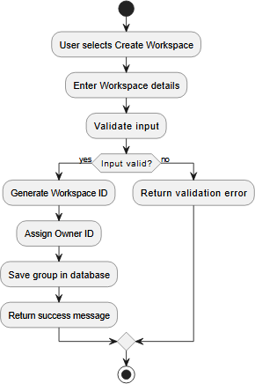
    - Wireframe

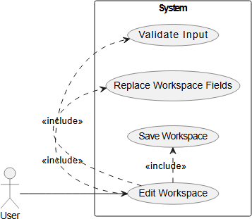
Edit Group

Use Case Description
Pre Conditions:
      - User is logged in
      - Workspace already exists in the system Main Flow:
        - User selects a Workspace
        - User selects Edit Workspace
        - User enters new Edit details
        - System validates user input
        - System assigns Owner ID
        - System replaces workspace fields
        - System saves updated fields
        - Updated workspace is now shown the user Alternate Flow:
          - Missing required fields: System warns user for missing fields Post Conditions:
            - Workspace is successfully edited

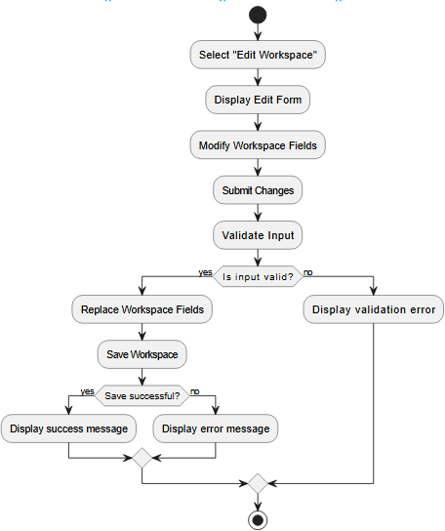
    - Wireframe

. . .

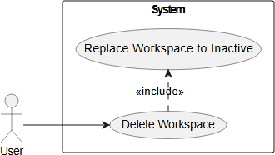
Delete Workspace

Use Case Description
Pre Conditions:
      - User is logged in
      - Workspace already exists in the system Main Flow:

- User selects a Workspace
- User selects Delete Workspace
- System asks for confirmation
- User confirms deletion
- System sets workspace to inactive
- Workspace is removed from the user’s workspaces
Alternate Flow:
- User cancels: Workspace remains unchanged Post Conditions:
  - Workspace is successfully deleted

Module 3: Document Extractor

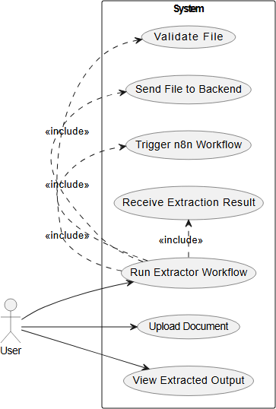
Run Workflow

Use Case Description
Pre Conditions:
      - User is logged in
      - User is inside a workspace
      - File is in PDF format
      - User in Extracto node

Main Flow:
- User navigates to Extractor node
- User uploads a PDF file
- User clicks Run Workflow
- System validates the file
- System processes the document
- System returns the result
- System displays extracted output Alternate Flow:
  - Processing fails: System displays processing failed error Post Conditions:
    - Extracted data is available for the user to view
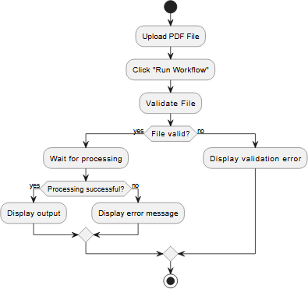

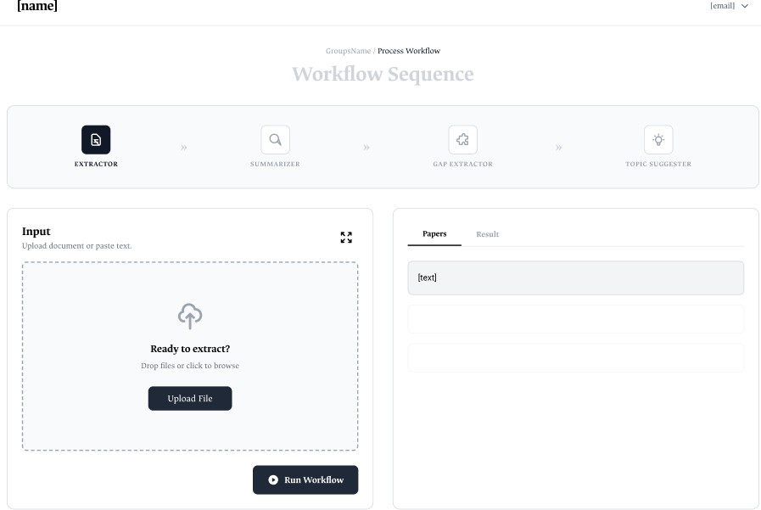

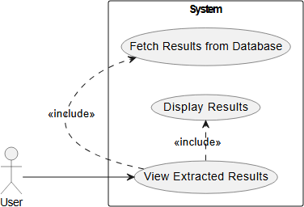
View Extracted Documents

Use Case Description
Pre Conditions:
      - User is logged in
      - User is inside a workspace

      - User is in Extractor Node Main Flow:
        - System sends request to backend
        - System returns the results
        - System displays extracted outputs Alternate Flow:
          - No Results: System displays extracted papers Post Conditions:
            - Extracted results are available for the user to view

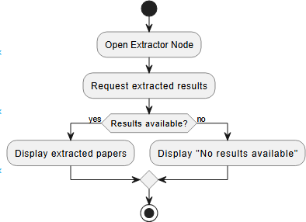

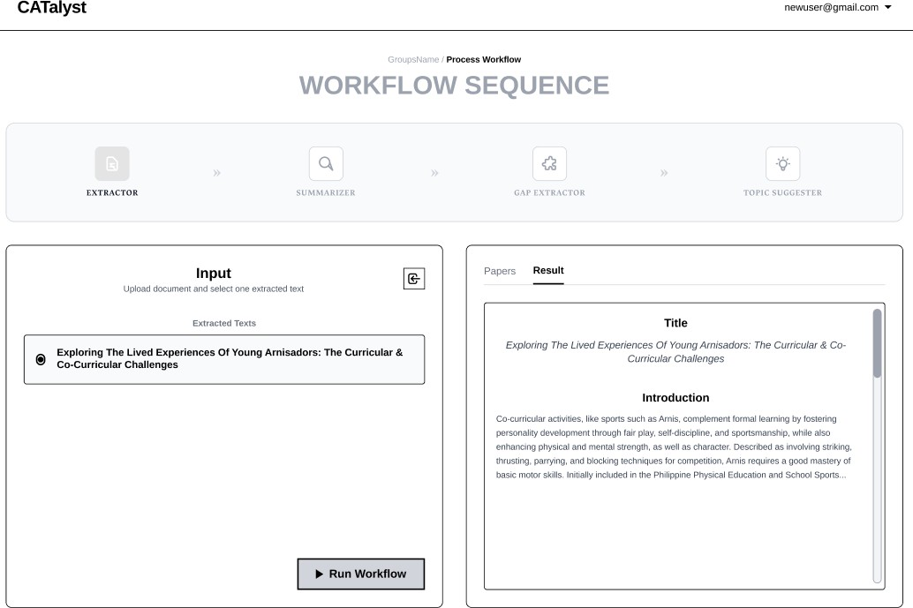

Module 4: Summarizer

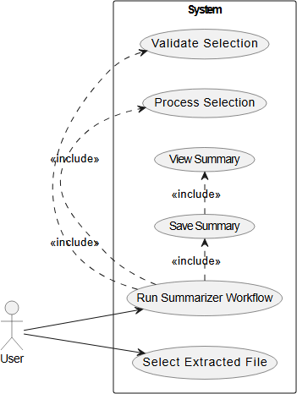
Run Workflow

Use Case Description
Pre Conditions:
      - User is logged in
      - User is inside a workspace
      - User has an existing extracted file
      - User in Summarizer node Main Flow:
        - User selects an extracted file
        - User clicks “Run Workflow”
        - System validates the selection
        - System processes the selection
        - System saves the result
        - System displays summarized output Alternate Flow:
          - No extracted files exist: System displays and empty state

Post Conditions:
- Summary results are available for the user to view
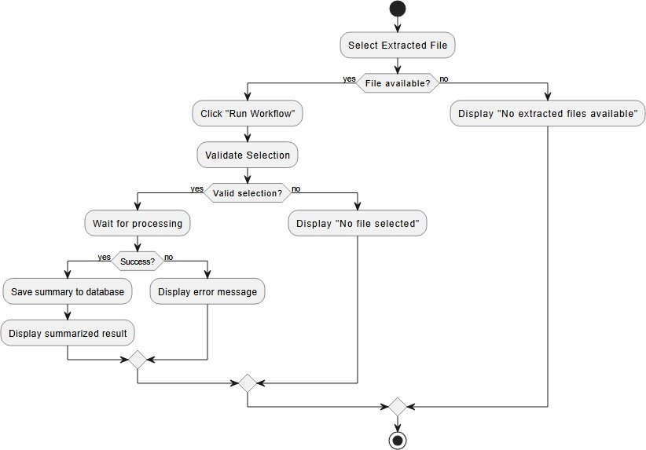

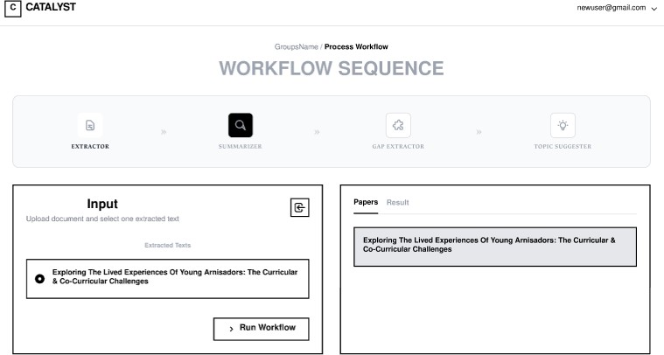

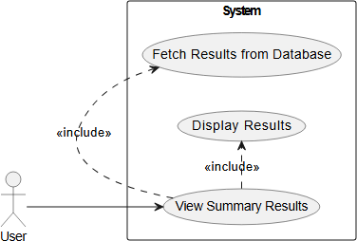
View Summaries

Use Case Description
Pre Conditions:
      - User is logged in

      - User is inside a workspace
      - User in Summarizer node Main Flow:
        - System sends request to backend
        - System returns the results
        - System displays summarized outputs Alternate Flow:
- No Results: System displays no summarized outputs Post Conditions:
  - Summarized results are available for the user to view
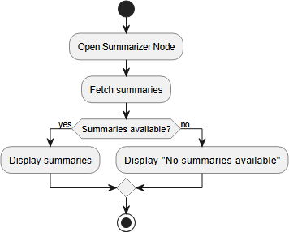

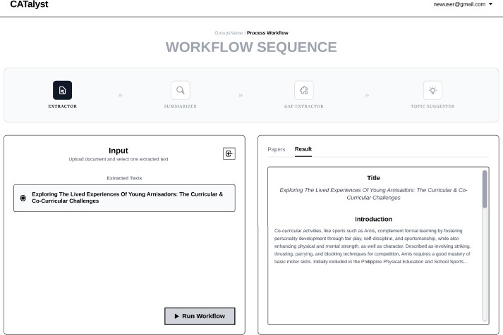

Module 5: Gap Extractor

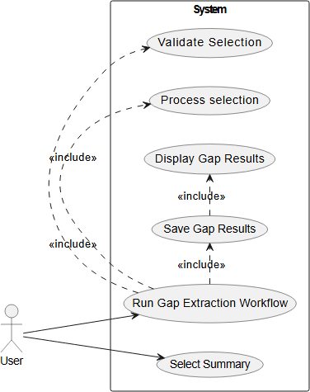
Run Workflow

Use Case Description
Pre Conditions:
      - User is logged in
      - User is inside a workspace
      - User has an existing summary
      - User in Gap Extractor node Main Flow:
        - User selects a summary
        - User clicks “Run Workflow”
        - System validates the selection
        - System processes the selection
        - System saves the result
        - System displays extracted gaps result Alternate Flow:
          - No summaries exist: System displays and empty state Post Conditions:
            - Gap results are available for the user to view

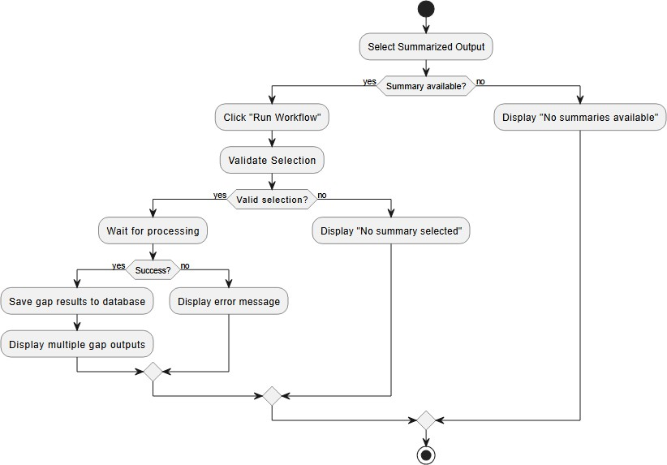

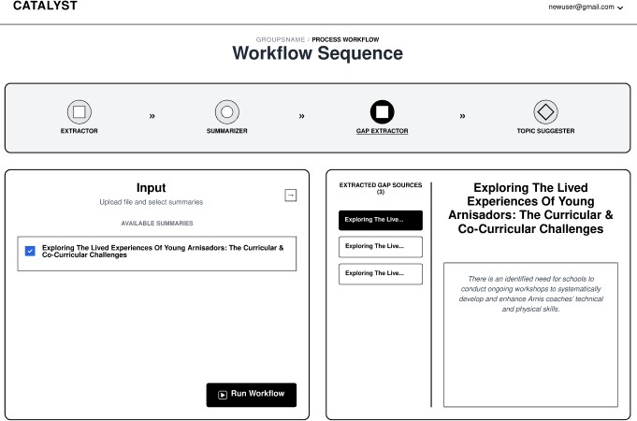

View Extracted Gaps
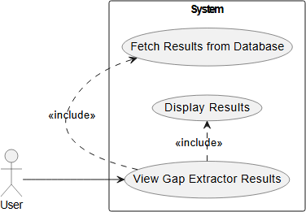

Use Case Description
Pre Conditions:

      - User is logged in
      - User is inside a workspace
      - User in Gap Extractor node Main Flow:
        - System sends request to backend
        - System returns the results
        - System displays extracted gap outputs Alternate Flow:
- No Results: System displays no extracted gap outputs Post Conditions:
  - Extracted Gap outputs are available for the user to view
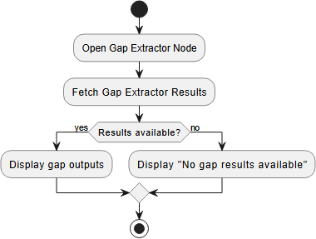

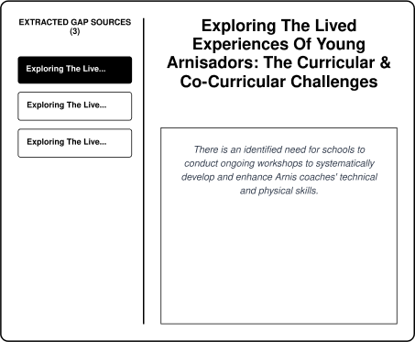

Module 6: Topic Suggester

Run Workflow
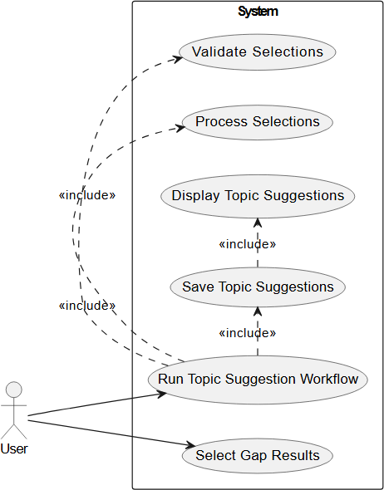

Use Case Description
Pre Conditions:
      - User is logged in
      - User is inside a workspace
      - User has an existing extracted gap/s
      - User in Topic Suggester node Main Flow:
        - User selects one or mode extracted gap
        - User clicks “Run Workflow”
        - System validates the selection
        - System processes the selection
        - System saves the result
        - System displays suggested topic result Alternate Flow:

- No Gaps exist: System displays and empty state Post Conditions:
  - Topic Suggestion is available for the user to view
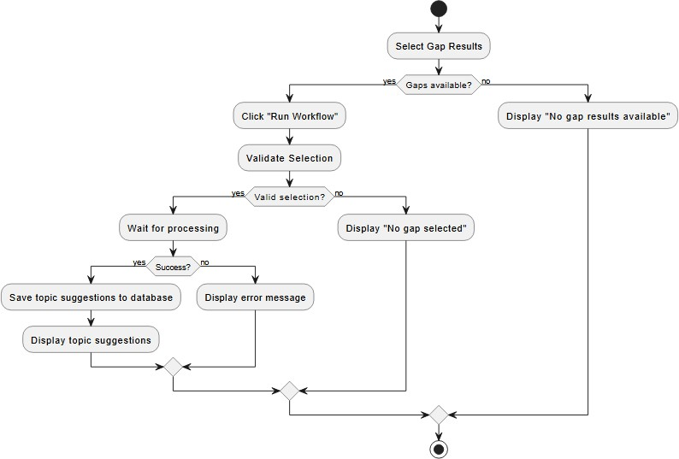

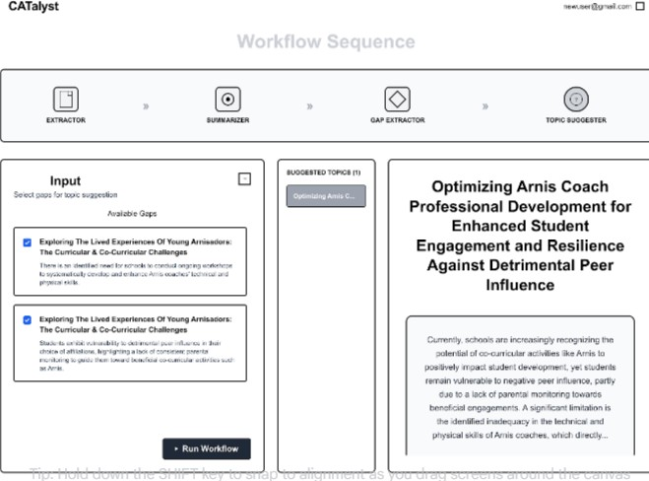

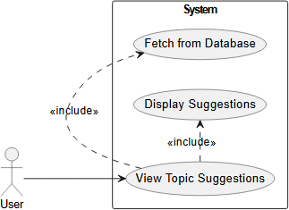
View Extracted Topics

Use Case Description
Pre Conditions:
      - User is logged in

      - User is inside a workspace
      - User in Topic Suggester node Main Flow:
        - System sends request to backend
        - System returns the results
        - System displays extracted Topic Suggester results Alternate Flow:
        - No Results: System displays no topic suggester results Post Conditions:
          - Topic Suggester outputs are available for the user to view
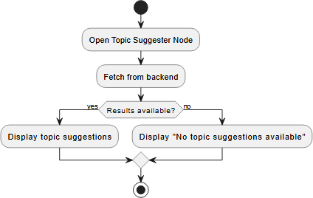


  - Non-functional requirements

Performance
- The system shall process user input and return analysis within a reasonable time frame under normal usage conditions.
- The system shall support multiple users accessing the platform simultaneously without significant degradation of system performance.
- The system shall handle document uploads and analysis processes efficiently to minimize delays in generating outputs.

Security
- The system shall require user authentication before allowing access to protected features.
- The system shall protect uploaded research materials and generated outputs from unauthorized access.
- The system shall ensure that user data is stored and transmitted securely.
- The system shall restrict system access based on user roles and permissions.

Reliability
- The system shall operate reliably during normal usage conditions without unexpected failures.
- The system shall maintain system functionality even when handling multiple user requests.
- The system shall ensure that user-submitted data and generated outputs are preserved and not lost during system operations.
- The system shall recover from temporary failures or service interruptions.

