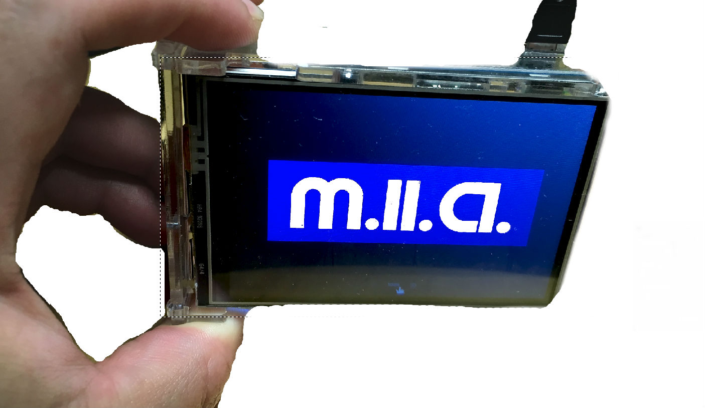
The Machine-learning Investment Appliance
By Carlos Rodriguez <carlos@S8F.org>, June 5th 2018.
Decrypting A Message from the Future...
It's the future, and we no longer have day jobs. We have ROBOTS that create and maintain Automated Investments, which are controlled by crypto-currency and security trading algorithms that us humans can't even understand. What we do understand, is that they are so efficient, it's a guaranteed system to make profits from N starting capital.

The result is what we call Universal Basic Income. The ROBOTS took all our day jobs, so what we are left with, is simply the choice of WHAT to invest our savings in. We simply buy a tiny $200 appliance called “M.I.A.” on Amazon, send it Bitcoins periodically, and we get back way more Bitcoins than we put in. And because of her, we do a lot of partying and slacking off. Cheers!
Ready to get Plug-&-PAID?
- Buy a 4”x2” IOT micro-appliance, known as “M.I.A.” from GetMIA.io, for $275 fully assembled.
- Power it with a USB cable (or battery pack) and connect via Wi-Fi or Ethernet cable.
- MIA creates a locally-hosted Bitcoin wallet, and a BTC address (or choose your crypto-currency) for you send coins to, displays the QR code on her 3.5” touch screen. Control it with a built-in webserver/GUI, or SSH/VNC for nerds.
- Send her capital, and she invests using a strategy you can choose from some presets. These presets are the statistically most profitable algorithms on the ZalgoNet “SWARM” p2p network, sorted by projected risk, based on empirical, anonymized telemetry results. Through SWARM, she works and benefits from other M.I.A.'s anonymously, creating a hive-mind mesh network.
- M.I.A. invests your BTC with artificially-intelligent day trading algorithms and “smart” hedge-funding, communicating directly with exchanges using API keys you've entered into the GUI.
- Any profits are sent to you as daily payments to a BTC address of your choosing.
- Go party!
Meshed online learning for the Everyman.
Online Machine-Learning will liberate mankind one day. The problem is that currently, it's just TOO DAMN HARD for the Everyman to set up or even understand. Thus, as of yet, those who benefit from Machine Learning are the Big Corps and Govt's. M.I.A. Changes this by making it trivial to use the vast powers of Intelligent ROBOTS for immediate gain, thus granting financial stability to all.
Beneficial Side-effect: A massive increase in market participation, and liquidity.
With the Average Joe in 3rd world countries investing his wages in global markets, get ready for a huge tidal wave of liquidity. Suddenly, struggling markets will spring to new life. And this is just the beginning. Thanks, M.I.A.!
https:// → Bot18.net (core functionality, now taking Beta testers!)
https:// → GetMIA.io (buy a M.I.A., coming soon!)
https:// → Zalgo.net (p2p network, coming soon!)
Patents pending.
ありがとございますSN.

