EBS.01
Functional Specification



Enterprise Business System
Web Application Development Platform

Version: 1.0
Release date: May 16th, 2006
Status: final

Please send comments and suggestions to comments@netx.com.
This document and the most up-to-date version may be obtained from http://www.netx.com/publish?document=EBS.01.
This document follows the standards specified in the Functional Specification Document Definition version 1, which can be obtained from http://www.netx.com/publish?document=DD_Functional_Specification_v1.
Copyright © NetX, 2006.
Rua da Olivença nº181, Arcozelo, Barcelos – Portugal
All rights reserved.

NOTICE:
This document is protected by copyright and the information described therein may be protected by one or more patents or pending applications. No part of this document may be reproduced in any form by any means without the prior written authorization of NetX. By viewing, downloading or otherwise copying this document, you agree that you have read, understood, and will comply with all of the terms and conditions set forth herein.

TERMS AND CONDITIONS:
NetX hereby grants you a fully paid, non-exclusive, non-transferable, worldwide, limited license (without the right to sublicense), under NetX’s intellectual property rights that are essential to practice this Specification, to internally practice the Specification for the purpose of designing and developing proprietary NetX applications.
This document contains proprietary information of NetX and may only be used in accordance with the license terms set forth herein. This license will terminate immediately without notice from NetX if you fail to comply with any provision of this license. Upon termination or expiration of this license, you must cease use of and destroy this document.

DISCLAIMER OF WARRANTIES:
THIS DOCUMENT IS PROVIDED “AS IS”. NETX MAKES NO REPRESENTATIONS OR WARRANTIES, EITHER EXPRESS OR IMPLIED, INCLUDING BUT NOT LIMITED TO, WARRANTIES OF MERCHANTABILITY, FITNESS FOR A PARTICULAR PURPOSE, OR NON-INFRINGEMENT THAT THE CONTENTS OF THIS DOCUMENT ARE SUITABLE FOR ANY PURPOSE OR THAT ANY PRACTICE IN ANY WAY RELATED TO THE CONTENTS OF THIS DOCUMENT WILL NOT INFRINGE ANY THIRD PARTY PATENTS, COPYRIGHTS, TRADE SECRETS OR OTHER RIGHTS.
THIS DOCUMENT MAY INCLUDE TECHNICAL INACCURACIES OR TYPOGRAPHICAL ERRORS. NETX MAY MAKE IMPROVEMENTS AND/OR CHANGES TO THE SPECIFICATION AND ANY PRODUCT(S) RELATED TO THE SPECIFICATION AT ANY TIME. ANY USE OF SUCH CHANGES IN THIS DOCUMENT WIL BE GOVERNED BY THE THEN-CURRENT LICENCE FOR THE APPLICABLE VERSION OF THE DOCUMENT.

LIMITATION OF LIABILITY:
TO THE EXTENT NOT PROHIBITED BY LAW, IN NO EVENT WILL NETX OR IT’S LICENSORS BE LIABLE FOR ANY DAMAGES, INCLUDING WITHOUT LIMITATION, LOST REVENUE, PROFITS OR DATA, OR FOR SPECIAL, INDIRECT, CONSEQUENTIAL, INCIDENTAL OR PUNITIVE DAMAGES, HOWEVER CAUSED AND REGARDLESS OF THE THEORY OF LIABILITY, ARISING OUT OF OR RELATED TO ANY FURNISHING, PRACTICING, MODIFYING OR ANY USE OF THIS DOCUMENT, EVEN IF NETX AND/OR IT’S LICENCORS HAVE BEEN ADVISED OF THE POSSIBILITY OF SUCH DAMAGES.

REPORT:
You may wish to report any ambiguities, inconsistencies or inaccuracies you may find in connection with your use of this document (“Feedback”). To the extent that you provide NetX with any Feedback, you hereby: (i) agree that such Feedback is provided in a non-proprietary and non-confidential basis, and (ii) grant NetX a perpetual, non-exclusive, worldwide, fully paid-up, irrevocable license, with the right to sublicense through multiple levels of sub licensees, to incorporate, disclose, and use without limitation the Feedback for any purpose related to this document and future versions, and any product(s) in any way related to this document.

Index
1. Introduction 2
2. Overview 3
2.1. EBS Application Functions 3
2.2. EBS Application Components 3
2.3. Data Model 4
3. Application Lifecycle 6
3.1. Start-up and out-of-service 6
3.2. Start and stop 7
4. Security 8
4.1. Authentication 8
4.1.1. Login procedure 8
4.1.2. Sessions 9
4.1.3. Logout procedure 11
4.2. Authorization 12
4.3. Illegal operations 12
5. Error Handling 13
6. Application Administration & Maintenance 14
7. Annex I – Detailed Entity Fields 16
8. Annex II – Authentication Use Cases 18

Introduction
The EBS web application development specification is a functional model for web applications suitable to be used in enterprise intranets. It defines a set of functions common to enterprise web applications. Implementations of this specification should be made available using appropriate web development technologies (e.g. Java Servlets, PHP, etc). The intent of this document is to provide the functional model without limiting the application of such technologies.
The use of a particular EBS platform implementation improves the web application development process by:
- Ensuring a consistent, proven functional model for enterprise web applications
- Providing a set of common web application functions, which typically are a considerable part of the implementation effort
While the EBS specification provides the functional model for web applications, EBS implementations provide (at least) an API specific to the underlying technology. The combination of both supplies a web development platform, which may be used to provide a product. A product is an end-user software package.
End-user EBS applications, as depicted below, are (ideally) independent of the EBS implementation used. For example, if an end-user application is implemented over a Servlet-based EBS platform, changing the implementation to a .NET-based EBS platform should have no effect at the end user level, as the functional model is retained (although the application itself needs to be changed from a development perspective, as the used API is different).
Figure 1 – Relationship between the EBS specification, products and EBS implementations
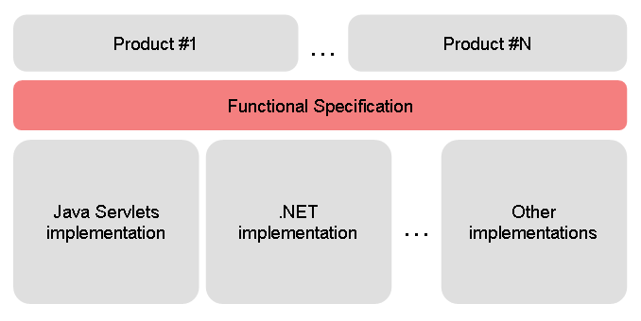
The details provided in this document should be sufficient to define the rules for an implementation. Please refer to the Userdoc and API documents for details regarding EBS platform implementations.

Overview

EBS Application Functions
The EBS specification defines the following functions:
- Application lifecycle: standard procedures for applications to follow when starting and exiting the application.
- Security model: based on authentication, authorization and prevention of illegal operations. It defines and provides all the user session management and server resource access protection functions.
- Error handling: specification of a standard error-handling mechanism for different kinds of errors.
- Application administration: basic functions for application administrators to manage and maintain a web application. These functions include controlling the application lifecycle, configuring users, managing user sessions and keeping track of application errors.

EBS Application Components
There are three special server resources in EBS applications:
- The [initializer] is a server resource which is responsible for the start-up and out-of-service procedures (that is, starting and exiting the application).
- The [error-handler] resource handles all application errors, showing useful error messages to the users and logging error information.
- The [authenticator] resource handles the login procedure. HTTP GET requests show login forms to the users, and HTTP POST requests process user information in order to log users into the application.
Figure 2 - Main components of EBS applications
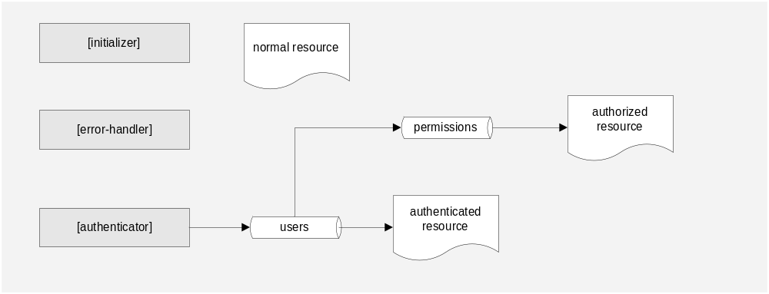

Application developers may develop normal resources, or they may configure a resource to be an authenticated resource (that is, a resource which is only accessible to users who have successfully logged in) or an authorized resource (an authenticated resource which has a special permission, and only authenticated users who have been assigned that permission may access it).
Details about the [initializer] resource can be found at 3.Application Lifecycle. Details about the [authenticator], authenticated, authorized and administration resources can be found at 4.Security. Details about the [error-handler] resource can be found at 5.Error Handling.

Data Model
The underlying data model supports information about the users and provides a means for applying security configurations (authentication and authorization). The following figure represents EBS’ data model:
Figure 3 – Data Model
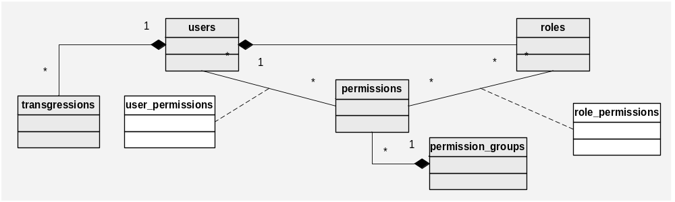
Each user has one specific role. Based on the user’s role, several actions may be applied. One of the roles’ properties is the login_resource. roles.login_ resource specifies a resource where the application will be redirected after a successful login. Each role has also a set of permissions. Setting permissions at the role level makes them applicable to all users assigned to that role.
Permissions may also be set at the user level, in order to provide a means to specify specific functions or responsibilities to individual users.
For example, an application may be used by a manager which uses specific management-related pages. Permissions may be set at the manager role level, therefore allowing all managers access to these pages. If other workers do not have these permissions, they may not use the pages. On the other hand, one of these workers may be assigned specific management functions. In this case, he may have a permission assigned to his user, allowing him access to the required page without affecting other user’s permissions (even if they have the same role).
All permissions must be assigned to permission groups. Grouping permissions may allow the application level to manage the user-interface, by determining how to separately show permissions in their corresponding groups (if required).
A minimal implementation (for example, an application that only runs batch processes) requires this data model as well, at least to provide the means for one administrator user to manage the application. That is, one user (e.g. user01), his role (e.g. admin) with one permission (e.g. all) belonging to one permission group (e.g. ADM).
Transgressions made by users may be tries of an unauthorized access, or illegal operations on forms sent to the application (See 4.Security for details). These are stored in the database for later analysis by system administrators.
See Annex I – Detailed Entity Fields for the complete list of fields for each entity.

Application Lifecycle

Start-up and out-of-service
The application has a moment of start-up, where it does the following operations:
- Read configuration parameters
- Test the database connection
- Check the database for all the needed tables
After a successful start-up, the application is in the running state. If the start-up is not successful, the application is in the not-initialized state and every request shall respond with the same web page displaying the start-up errors with sufficient detail for the developer to correct them.
Inversely, the application may also go out-of-service. This procedure makes the server deny every request to the application (therefore sending a page not found or similar error to the user). Putting an application out-of-service and starting it up immediately after is called a reload. In most cases, the start-up and out-of-service procedures are handled by the web server itself.
Configuration parameters may be provided in different manners, according to what is suitable to the underlying implementation. Most implementations use either XML configuration files deployed at a standard file system location, or by storing them in a database. The existence of a configuration file is unavoidable, at least to specify database connection parameters. EBS applications’ configuration parameters are as follows:
- authenticator-name: implementation name of the [authenticator] resource (for example, “authenticator.jsp”).
- error-handler-name: implementation name of the [error-handler] resource (for example, “error-handler.jsp”).
- send-error-codes: boolean parameter that specifies whether the HTTP status codes should be sent with the response or all responses should send status code 200 (OK). This is needed in some situations where the application’s responses are filtered by proxies. Some proxies catch the response codes and provide their own error pages, preventing the application’s custom error pages from being displayed. Setting this parameter to false will override this behaviour. Defaults to true.
- keep-sessions-on-reload: boolean parameter which indicates whether the user sessions should be kept when the application is reloaded. Defaults to true.
- session-mode: parameter that specifies the way the authenticated user’s session is handled. See 4.Security for details. Defaults to normal.
- allow-multiple-sessions: specifies whether users may have multiple sessions. If this parameter is true, the [authenticator] resource will not verify the presence of a live session on another client. See 4.Security for details. Defaults to false.
- session-check-daemon-period: time parameter which specifies the period of time in which the session checking daemon task runs. See 4.Security for details.
- notification-check-daemon-period: time parameter which specifies the period of time in which the notification deleting daemon task runs. See 4.Security for details.
- notification-keep-time: parameter which specifies the amount of time session notifications must be kept. See 4.Security for details about session notifications.
Parameters which do not refer a default value are mandatory.
The application also has the following configuration parameters, although defined in an implementation-specific manner:
- Log parameters (logging level and log file location)
- Database connection parameters

Start and stop
It might be needed to temporarily stop the application in order to perform maintenance operations (for instance, backing up the database).
While the application is stopped, it accepts and responds to requests, sending the application users a warning page informing the kind of operation being performed (e.g., database maintenance), and the expected duration of the operation (e.g., 10 minutes). Application administrators, on the other hand, may access administration resources while the application is stopped. This is different from putting the application out-of-service, which makes the server deny every request.
Stopping the application can be done through the administration pages. The application administrator specifies a description of the operation being performed, the expected duration of the operation, and the time at which the application will be stopped (which may be immediately). While the application is stopped it is in the stopped state.
After the operation is performed, there is also an option in the administration pages to start the application. Alternatively, a reload procedure may be applied, which restores the application’s running state. In this case, if the keep-sessions-on-reload parameter is false, the users will need to re-login.

Security

Authentication
A user becomes authenticated when he provides valid credentials to the application, i.e., logs in. Some resources may be configured to be accessible only by authenticated users – these are called authenticated resources.
If a non-authenticated user tries to access a resource which is configured to be available to authenticated users only, he is redirected to [authenticator]?action=error&reason=no-auth, which shows a message warning the user that he must log into the application.

Login procedure
The authentication process is called login and is performed by one specific resource in the application which is referred to as the [authenticator] and is named in an implementation-specific way (for example, authenticator.php, authenticator.jsp).
The login procedure is executed by submitting an HTTP POST to the [authenticator] resource with the username and password parameters set. After a successful login, a user session is created and the application is redirected to roles.login_resource.
During the authentication process, the following exceptional situations may occur:
Table 1 – Exceptional situations that may occur during login
Situation | Action | Resource
The entered username / password pair is not found in the database. | The user is warned of the error and prompted to log in again. | [authenticator]?action=error&reason=failed&user=<username sent>
There is another session started by the same user in another client. | The user is warned of the error and prompted to log in again. The other session is terminated with notification-aborted. | [authenticator]?action=error&reason=aborted&user=<username sent>
There is another session started by the same user in the same client. | The login succeeds normally. | Resource indicated in roles.login_resource
There is another session started by another user in the same client. | The user is directed to his initial page. The previous session is terminated with notification-logout. | Resource indicated in roles.login_resource

Please refer to Annex II – Authentication Use Cases for different authentication scenarios.

Sessions
After the authentication process, an HTTP session is started for the user. The session has the following parameters:
- session-ID: unique identifier of the session. Corresponds to the same value as the client-ID cookie (see below).
- session-username: username of the owner of the session. Corresponds to the same value as the user-ID cookie (see below).
- session-IP-address: IP address of the client machine. May be useful for network management purposes or to track users.
- session-last-access: time stamp of the last access to the session. Any request to an authenticated resource updates this parameter.
- session-last-modification: time stamp of the last modification made to the session. This parameter is updated after adding, deleting or changing a user-defined parameter (see below).
Sessions may also hold user-defined parameters. These are simple name-value pairs. The application programmer may add, delete or update a user-defined parameter. User-defined parameters are not kept after an application reload.

Session modes:
There are two different session modes:
- Normal: the session is kept for the specified timeout period, independently of whether or not the browser windows are closed after a session has been started. This differs from normal HTTP sessions, which are terminated once all the browser windows are closed.
- Fixed-IP: the session is fixed to the client’s IP address. Only the specific user mapped to the request’s IP address may log in from that client. If the IP address is found, the corresponding username is automatically set on the login form and cannot be edited. Any request to the [authenticator] resource from a client with an IP address unknown to the application is redirected to [authenticator]?action=error&reason=unknown-address, which displays an error message to the user. This session mode is suitable for use in applications designed to be deployed in intranets with high security requirements.

Session termination:
If a user tries to use an authenticated resource and his session has been terminated, the request is directed to [authenticator]?action=error&reason=session-terminated&user=<username>&notification=<n otification-code>&message=<message>.
The session may be terminated by the following reasons:
Table 2 – Possible reasons for session termination
Reason | Action | Notification message
The user has logged out (may happen when the user is using several browser windows). | The user is warned that the session has been terminated and why, and prompted to log in again. | logout
The user has logged in on another client. | The user is warned that the session has been terminated and why, and prompted to log in again. | aborted
The session has timed out. | The user is warned that the session has been terminated and why, and prompted to log in again. | timeout
The session has been terminated by a system administrator. | The user is warned that the session has been terminated and why, including a message specified by the system administrator. The message specified is sent as an additional parameter called message. | terminated

The termination mechanism follows two steps:
- A termination message – called a notification – is sent to the session. Notifications are kept after the session is terminated, so that it is possible to provide a message describing the session termination reason to the user. The notification message is specified as the notification parameter sent to the [authenticator] resource, and can have the values specified in Table 2.
- The session object on the server side is deleted.
Notifications are kept on the server for a period of time specified by the notification-keep-time configuration parameter. Once the user has seen the message describing why the session was terminated, the notification is deleted so it is not displayed repeatedly.
Periodically, the server runs a daemon task which deletes notifications older than the specified life time of the notifications. The period of time in which the daemon task runs is configured through the notification-check-daemon-period configuration parameter.

Session timeout:
Session timeout is a special case of session termination. After a session has been inactive for a specific period of time (which may be specified by the user), it is timed out, that is, terminated with notification-timeout. The time-out procedure is implemented by the following measures:
- The user-ID cookie has a timeout of n minutes. Therefore, after n minutes of inactivity, the cookie is deleted from the browser.
- Every request to the server is checked for the presence of user-ID. If it is not present (because the browser has already deleted it), the server checks the session for timeout based on its session-last-access time.
- The server runs a daemon task that checks sessions for timeout based on session-last-access at specified intervals in time. This period is specified as the session-check-daemon-period configuration parameter. If the difference between session-last-access and the current time is greater than n minutes, the session is timed out.

Cookie handling:
The session is kept using two different cookies:
- client-ID: unique session identifier formed by a random sequence that is kept for a year in the client machine.
- user-ID: username of the logged in user. This cookie is only kept for active sessions.
Every request to an authenticated resource is tested for the existence and validity of a session through these cookies. The procedure follows the steps described below:
- The request is checked for the presence of client-ID. If this cookie is not present, the user is considered to be not authenticated and redirected to [authenticator]?action=error&reason= no-auth.
- If client-ID is present, the request is checked for the presence of user-ID. If this cookie is not present, the session has been terminated for some reason. The server then checks for the existence of a notification message for the client-ID, and:
- If there is a notification, the application is redirected to [authenticator]?action=error& reason=session-terminated&user=<username>&message=<message>. This resource shows the reason why the session was terminated, and deletes the notification message. See the section above, Session termination, for more information.
- If there are no notifications, it means notification-keep-time has passed and the notification has been deleted. In this case, the user is considered to be not authenticated and redirected to [authenticator]?action=error&reason=no-auth.
- If both client-ID and user-ID are present, the server checks for the existence of a current registered session associated to client-ID. If the session exists, the control is handed to the application. Otherwise (this happens only if the server keeps sessions in memory and not in a persistent manner):
- If keep-sessions-on-reload is false, the user is considered to be not authenticated and redirected to [authenticator]?action=error&reason=no-auth.
- If keep-sessions-on-reload is true, it means the application has been reloaded and the session is created once again.

Logout procedure
To log the user out, it is necessary to redirect him to [authenticator]?action=logout. The session will be notified with notification-logout and terminated. Calling [authenticator]?action=logout when there is no session (either because it hasn’t been created, or it has been terminated) will redirect the user to [authenticator].

Authorization
Some resources may be available only to authorized users. These are called authorized resources. For this kind of resource, after testing the presence of a session, there is also a check to the user’s permissions, guaranteeing that the requested resource may be accessed by the user. If the user does not have permission to access the request, he is redirected to the [error-handler] resource and the access try is stored in the transgressions table.
The permission list for a user is composed by the user’s role’s permissions added to the user’s permissions (if any). Permissions may be added or removed from users or roles in administration pages.
Permissions are retrieved from the database during the login procedure and stored in the user’s session. Therefore, access to an authorized resource does not need a database query in order to determine if the user has the required permission.

Illegal operations
There are resources which need some required parameters in order to operate. For instance, when the [authenticator] resource is called with action=error, the reason parameter is required. In these situations, the application level must specify the parameters which are required for the request. If one or more of the required parameters is missing, the request is redirected to the [error-handler] resource and logged. This avoids trying to generate application errors by submitting requests or form data with missing parameters.

Error Handling
EBS applications use the [error-handler] resource to catch and treat application errors. When an error occurs, the application must hand control to the [error-handler] in an internal way, that is, without using HTTP redirects and URL parameters. For example, implementing an [error-handler] which responds to URLs like [error-handler]?error=no-perm&user=<user>&permission=<permission> (as a response to a user trying to access a resource for which he does not have permission) is not adequate. As the [error-handler] is responsible for logging errors, exposing this resource through HTTP parameters would allow reporting false errors (for example, by calling [error-handler]?error=no-perm&user=<user>&permission =<permission> repeatedly).
The EBS platform handles the following types of errors in a standardized way:
- Input and output errors, like errors accessing a file on disk or while communicating with a URL.
- Database errors like the database server being inaccessible.
- Runtime errors, like accessing a non-existing position of an array.
For all these, standard error messages are displayed to the users. Runtime errors are the only kind of error which is considered to be an application error that needs correction (in this case, the error message asks the user to contact the system administrator).
All application errors must be logged. EBS applications should use a two level error logging mechanism:
- Database logging, used to log I/O and runtime errors in normal conditions. Database logging is inherently more efficient and thread-safe than file logging and therefore more suitable for use in heavy load environments.
- File logging, used as a backup logging mechanism to log all kinds of errors when the database is not available.
These error logging mechanisms should be provided by the [error-handler] resource, to ensure consistent error handling across the application.

Application Administration & Maintenance
The administration and maintenance pages provide the following functions:

Initialization parameter configuration
- View and edit the configuration parameters

Application lifecycle management
- Stop the application, specifying the expected duration of the operation
- Start the application
- Reload the application

User, role and permission management
- Roles: add, remove and edit (name, login redirection URL, assign / remove role permissions)
- Permission groups: add, remove and edit (id and name)
- Permissions: add, remove and edit (id, name and permission group)
- Users: add, de-activate, activate and edit (personal data, role, assign / remove user-specific permissions)
If the user’s role, permissions or personal data are changed, the application might need to refresh its user interface (for instance, changing the users’ role may imply a different workspace). It is left to the application level to decide whether the session must be terminated when performing one of these operations.

Session management
- List current sessions (session-ID, session-username, session-IP-address, session-last-access, session-last-modification and user-defined parameters)
- Terminate a session, specifying a reason

Database management
EBS implementations should provide, whenever possible, connection pooling for database access. In these cases, the following administration pages should be available:
- View the number of active connections in the connection pool
- View the number of idle connections in the connection pool, and the time of inactivity

User account configuration
These functions are provided to the users themselves, by a personal account configuration page.
- Change password
- Specify session timeout time

Transgression management
- View transgressions made by users (user, date and time, resource used)

Error Management
- View the application error log
- Clean the application error log

Annex I – Detailed Entity Fields
Users
Field | Type | Default value | Description / Rules
user_id | long |  | primary key
username | binary(20) |  | Identifier, must start with a letter or _ and can only have the following characters: [a-Z][0-9]._-$
password | binary(20)
ip_address | text(15) |  | Internet Protocol address of this user’s client machine. This field is used when “session-mode” is “fixed-ip”.
name | text(50) |  | can only contain letters
sex | text(1) |  | {male, female}
birthdate | date
registration_date | date
active | Boolean | true
session_timeout | int | 30 | Timeout value specified in minutes. If 0, the session never times out.
role_id | foreign-key(roles)
Constraints
unique {username}

Roles
Field | Type | Default value | Description / Rules
role_id | long |  | primary key
name | text(20)
description | text(200) | NULL
login_resource | text(50) |  | Must be relative to the application root, without a leading “/”. For example, if the user is to be redirected to http://apps.server.com/application1/ user-start, this field must have the value user-start.

Permissions
Field | Type | Default value | Description / Rules
permission_id | text(6) |  | primary key
permission_group_id | foreign-key(permission_ groups)
name | text(20)
Constraints
unique {name}

Permission Groups
Field | Type | Default value | Description / Rules
permission_group_id | text(6) |  | primary key
name | text(20)
Constraints
unique {name}

Errors
Field | Type | Default value | Description / Rules
error_id | long |  | primary key
user_id | foreign-key(users) | NULL
request_url | text(300) | NULL
message | text(16M)
time_occurred | moment
stack_trace | text(16M) | NULL

Transgressions
Field | Type | Default value | Description / Rules
transgression_id | long |  | primary key
user_id | foreign-key(users) | NULL
type | text(1) |  | {illegal access, illegal operation}
request_url | text(300)
message | text(16M)
time_occurred | moment

Annex II – Authentication Use Cases
The following use cases are examples of several possible authentication situations and the corresponding results in terms of application behaviour.
Login followed by a logout:
- A user logs into the application, and opens two different browser windows.
- After using the application for a while, he logs out using one of the windows.
- He tries to use the other application window, and he gets a message specifying his session has been terminated.
Login, logout, and login with the same user:
- A user logs into the application, and opens two different browser windows.
- After using the application for a while, he logs out using one of the windows.
- Using the same window, he logs in again, with the same username and password.
- He tries to use the other application window. As the username is the same, there are no modifications to the session and the user may access the second window without problems.
Login, logout, and login with a different user:
- A user logs into the application, and opens two different browser windows.
- After using the application for a while, he logs out using one of the windows.
- Using the same window, he logs in again, with a different username and password.
- He tries to use the other application window, and the window is refreshed, showing data form the new session.
Login, and login from a different client:
- A user logs into an application which has its allow-multiple-sessions parameter set to false.
- Using a different client machine, he logs in using the same username and password.
- He gets a message specifying that the login has failed, because he had an active session on another client ([authenticator]?action=error&reason=aborted&user=<username>).
- He tries to use the window opened in the first client machine and gets a message stating that the session has been terminated because there’s been a login on another machine.
Session terminated by a system administrator:
- A user logs into the application.
- A system administrator terminates the session and specifies the reason.
- The user tries to use a resource of the application and he gets a message stating that his session has been terminated by a system administrator, and the reason for termination.

Change Log
Version | Date | By | Changes
0.1 | 2006-01-26 | Carlos Pereira | Draft 1
0.2 | 2006-02-05 | Carlos Pereira, Filipa Fernandes | Revision 1. Added permission_groups, Annex II, Templates and refactored session termination.
0.3 | 2006-04-25 | Carlos Pereira, Filipa Fernandes | Passed Template responsibility to Java implementation. Reviewed session termination.
1.0 | 2006-05-16 | Carlos Pereira | First release. Added message parameter to session notified with notification=terminated.

Implementations are free to provide whatever resources are useful for application developers. Resources provided by EBS implementations may be an API, predefined web pages, or pre-implemented software parts.
The session timeout time can be specified by the user.

