EBS.02
Userdoc



Enterprise Business System
Web Application Framework

Version: 0.1
Release date: 2006-02-07
Status: draft

Please send comments and suggestions to comments@netx.com.
This document and the most up-to-date version may be obtained from http://www.netx.com/publish?document=EBS.02.
This document follows the standards specified in the Userdoc Document Definition version 1, which can be obtained from http://www.netx.com/publish?document=DD_Userdoc_v1.
Copyright © NetX, 2006.
Rua da Olivença nº181, Arcozelo, Barcelos – Portugal
All rights reserved.

NOTICE:
This document is protected by copyright and the information described therein may be protected by one or more patents or pending applications. No part of this document may be reproduced in any form by any means without the prior written authorization of NetX. By viewing, downloading or otherwise copying this document, you agree that you have read, understood, and will comply with all of the terms and conditions set forth herein.

TERMS AND CONDITIONS:
NetX hereby grants you a fully paid, non-exclusive, non-transferable, worldwide, limited license (without the right to sublicense), under NetX’s intellectual property rights that are essential to practice this Specification, to internally practice the Specification for the purpose of designing and developing proprietary NetX applications.
This document contains proprietary information of NetX and may only be used in accordance with the license terms set forth herein. This license will terminate immediately without notice from NetX if you fail to comply with any provision of this license. Upon termination or expiration of this license, you must cease use of and destroy this document.

DISCLAIMER OF WARRANTIES:
THIS DOCUMENT IS PROVIDED “AS IS”. NETX MAKES NO REPRESENTATIONS OR WARRANTIES, EITHER EXPRESS OR IMPLIED, INCLUDING BUT NOT LIMITED TO, WARRANTIES OF MERCHANTABILITY, FITNESS FOR A PARTICULAR PURPOSE, OR NON-INFRINGEMENT THAT THE CONTENTS OF THIS DOCUMENT ARE SUITABLE FOR ANY PURPOSE OR THAT ANY PRACTICE IN ANY WAY RELATED TO THE CONTENTS OF THIS DOCUMENT WILL NOT INFRINGE ANY THIRD PARTY PATENTS, COPYRIGHTS, TRADE SECRETS OR OTHER RIGHTS.
THIS DOCUMENT MAY INCLUDE TECHNICAL INACCURACIES OR TYPOGRAPHICAL ERRORS. NETX MAY MAKE IMPROVEMENTS AND/OR CHANGES TO THE SPECIFICATION AND ANY PRODUCT(S) RELATED TO THE SPECIFICATION AT ANY TIME. ANY USE OF SUCH CHANGES IN THIS DOCUMENT WIL BE GOVERNED BY THE THEN-CURRENT LICENCE FOR THE APPLICABLE VERSION OF THE DOCUMENT.

LIMITATION OF LIABILITY:
TO THE EXTENT NOT PROHIBITED BY LAW, IN NO EVENT WILL NETX OR IT’S LICENSORS BE LIABLE FOR ANY DAMAGES, INCLUDING WITHOUT LIMITATION, LOST REVENUE, PROFITS OR DATA, OR FOR SPECIAL, INDIRECT, CONSEQUENTIAL, INCIDENTAL OR PUNITIVE DAMAGES, HOWEVER CAUSED AND REGARDLESS OF THE THEORY OF LIABILITY, ARISING OUT OF OR RELATED TO ANY FURNISHING, PRACTICING, MODIFYING OR ANY USE OF THIS DOCUMENT, EVEN IF NETX AND/OR IT’S LICENCORS HAVE BEEN ADVISED OF THE POSSIBILITY OF SUCH DAMAGES.

REPORT:
You may wish to report any ambiguities, inconsistencies or inaccuracies you may find in connection with your use of this document (“Feedback”). To the extent that you provide NetX with any Feedback, you hereby: (i) agree that such Feedback is provided in a non-proprietary and non-confidential basis, and (ii) grant NetX a perpetual, non-exclusive, worldwide, fully paid-up, irrevocable license, with the right to sublicense through multiple levels of sub licensees, to incorporate, disclose, and use without limitation the Feedback for any purpose related to this document and future versions, and any product(s) in any way related to this document.

Index
1. Introduction 2
2. Overview 3
2.1. Package Model 3
2.2. Class Model 3
2.3. Entity Model 4
2.4. Exception Model 5
3. EBS Functions 6
3.1. Application Lifecycle 6
3.1.1. Start-up 6
3.1.2. Out-of-service 8
3.1.3. Start and Stop 8
3.2. Security 8
3.3. Error Handling 8
3.4. Application Administration & Maintenance 9
4. Configuration File 10
5. Templates 11
5.1. Variables 11
5.2. Lists 12
5.3. Conditions 13

Introduction
This document is the Java Userdoc specification for the EBS web application framework. The full documentation of the EBS Java implementation is composed of EBS.01 – Technical Specification (high level, cross-implementation specification), EBS.02 – Java Userdoc (this document) and EBS.03 – Java API.
Intended audience:
This document should be read by developers willing to implement Java web applications based on the EBS framework. Please refer to EBS.01 for further details.
Pre-requisites:
In order to fully understand this document, it is recommended that the reader understands the Documentation Rules, which present basic principles of the Userdoc documentation. The reader must also have knowledge of the Servlet Specification v2.3.
The package model specifies the functional dependencies of this module. The reader must also understand the interface of these modules.

→ Explanation of the division of the document, what is discussed in each chapter
→ This chapter explains in which way this module implements the EBS specification.

Overview

Package Model
The ebs module provides a Java Servlet-based implementation for the EBS platform. This implementation builds upon the Servlet specification and specializes it further in order to provide all the functions defined in EBS.01.
The package model below shows the modules used by ebs:1:
Figure 1 - Package model
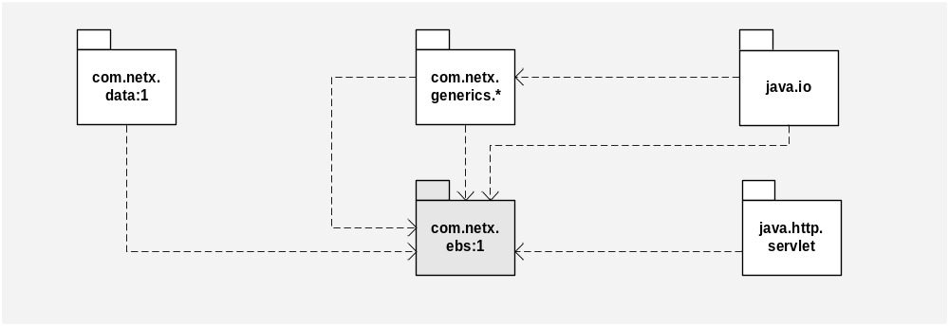
com.netx.generics.* is used to apply NetX’s development framework to the ebs module;
com.netx.io:1 is used to access the server’s file system;
com.netx.data:1 is used for database access, connection pooling and database entity management.

Class Model
The ebs module provides a series of classes which can be directly mapped to the EBS components defined in EBS.01. The following class diagram specifies the main classes provided by ebs:1, and their relationships:
Figure 2 - EBS class model
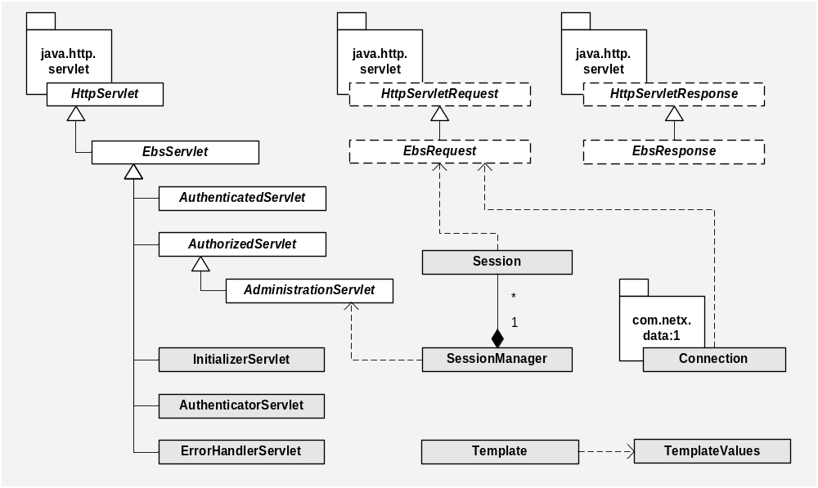
- InitializerServlet, AuthenticatorServlet and ErrorHandlerServlet are the implementations of EBS’ [initializer], [authenticator] and [error-handler] resources.
- EbsServlet is the super-class of all EBS Servlets, and provides the base for creating normal resources in EBS terminology. EbsServlets provide two specific methods for handling requests, similar to HttpServlet’s doGet and doPost, but using a specialized version of requests (EbsRequest) and responses (EbsResponse).
- AuthenticatedServlet provides the base for creating authenticated resources.
- AuthorizedServlet provides the base for creating authorized resources.
- AdministrationServlet is a special kind of AuthorizedServlet targeted for implementing application administration functions. These put an API available which allow controlling user sessions, managing users and permissions, etc.
- Session and SessionManager are used to hold user sessions.
- Template and TemplateValues are used to provide a presentation layer. See 5.Templates for details.

Entity Model
The entities used by EBS applications are represented in the following diagram:
Figure 3 - Entity model
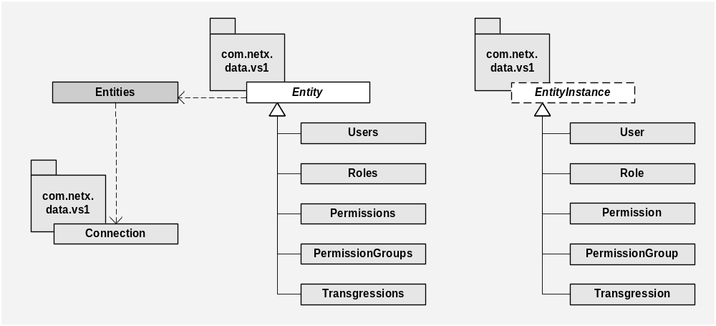
The entity model follows the guidelines defined by data:1, representing directly all the entities defined in EBS.01.

Exception Model
The ebs:1 module does not add any exceptions. Instead, it provides a model for handling the following exceptions:
Figure 4 – Exception model
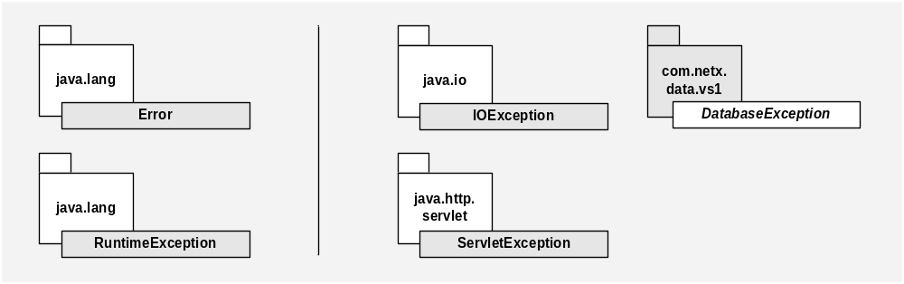
All the exceptions depicted in the model, if thrown by a Servlet, are caught by ErrorHandlerServlet. The application developer may specify custom error messages which are shown for each thrown exception.

EBS Functions

Application Lifecycle

Start-up
Application initialization is made when the Servlet container loads the application Servlets. EBS applications must load all of their Servlets at start-up, putting the application in the RUNNING state only if all the Servlets have been successfully initiated. In order to comply with that behaviour, the following actions must take place:
- There must be exactly one concrete subclass of InitializerServlet with its load-on-startup parameter set to 0, forcing this to be the first Servlet to be loaded. This class will be EBS’ [initializer] resource. InitializerServlet should have no mapping, since it does not respond to the doGet and doPost methods (it sends an HTTP 403 status code– Forbidden) and does not allow these methods to be overridden.
- All Servlets must have the load-on-startup parameter set to a value above 0.
The Servlet specification indicates a per-Servlet error-handling mechanism. Oppositely, EBS applications handle initialization errors in a per-application basis. By setting the load-on-startup parameter for each Servlet, the whole application is loaded at once, therefore detecting start-up problems occurred in any of the application’s Servlets. If there is a problem with any of the Servlets, the application enters the NOT_INITIALIZED state.
The Servlet specification refers that Servlets which find initialization errors should throw a ServletException and the Servlet container will put this Servlet out of service. EbsServlets do not throw exceptions in init, and therefore are not put out of service. Instead, if the application initialization fails, they answer requests with a page describing the initialization errors to the user. If the initialization errors were thrown and the throwing Servlet was put out of service, every request to this Servlet would send a container-managed response instead of an application-managed response.
In order to force this behaviour, EbsServlet.init follows the algorithm shown below:
public final void init(ServletConfig config) {
try {
super.init(config);
// specific EBS initialization code here...
if(getEbsContext().getApplicationState() != APPLICATION_STATE.NOT_INITIALIZED) {
ebsInit(config);
}
}
catch(Throwable t) {
addInitError(t);
}
}

EbsServlets whishing to provide specific initialization behaviour must override ebsInit instead of init (since init is made final). Any exceptions thrown in ebsInit will be caught and properly accounted for. ebsInit implementations, just as in init, must begin by calling super.ebsInit:
public void ebsInit(ServletConfig config) throws Throwable {
super.ebsInit(config);
// application code here...
}

Note that, if the application is not properly initialized, ebsInit will not be called. This avoids throwing exceptions in Servlets which override ebsInit by some of the applications’ resources not being available.

InitializerServlet:
During start-up, the InitializerServlet reads all the application’s configuration parameters. Application configuration is made using generics.basic.ApplicationContext, and through a standard XML configuration file as specified by generics.util.Tools.loadContext. For managing database connections and entities, ebs relies upon the data:1 module, which also requires an XML configuration file. Therefore, the first action performed by the InitializerServlet is to look for both configuration files and load them. InitializerServlet requires a mandatory configuration parameter, config-dir, which specifies the file system directory where these files are located. In this directory, InitializerServlet looks for config.xml as the ApplicationContext’s configuration file, and database.xml as the Database configuration file.
The table below list all the configuration parameters configurable in config.xml’s ebs context. Parameters which do not specify a default value are mandatory. String parameters, if not noted otherwise, are case-sensitive.
Table 1 – Configuration Parameters
Parameter | Class | Default Value | Description
authenticator-name | String | N/A | See EBS.01.
error-handler-name | String | N/A | See EBS.01.
send-error-codes | boolean | true | See EBS.01.
keep-sessions-on-reload | boolean | true | See EBS.01.
session-mode | String {“normal” | “fixed-ip”} | “normal” | See EBS.01. This parameter is case-insensitive.
allow-multiple-sessions | boolean | false | See EBS.01.
session-check-daemon-period | generics.time. TimeValue | N/A | See EBS.01.
notification-check-daemon-period | generics.time. TimeValue | N/A | See EBS.01.
notification-keep-time | generics.time. TimeValue | N/A | See EBS.01.
charset | String | “UTF-8” | Application-wide character set. Data sent by HTTP POST requests will be interpreted using this character set, and EbsResponse. setContentType will use this character set if not explicitly specified otherwise.
show-stack-trace | boolean | true | Indicates whether, in case an exception is caught by the [error-handler], the stack trace should be shown to the user. This parameter is only used in DEV environments.

Additionally to the ebs parameters, the ApplicationContext’s logger property should be set to EbsLogger in order to use ebs’ error logging functions. (not anymore)
Refer to chapter 6.Configuration File for a complete specification of config.xml.

EbsContext:
All of these parameters are available through the ApplicationContext’s “ebs” context. A special class, EbsContext, is provided to ease obtaining these parameters. See the API documentation for EbsContext and EbsServlet.getEbsContext for further details. Besides the configuration parameters, EbsContext also holds another set of useful properties which are set during application initialization. Check the following table for a complete listing of these properties.
Table 2 - Other EbsContext properties
Name | Class | Description
database | Database | Database object loaded from the database.xml configuration file. It is not advisable using this object directly to obtain Connections, but rather request.getConnection, as Connections obtained in this way are automatically closed when the request is finished.
application-name | String | Name of the web application, based on the physical context name. For example, for an application deployed at http://<server>/context1, the application name would be “context1”.
application-root | FileSystem | FileSystem object which refers to the application context root.

Out-of-service
Putting the application out-of-service is done through the Servlet container. Each Servlets’ destroy method will be called, releasing all of its resources. Similarly to the start-up procedure, destroy in EbsServlets is substituted by ebsDestroy. In EbsServlet.destroy, all thrown exceptions are caught and logged.
public final void destroy() {
try {
// specific EBS finalization code here...
ebsDestroy();
super.destroy();
}
catch(Throwable t) {
getLogger().error(t);
}
}

So, ebsDestroy should have the following structure:
public void ebsDestroy() throws Throwable {
// application code here...
super.ebsDestroy();
}

Inversely to the ebsInit method, it is advisable to call super.ebsDestroy only after the cleanup code has been called to prevent the underlying Servlet super-class from cleaning up resources which will be necessary for the remaining cleanup.

Start and Stop
Starting and stopping the application can be made through AdministrationServlets, using the startApplication and stopApplication methods.

Security

Error Handling
For Servlets:
- Use Errors.save(request.getURL(), "a message", t), Errors.save(t)
In other classes (ex: Thread, Task):
- Use the application Logger, which is backed up by the database
- request_url is not necessary

- infos and warnings are logged by the Logger specified by the developer
- errors are sent to the database (because the logger does that)
- possibility of extending the model to provide a table which records info and warning

Application Administration & Maintenance

→ Talk about the application administration, which can be provided by an out-of-the-box application

- Application administration through AdminServlet

Configuration File Format
The configuration file is a XML application configuration file as defined by generics.util.Tools. loadContext. Currently, there is only version 1 of the configuration file. The file has the following format:
[application-configuration name=“<name>“ version=”<integer>.<integer>”]:
(context|property)*
([context name=”ebs”])1
(context|property)*
Used in: top-level
Description: defines the top-level element for an EBS application configuration file. The version argument identifies the module version, therefore defining the format of the configuration file.

The ebs context is used to configure this module’s initialization properties. Setting properties which are not part of the EBS specification in this context is considered an error. In any other context, the application developer can set application-specific properties.
Following is an example of a configuration file for an EBS application:
<application-context name=”my-application” version=”1.0”>
<property name=”locale” value=”pt_PT” />
<property name=”logger” class=”com.netx.ebs.EbsLogger”>
<create>
<argument class=”com.netx.data.Database”
value=”$context(‘root.ebs.database’)”>
</create>
</property>
<context name=”ebs”>
<property name=”authenticator-name” value=”auth” />
<property name=”allow-multiple-sessions” value=”false” />
</context>
<context name=”my-context”>
<property name=”batch-process-period” class=”com.netx.generics.time.Time”
value=”10m” />
</context>
</application-context>

Add a real file during development.

In this example, it is possible to see how the application-wide Logger object is set, using one specific implementation (CsvLogger, which sends logging information to a CSV file).

Templates
Refactor according to Userdoc
HTML templates are used to separate design from implementation. With HTML templates, development can be made separately by web designers and application developers. The web designers may design HTML pages and specify variables which may then be substituted by values retrieved from the database. The application developers may develop resources which perform the application logic (like connecting to the database and retrieving the wanted records), and simply map the retrieved values to the corresponding variables.
To do this, EBS applications supply a component which, given the HTML template descriptor, the variable’s name and the variable’s value, performs a text substitution in order to produce a final HTML result. This result may then be used as the response to an HTTP request.
The template descriptor is a name which uniquely identifies the HTML template, whether it is a direct filename, a name representing a template stored in a database or in memory, etc. Details of the HTML template storage and availability to the application are implementation-dependent.
HTML templates support three different features: simple variable substitution, lists and conditions.

Variables
Variables are specified using the following format: $[name]. The following example is a very basic HTML file with one single variable specified:
<html>
<head>
<title>A simple HTML template</title>
</head>
<body>
<font face=”Verdana” size=”10”>Current time: $[time]</font>
</body>
</html>

If the developed application resource would determine that the value for the time variable was 12:30, the resource’s response would be:
<html>
<head>
<title>A simple HTML template</title>
</head>
<body>
<font face=”Verdana” size=”10”>Current time: 12:30</font>
</body>
</html>

By this example, it is possible to see that the HTML template may be easily modified without needing to change the resource that produces the results (given that the template’s descriptor and the variable name do not change).

Lists
HTML templates also support repeating text, in order to show multiple values. The following is an example of a list:
<html>
<head>
<title>A simple HTML template</title>
</head>
<body>
<table>
<!-- $[list:elements] -->
<tr><td><font face=”Verdana”>element $[num]</font></td></tr>
<!-- $[list-end] -->
</table>
</body>
</html>

In this case, the application developer may specify a list called elements, with a series of values. If the list would have three elements for the variable num (for example, values “one”, “two” and “three”), the resulting response would be:
<html>
<head>
<title>A simple HTML template</title>
</head>
<body>
<table>
<tr><td><font face=”Verdana”>element one</font></td></tr>
<tr><td><font face=”Verdana”>element two</font></td></tr>
<tr><td><font face=”Verdana”>element three</font></td></tr>
</table>
</body>
</html>

That is, the component performs text substitution for the number of list elements found.
Please note that the $[list:<name>] and $[list:end] elements are in comments; although this is not required, it allows for the correct display of the HTML file without the interference of these elements.

Conditions
Conditions allow the display of one or other part of text, according to the evaluation of one specific value. Consider the following example:
<html>
<head>
<title>A simple HTML template</title>
</head>
<body>
<table>
<!-- $[if:result] -->
<font face=”Verdana”>Result OK!</font>
<!-- $[else] -->
<font face=”Verdana”>Oh no...</font>
<!-- $[endif] -->
</table>
</body>
</html>

The result variable should be assigned a Boolean value, true or false. In case the application resource would determine that the result variable was false, the resulting response would be:
<html>
<head>
<title>A simple HTML template</title>
</head>
<body>
<table>
<font face=”Verdana”>Oh no...</font>
</table>
</body>
</html>

Change Log
Version | Date | By | Changes
0.1 | 2006-02-07 | Carlos Pereira | First draft version.
0.2

The component’s usage is dependant on the EBS implementation, although all of them follow the rules specified herein.

