ECE 532 Writing Assignment – Spring 2015

Novel Monolithic Doherty Power Amplifier Topologies in GaN

Carlos Mariscal

Raymond Schemelzer

Cameron Tribe

Department of Electrical and Computer Engineering

Portland State University, Portland, OR

***Abstract* – The use of carbon nanotubes**

I. Introduction

Since the advent of wireless communication RF power amplifiers have played a crucial role. RF power amplifiers were initially used in AM/FM radio transmitters. These Transmitters would transmit upwards of 500KW and were not very efficient. I class AB amplifier would have an efficiency of about 33%. Clearly this is unacceptable in today’s standards. Today mobile communications demand high efficiency and high bandwidth. The Doherty Power Amplifier (DPA) has shown improved efficiency and is now gaining attention. In this paper various novel topologies are explored. These topologies aim to increase efficiency, bandwidth and gain.

This paper is organized as follows. Section II explores the DPA and some of its disadvantages. Section III explores novel DPA topologies that increase efficiency and bandwidth.

II. The Doherty Amplifier

A DPA is composed of two amplifier branches as shown in Figure 1.

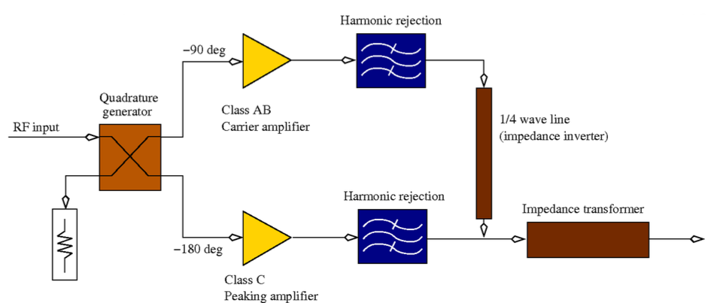

Figure 1 Basic schematic of Doherty amplifier

III. Doherty Amplifier Topologies

Write some kind of intro here

1. Reconfigurable Matching Networks

For proper operation of the DPA the inputs of the carrier and peaking amplifiers must be 90° out of phase. 90° phase shift is realized with a λ/4 transformer ether in micro strip or lumped element depending on the operating frequency. It is obvious that this presents a challenge if large bandwidth is desired. To solve this problem reconfigurable input and output matching networks (IMN/OMN) are proposed. Figure 2 shows a schematic of a reconfigurable DPA.

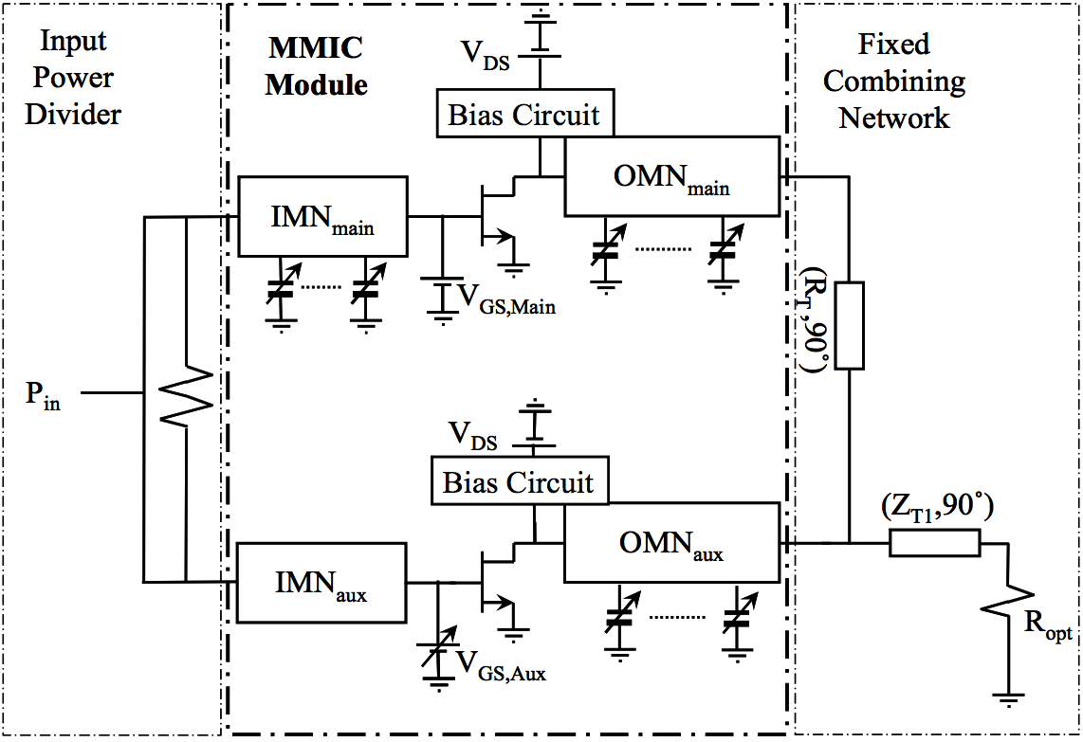

Figure 2 Schematic of Reconfigurable DPA [1]

To achieve reconfigurable matching networks microelectromechanical systems (MEMS) are used. MEMS devices are preferred due to their ultra-linearity, low losses, and easy of integration in current MMIC processes [1]. A reconfigurable matching network can present the optimum impedances to both input and output of the transistor for the best gain and efficiency at various operating frequencies. As shown in [1] such topology yielded high power gains and efficiency at 1.7, 2.14 and 2.6 GHz using the same amplifier with reconfigurable matching networks.

1. Class F amplifier in Peaking branch
2. Raymonds section
3. another section maybe? driver stage

IV. Conclusion

In this paper we explored some of the

References

[1] A. M. M. Mohamed, S. Boumaiza, I. Zine-El-Abidine, and R. Mansour, “Frequency Agile Monolithic GaN Doherty Power Amplifier,” in 2013 IEEE Compound Semiconductor Integrated Circuit Symposium (CSICS), 13-16 Oct. 2013, 2013, p. 4 pp.

[2] L. Piazzon, P. Colantonio, F. Giannini, and R. Giofre, “15% bandwidth 7 GHz GaN-MMIC Doherty amplifier with enhanced auxiliary chain,” Microwave and Optical Technology Letters, vol. 56, no. 2, pp. 502–4, Feb. 2014.

[3] P. Colantonio, F. Giannini, R. Giofre, and L. Piazzon, “Efficiency improvement in Doherty power amplifier by using Class F approach,” in 2009 European Microwave Integrated Circuits Conference (EuMIC), 28-29 Sept. 2009, 2009, pp. 17–20.

[4] R. Giofre, L. Piazzon, P. Colantonio, F. Giannini, V. Camarchia, R. Quaglia, M. Pirola, and C. Ramella, “GaN-MMIC Doherty power amplifier with integrated reconfigurable input network for microwave backhaul applications,” in 2015 IEEE MTT-S International Microwave Symposium (IMS2015), 17-22 May 2015, 2015, pp. 1–3.

[5] B. Slade, “The Basics of the Doherty Amplifier”