Carlos Mariscal

Cameron Tribe

Lab7

ECE 532

**Intro**

In this lab the characterization of a zero bias diode is performed and ultimately a 2.4-2.6 GHz diode detector circuit is simulated and built. Schottky diode HSMS-2850 is use for this lab.

**Simulation**

We begin by creating an accurate model of the diode. Using the datasheet (see references) for the HSMS-2850 all of the small signal parameters are entered into ADS. Since the diode will be used without a DC bias we are interested on the large signal characteristics. As in all RF circuits the behavior of the diode is strongly dependent on the DC bias point and input power. In this case there is no DC bias so we sweep input power. \*all plots assume parameters of HSMS-2850 not the same as other app note.

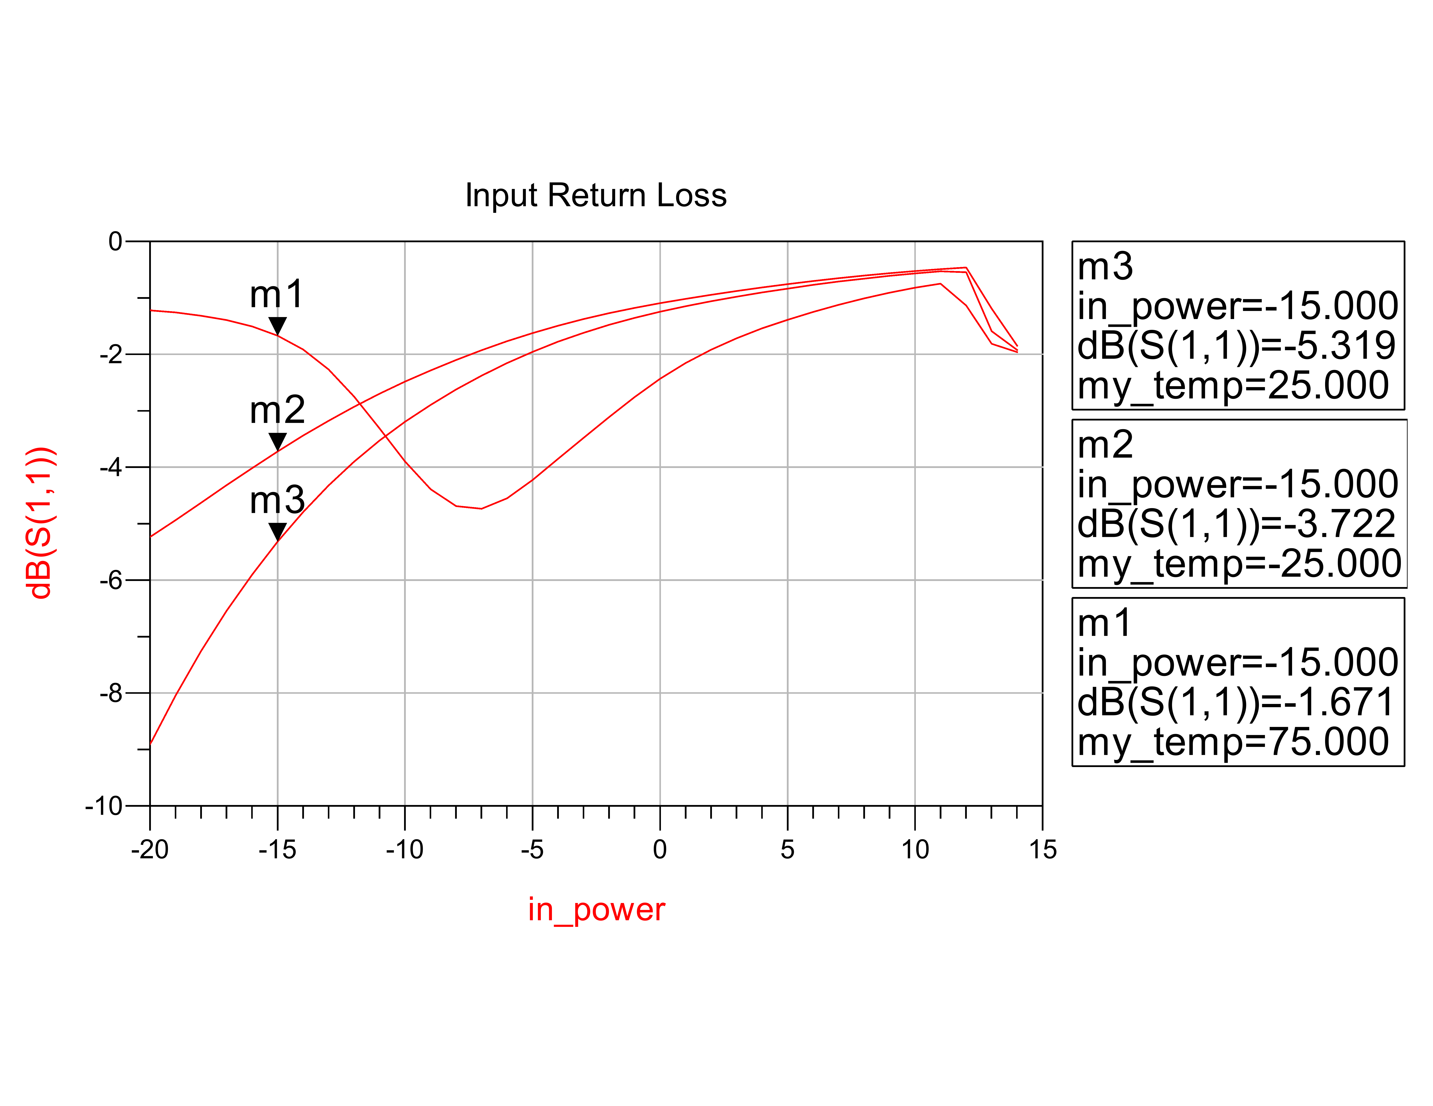

Figure 1 input return loss vs. power and temp.

Figure 1 shows how the input return loss varies with input power and temperature. In order to build a matching network this dependency must be accounted for. The design must be made for the desired power levels.

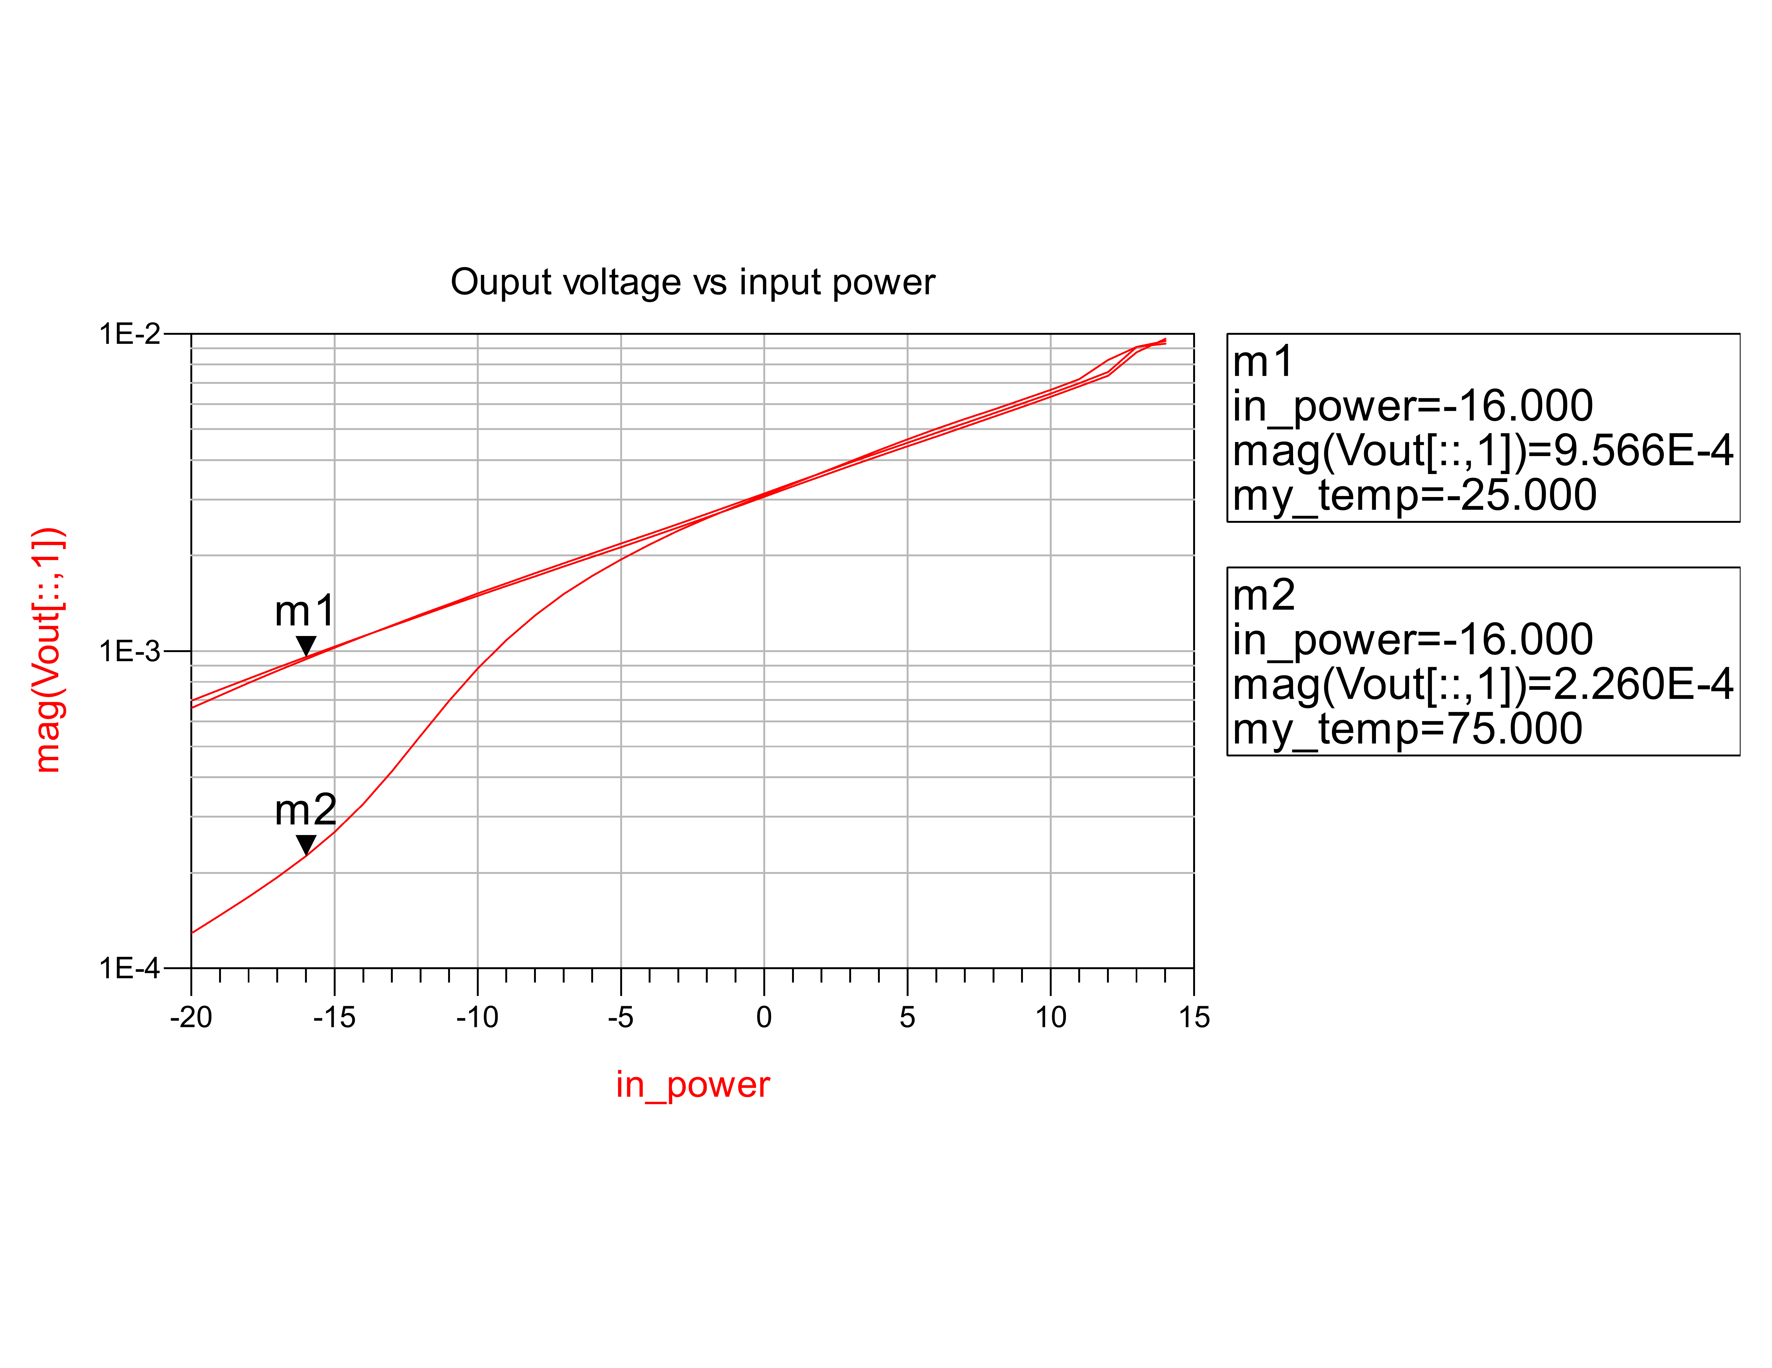

Figure 2 DC voltage output vs. input power and temp.

Figure 2 shows the DC voltage output of the diode given an input power. This DC violate will serve as means of detecting the presence of the desired 2.4 or 2.6 GHz signals. Since the diode presently does not have a matching network these DC voltages are low and will increase when a matching network is implemented.

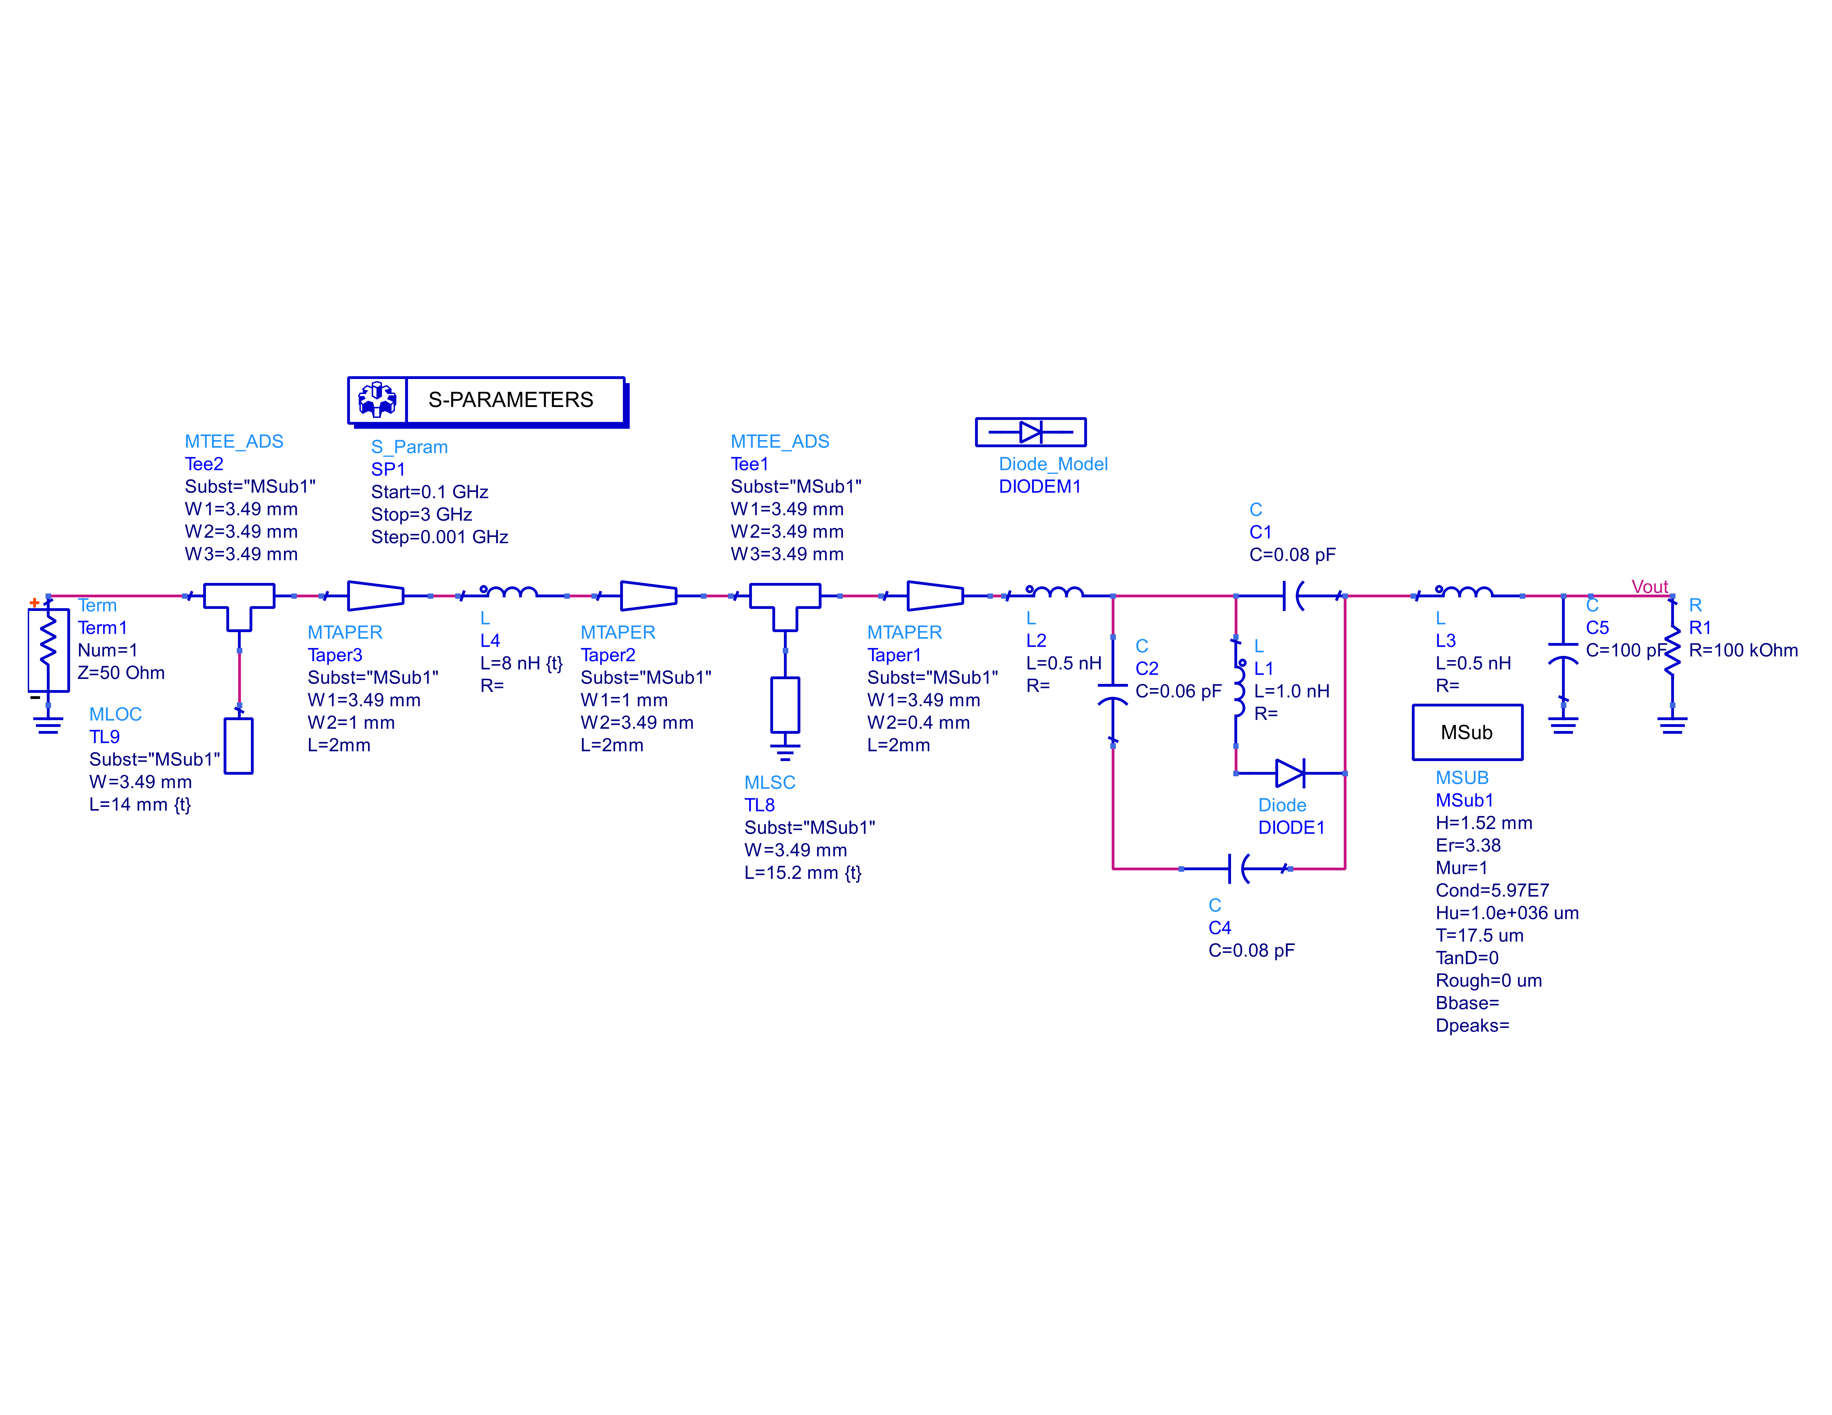

Figure 3 diode detector schematic

The schematic above shows our matching network for the diode detector. Notice that we have added parasitics due to the diode’s packaging per app note Avago Technologies 1124. The short circuited stub serves two purposes, its is used as a matching network but more importantly it serves as a path to ground when the diode is not conducting.

**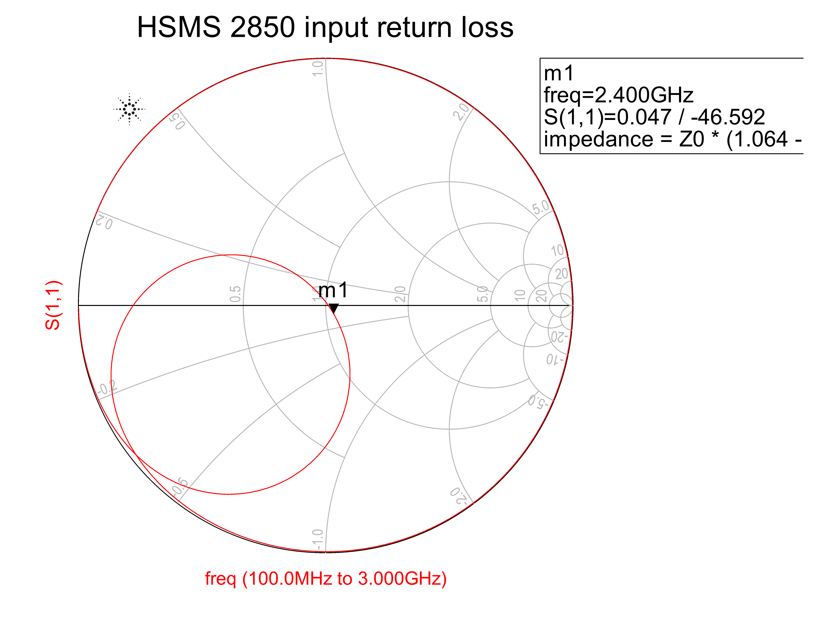**

Figure 4 Simulated diode detector circuit

**Prototyping**

**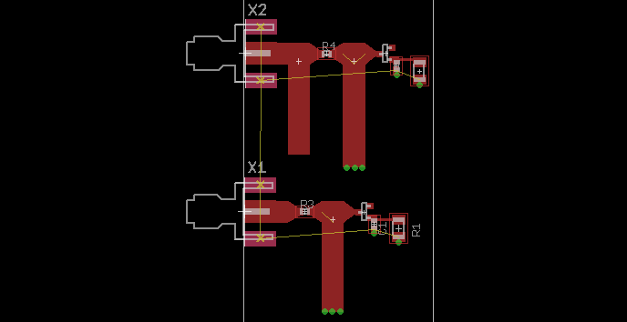**

Figure 5 Diode detector layout

Shown above is the layout of the diode detector along with the matching network. The bottom portion of the layout excludes the open circuit stub for testing.

**Results**

Macintosh HD:Users:carlos97080:github:ece532:labs:lab7:measrued_results.pdf

Figure 6 Measured Results

Shown in Figure 6 are the measured results of the 2.4GHz diode detector. As shown the matching network successfully transformed the large impedance of the diode closer to 50 Ohms. Attaching a function generator to the input allowed us to measure the output DC voltages which ranged from a few millivolts to half a volt obviously depending on input power.

**Summary/ Comments**

We were able to create a matching network for the diode. Surprisingly the matching remained constant at various power levels ranging from -20 to 0 dBm.

**References**

Diode datasheet

<http://www.avagotech.com/products/wireless/diodes/schottky/hsms-2850>

Avago app note 1124

http://www.avagotech.com/docs/AV02-0038EN