**2.4-2.6GHz FSK Receiver**

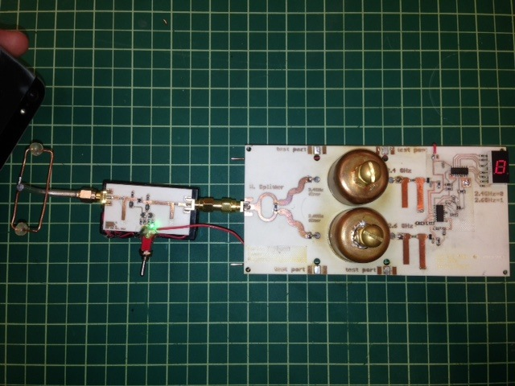

**Abstract**

Frequency Shift Keying is currently used in many applications such as wirelessly transmitting binary data. Using high frequency sinusoids, a transmitter shifts between two frequencies which are later interpreted a logic ‘1’ or ‘0’. A 2.4 – 2.6GHz FSK receiver was designed, simulated in ADS and built using the rapid prototyping equipment in the Lab for Interconnected Devices at Portland State University. The receiver included an LNA on the front end, a Wilkinson power divider, resonant cavity filters and diode detectors. Later a 7-segment display with the appropriate logic was used to interpret the data and display the binary output.

**Requirements**

* Operate at 2.4 and 2.6 GHz
* Reliably distinguish between 2.4GHz and 2.6GHz signals
* Amplifier with at least 10dB gain and S11 < -10dB.
* 3dB power divider
* 2.4 and 2.6GHz Bandpass filters
* Diode detector to output DC when signal is received.

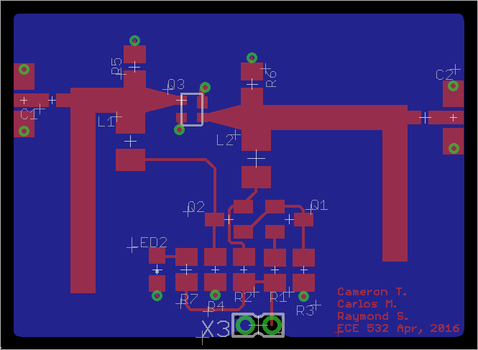**LNA**

The LNA is the front end of the receiver. Its purpose is to amplify very weak signals without adding much noise to the system. This is done through various input and output matching networks. Initially, a packaged LNA (PSA-5043+) was going to be used, however after several iterations the measured performance did not meet specs, and instead an LNA (shown in Figure 1) designed for a previous project was used. The alternate LNA has a gain of 13dB at 2.4GHz and 11dB at 2.6GHz. S11~ -10dB at 2.4GHz. This was decided to be sufficient to be used in the final receiver.

Figure : LNA Layout

**Wilkinson Splitter**

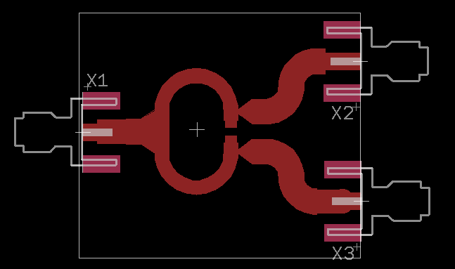A simple Wilkinson power divider, designed for 2.5GHz was implemented. The design was simulated in ADS, and the layout was done in Eagle CAD (shown in figure 2). The measurement of the splitter showed that the center frequency was indeed at 2.5GHz and the output on each channel had a loss of 3dB when properly terminated with 50 Ohms. S11 was measured to be approximately -15dB.

Figure : Wilkinson Splitter Layout

**Filters**

There were two different types of filters that were investigated in this project. First, a lumped element filter, using a combination of microstrip capacitors, and SMD components was designed in ADS. Second, a resonant cavity type filter was used.

**Resonant Cavity Filters (Pipe Cap)**

The resonant cavity filters were chosen because they offer a very high Q and low insertion loss, which will allow the receiver to easily distinguish between 2.4GHz and 2.6GHz. Shown below is an equivalent circuit for the resonant cavity. To construct the filter a one-inch copper pipe cap was used as a cavity. The volume of the pipe cap happens to be just right for the frequency range of interest. To tune the filter, a #4-40 brass screw was used to vary the inductance and capacitance of the cavity to just the desired frequency response. The insertion loss of the cavity filters is around 1dB, and a bandwidth of approximately 15MHz was achieved. S11 was also decent at approximately -15dB.

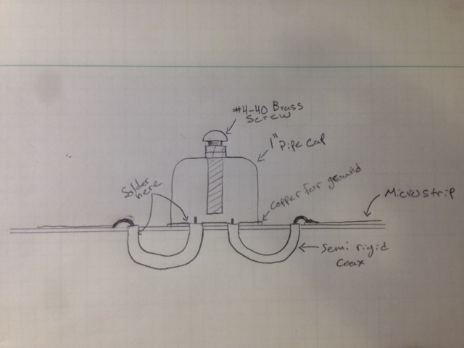Construction of the filters also posed to be a challenge. Since the entire receiver was going to be on a single PCB, the filters needed to be mounted to the board. However getting the signal into the cavity while mounted to the board was not straightforward. To achieve this, two small sections of semi-rigid coax were used to loop underneath the PCB and come back through a hole inside the cavity filter. This method was very successful and was also cost effective. Figure 3 is a sketch of how the filter is constructed.

Figure : Pipe Cap Filter Sketch

**Lumped Element**

**Diode Detectors**

To begin, an accurate model of the diode was created in ADS. Using the datasheet (see references) for the HSMS-2850 all of the small signal parameters are entered into ADS. Since the diode will be used without a DC bias, the focus was on the large signal characteristics. As in all RF circuits the behavior of the diode is strongly dependent on the DC bias point and input power. In this case there is no DC bias so input power was swept.

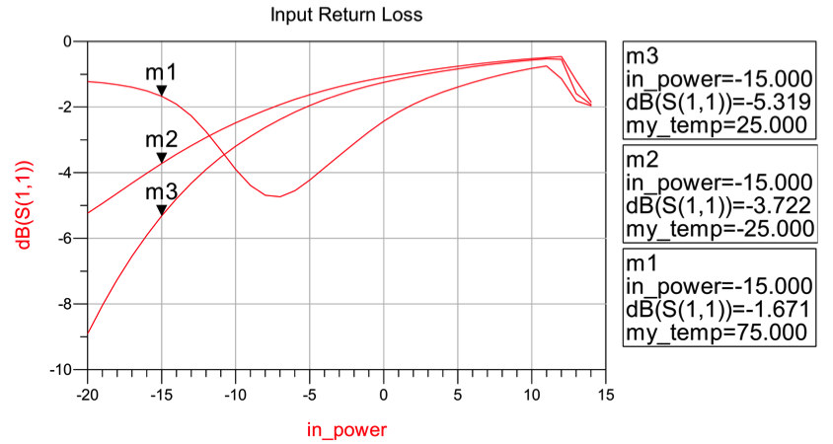

The schematic below shows the matching network for the diode detector. Parasitics have been added due to the diode’s packaging per app note Avago Technologies 1124. The short circuited stub serves two purposes, its is used as a matching network but more importantly it serves as a path to ground when the diode is not conducting.

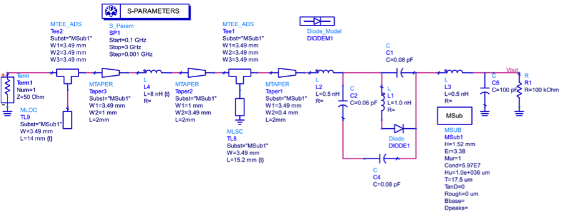

**Display**

A 7-segment display along with some digital logic was used to display when data has been received. The output of the diode detectors is sent to comparators, which sends signals to an OR gate and a 7-segment display driver to decide when to light up the display, and whether the signal is 2.4GHz or 2.6GHz. If the signal is 2.4GHz, the display will show a ‘0’ and when the input signal is 2.6GHz, the display will show a ‘1’.

The comparators have a threshold of approximately 1 to 3mV, which is set by a resistive voltage divider. In total, there are three comparators that are being used; the first is used to detect the 2.4GHz signal, the second and third are used for the 2.6GHz signal. When the output of the 2.4GHz diode detector goes above the threshold, the output of comparator 1 goes high, this sends a signal to the OR gate, which allows the display to turn on. Comparator 2 is used in the same way for the 2.6 GHz signal, and comparator 3 is used in parallel with comparator 2 to send a signal to the 7-segment display driver to make the display show a 0 if it is low or a 1 if it is high. Shown below in figure 4 is the schematic of the logic circuit for the display.

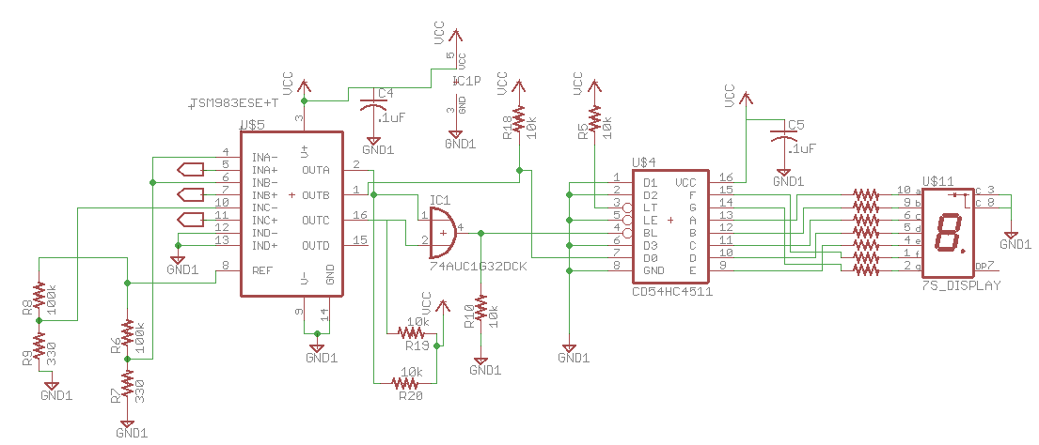

Figure : 7-Segment display Schematic

**Antennas**

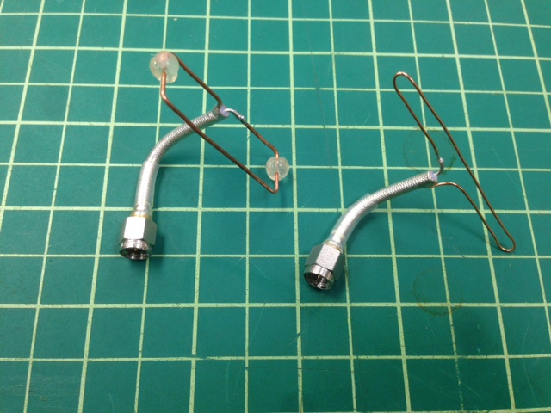To allow the receiver to pick up wireless signals, an antenna was added to the input to the LNA. There were two types of antennas that were explored, a folded dipole, and a Moxon antenna. A Folded dipole antenna is a λ/2 antenna that has input impedance around 300 Ohms. To transform this impedance to 50 Ohms, typically a balun with an appropriate turns ratio would be used, however the antenna seemed to still work fine without it.

Figure : Moxon and Folded Dipole Antennas

The Moxon antenna is another form of a λ/2 antenna, however there is a reflector element in the near field that reflects the rear lobe of the radiation pattern to the front, which increases directivity and antenna gain. Below is a simulated Azimuth radiation pattern from EZNEC software.

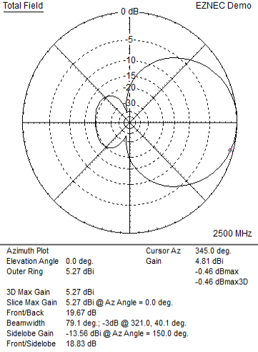  
**Board Layout**

Figure : Radiation Pattern for Moxon Antenna

Initially, there was an attempt to layout the entire PCB in ADS, however there were many issues that were encountered. Since time was also a constraint from this project, it was decided to generate the entire layout in Eagle. Certain circuit elements such as tuning stubs needed to be generated using ADS so that appropriate simulations could be made. Once trace lengths and widths were figured out, that design was exported from ADS and imported into Eagle. From here, other circuit elements such as resistors, capacitors and ICs could be inserted into the layout.

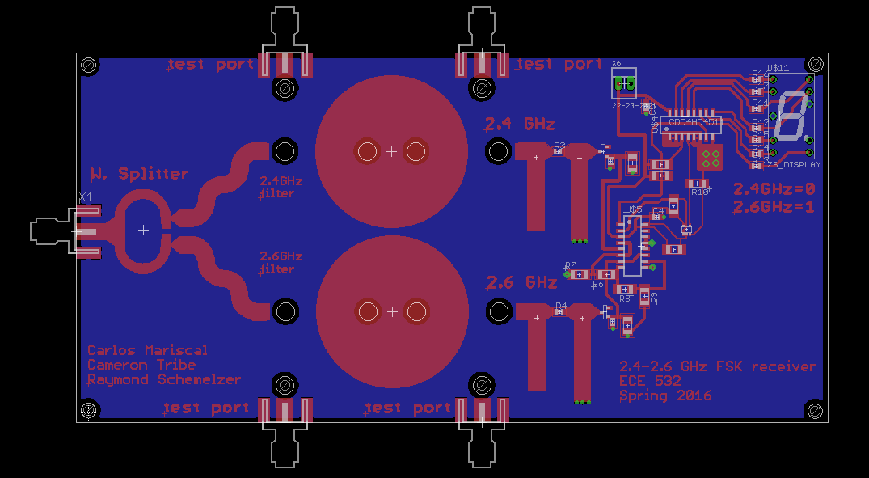

Figure : FSK Receiver Layout in Eagle CAD

**Measurements**

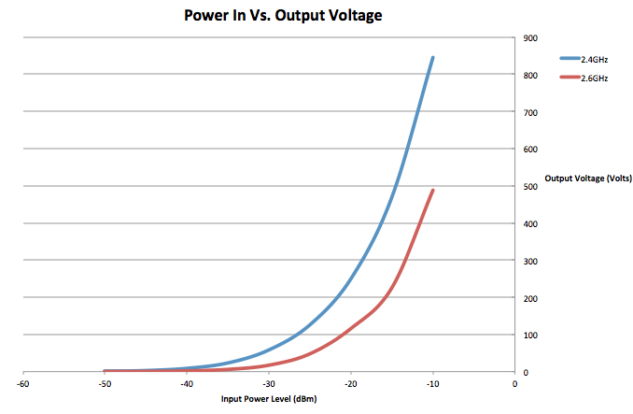Performance based measurements were made to determine characteristics of the receiver. First, the antenna was removed and a signal generator was attached to the input of the LNA. The input power level was varied, and the frequency was held constant first at 2.4GHz then again at 2.6GHz. Input power was swept from -50dBm to -10dBm, below is the resulting curves from the output of the diode detectors.

Figure : Power In Vs. Voltage Out

From this plot it can be concluded that the minimum detectable level is approximately -45dBm.

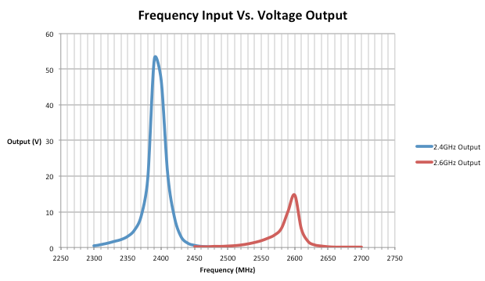Next, the input power level was held constant, the input frequency was varied and output voltage was measure for both 2.4 and 2.6GHz outputs. Shown in figure 9 are the results of the test. From these two sets of measurements, it was discovered that the 2.6GHz was much less sensitive than2.4GHz output. This is most likely caused by the lack of gain at 2.6GHz from the LNA. Other contributions to the lower output level could come from mismatches between stages, filter insertion loss, or diode detector insertion loss.

Figure : Frequency In Vs. Voltage Out

**Conclusion**

**References**