**Documento de apoyo guía 5. Apropiación de conocimientos**

En este documento se proponen los siguientes temas, correspondiente al nivel 5 de inglés.

**Grammar and vocabulary:**

* Descripción de situaciones de trabajo, elementos y equipos de trabajo,
* Medios de comunicación aplicados a su ocupación,
* Como expresarse sobre temas técnicos de actualidad.

**Contenidos**:

* Used to, en todas las formas
* Modal verbs utilizados en suposiciones
* Perfect present tense
* Connectors

**Expressing opinions**

Here are some very common expressions to express your opinion about something:

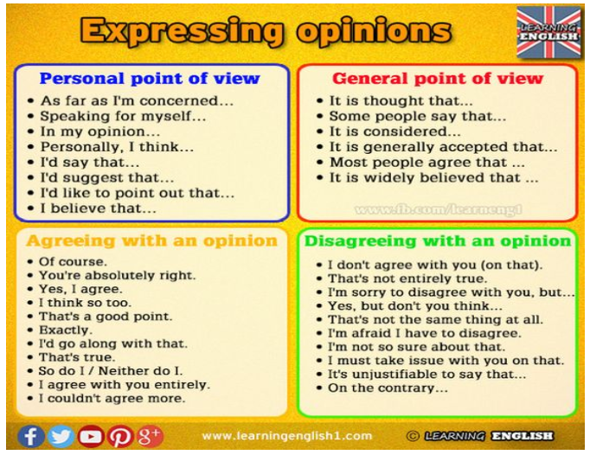

No tienes que memorizarlas, explora dos o tres frases con las que te sientas cómodo y practícalas en contextos reales o ficticios.

**Used to**

En inglés se usa la forma **used to** para expresar hábitos pasados y para contar sobre cosas que solían se reales y ya no.

En la siguiente tabla podemos ver algunos ejemplos para cada una de las formas en que podemos usar USED TO.

|  |  |  |
| --- | --- | --- |
| **Affirmative Sentences** | **Negative Sentences** | **Interrogative Sentences** |
| Sujeto + “used to” + verbo… | Sujeto + “didn’t” + “use to” + verbo… | Did + sujeto + “use to” + verbo…? |
| We used to go to the beach every summer when I was young. (Cuando era joven solíamos ir a la playa cada verano.)  He used to smoke a pack of cigarettes a day, but he quit last year. (Solía fumar un paquete de cigarrillos al día, pero lo dejó el año pasado.)  I used to like mushrooms, but not anymore. (Antes me gustaban las setas, pero ya no.)  There used to be a great restaurant here, but it closed a few years ago. (Había un buen restaurante aquí, pero cerró hace unos años.) | I didn’t use to like mushrooms, but now I do. (Antes no me gustaban las setas, pero ahora sí.)    Food didn’t use to be so expensive. (La comida no solía ser tan cara.)    We didn’t use to go away on holiday very often when I was young. (No solíamos ir de vacaciones a menudo cuando era joven.) | Didn’t he use to smoke a lot? (Él fumaba mucho antes, ¿no?)    Did you use to live here? (¿Vivías aquí antes?)    Did they use to go to the beach in the summers? (¿Solían ir a la playa durante los veranos?) |

**To be used to (Estar acostumbrado a)**

Cuando se utiliza “to be used to” como adjetivo significa “estar acostumbrado a”. Se usa para cosas que son familiares, normales o comunes y se puede usar en cualquier tiempo verbal. **Cuando “to be used to” está seguido por un verbo, el verbo tiene que estar en gerundio (“‑ing”).**

* She**’s used to living** alone. (Ella está acostumbrada a vivir sola.)
* We **weren’t used to traveling** a lot. (No estábamos acostumbrados a viajar mucho.)
* I’**m not used to** this cold weather. (No estoy acostumbrado a este frío.)

**Modals to express assumption: WILL, SHOULD**

**present and future**

*Will* and *should* + infinitive are used to express assumptions. Assumptions with *will* are more probable:

*"The phone's ringing." "That'****ll be****for me."  
There's no point in speaking louder. He****won't understand****.  
I****should get back****before 9.  
"Is it far from here?" "I****should think****so."  
"We're going to the Swiss Alps next week." "That****should be****nice."  
I have never tried to set up a website, but it****shouldn't be****too difficult.*

**Past**

Will, should and ought to + perfect infinitive

Some of you ***will have met*** me before.The plane ***should have landed*** by now.

If you want to practice you can click these links:

<https://www.perfect-english-grammar.com/modal-verbs-of-probability-exercise-1.html>

<https://www.perfect-english-grammar.com/modal-verbs-of-probability-exercise-2.html>

Los verbos modales para expresar probabilidad pueden usarse igualmente para hacer suposiciones.

**Perfect present tense**

El presente perfecto es una forma verbal bastante usada y común en la redacción de textos formales y científicos. En general, es una mezcla entre el presente y el pasado. **Lo usamos para acciones en el pasado que tienen importancia en el presente.**

**A continuación, se presentan los usos con algunos ejemplos:**

|  |  |
| --- | --- |
| **Acciones iniciadas en el pasado y que continúan en el presente** | * They ***haven't lived*** here for years. * She ***has worked*** in the bank for five years. * We ***have had*** the same car for ten years. * ***Have you played*** the piano since you were a child? |
| **Cuando se hace referencia a un periodo temporal inacabado** | * ***I have worked*** hard***this week***. * It ***has rained*** a lot ***this year***. * We ***haven't seen*** her ***today***. |
| **Acciones reiteradas en un periodo inespecífico, entre el pasado y el presente.** | * They ***have seen*** that film six times * It ***has happened*** several times already. * She ***has visited*** them frequently. * We ***have eaten*** at that restaurant many times. |
| **Acciones concluidas en un pasado muy reciente (+just)** | * ***Have you just finished*** work? * I ***have just eaten***. * We ***have just seen*** her. * ***Has he just left***? |
| **Cuando la dimensión temporal no es relevante o conocida** | * Someone***has eaten****my soup*! * ***Have you seen***'Gone with the Wind'? * ***She's studied***Japanese, Russian, and English. |

En el siguiente grafico se pueden ver otros usos de esta forma así mismo algunos ejemplos:

|  |  |
| --- | --- |
| **Life experiences** | Have you ever eaten sushi before?  Have you ever been to the USA? |
| **Accomplishments** | Man has walk on the moon  They have won the match |
| **Changes over time** | I have become more interested in medical issues.  I have |

**Expresiones comunes con el presente perfecto**

* Just
* Yet
* Already
* Never
* Ever
* How long
* This month
* This week
* Today
* For
* Since

**Connectors**

Connectors are word that link sentences in a written or oral production. They are used to make it flow naturally.

When you start learning a language, you begin by creating short phrases, for example “I like coffee”. The next step in the learning process is to link this phrase to another one, for example, “I like coffee and I like tea”. The word ‘and’ is what we call a connector, and it is one of the first connectors you learn. There are many more connectors, all of which can significantly enrich your conversational English.

|  |  |  |  |
| --- | --- | --- | --- |
| Function | connectors | Use | Examples |
| **ADDITION** | **and** **plus** **furthermore** **moreover** **in addition****also****as well as** | We can use addition connectors when we want to add one phrase to another or to give extra information. Obviously the most common of these is ‘and’, while the other addition connectors give a little more emphasis and are also more common in written English, especially ‘moreover’ and ‘furthermore’. | * *They like English****and****study a lot.* * *He’s well-qualified,****plus****he’s very charismatic.* * *The house is beautiful.****Furthermore****, the price is low.* * *Sport is fun.****Moreover****, it’s a great way to socialize.* * ***In addition****to the new tunnel, the local council is constructing a bridge.* * *I play the piano and I****also****play the violin.* * ***As well as****being helpful, Carmen is very practical.* |
| **TIME** | **when****while****as****as soon as** | We can use time connectors to link actions that happened at the same moment. The connectors ‘when’ and ‘as’ are very similar in meaning. We generally use ‘while’ for a longer action, especially with a continuous form. | * ***When****we arrived we sat down at our desks.* * *I watched television****while****I was ironing.* * *It started to rain just****as****I went out.* * *We’ll start****as soon as****everyone gets here.* |
| **SEQUENCE** | **then,** **after,** **afterwards,** **next,** **firstly,** **secondly,** **finally,** | Sequential connectors enable us to indicate the order of events. | * *She talked about the agenda****then****she began her presentation.* * *He’s coming here****after****lunch.* * *He’s having lunch and is coming here****afterwards.*** * *Turn on the oven.****Next****, mix all the ingredients.* * ***Firstly****, I’d like to thank you all for coming.* * ***Secondly****, I want to give you a brief overview of the new products.* * ***Finally****, I will invite our president to speak.* |
| **CONTRAST** | **but,****however,** **though,** **although,** **nevertheless****despite****whereas,** **while** | These connectors can link two contrasting ideas. ‘But’ and ‘however’ are very  similar, though ‘however’ gives more emphasis to the contrast and is more common at the start of a sentence. The connectors ‘though’ and ‘although’ are also very similar with the only difference being their position. ‘Though’ can be at the beginning, middle, or end of a sentence, while ‘although’ cannot be used at the end of a sentence. | * *They like pasta****but****they don’t like rice.* * *It’s a nice city and it’s fun for a holiday.****However****, I wouldn’t like to live there.* * *She studies quite a lot****though****she could do more.* * ***Although****he works hard he hasn’t had a promotion for years.* * *I like this model a lot.****Nevertheless****, I’m not going to buy it yet.* * ***Despite****the rain, they went for a walk.* * *The central area of the country is quite flat,****whereas****the north is hilly.* * *I thought the film was terrible,****while****my friends thought it was really good.* |
| **REASON** | * ***because,*** * ***as,*** * ***due to,*** * ***so (that),*** * ***in order to*** | When we want to explain the reason for something we need to use this groups of connectors, the most common of which is ‘because’. | * *Many people study English****because****it’s important for their jobs.* * ***As****you didn’t do a very good job with this essay, I’d like you to do it again.* * ***Due to****heavy traffic we arrived half an hour late.0* * *We left early****so****we could have a coffee before starting.* * *They are having a conference call****in order to****finalize the contract details.* |
| **CONDITION** | **as long as,** **provided that,** **unless,** **otherwise** | When we want to express the idea that something can happen only in certain conditions, we can use conditional connectors. | * *You can play video games****as long as****you tidy your room first.* * *We’ll keep the goods for you****provided that****we receive the payment soon.* * ***Unless****the economy improves, interest rates will go down again.* * *We need to hurry up,****otherwise****we’ll miss the flight.* |
| **RESULT** | * ***so,*** * ***therefore,*** * ***as a result,*** * ***consequently*** | When you want to express the consequence of an action, use result connectors. They all have a similar meaning though ‘so’ is more common in spoken English and is more informal. The others are more appropriate in a formal, written context. | * *I’d forgotten my car keys****so****I had to go back into the office to get them.* * *Last year’s results were excellent,****therefore****you will all receive a bonus.* * *Crime rates are increasing.****As a result****the government is going to hire more police officers.* * *Marco did really well at university and****consequently****received several job offers.* |

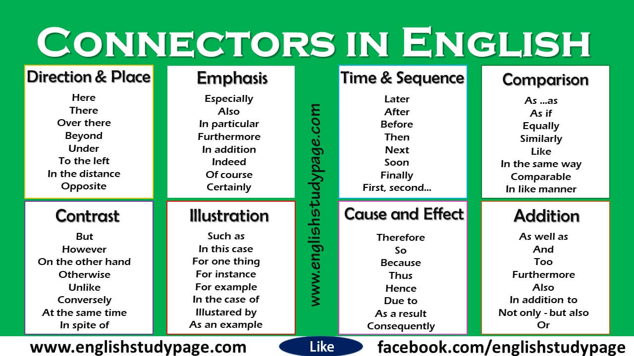

**References:**

<https://www.curso-ingles.com/aprender/cursos/nivel-intermedio/verb-tenses-past/used-to>

<https://www.ef.com/ca/english-resources/english-grammar/future/>

<https://www.wallstreetenglish.com/blog/speak-fluent-english-thanks-to-conversational-connectors-the-complete-list/>