###### KICKSTARTER dataSET analysis report

**BACKGROUND[1]**

Kickstarter is an American public benefit corporation based in Brooklyn, New York, that maintains a global crowdfunding platform focused on creativity. The company's stated mission is to "help bring creative projects to life". As of December 2019, Kickstarter has received more than $4.6 billion in pledges from 17.2 million backers to fund 445,000 projects, such as films, music, stage shows, comics, journalism, video games, technology, publishing, and food-related projects.

People who back Kickstarter projects are offered tangible rewards or experiences in exchange for their pledges. This model traces its roots to subscription model of arts patronage, where artists would go directly to their audiences to fund their work.

Kickstarter is one of a number of crowdfunding platforms for gathering money from the public, which circumvents traditional avenues of investment. Project creators choose a deadline and a minimum funding goal. If the goal is not met by the deadline, no funds are collected (a kind of assurance contract).

**HOMEWORK**

Organize and analyze a database of 4,000 past projects in order to uncover any hidden trends.

1. Given the provided data, what are three conclusions we can draw about Kickstarter campaigns?

1.1. The successful rate indicates an extremely competitive environment that demand well-structured projects and very aligned with the platform requirement – Creativity.

Table - I

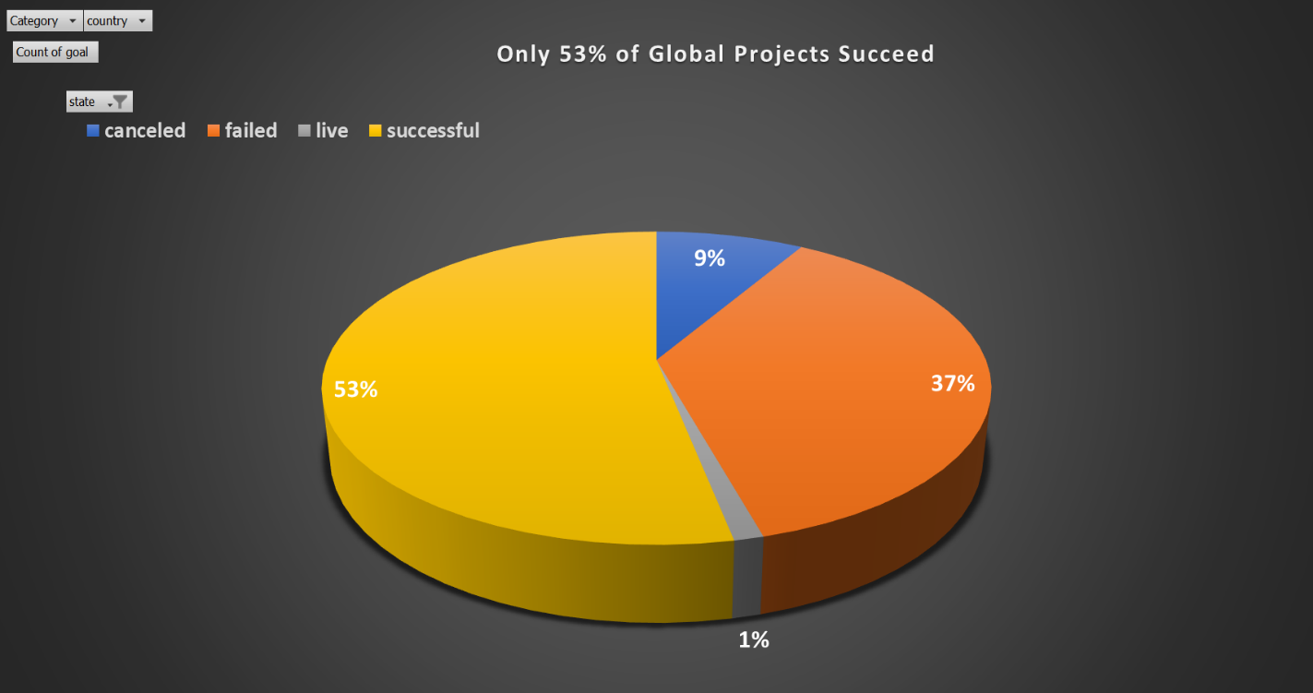

1.2. The United States of America has the best environment for crowdfunding projects with more than 74% of the project goals.

Table II

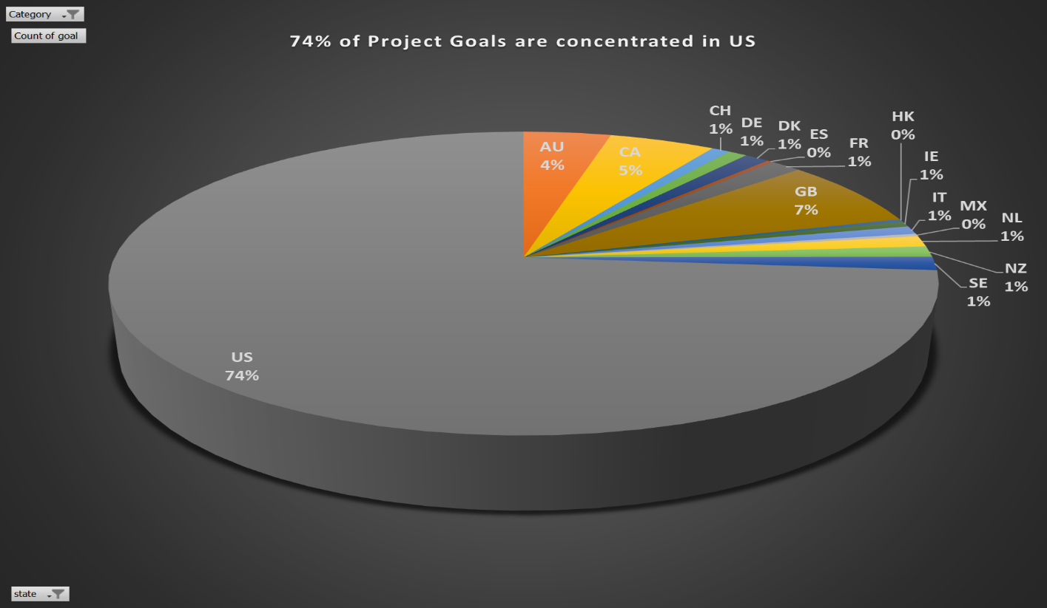

1.3. The categories Theater, Technology, Music and Film & Video concentrate 79% of projects and within these categories the relevant sub-categories are: Theater (Plays); Technology (hardware); Music (Rock and Indie Rock) and Film & Video ( Documentary).

Table III

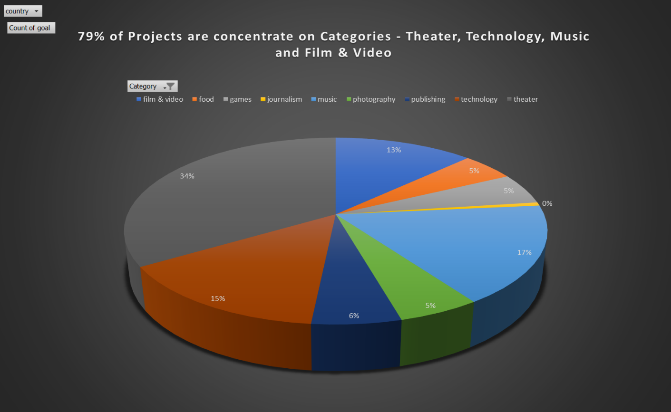

Table IV

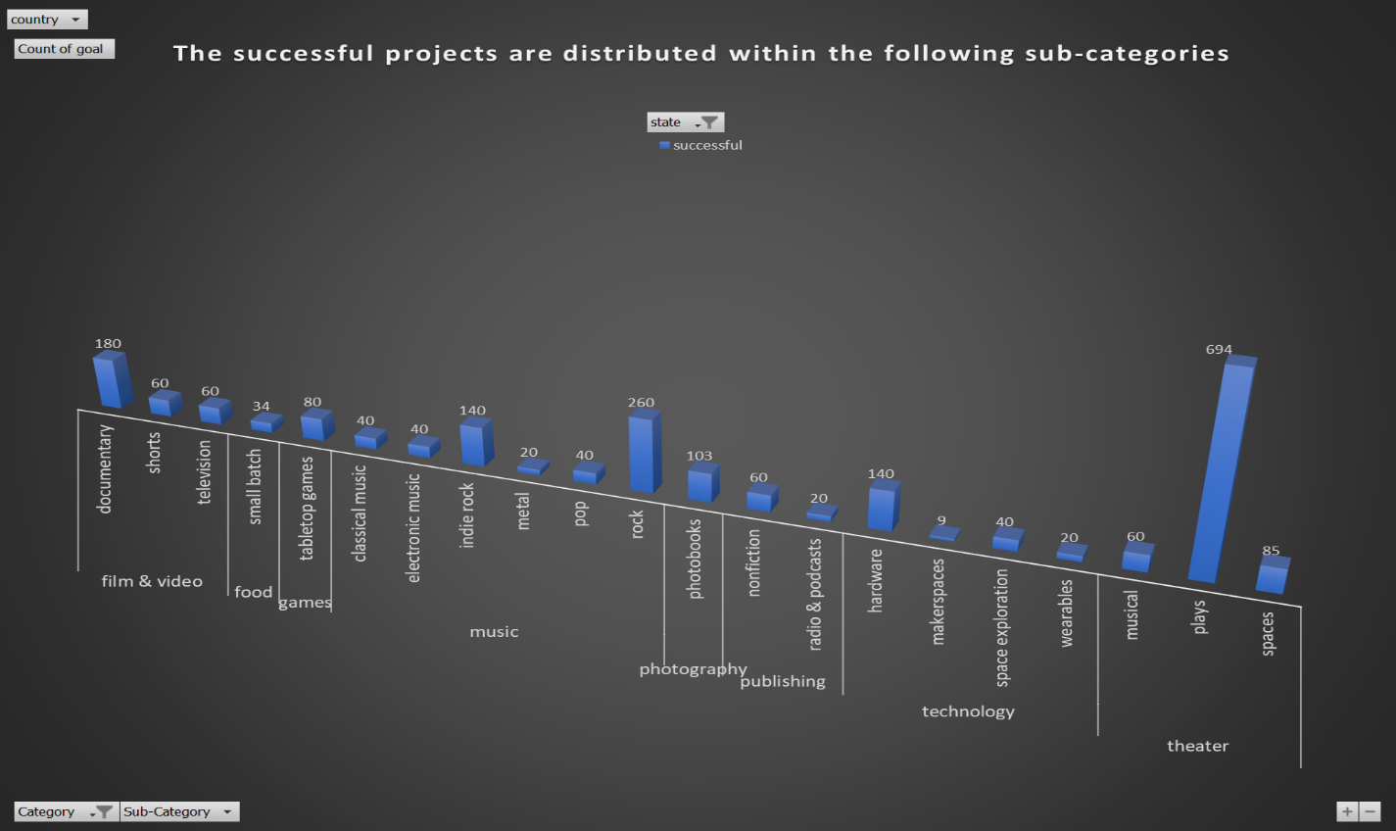

1.4. Projects associated with technology were most funded projects; i.e a creative projects when related to technology add more value based on backers pledged.

Table V

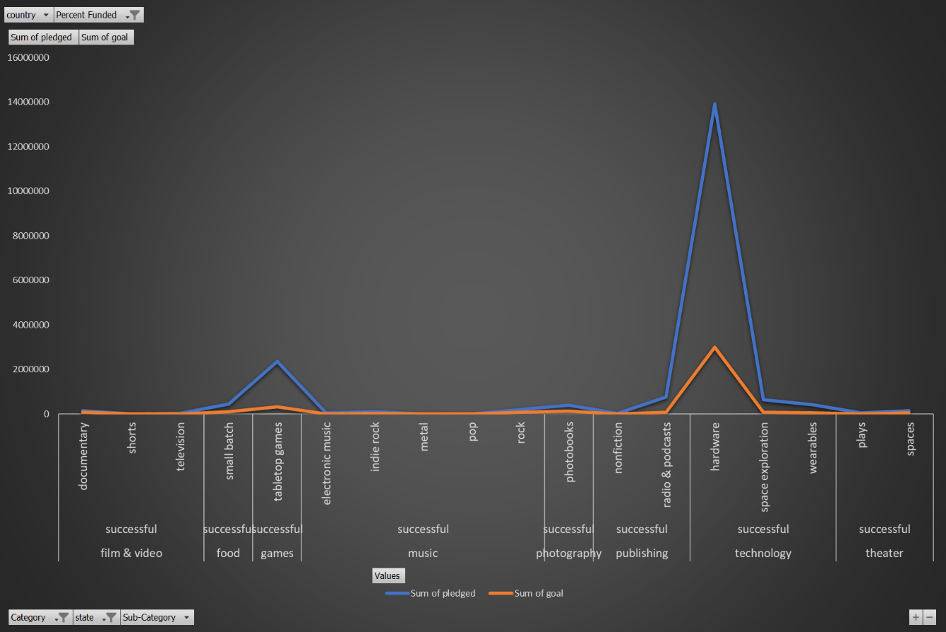

1.5. Crowdfunding duration with more than 40 days decrease the projects’ successful percentage.

Table VI

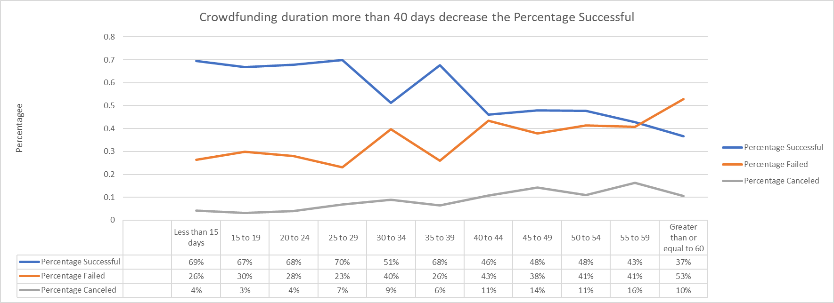

1.6 Crowdfunding shows some sazonalite that is been aligned to the holliday callendar from US since 2014.

Table VII

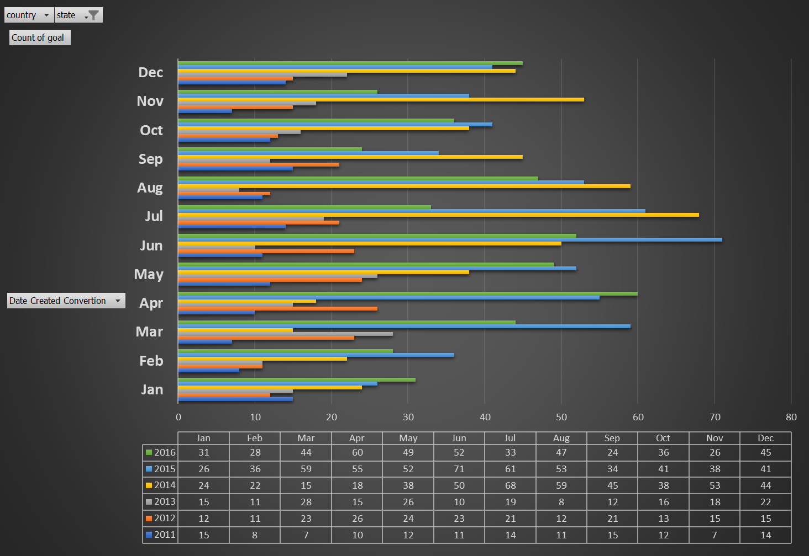

2. What are some limitations of this dataset?

2.1. Considering all the above, a marketing campaign is a very strategic part to succeed, in this sense the dataset is not showing some product qualification like: are the product solving a problem in a new way? Is there any prototype available? What is the Kickstarter target audience?

2.2 Also, the project may have a success fundraising campaign and fail due to other reasons like underestimate costs and technical difficulties to be overcome, a data with this information will be very useful to make a proper relation to the data indicate in the item 2.1 and spotlight information. These data should allow to visualize the effectiveness of a marking campaign in this process.

3. What are some other possible tables and/or graphs that we could create?

3.1 Please consider all the tables above and tables

Table VIII

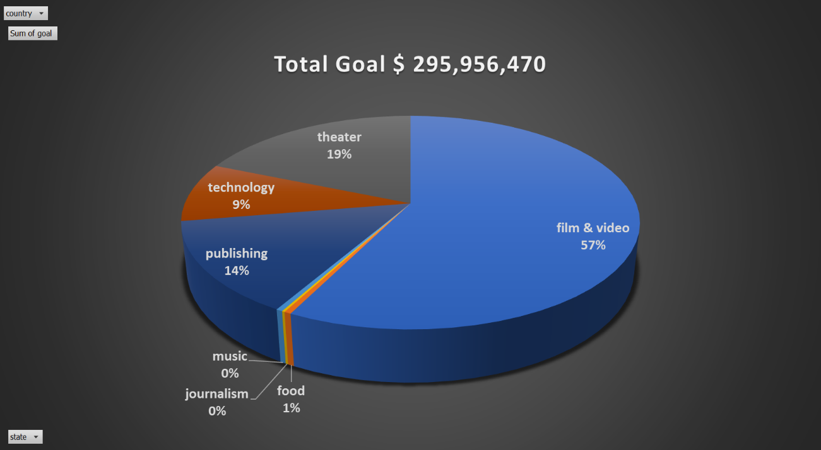

Table IX

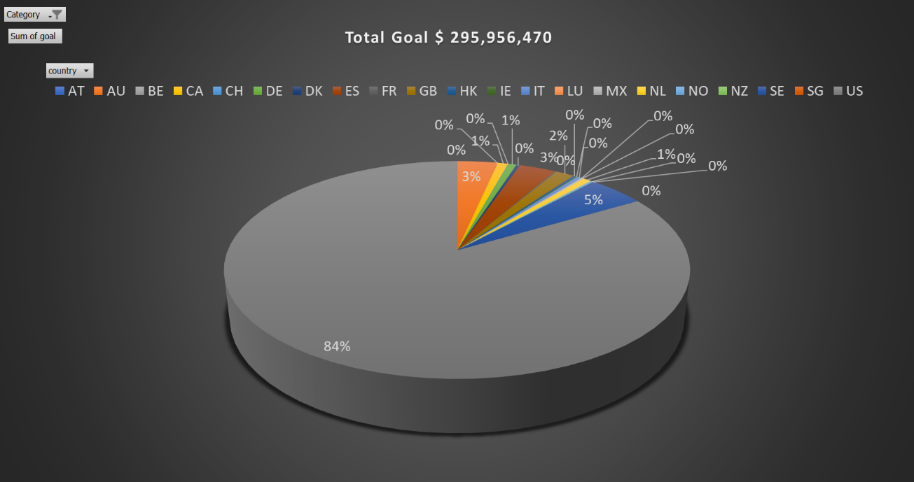

Table X

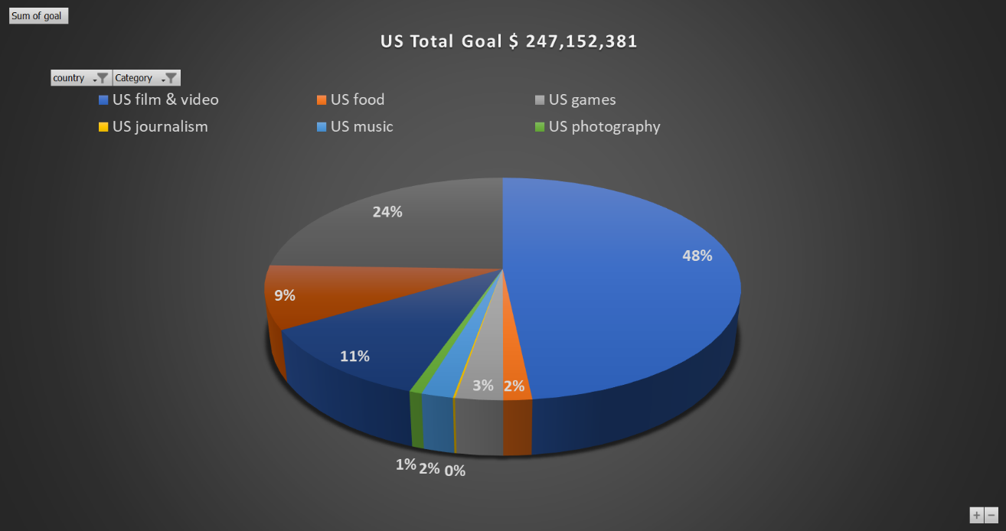

Table XI

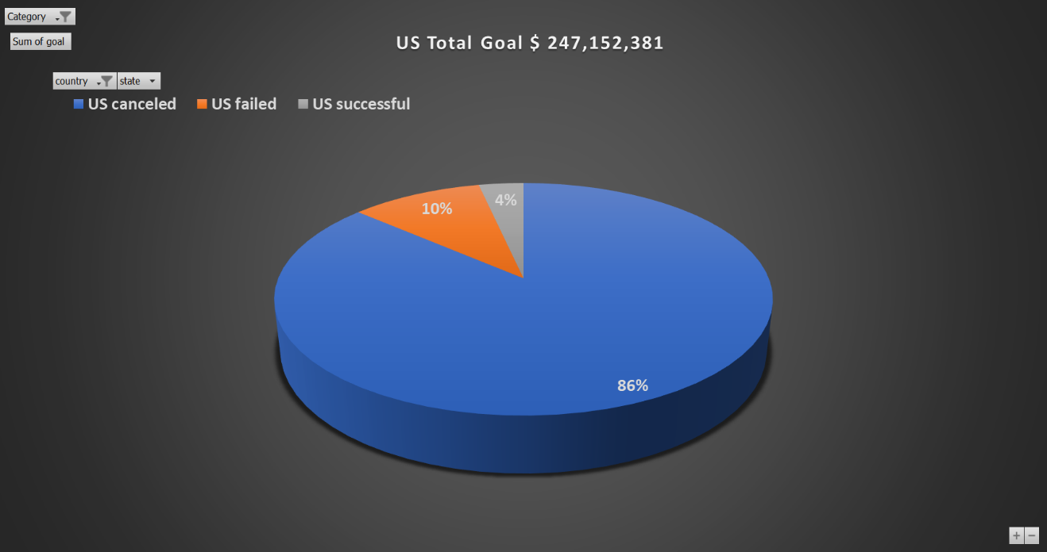

Table XII

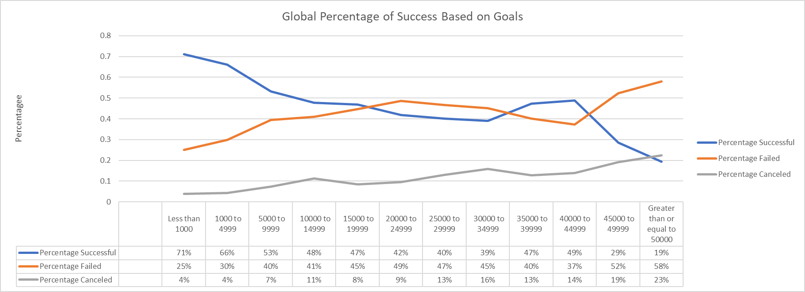

Table XIII

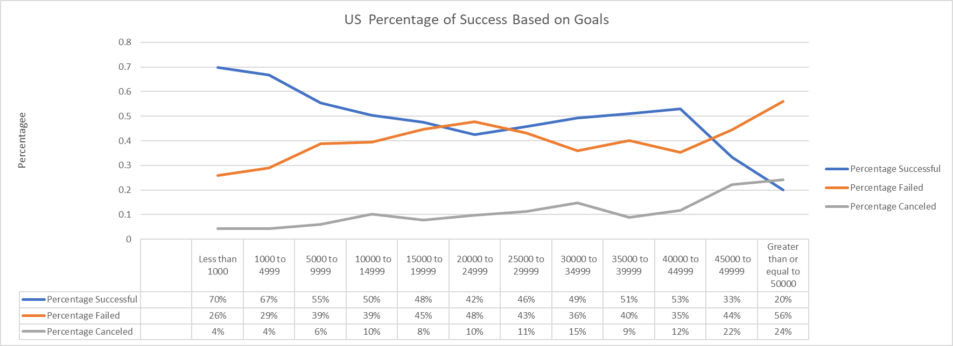

Table XIV

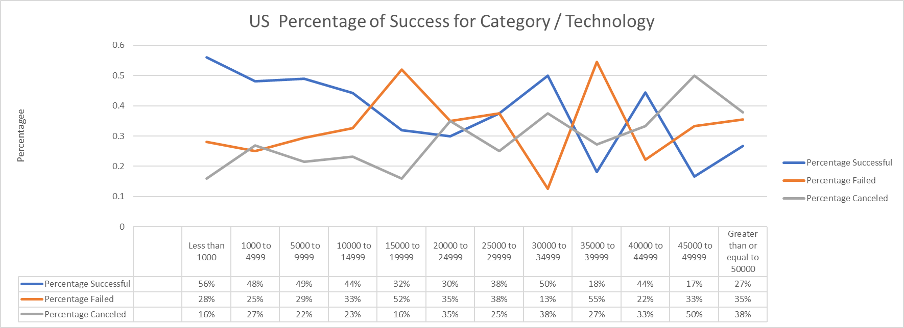

1. Source: Wikipedia