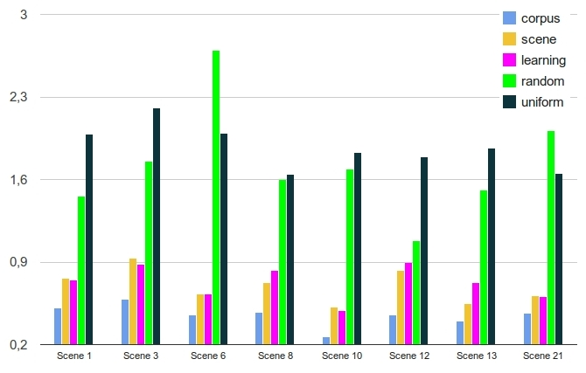
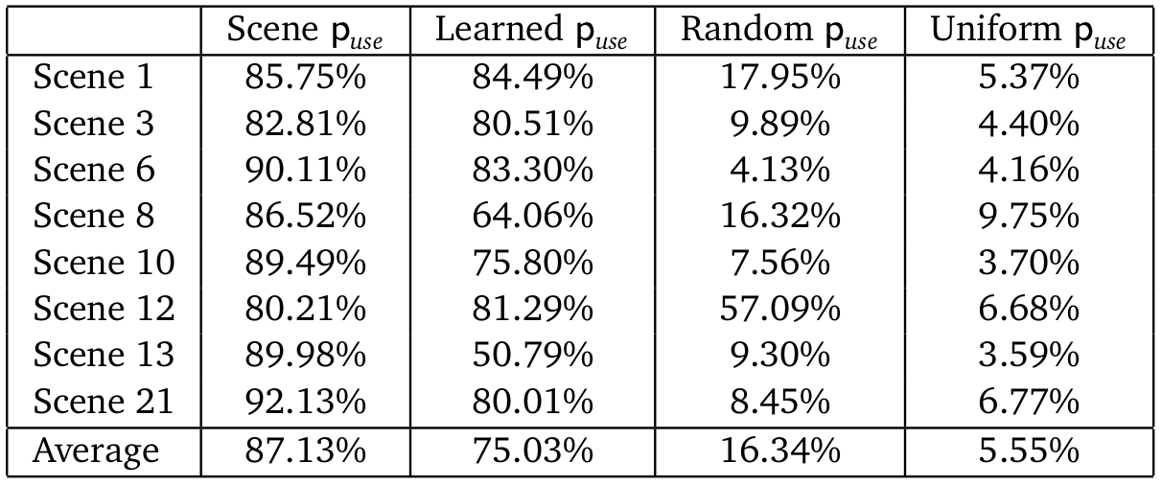
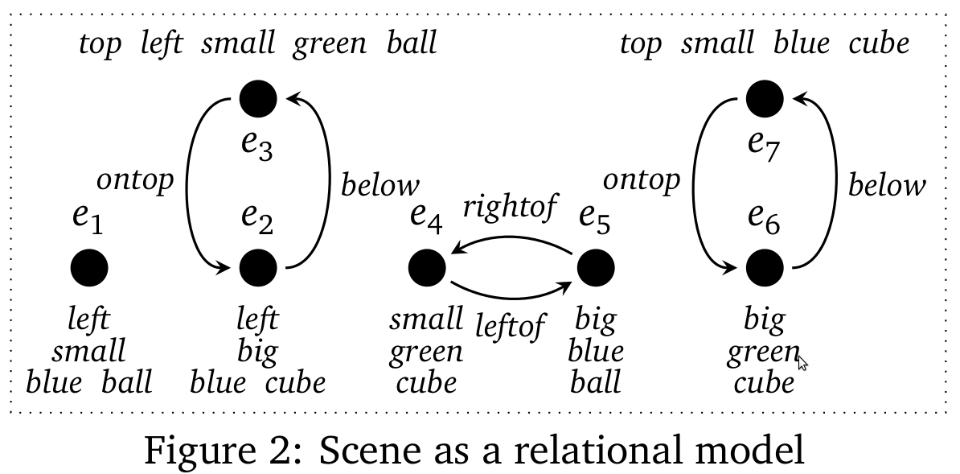
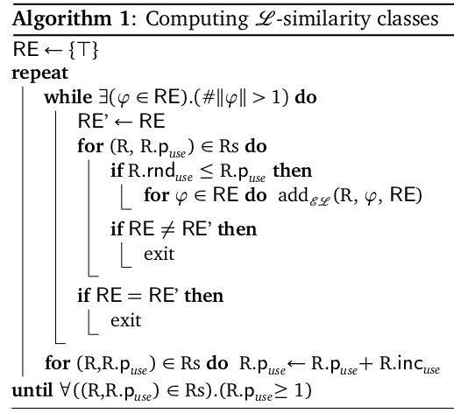
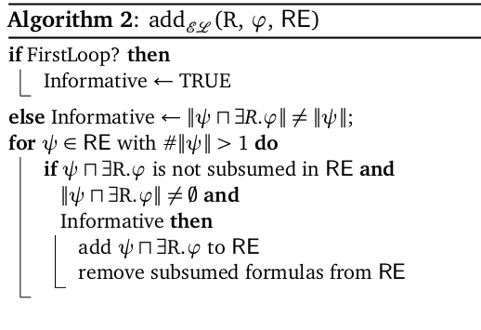


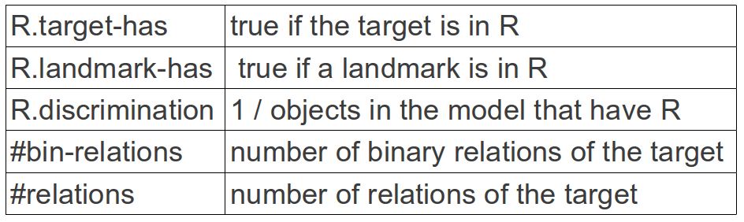
Probabilistic Refinement Algorithms for the
Generation of Referring Expressions

Romina Altamirano¹ Carlos Areces^{1,2} Luciana Benotti ¹
(1) FaMAF, Universidad Nacional de Córdoba, Argentina, (2) Consejo Nacional de Investigaciones Científicas y Técnicas, Argentina

REFINEMENT ALGORITHMS
NON-DETERMINISM AND OVER-SPECIFICATION
EVALUATION WITH PRECISION
INTRODUCTION

We propose a refinement algorithm that generates referring expressions that are:
￭Relational: ball on the blue cube
￭ Overspecified: small green ball on the blue cube
￭Non-deterministic: green ball, small ball on the right
If there is corpus available:
R.p_{pus}e = #appear(R)/#RE

Feature used to learn R.p_{use} when there is not corpus available

Accuracy between the REs in the corpus and those generated using puse values computed from the scene, machine learned, random and uniform.
EVALUATION WITH CROSS ENTROPY
Cross-entropy between the corpus distribution and different runs of the algorithm.
Completeness
step
Probabilistic
Non-deterministic
step
Overspecification
Step/ (Egocentric)
Refinement
Step/(Adjustment)

