|  |  |
| --- | --- |
| DS 3001  Homework 2 | Carlos Barcelos  April 4, 2018 |

# Task 1

## Data Cleaning

The first task was to collect the tables of Circle, Triangle, and Fireball shaped UFOs and combine them into one file. This was accomplished using a simple HTML to CSV converter [online](http://www.convertcsv.com/html-table-to-csv.htm) and combining the three CSV files into one in Microsoft excel. The next step was to remove missing files using Pandas’s [dropna()](https://pandas.pydata.org/pandas-docs/stable/generated/pandas.DataFrame.dropna.html) function. This reduced the dataset from 31,385 to 28,472 rows, an acceptable 9% decrease in the dataset. In dropping rows with missing values, I also dropped any datetime that was incorrectly formatted. This involved using the Pandas [to_datetime()](https://pandas.pydata.org/pandas-docs/stable/generated/pandas.to_datetime.html) function with the errors attribute to convert improper datetimes to null values; this operation eliminated 25 dirty rows from the dataset. Finally, it was necessary to restrict our dataset to consider only sightings made between January 1, 2005 and September 22, 2016. This reduced the dataset greatly but increased the reliability of the data by using only the most recent sightings.

The next consideration was converting the **Duration** column into a more usable form. This required removing all instance of text only entries (e.x. ‘Frequently’ is not a usable duration). Then I was able to collect the upper bound of the duration and convert the time to seconds. This was accomplished using regular expressions and a function which would convert whatever time the duration was recorded in (ex. ‘minutes’, ‘hours’, ‘years’, etc.) into seconds. This process removed 3,332 rows of data.

In summary, the initial dataset of 31,385 rows was reduced to 16,706 clean rows of usable data. This is a 46.7% reduction in data that is necessary to get a better, numerical analysis of UFO sightings. The majority of the cleaning came from limiting the range of sightings.

## Data Analysis

The first step to creating a boxplot for each of the UFO sightings was to remove outliers. This was accomplished by finding the interquartile range of each UFO shape and removing values according to the following formula:

$$Outlier=Q1-(1.5*IQR)$$

$$Outlier=Q3+(1.5*IQR)$$

With no outliers, the boxplot in Figure 1 could be created. This shows the five-figure analysis of the duration of sightings according to UFO shape.

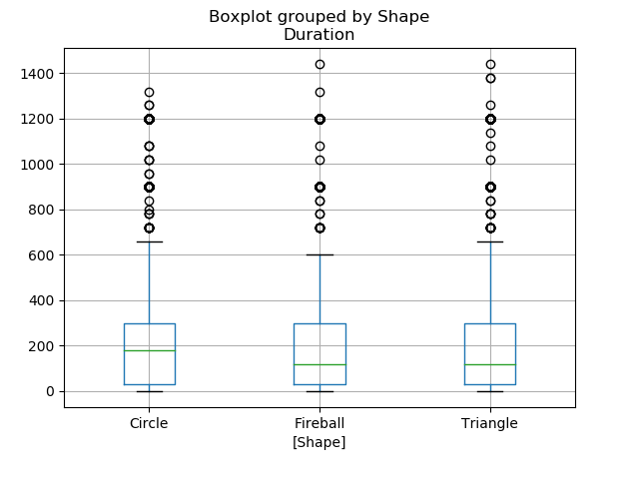

Figure Duration of UFO sightings by shape of UFO

In order to create a time series figure I first created a unique data frame with the **shape** and **year** of the sighting. I was then able to create a pivot table indexed over the year of the sighting, sorted by the shape and aggregated by the count. This was then turned into an easy to digest time series figure as seen in Figure 2.

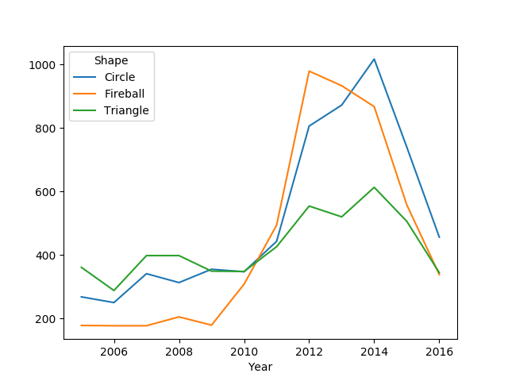

Figure Time series figure of number of sightings per year

A bar chart listing sightings by state is another useful visualization of the data. Figure 2 displays the number of UFO sightings by state.

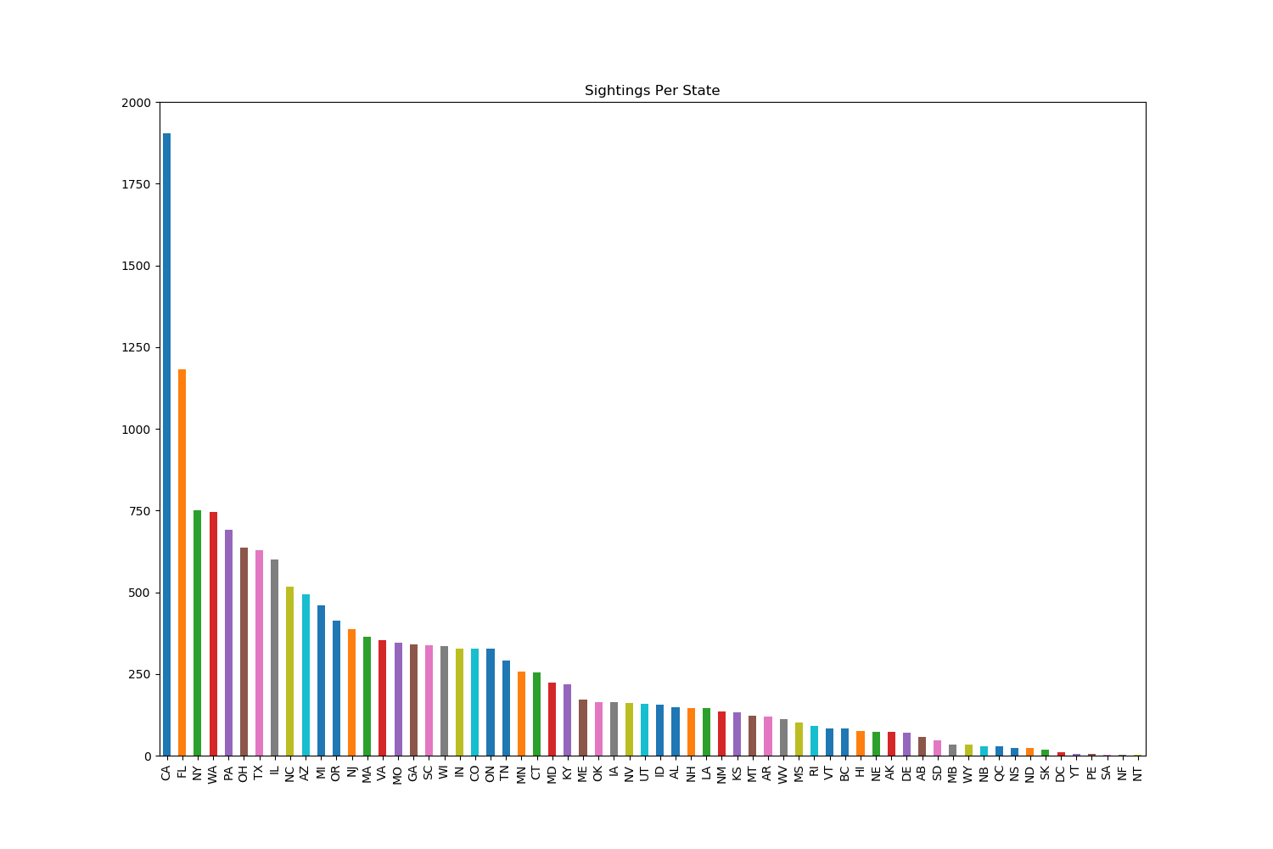

Figure UFO sightings by state

To normalize the sighting by state population the first step was the extract the information of sightings by state. With this CSV file I was able to remove entries that were not states in the United States of America (there was several misprints on state names, 13 to be exact). I then found the populations of each of the states. Finally, I followed the formula below to find the number of UFO sightings per state per 100,000 citizens.

$$Normalized=\frac{count}{population}*100,00$$

The result of this normalization is seen in Figure 4. It is interesting to note that by normalizing the sightings by state population, the states with the most number of sightings are no longer on top. In fact, the states that had the most number of sightings in Figure 3 seem to be those states with the largest population. This leads me to believe that the number of sightings is not related to any actual UFO sighting but the number of people living in the state. The more people there were, the more people claimed to see a UFO.

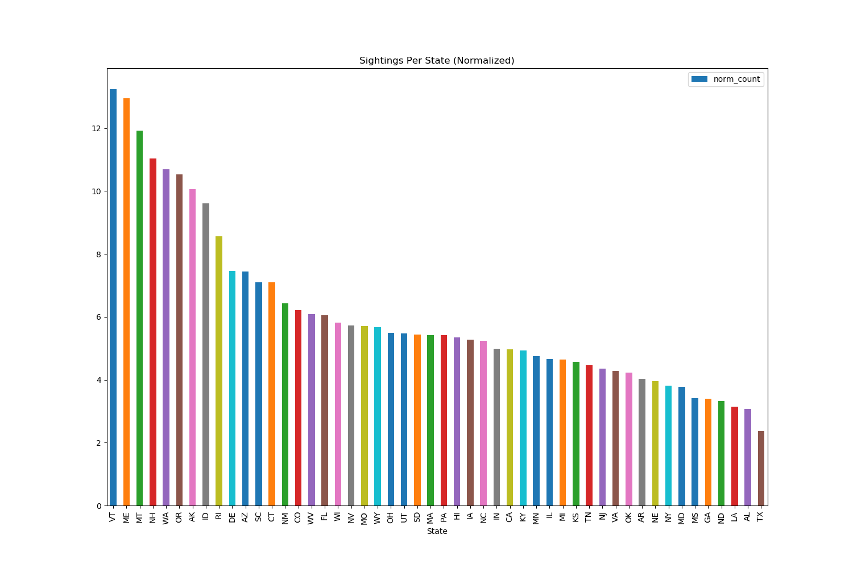

Figure UFO sightings by state normalized by population

# Task 2

The first step to predicting UFO shapes was to create categories in which to organize the data. The two categories were **country region** and **time of day** of the sightings. Creating each category involved binning the various ‘State’ and ‘Time’ columns into four pieces. This was accomplished within Pandas using lambda expressions and a few levels of if statements.

Then the new data frame was to separate the cleaned UFO sightings into a training and testing set. This was accomplished by dividing the initial data frame according to a *split_date* (December 31, 2013). Using Pandas [datetime](https://pandas.pydata.org/pandas-docs/stable/timeseries.html) objects it was easy to create a simple conditional; training data have dates below or on the *split_date* and testing data points have dates above the *split_date*.