**DEPARTMENT OF ENVIRONMENT AND NATURAL RESOURCES (DENR)**

**DENR Central Office 2nd Floor, DENR Main Building, Visayas Avenue, Diliman Quezon City, Philippines,**

**INTRODUCTION**

The Department of Environment and Natural Resources (DENR) is a pivotal institution in the Philippines, established in 1987 under Executive Order No. 192. Charged with safeguarding the nation's ecosystems and promoting sustainable development, the DENR plays a central role in environmental governance and conservation efforts. Its mission centers on environmental protection, biodiversity conservation, and responsible natural resource management. Throughout its existence, the DENR has worked tirelessly to uphold these principles, ensuring the preservation of the Philippines' natural heritage.

One of the DENR's primary functions is environmental protection. It formulates and implements policies, programs, and projects aimed at conserving air, water, land, and biodiversity. From addressing pollution to mitigating the impacts of climate change, the DENR is at the forefront of safeguarding the country's ecological balance. Additionally, the department oversees the management of natural resources, including forests, minerals, and lands. It develops strategies for sustainable forestry, responsible mining practices, and land use planning to ensure the long-term sustainability of these resources.

Biodiversity conservation is another critical aspect of the DENR's mandate. Given the Philippines' status as one of the world's biodiversity hotspots, the DENR is committed to protecting its rich biological diversity. Through the establishment of protected areas, wildlife habitat management, and conservation initiatives, the DENR works to safeguard endangered species and ecosystems. As the primary environmental regulatory agency, the DENR enforces laws, regulations, and standards related to environmental protection and natural resource management. Through monitoring, assessment, and enforcement activities, it ensures compliance and accountability.

In this paper, we will delve into various dimensions of the DENR's role and functions. We will explore its regulatory framework, flagship programs, and initiatives, as well as the challenges it faces in fulfilling its mandate. Additionally, we will discuss future directions and opportunities for the DENR, highlighting the importance of innovation, collaboration, and policy reform in advancing environmental conservation and sustainable development in the Philippines. Through a comprehensive analysis, we aim to gain insights into the DENR's pivotal role in shaping the environmental landscape of the nation.

The DENR plays a crucial role in promoting environmental awareness and education, fostering community engagement, and building partnerships with various stakeholders. Through outreach programs, environmental campaigns, and educational initiatives, the DENR seeks to instill a sense of environmental responsibility and stewardship among the Filipino populace, empowering communities to actively participate in conservation efforts.

The DENR is actively involved in international cooperation and partnerships to address transboundary environmental issues and promote sustainable development on a global scale. It engages with international organizations, bilateral partners, and regional initiatives to share knowledge, resources, and best practices in environmental management and conservation. By collaborating with the global community, the DENR contributes to collective efforts to combat climate change, conserve biodiversity, and achieve the Sustainable Development Goals (SDGs).

One of the DENR's notable achievements is the establishment and management of protected areas, which serve as sanctuaries for threatened species and ecosystems. These protected areas include national parks, wildlife reserves, marine sanctuaries, and other conservation areas that are vital for preserving biodiversity and ecological balance. The DENR works closely with local communities, indigenous peoples, and other stakeholders to ensure the effective management and sustainable use of these protected areas, balancing conservation goals with socio-economic needs.

Despite its efforts, the DENR faces numerous challenges in fulfilling its mandate, including inadequate resources, institutional capacity constraints, governance issues, and conflicting interests among stakeholders. Illegal logging, mining activities, land conversion, and habitat destruction continue to pose significant threats to the environment, requiring concerted efforts and innovative solutions to address. Additionally, the impacts of climate change, such as rising sea levels, extreme weather events, and loss of biodiversity, present urgent challenges that demand proactive adaptation and mitigation measures.

Looking ahead, the DENR must embrace technological advancements, leverage data-driven approaches, and strengthen collaboration with relevant agencies and sectors to enhance its effectiveness in environmental management and conservation. By harnessing the power of technology, such as geographic information systems (GIS), remote sensing, and big data analytics, the DENR can improve monitoring, assessment, and decision-making processes. Furthermore, fostering multi-stakeholder partnerships, promoting community-based conservation initiatives, and integrating indigenous knowledge systems into environmental governance can enhance the DENR's resilience and sustainability in the face of evolving challenges.

The DENR's role in protecting the environment and natural resources is indispensable to the Philippines' sustainable development and future prosperity. Through its mission-driven approach, collaborative efforts, and innovative solutions, the DENR continues to make significant strides in environmental conservation, biodiversity protection, and sustainable resource management. However, addressing the complex environmental challenges requires collective action, political will, and ongoing commitment from all sectors of society. By working together towards common goals, we can build a resilient and sustainable future for generations to come.

**BODY**

The modern iteration of the DENR was officially established on June 10, 1977, through Presidential Decree No. 1151, also known as the Philippine Environmental Policy. This decree consolidated the environmental management functions of various government agencies under a single umbrella organization, emphasizing the need for integrated and holistic approaches to environmental protection and natural resource management.

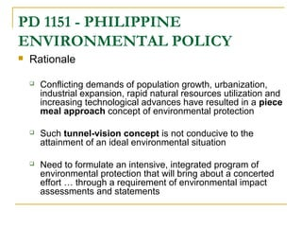

**Figure 1: Philippine Environmental Policy.**

Over the years, the DENR has undergone significant transformations in response to changing environmental priorities, evolving socio-economic contexts, and emerging global challenges such as climate change and biodiversity loss. Its organizational structure, mandate, and programs have been continuously refined to address emerging environmental issues and promote sustainable development.

Today, the DENR's mandate encompasses a wide range of functions related to environmental protection, natural resource management, and sustainable development. These include formulating policies, implementing programs, conducting research, and enforcing laws and regulations aimed at conserving the Philippines' rich biodiversity, protecting its ecosystems, and ensuring the sustainable use of its natural resources.

Among its key responsibilities are the conservation and management of forests, protected areas, wildlife habitats, watersheds, and coastal and marine resources. The DENR also plays a crucial role in addressing environmental pollution, promoting sustainable land use practices, and enhancing resilience to climate change impacts. Additionally, it is responsible for the regulation of mining activities, the issuance of environmental permits, and the enforcement of environmental laws to safeguard public health and the environment.

Despite its efforts, the DENR faces numerous challenges, including inadequate resources, governance issues, conflicting interests, and environmental degradation. However, it also presents opportunities for innovation, collaboration, and policy reform to address these challenges effectively. By leveraging technology, fostering partnerships, and engaging stakeholders, the DENR can enhance its capacity to protect the environment, conserve natural resources, and promote sustainable development for the benefit of present and future generations.

The Department of Agriculture and Natural Resources (DANR) has played a pivotal role in shaping the Philippines' agricultural and environmental landscape. Established in 1916 through Act No. 2666 by the Philippine Commission, the DANR emerged as a key institution tasked with reorganizing the executive department of the government. At its inception, the DANR absorbed the functions and authority previously held by the Department of Interior, consolidating control over bureaus related to agriculture, forestry, lands, science, and weather.

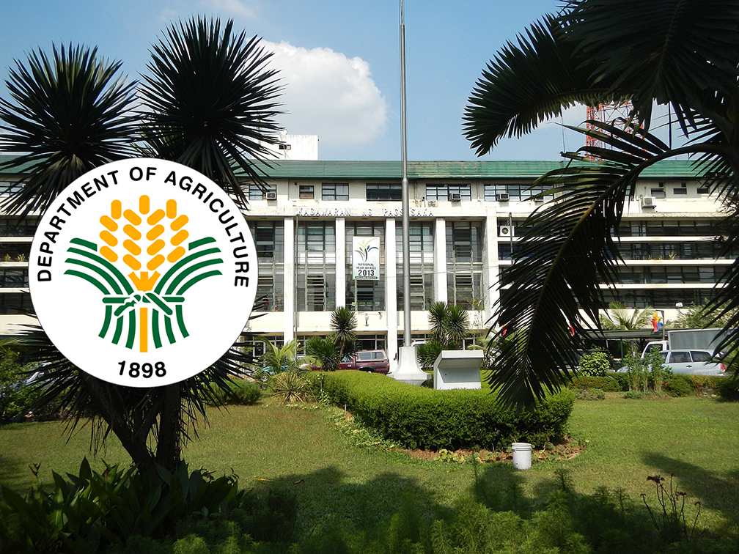

**Figure 2: Department of Agriculture and Natural Resources (DANR)**

The creation of the DANR marked a significant milestone in the Philippines' governance structure, reflecting a growing recognition of the importance of agricultural development and natural resource management. By centralizing various functions under one department, the DANR aimed to streamline administrative processes, enhance coordination, and facilitate more effective policymaking in the areas of agriculture and natural resources.

Under the DANR's purview, several bureaus and agencies were established to oversee specific aspects of agricultural and environmental management. These included bureaus dedicated to agriculture, forestry, lands, science, and weather, each tasked with distinct responsibilities aimed at promoting sustainable resource use, enhancing productivity, and ensuring the welfare of rural communities.

Throughout its history, the DANR has played a critical role in driving agricultural innovation, implementing land reform initiatives, and conserving the Philippines' rich natural heritage. Its efforts have encompassed a wide range of activities, including land administration, crop research, reforestation, watershed management, and disaster risk reduction.

Despite its contributions, the DANR has faced numerous challenges over the years, including issues related to inadequate resources, conflicting interests, and environmental degradation. However, it has also presented opportunities for innovation, collaboration, and policy reform to address these challenges effectively.

The establishment of the Department of Agriculture and Natural Resources (DANR) in 1916 marked a significant milestone in the Philippines' governance framework, reflecting a growing recognition of the importance of agricultural development and natural resource management. Over the years, the DANR has played a pivotal role in driving agricultural innovation, implementing land reform initiatives, and conserving the country's natural heritage. While facing various challenges, it continues to serve as a key institution in promoting sustainable development and ensuring the welfare of rural communities across the Philippines.

In 1932, the Department of Agriculture and Natural Resources (DANR) underwent a significant transformation, leading to its renaming as the Department of Agriculture and Commerce (DAC). This renaming signaled a broader focus on both agricultural development and commercial activities within the Philippines. With this change, the DAC expanded its scope by incorporating the Bureau of Commerce into its existing bureaus, reflecting an acknowledgment of the interconnectedness between agriculture and commerce in driving economic growth and development.

During the period of its existence as the DAC, the department witnessed further organizational changes aimed at enhancing its effectiveness in fulfilling its mandate. One notable development was the restructuring of the Bureau of Agriculture, which led to the creation of two distinct bureaus: the Bureau of Plant Industry and the Bureau of Animal Industry. This restructuring reflected a growing recognition of the diverse needs and challenges facing the agricultural sector, with specialized bureaus dedicated to addressing the unique requirements of plant and animal agriculture.

The renaming of the DANR to the DAC and the subsequent restructuring of its bureaus represented a strategic response to evolving socio-economic dynamics and emerging challenges facing the agricultural sector in the Philippines. By expanding its focus to include commerce and trade-related activities, the DAC aimed to foster greater synergy between agricultural production and marketing, facilitating the flow of goods and services within the domestic and international markets.

Despite these organizational changes, the DAC continued to prioritize agricultural development and natural resource management as core components of its mandate. Through its various bureaus and agencies, the department remained committed to promoting sustainable agriculture, enhancing productivity, and supporting the livelihoods of rural communities across the Philippines.

The renaming of the DANR to the Department of Agriculture and Commerce (DAC) in 1932 marked a significant milestone in the evolution of agricultural governance in the Philippines. By incorporating commerce-related functions into its mandate and restructuring its bureaus, the DAC demonstrated a proactive approach to addressing the evolving needs of the agricultural sector. Through these changes, the department reaffirmed its commitment to driving agricultural development, promoting trade, and fostering economic growth within the country.

On May 17, 1974, a significant reorganization took place within the Philippine government with the issuance of Presidential Decree No. 461. This decree led to the restructuring of the Department of Agriculture and Commerce (DAC), dividing it into two distinct departments: the Department of Agriculture (DA) and the Department of Natural Resources (DNR). This restructuring marked a pivotal moment in the evolution of environmental governance in the Philippines, as it recognized the need for a dedicated agency to oversee matters pertaining specifically to the management and conservation of natural resources.

As a result of Presidential Decree No. 461, the Department of Natural Resources (DNR) was established with a clear mandate to assume direct control over various aspects related to the country's natural resources. These included forests, wildlife, water, and land, among others. By consolidating jurisdiction over these critical areas under a single department, the DNR was empowered to develop comprehensive policies, programs, and initiatives aimed at promoting the sustainable management and conservation of the Philippines' rich natural heritage.

The creation of the Department of Natural Resources (DNR) represented a strategic response to the growing environmental challenges facing the Philippines, including deforestation, habitat loss, biodiversity decline, and water resource degradation. By establishing a dedicated agency focused solely on natural resource management, the government aimed to strengthen its capacity to address these pressing issues and safeguard the country's ecological integrity for future generations.

Under the leadership of the Department of Natural Resources (DNR), significant efforts were made to enhance environmental protection, biodiversity conservation, and sustainable development across the Philippines. Through the formulation and implementation of policies, regulations, and initiatives, the DNR played a vital role in promoting responsible stewardship of natural resources, fostering ecosystem resilience, and supporting the socio-economic well-being of local communities dependent on these resources.

The establishment of the Department of Natural Resources (DNR) in 1974 marked a milestone in the history of environmental governance in the Philippines. By creating a dedicated agency focused on natural resource management, the government demonstrated its commitment to addressing environmental challenges and promoting sustainable development. Through its various programs and initiatives, the DNR continues to play a crucial role in conserving the Philippines' natural heritage and ensuring the long-term health and prosperity of its ecosystems and communities.

On January 1, 1987, the Department of Natural Resources (DNR) underwent a significant transformation, culminating in its renaming as the Department of Environment and Natural Resources (DENR). This rebranding reflected an expanded scope of responsibilities and a renewed commitment to environmental conservation, sustainable development, and the prudent utilization of the Philippines' abundant natural resources. With its new mandate, the DENR assumed a pivotal role in spearheading initiatives aimed at safeguarding the environment, preserving biodiversity, and promoting the harmonious coexistence between humans and nature.

The renaming of the DNR to the DENR represented a strategic response to the evolving environmental challenges facing the Philippines, both domestically and globally. Recognizing the interconnectedness of environmental issues and their profound impact on human well-being, the government sought to consolidate its efforts under a single agency dedicated to environmental protection and natural resource management. By incorporating environmental conservation into its core mission, the DENR signaled a paradigm shift towards a more holistic and integrated approach to sustainable development.

Under the leadership of the Department of Environment and Natural Resources (DENR), a wide range of initiatives and programs were initiated to address pressing environmental concerns and promote ecological sustainability. These initiatives encompassed various aspects of environmental management, including pollution control, waste management, biodiversity conservation, reforestation, and climate change mitigation. By adopting a comprehensive and proactive approach to environmental governance, the DENR sought to enhance the resilience of ecosystems, mitigate environmental degradation, and foster a culture of environmental stewardship among citizens.

The transformation of the DNR into the DENR ushered in a new era of environmental governance in the Philippines, characterized by a heightened focus on sustainability, resilience, and conservation. By consolidating its efforts under a unified department dedicated to environmental protection, the government signaled its commitment to addressing environmental challenges in a holistic and coordinated manner. As the custodian of the nation's environmental heritage, the DENR continues to play a pivotal role in shaping policies, implementing initiatives, and mobilizing stakeholders to ensure the sustainable management of the Philippines' precious natural resources for generations to come.

Since its inception, the Department of Environment and Natural Resources (DENR) has been guided by a clear mandate and vision aimed at ensuring the sustainable management of the Philippines' environment and natural resources. As the primary agency tasked with the conservation, management, development, and proper use of the country's rich ecological heritage, the DENR plays a pivotal role in shaping environmental policies and implementing initiatives to promote environmental sustainability and stewardship. With a vision of a nation enjoying and sustaining its natural resources and a clean and healthy environment, the DENR has pursued a diverse range of policies and initiatives to fulfill its mandate and realize its vision.

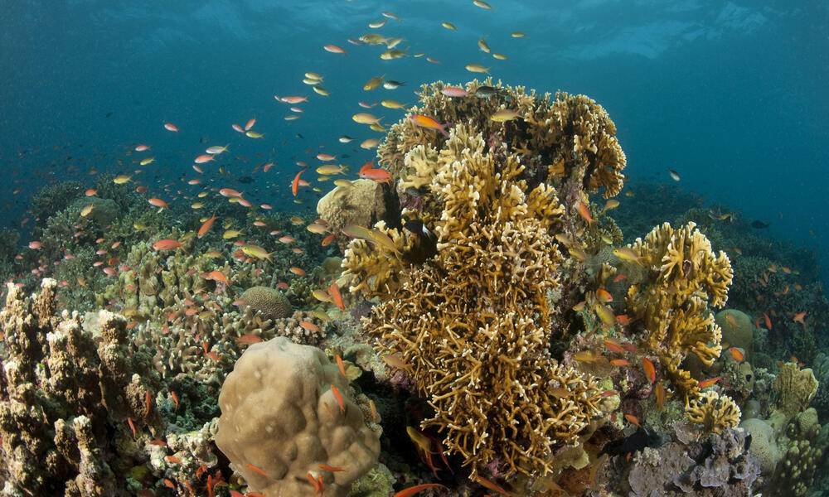

**Figure 3: A Biodiversity Hotspot in the Philippines**

One of the key priorities of the DENR has been to protect and conserve the Philippines' diverse ecosystems, wildlife, and natural habitats. To achieve this goal, the DENR has implemented various policies and programs aimed at preserving biodiversity, preventing habitat loss, and mitigating environmental degradation. These initiatives include the establishment of protected areas, such as national parks, marine sanctuaries, and wildlife reserves, to safeguard critical habitats and endangered species. Additionally, the DENR has implemented reforestation and afforestation projects to restore degraded landscapes and promote sustainable forest management practices.

**Natural Resource Management**

In line with its mandate, the DENR is tasked with the sustainable management and utilization of the Philippines' natural resources, including forests, minerals, lands, and water resources. To this end, the DENR has developed policies and regulations to regulate extractive industries, such as mining and logging, and promote responsible resource exploitation practices. The agency also oversees land use planning initiatives to ensure the efficient allocation of land resources for agricultural, residential, industrial, and conservation purposes. Furthermore, the DENR is involved in watershed management efforts to protect and restore critical watersheds that serve as vital sources of freshwater for communities and ecosystems.

**Environmental Governance and Regulation:**

As the primary environmental regulatory agency, the DENR plays a critical role in enforcing environmental laws, regulations, and standards to ensure compliance and accountability. The agency conducts monitoring, inspection, and enforcement activities to address environmental violations, such as illegal logging, mining pollution, and land encroachment. Additionally, the DENR works closely with other government agencies, local government units, civil society organizations, and the private sector to promote collaborative approaches to environmental governance and regulation. Through capacity-building initiatives and public awareness campaigns, the DENR seeks to empower stakeholders to become active participants in environmental protection and conservation efforts.

In response to the growing threat of climate change, the DENR has prioritized efforts to mitigate greenhouse gas emissions, enhance climate resilience, and promote sustainable development practices. The agency has developed policies and strategies to mainstream climate change considerations into its programs and initiatives, including the integration of climate-smart practices in forestry, agriculture, and land use planning. Additionally, the DENR collaborates with international partners and participates in global climate negotiations to advocate for ambitious climate action and secure funding support for adaptation and mitigation projects.

Since its inception, the Department of Environment and Natural Resources (DENR) has been at the forefront of environmental protection, conservation, and sustainable development in the Philippines. Through its diverse range of policies, programs, and initiatives, the DENR has made significant strides in preserving the country's ecological heritage, promoting responsible resource management practices, and addressing emerging environmental challenges, such as climate change and biodiversity loss. As the custodian of the nation's environmental future, the DENR continues to play a pivotal role in shaping policies, mobilizing stakeholders, and driving action towards a more sustainable and resilient Philippines.

The Department of Environment and Natural Resources (DENR) aligns its efforts with overarching development goals aimed at ensuring human well-being, environmental quality, and sustainability. By pursuing these goals, the DENR seeks to achieve outcomes that promote the well-being of both people and the environment, foster sustainable resource management practices, and enhance the adaptive capacities of communities and ecosystems.

Central to the DENR's mission is the promotion of human well-being, which encompasses aspects such as health, livelihoods, and quality of life. Through its various environmental conservation and protection initiatives, the DENR aims to safeguard public health by ensuring access to clean air, safe drinking water, and unpolluted environments. Additionally, the DENR's programs support sustainable livelihood opportunities for communities dependent on natural resources, thereby enhancing their economic resilience and social well-being. By prioritizing the health and livelihoods of communities, the DENR contributes to overall human well-being and prosperity.

Another key focus of the DENR is to promote sustainable resource management practices that balance the needs of present and future generations. By implementing policies and regulations that govern the use of forests, minerals, lands, and water resources, the DENR aims to ensure the sustainable utilization of natural resources while minimizing environmental degradation and depletion. Through initiatives such as reforestation, watershed management, and sustainable agriculture, the DENR works to conserve ecosystems, protect biodiversity, and maintain ecological balance. By fostering sustainable resource management, the DENR contributes to the long-term sustainability of ecosystems and the services they provide to society.

In the face of climate change and other environmental challenges, building adaptive capacities is essential for ensuring the resilience of communities and ecosystems.

The DENR recognizes the importance of enhancing the adaptive capacities of both human and natural systems to respond effectively to environmental changes and uncertainties. Through climate change adaptation strategies, disaster risk reduction efforts, and community-based resilience programs, the DENR works to strengthen the resilience of vulnerable communities and ecosystems. By empowering communities to adapt to changing environmental conditions and mitigate risks, the DENR contributes to building a more resilient and sustainable future for all.

The Department of Environment and Natural Resources (DENR) is committed to advancing development goals that prioritize human well-being, environmental quality, and sustainability. By promoting well-being, sustainable resource management, and adaptive capacities, the DENR seeks to create a future where people and the environment thrive together in harmony. Through its collaborative efforts with stakeholders, communities, and partners, the DENR continues to work towards achieving these goals and building a more resilient and sustainable Philippines for generations to come.

**Strategies and Initiatives**

The Department of Environment and Natural Resources (DENR) employs various strategies and initiatives to address environmental challenges and promote sustainable development. Among these, the watershed and river basin framework stand out as critical approaches for ecosystem management and conservation. Here are some key strategies and initiatives implemented by the DENR within this framework:

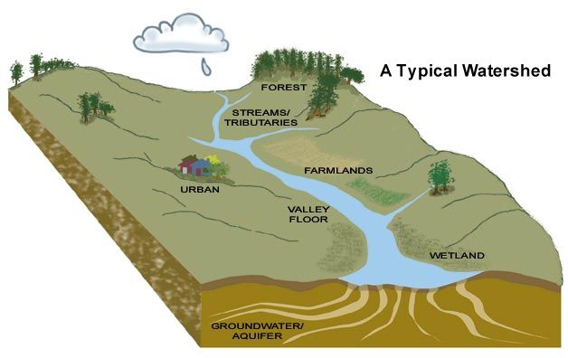

**Figure 4: Watershed management**

**Prioritizing Areas within Watersheds**

One of the primary strategies adopted by the DENR is to prioritize areas within watersheds for conservation and sustainable management. Watersheds play a crucial role in regulating water flow, maintaining biodiversity, and supporting various ecosystem services. By identifying and prioritizing critical areas within watersheds, the DENR can allocate resources more effectively and focus conservation efforts where they are most needed. This targeted approach allows for the protection of key habitats, restoration of degraded ecosystems, and enhancement of watershed resilience to environmental threats.

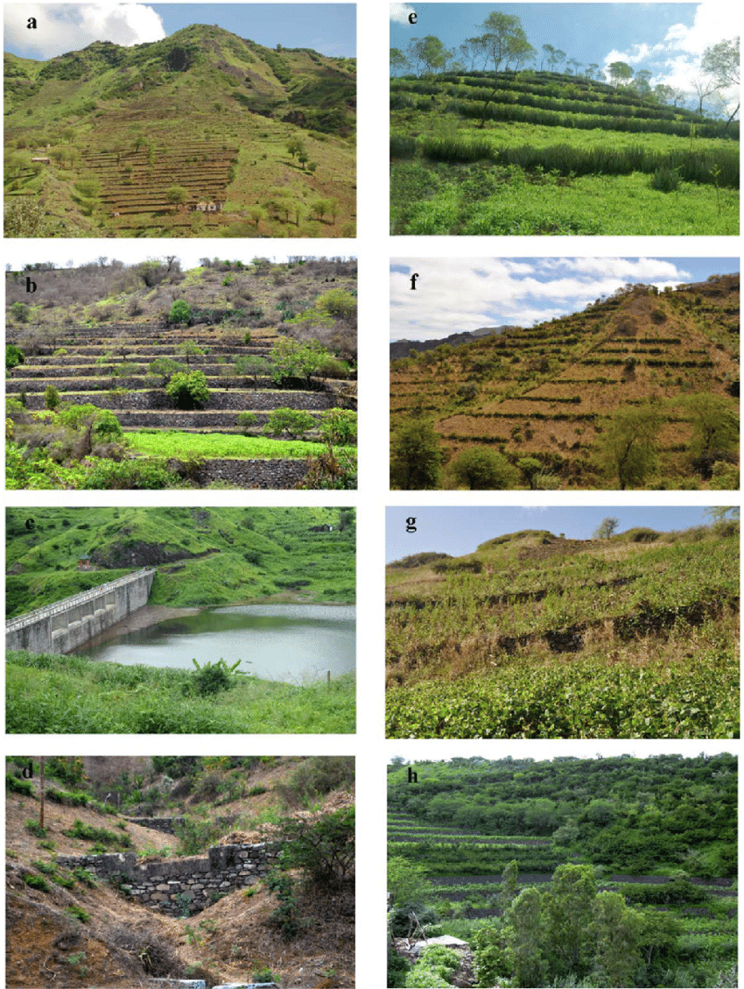

**Figure 5: soil and water conservation measures**

**Adopting Soil and Water Conservation Measures:**

To mitigate soil erosion, sedimentation, and water pollution, the DENR promotes the adoption of soil and water conservation measures within watersheds. These measures include terracing, contour farming, reforestation, and the establishment of vegetative buffer strips along water bodies. By implementing these practices, the DENR aims to improve soil stability, reduce sediment runoff, and enhance water quality within watersheds. These conservation measures not only protect natural resources but also contribute to the long-term sustainability of agricultural and forestry activities in the area.

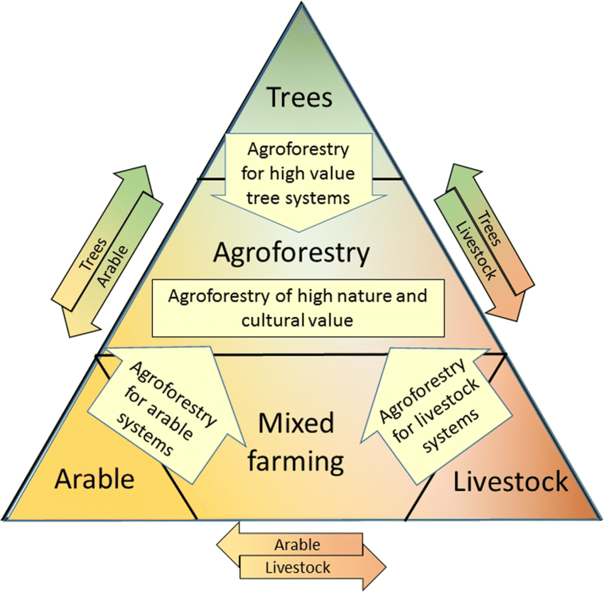

**Figure 6: Promoting Agroforestry**

**Promoting Agroforestry Systems**

Agroforestry systems integrate trees, crops, and livestock on the same land, offering multiple environmental, social, and economic benefits. Within watersheds, agroforestry can help improve soil fertility, conserve water, and enhance biodiversity while providing livelihood opportunities for local communities. The DENR promotes the adoption of agroforestry practices as a sustainable land use strategy within watersheds. By encouraging farmers to plant trees alongside their crops and integrate livestock into their agricultural systems, the DENR contributes to ecosystem restoration, climate resilience, and rural development in watershed areas.

By implementing these strategies and initiatives within the watershed and river basin framework, the DENR aims to achieve multiple objectives, including biodiversity conservation, sustainable land use, and watershed management. Through collaboration with local communities, government agencies, and other stakeholders, the DENR seeks to build resilience, enhance ecosystem services, and promote the sustainable use of natural resources for the benefit of present and future generations.

One of the key strategies employed by the Department of Environment and Natural Resources (DENR) is the closure of open access forestlands through appropriate tenure or management arrangements. Open access areas are vulnerable to exploitation, illegal logging, and deforestation, leading to environmental degradation and loss of biodiversity. By granting tenure or implementing management schemes in these areas, the DENR aims to regulate access, prevent unauthorized activities, and promote sustainable forest management practices. This approach helps protect valuable ecosystems, conserve biodiversity, and ensure the long-term sustainability of forest resources.

The DENR adopts a convergence approach that fosters collaboration among national government agencies (NGAs), local government units (LGUs), and civil society organizations (CSOs) to address environmental challenges and achieve common goals. Through partnerships and multi-stakeholder engagement, the DENR leverages collective expertise, resources, and networks to implement integrated solutions for sustainable development. By working together, stakeholders can harmonize policies, streamline processes, and maximize the impact of interventions, leading to more effective and efficient environmental management practices.

In pursuit of impactful service delivery, the DENR implements an integrated area management approach that focuses on holistic development and management of specific geographic areas. By adopting this approach, the DENR aims to address interconnected environmental, social, and economic issues within targeted areas. Integrated area development involves coordinated planning, resource allocation, and implementation of programs and projects to achieve sustainable outcomes. Through this approach, the DENR seeks to promote ecosystem resilience, enhance livelihood opportunities, and improve the overall well-being of communities.

Capacity building is a cornerstone of the DENR's efforts to strengthen institutional capabilities and empower stakeholders involved in environmental management. The DENR conducts training programs for its frontliners, LGUs, CSO partners, and social entrepreneurs to enhance their knowledge, skills, and competencies in various aspects of environmental conservation and natural resource management. By investing in capacity building, the DENR aims to build a skilled workforce, foster innovation, and promote effective governance practices that support sustainable development goals. Information, education, and communication (IEC) campaigns, advocacy efforts, and social mobilization play a crucial role in raising awareness, fostering behavior change, and mobilizing collective action for environmental conservation. The DENR conducts IEC activities to disseminate information, promote environmental awareness, and engage stakeholders in conservation initiatives. Through advocacy efforts and social mobilization, the DENR seeks to mobilize public support, galvanize community participation, and build momentum for environmental action. These activities help foster a culture of environmental stewardship, empower communities, and mobilize resources for sustainable development.

The DENR promotes the adoption of certification systems to ensure sustainable consumption and production practices across various sectors. Certification schemes provide market incentives for producers to adopt environmentally friendly practices, adhere to standards, and comply with regulations. Additionally, the DENR explores innovative mechanisms such as payment for ecosystem services (PES) to incentivize environmental conservation and reward communities for their stewardship efforts. By implementing PES schemes, the DENR aims to create economic incentives for the preservation of ecosystems, enhance biodiversity conservation, and promote sustainable land management practices. Moreover, the DENR holds polluters accountable through enforcement mechanisms, penalties, and regulatory measures to deter environmental violations and ensure compliance with environmental laws and regulations. Through these initiatives, the DENR strives to promote environmental sustainability, foster green growth, and safeguard the country's natural resources for future generations.

The Department of Environment and Natural Resources (DENR) operational plan underscores the importance of addressing climate change through strategies aimed at achieving water sufficiency, ecological stability, and climate action. As climate change continues to pose significant challenges to the environment and society, the DENR recognizes the urgency of implementing initiatives to mitigate its impacts, enhance resilience, and promote sustainable practices. In line with this commitment, the DENR has launched various programs and projects to address key climate change issues and advance environmental sustainability.

One of the key focus areas of the DENR's climate change initiatives is water sufficiency, which entails ensuring the availability and accessibility of water resources to meet the needs of both present and future generations. Given the increasing frequency and intensity of droughts, water scarcity, and other climate-related events, the DENR implements measures to enhance water conservation, improve water governance, and strengthen water resource management practices. By promoting sustainable water use and management, the DENR aims to safeguard water security, support ecosystem health, and enhance the resilience of communities to climate change impacts.

In addition to water sufficiency, the DENR prioritizes efforts to promote ecological stability, which involves protecting and restoring ecosystems, conserving biodiversity, and enhancing ecosystem resilience in the face of climate change. Through initiatives such as reforestation, forest conservation, and biodiversity conservation programs, the DENR seeks to mitigate the adverse impacts of climate change on ecosystems, habitats, and species. By restoring degraded landscapes, conserving critical habitats, and promoting sustainable land use practices, the DENR contributes to ecological stability and biodiversity conservation, thereby enhancing ecosystem services and supporting sustainable development.

The DENR is actively engaged in climate action, which involves reducing greenhouse gas emissions, enhancing climate resilience, and transitioning to low-carbon and climate-resilient pathways. The DENR collaborates with various stakeholders, including government agencies, local communities, civil society organizations, and the private sector, to develop and implement climate change adaptation and mitigation measures. These measures include promoting renewable energy, adopting sustainable land management practices, implementing climate-smart agriculture initiatives, and mainstreaming climate change considerations into development planning processes. Through these efforts, the DENR contributes to national and global climate change goals, enhances environmental sustainability, and fosters resilience to climate change impacts across the Philippines.

The DENR's climate change initiatives underscore its commitment to addressing climate change challenges and advancing environmental sustainability in the Philippines. By focusing on water sufficiency, ecological stability, and climate action, the DENR aims to mitigate climate change impacts, enhance resilience, and promote sustainable practices that benefit both people and the planet. Through collaborative efforts and innovative solutions, the DENR contributes to building a climate-resilient and sustainable future for present and future generations.

Under the administration of President Ferdinand Marcos Jr., the Department of Environment and Natural Resources (DENR) has articulated policy directions that prioritize environmental protection and natural resource conservation. These policy directives underscore the government's commitment to addressing pressing environmental challenges while promoting sustainable development and economic growth. By emphasizing the importance of balancing economic progress with ecological integrity, the DENR aims to foster a harmonious relationship between human activities and the environment, ensuring the long-term well-being of both present and future generations.

Central to the DENR's policy directions is the recognition of the intrinsic value of the environment and the need to conserve and protect natural resources for the benefit of all. In line with this principle, the DENR implements policies aimed at safeguarding critical ecosystems, preserving biodiversity, and mitigating environmental degradation. By promoting responsible stewardship of natural resources, the DENR seeks to maintain ecological balance, support ecosystem services, and enhance the resilience of ecosystems to climate change impacts and other environmental stressors.

The DENR's policy directions emphasize the integration of environmental considerations into broader development planning processes, ensuring that economic activities are conducted in a manner that is environmentally sustainable and socially responsible. By mainstreaming environmental concerns into development policies, programs, and projects, the DENR seeks to minimize adverse environmental impacts, promote sustainable resource management practices, and foster inclusive and equitable development that benefits all sectors of society.

The DENR's policy directions emphasize the importance of stakeholder engagement, collaboration, and partnership in achieving environmental goals and objectives. Recognizing that addressing complex environmental challenges requires collective action and cooperation, the DENR seeks to engage with various stakeholders, including government agencies, local communities, civil society organizations, and the private sector, in the formulation and implementation of environmental policies and programs. By fostering partnerships and dialogue, the DENR aims to harness the collective expertise, resources, and innovation of diverse stakeholders to address environmental issues effectively and achieve shared environmental objectives.

The DENR's policy directions under President Ferdinand Marcos Jr.'s administration reflect a commitment to environmental protection, natural resource conservation, and sustainable development. By promoting a balanced approach that integrates environmental considerations into development planning, fostering stakeholder engagement and collaboration, and emphasizing the importance of responsible stewardship of natural resources, the DENR seeks to advance its mission of ensuring the long-term sustainability and resilience of the Philippines' environment and natural resources. Through coherent and forward-thinking policies, the DENR aims to address pressing environmental challenges, promote inclusive and equitable development, and create a sustainable future for all Filipinos.



**Figure 7: Global agreements**

In addition to its domestic initiatives, the Department of Environment and Natural Resources (DENR) actively contributes to global environmental agreements and commitments, aligning its efforts with international efforts to address pressing environmental challenges and promote sustainable development worldwide. As a responsible member of the global community, the DENR recognizes the interconnectedness of environmental issues and the importance of collective action in addressing them effectively. By participating in global environmental agreements, the DENR reaffirms the Philippines' commitment to upholding environmental sustainability, biodiversity conservation, and climate resilience on a global scale.

One of the key global agreements that the DENR is actively involved in is the Paris Agreement, which aims to combat climate change and accelerate the transition to a low-carbon, resilient future. By ratifying the Paris Agreement, the Philippines has committed to reducing greenhouse gas emissions, enhancing climate resilience, and supporting international efforts to limit global temperature rise to well below 2 degrees Celsius above pre-industrial levels. The DENR plays a crucial role in implementing the country's commitments under the Paris Agreement, spearheading initiatives to mitigate climate change impacts, promote renewable energy development, and enhance climate adaptation measures.

The DENR is actively engaged in the Convention on Biological Diversity (CBD), an international treaty that aims to conserve biodiversity, ensure the sustainable use of natural resources, and promote equitable sharing of the benefits derived from genetic resources. As a party to the CBD, the Philippines is committed to protecting its rich biological diversity, preserving critical habitats, and promoting sustainable management of ecosystems. The DENR works closely with other government agencies, civil society organizations, and international partners to implement the objectives of the CBD, including the establishment of protected areas, the conservation of endangered species, and the sustainable use of biological resources.

By participating in global environmental agreements such as the Paris Agreement and the Convention on Biological Diversity, the DENR reaffirms its commitment to advancing environmental sustainability, biodiversity conservation, and climate resilience at both the national and international levels. Through collaborative action and partnerships with other countries and stakeholders, the DENR seeks to address transboundary environmental challenges, promote sustainable development, and safeguard the planet for future generations. As a responsible steward of the Philippines' environment and natural resources, the DENR remains dedicated to upholding the country's global commitments and contributing to the achievement of shared environmental goals on the global stage.

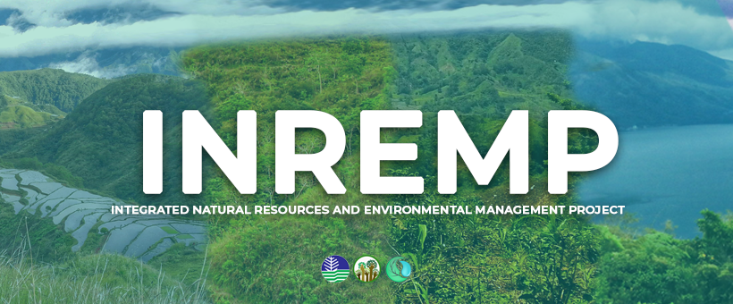

**Figure 8: The Integrated Natural Resources and Environmental Management Project (INREMP)**

The Integrated Natural Resources and Environmental Management Project (INREMP) stands as a significant five-year initiative designed to address the issue of unsustainable watershed management in priority river basins across the Philippines. With a focus on indigenous peoples and resource-poor communities, INREMP aims to mitigate the degradation caused by forest denudation and unsustainable farming practices. By implementing sustainable land and water management strategies, such as reforestation, soil conservation, and agroforestry, the project seeks to restore ecosystem health, enhance watershed resilience, and improve the livelihoods of local communities. Through community involvement and capacity building, INREMP fosters a participatory approach to natural resource management, empowering communities to become stewards of their environment and advocates for sustainable development.



**Figure 9: States Agency for International Development (USAID)**

In collaboration with the United States Agency for International Development (USAID), the DENR has launched the Protect Wildlife Project to address the pressing issues of biodiversity loss and wildlife trafficking in the Philippines. Recognizing the importance of protecting the country's rich biological diversity, the project focuses on enhancing protection and conservation efforts through community involvement and sustainable practices. By engaging local communities, law enforcement agencies, and conservation organizations, the Protect Wildlife Project aims to combat illegal wildlife trade, promote habitat conservation, and raise awareness about the value of biodiversity. Through targeted interventions and capacity-building initiatives, the project seeks to strengthen the Philippines' capacity to safeguard its wildlife heritage and ensure the long-term survival of endangered species.

The DENR plays a crucial role in geohazard assessment, which involves identifying areas susceptible to geologic hazards such as landslides, floods, and subsidence. Through comprehensive mapping, monitoring, and risk assessment activities, the DENR provides critical data for disaster preparedness and land use planning. By identifying high-risk areas and implementing appropriate mitigation measures, the DENR helps to reduce the vulnerability of communities to geologic hazards and minimize the impact of natural disasters. Geohazard assessment is essential for enhancing resilience, ensuring sustainable development, and safeguarding lives and property in hazard-prone areas.

As part of its commitment to sustainable forest management, the DENR spearheads various forest stewardship and reforestation initiatives aimed at combating deforestation, promoting reforestation, and preventing wildfires. Through partnerships with local communities, government agencies, and non-governmental organizations, the DENR implements reforestation programs, agroforestry projects, and sustainable land management practices to restore degraded forests, enhance biodiversity, and mitigate climate change. By engaging stakeholders in forest conservation efforts and promoting sustainable livelihood opportunities, the DENR works to ensure the long-term health and resilience of the Philippines' forest ecosystems.

The regulatory framework governing environmental protection and natural resource management in the Philippines is robust and multifaceted. Encompassing a series of laws, decrees, and regulations, this framework provides the legal basis for addressing environmental concerns and promoting sustainable development.

Enacted in 1977, the Philippine Environment Code outlines policy objectives and mechanisms for environmental management. It covers various aspects such as air and water quality, natural resources conservation, wildlife management, and waste management. The code also establishes guidelines for conducting environmental impact assessments and statements, ensuring that development projects consider their environmental implications.

This decree, created in response to growing pollution concerns, established the National Pollution Control Commission (NPCC) and addressed issues related to pollution control and prevention. Subsequent regulations, such as the Motor Vehicle Pollution Control Decree (PD 1181), supplemented PD 984 to address specific sources of pollution and promote cleaner technologies.

Instituted by PD 1586 in 1978, the Environmental Impact Assessment (EIA) System requires proponents of environmentally critical projects and those located in critical areas to prepare an EIA. This systematic process ensures that development projects undergo rigorous assessment of their potential environmental impacts before implementation, allowing for informed decision-making and mitigation measures.

In addition to the laws, several other statutes contribute to the Philippines' environmental regulatory framework. These include RA 6969 (Toxic Substances and Hazardous and Nuclear Wastes Control Act), RA 9003 (Ecological Solid Wastes Management Act), and RA 9275 (Clean Water Act), among others. Each of these laws addresses specific environmental issues and provides guidelines for their management and regulation.

As the primary government agency tasked with environmental protection and natural resource management, the Department of Environment and Natural Resources (DENR) plays a central role in enforcing environmental laws and regulations. Some key aspects of the DENR's role include:

The DENR is responsible for conserving, managing, and developing the Philippines' environment and natural resources. This includes overseeing forestlands, protected areas, wildlife habitats, and marine ecosystems, among others.

The DENR is entrusted with licensing and regulating activities that impact the environment and natural resources. This includes issuing permits for resource extraction, land use conversion, and environmental compliance certificates for development projects.

One of the DENR's primary functions is to enforce environmental laws and regulations, ensuring compliance and accountability among individuals, industries, and government agencies. This involves conducting inspections, investigations, and enforcement actions against violators of environmental laws.

Recognizing the complexity of environmental issues, the DENR collaborates with other government agencies, civil society organizations (CSOs), industries, and academic institutions to address environmental challenges and promote sustainable practices. By fostering partnerships and synergies, the DENR maximizes its impact and effectiveness in achieving its environmental objectives.

In summary, the regulatory framework governing environmental protection and natural resource management in the Philippines, coupled with the DENR's role and collaboration with other stakeholders, forms the cornerstone of the nation's efforts to promote environmental sustainability and ensure the responsible stewardship of its natural resources.

The Department of Environment and Natural Resources (DENR) encounters various challenges and issues in fulfilling its mandate of environmental protection and natural resource management. Some of the prominent challenges include:

**Illegal Logging**

Illegal logging remains a significant threat to the Philippines' forests, leading to deforestation, habitat loss, and degradation of biodiversity. Despite efforts to combat illegal logging through law enforcement and forest protection measures, clandestine logging activities persist, fueled by demand for timber and wood products.

**Mining Activities**

Mining activities, particularly in ecologically sensitive areas such as watersheds and biodiversity hotspots, pose environmental risks such as soil erosion, water pollution, and habitat destruction. Inadequate regulation and enforcement, as well as conflicts over land and resource rights, exacerbate the environmental impacts of mining operations.

**Pollution**

Pollution from various sources, including industrial discharge, improper waste management, and urbanization, threatens air and water quality, as well as public health. Contamination of water bodies, soil, and air with pollutants adversely affects ecosystems, wildlife, and human communities, leading to ecological degradation and health hazards.

**Climate Change**

Climate change poses profound challenges to the Philippines, including rising temperatures, changing rainfall patterns, sea-level rise, and increased frequency of extreme weather events. These climate-related impacts exacerbate existing environmental vulnerabilities, affecting agriculture, water resources, coastal areas, and biodiversity.

**Factors Contributing to Challenges**

**1. Socio-economic Factors**

- Poverty and livelihood pressures drive communities to engage in activities such as illegal logging and informal mining as means of economic survival.

- Inequitable distribution of resources and land tenure issues contribute to conflicts over natural resource management and exacerbate environmental degradation.

**2. Political Factors**

- Political interests, corruption, and patronage networks can undermine environmental governance and enforcement efforts, leading to regulatory capture and impunity for environmental offenders.

- Lack of political will and commitment to sustainable development goals may hinder the implementation of effective environmental policies and initiatives.

**3. Environmental Factors**

- Fragile ecosystems, biodiversity hotspots, and vulnerable coastal areas are particularly susceptible to environmental degradation and climate change impacts.

- Natural disasters such as typhoons, floods, and landslides further exacerbate environmental challenges, causing loss of lives, property damage, and displacement of communities.

Addressing these challenges requires a multi-faceted approach that integrates environmental protection with socio-economic development, governance reforms, and climate resilience strategies. Collaboration among government agencies, civil society organizations, private sector entities, and local communities is essential to effectively tackle these issues and achieve sustainable environmental outcomes. Moreover, enhancing public awareness, promoting environmental education, and strengthening regulatory enforcement mechanisms are crucial for overcoming the complex challenges faced by the DENR in carrying out its mandate.

**2. Biodiversity Conservation through Protected Area Management:**

DENR's concerted efforts in managing and expanding protected areas contribute significantly to biodiversity conservation.

Success stories include the establishment and effective management of marine protected areas (MPAs) like Tubbataha Reefs Natural Park and Apo Reef Natural Park.

These initiatives safeguard critical habitats, preserve biodiversity, and support sustainable fisheries management, benefiting both ecosystems and local communities.

**3. Rehabilitation of Manila Bay:**

In collaboration with various stakeholders, DENR spearheaded the Manila Bay Rehabilitation Program, aiming to restore the bay's water quality and ecosystem health.

The initiative involves cleanup and dredging activities, relocation of informal settlers, and enforcement of environmental regulations to reduce pollution.

Initial results show improvements in water quality and ecosystem condition, signaling progress toward revitalizing this vital coastal area.

**4. Strengthening Environmental Law Enforcement:**

DENR's efforts to enhance environmental law enforcement have yielded positive outcomes, including increased prosecution of environmental violators and confiscation of illegal logging and mining equipment.

The agency conducts regular monitoring and surveillance operations, supported by community engagement and coordination with law enforcement agencies, resulting in improved compliance and deterrence of environmental crimes.

**5. Climate Change Adaptation and Mitigation:**

Recognizing the urgency of climate change, DENR implements various initiatives to enhance climate resilience and mitigate greenhouse gas emissions.

These include reforestation and afforestation programs, ecosystem-based adaptation projects, and promotion of renewable energy and energy efficiency measures.

DENR's climate actions contribute to national commitments under international agreements like the Paris Agreement, demonstrating the Philippines' proactive stance on climate change mitigation and adaptation.

Overall, DENR's achievements and initiatives underscore its commitment to environmental stewardship and sustainable development in the Philippines. By addressing environmental challenges holistically and engaging stakeholders collaboratively, the agency plays a vital role in safeguarding natural resources, protecting ecosystems, and promoting the well-being of present and future generations.

6. Rehabilitation of Boracay and Manila Bay:

The DENR's involvement in the rehabilitation of Boracay Island and Manila Bay exemplifies its commitment to restoring degraded ecosystems and promoting sustainable tourism and coastal management.

In the case of Boracay Island, the DENR spearheaded a comprehensive rehabilitation program in response to environmental degradation caused by unregulated tourism activities and inadequate waste management. The initiative involved beach nourishment, mangrove restoration, and strict enforcement of environmental regulations to mitigate pollution and habitat degradation. Through collaborative efforts with local government units, businesses, and civil society, Boracay's beaches were revitalized, and environmental sustainability was prioritized to ensure the island's long-term viability as a premier tourist destination.

Similarly, the Manila Bay Rehabilitation Program led by the DENR aims to address water quality issues, habitat degradation, and coastal erosion in one of the Philippines' most iconic and historically significant bays. The initiative involves dredging activities to remove solid waste and sediments, construction of sewage treatment plants to improve wastewater management, and rehabilitation of mangrove ecosystems to enhance coastal resilience. By mobilizing resources, engaging stakeholders, and implementing science-based solutions, the DENR's efforts in rehabilitating Manila Bay contribute to revitalizing this vital marine ecosystem and promoting sustainable coastal development in the region.

Through these rehabilitation initiatives, the DENR demonstrates its proactive approach to environmental restoration and sustainable development, setting a precedent for integrated and collaborative efforts to address complex environmental challenges and safeguard the Philippines' natural heritage for future generations.

Project TRANSFORM is a groundbreaking initiative led by the Department of Environment and Natural Resources (DENR) that embodies the spirit of multistakeholder collaboration and evidence-based programming. This innovative project focuses on three core objectives: recovering degraded forests, enhancing community resilience, and promoting public-private partnerships. Through successful rollouts in various pilot areas across Visayas, Luzon, and Mindanao, Project TRANSFORM has emerged as a beacon of hope for sustainable development and environmental resilience in the Philippines.

One of the primary goals of Project TRANSFORM is to rehabilitate and restore degraded forests, which have suffered from deforestation, illegal logging, and unsustainable land use practices. By implementing science-based forest restoration techniques and engaging local communities in tree planting and reforestation efforts, Project TRANSFORM aims to revitalize ecosystem health, conserve biodiversity, and mitigate the impacts of climate change. Through strategic partnerships with government agencies, NGOs, and private sector stakeholders, the project has made significant strides in reclaiming lost forest cover and promoting landscape-scale restoration initiatives.

Project TRANSFORM recognizes the critical role of local communities in building resilience to environmental challenges and natural disasters. By empowering communities with knowledge, skills, and resources, the project strengthens their capacity to adapt to climate variability, mitigate environmental risks, and improve livelihood opportunities. Through participatory approaches, community-based disaster risk reduction strategies, and sustainable livelihood programs, Project TRANSFORM fosters resilience at the grassroots level, ensuring that vulnerable communities are better prepared to withstand and recover from environmental shocks and hazards.

Project TRANSFORM leverages the strengths and resources of both the public and private sectors to achieve its objectives. By forging strategic partnerships with businesses, industry associations, and corporate entities, the project unlocks new opportunities for investment, innovation, and sustainable development. Through public-private collaborations, Project TRANSFORM facilitates the co-creation of solutions to environmental challenges, harnessing the collective expertise, technology, and financial resources of diverse stakeholders. These partnerships not only drive economic growth and job creation but also foster a culture of corporate social responsibility and environmental stewardship.

In conclusion, Project TRANSFORM represents a bold and ambitious vision for environmental resilience and sustainable development in the Philippines. By engaging society in evidence-informed programs, recovering degraded forests, enhancing community resilience, and promoting public-private partnerships, the project is laying the foundation for a more resilient, equitable, and environmentally sustainable future. As Project TRANSFORM continues to expand its reach and impact, it serves as a model for collaborative action and transformative change in addressing the most pressing environmental challenges of our time.

The Department of Environment and Natural Resources (DENR) recognizes the importance of collaborative partnerships in achieving its environmental conservation and sustainable development goals. Through strategic alliances with various stakeholders, including government agencies, civil society groups, the private sector, and local communities, the DENR endeavors to leverage collective expertise, resources, and efforts towards the common objective of environmental stewardship. Here's how the DENR collaborates with different partners:

Collaborating with other government agencies ensures coordinated efforts and inclusive standards for environmental management and protection. By working closely with agencies responsible for agriculture, tourism, infrastructure development, and disaster risk reduction, the DENR strengthens policy coherence, enhances regulatory enforcement, and promotes integrated approaches to environmental governance. Through interagency cooperation, the DENR can address complex environmental challenges more effectively and implement holistic solutions that benefit society as a whole.

Engaging civil society organizations (CSOs) is essential for mobilizing grassroots support, promoting public awareness, and fostering community participation in environmental conservation efforts. The DENR collaborates with environmental NGOs, advocacy groups, community-based organizations, and academic institutions to harness local knowledge, grassroots innovations, and social mobilization strategies. By involving CSOs in policy dialogue, decision-making processes, and project implementation, the DENR ensures that environmental initiatives are contextually relevant, socially inclusive, and responsive to community needs and priorities.

Partnerships with the private sector play a crucial role in leveraging financial resources, technical expertise, and innovation for environmental conservation and sustainable development. The DENR collaborates with businesses, industry associations, and corporate entities to promote responsible stewardship of natural resources, adopt eco-friendly technologies, and implement corporate environmental sustainability initiatives. Through public-private partnerships, the DENR can scale up reforestation and rehabilitation efforts, support sustainable agriculture practices, and implement green infrastructure projects that contribute to environmental resilience and biodiversity conservation.

Engaging local communities is fundamental to the success of environmental governance and natural resource management initiatives. The DENR collaborates with indigenous peoples, rural communities, and local stakeholders to empower them as stewards of their natural environment. By involving communities in environmental planning, decision-making, and implementation processes, the DENR fosters a sense of ownership, responsibility, and pride in local environmental assets. Through community-based approaches, the DENR promotes environmental education, sustainable livelihoods, and participatory resource management practices that empower communities to safeguard their ecosystems for future generations.

In summary, collaborations and partnerships are integral to the DENR's efforts to address environmental challenges and promote sustainable development in the Philippines. By working hand in hand with government agencies, civil society groups, the private sector, and local communities, the DENR can harness collective action, expertise, and resources to achieve its mission of protecting the environment and ensuring the sustainable management of natural resources for the benefit of present and future generations.

The Department of Environment and Natural Resources (DENR) adopts innovative approaches to enhance accessibility, efficiency, and inclusivity in delivering environmental services and promoting sustainable development. Here are two notable examples of innovative initiatives implemented by the DENR:

The DENR Services on Wheels is a pioneering initiative that brings environmental services directly to communities, particularly in remote or underserved areas where access to government offices may be limited. This mobile one-stop shop serves as a convenient platform for individuals, businesses, and organizations to access a wide range of environmental services, including permit applications, consultations, and information dissemination. Equipped with essential facilities and staffed by knowledgeable personnel, the DENR Services on Wheels offers a user-friendly interface for processing applications for Environmental Compliance Certificates (ECCs), tenurial instruments for land and resource management, as well as other environmental permits and clearances. By leveraging technology and innovation, such as online application systems, the DENR Services on Wheels enhances the efficiency of service delivery, reduces bureaucratic barriers, and promotes greater transparency and accountability in environmental governance.

Recognizing the importance of gender equality and women's empowerment in environmental management and sustainable development, the DENR integrates gender considerations into its policies, programs, and initiatives. Gender-responsive programming entails addressing the differentiated needs, roles, and interests of women and men in environmental decision-making processes, resource management activities, and conservation efforts. The DENR ensures that its policies and programs promote gender equality, social inclusion, and women's participation in environmental governance through targeted interventions, capacity-building initiatives, and advocacy campaigns. By mainstreaming gender perspectives into its operations, the DENR aims to create an enabling environment where women and men have equal opportunities to contribute to and benefit from environmental protection, natural resource management, and sustainable development initiatives.

In summary, the DENR's innovative approaches, such as the Services on Wheels and gender-responsive programs, exemplify its commitment to improving service delivery, promoting social inclusion, and advancing environmental sustainability. By embracing innovation and inclusivity, the DENR strives to enhance its effectiveness in addressing environmental challenges and meeting the diverse needs of stakeholders, thereby contributing to the achievement of national development goals and the realization of a greener, more equitable future for all.

**PITFALL**

Observing the Department of Environment and Natural Resources (DENR) reveals a multifaceted institution deeply engaged in preserving and managing natural resources while balancing environmental conservation with sustainable development. One notable aspect of the DENR's work is its comprehensive approach to environmental stewardship. Through monitoring air and water quality, managing protected areas, and enforcing environmental regulations, the department plays a crucial role in safeguarding ecosystems and biodiversity. One can witness experts within the DENR conducting research, gathering data, and collaborating with stakeholders to develop policies that promote responsible resource utilization and mitigate environmental impacts.

DENR's commitment to environmental education and outreach is evident in its efforts to raise public awareness about conservation issues and promote eco-friendly practices. Through educational campaigns, workshops, and community engagement initiatives, the department empowers individuals and organizations to play an active role in environmental protection. Additionally, the DENR collaborates with industries, NGOs, and local governments to foster sustainable practices, implement pollution control measures, and promote renewable energy solutions. Overall, the observation of the DENR highlights its pivotal role in addressing environmental challenges, promoting ecological resilience, and fostering a culture of environmental stewardship for present and future generations.

**SUMARRY**

The Department of Environment and Natural Resources (DENR) in the Philippines shoulders a significant responsibility in safeguarding the nation's environment and natural resources. Despite confronting various challenges such as illegal activities, rapid urbanization, and the impacts of climate change, the DENR remains committed to its mandate of environmental stewardship and conservation. Through its multifaceted approach, which includes enforcing environmental laws, promoting sustainable resource management, and engaging with stakeholders, the DENR strives to strike a balance between economic development and ecological integrity.

Moreover, the DENR recognizes the importance of collaboration and partnership in addressing complex environmental issues. By working closely with government agencies, civil society organizations, the private sector, and local communities, the DENR can leverage collective expertise and resources to achieve common goals. These partnerships facilitate information sharing, capacity building, and the implementation of innovative solutions to pressing environmental challenges. Additionally, community involvement and empowerment are central to the DENR's strategy, as it seeks to foster a sense of ownership and responsibility among citizens for the protection and preservation of their natural surroundings.

Looking ahead, the DENR faces both challenges and opportunities in its pursuit of sustainable development and environmental resilience. Embracing technological advancements, strengthening regulatory frameworks, and promoting inclusive decision-making processes are essential steps toward enhancing the DENR's effectiveness and efficiency. By addressing these areas of improvement and building on its achievements, the DENR can continue to play a vital role in shaping a more sustainable and prosperous future for the Philippines.

**CONCLUSION**

The Department of Environment and Natural Resources (DENR) emerges as a critical guardian of our planet's ecological integrity and natural resources. Through its multifaceted approach encompassing environmental monitoring, conservation efforts, regulatory enforcement, and community engagement, the DENR plays a pivotal role in promoting sustainable development while safeguarding the environment. One of the key takeaways from observing the DENR is its dedication to evidence-based decision-making, where scientific research and data-driven analyses form the basis for policies and initiatives aimed at mitigating environmental degradation and preserving biodiversity.

DENR's emphasis on collaboration and partnerships is commendable. By working closely with diverse stakeholders including government agencies, non-governmental organizations, industries, local communities, and international bodies, the department fosters a collective effort towards addressing complex environmental challenges. This collaborative approach not only facilitates the sharing of resources, expertise, and best practices but also promotes innovation and creative solutions to environmental issues. Moving forward, the DENR must continue to evolve and adapt in response to emerging environmental threats such as climate change, deforestation, pollution, and habitat loss. Strengthening regulatory frameworks, enhancing technological capabilities for monitoring and enforcement, promoting sustainable practices across sectors, and fostering environmental literacy and advocacy are crucial strategies for the DENR to remain effective in its mission of protecting and conserving our natural heritage for generations to come.

**RECOMENDATION**

Moving forward, further research, policy development, and action are essential to support the Department of Environment and Natural Resources (DENR) in achieving its goals and objectives. To enhance collaboration, stakeholders can explore the following recommendations:

**1. Strengthening Multi-Stakeholder Partnerships**

- Foster closer collaboration between the DENR, government agencies, civil society organizations, academia, and the private sector.

- Establish platforms for regular dialogue, information sharing, and joint decision-making to address environmental challenges comprehensively.

**2. Empowering Local Communities**

- Promote community-led initiatives for environmental management and conservation.

- Provide capacity-building programs, technical assistance, and financial support to empower local communities to participate actively in decision-making processes.

**Enhancing Governance Frameworks**

- Review and reform existing governance structures to improve efficiency, transparency, and accountability in environmental management.

- Strengthen enforcement mechanisms, enhance monitoring and evaluation systems, and streamline regulatory processes to ensure effective implementation of environmental policies.

**Integrating Indigenous Knowledge and Practices:**

- Recognize and integrate indigenous knowledge systems and practices into environmental planning and decision-making processes.

- Collaborate with indigenous communities to develop culturally appropriate and sustainable approaches to natural resource management.

**Investing in Research and Innovation:**

- Allocate resources for research and innovation to address emerging environmental issues, such as climate change adaptation, biodiversity loss, and pollution.

- Support interdisciplinary research collaborations to generate evidence-based solutions and technologies for sustainable development.

**Promoting Environmental Education and Awareness:**

- Launch educational campaigns and awareness programs to promote environmental literacy and behavior change among the general public.

- Integrate environmental education into school curricula and community outreach initiatives to cultivate a culture of environmental responsibility.

By implementing these recommendations, stakeholders can contribute to the DENR's efforts in achieving its goals of environmental protection, biodiversity conservation, and sustainable development. Through collaborative action and collective commitment, we can build a more resilient and environmentally sustainable future for the Philippines.