**Objective**

The challenge was discovering how many stops a specific starship needs to make to resupply until it finishes the travel between the planets according to a specific distance in MGLT. In addiction, all the essential information to calculation are provided by SWAPI.

**Calculation**: (Distance Input by User in MGLT / (Starship MGLT * Starship Consumables in hours))

**Instructions**

First all, you need to locate and execute ConsoleAppSWAPI application located in the bin folder

Notice: Newtonsoft.Json v10.0.2 framework is already included, if it won’t be restored during the build process, you should install it via NuGet Package.

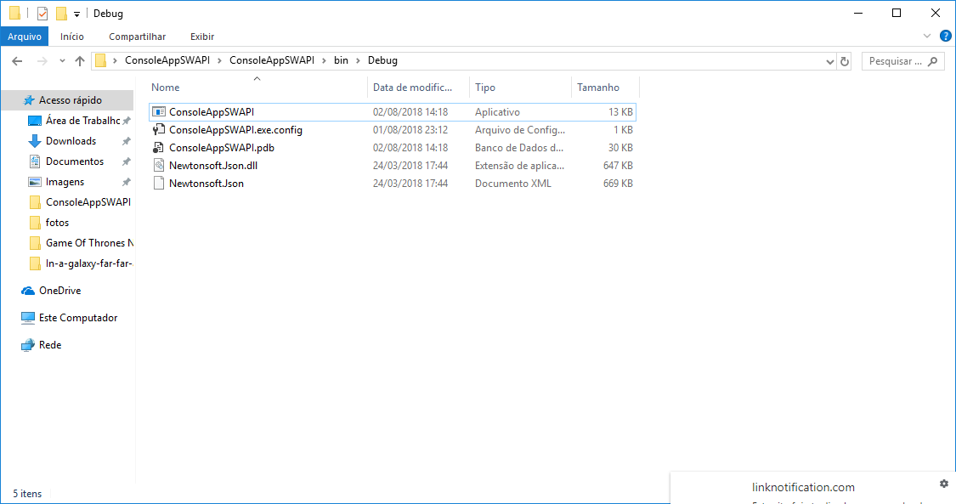

Firstly, when the application starts you need to input the distance in MGLT.

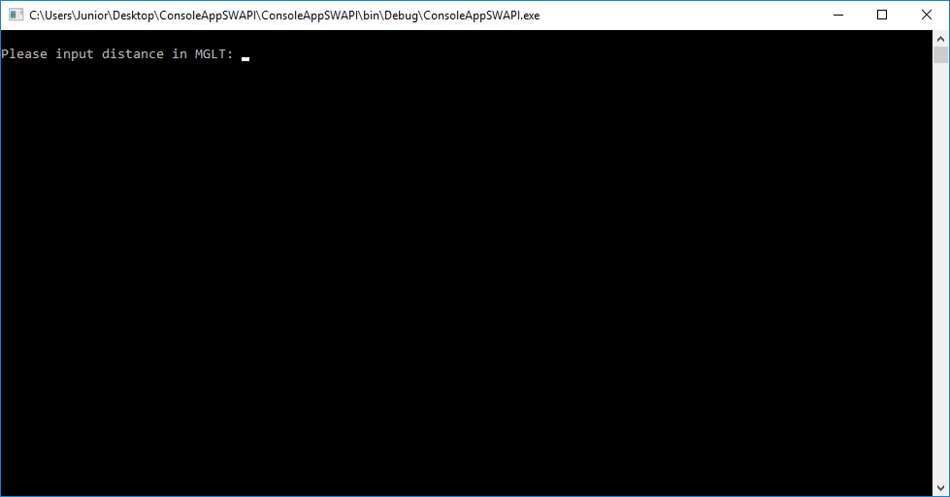

If the value is invalid the application will show a message requesting a valid distance.

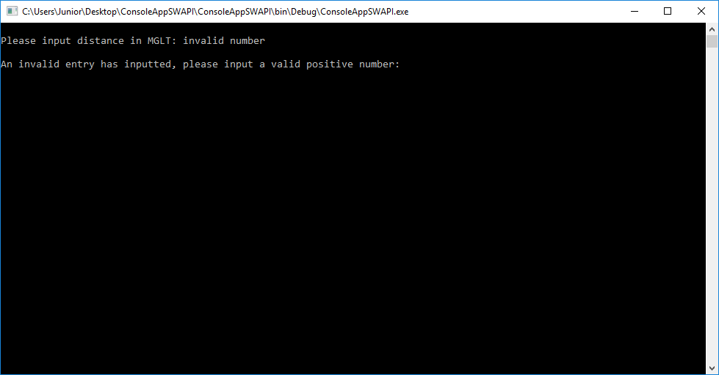

On the other hand, it will be requesting the information using SWAPI.

Finally, it will show all the results ordering by name.

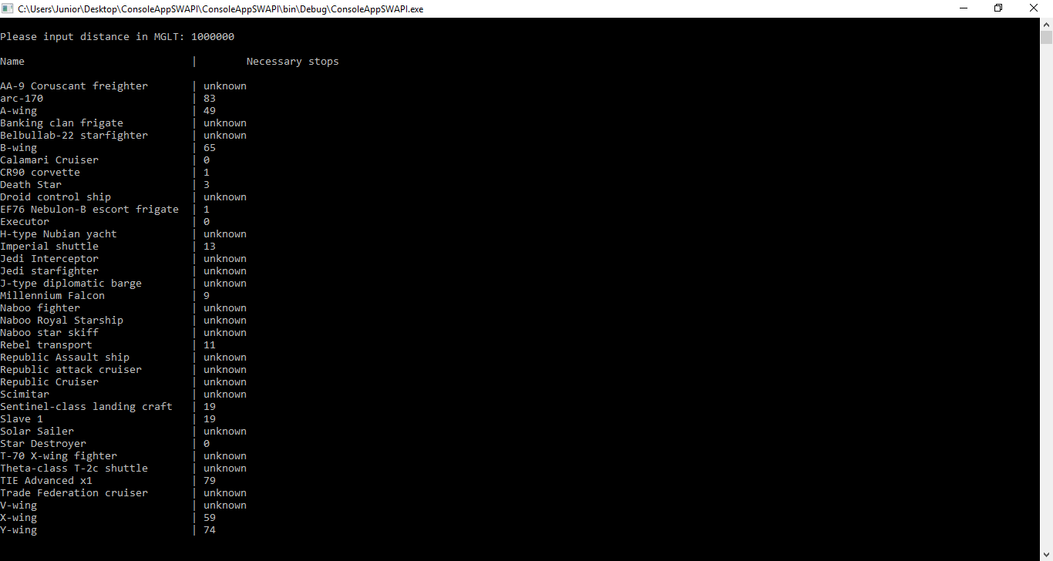

To use the application again press any key or ‘Esc’ to exit