**1 Region and Domain**

**Maputo, Cidade de Maputo, Mozambique**

**Sofala, Cidade da Beira, Mozambique**

**2 Research Question**

How have the CPI indicators:” homologous variation and the Average Variation (12 months) “changed in Maputo in the period of [2009-2014] and Beira Province in the period of [2016-2018]?

**3 Links**

file_1: <http://www.ine.gov.mz/estatisticas/estatisticas-economicas/indice-de-preco-no-consumidor/quadros/maputo/ipcmaputo_quadros_dezembro14.xls/at_download/file>

file_2: <http://www.ine.gov.mz/estatisticas/estatisticas-economicas/indice-de-preco-no-consumidor/quadros/beira/ipcbeira_quadros_fevereiro18.xls/at_download/file>

**4 Image**

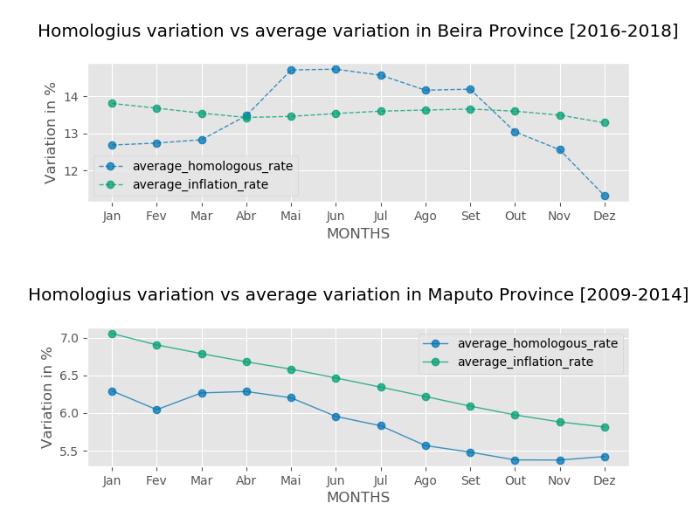

**5 Discussion**

This visualization was concerned with answering the question of how the CPI indicators: **homologous variation and the Average Variation (12 months)** changed in Maputo in the period of [2009-2014] and Beira Province in the period of [2016-2018]? The Data was extracted from the National Institute of Statistics of Mozambique website. The analysis was made based on the data that was available, reason why the analysis was made in different periods.

The plot from Maputo indicates that there is a negative correlation between the two indicators. The average homologous rate had an increase in February, maintained during March and decreased until December. The plot from Beira shows that the inflation did not change that much, different from the homologous average indicator that varied several times during the months, reaching its peak during March.

**Albert Cairo`s**

**Thruthfulness:** The Visual displays both the homologous and the average (12 months) variation in the two graphs, which allows the reader to be able to compare them in the same graph and extract insights related to each location.

**Beauty: In the two visuals displayed, the style used was ggplot only, so that the reader doesn’t get confused with the information displayed.**

**Functionality: The visuals displayed where about indicators that play a major role when it comes to analyze the CPI Indicators. For that reason, in this project, they were used the two indicators from a total of five used in the CPI Methodology analysis**

**Insightfulness: The reader can clearly see how the two indicators behaved in the analyzed periods, as for Maputo both indicators in general decreased during the months, which we can also conclude that we have a negative correlation, different from Beira, where one was constant and the other with several variations during the months.**

**OK**