

Cyber Security
What you need to know

By
Basil Abdirahman
Prodan Boyadzhiev
Carlos Cruz
Teddy Kassa
Introduction:

In the late 1960s an arm of the US Defense Department funded the development of the Advanced Research Projects Agency Network (ARPANET). On the surface it’s goal was to allow direct communication between research institutions that the US government was funding (Featherly, 2016). In reality the nature of the network, many different computers all around the country, made for a decentralized communication system impervious to an isolated attack at any one location.

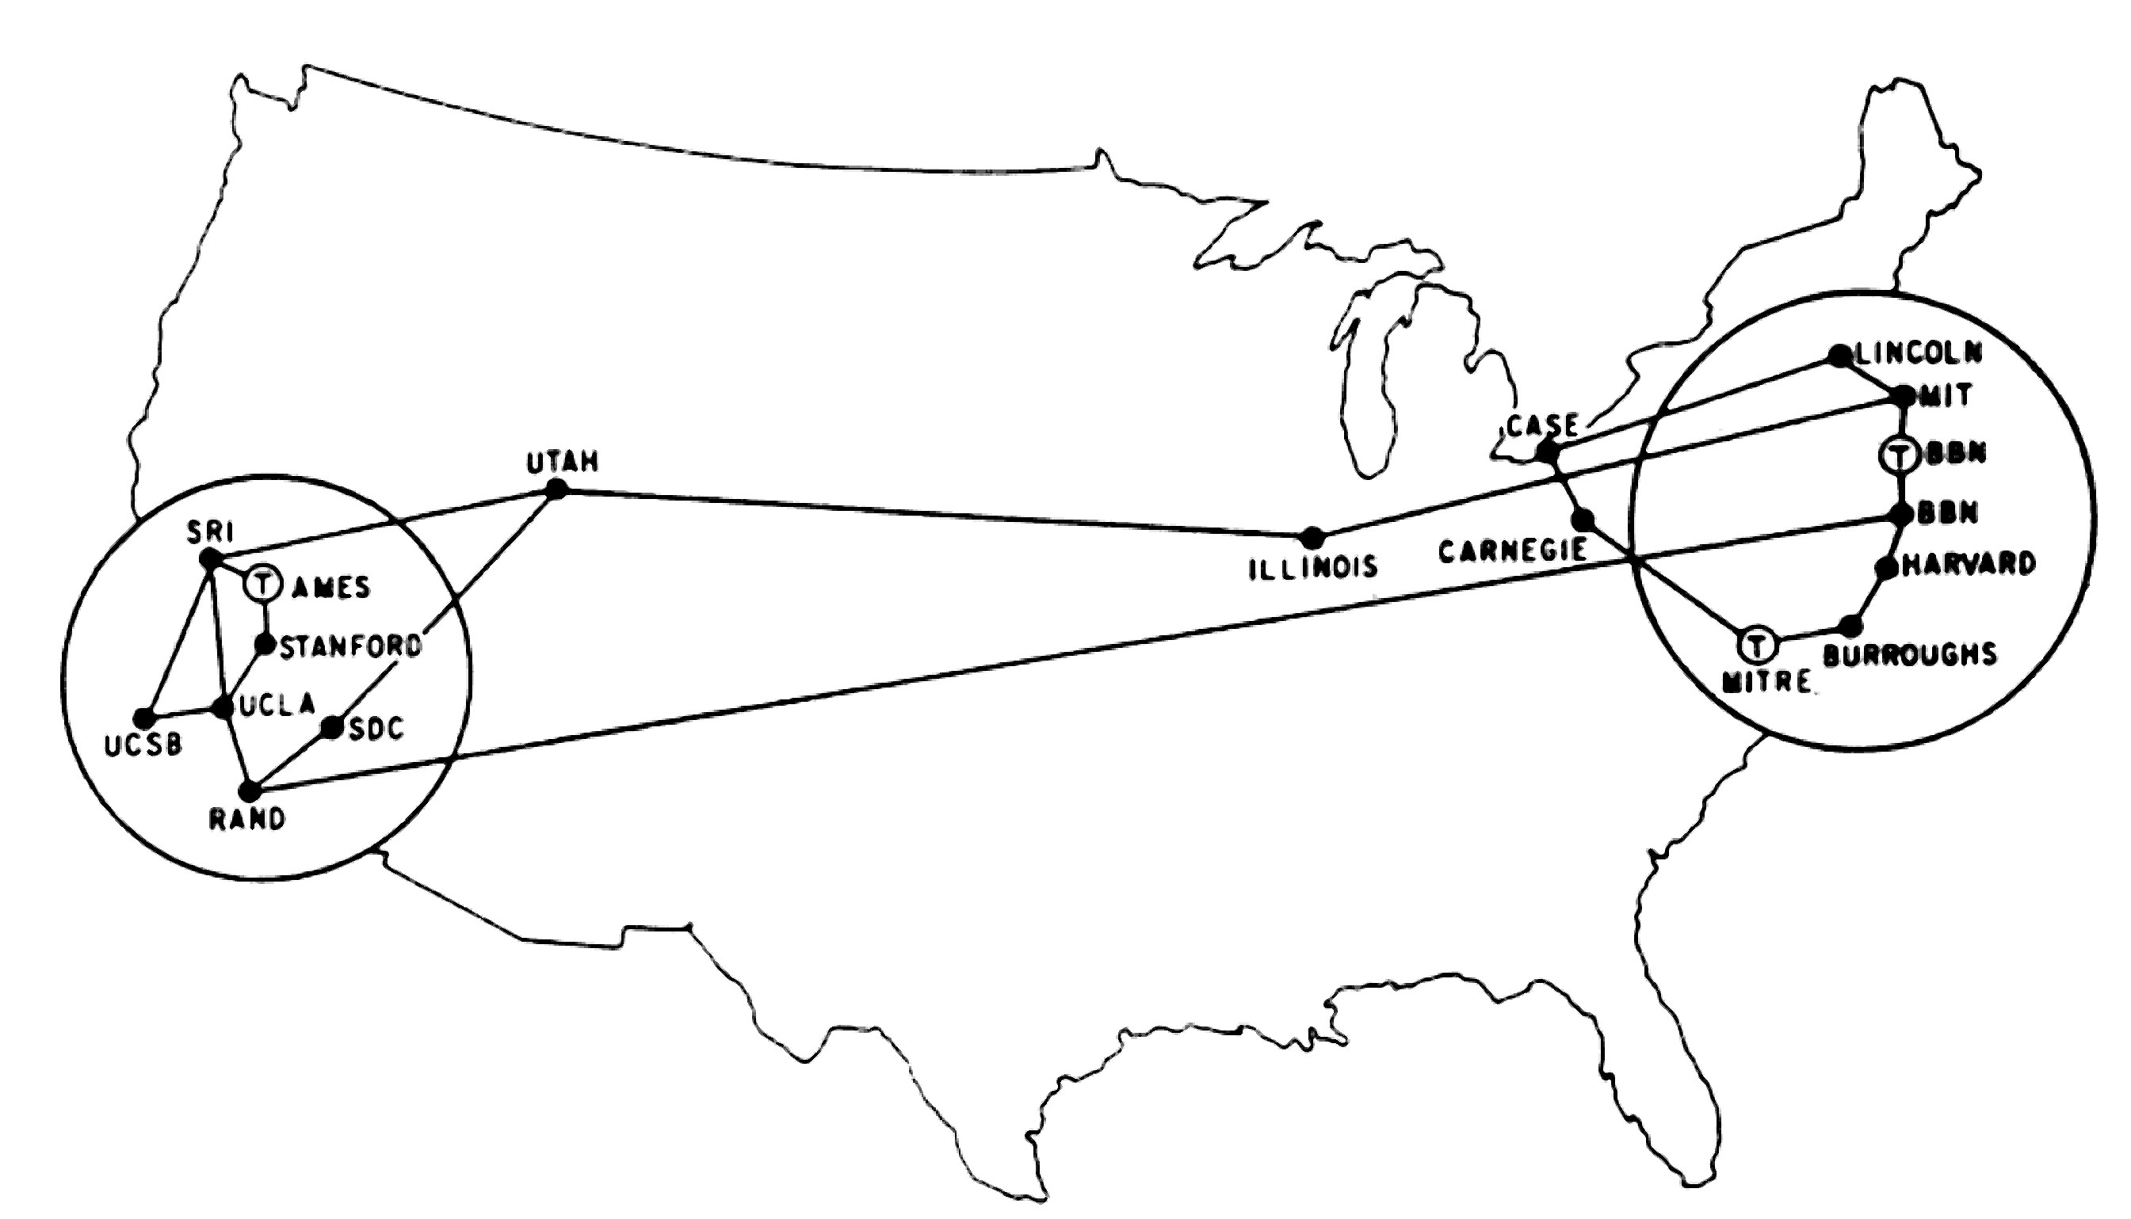
A diagram of the ARPANET by geographic location circa 1972

This first network of interconnected computers, physically hundreds of miles from one another, was to be the precursor of the modern internet as we know it today. Back then, receiving or sending a transmission to or from any one of these computers, required a physical connection to one of the leased telephone lines of which the network was composed (Beranek, 2022).

At the time only a select number of universities were allowed access to the network. In contrast, there were a projected 46 billion devices to be connected to the internet in 2021, with another 31 billion being added before the end of the year (G, 2022). These figures are almost impossible to visualize in any meaningful way compared to the handful of computers connected on the ARPANET in the 1970s. The internet as it stands today is one of the marvels of the modern world, but it is not without its perils. Today anybody can access the internet, regardless of their intentions. For someone with malicious intent, the ubiquity of internet connected devices means there are that many more targets upon which to perform their attacks.

In 2018, there were an estimated 812.67 million devices compromised with malware, software written with the express purpose of causing harm. Ransomware attacks, attacks that deny access to your own data until a ransom is paid, cost businesses an estimated $75 billion per year (Firch, 2021). In 2018 there were 80,000 cyber attacks daily (2021 Cyber Security Statistics Trends & Data). With the number of attacks and breaches of security on the internet expected to keep growing exponentially, there is a paramount need to protect individuals and companies from malicious actors on the web. The Cyber Security Specialist’s role in protecting networks and systems will become ever more pivotal in the coming years.

History:

The first ever computer virus was written as an experiment by Bob Thomas in 1971 (Chen & Robert, 2004). Nicknamed Creeper, it was designed to traverse the ARPANET from computer to computer, outputting the following message to the user:

I’M THE CREEPER : CATCH ME IF YOU CAN

Although this early piece of malware was not designed to cause harm to the host machine, it further embraced the nomenclature of computer virus when Ray Tomlinson developed an enhanced version of the program allowing it to self-replicate (Chen & Robert, 2004). Much like naturally occurring viruses do in living organisms. These types of viruses are referred to as computer worms.

In response to his own design Ray Tomlinson, the father of the computer worm, wrote another program to combat Creeper, nicknamed Reaper. The original antivirus. This new program would similarly traverse the ARPANET destroying any copies of Creeper that it could find (Metcalf, 2014). Ironically, Reaper by today’s standards would be classified as malware; its self replicating mechanism leading to its designation as a computer worm itself. The first ever virus and antivirus programs had been written and unleashed on a network of interconnected computers and thus, the game was afoot.

These experiments were conducted by professionals in a controlled environment, the concept of personal computers was still a distant dream for most. The first personal computer that received wide attention was the MITS Altair released in 1974 (Forrest, 2017). Even then this computer kit was targeted towards computer enthusiasts, thus the Altair did not see wide acceptance in the common household. Additionally this primitive computer had no networking capabilities of which to speak, therefore was not at risk from any hackers unless they were invited into the home and given access to the device.

It wouldn’t be until 1989 that the conventional internet was made available to the general public. Almost immediately malicious actors began testing the limits of what they could gain unauthorized access to on the web. State actors were hacking private companies and stealing intellectual property, cybercriminals began using rootkits to take control of others computers and steal sensitive information, the first phishing emails were sent (Pinkerton, 2019). The web became a sort of wild west in need of sheriffs to offer protection from digital bandits.
Social Impact:

The amount of data in the world was estimated to be 44 zettabytes (one trillion GB) at the dawn of 2020. In 2025, the amount of data generated each day is expected to reach 463 exabytes (one billion GB) globally. With all this data, you can imagine how easy it is to know everyone’s history or predict what they’re about to do to a certain extent by just drawing a simple pattern. A lot of people all around are terrified because of the significant increase in cyber-attacks. In 2020 nearly 330 million people were victims of some type of cybercrime. The social impact of cyber security is the disruption of people’s daily life that is caused by cyber-attacks, which could cause anywhere from disbelief to war or a market crash.

Cyber-attack has numerous social impacts on the community. The three main impacts are psychological, financial, and physical impacts. One of the best examples of a psychological impact was back in 2016. A hacker named Ryan Collins used a phishing scheme where he sent emails to celebrities that looked like it was from Google or Apple, which will ask the victims to provide their login information and have access to their files on the cloud. He then sold it for bitcoin. A lot of celebrities were victims of this cyber-attack.

The next social impact is a financial cyber-attack. A South Korean crypto exchange named Coinrail was hacked in January of 2019. The hacker manages to steal around $37 million. When it comes to crypto, the amount of money that was stolen is not the only problem, People will sell their coins to avoid getting hit as well. This panic caused Bitcoin, one of the most stable and successful crypto coins, to lose around 11% of its total value right after.

The most dangerous and frightening of all the cyber-attacks are the ones that can do a lot of physical damage. Back in 1999, a 15 year old kid was able to hack into multiple computers of NASA and the Department of Defense. Not only did he have access to almost all the files they have, but he was also able to gain access to the control center of the International Space Station’s physical environment including temperature and humidity of the living quarters. This is the main reason why cyber security jobs have been increasing exponentially.

Jobs:

To work in cybersecurity you need to obtain a bachelor’s degree. Employment of information security analysts is projected to grow 33 percent from 2020 to 2030, much faster than the average for all occupations.

About 16,300 openings for information security analysts are projected each year, on average, over the decade. Many of those openings are expected to result from the need to replace workers who transfer to different occupations or exit the labor force, such as to retire.

Future:

The future of cyber security is very important, you may ask why is it important? Cyber security has been around since the creation of the first computer virus in 1971. Cyber security is based on protecting computer systems from unauthorized access, a lot of things can change in the future and Cyber Security is one of them. The current biggest threat is “The state of passwords”, stealing passwords has been around for quite some time. And with the current and future technology, the threat to steal passwords is not slowing down.

Sources:

Featherly, K. (2016, May 11). ARPANET. Encyclopædia Britannica. Retrieved April 16, 2022, from https://www.britannica.com/topic/ARPANET

Beranek, L. (2022, January 4). Who invented the internet? A first-hand account. History Cooperative. Retrieved April 16, 2022, from https://historycooperative.org/who-invented-the-internet/

G, N. (2022, March 14). How many IOT devices are there in 2022? [all you need to know]. Techjury. Retrieved April 17, 2022, from https://techjury.net/blog/how-many-iot-devices-are-there/#gref

Firch, J. (2021, October 28). 10 cyber security trends you can't ignore in 2021. PurpleSec. Retrieved April 17, 2022, from https://purplesec.us/cyber-security-trends-2021/

2021 Cyber Security Statistics Trends & Data. PurpleSec. (2021, August 6). Retrieved April 17, 2022, from https://purplesec.us/resources/cyber-security-statistics/

Chen, T. & Robert, J. (2004). The Evolution of Viruses and Worms

Metcalf, J. (2014). Core War: Creeper and reaper. Creeper & Reaper. Retrieved April 17, 2022, from https://corewar.co.uk/creeper.htm

Forrest, M. (2017, November). The Altair story; early days at MITS. The altair story; early days at MITS. Retrieved April 19, 2022, from https://www.atarimagazines.com/creative/v10n11/17_The_Altair_story_early_d.php

Pinkerton. (2019). Cybercrime risks: Then and now. Retrieved April 19, 2022, from https://pinkerton.com/our-insights/blog/cybercrime-risks-then-and-now

Vuleta, B. (2022, February 7). How much data is created every day? [27 powerful stats]. SeedScientific. Retrieved April 17, 2022, from https://seedscientific.com/how-much-data-is-created-every-day/

Safeatleast (2022, February 14). How many people are victims of cybercrime? [Terrifying cybercrime statistics]. Safeatleast Retrieved April 17, 2022 from
https://safeatlast.co/blog/cybercrime-statistics/#gref

BBC (2016, March 16). What are the psychological impacts of cybercrime?
[meet the man behind the leak of celebrity nude photos, called the fappening. BBC
Retrieved April 17, 2022 from
https://www.bbc.com/news/newsbeat-35820521

Reiff, N. (2019, January 25) What kind of financial impact does cybercrime have? [The largest cryptocurrency hack so far] Retrieved April 17, 2022 from
https://www.investopedia.com/news/largest-cryptocurrency-hacks-so-far-year/

Cohen, G (2021, April 21) What kind of physical impact does cybercrime have? [A Florida teen hacks the Department of Defense and NASA] Cybersecurity Pulse Retrieved April 17, 2022 from
https://www.industrialcybersecuritypulse.com/throwback-attack-a-florida-teen-hacks-the-department-of-defense-and-nasa/

