****Tarlac State University

**COLLEGE OF COMPUTER STUDIES**

Case Study

in

Integrative Programming Technology 2

Submitted By:

**Anna Mikaela M. Viado**

BSIT WMA – 4B

Submitted To:

**Kwinno L. Pineda**

Subject Teacher

Date:

October 22, 2022

Table of Contents

A. Definition 3

B. Case Analysis 4

B.1 Documentation 4

B.2 Git Log 11

B.3 Portfolio 4

C. Group Members 5

C.1 Contributions 5

D. References 6

# Definition

The Lab Quiz#2 you did (Static Website) upload the documentation and files in your GitHub repository and add a minimum of 3 more webpages to add in your repository during the development use Git and GitHub and create a documentation of all.

**For the development of the Portfolio Webpages using (Git and GitHub) Issues, Pull Request, Milestone, Branching**

**Quiz # 1 LAB: Portfolio**

**Portfolio Web Pages Upload to GitHub Using Git**

**Requirements:**

* Each member in your group will need to upload **a webpage**
* Create a **Pull Request** for each member in Github with comments.
* Create an **Issue** for each member in Github and comment.
* Create a **Milestone** for the group in Github.
* Create a branch for each member and merge it with your master in Github.

**Define and describe how you use of each command with screenshot in your case study.**

* Git clone
* Git Pull
* Git Push
* Git Fetch
* Git Merge
* Issue
* Pull Request
* Milestone
* Branch

**Note: List the contributions of your group members**

# Case Analysis (Git and GitHub Workflow)

## Documentation

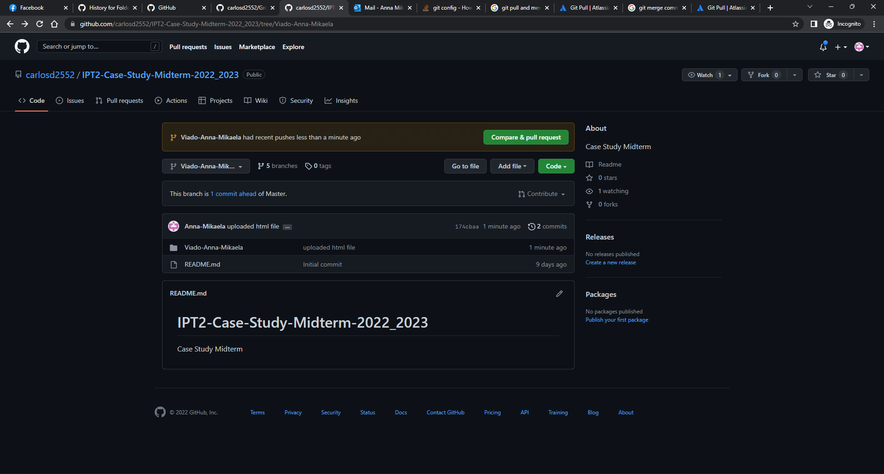

*Figure 1. Uploaded HTML File and Folder in Viado-Anna-Mikaela Branch*

As shown in Figure 1, I have uploaded a folder named Viado-Anna-Mikaela and inside that folder is the first draft of my webpage portfolio in the HTML format named index.html. This is located in my branch named Viado-Anna-Mikaela.

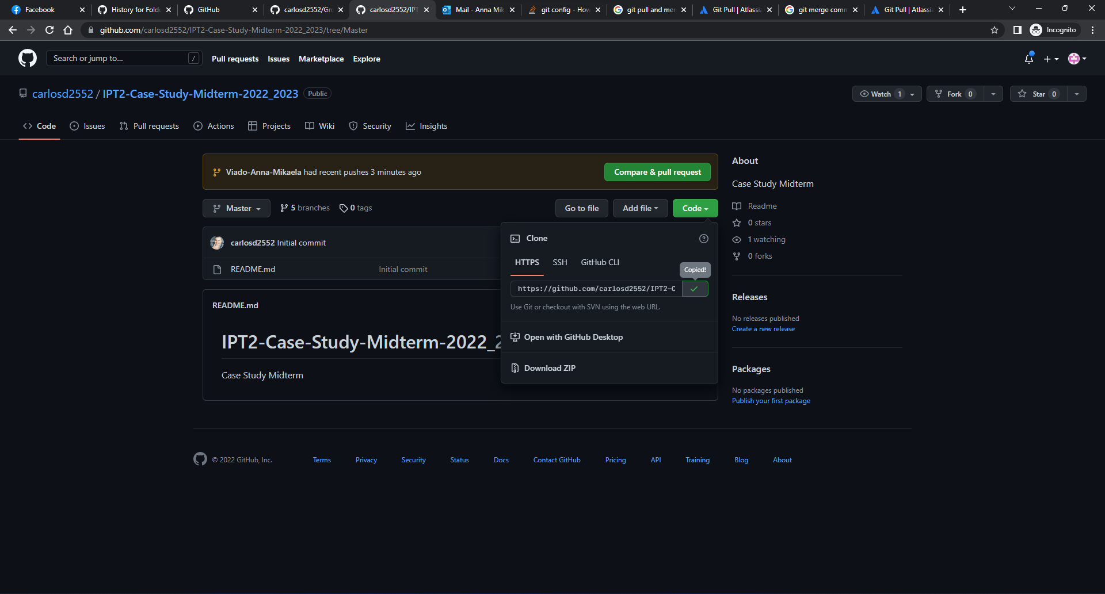

*Figure 2. Copy GitHub Repository Link*

After uploading my initial webpage, I now need to get a local copy of our GitHub repository. As shown here, I copied the HTTPS link for our repository.

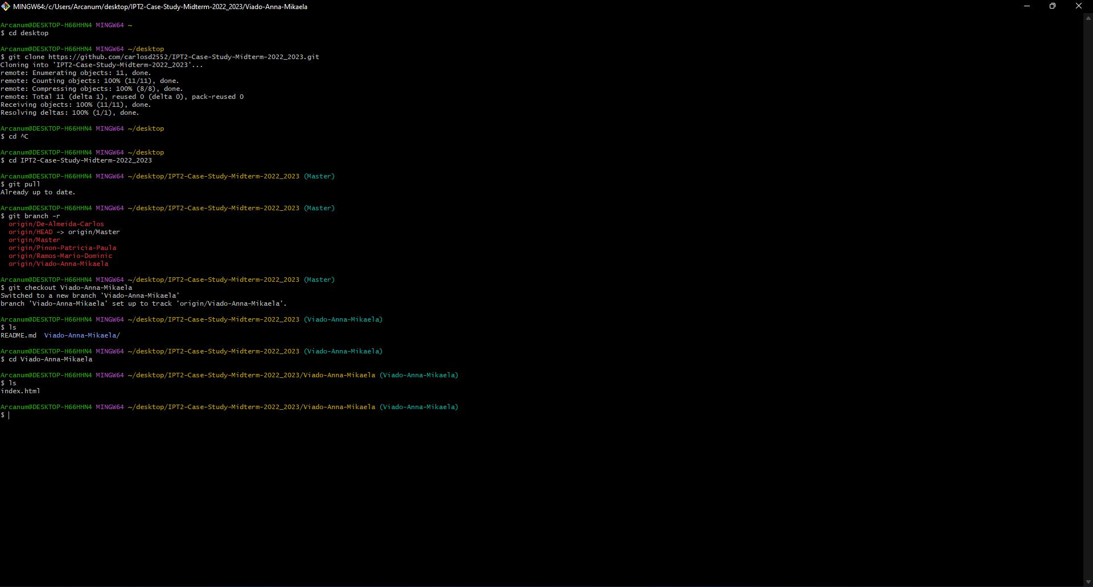

*Figure 3. Git Clone*

After copying the HTTPS link from our GitHub repository, I opened GitBash and entered the command “git clone [the HTTPS link of GitHub repository]”. This creates a local repository that is a copy of our remote GitHub repository.

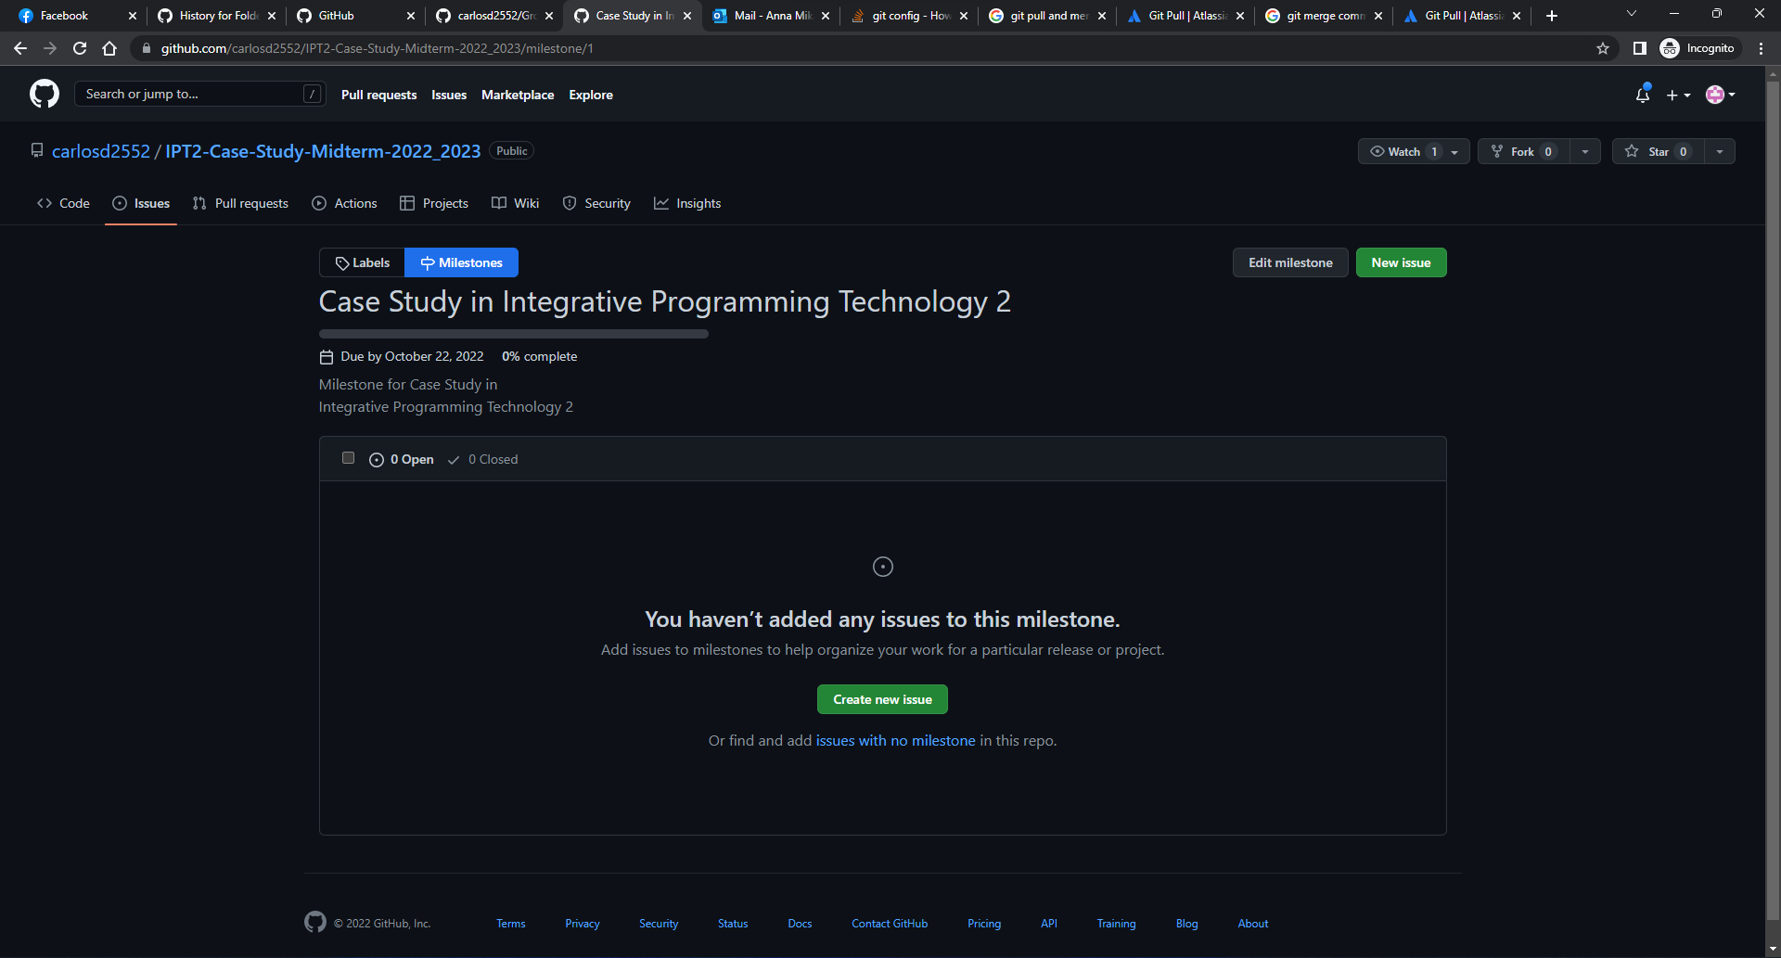

*Figure 4. Milestone*

As shown in Figure 4, this is our GitHub repository’s Milestone entitled Case Study in Integrative Programming Technology 2. In this Milestone, I created an Issue. When this Issue is resolved, the progress bar for the Milestone will increase.

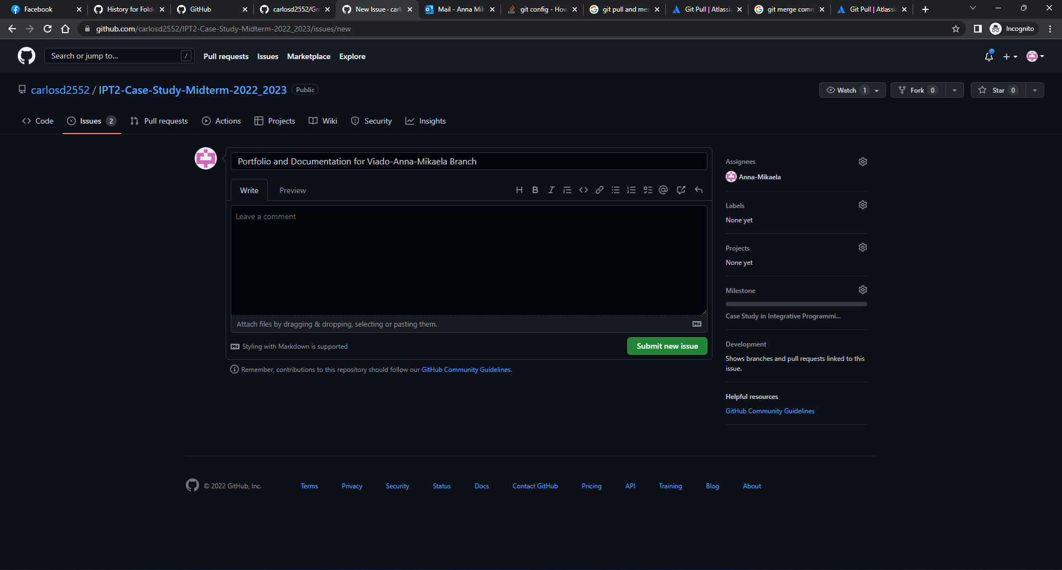

*Figure 5. Creating Issue*

As shown in the image above, this is how an Issue is created and submitted. A title and a description would be fillable to successfully file an Issue.

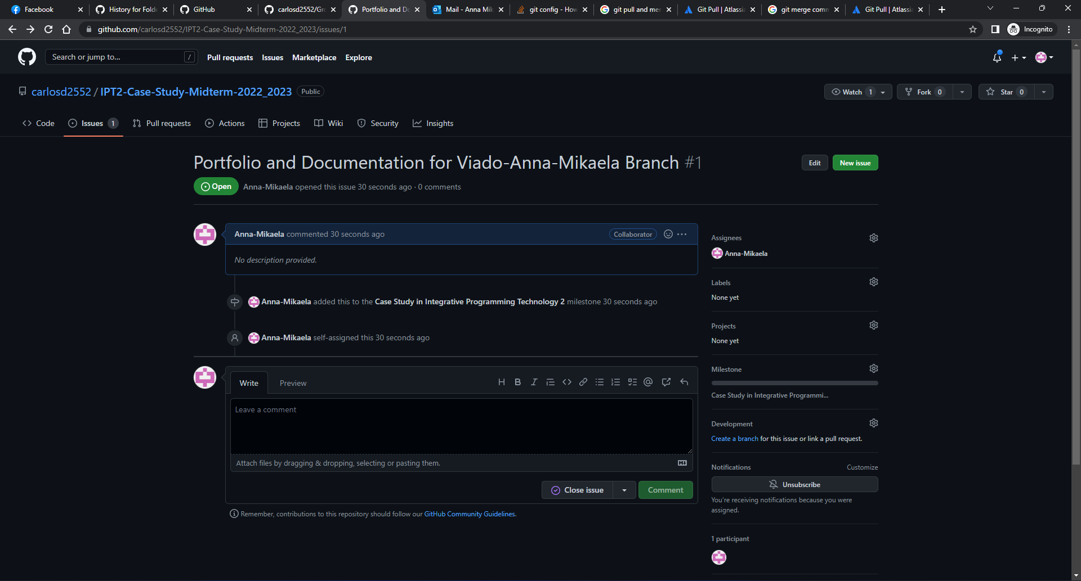

*Figure 6. Issue Overview*

When an Issue is submitted, a list of actions related to the Issue will be shown in its overview so the progress of the Issue is being tracked on.

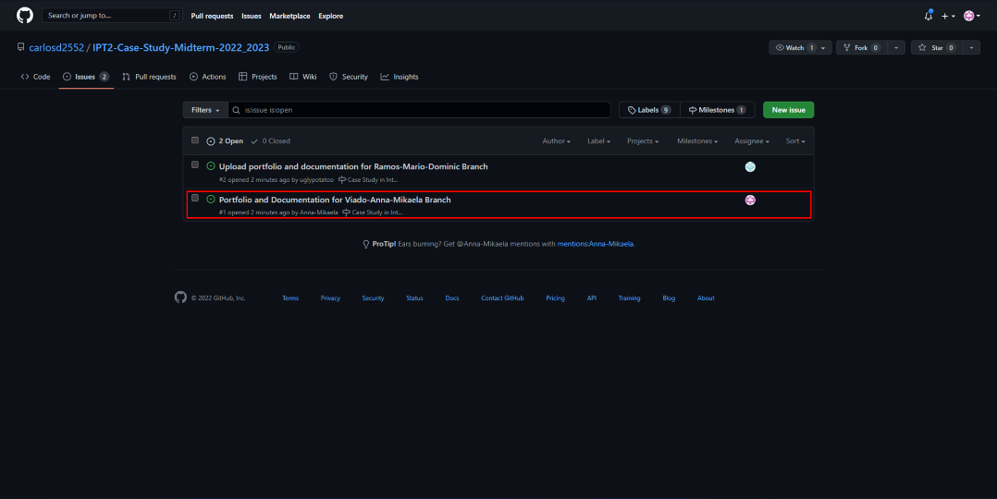

*Figure 7. Issues List*

The shown image above shows the existing or open Issues of the repository. It can be seen that there are two Issues submitted.



*Figure 8. Git Pull, Git Branch, and Git Checkout*

The command “git pull” fetches and downloads the content from our remote repository and updates my local repository. In the shown figure above, the command “git pull” resulted into the message “already up to date” because I just finished cloning the remote repository to my local repository which means there are still no new contents in the remote repository for my local repository to update.

The command “git branch -r” shows all the branches in the remote repository in which I could go to. The branch assigned to me is the Viado-Anna-Mikaela branch, in this case, I used the command “git checkout Viado-Anna-Mikaela” to go to my assigned branch.

As I entered my branch, I checked its contents with the command “ls” in which it showed the folder and the index file I uploaded earlier directly from our GitHub repository.

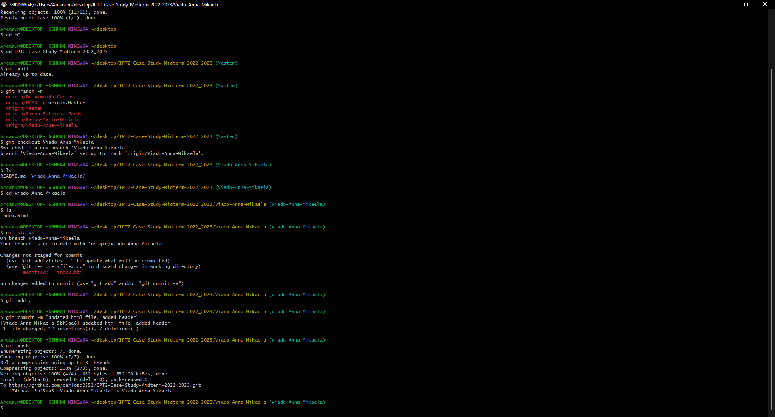

*Figure 9. Development Phase: Git Status, Git Add, Git Commit, and Git Push*

Shown in Figure 9 are the common commands I used in developing my portfolio. The command “git status” is used to check if there are any updated files that needs to be added or committed to the repository. The command “git add .” adds all files that are modified or newly created to the committing stage where they are being tracked and ready to be committed. The command “git commit -m [message or description]” captures snapshots of the staged changes. The command “git push” is used to upload the newly created or modified files from the local repository to the remote repository.

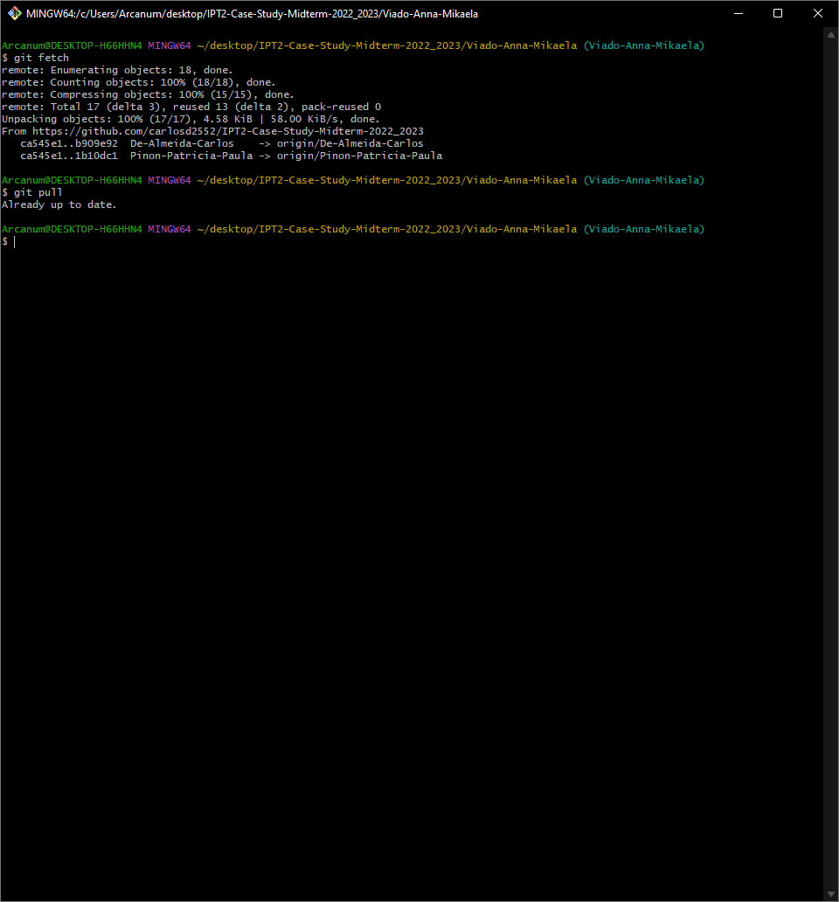

*Figure 10. Git Fetch*

In Figure 10, I used the command “git fetch” which downloads new contents from the remote repository. This time, as my groupmates already made commits in their respective branches, my local repository also updated with their commits. When “git fetch” has already been made, the “git pull” will result into a message of “already up to date” as both commands do the same thing.

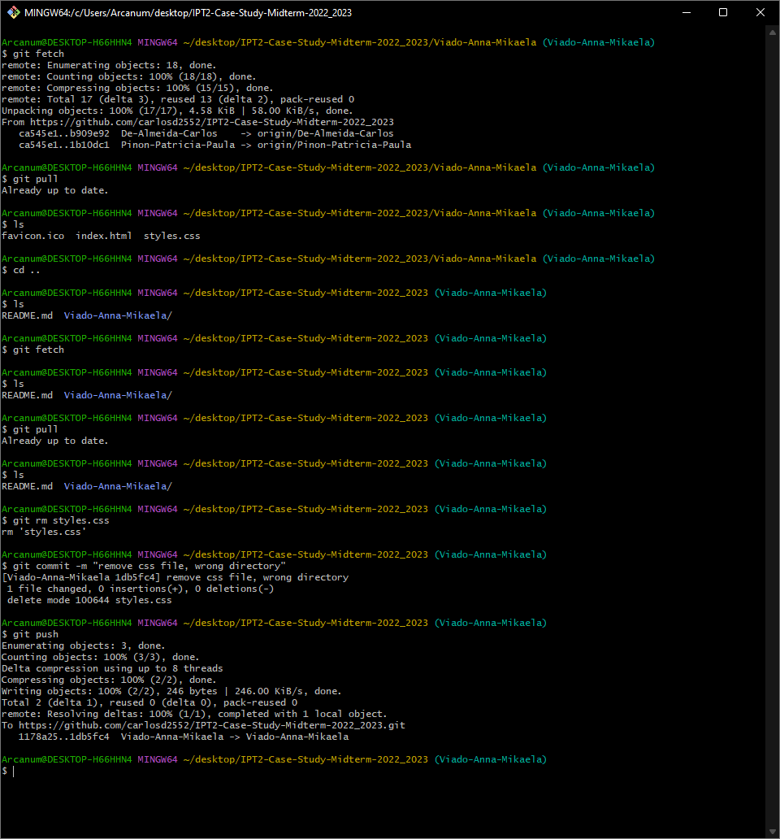

*Figure 11. Remove File*

In Figure 11 shown above, I accidentally created the css file outside my folder. To remove the file from both my local and remote repository I used the command “git rm [name of the file]”, followed by “git commit” and “git push” to also reflect in the remote repository.

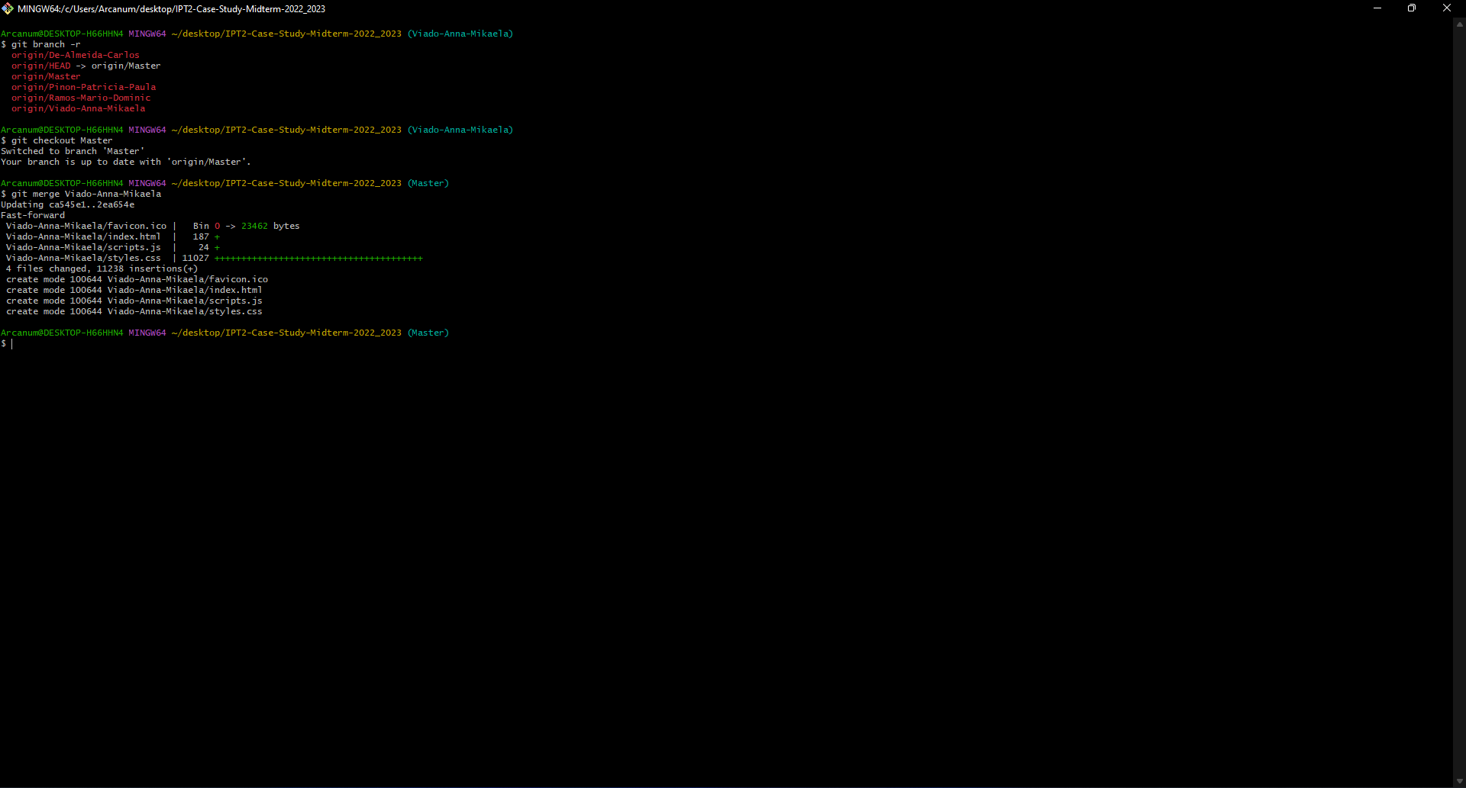

*Figure 12. Git Merge*

Shown in Figure 12, I went to the main directory which is named Master with the use of the command “git checkout Master”. In the main branch, I used the command “git merge [name of my branch]” to merge my branch’s contents to the main branch of the repository.

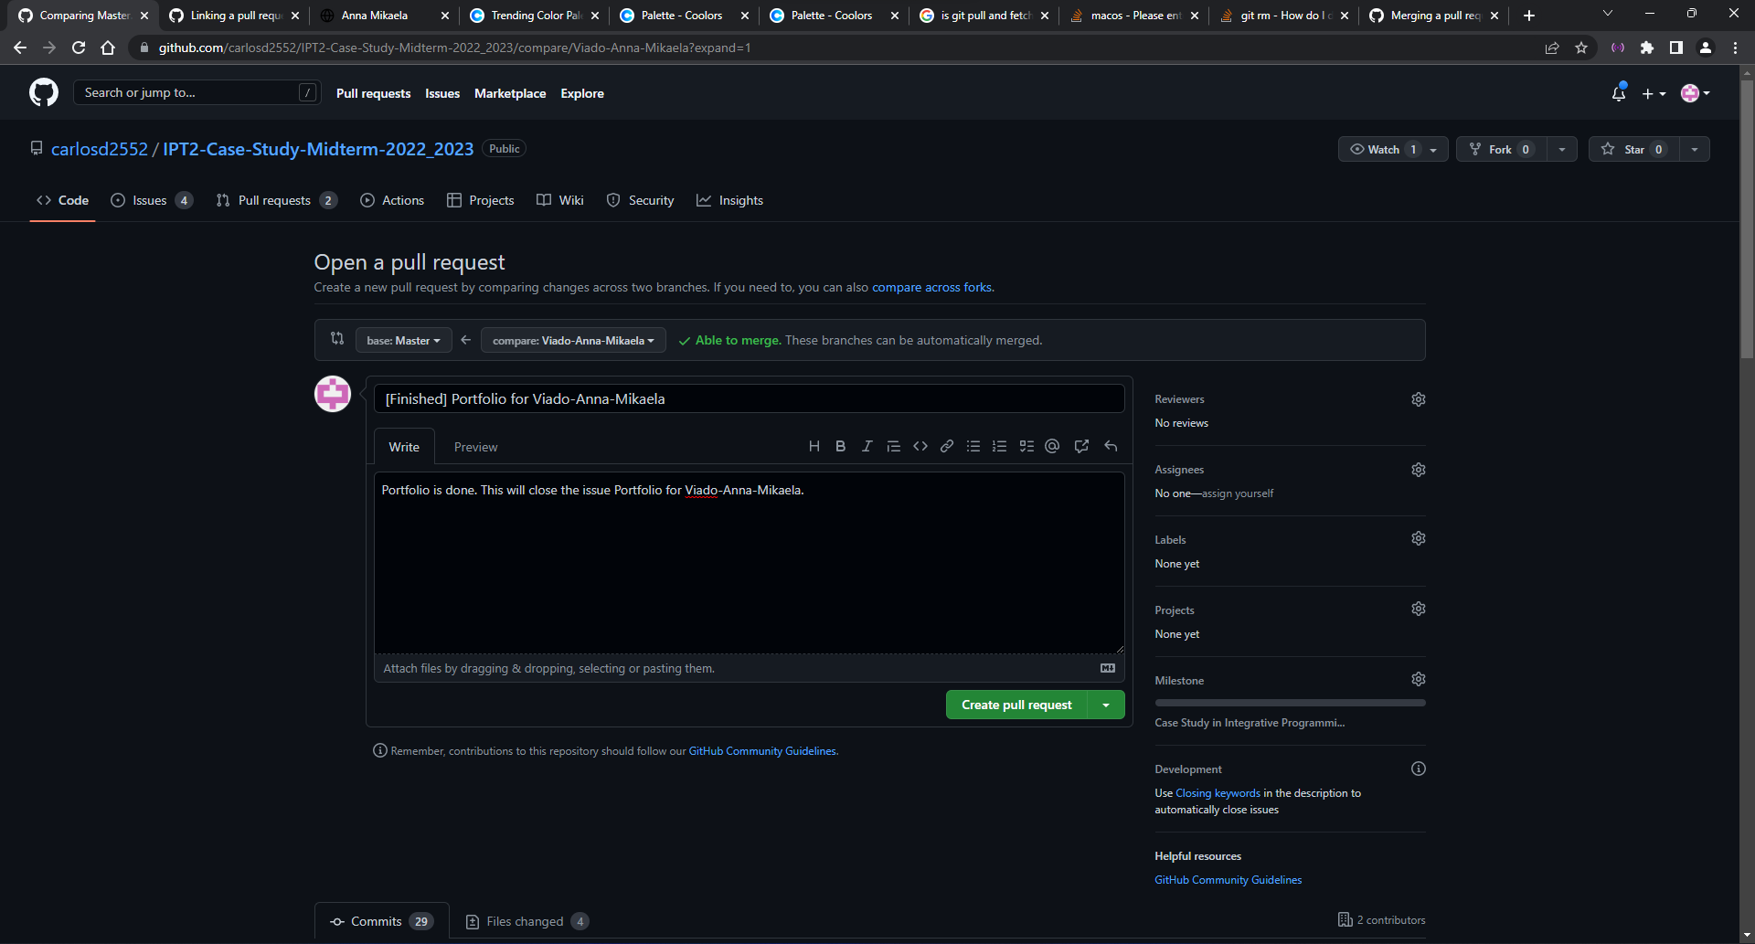

*Figure 13. Pull Request*

After merging, I went to our GitHub repository and opened a Pull Request for my branch to merge to our main branch. In filing for a Pull Request, a title and description are fillable.

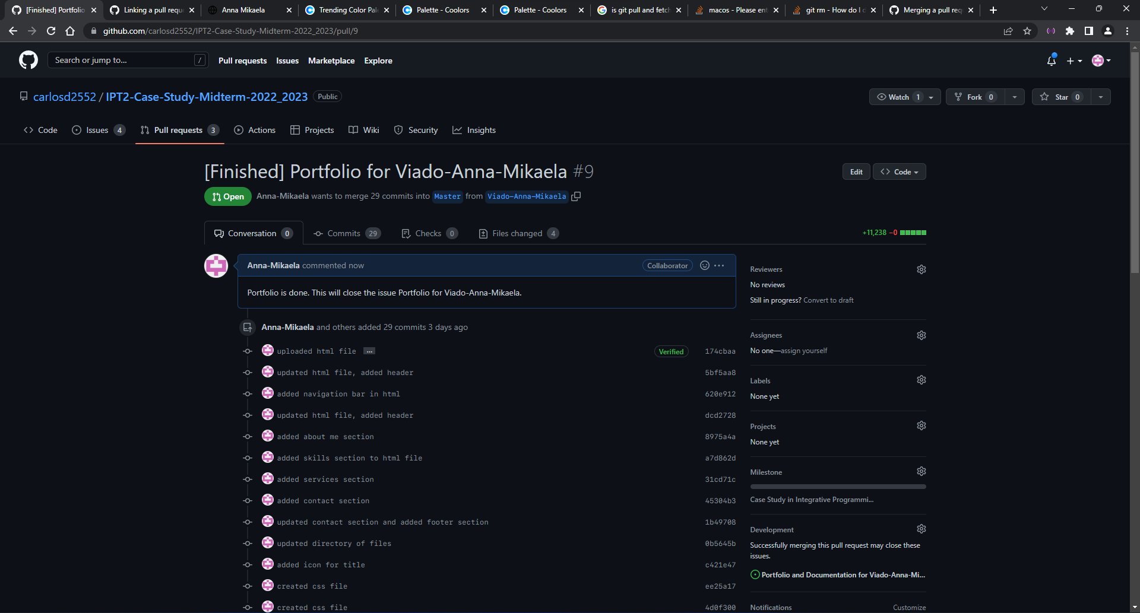

*Figure 14. Open Pull Request*

When a Pull Request is open, it shows the list of commits made in that branch and also if it will not have any conflict between the main branch.

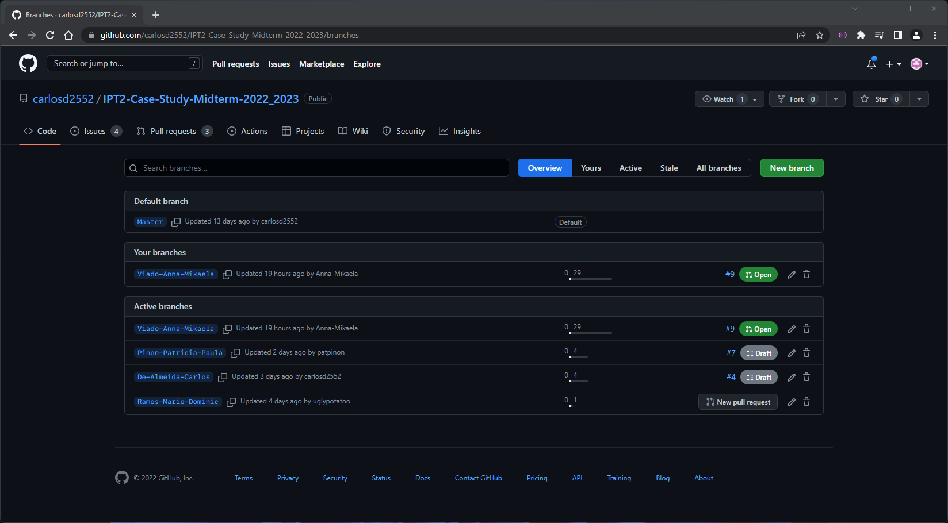

*Figure 15. Branch*

Here shows the existing Branches made in our GitHub repository. Our GitHub repository consists of 5 branches, my branch and my groupmates’ and our Master or main branch.

## B.2 Git Log

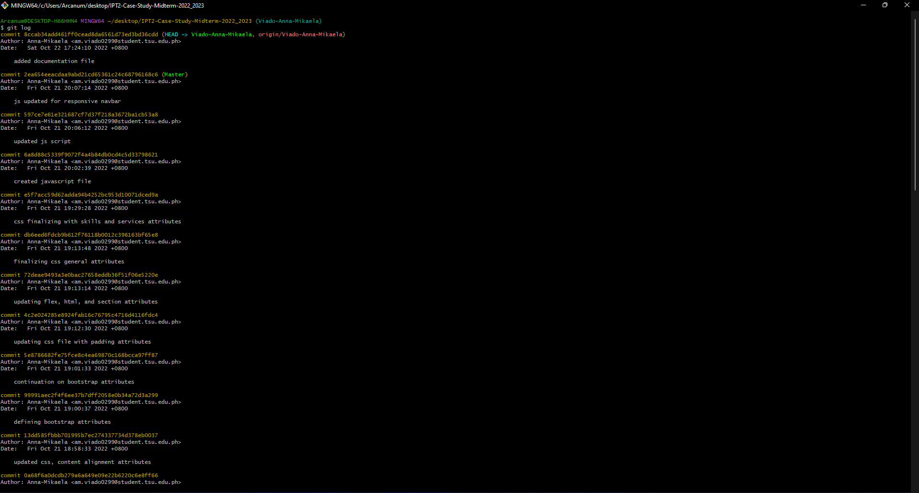

*Figure 16. Git Log*

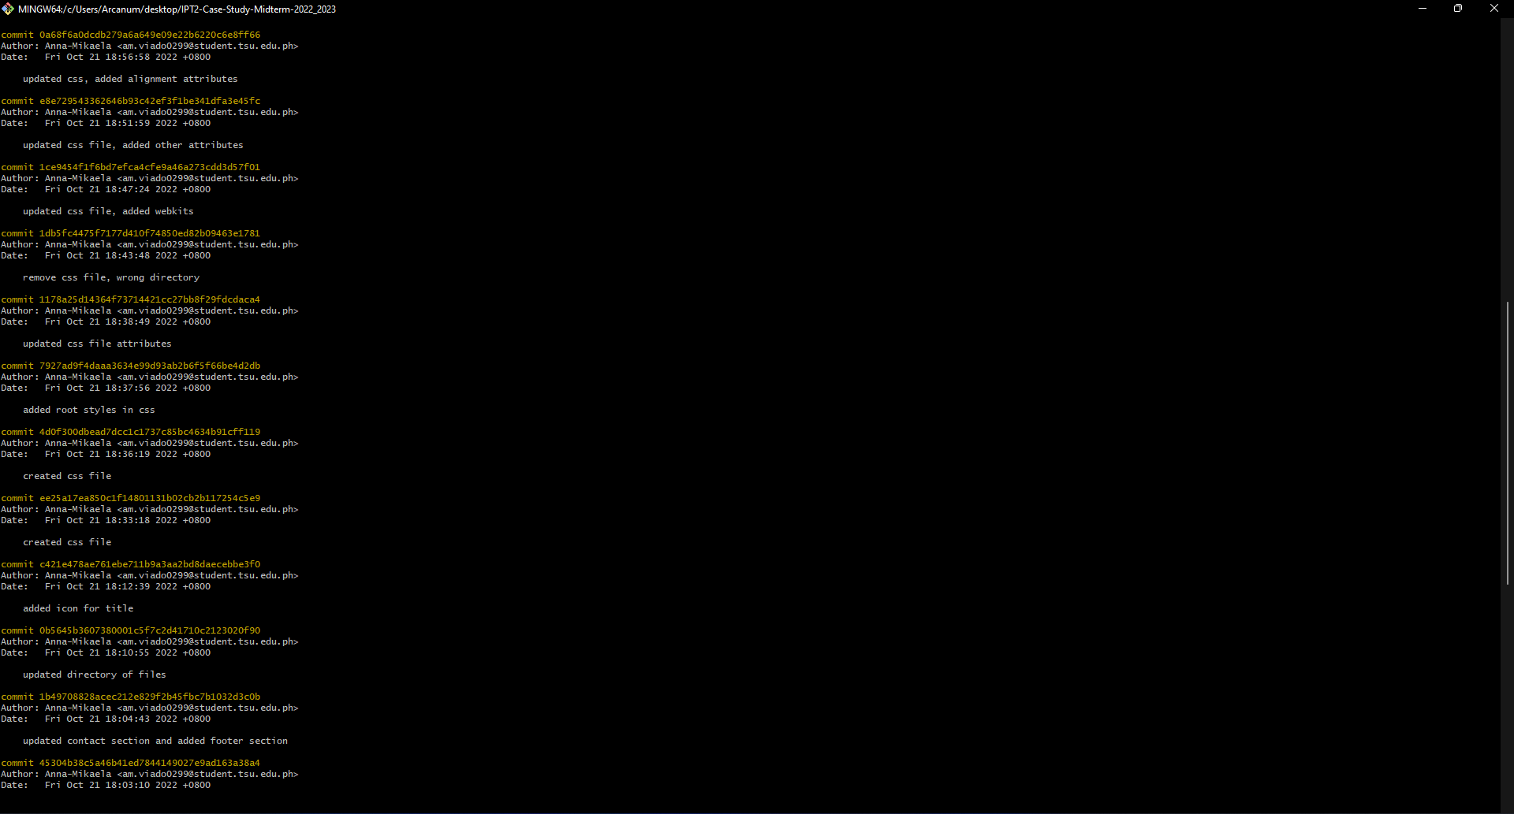

*Figure 17. Git Log Continuation*

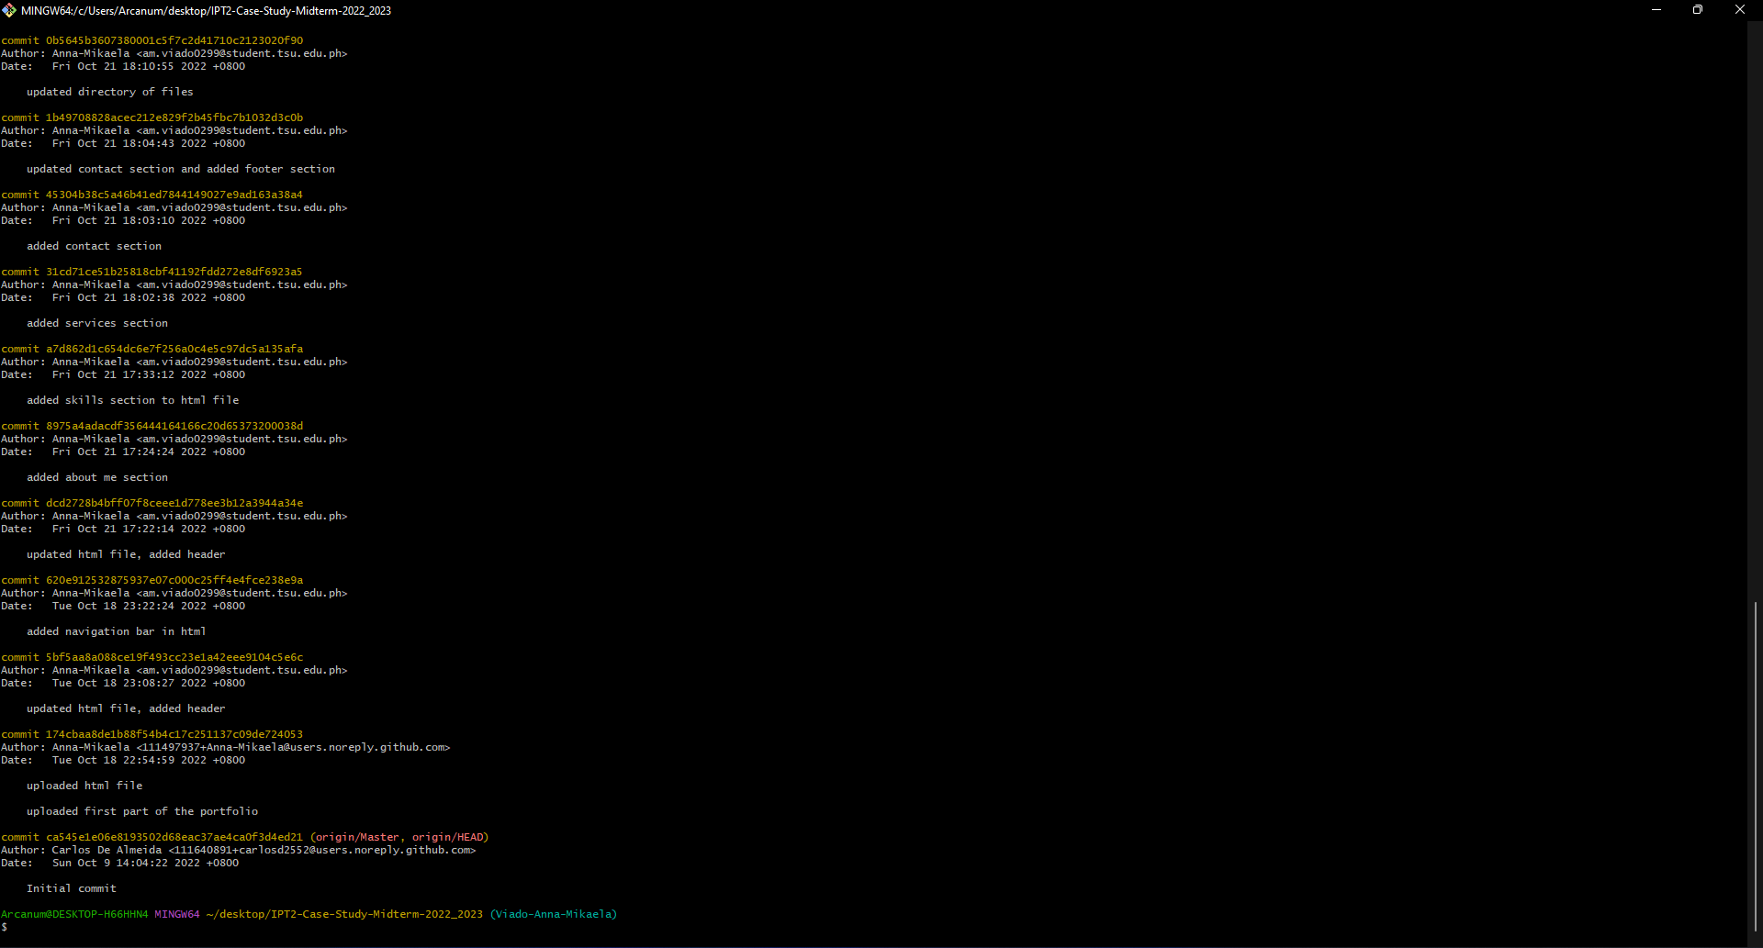

*Figure 18. Git Log Continuation-A*

## B.3 Portfolio

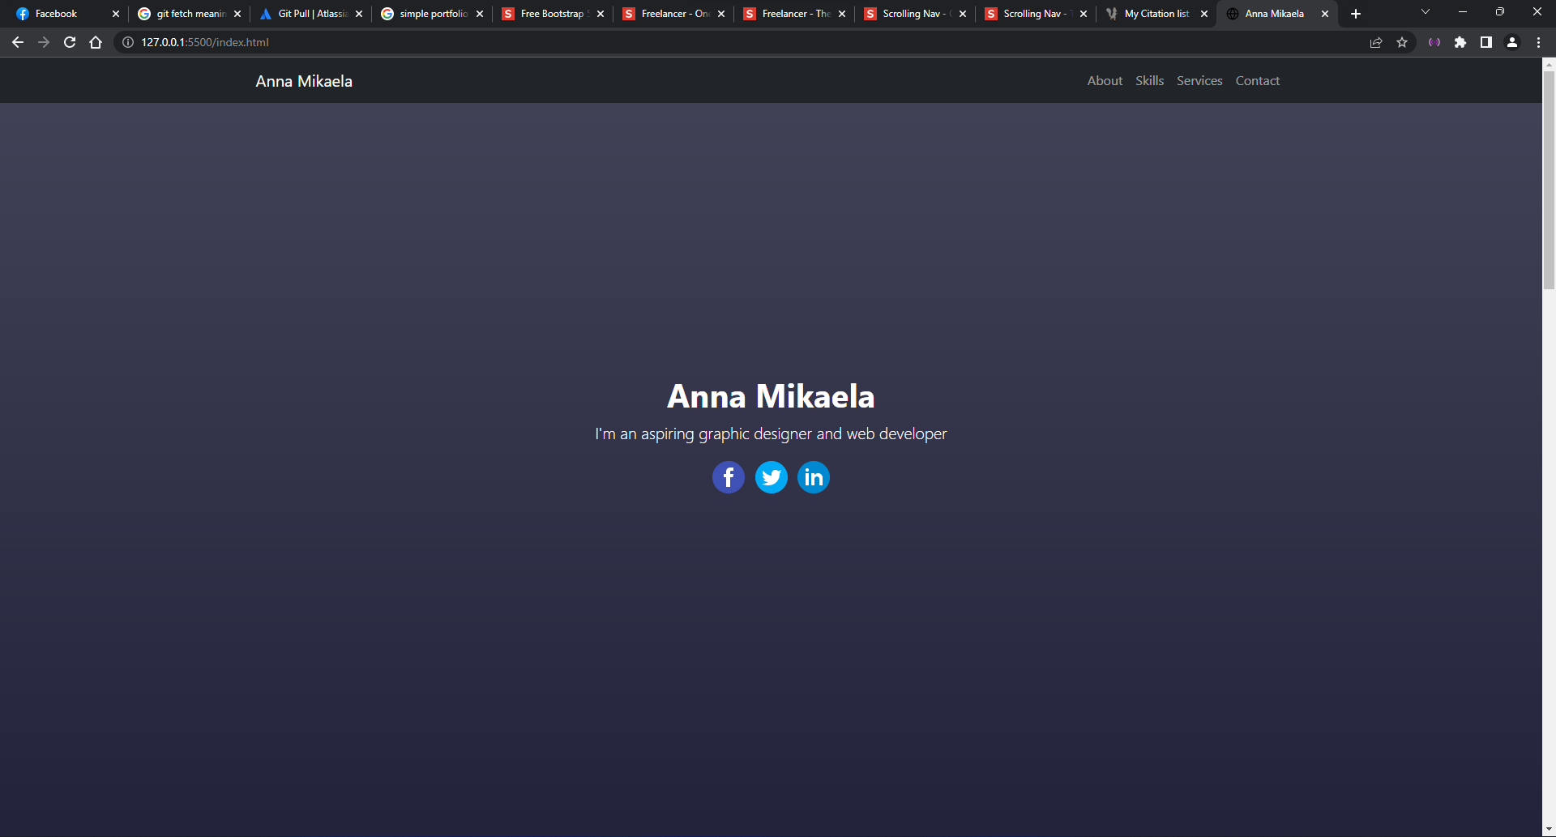

*Figure 19. Portfolio Header*

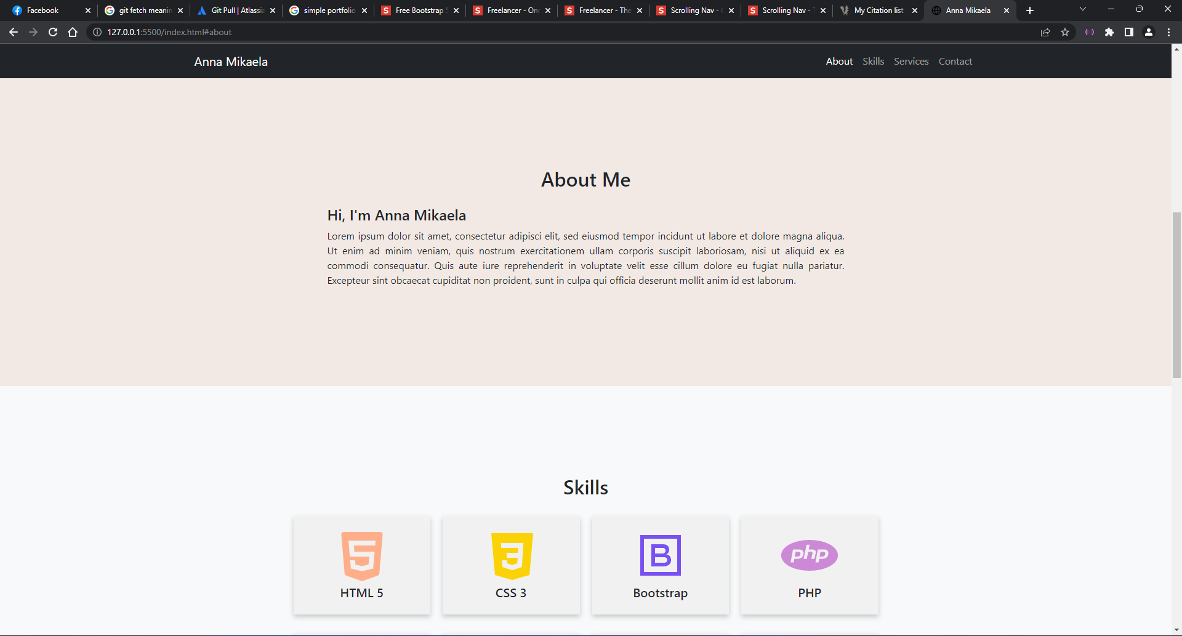

*Figure 20. Portfolio About*

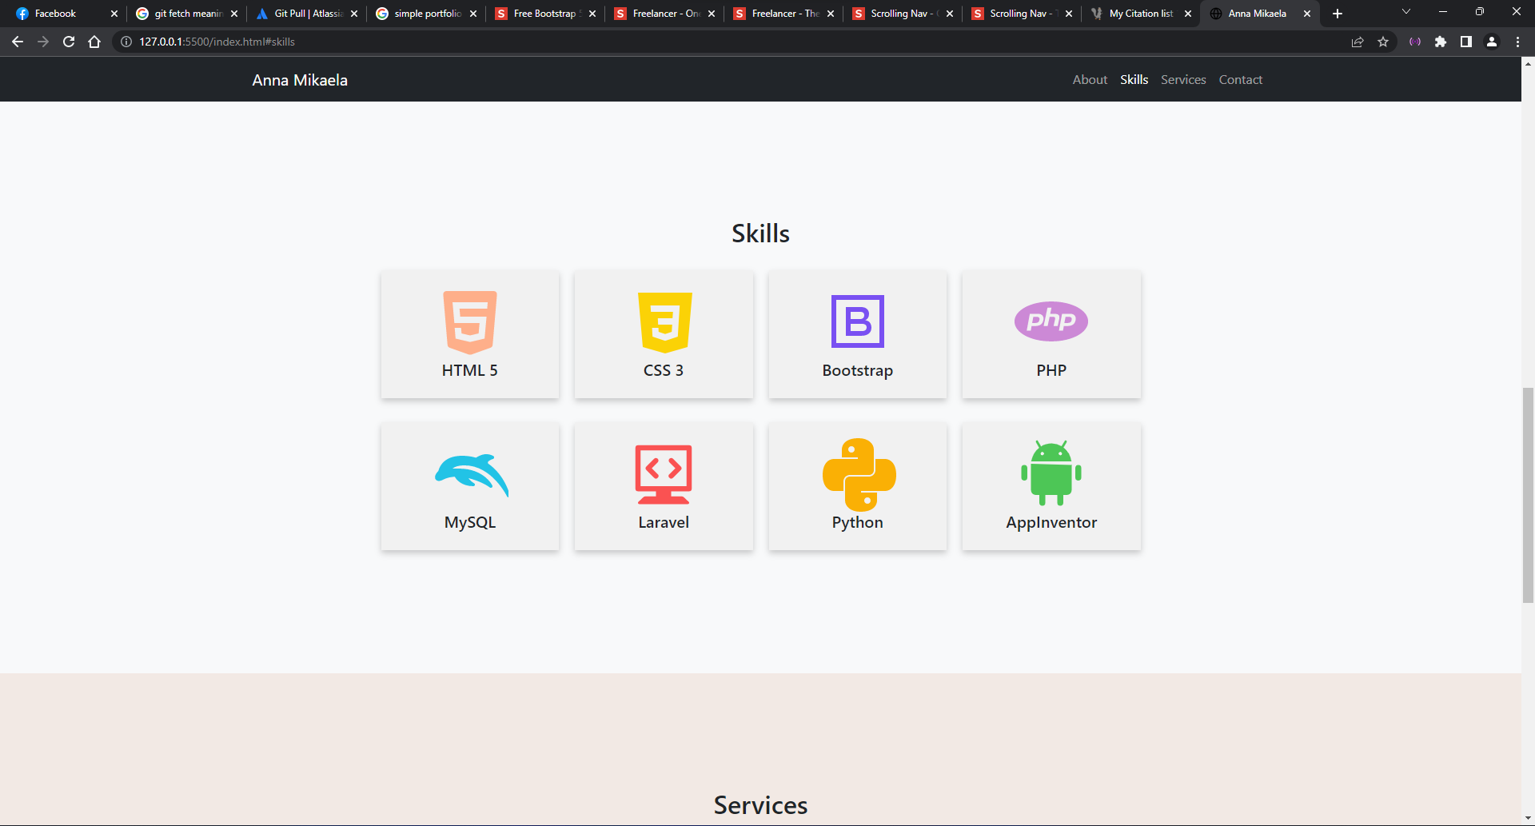

*Figure 21. Portfolio Skills*

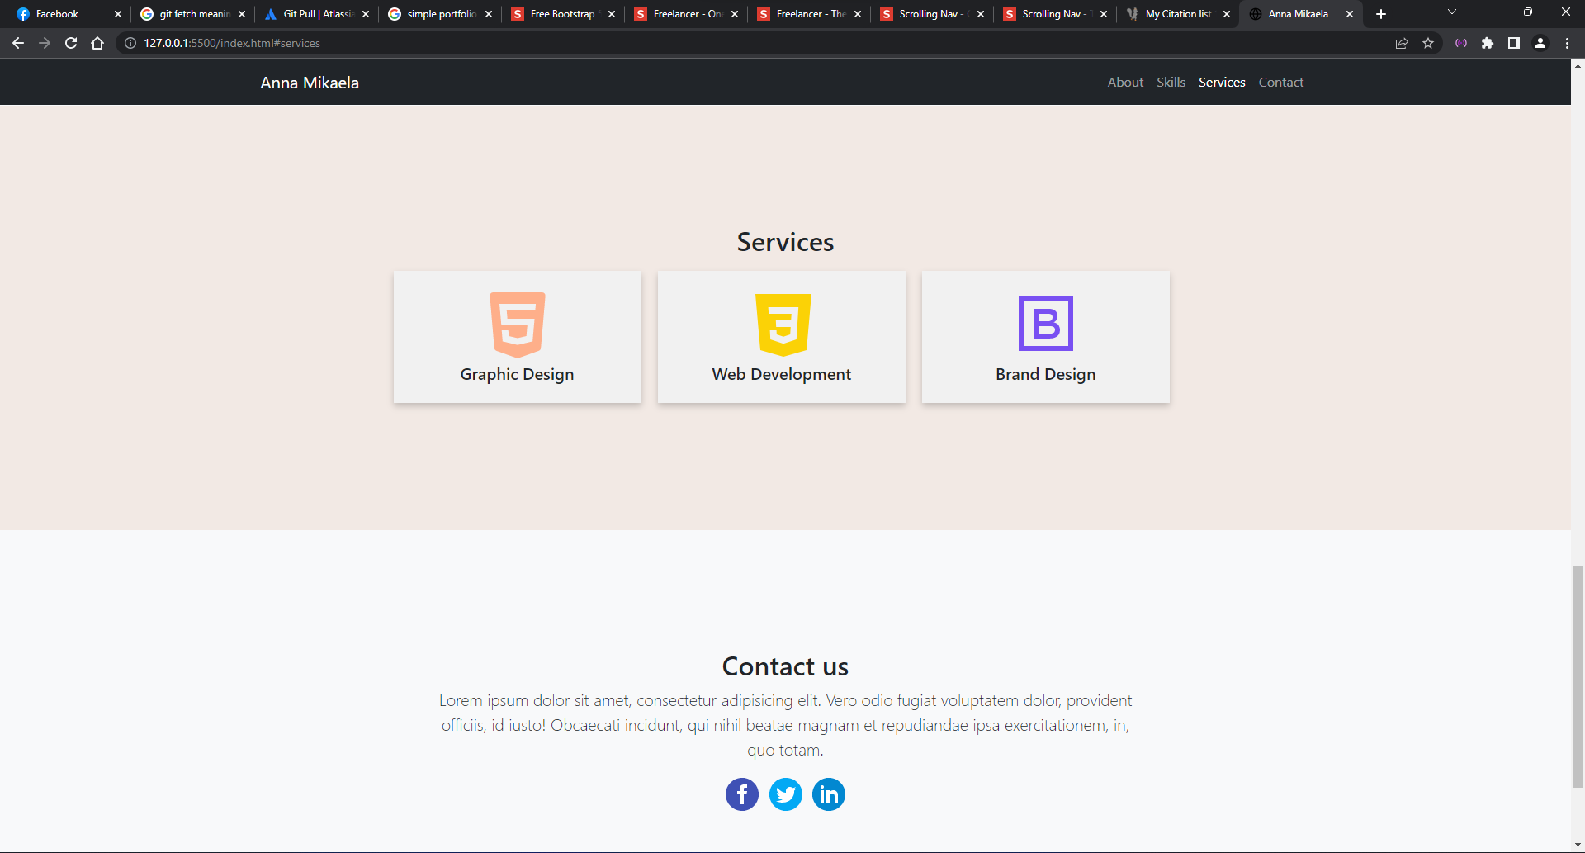

*Figure 22. Portfolio Services*

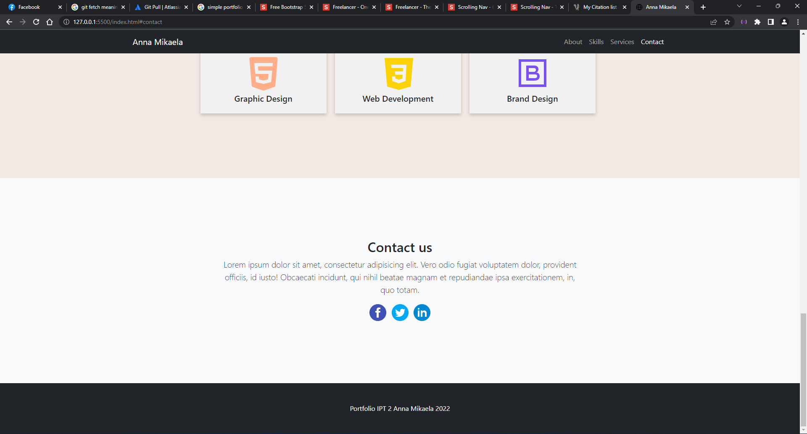

*Figure 23. Portfolio Contact*

# Groupmates

## C.1 Contributions

1. **De Almeida, Carlos**: Contributed on executing the command requirements and documentation.
2. **Ramos, Mario Dominic**: Contributed on executing the command requirements and documentation.
3. **Piñon, Patricia Paula**: Contributed on executing the command requirements and documentation.
4. **Viado, Anna Mikaela**: Contributed on executing the command requirements and documentation.

# References

* “Scrolling nav - one page scrolling bootstrap template,” One Page Scrolling Bootstrap Template - Start Bootstrap. [Online]. Available: <https://startbootstrap.com/template/scrolling-nav>.

**Grade Matrix:**

Git Command : **20%**

GitHub Implement : **20%**

Documentation : **40%**

Webpage (Development) : **30%**

**100%**