Lo primero que hay que hacer para descargar sakila es ir al siguiente enlace

<https://dev.mysql.com/doc/index-other.html>.

Después descargaremos el .zip

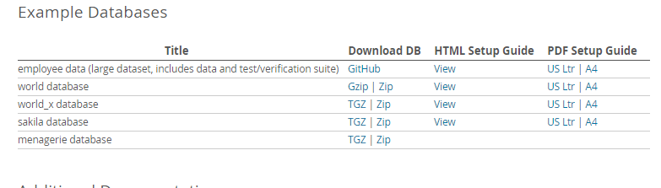

Ahora se debe crear una carpeta en cualquier lugar ,ya sea documentos o escritorio y en esa pasaremos el .zip

En este caso se ha guardado en

**C:\Users\304\Downloads\sakila**

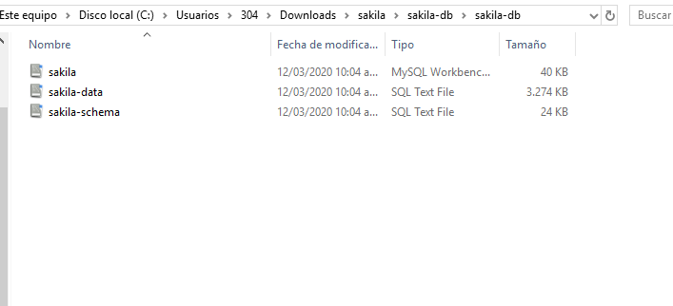

Esto es lo que descomprime el .zip

Ahora se va a importar los .sql con workbench

En file se abre la opción run sql script

Una vez importado todo se obtiene:

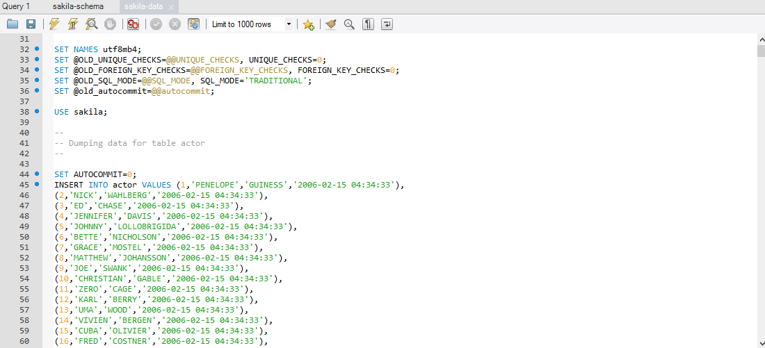

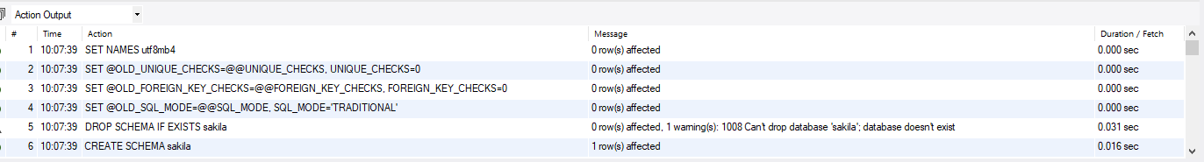

Si hacemos un select se obtiene:

mysql> select * from actor;

+----------+-------------+--------------+---------------------+

| actor_id | first_name | last_name | last_update |

+----------+-------------+--------------+---------------------+

| 1 | PENELOPE | GUINESS | 2006-02-15 04:34:33 |

| 2 | NICK | WAHLBERG | 2006-02-15 04:34:33 |

| 3 | ED | CHASE | 2006-02-15 04:34:33 |

| 4 | JENNIFER | DAVIS | 2006-02-15 04:34:33 |

| 5 | JOHNNY | LOLLOBRIGIDA | 2006-02-15 04:34:33 |

| 6 | BETTE | NICHOLSON | 2006-02-15 04:34:33 |

| 7 | GRACE | MOSTEL | 2006-02-15 04:34:33 |

| 8 | MATTHEW | JOHANSSON | 2006-02-15 04:34:33 |

| 9 | JOE | SWANK | 2006-02-15 04:34:33 |

| 10 | CHRISTIAN | GABLE | 2006-02-15 04:34:33 |

| 11 | ZERO | CAGE | 2006-02-15 04:34:33 |

| 12 | KARL | BERRY | 2006-02-15 04:34:33 |

| 13 | UMA | WOOD | 2006-02-15 04:34:33 |

| 14 | VIVIEN | BERGEN | 2006-02-15 04:34:33 |

| 15 | CUBA | OLIVIER | 2006-02-15 04:34:33 |

| 16 | FRED | COSTNER | 2006-02-15 04:34:33 |

| 17 | HELEN | VOIGHT | 2006-02-15 04:34:33 |

| 18 | DAN | TORN | 2006-02-15 04:34:33 |

| 19 | BOB | FAWCETT | 2006-02-15 04:34:33 |

| 20 | LUCILLE | TRACY | 2006-02-15 04:34:33 |

| 21 | KIRSTEN | PALTROW | 2006-02-15 04:34:33 |

| 22 | ELVIS | MARX | 2006-02-15 04:34:33 |

| 23 | SANDRA | KILMER | 2006-02-15 04:34:33 |

| 24 | CAMERON | STREEP | 2006-02-15 04:34:33 |

| 25 | KEVIN | BLOOM | 2006-02-15 04:34:33 |

| 26 | RIP | CRAWFORD | 2006-02-15 04:34:33 |

| 27 | JULIA | MCQUEEN | 2006-02-15 04:34:33 |

| 28 | WOODY | HOFFMAN | 2006-02-15 04:34:33 |

| 29 | ALEC | WAYNE | 2006-02-15 04:34:33 |

| 30 | SANDRA | PECK | 2006-02-15 04:34:33 |

| 31 | SISSY | SOBIESKI | 2006-02-15 04:34:33 |

| 32 | TIM | HACKMAN | 2006-02-15 04:34:33 |

| 33 | MILLA | PECK | 2006-02-15 04:34:33 |

| 34 | AUDREY | OLIVIER | 2006-02-15 04:34:33 |

| 35 | JUDY | DEAN | 2006-02-15 04:34:33 |

| 36 | BURT | DUKAKIS | 2006-02-15 04:34:33 |

| 37 | VAL | BOLGER | 2006-02-15 04:34:33 |

| 38 | TOM | MCKELLEN | 2006-02-15 04:34:33 |

| 39 | GOLDIE | BRODY | 2006-02-15 04:34:33 |

| 40 | JOHNNY | CAGE | 2006-02-15 04:34:33 |

| 41 | JODIE | DEGENERES | 2006-02-15 04:34:33 |

| 42 | TOM | MIRANDA | 2006-02-15 04:34:33 |

| 43 | KIRK | JOVOVICH | 2006-02-15 04:34:33 |

| 44 | NICK | STALLONE | 2006-02-15 04:34:33 |

| 45 | REESE | KILMER | 2006-02-15 04:34:33 |

| 46 | PARKER | GOLDBERG | 2006-02-15 04:34:33 |

| 47 | JULIA | BARRYMORE | 2006-02-15 04:34:33 |

| 48 | FRANCES | DAY-LEWIS | 2006-02-15 04:34:33 |

| 49 | ANNE | CRONYN | 2006-02-15 04:34:33 |

| 50 | NATALIE | HOPKINS | 2006-02-15 04:34:33 |

| 51 | GARY | PHOENIX | 2006-02-15 04:34:33 |

| 52 | CARMEN | HUNT | 2006-02-15 04:34:33 |

**Modelo relacional**

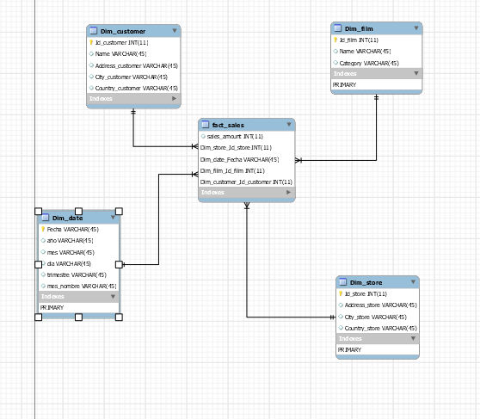

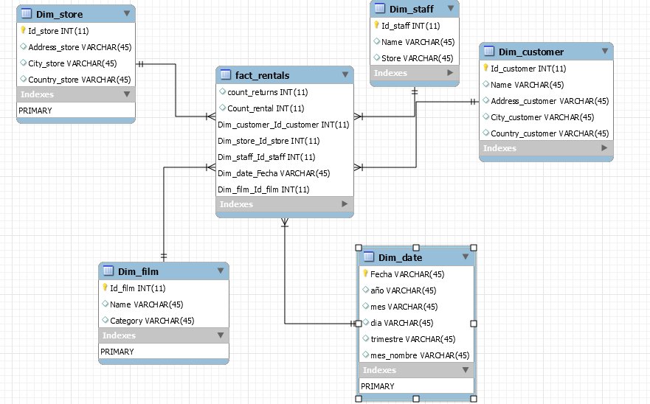

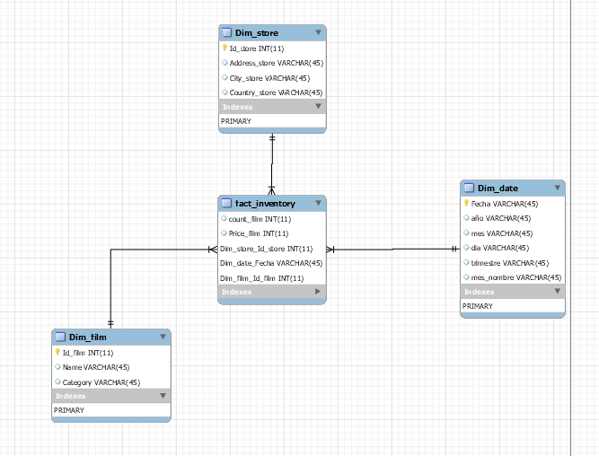

**Modelo Organizado**

