Primer paso

Carlos

1 de junio de 2018

## R Markdown

This is an R Markdown document. Markdown is a simple formatting syntax for authoring HTML, PDF, and MS Word documents. For more details on using R Markdown see <http://rmarkdown.rstudio.com>.

When you click the **Knit** button a document will be generated that includes both content as well as the output of any embedded R code chunks within the document. You can embed an R code chunk like this:

summary(cars)

## speed dist   
## Min. : 4.0 Min. : 2.00   
## 1st Qu.:12.0 1st Qu.: 26.00   
## Median :15.0 Median : 36.00   
## Mean :15.4 Mean : 42.98   
## 3rd Qu.:19.0 3rd Qu.: 56.00   
## Max. :25.0 Max. :120.00

## Including Plots

You can also embed plots, for example:



Note that the echo = FALSE parameter was added to the code chunk to prevent printing of the R code that generated the plot.

library(dplyr)

##   
## Attaching package: 'dplyr'

## The following objects are masked from 'package:stats':  
##   
## filter, lag

## The following objects are masked from 'package:base':  
##   
## intersect, setdiff, setequal, union

library(ggmap)

## Warning: package 'ggmap' was built under R version 3.4.4

## Loading required package: ggplot2

## Warning: package 'ggplot2' was built under R version 3.4.4

crimes.houston <- crime %>%  
 filter(!crime$offense %in% c("auto theft", "theft", "burglary"))

## Warning: package 'bindrcpp' was built under R version 3.4.4

houston <- c(lon=-95.3698,lat= 29.76043)  
HoustonMap <- get_map(houston, zoom = 14, color = "bw")

## Map from URL : http://maps.googleapis.com/maps/api/staticmap?center=29.76043,-95.3698&zoom=14&size=640x640&scale=2&maptype=terrain&language=en-EN&sensor=false

ggmap(HoustonMap)

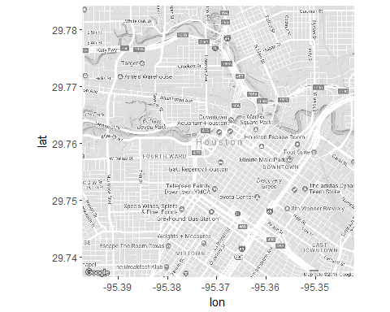

ggmap(HoustonMap) +   
 geom_point(aes(x = lon, y = lat, colour = offense), data = crimes.houston, size = 1)

## Warning: Removed 13317 rows containing missing values (geom_point).

