Activity 1. Remaining years for currentTimeMillis()

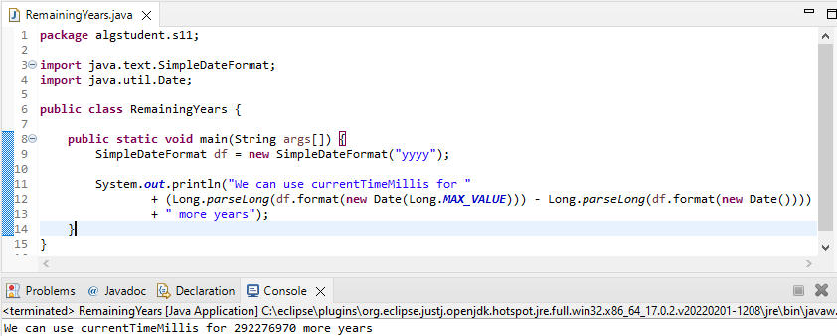

Activity 2. Input value at which we start to get reliable times

When the time measured is 0 it means that the time elapsed is so low that it is rounded to zero.



(note that many executions were made and this was always the time)

Activity 3. Vector4.java questions

If the complexity is O(n), the time should be doubled.

If the complexity is O(n), like in problem 2, we get 3 and 4 times greater execution times.

This is an example using Vector2.java







The times obtained are the expected ones, as it can clearly be seen.

TABLE1 (