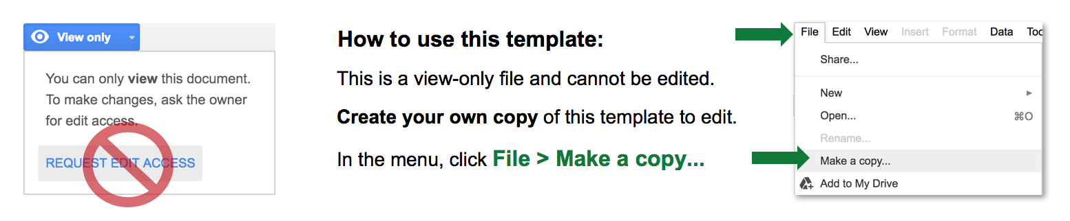


BUSINESS REQUIREMENTS
DOCUMENT TEMPLATE



Template begins on page 2.
BUSINESS REQUIREMENTS DOCUMENT TEMPLATE

PROJECT DETAILS
PROJECT NAME
CREATOR
DOCUMENT NO. | DATE | VERSION NO.

1. EXECUTIVE SUMMARY SNAPSHOT
Provide an executive summary (overview of your business requirements) here. Your executive summary should be a “snapshot” of the purpose of your business requirements, including a brief description of any analysis, findings, project details, scope, business drivers, proposed process, current process, and functional requirements. An executive summary provides an overview of a larger document or of research and is usually the first thing your reader will see. Here are the questions you should answer when writing your business requirements executive summary:
- What is the goal (purpose) of this business requirements document (BRD)?
- Who is the audience for this business requirements document?

2. PROJECT DESCRIPTION
In this section, describe the project for which you are writing this business requirements document. Describe the project’s purpose, what the current process/solution is for the project, what the challenges are, and why you need to undertake the project.

3. PROJECT SCOPE
Provide a high-level description of the project’s scope, including a list of project-specific goals, tasks, deliverables, costs, deadlines -- everything that is “in” and “out” of scope for the project. This information provides team members with guidelines for the scope of the project, so they can plan and resource accordingly.
IN-SCOPE ITEMS | OUT-OF-SCOPE ITEMS
Item 1: | Item 1:
Item 2: | Item 2:
Item 3: | Item 3:
Item 4: | Item 4:
Etc.

4. BUSINESS DRIVERS
Enter the reasons (i.e., business drivers) why your business is initiating the project. In short, Why are you undertaking the project? Examples might include the following: legal requirements, cost savings with a more efficient practice, updated import/export laws, improved efficiency, improved sales, etc.
Business Driver 1: | Provide a detailed explanation for this driver...
Business Driver 2: | Provide a detailed explanation for this driver…
Business Driver 3: | Provide a detailed explanation for this driver…
Business Driver 4: | Provide a detailed explanation for this driver…

5. PRESENT PROCESS
Provide details of your current, prevailing process for addressing the primary issue your project attempts to solve. Feel free to include diagrams, flowcharts, or other visuals to illustrate the current process.

6. PROPOSED PROCESS
Provide details of the proposed process for addressing the primary issue your project attempts to solve. Feel free to include diagrams, flowcharts, or other visuals to illustrate the proposed process. For this process, we recommend that you
use the same illustrative tool/style that you used for your present/current process (above).

7. FUNCTIONAL REQUIREMENTS
Detail the project’s functional requirements by enumerating the ways in which the current process addresses the issue and by describing the functional requirements necessary to make the project successful.

– PRIORITY
Use the following priority table. It allows you to apply a ratings system to your requirements, so you have the visibility (into the value, status, and description of each requirement) that is necessary for determining whether a particular requirement is essential to project success.
VALUE | STATUS | DESCRIPTION
1 | Immediate | The requirement is critical to the project’s success. Without fulfilling this requirement, the project is not possible.
2 | High | The requirement is high priority re the project's success, but the project could still be implemented in a minimum viable product (MVP) scenario.
3 | Moderate | The requirement is important to the project’s success, as it provides value, but the project could still be implemented in an MVP scenario.
4 | Low | The requirement is of low priority, but the project’s success is not dependent upon it.
5 | Prospective | The requirement is out of the project’s scope and is included as a possible component of a prospective release and/or feature.

– CATEGORIES (RC1)
In this section, detail the project’s functional use; break down your project’s requirements into categories so that they’re easy to understand. You can duplicate this section for any successive project categories as needed. The following table includes a unique ID for each requirement, the details of each requirement, the priority of each requirement, and the name of the person who is driving or is responsible for the requirement. Include descriptions of how the current process addresses the issue. Also include the functional requirements necessary to achieve success.
ID | REQUIREMENT | PRIORITY | RAISED BY

8. NON-FUNCTIONAL REQUIREMENTS
Detail all non-functional requirements (NFRs) of the project, including such things as features, system behavior, and project characteristics that relate to user experience.
ID | REQUIREMENT

9. GLOSSARY
For easy reference, enter any terms, abbreviations, and/or acronyms that you include in this document.
TERM/ABBREVIATION | EXPLANATION

10. REFERENCES
Provide links to all referenced resources (websites, documents, etc.) throughout this document.
NAME | LOCATION

11. APPENDIX
Include any additional information for reference, e.g., process details, analysis results, studies, third-party examples, etc.

DISCLAIMER

Any articles, templates, or information provided by Smartsheet on the website are for reference only. While we strive to keep the information up to date and correct, we make no representations or warranties of any kind, express or implied, about the completeness, accuracy, reliability, suitability, or availability with respect to the website or the information, articles, templates, or related graphics contained on the website. Any reliance you place on such information is therefore strictly at your own risk.

