RESULTADOS ESTADÍSTICOS REPRODUCIBLES
Evaluación experimental del desempeño técnico del radioenlace
El presente documento fue generado automáticamente a partir de las tablas y figuras producidas por el flujo reproducible de análisis. Su finalidad es facilitar la revisión, auditoría e incorporación de los resultados en el informe de investigación.

1. Tablas de resultados

Tabla 4.1. Estadísticos descriptivos principales por escenario
escenario | frecuencia_mhz | ancho_canal_mhz | n_registros | dias_unicos | rssi_dl_media | rssi_dl_de | snr_dl_media | snr_dl_de | mcs_dl_media | mcs_dl_de
E0 | 5800 | 20 | 14400 | 10 | -76.23104166666667 | 1.1106666527677809 | 20.595694444444444 | 0.8950067540343125 | 104.99479166666669 | 1.9296720541979544
E1 | 5660 | 40 | 2760 | 10 | -76.66825513196481 | 1.0921547241505989 | 21.115102639296182 | 0.9797842520237556 | 104.74633431085044 | 0.948328261620924
E2 | 5660 | 80 | 2245 | 9 | -74.39641255605382 | 0.9099350201481824 | 21.6780269058296 | 0.8532584256563975 | 103.3000447828034 | 1.804883111059712
E3 | 5730 | 40 | 2381 | 10 | -76.35634648370497 | 0.8109281672935975 | 19.936106346483704 | 0.4242134294557618 | 104.64365351629505 | 0.6897161087099322
E4 | 5730 | 80 | 2184 | 9 | -75.69400921658986 | 0.6731435443930787 | 20.615668202764976 | 1.0473940264801551 | 103.67188940092166 | 1.223028094295379
E5 | 5805 | 40 | 2137 | 9 | -75.62619961612285 | 1.0434187827050214 | 21.136276391554706 | 0.8410088998687281 | 104.97552783109406 | 0.644691726092908

Tabla 4.2. Resultados de la prueba de Kruskal-Wallis
Métrica | Escenarios comparados | N | Estadístico H | gl | Valor p | Épsilon cuadrado | Magnitud del efecto | Decisión
RSSI DL | E0–E5 | 25944 | 5846.432 | 5 | < 0.001 | 0.225 | Grande | Se rechaza H0
SNR DL | E0–E5 | 25944 | 5385.396 | 5 | < 0.001 | 0.207 | Grande | Se rechaza H0
MCS DL | E0–E5 | 25947 | 4429.28 | 5 | < 0.001 | 0.171 | Grande | Se rechaza H0
Throughput DL | E1–E5 | 11492 | 1659.254 | 4 | < 0.001 | 0.144 | Grande | Se rechaza H0
Nota. El escenario E0 se excluyó del análisis de throughput por no disponer de registros equivalentes a cnMaestro.

Tabla 4.3. Distribución de registros según condición de precipitación
condicion_lluvia | n_registros | porcentaje
Con lluvia | 25566 | 99.67
Sin lluvia | 84 | 0.33

Tabla 4.3-A. Comparaciones post hoc de Dunn completas
Métrica | Comparación | N 1 | N 2 | Mediana 1 | Mediana 2 | Estadístico z | Valor p ajustado | Diferencia significativa
RSSI DL | E0–E1 | 14400 | 2728 | -76.0 | -77.0 | 21.815 | < 0.001 | Sí
RSSI DL | E0–E2 | 14400 | 2230 | -76.0 | -74.0 | -63.476 | < 0.001 | Sí
RSSI DL | E0–E3 | 14400 | 2332 | -76.0 | -76.0 | 4.326 | < 0.001 | Sí
RSSI DL | E0–E4 | 14400 | 2170 | -76.0 | -76.0 | -22.372 | < 0.001 | Sí
RSSI DL | E0–E5 | 14400 | 2084 | -76.0 | -75.0 | -24.011 | < 0.001 | Sí
RSSI DL | E1–E2 | 2728 | 2230 | -77.0 | -74.0 | -66.555 | < 0.001 | Sí
RSSI DL | E1–E3 | 2728 | 2332 | -77.0 | -76.0 | -12.727 | < 0.001 | Sí
RSSI DL | E1–E4 | 2728 | 2170 | -77.0 | -76.0 | -33.746 | < 0.001 | Sí
RSSI DL | E1–E5 | 2728 | 2084 | -77.0 | -75.0 | -35.0 | < 0.001 | Sí
RSSI DL | E2–E3 | 2230 | 2332 | -74.0 | -76.0 | 52.031 | < 0.001 | Sí
RSSI DL | E2–E4 | 2230 | 2170 | -74.0 | -76.0 | 30.82 | < 0.001 | Sí
RSSI DL | E2–E5 | 2230 | 2084 | -74.0 | -75.0 | 28.941 | < 0.001 | Sí
RSSI DL | E3–E4 | 2332 | 2170 | -76.0 | -76.0 | -20.51 | < 0.001 | Sí
RSSI DL | E3–E5 | 2332 | 2084 | -76.0 | -75.0 | -21.873 | < 0.001 | Sí
RSSI DL | E4–E5 | 2170 | 2084 | -76.0 | -75.0 | -1.552 | 0.1207 | No
SNR DL | E0–E1 | 14400 | 2728 | 21.0 | 21.0 | -28.823 | < 0.001 | Sí
SNR DL | E0–E2 | 14400 | 2230 | 21.0 | 22.0 | -47.68 | < 0.001 | Sí
SNR DL | E0–E3 | 14400 | 2332 | 21.0 | 20.0 | 35.558 | < 0.001 | Sí
SNR DL | E0–E4 | 14400 | 2170 | 21.0 | 20.0 | 0.157 | 1.0000 | No
SNR DL | E0–E5 | 14400 | 2084 | 21.0 | 21.0 | -25.865 | < 0.001 | Sí
SNR DL | E1–E2 | 2728 | 2230 | 21.0 | 22.0 | -16.926 | < 0.001 | Sí
SNR DL | E1–E3 | 2728 | 2332 | 21.0 | 20.0 | 49.483 | < 0.001 | Sí
SNR DL | E1–E4 | 2728 | 2170 | 21.0 | 20.0 | 21.049 | < 0.001 | Sí
SNR DL | E1–E5 | 2728 | 2084 | 21.0 | 21.0 | -0.15 | 1.0000 | No
SNR DL | E2–E3 | 2230 | 2332 | 22.0 | 20.0 | 63.432 | < 0.001 | Sí
SNR DL | E2–E4 | 2230 | 2170 | 22.0 | 20.0 | 36.103 | < 0.001 | Sí
SNR DL | E2–E5 | 2230 | 2084 | 22.0 | 21.0 | 15.717 | < 0.001 | Sí
SNR DL | E3–E4 | 2332 | 2170 | 20.0 | 20.0 | -26.489 | < 0.001 | Sí
SNR DL | E3–E5 | 2332 | 2084 | 20.0 | 21.0 | -46.44 | < 0.001 | Sí
SNR DL | E4–E5 | 2170 | 2084 | 20.0 | 21.0 | -19.882 | < 0.001 | Sí
MCS DL | E0–E1 | 14400 | 2728 | 105.0 | 105.0 | 11.076 | < 0.001 | Sí
MCS DL | E0–E2 | 14400 | 2233 | 105.0 | 103.0 | 46.204 | < 0.001 | Sí
MCS DL | E0–E3 | 14400 | 2332 | 105.0 | 105.0 | 18.605 | < 0.001 | Sí
MCS DL | E0–E4 | 14400 | 2170 | 105.0 | 104.0 | 51.196 | < 0.001 | Sí
MCS DL | E0–E5 | 14400 | 2084 | 105.0 | 105.0 | -1.158 | 0.2469 | No
MCS DL | E1–E2 | 2728 | 2233 | 105.0 | 103.0 | 28.719 | < 0.001 | Sí
MCS DL | E1–E3 | 2728 | 2332 | 105.0 | 105.0 | 6.525 | < 0.001 | Sí
MCS DL | E1–E4 | 2728 | 2170 | 105.0 | 104.0 | 32.945 | < 0.001 | Sí
MCS DL | E1–E5 | 2728 | 2084 | 105.0 | 105.0 | -8.882 | < 0.001 | Sí
MCS DL | E2–E3 | 2233 | 2332 | 103.0 | 105.0 | -21.465 | < 0.001 | Sí
MCS DL | E2–E4 | 2233 | 2170 | 103.0 | 104.0 | 4.249 | < 0.001 | Sí
MCS DL | E2–E5 | 2233 | 2084 | 103.0 | 105.0 | -35.393 | < 0.001 | Sí
MCS DL | E3–E4 | 2332 | 2170 | 105.0 | 104.0 | 25.602 | < 0.001 | Sí
MCS DL | E3–E5 | 2332 | 2084 | 105.0 | 105.0 | -14.677 | < 0.001 | Sí
MCS DL | E4–E5 | 2170 | 2084 | 104.0 | 105.0 | -39.323 | < 0.001 | Sí
Throughput DL | E1–E2 | 2716 | 2231 | 0.43 | 0.43 | 1.016 | 0.3095 | No
Throughput DL | E1–E3 | 2716 | 2307 | 0.43 | 0.63 | -28.903 | < 0.001 | Sí
Throughput DL | E1–E4 | 2716 | 2163 | 0.43 | 0.6 | -26.397 | < 0.001 | Sí
Throughput DL | E1–E5 | 2716 | 2075 | 0.43 | 0.58 | -22.413 | < 0.001 | Sí
Throughput DL | E2–E3 | 2231 | 2307 | 0.43 | 0.63 | -28.538 | < 0.001 | Sí
Throughput DL | E2–E4 | 2231 | 2163 | 0.43 | 0.6 | -26.172 | < 0.001 | Sí
Throughput DL | E2–E5 | 2231 | 2075 | 0.43 | 0.58 | -22.379 | < 0.001 | Sí
Throughput DL | E3–E4 | 2307 | 2163 | 0.63 | 0.6 | 1.926 | 0.1083 | No
Throughput DL | E3–E5 | 2307 | 2075 | 0.63 | 0.58 | 5.448 | < 0.001 | Sí
Throughput DL | E4–E5 | 2163 | 2075 | 0.6 | 0.58 | 3.489 | 0.0015 | Sí
Nota. Los valores p fueron ajustados mediante el procedimiento de Holm.

Tabla 4.3-B. Comparaciones post hoc de Dunn significativas
Métrica | Comparación | N 1 | N 2 | Mediana 1 | Mediana 2 | Estadístico z | Valor p ajustado | Diferencia significativa
RSSI DL | E0–E1 | 14400 | 2728 | -76.0 | -77.0 | 21.815 | < 0.001 | Sí
RSSI DL | E0–E2 | 14400 | 2230 | -76.0 | -74.0 | -63.476 | < 0.001 | Sí
RSSI DL | E0–E3 | 14400 | 2332 | -76.0 | -76.0 | 4.326 | < 0.001 | Sí
RSSI DL | E0–E4 | 14400 | 2170 | -76.0 | -76.0 | -22.372 | < 0.001 | Sí
RSSI DL | E0–E5 | 14400 | 2084 | -76.0 | -75.0 | -24.011 | < 0.001 | Sí
RSSI DL | E1–E2 | 2728 | 2230 | -77.0 | -74.0 | -66.555 | < 0.001 | Sí
RSSI DL | E1–E3 | 2728 | 2332 | -77.0 | -76.0 | -12.727 | < 0.001 | Sí
RSSI DL | E1–E4 | 2728 | 2170 | -77.0 | -76.0 | -33.746 | < 0.001 | Sí
RSSI DL | E1–E5 | 2728 | 2084 | -77.0 | -75.0 | -35.0 | < 0.001 | Sí
RSSI DL | E2–E3 | 2230 | 2332 | -74.0 | -76.0 | 52.031 | < 0.001 | Sí
RSSI DL | E2–E4 | 2230 | 2170 | -74.0 | -76.0 | 30.82 | < 0.001 | Sí
RSSI DL | E2–E5 | 2230 | 2084 | -74.0 | -75.0 | 28.941 | < 0.001 | Sí
RSSI DL | E3–E4 | 2332 | 2170 | -76.0 | -76.0 | -20.51 | < 0.001 | Sí
RSSI DL | E3–E5 | 2332 | 2084 | -76.0 | -75.0 | -21.873 | < 0.001 | Sí
SNR DL | E0–E1 | 14400 | 2728 | 21.0 | 21.0 | -28.823 | < 0.001 | Sí
SNR DL | E0–E2 | 14400 | 2230 | 21.0 | 22.0 | -47.68 | < 0.001 | Sí
SNR DL | E0–E3 | 14400 | 2332 | 21.0 | 20.0 | 35.558 | < 0.001 | Sí
SNR DL | E0–E5 | 14400 | 2084 | 21.0 | 21.0 | -25.865 | < 0.001 | Sí
SNR DL | E1–E2 | 2728 | 2230 | 21.0 | 22.0 | -16.926 | < 0.001 | Sí
SNR DL | E1–E3 | 2728 | 2332 | 21.0 | 20.0 | 49.483 | < 0.001 | Sí
SNR DL | E1–E4 | 2728 | 2170 | 21.0 | 20.0 | 21.049 | < 0.001 | Sí
SNR DL | E2–E3 | 2230 | 2332 | 22.0 | 20.0 | 63.432 | < 0.001 | Sí
SNR DL | E2–E4 | 2230 | 2170 | 22.0 | 20.0 | 36.103 | < 0.001 | Sí
SNR DL | E2–E5 | 2230 | 2084 | 22.0 | 21.0 | 15.717 | < 0.001 | Sí
SNR DL | E3–E4 | 2332 | 2170 | 20.0 | 20.0 | -26.489 | < 0.001 | Sí
SNR DL | E3–E5 | 2332 | 2084 | 20.0 | 21.0 | -46.44 | < 0.001 | Sí
SNR DL | E4–E5 | 2170 | 2084 | 20.0 | 21.0 | -19.882 | < 0.001 | Sí
MCS DL | E0–E1 | 14400 | 2728 | 105.0 | 105.0 | 11.076 | < 0.001 | Sí
MCS DL | E0–E2 | 14400 | 2233 | 105.0 | 103.0 | 46.204 | < 0.001 | Sí
MCS DL | E0–E3 | 14400 | 2332 | 105.0 | 105.0 | 18.605 | < 0.001 | Sí
MCS DL | E0–E4 | 14400 | 2170 | 105.0 | 104.0 | 51.196 | < 0.001 | Sí
MCS DL | E1–E2 | 2728 | 2233 | 105.0 | 103.0 | 28.719 | < 0.001 | Sí
MCS DL | E1–E3 | 2728 | 2332 | 105.0 | 105.0 | 6.525 | < 0.001 | Sí
MCS DL | E1–E4 | 2728 | 2170 | 105.0 | 104.0 | 32.945 | < 0.001 | Sí
MCS DL | E1–E5 | 2728 | 2084 | 105.0 | 105.0 | -8.882 | < 0.001 | Sí
MCS DL | E2–E3 | 2233 | 2332 | 103.0 | 105.0 | -21.465 | < 0.001 | Sí
MCS DL | E2–E4 | 2233 | 2170 | 103.0 | 104.0 | 4.249 | < 0.001 | Sí
MCS DL | E2–E5 | 2233 | 2084 | 103.0 | 105.0 | -35.393 | < 0.001 | Sí
MCS DL | E3–E4 | 2332 | 2170 | 105.0 | 104.0 | 25.602 | < 0.001 | Sí
MCS DL | E3–E5 | 2332 | 2084 | 105.0 | 105.0 | -14.677 | < 0.001 | Sí
MCS DL | E4–E5 | 2170 | 2084 | 104.0 | 105.0 | -39.323 | < 0.001 | Sí
Throughput DL | E1–E3 | 2716 | 2307 | 0.43 | 0.63 | -28.903 | < 0.001 | Sí
Throughput DL | E1–E4 | 2716 | 2163 | 0.43 | 0.6 | -26.397 | < 0.001 | Sí
Throughput DL | E1–E5 | 2716 | 2075 | 0.43 | 0.58 | -22.413 | < 0.001 | Sí
Throughput DL | E2–E3 | 2231 | 2307 | 0.43 | 0.63 | -28.538 | < 0.001 | Sí
Throughput DL | E2–E4 | 2231 | 2163 | 0.43 | 0.6 | -26.172 | < 0.001 | Sí
Throughput DL | E2–E5 | 2231 | 2075 | 0.43 | 0.58 | -22.379 | < 0.001 | Sí
Throughput DL | E3–E5 | 2307 | 2075 | 0.63 | 0.58 | 5.448 | < 0.001 | Sí
Throughput DL | E4–E5 | 2163 | 2075 | 0.6 | 0.58 | 3.489 | 0.0015 | Sí
Nota. Se consideró diferencia significativa cuando p ajustado < 0.05.

Tabla 4.4. Desempeño técnico según condición de precipitación
Unnamed: 0 | rssi_dl | rssi_dl.1 | rssi_dl.2 | snr_dl | snr_dl.1 | snr_dl.2 | mcs_dl | mcs_dl.1 | mcs_dl.2 | throughput_dl | throughput_dl.1 | throughput_dl.2
 | mean | std | median | mean | std | median | mean | std | median | mean | std | median
condicion_lluvia
Con lluvia | -76.05184952238689 | 1.1791458248106783 | -76.0 | 20.716341051141946 | 0.971832177221965 | 21.0 | 104.67750176872887 | 1.7290515312872894 | 105.0 | 0.6948603148603149 | 0.40629319916304435 | 0.56
Sin lluvia | -74.16867469879519 | 0.9730424640225429 | -74.0 | 21.879518072289155 | 1.0522634183029824 | 22.0 | 103.7710843373494 | 1.8301359486009394 | 104.0 | 0.6525301204819277 | 0.41007983569381723 | 0.41

Tabla 4.5. Correlación entre precipitación y métricas técnicas
variable | rho_spearman | n
rssi_dl | -0.1227143090491442 | 25522
snr_dl | -0.0484048100048703 | 25522
mcs_dl | 0.0407470861973154 | 25525
throughput_dl | 0.124755629960309 | 11072

Tabla 4.6. Indicadores de estabilidad operativa por escenario
escenario | rssi_dl_mean | rssi_dl_std | rssi_dl_cv | snr_dl_mean | snr_dl_std | snr_dl_cv | mcs_dl_mean | mcs_dl_std | mcs_dl_cv | throughput_dl_mean | throughput_dl_std | throughput_dl_cv
E0 | -76.23104166666667 | 1.1106666527677809 | 1.4569742567920845 | 20.595694444444444 | 0.8950067540343125 | 4.345601244223813 | 104.99479166666669 | 1.9296720541979544 | 1.8378740731485053
E1 | -76.66825513196481 | 1.0921547241505989 | 1.4245201254035762 | 21.115102639296182 | 0.9797842520237556 | 4.640205964238751 | 104.74633431085044 | 0.948328261620924 | 0.905356992070594 | 0.6012628865979381 | 0.3768409780823354 | 62.67491083884698
E2 | -74.39641255605382 | 0.9099350201481824 | 1.2230899164157865 | 21.6780269058296 | 0.8532584256563975 | 3.936052064899604 | 103.3000447828034 | 1.804883111059712 | 1.7472239386290906 | 0.588027790228597 | 0.3753926030201511 | 63.83926223524512
E3 | -76.35634648370497 | 0.8109281672935975 | 1.0620311272575826 | 19.936106346483704 | 0.4242134294557618 | 2.127865000733124 | 104.64365351629505 | 0.6897161087099322 | 0.6591093540159414 | 0.7703120936280884 | 0.3829713197922649 | 49.71638417209712
E4 | -75.69400921658986 | 0.6731435443930787 | 0.8892956673320795 | 20.615668202764976 | 1.0473940264801551 | 5.080572776873071 | 103.67188940092166 | 1.223028094295379 | 1.1797104319818696 | 0.7912390198797966 | 0.4283025244658194 | 54.13061207862148
E5 | -75.62619961612285 | 1.0434187827050214 | 1.3797054301305571 | 21.136276391554706 | 0.8410088998687281 | 3.97898326218314 | 104.97552783109406 | 0.644691726092908 | 0.6141352555332886 | 0.7434024096385542 | 0.4064250017627311 | 54.67092875853562

2. Figuras de resultados
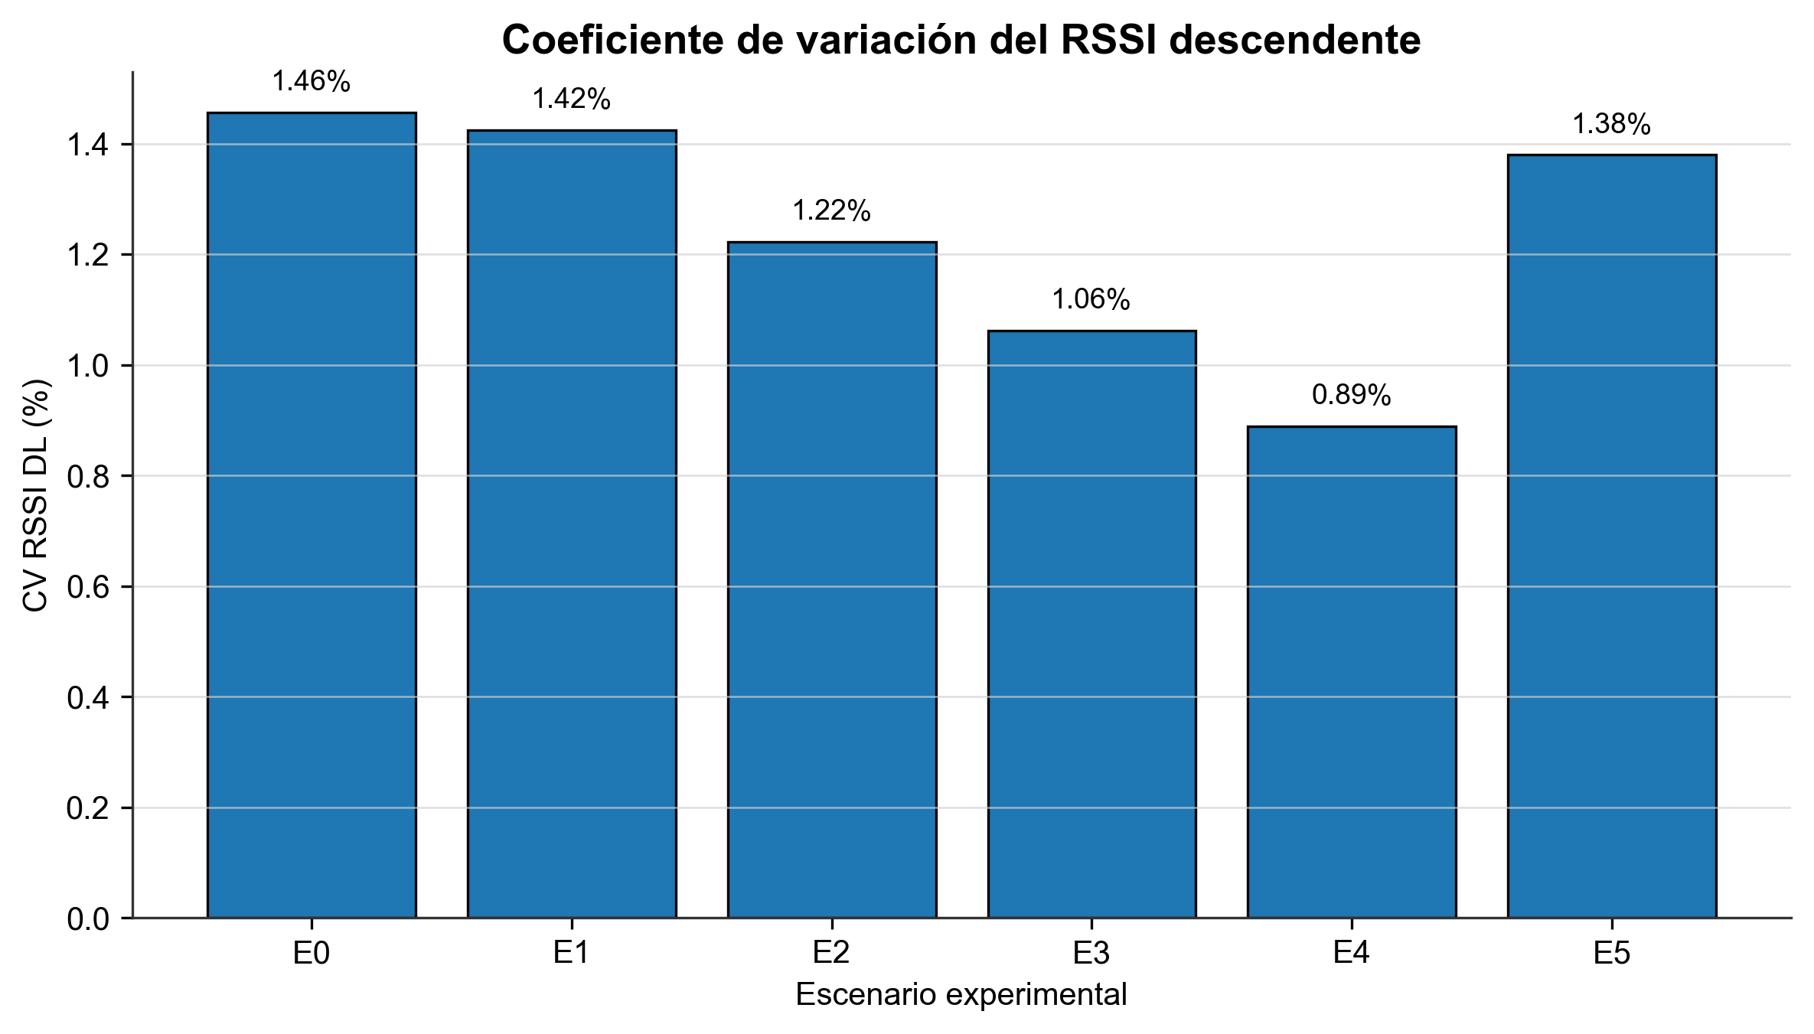
Fig. 1. Cv rssi.
Fuente: Elaboración propia.

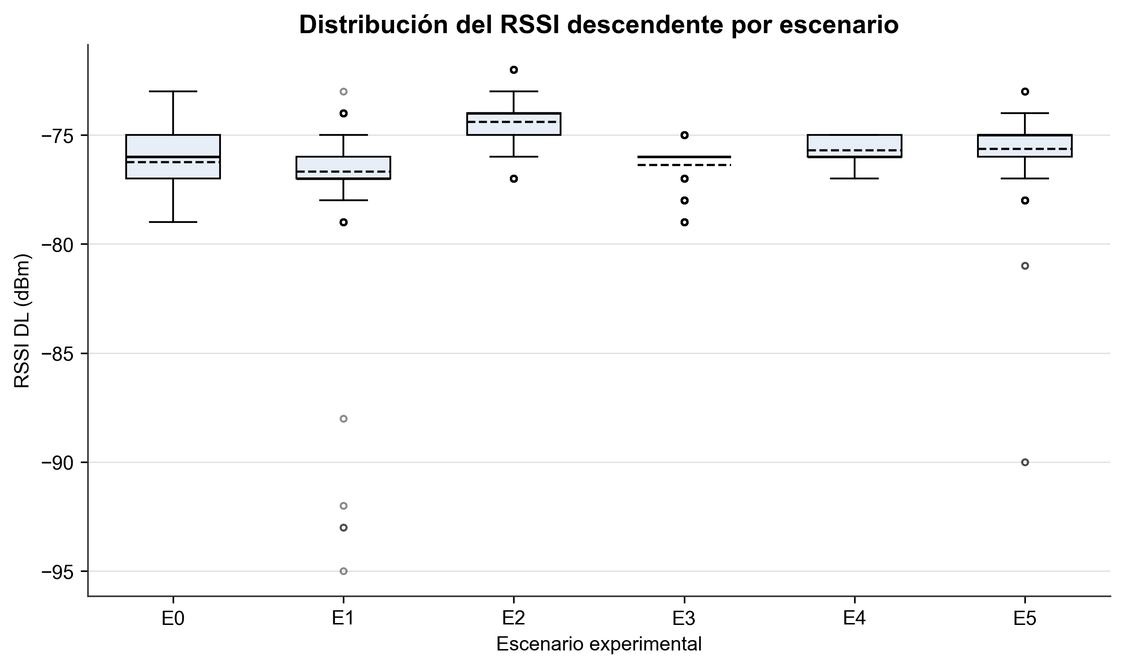
Fig. 2. Boxplot rssi.
Fuente: Elaboración propia.

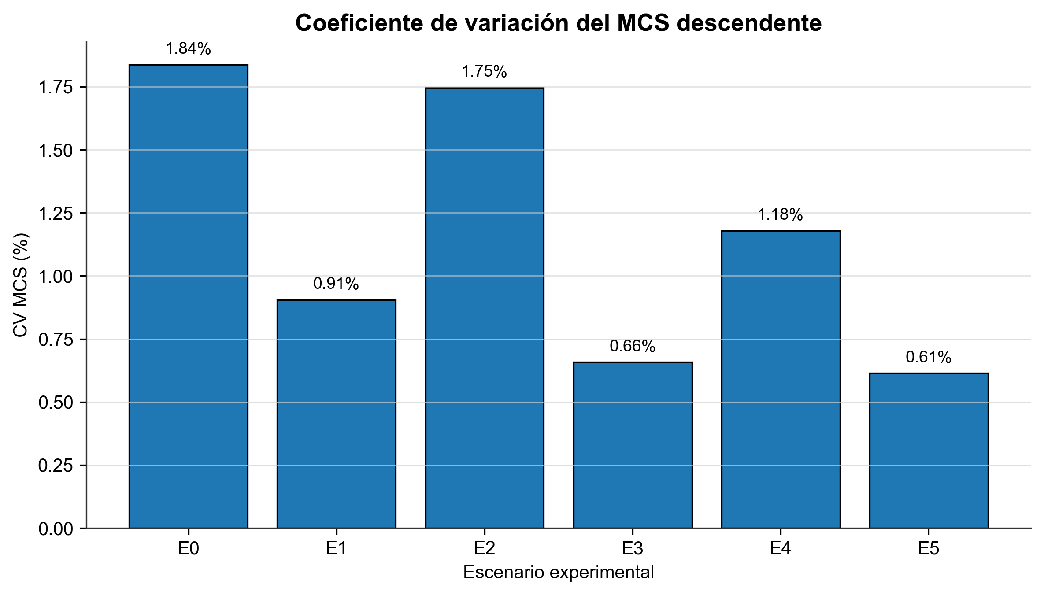
Fig. 3. Cv mcs.
Fuente: Elaboración propia.

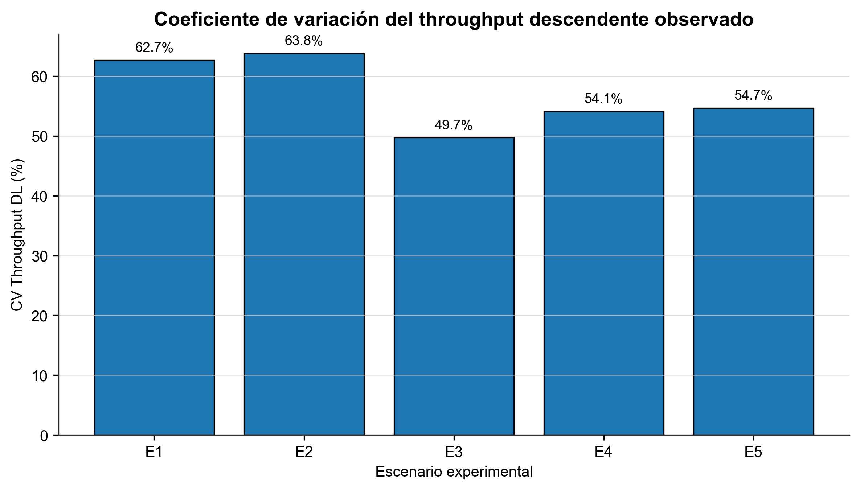
Fig. 4. Cv throughput.
Fuente: Elaboración propia.

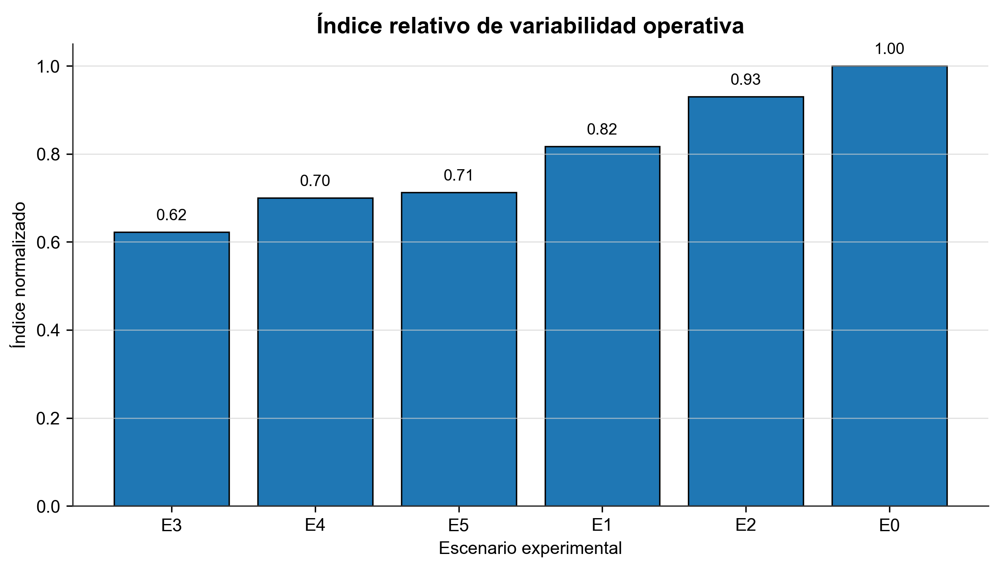
Fig. 5. Indice variabilidad.
Fuente: Elaboración propia.

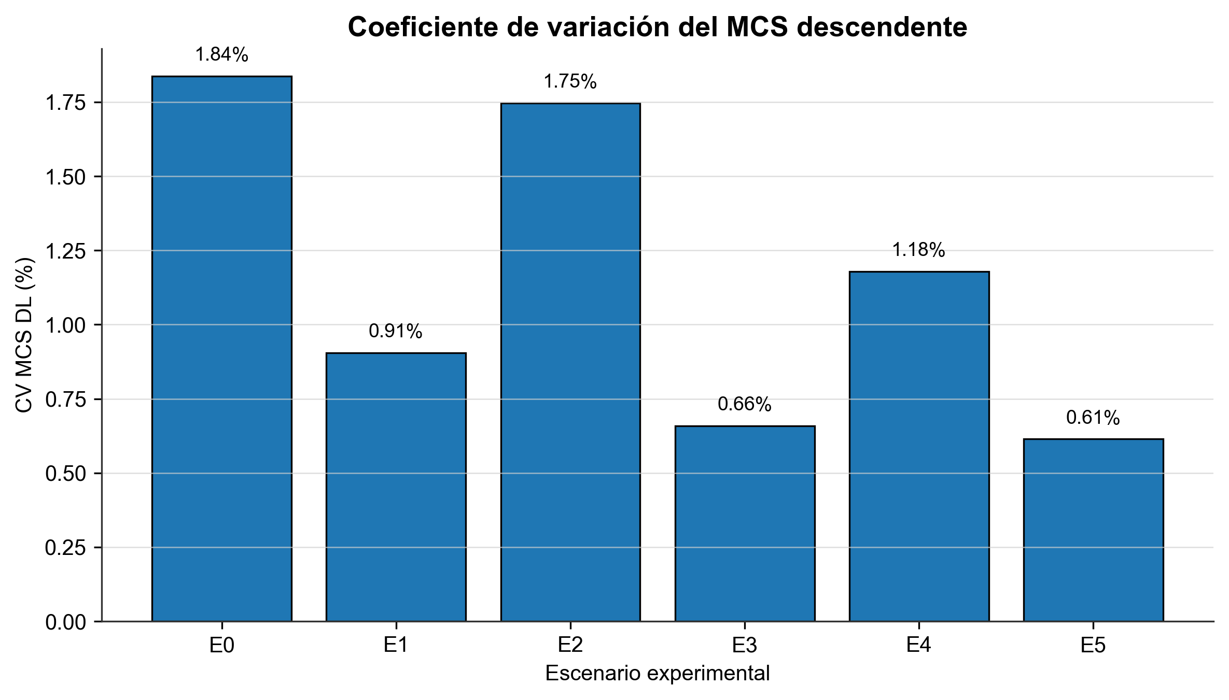
Fig. 6. Cv mcs.
Fuente: Elaboración propia.

3. Trazabilidad de archivos
- Tabla incorporada: outputs/tables/tabla_4_1_descriptivos_principales.csv
- Tabla incorporada: outputs/tables/tabla_4_2_kruskal_wallis.csv
- Tabla incorporada: outputs/tables/tabla_4_3_conteo_lluvia.csv
- Tabla incorporada: outputs/tables/tabla_4_3_dunn_completa.csv
- Tabla incorporada: outputs/tables/tabla_4_3_dunn_significativas.csv
- Tabla incorporada: outputs/tables/tabla_4_4_desempeno_lluvia.csv
- Tabla incorporada: outputs/tables/tabla_4_5_correlacion_precipitacion.csv
- Tabla incorporada: outputs/tables/tabla_4_6_estabilidad_por_escenario.csv
- Figura incorporada: outputs/figures/fig_4_9_cv_rssi.png
- Figura incorporada: outputs/figures/fig_4_10_boxplot_rssi.png
- Figura incorporada: outputs/figures/fig_4_11_cv_mcs.png
- Figura incorporada: outputs/figures/fig_4_11_cv_throughput.png
- Figura incorporada: outputs/figures/fig_4_12_indice_variabilidad.png
- Figura incorporada: outputs/figures/fig_7_cv_mcs.png

